Santa Clara County Council

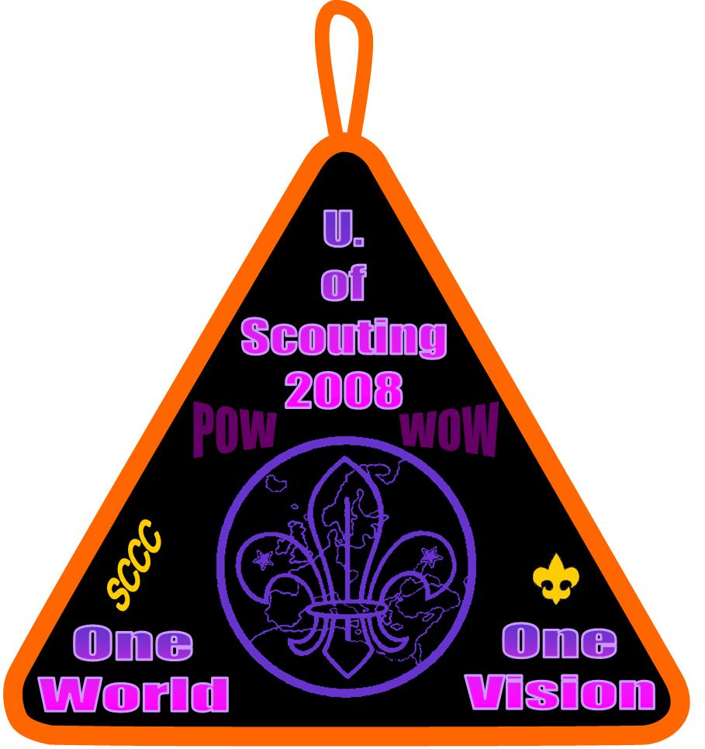

Cub Scout Pow Wow
-- and --
University of Scouting

Introduction to the 2008
Cub Scout Pow Wow & University of Scouting CD

WELCOME! It’s amazing how technology changes our Scouting lives. In 1999 we produced about 300 Pow Wow books. In 2000 we produced the same number, but also gave everyone a CD with the book and lots more resources. In 2007 we gave all participants a CD, and could not give away the paper books. This year, no books, only CD’s.
You had a great time at Pow Wow, learned a lot, met fellow Scouters, made some new friends. Now its time to get to work, and take what you learned back to your youth. Here is your resource CD for 2008. For Cub Scout leaders, the 2008 resources will are intended to supplement your monthly Program Helps, to plan Den and Pack meetings. So print out sections, mark them up. After all, you’ll get another one next year!
Your editors know that you look forward to the Pow Wow Resource each year, and depend on new material and resources to help your programs. It is getting harder to find new material – much is recycled these days. We have sought out material from old Pow Wow books, fourteen years of Baloo’s Bugle and other documents, original material from Scouters around the world, web sites and sources outside Scouting. We know that some material will be familiar to you, but you should also find a lot of fresh ideas -- crafts, skits, songs, and lots more.
In this age of internet Scouting, you also need to know that there are many resources to help your program, as close as your computer. The US Scouting Service Project at http://www.usscouts.org is the largest resource on the internet for Cub Scouts and Boy Scouts programs. For Cub Scout programs, the very best resource is Baloo’s Bugle, at http://www.usscouts.org/bbugle. You will also find online Pow Wow books, songs, skits, stories, recipes and much more, at http://www.macscouter.com.
This book represents far less than 10% of what you will find on the accompanying CD. On the CD you will find all of the backup material provided by the University of Scouting instructors, and many Pow Wow books, going back several years.
We want to thank a whole bunch of people for their significant contributions to this book: A special thanks to Dave Lyons, editor of Baloo’s Bugle – much of the Cub Scout monthly theme resources were gleaned from older Bugles with similar themes. Thanks to all the UOS instructors who provided their class notes and backup material. Thanks to the many councils who have provided their Pow Wow book files to include on the CD. Thanks to all the many Cub Scout contributors to the US Scouting Service Project web site, the participants on Scouts-L and the local Scouters who responded to our plea for HELP!!!
-- Gary & Kyna Hendra
Part 1: Cub Scout Pow Wow
And the 2008 Monthly
Cub Scout Themes

2008 Cub Scout Monthly Themes and Webelos Activity Badges

It’s a very good idea to plan your Den and Pack program around the monthly themes suggested by BSA. This is because the program helps which you receive each month in Scouter magazine, follow the sequence of themes and Webelos Activity badges. The program helps, and the monthly theme resources in this book, can save you a lot of time and effort preparing activities for your Scouts. The table below gives the themes and badges by month, until we meet again at Pow Wow.
Following this table you will find the theme resources for each month. These resources consist of den activities and gathering activities, opening ceremonies, advancement ceremonies, songs, audience participations, cheers, closing ceremonies and Cubmaster’s Minutes, for each theme. Following all that, you will find resources to help with each Webelos Activity badge.

2008 Cub Scout Monthly Themes and Webelos Activity Badges

Scouting Month | Theme | Description | Webelos Activity Badges
February 2008 | Chinese New Year | Happy Chinese New Year! Or more appropriately, Gung Hay Fat Choy! (The traditional Chinese New Year greeting). This month we welcome the year 4705. Let's celebrate and welcome the New Year with dragon dances, paper lanterns, fortune cookies and oranges for abundant joy. Decorate your blue and gold banquet with banners inscribed with Chinese characters for luck and lots of red, the symbol of a bright and sunny future. Why not earn the Language and Culture belt loop and pin as we learn about and enjoy the culture of China. | Scholar  Engineer
March 2008 | Litter To Glitter | This month Cub Scouts will turn recycled items into treasure and learn about conservation at the same time. Using items that would normally go in the trash or recycling bin, build artistic masterpieces of your own design. It's amazing what some recycled bottles and paper can do when combined with glue and a little imagination. Have a gallery opening at your pack meeting with all your art displayed. Don't forget the Art belt loop and pin. | Athlete - Engineer
April 2008 | Abracadabra | Cub Scouts love to amaze and be amazed! Boys discover secrets of the magician's art this month as they demonstrate magical illusions and learn new tricks with cards, coins and other everyday objects. The Cub Scout Magic Book is a great resource for age-appropriate tricks and puzzles. Visit a magic shop or have a magician come to your den or pack meeting to teach the boys a few tricks of the trade. Prepare to watch in wonder at the pack meeting as your Cub Scouts entertain their audience with skits, stunts and sparklers that they have practiced at den meetings. The Cubmaster uses the magic of ceremonies to pull awards from his hat at the mystifying pack meeting magic show. This would be a good month to hold your pack space derby. | Sportsman - Family Member
May 2008 | Leaf It To Cubs | Cub Scouts will learn about the wonders of nature's gift to us, a tree! Learn to identify poison oak, poison ivy and various trees by their shape and leaf design. Try leaf rubbing, leaf prints, making a leaf collage, preserving leaves with wax paper or making a leaf collection from fallen leaves. Make a leaf boat and race it at a den or pack meeting. Participate in a tree planting or your local Arbor Day activities. Either adopt a tree or plant one and watch it grow. Research how trees are used to help us in our daily lives. Field trips can be to a lumberyard, nature center, forest preserve or local park. Earn the Collecting belt loop and pin. | Outdoorsman - Artist
June 2008 | Go For The Gold | As the athletes of the world strive to do their personal best in international competition, Cub Scouts have the opportunity to "Go for the Gold" by doing their best in feats of skill and prowess. This month Cub Scouts learn about exercise and sports and put that knowledge to use playing Ultimate or another sport not played before. Remember that not only is it important to do your best when you play a sport but it is important to understand the rules of being a good sport no matter the outcome of the game. This month would be a great time to work on one of the Cub Scout Sports belt loops and pins in baseball, golf or flag football. | Traveler - Handyman
July,2008 | H2Ohhh! | Dive right in as Cub Scouts spend a month learning about water, our most precious resource. Learn about marine life. Dens can visit a water treatment facility, local aquarium or fish farm. Cub Scouts may even want to prepare their own aquarium or fish bowl and "adopt a gold fish". This is also an excellent opportunity to teach our Cub Scouts about water conservation. Don't forget learning about water safety. Enjoy water games; hunt for shells and experience all the beach has to offer. Cub Scouts love to get wet. What could be better than a water carnival complete with games, competition, and safe swim demonstrations? This would be a great time to work on the Wildlife Conservation, Fishing, or Swimming belt loop and pin. Have an outdoor Cub Scout raingutter regatta race. | Aquanaut - Geologist
August 2008 | S'more Summer Fun | Summer memories can last a lifetime and memories made with your Cub Scout den or pack can be some of the best. So let's make "S'More" Cub Scout memories this month. Since "outing" is part of Cub Scouting, let's get outside and have some fun. Be it having a picnic, water party, softball game or campout; there is no limit to the amount of fun to be had by all this month. Why not have a pack family campout following the guidelines your leaders learned in BALOO training? What could be better than an outdoor pack meeting complete with a campfire? Whether you make a real or synthetic fire, the fun is 100% genuine. This would be a good opportunity to work on the Softball belt loop and pin or the Weather belt loop and pin. | Naturalist - Forester
September 2008 | New Buddies | Wonderful opportunities are waiting! The new school year brings possibilities of new friends. This month a Cub Scout can invite a new buddy to join the fun and adventure of Cub Scouting! This single act can influence the lives of many others. The boys will make new friends while keeping the old by learning to share and treat buddies with kindness. In the den meeting the boys can learn the value of friendship, cooperation, and respect through games and activities. This new team of buddies can develop secret codes and write messages to each other. They will all learn the Cub Scout handshake and motto which will signify belonging to that special group. The boys can practice the buddy system as they go on hikes, work on projects, play games, and participate in sports. This is a great month for boys to earn a Cub Scout Academics or Sports belt loop or pin as they work and play together with an interest they all share. | Communicator - Citizen
October 2008 | Adventures In Books | What great adventures come in books? Let's discover some this month. Visit the library and learn to navigate your way through the "card catalog computer," down the aisles of many adventures, and to an adventure of your own choice. Sign up for your library card while on your visit. Create your own outdoor epic adventure on a hike, campout, or maybe at a ball field or park. Make a costume for one of the characters from your favorite story. At the pack meeting the boys can perform some of their favorite stories and share some of their adventures with the pack. Take part in Pedro's "Say Yes to Reading" program in Boy's Life. This might also be a good month to work on the Communication or Computer belt loop and pin. Encourage the boys to have the courage to search for, discover, and share adventure this month. | Showman - Citizen
November 2008 | Seeds Of Kindness | As we approach Thanksgiving, let us spread seeds of kindness in the form of multiple small service projects. Helping others gives the boys the opportunity to see the bounty produced by spreading many small seeds of kindness and encourages compassion. The boys can discover that just as the large strong oak tree came from the small acorn, big things can happen from spreading small seeds of kindness and charity. Conduct a food drive or collect coats and gloves for those in need; report your hours to Good Turn for America. Work on the Citizenship belt loop and pin. | Craftsman - Readyman
December 2008 | Holiday Lights | The Star of Bethlehem, the Miracle of the Lamp, the Morning Star that enlightened Buddha, the bonfires of Yule: many of our holiday traditions this month involve lights. Share your holiday traditions with your pack and den: lights on a Christmas tree, candles on a Menorah for Chanukah, or on a Kinara for Kwanzaa. Boys can be stars this month by brightening someone's holiday season with a gift of compassion. As a pack or den, visit a nursing home, preschool, or children's ward and sing holiday favorites. End your outing by sharing cookies that the boys decorated. Help those less fortunate with a service project or toy drive. How about a holiday campfire at your pack meeting? This is great month to work on the Language and Culture belt loop and pin or the Heritages belt loop and pin. | Craftsman - Scientist
January 2009 | "A-MAZE-ing" GAMES | January is a good time for indoor fun. Make and solve puzzles. Stump your friends with riddles. Build a maze, do crossword puzzles, and word searches. Have a pack games night in which your family joins in for relays, board games, and other cooperative games. Play Cub Scout Jeopardy; how much do you know about Cub Scouting? Rediscover some of the games that your parents and your grandparents could have played and work on the Heritages belt loop and pin. Discuss why playing by the rules is important. The pinewood derby is a good opportunity to learn about rules and good sportsmanship. Why not work on the Chess belt loop and pin. | Fitness  Scientist

Part 2: 2008 Monthly
Webelos Activity Badge Resources

Part 3: 2008 University of Scouting Class Notes

