POW WOW 2008

Jazzing Up Meetings with Songs and Pizzazz

Table of Contents
20 Tips for Cub Scout Song Leaders 2
A Pack Song 2
The Pack Yell 3
Gopher Guts 3
Boom Chick-a Boom 3
Worms 4
Grandma’s In The Cellar 4
Wheels, Wings, Rudders 4
Ping-Pong Ball 5
The More We Get Together 5
Scout Vesper Song 5
Billy the Cub Scout 6
Cub Scouts Sound off 6
She’ll Be Comin’ Round the Mountain (Cub Scout Style) 7
Boom Chick-a Boom 7
BLOW YOUR BOAT 7
Battle of New Orleans 8
Pinewood Derby Song 8
My Bonnie (With Cub Scout Words) 9
Verses to My Bonnie to use at your Pinewood Derby 9
Trash Rap 10
God Bless My Underwear 11
Bug Juice 11
Boa Constrictor 12
Skits 13
Yapoocha 13
If I Weren’t A Cub Scout 14

20 Tips for Cub Scout Song Leaders

- Leading songs is all about having fun. So smile at your group. Relax. Radiate confidence and enthusiasm, even if you don’t feel particularly confident or enthusiastic.
- Morale is contagious. So is fear. If you’re not having fun, then your boys won’t either.
- Remember, it’s not a concert. It’s a sing along. Your job is not to sing – it’s to get the boys singing.
- Look for songs that have a chorus that the kids can pick up quickly. (See the Pack Song based on “Doo-Wah-Diddy”)
- Look for songs that have a “call-and-response” structure. (See “Billy the Cub Scout)
- Stick to rousing, well-known, numbers so that everybody, including you, can sing out with confidence. Stay away from anything that’s too complex.
- Remember – this is kids music – not children’s music. Stay away from “Barney” Songs. Surprise people.
- Start by giving the right pitch. Sing or play a few bars yourself to get things started.
- Don’t play a musical instrument? Then find somebody who does. (Moms or dads who are in their church choirs are a great resource for finding guitarists or pianists who will be glad to help you out.) And remember, it’s never too late to learn to play yourself!
- If you can’t find somebody to accompany you (and don’t play an instrument yourself), then look for “Yells” like “Boom-Chick-A-Boom”.
- Start the singing with a downbeat. Count the song off, holding your arm up and then bring it down decisively at the start of the song.
- Don’t worry if some kids don’t start singing with the first note – focus on the ones that are singing. The rest will join in soon enough.
- Beat time with a simple up-and-down motion of the arm, but make it definite and brisk. Be in command!!!
- Control the volume by raising your hands for loudness and lowering them for softness.
- Don’t just stand there - move around! Inject a little pep and personality. Keep smiling.
- Spark enthusiasm by dividing the crowd for a song or two. Groups can sing separately when you point to them, and then all together. Vary unison singing with occasional humming, whispering, or rhythm clapping.
- Stop before somebody stops you! Leave them wanting more.
- Never try to shame anybody into singing. Give the kids who don’t want to sing something else to do (stomp, shout, etc.)
- Songs can be used to instill pack pride in your scouts. Make your scouts throw their chest out when they say what pack they belong. And besides, they’ll have a lot of fun.
- Help the kids to make up a pack (or den) song.

Write Yourself A Pack Song
A pack song gives every Scout a chance to sing. The example below is based in part on the old rock song “Doo-Wah-Diddy” and partly on “Twist and Shout”. These words were written for the pack that my boys were in when they were in Cub Scouts – but you and your Cubs can easily make up new words for your pack or den.

We are the Cub Scouts of Cub Pack 218,
Singing doo wa didee didee dum didee doo
Best Little Cub Pack You Have Ever Seen
Singing doo wa didee didee dum didee doo
We sing good (sing good)
We sing loud( sing loud)
We sing good (good and loud)
Cub Scouting Makes us Proud,
AAAH!, AAAH!, AAAH!, AAAH!, AAAH!

This is our pack and this is our song
Singing doo wa didee didee dum didee doo
And we’re gonna sing it the whole night long.
Singing doo wa didee didee dum didee doo
We sing good (etc.)

We follow Akela, and do our good deeds,
Singing doo wa didee didee dum didee doo
I love Cub Scouting, it’s the greatest thing to me,
Singing doo wa didee didee dum didee doo
We sing good…. (etc.)

Here’s a pack song based on an old Irish folk melody called “Rosin the Beau”, It’s been known by many other names, such as “Acres of Clams” & was used as Abraham Lincoln’s campaign song!
I’ve traveled all over this world.
Any many a Cub Pack I’ve seen.
But never a Cub pack so mighty
As the Cub Scouts of Pack 218….
The Cub Scouts of Pack 218!
The Cub Scouts of Pack 218.
Never a Cub Pack so mighty
Aaaaaaas the Cub Scouts of Pack 218.

Adapting this song to your own pack requires words that rhyme with your unit number. Here’s a few examples:

There’s Cub Scouts all over this world.
Their packs and their dens are all fine.
But none of those Packs can compare with the Cub Scouts of 229
OR
There’s lots of fun places to go to.
And lots of fun things you can do
But none can compare with the fun that I’ve had with Pack 362
OR
Some kids think it’s fun to go camping.
And some kids like climbing a tree.
But none of these things can compare with The Cub Pack called 183.

When you’re writing words for a Pack song, make sure that your words match the rhythm of the song, not the other way around. If your unit number has a lot of syllables, you need to get creative to make it fit. So for example, if your unit number is 174, the last line of a song based on “Rosin the Beau” could be “the scouts of pack one-seven-four” but not “the scouts of pack one seventy four”, because there aren’t enough notes in the song to hold that many syllables.

The Pack Yell
(Just like den yells, every pack should have its own yell for the scouts to identify. This simple yell has raised spirit in pack meetings, heard in parades, and shouted at day camps.

(Start softly, use hand at low level to send message)
Pack two thirteen, we couldn’t be prouder
If you can’t hear us, We’ll shout a little louder !!!

(Medium volume, raise hand to shoulder level)
Pack two thirteen, we couldn’t be prouder
If you can’t hear us, we’ll shout a little louder !!!

(Loud volume, raise hand to head level)
Pack two thirteen, we couldn’t be prouder
If you can’t hear us, we’ll shout a little louder !!!

(Very loud volume, throw both hands overhead)
Pack two thirteen, we couldn’t be prouder
If you can’t hear us, THAT’S TOUGH !!!

Gopher Guts
(Gross song, loved by boys everywhere!)
Great green gobs of greasy grimy gopher guts,
Multilated monkey meat,
Little dirty birdy feet,
French fried eye-balls,
Rolling down a muddy street,
And I forgot my spoon.
(Repeat two times)

(pause)
But I got my straw!

Boom Chick-a Boom
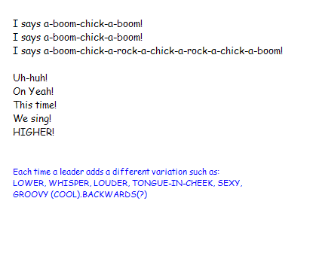

Worms
(Another well known gross one)
Nobody likes me,
Everybody hates me!
Guess I’ll go eat worms.
Chorus (Repeat after each verse)
Long, slim slimy ones,
Short, fat juicy ones,
Itsy, bitsy, fuzzy, wuzzy worms.
First you get a bucket,
Then you get a shovel,
Oh how they wiggle and squirm.
First you pull the heads off,
Then you suck the guts out.
Oh how they wiggle and squirm.
Down goes the first one,
Down goes the second one,
Oh how they wiggle and squirm.
Up comes the first one,
Up comes the second one,
Oh how they wiggle and squirm.

Grandma’s In The Cellar
Grandma's in the cellar
Glory, can't you smell her
Cooking biscuits on her brown and dirty stove.
In her eye there is some matter that keeps drippin'
in the batter
And she whistles while the (snort) runs down her nose.

Down her nose.
Down her nose.
And she whistles while the (snort) runs down her nose.
In her eye there is some matter that keeps drippin'
in the batter
As she whistles while the (snort) runs down her nose.

Wheels, Wings, Rudders
Tune: “Three Blind Mice”

Wheels, wings, rudders
Wheels, wings, rudders
See how they go,
See how they go.
The wheels will roll and the wings will flap.
The rudders will go back and forth – slap, slap!
I can’t think of anything more
fun than that.
Wheels, wings, rudders

Ping-Pong Ball
(Tune - "William Tell Overture")

A guy had a game with a ping-pong ball,
A guy had a game with a ping-pong ball,
Oh, a guy had a game with a ping-pong ball,
With a ping, ping-pong ball.

Oh, a guy had a game with a ping-pong, ping-pong, ping-pong, ping-pong, ping-pong ball,
With a ping, with a ping, with a ping-pong, ping-pong, ping-pong, ping-pong ball.
Ping, ping, ping, ping, ping, ping, ping, ping, ping, ping!

A guy had a game with a ping-pong ball,
Oh, a guy had a game with a ping-pong ball,
A guy had a game with a ping-pong ball,
With a ping, ping-pong ball.

(repeat, but this time say "pong" for "ping" and vice-versa)

The More We Get Together
Tune: “Ach Du Lieber Augustine”

The more we get together, together, together,
The more we get together, the happier we’ll be.
For your friends are my friends,
And my friends are your friends.
The more we get together, the happier we’ll be.

The more we get together, together, together,
The more we get together, the happier we’ll be.
For you know that I know,
And I know that you know,
The more we get together, the happier we’ll be.

Scout Vesper Song
Tune: “O Tannenbaum”

Softly falls the light of day,
While our campfire fades away.
Silently each Scout should ask:
“Have I done my daily task?

Have I kept my honor bright?
Can I guiltless sleep tonight?
Have I done and have I dared
Everything to be prepared?”

Billy the Cub Scout
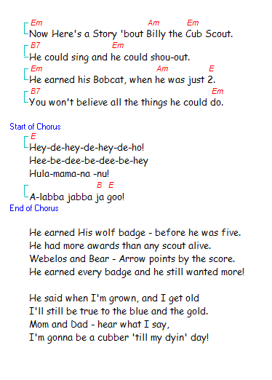

Cub Scouts Sound off
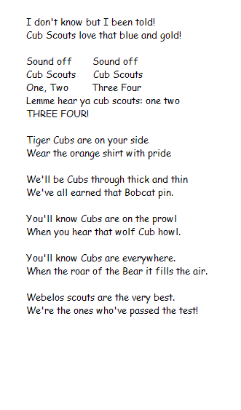

She’ll Be Comin’ Round the Mountain (Cub Scout Style)
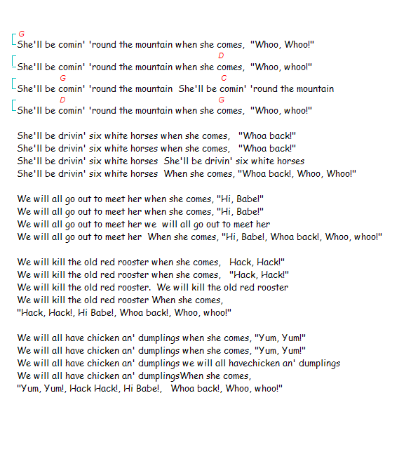

BLOW YOUR BOAT
Tune: “Row, Row, Row”

This is an example of a song to use as part of a Pack event. A Cub Scout boat race is like the pinewood derby, only using toy sail boats instead of cars. The boys move the boats along a race track by blowing on the sails. The Track is a built from house gutter material filled with water, and the boat kits are available from the scout shop. Here’s a song that you can use at the pack meeting…

Blow, Blow, blow your boat
Fast along the waves
Do your best, do your best
We’re the Cub Scout braves.

Blow, blow, blow your sail,
Passing others by.
Do your best, do your best
Aye-aye! Aye-aye! Aye-aye!

Blow, blow, blow your boat.
The finish line is near.
Do your best, do your best
Hey! The end is here!

Battle of New Orleans
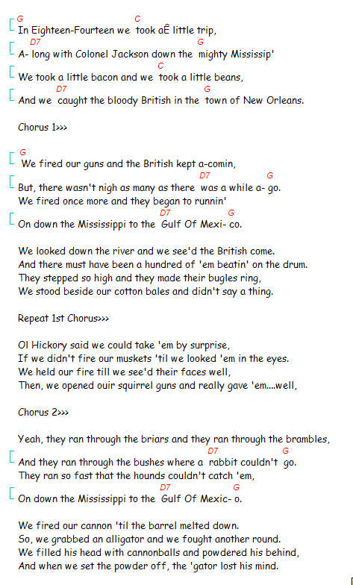

Pinewood Derby Song
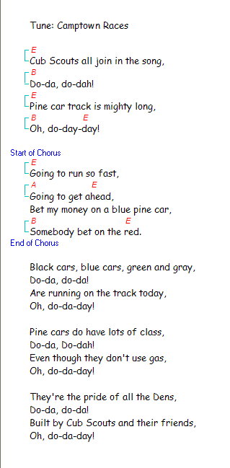

My Bonnie (With Cub Scout Words)
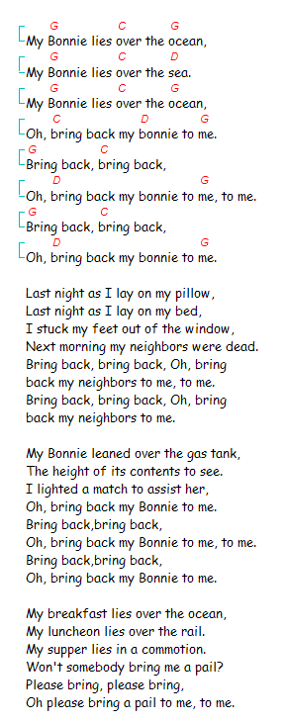

Verses to My Bonnie to use at your Pinewood Derby
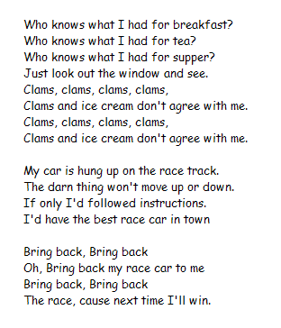

Trash Rap
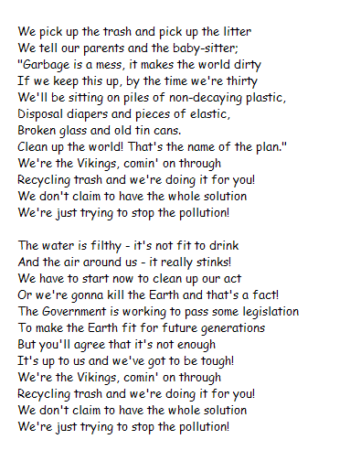
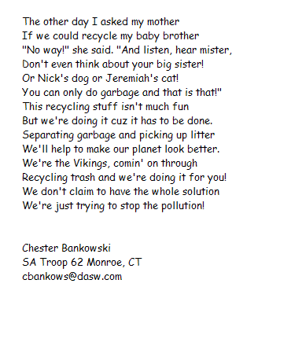

God Bless My Underwear
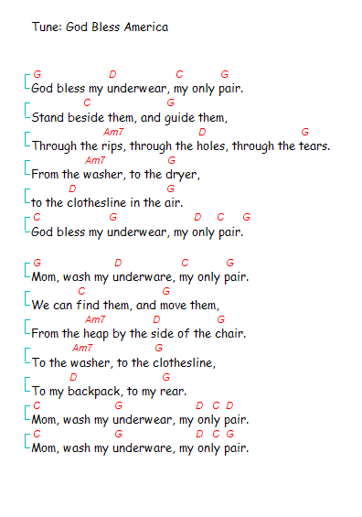

Bug Juice
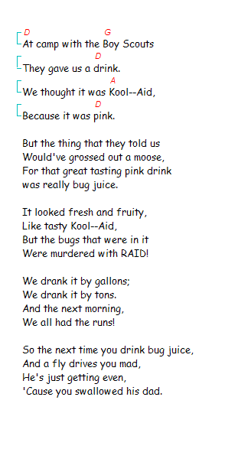
Banana Boat Song
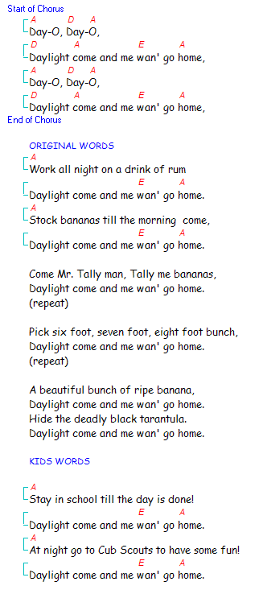
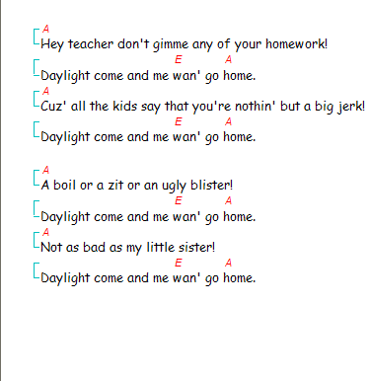

Boa Constrictor
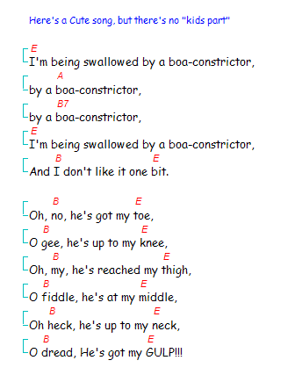

Skits
The keys to a good skit are simplicity and audibility. Evaluate your den – assign the major speaking parts to those that don’t get stage fright. You must be more selective if you have fewer loud boys.

The boys won’t want to rehearse at first, but when one of the dens in your pack pulls off a skit successfully, there’s no greater confidence builder! Encourage them to rehearse by rewarding them when they do well.

Here are a couple of skits that include a musical element. Musical skits can actually be easier for the boys to “pull off” than skits that are made up of straight dialog – the music provides some structure so that everybody knows what to do (and when).

Yapoocha
Skits that include songs are especially funny. “Yapoocha” is a good example. A tribe of "Indians" are dancing around their fire, while the "Chief" sits cross legged to one side. After a while they all stop dancing, and one approaches the chief.
"Oh great chief, is it time for Yapoocha?" The chief looks up at the stars and the moon, then shakes his head. "It is not yet time for Yapoocha".
The dance continues for a while, then stops and someone else approaches the chief and asks the same question.
Once again the chief looks at the stars and the moon and answers, "It is not yet time for Yapoocha".
The dancing carries on again, then stops and yet another person approaches the chief. This time the chief looks at the stars and moon, pretends to think hard for a moment, then says, "Yes, now is the time for Yapoocha!"
Solemnly, the "Indians" make a line, and on a cue from the chief, they begin to sing and dance…… - "Yapoocha left hand in, yapoocha left hand out..."

If I Weren’t A Cub Scout
(This skit requires all scouts to be loud. Each Cub speaks and acts out one part beginning with birdwatcher. As you add on occupations, each person continues to speak and act out their parts.)

If I weren’t a Cub Scout, I wonder what I’d be.
If I weren’t a Cub Scout, a birdwatcher I would be
Hark! A Lark! It’s flying through the park. Splat!

If I weren’t a Cub Scout, I wonder what I’d be.
If I weren’t a Cub Scout, a carpenter I would be.
2 by 4. Nail it to the floor.

If I weren’t a Cub Scout, I wonder what I’d be.
If I weren’t a Cub Scout, a plumber I would be.
Plunge it, flush it, look out below.

If I weren’t a Cub Scout, I wonder what I’d be.
If I weren’t a Cub Scout, a teacher I would be.
Sit down, listen up. Throw away your gum.

If I weren’t a Cub Scout, I wonder what I’d be.
If I weren’t a Cub Scout, a typist I would be.
Ticka, ticka, ticka, ticka, ticka, ticka, Zing!

If I weren’t a Cub Scout, I wonder what I’d be.
If I weren’t a Cub Scout, a Superman I would be.
It’s a bird, it’s a plane. Where is Lois Lane?

If I weren’t a Cub Scout, I wonder what I’d be.
If I weren’t a Cub Scout, a Cubmaster I would be.
Do this, do that, I’m going to take a nap Z-z-z-z.

