Finance & Fundraising

Outline

Figure 1: Unit budget work sheet

Figure 2: Unit Fund Raising guide lines

Figure 3: Example for budget expenses for re-charters

Figure 4: Insurance Coverage guide lines

Figure 5: SS-4 IRS Application for Identification

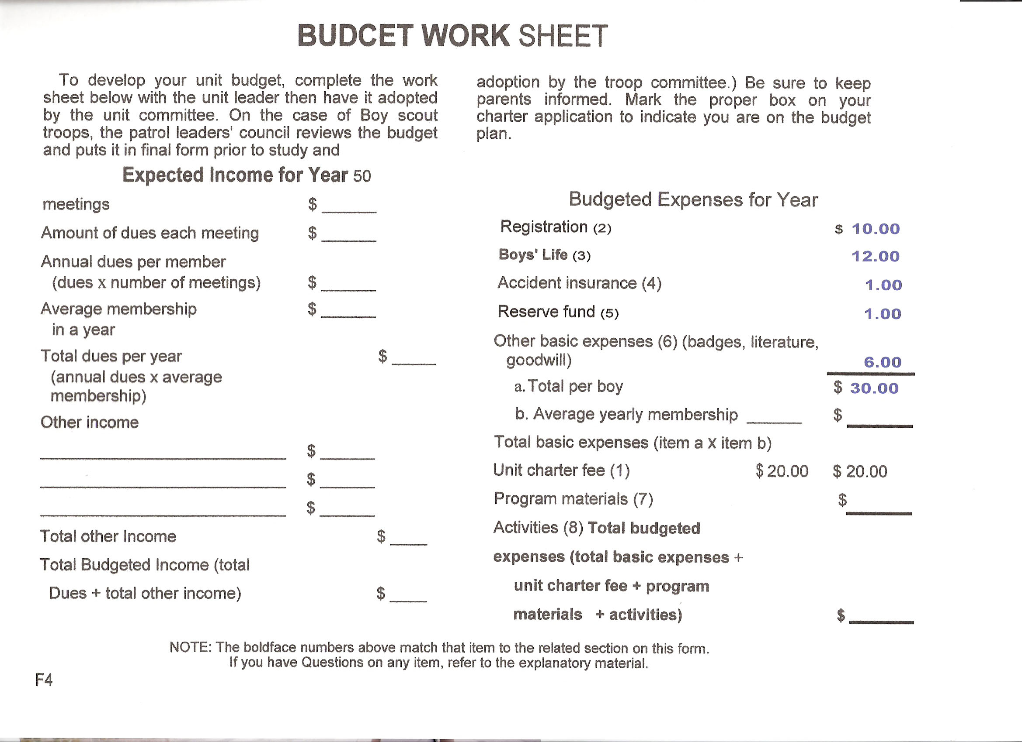
Figure 1

Guide Lines for Conducting Fund Raising Activities

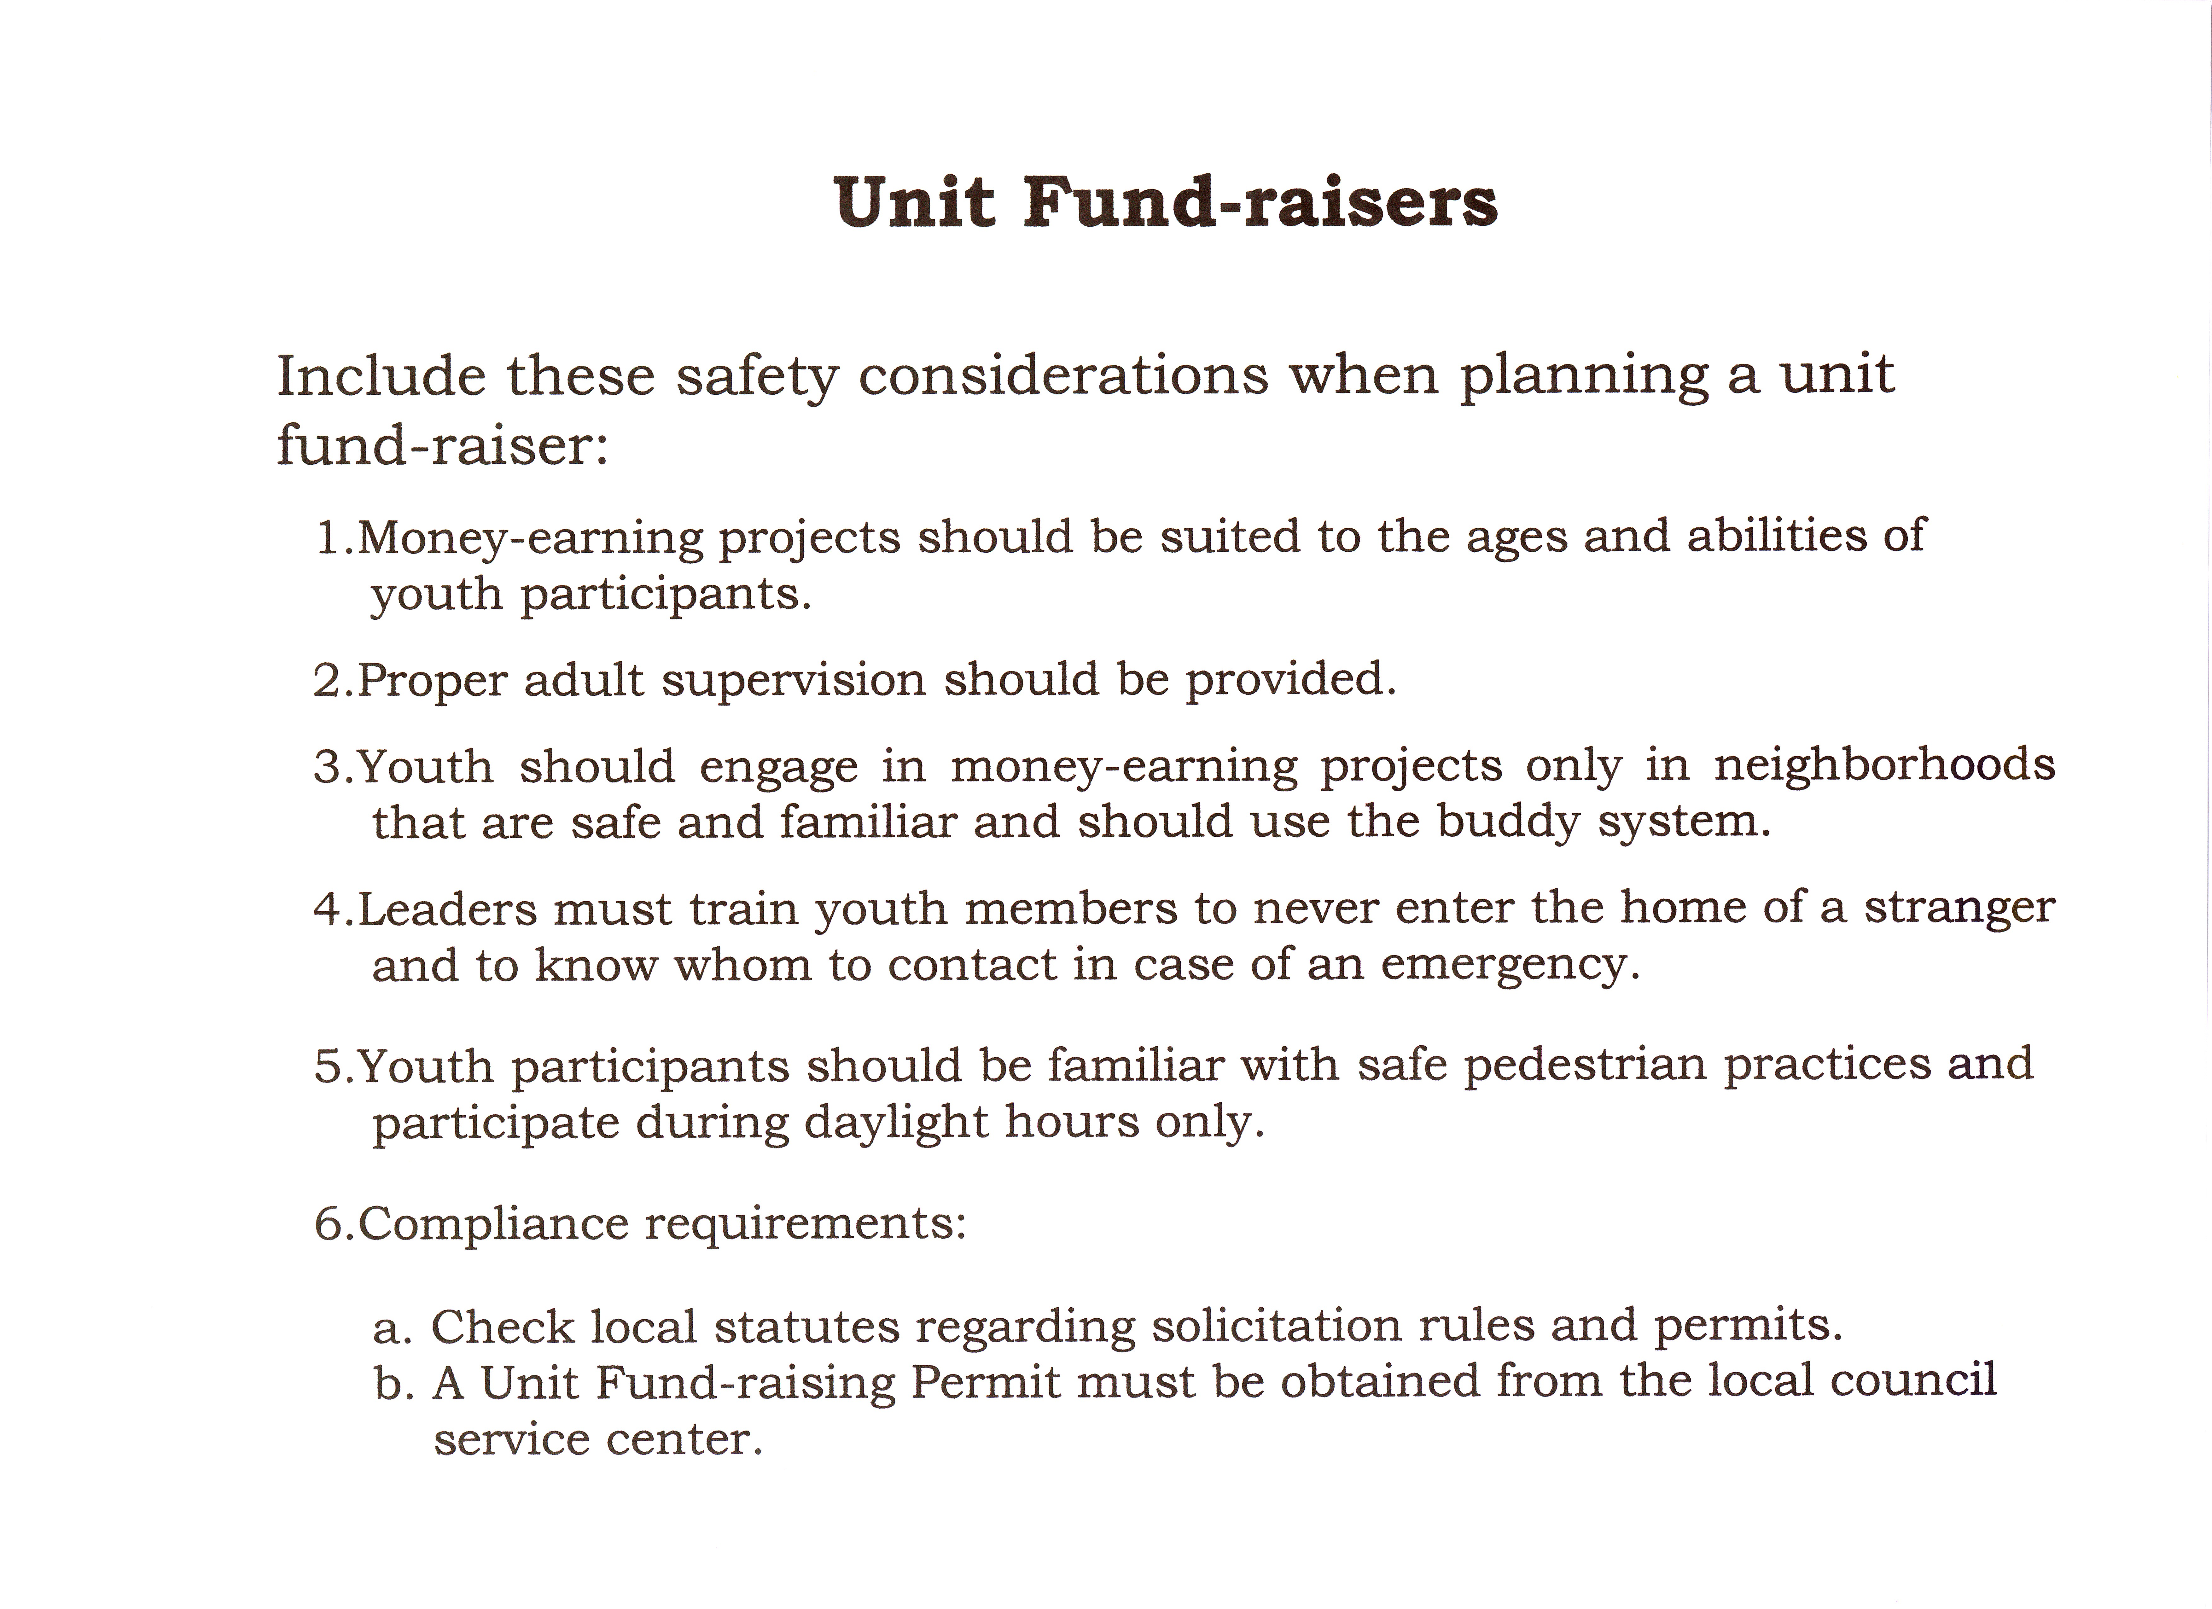

Figure 2

Example of Budget Expenses paid for re-charters

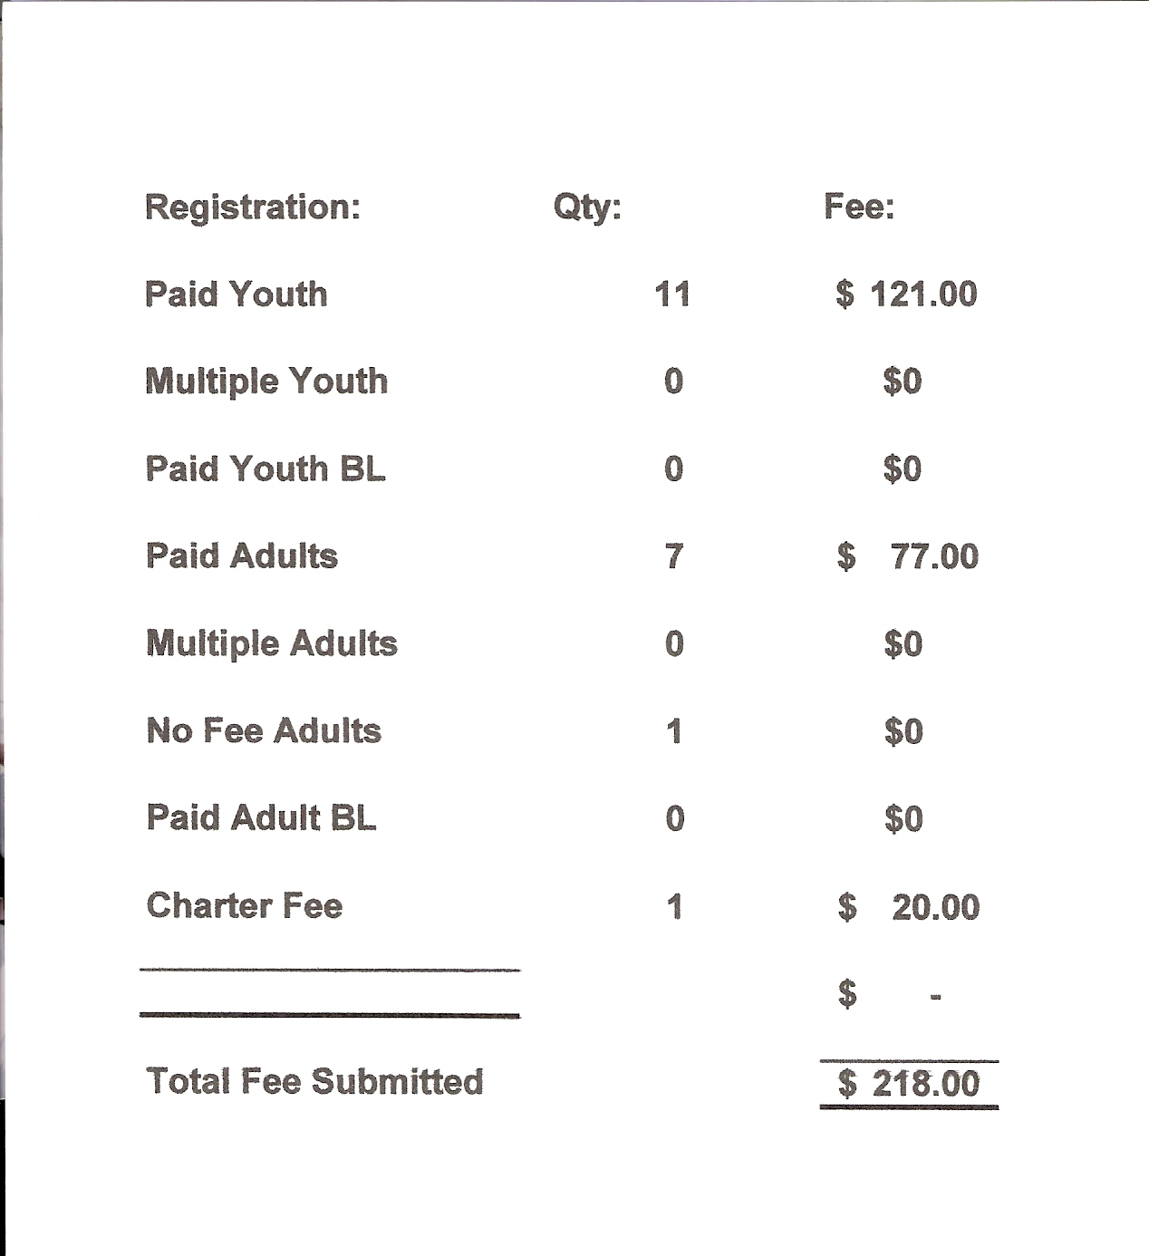

Figure 3

Insurance Coverage

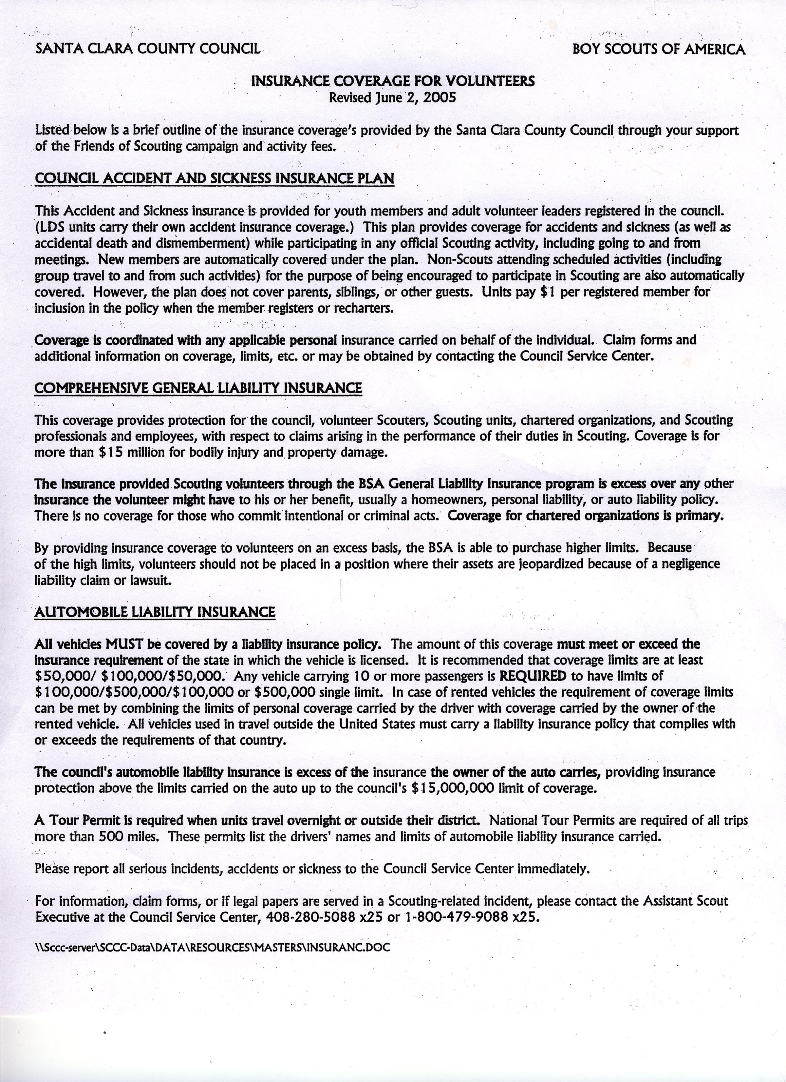
Figure 4

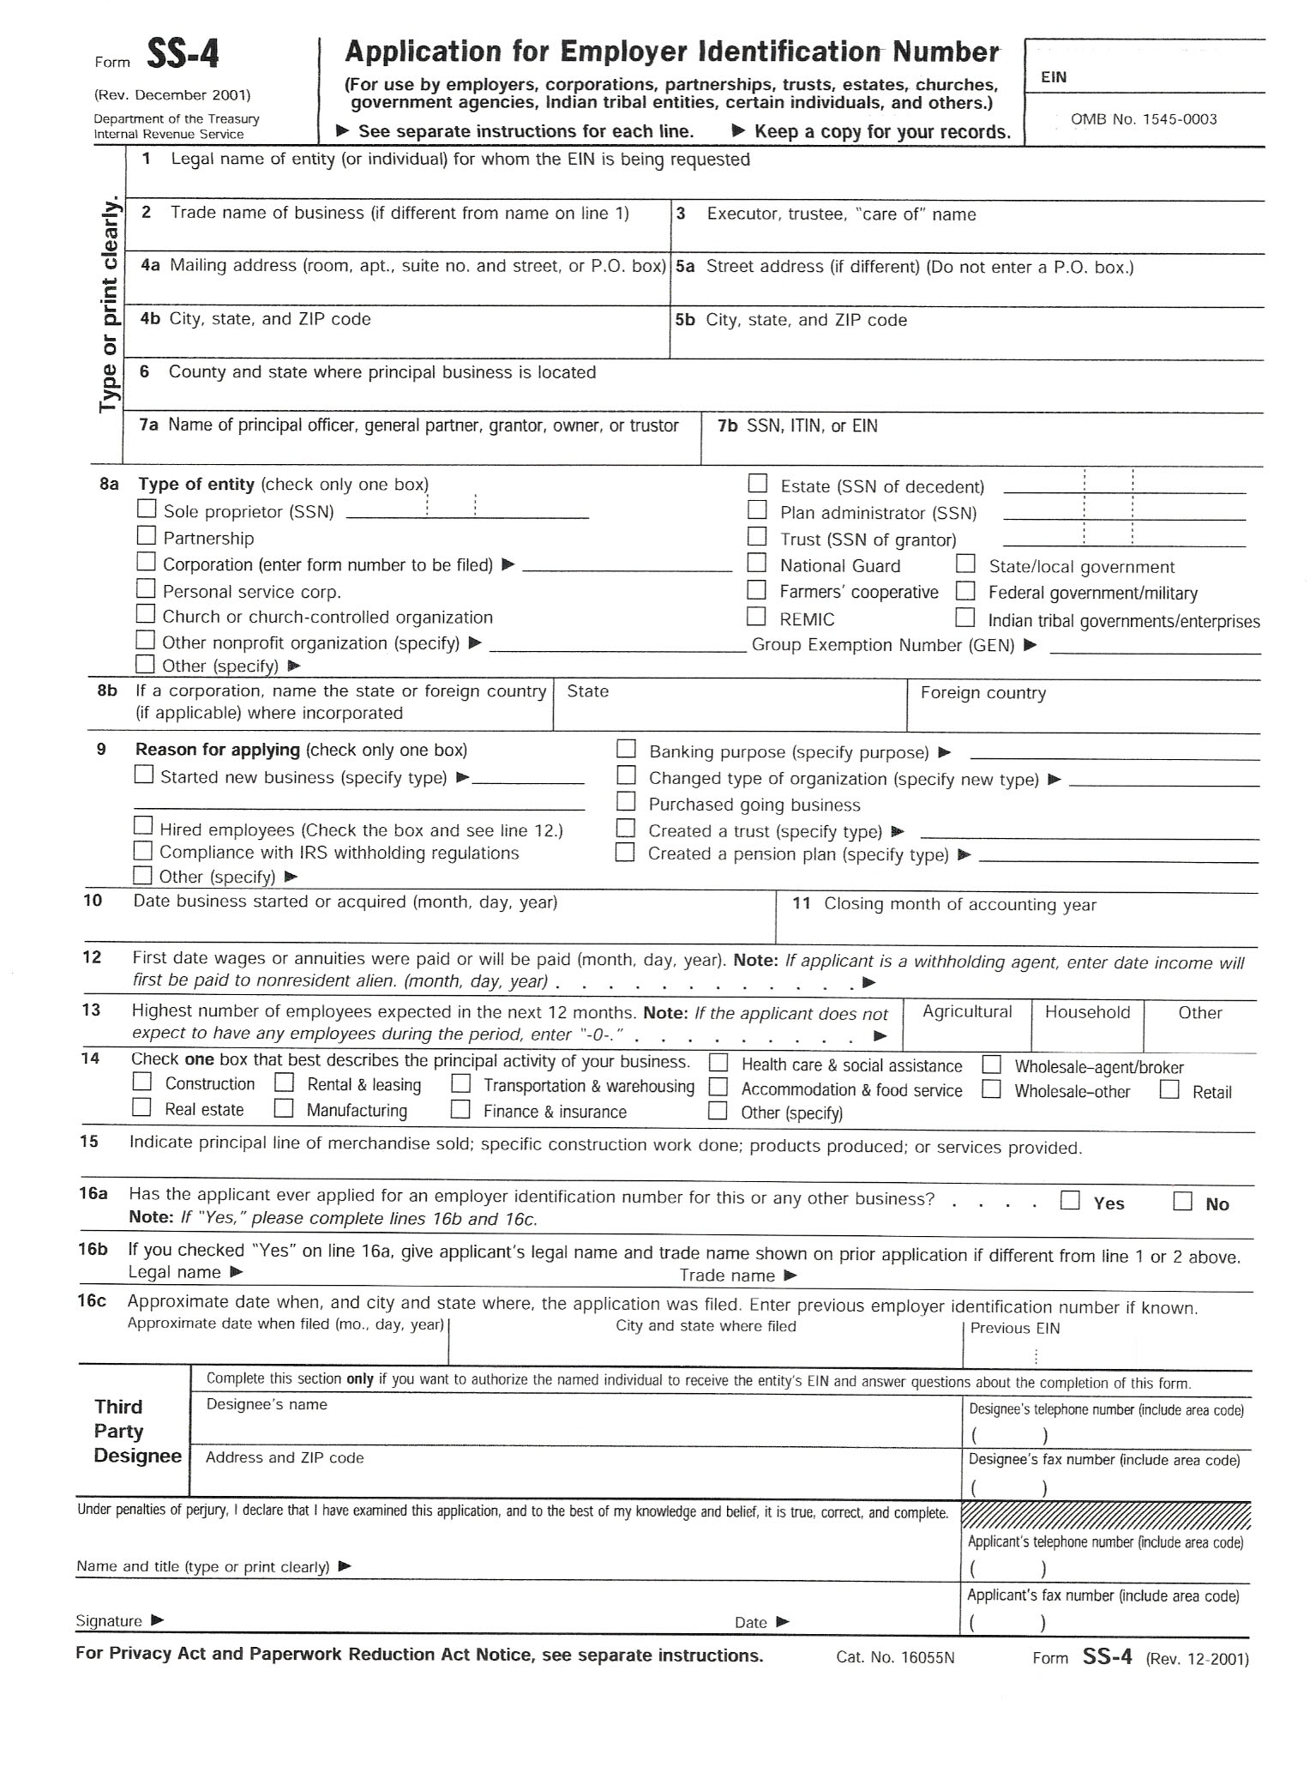
Figure 5 (Use Current form when filing)

