Pioneering

It’s More Than Just Knots and Rope
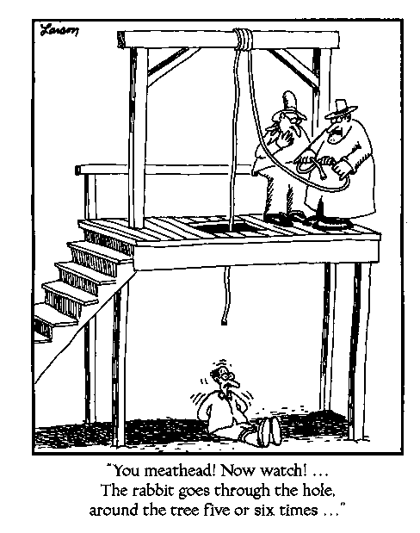

Mark Montrose
Retired Scoutmaster – Troop 14, Santa Clara
Venture Crew Advisor – Crew 14, Santa Clara
Assistant District Commissioner – Pioneer District
University of Scouting
19 January 2008
The History of Rope
Began with simple elements – vines, reeds, leather thongs. The leather thong was the real forerunner of ropes. Multiple thongs were too weak for some purposes thus 2 or 3 thongs were combined. Twisting the leather strips into a solid rope was a short and natural step.

Making rope
Two primary methods – twisting and braiding:
Twisting: fibers are twisted to the right to form a yarn, then a few yarns are twisted to the left to form a strand. Three (or sometimes four) strands are twisted to the right to form a rope. Three ropes are twisted to the left to form a large cable-laid rope.

Important element in twisted rope is the alternation of directions so the fibers and strands pull against each other and overcome their natural tendency to untwist and fray. Friction makes a hard compact rope.

Braided rope is made by special machine. It is smooth, compact and capable of long life before becoming soft. To test braided rope, moisten it. Poor grades will quickly make it pasty and sticky.

Care for Rope
- Good rope is expensive. Keep it clean and free of mud or grease.
- If damp, do not coil or store until thoroughly dried out.
- Always keep in a dry place.
- Never throw into a corner to tangle and kink.
- Keep rope available instantly in case of emergency.
- Always keep rope coiled so that it will pay out smoothly when needed.

Coiling: Use only the hand method (not coiling around one’s elbow), or lay flat on the ground. This helps one get access to the entire length quickly or to throw efficiently in case of an emergency.

What One Can Do With Rope
Whipping
Knots
Lashing
Splicing
Useful campsite gadgets

Categories of Knots
Unknown – what beginners try to tie.
Sailing
Scouting
Fishing
Climbing and Caving
Math
Celtic
Art (or fancy)
The Tie

Glossary
- Bight can have two meanings:
-- The main part of the rope from the running end to the standing end
-- Where the rope is bent back to form a loop.
- Running End - the end of the rope that is being used to tie the knot.
- Standing End - the static end of the rope.
- Jam - when the knot tightens under tension and you cannot get it undone!

Basic type of knots (sample list)
Stoppers – Used to stop the end of a rope fraying, or to stop it running through a small hole or constriction.
- Overhand or Half Knot
- Double Overhand
- Multifold-Overhand
- (Flemish) Figure Eight
Bends - To tie two ropes together.
- Square (Reef) - BSA
- Sheet bend - BSA
- Carrick (Josephine)
- Fisherman
- Weavers-Eight
Hitches - used to tie a rope to a spar, ring, post, or object. Hitches can also be used to tie one rope onto another rope.
- Half
- Clove - BSA
- Two Half - BSA
- Buntline
- Rolling Magnus
- Tautline - BSA
- Adjustable Jamming
- Marline or Single
- Strangle or Double Marline
- Constrictor
Loops
- Bowline – BSA
- Sheepshank - BSA
- Dutch Marine Bowline (Cowboy Bowline)
- Double Figure Eight
- Bowstring
- Tucked Double Overhand
- Butterfly or Lineman
- Artillery
- Pendant
The Noose
- Simple
- Strangle-Snare
- Scaffold or Gallows
- Hangman
- Reverse Eight

Fun
- Monkey Fist
- Dolly
- Woggle/Turkshead
- Man of War Sheapshank
Breast Plate (Fancy Knots)
- Bell
- Double Headed Carrick
- Handcuff Hitch Breastplate
- Mors du Cheval
- D-N

http://www.folsoms.net/knots/ (The best site in my opinion)
http://www.earlham.edu/~peters/knotlink.htm#knot%20tying (Everything you wanted to know about knots)
http://www.webofroses.com/scouting/knots.html
http://www.realknots.com/knots/index.htm
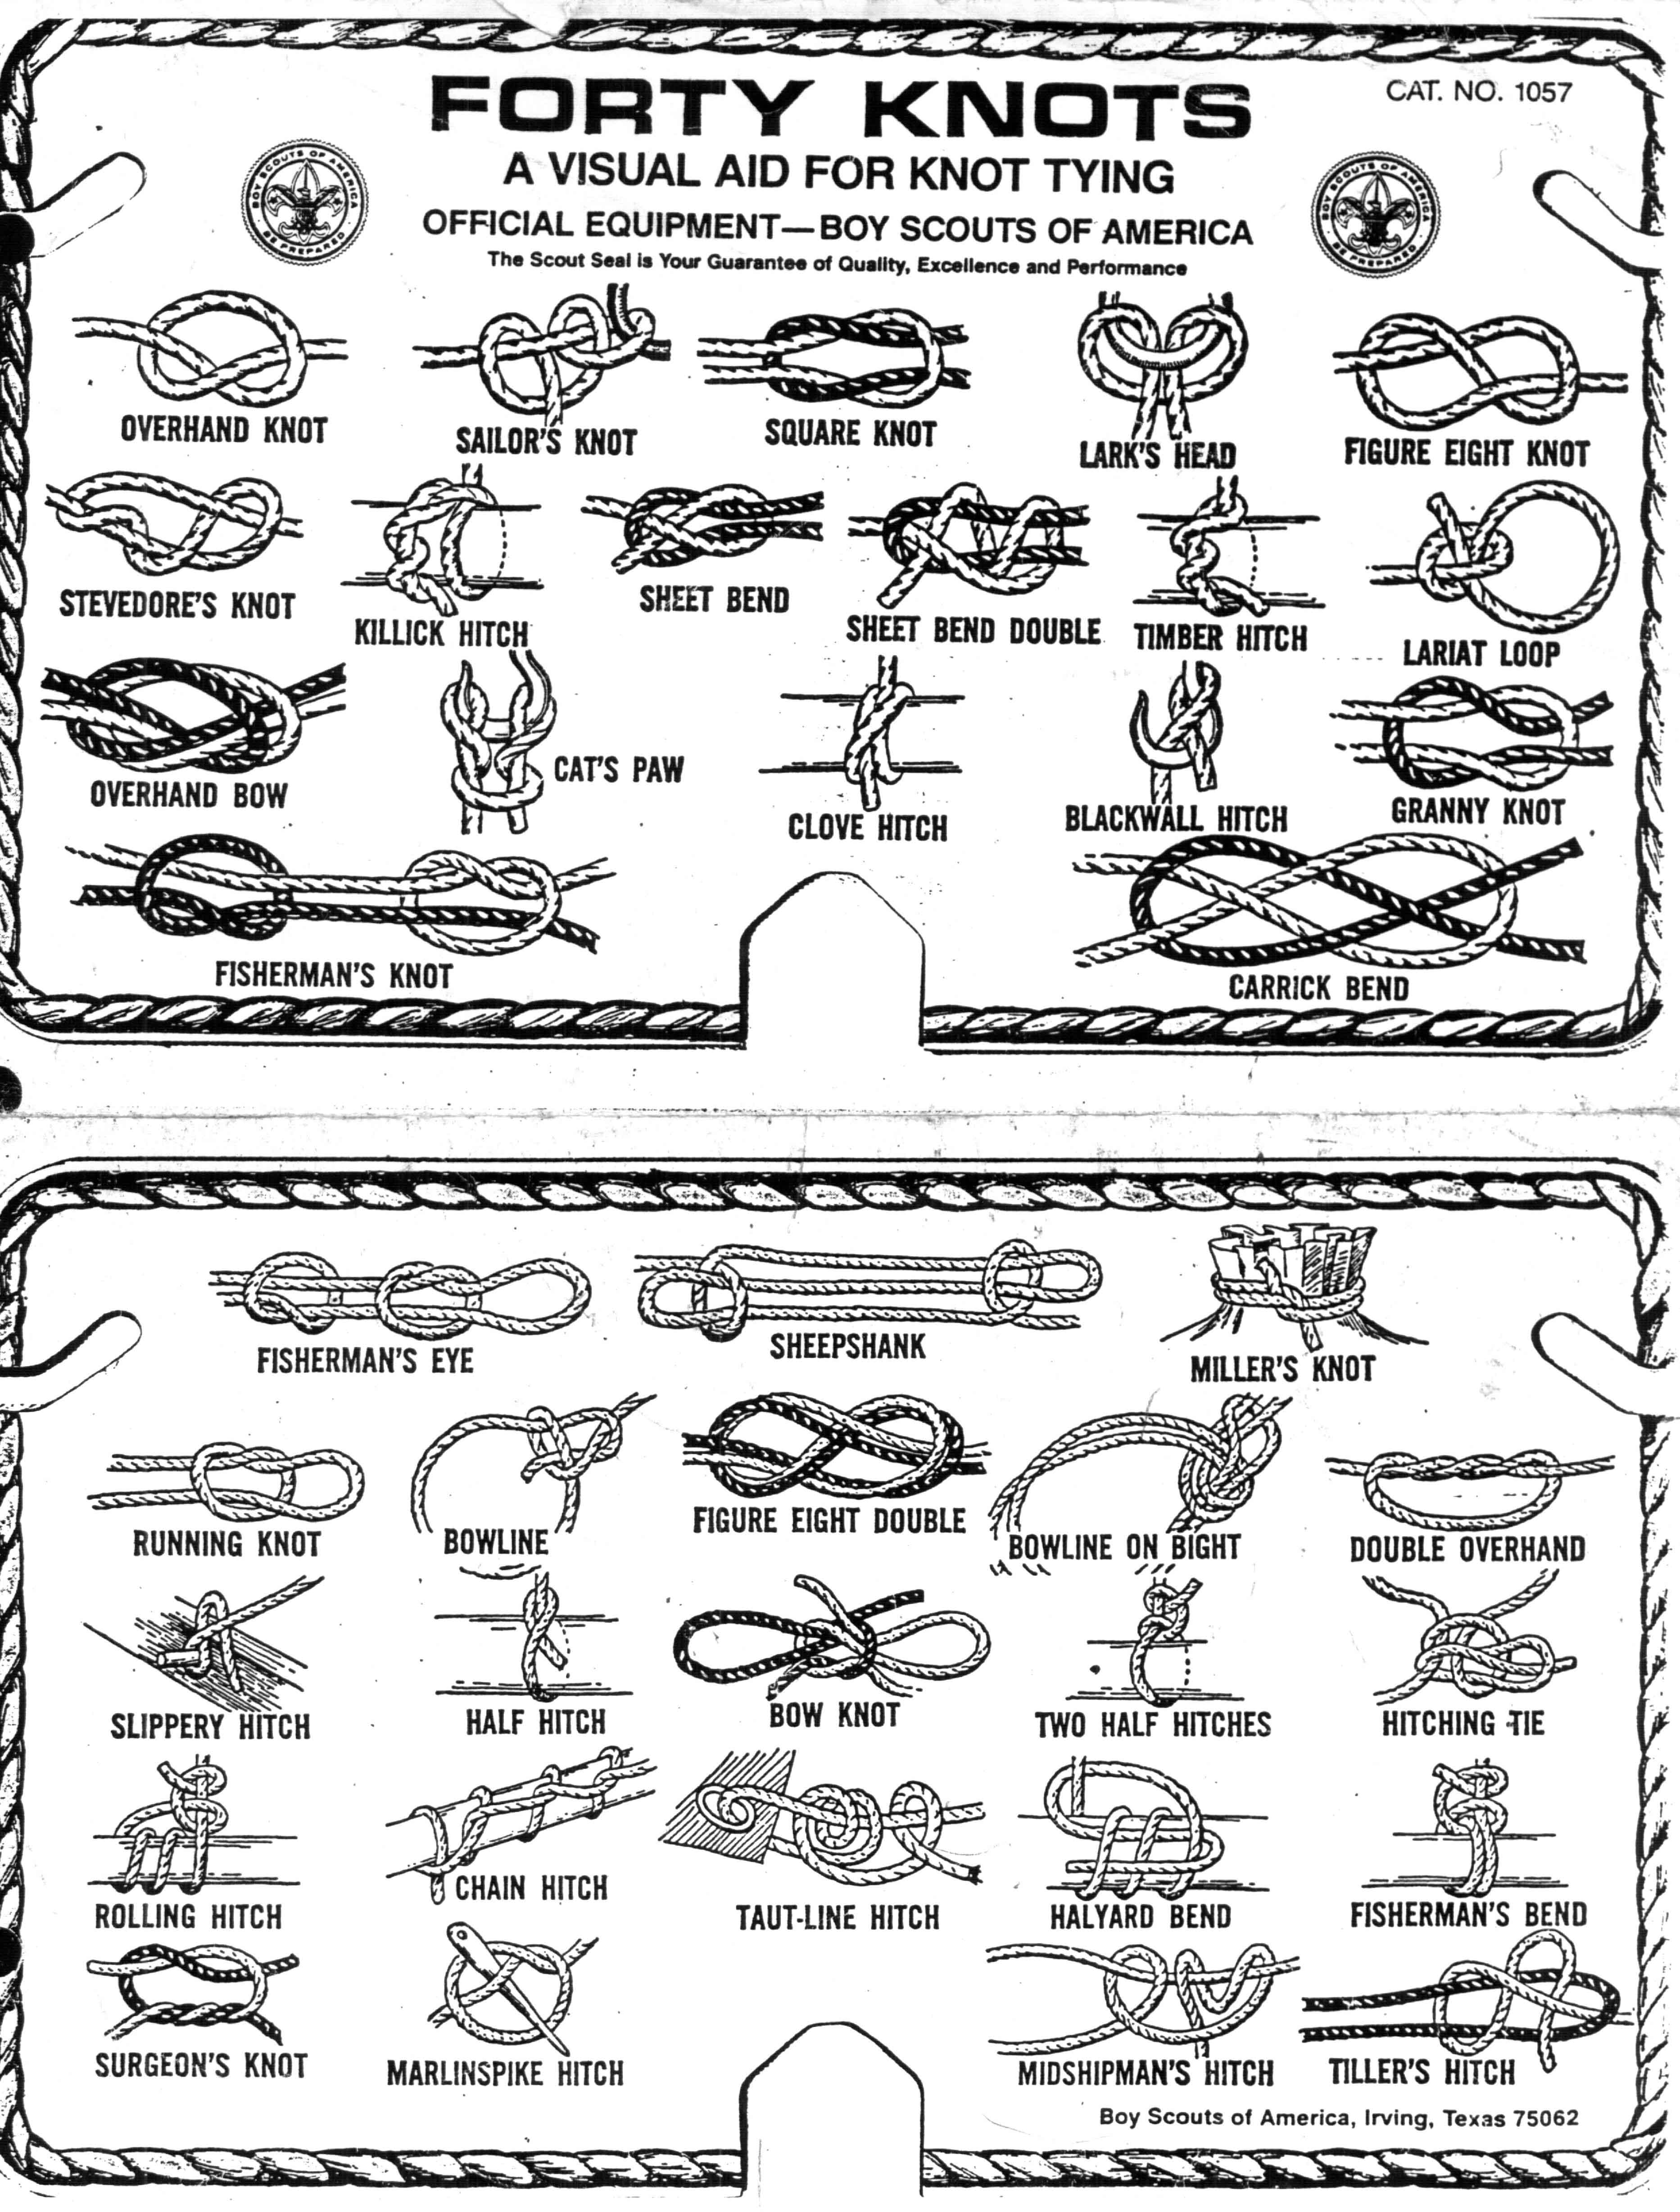
Lashings
Use to bind together timber. A lot of rope is required, appropriately sized for the diameter of the timber.
Frapping turns are used to draw the lashing tight.

Square Lashing

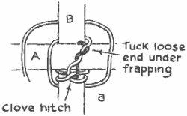 | 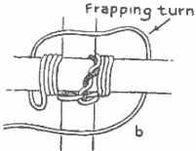
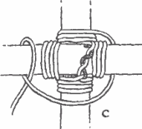 | 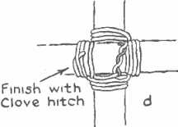

Shear lashing
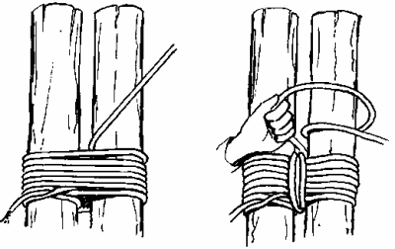

Tripod Lashing

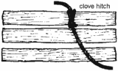 | 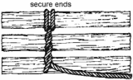 | 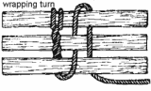
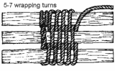 | 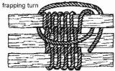 | 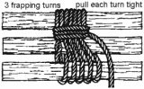
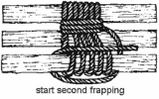 | 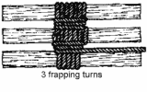 | 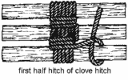
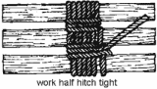 | 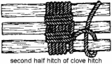 | 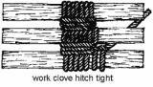

Round Lashing

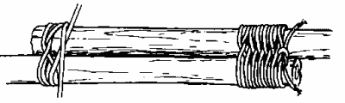
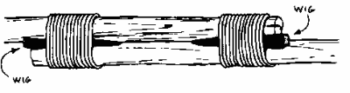

Diagonal Lashing

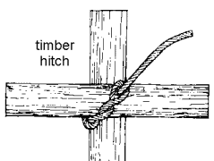 | 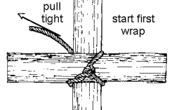
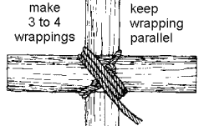 | 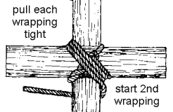
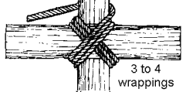 | 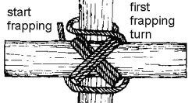
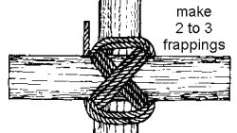 | 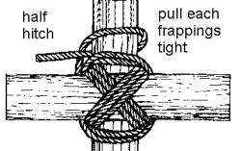
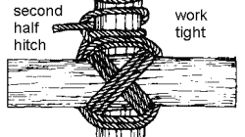 | 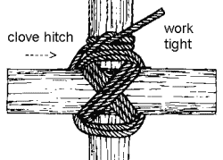

Splices
Used to join ropes permanently and leave the rope almost as strong as it was originally. Short splice is strongest with a bump in the rope to keep it from passing over a block. The long splice keeps the rope at the same diameter. Eye and back have special purposes.

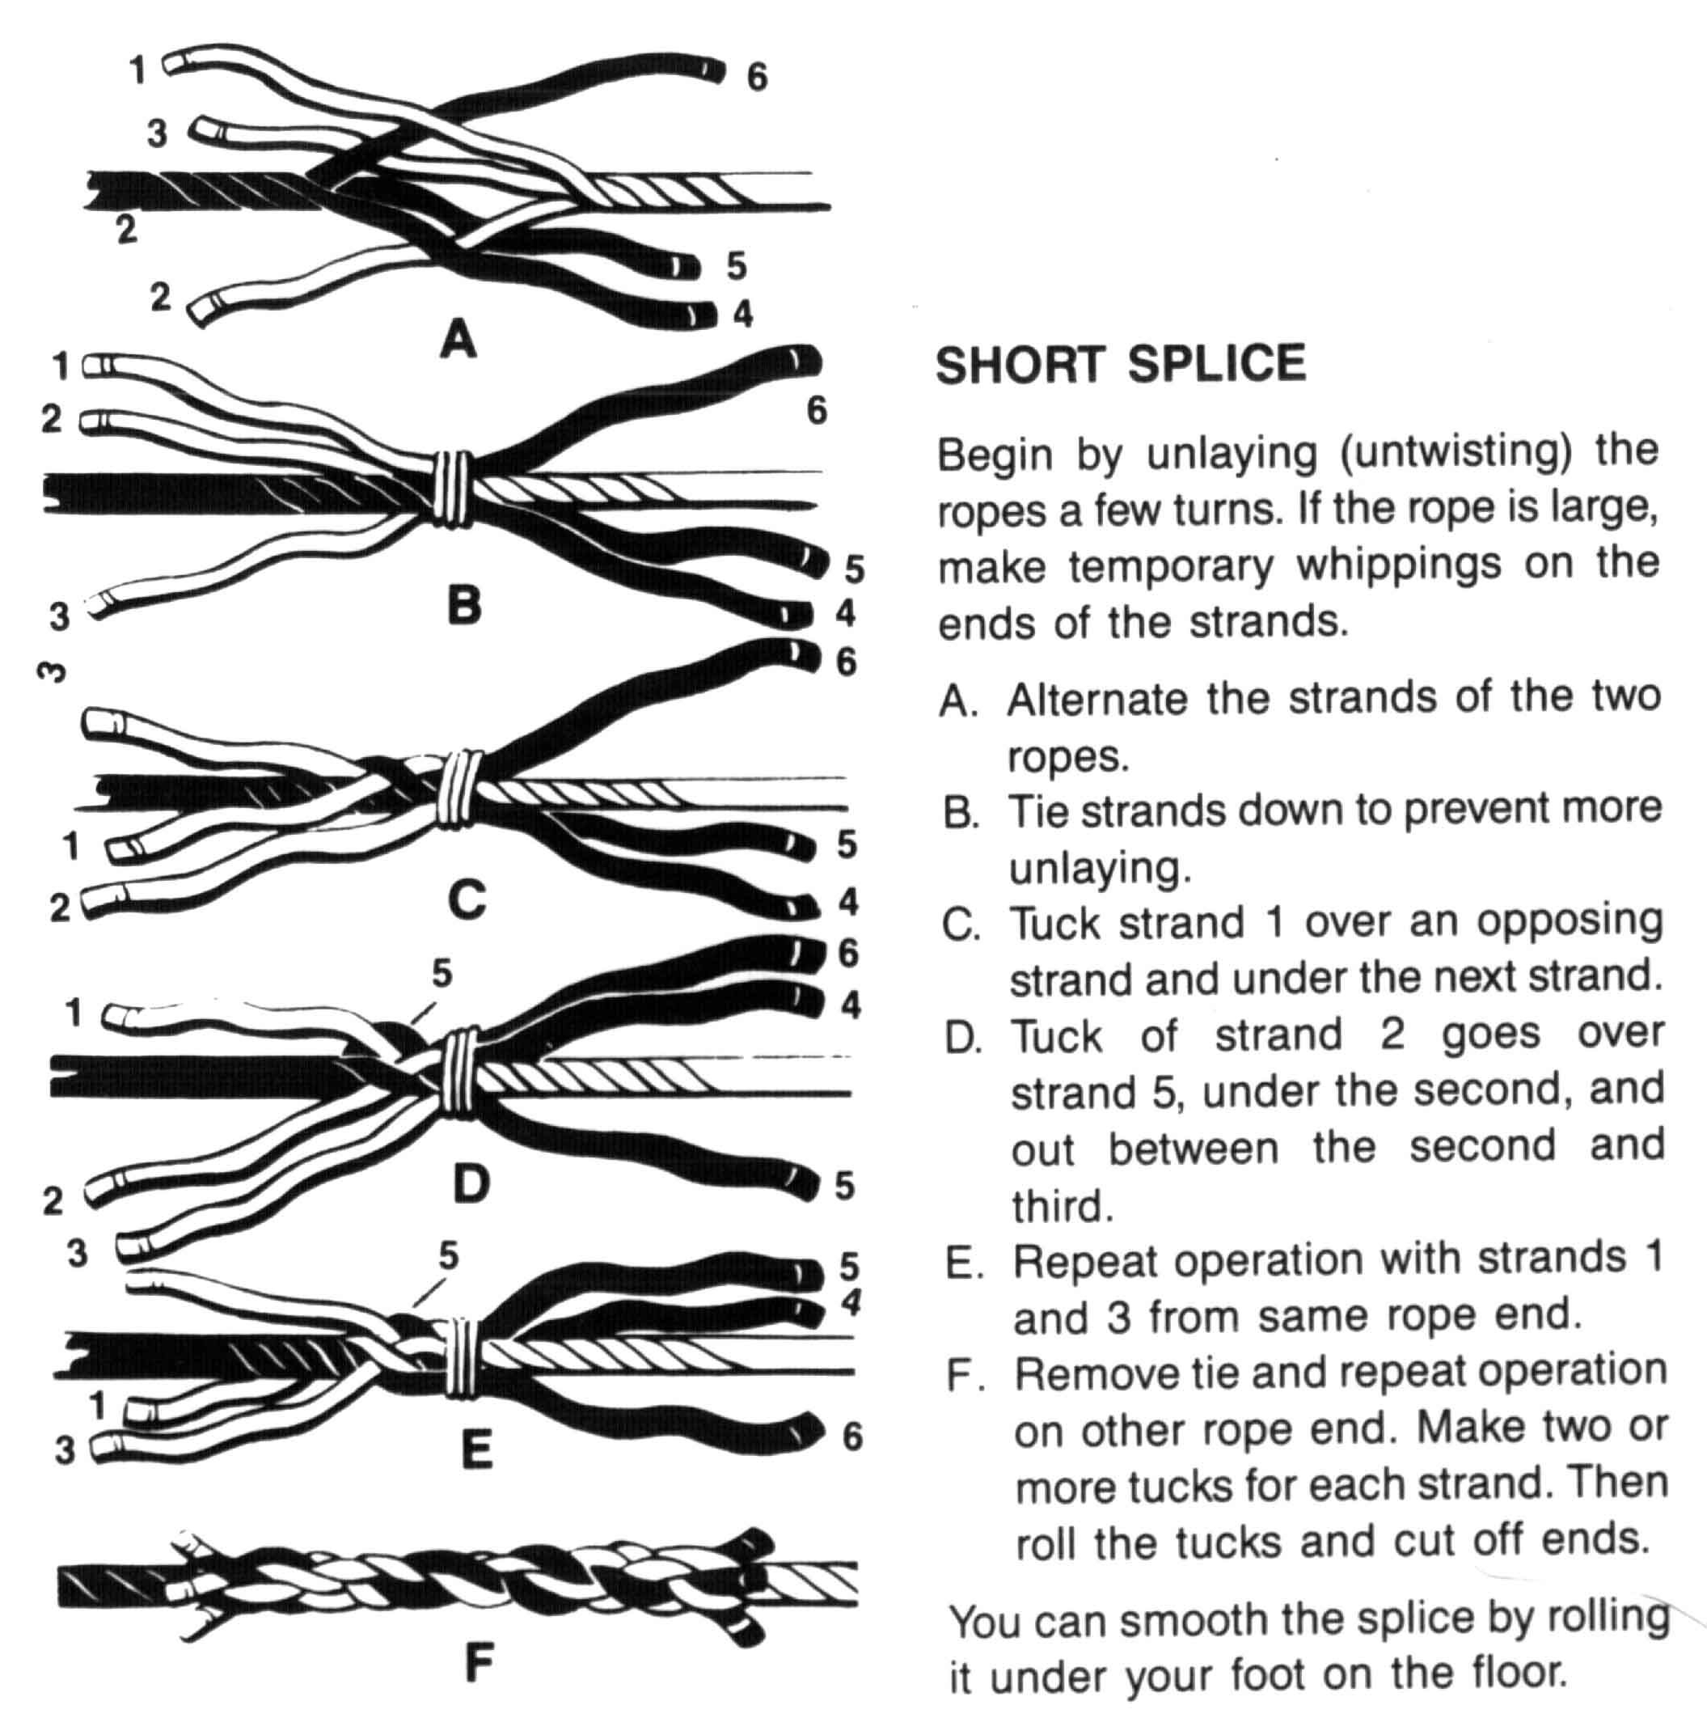
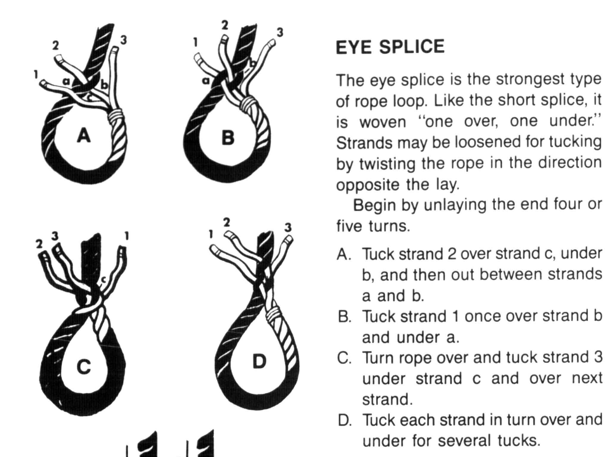
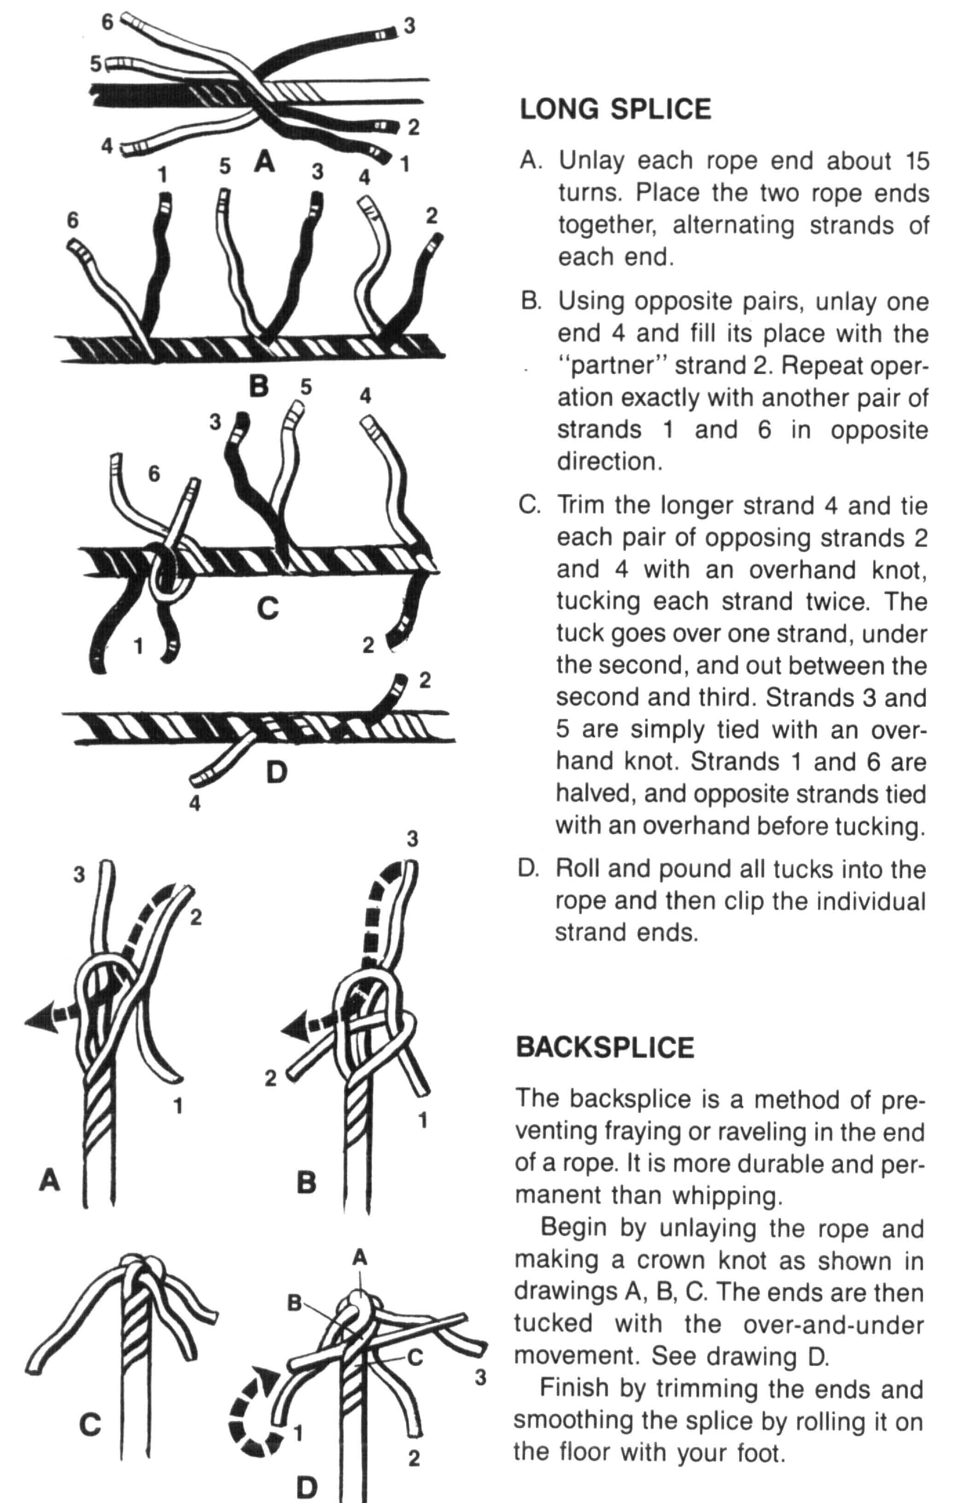

Examples of Useful Camp Gadgets

Fire Pail Stand Camp Table with and Without Seat
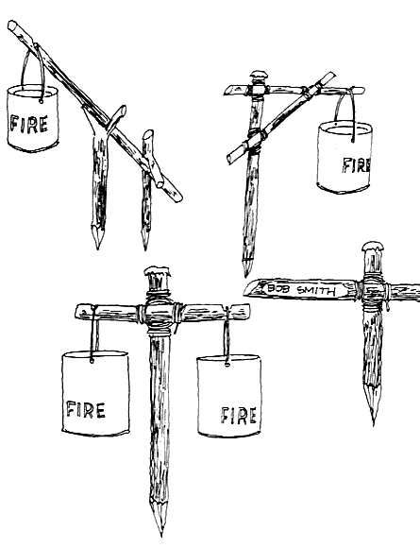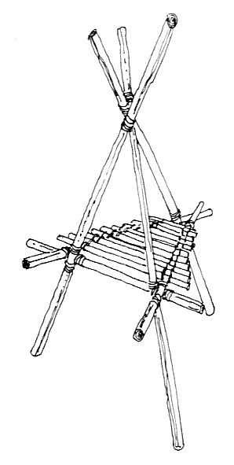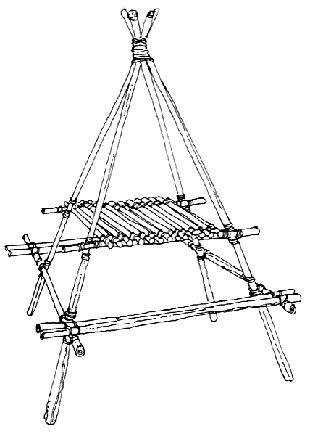

Equipment Rack Clothesline
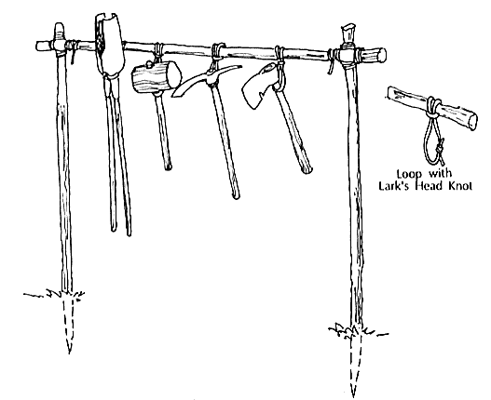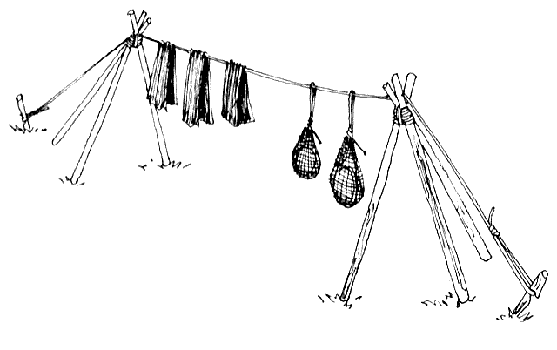

Wash Basin
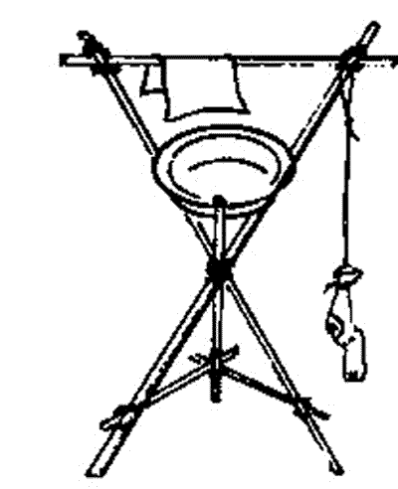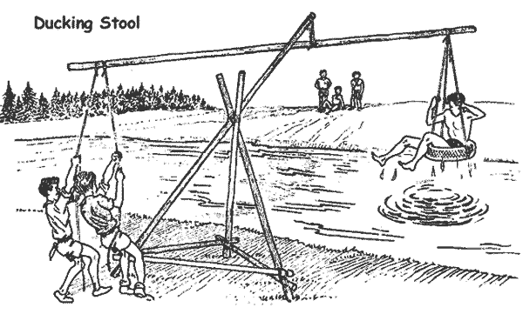

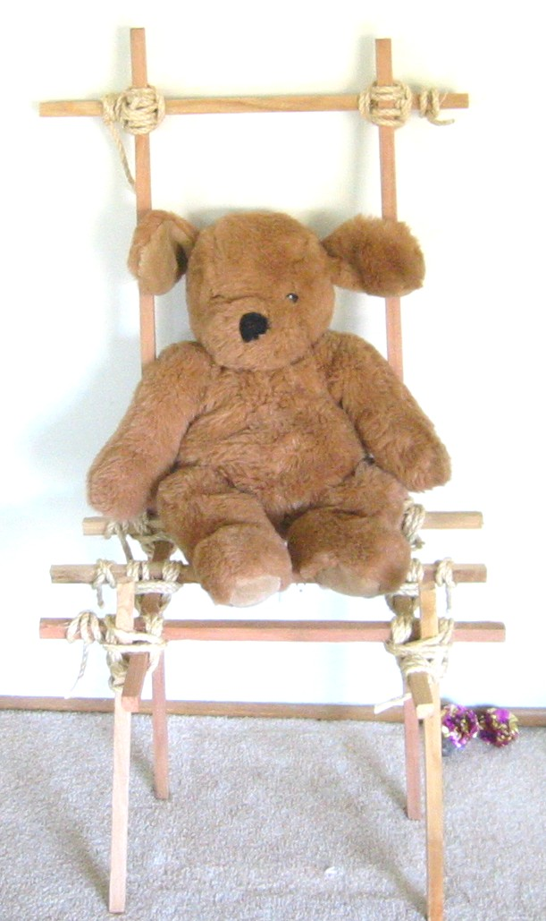

Boy Scout Merit Badge Requirements

PIONEERING


- Demonstrate how to coil and throw a 40-foot length of ¼-inch rope.
- Present five different rope samples, of any size or material. Explain the characteristics of each type of rope -- its strength, mildew resistance, durability, and stretch. Explain where and how each type of rope can be used in pioneering work.
- Demonstrate how to tie the following seven basic knots: square knot, timber hitch, clove hitch, bowline, sheepshank, sheet bend, and round turn with two half hitches. Also select five more knots found in the Pioneering merit badge pamphlet. Tie each one for the examiner, and tell where it could be used in pioneering, camping, or other Scout activities.
- Demonstrate how to make the back splice, eye splice, and short splice using ¼-inch three-strand rope.
- Construct a device or machine to make rope. Then use the device with binder twine to make a six-foot length of rope consisting of three strands, each having three yarns. Also demonstrate one method of whipping the end of the rope.
- Build a three-two-one or a log-and-stakes anchor using pioneering stakes. Build the anchor at a size suitable to anchor one end of a monkey bridge.
- Demonstrate the use of rope tackle to lift a weight of 25 pounds. Pull a log at least six inches in diameter and six feet long with the tackle. Use the tackle to put a strain on a line.
- By yourself, build an H-frame trestle with ropes and spars using square and diagonal lashings. Demonstrate how to tie two spars together using a west country shear lashing.
- With a group of Scouts, build a pioneering project. Before building, present a rough sketch of the project and a list of the ropes and spars needed to build it. (Note: This requirement may be done at summer camp, district or council events, or on a troop camp outing.)
BSA Advancement ID#: 84
Source: Boy Scout Requirements, #33215, revised 2004

