Webelos Athlete Activity Badge

Physical Skills Group
Athletes persevere to meet their goals. They try to do things that are a little bit harder than what they can do right now. With those goals, they make improvement and become a great athlete as they do their best one little step at a time.

IDEAS FOR DEN ACTIVITIES
- -Take the den on a short bicycle trip
- -Have a tug of war.
- -Do exercises as a den.
- -Attend a high school or college athletic event.
- -Attend a track meet or gymnastic event
- -Visit a gym and try out weight lifting equipment.
- -Invite a physical education teacher or gymnastics instructor to talk about fitness.
REMEMBER
- -When putting boys to any test, the important point is that they do their best!
- -While some in physical feats do excel, some others in mental abilities do well.
- -So don’t compare and expect the same of all.
- -Let each set his personal best goal.
- -Give them encouragement and praise their skill, and you’ll find they will strive their best to fulfill.

EXERCISES AND GAMES
AGILITY EXERCISES
Perform these exercises within the designated time limits.
Be sure to rest for two minutes between each set.
Set 1 – within 8 minutes
*Fish Flops – Lie flat on your stomach with arms and legs extended and off the ground. Rock back and forth. Do for two minutes.
*Grass Drill – Run in place. Drop to the ground and bounce up again for two minutes.
*Quick foot – Knee Touch – Drop quickly to one knee and bounce up again. Alternate knees for two minutes.
Set 2 – within 4 minutes
*Crab mirror – Two players on all fours. One moves at random to the left, right, back or forward. The other mirrors his moves. Switch leaders at the one minute mark. Do for two minutes.
*Sit ups – Lie on back with feet together, hands clasped behind head. Rise up and touch elbows to knees. Do as many as possible for one minute.

FLEXIBILITY EXERCISES
Fingers – Extend arms to side, palms down. Quickly flex the fingers by alternating between fist and open hand position. Continue for 30 seconds.
Wrists – Extend arms to front, palms down, wrists locked. Rotate wrists clockwise, then counterclockwise. Continue for 30 seconds.
Palms – Same position as wrists. Turn palms inward and outward in quick short movements. Continue for 30 seconds.

PULL OVER
This game is similar to tug-of-war – without a rope!
Divide the Scouts into pairs. Each pair grasps right hands, braces their feet and each tries to pull the opponent over a center line on the ground. The game may be varied by changing hands.

GORILLA RELAY
Webelos Scouts spread their feet shoulder width, then bend down and grasp their ankles. They then walk forward, keeping their knees locked and their legs straight. Divide into teams, and run as a relay over a course of however long you want it to be.

TORTOISE AND HARE
Boys are in a circle, about three feet apart, and begin jogging slowly in place. When the leader calls, “Hare,” the tempo is stepped up, knees are lifted high, and the arms are pumped vigorously. When the leader calls, “Tortoise,” the tempo slows to an easy jog. Make changes swiftly for more fun.

TREES IN THE WIND
Boys are in a circle facing counter-clockwise. They run slowly around the circle, bending left, right, forward, and back as though swaying in a breeze. On command, “Reverse,” they turn and run in the opposite directions.

INCHWORM
Boys assume push-up position. Holding their hands in place, they walk their feet up as close to the hands as possible. Then, holding their feet in place, they “walk” their hands out to push-up position again.

TIN CAN WALKER RACE
Needed: Several large tin cans and rope
- Make tin can walkers by punching two holes opposite each other near the tops of the tin cans. Tie ropes in large loops which pass through the holes in the tin cans.
- Boys stand on cans and hold ropes in hands. Pulling up on the ropes and stepping forward take steps.
- Try relay races between dens. Using three cans and two boys, (Sharing the middle can) a three-legged race can be run.

More on the Athlete Activity Badge
An athlete is one who keeps his body physically fit, strong, graceful and agile - a desire of practically every boy. Tell your Webelos Scouts about the athlete and what it takes to become one. Impress them with the fact that the body is a priceless gift and only a few minutes of exercise each day are required to keep it physically fit.
By adequate exercise, getting the proper food each day and taking care of himself, a boy can become an athlete. The activities for this badge can help the Webelos Scout measure up to the standards of strength, agility, endurance, and coordination necessary for good active Scouting activities in later life.
Many Webelos leaders use this badge to introduce a new Webelos Scout to the program. This begins their Webelos year with an appealing badge to inspire them onward. By laying out a permanent accurately measured 50 yard dash and 600 yard run near your meeting place, you can easily test your new Webelos Scouts in less than half an hour. Use a stopwatch when timing these sprint and distance runs.
Make up a permanent Fitness Progress Chart and retest the boys at different times throughout the year and chart their progress. They will be interested in bettering their records.
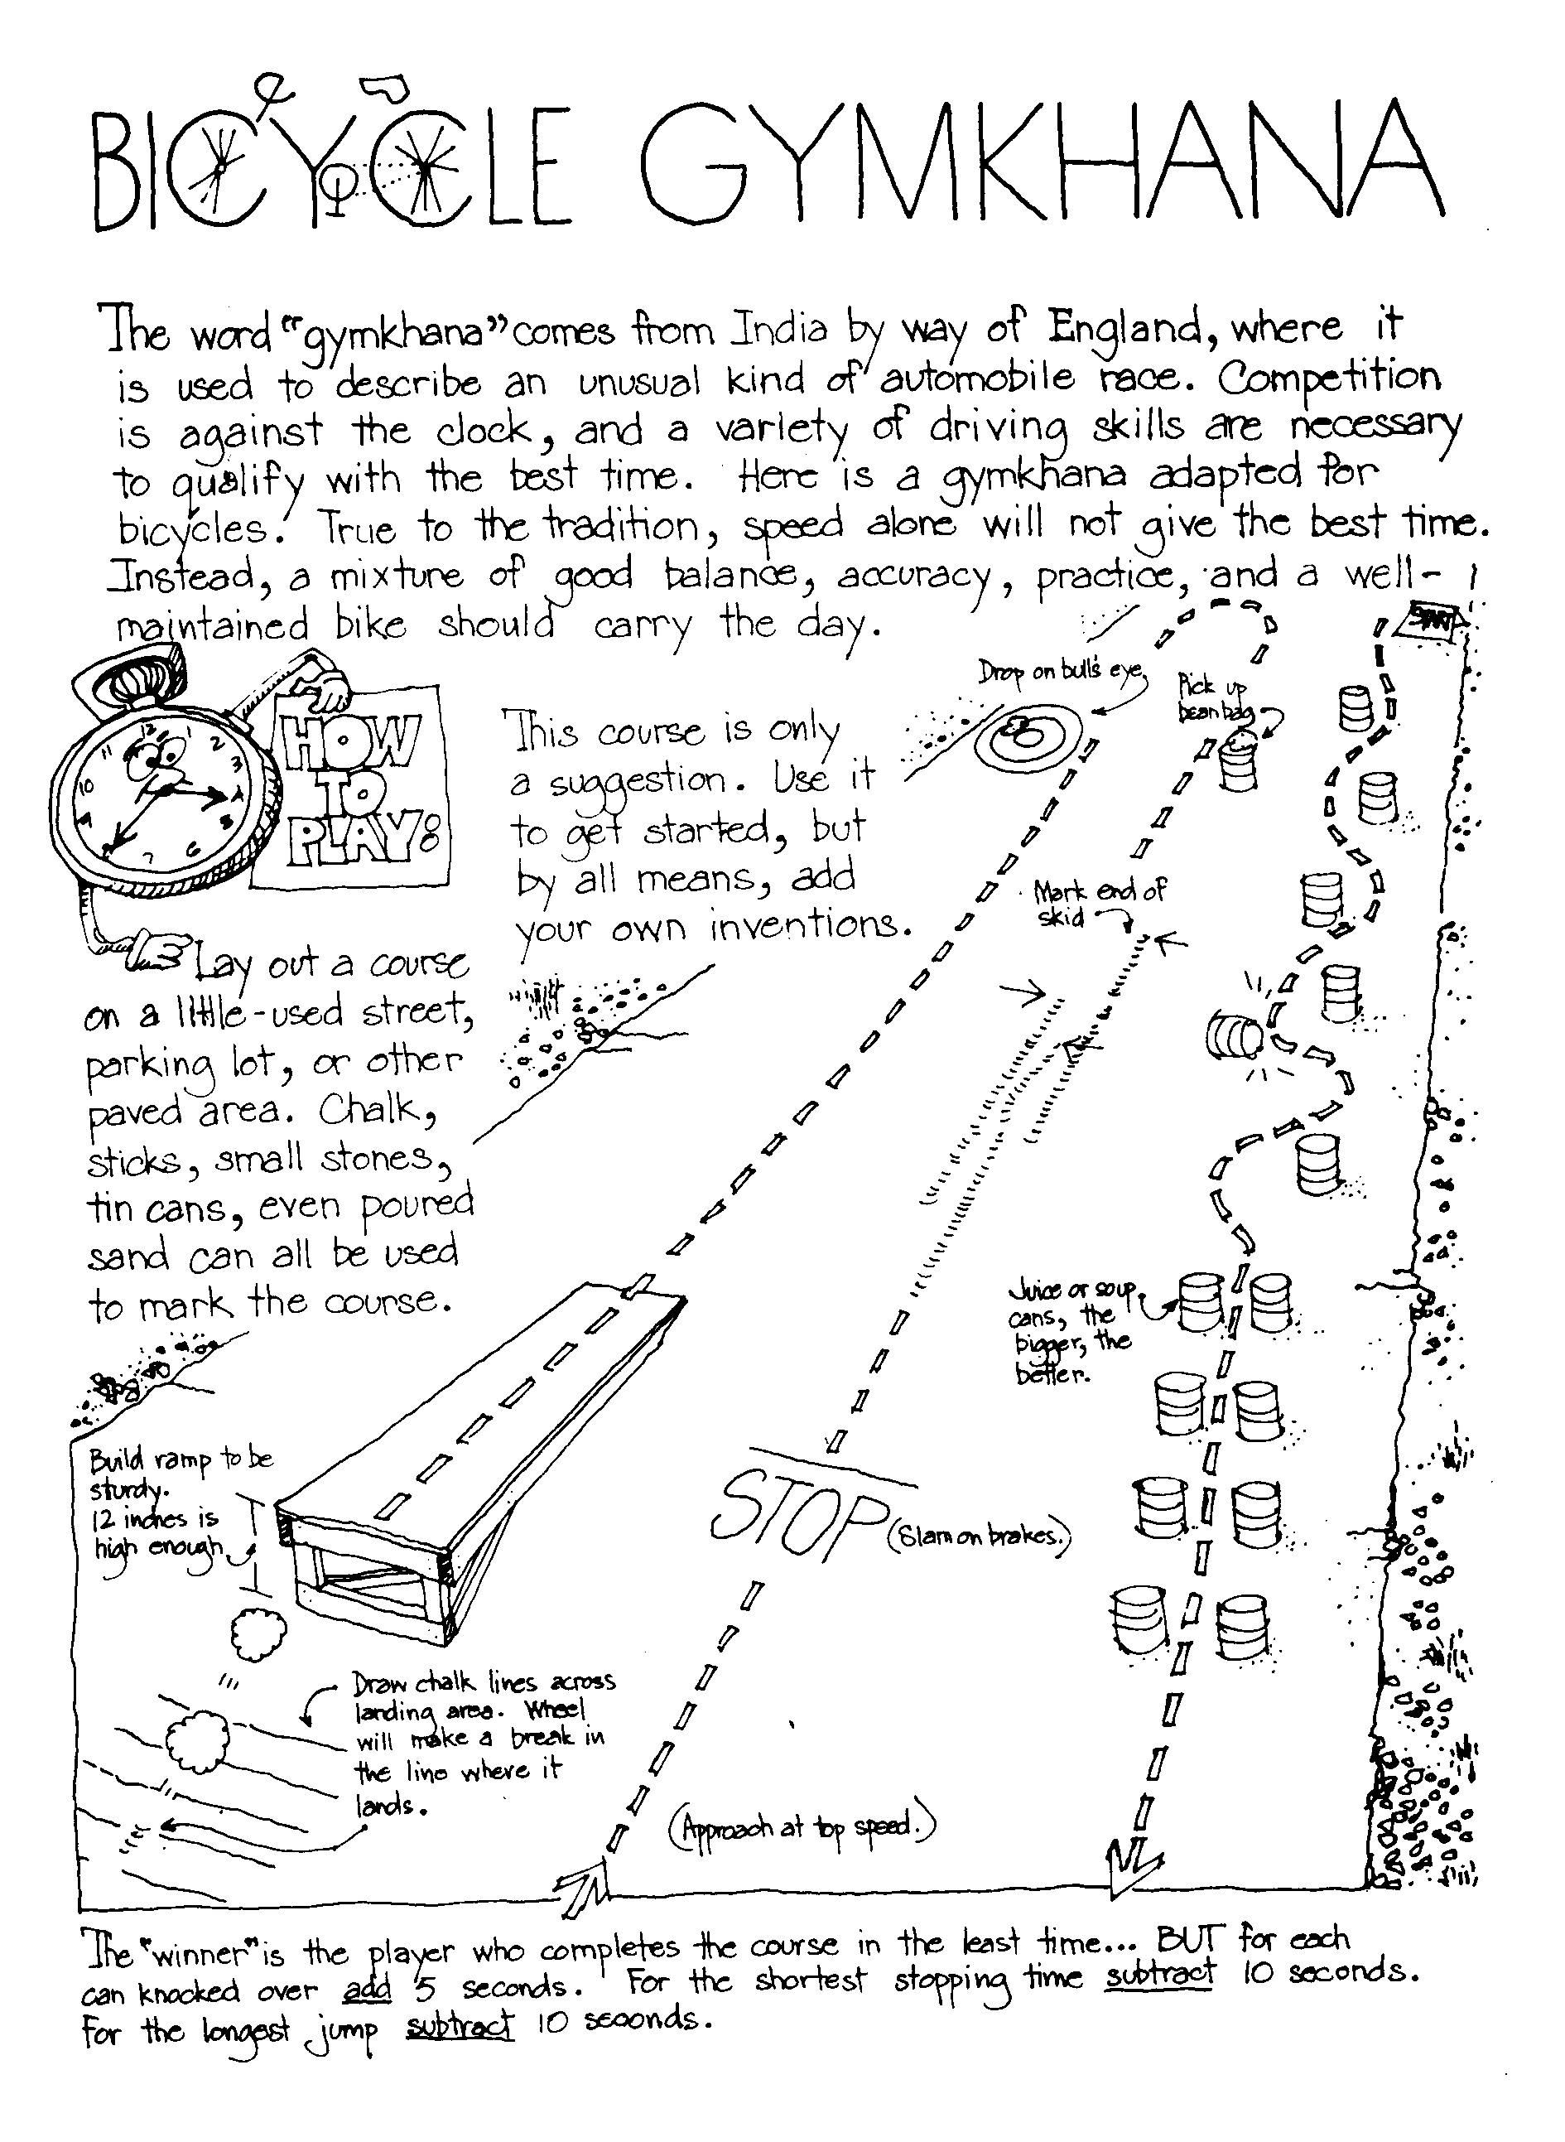
The boys can make their own physical fitness equipment. A barbell can be made using a 3 foot dowel or broomstick with 3/4" pipe caps on the ends. The latter are then embedded in 46 oz. cans filled with cement. Allow cement to set overnight. Dumbbells can be made similarly by using foot long dowels and No. 2 size cans filled with cement and placed on the ends of dowels. Plastic quart containers filled with sand may be used instead of the cans. A broomstick suspended at both ends in a garage, basement, or backyard makes an excellent chinning bar. A deflated bicycle inner tube makes a good exerciser.

Being Healthy
Good Health Habits Quiz
Circle the correct answer(s).
- Bathe/shower (everyday OR once per week) and especially after exercise.
- Wash your hair (1/month OR 2+ times/week).
- Wash hands (before eating OR after using the restroom) and when they're dirty.
- Eat right - (3 OR 4 OR 6) regular meals each day at regular times!
- Eat (just some OR a variety of) food from each of the 4 food groups.
- The average 10 year old should get at least (6 OR 9 OR 12) hours of sleep each night.

ANSWERS: 1. Everyday, 2. 2+ times, before eating and after using restroom, 3. 3 meals, 4. Variety, 9 hours

Clean & Strong
Circle T for True or F for False.
T F | Our bodies "repair" themselves while we sleep.
T F | Clean clothes aren't necessary after a bath or shower - they are just in the morning.
T F | Use proper lighting for all activities including reading, TV viewing, and playing.
T F | Fitness is never just physical - it involves both the mind and body together.
T F | Stand tall, and walk tall with shoulders back and stomach in.
T F | It's OK to share drinking cups, washcloths and towels.
T F | Different foods provide different nutrients, and no one food can sustain us.
T F | Rushing meals or skipping meals can be harmful to your body.
ANSWER: 1 - T, 2 - F, 3 - T, 4 - T, 5 - T, 6 - F, 7 - T, 8 - T

Volleyball Serve it Underhand
The underhand serve is the easiest to master for volleyball. In a game you must put the ball into play from a 10 foot wide area behind the end line. Always practice with a line in front of you so you will learn not to cross it until you have released the ball.
For the underhand serve (if right handed), stands with your left foot about 13” in front of the right foot. Bend both knees a little, lift the ball in both hands out in front of your chest, to your right side. Hold the ball in the left hand and start to bring the right hand down. Close the finger of the right hand as if you were making a loose fist.
Keep your eyes on the ball. Bring right hand down, back, and up behind you. Step a quarter step forward on your left foot. Swing your right hand at ball. Just before you hit it, toss the ball up a little and drop your left hand away from it. (The rules say – release your left hand from the ball before hitting it.) Strike ball solidly with the palm side of your fist and follow through. (Of left handed, reverse from right to left.)
Once you master the serve, try using the heel of hand instead of fist. Close hand instead of your fist. Close your hand half-way so fingertips come just below the base of the fingers with thumb-tip beside the first joint of forefingers

SONGS
The Athlete
Tune: My Bonnie
They gave me a suit and a number
And sent me out on the field
They gave me a ball called the pigskin,
And shoes with some cleats, toe and heel
CHORUS
Muscles, Cramps, wracking my body with pain, with pain
I stand, wondering, if ever I’ll do this again!
Next time they gave me a racquet,
They sent me out on the court
Funny the things you encounter,
While trying to learn a new sport.
(CHORUS)
The ordeal was finally over,
At least, that’s what I thought,
When they shoved me the soccer equipment
I fainted dead on the spot!
(CHORUS)

Athlete Den Activities
TOWEL PICKUP - Take off your shoes and socks. Pick up a towel with your toes.
PAPER PICKUP - Pick up a piece of paper from the floor without bending your knees
BOOK CARRY - Walk across the room with a book balanced on your head.
SKIN THE CAT - Clasp your hands in front of you. Try to step through the ring formed by your hands and finish standing upright with them clasped behind you. Return to your original position by stepping backwards through the ring.
TOE WRESTLING - Two wrestlers sit on the floor, facing each other with arms clasped around knees. When they are in this position, place a stick over each person’s elbows and under his bent knees. Their feet should be flat on the ground with the toes of one touching the toes of his opponent. The object is for one wrestler to get his toes under the toes of his opponent and roll him over backwards. If either wrestler breaks the handclasp above his knees, the other wins the contest.
SIDEWALK TENNIS - Played with a tennis ball on two squares of sidewalk or patch of level ground marked off in similar size. Ball is batted with the hands. Use regular tennis rules, except that there is no serving court

SUGGESTIONS FOR COMPLETING ATHLETE ACTIVITY BADGE
Requirement #1
Can be combined with the Fitness Activity Badge and the Sportsman Activity Badge. The subjects of being physically healthy, balanced diets, and bad effects of drugs, alcohol, and tobacco can be combined and signed off all together.
Requirement #2
Takes the longest amount of time to complete and sign off of all the Physical Skills Group. To earn the Physical Fitness Sports Pin, the boy needs to earn 60 points in a 90 day period. They must exercise or be involved in some activity for 30 minutes to earn one point. The boy can earn a maximum of five points in a day. Just remember 30 minutes for one point, 60 points total in a 90 day period.
You can pass off requirements 3 through 9 as part of this pin, use requirement 3 and 4 of the Sportsman badge to meet the requirement.

Den Activities
· Make your own physical fitness equipment (see above)
· Watch a high school track meet.
· Have a Physical Education instructor talk to your den concerning fitness.
· Invite a professional weight lifter to talk to your den and demonstrate.
· Attend a gymnastics exhibition or meet.
· Plan a physical fitness demonstration for pack meeting.

Barbell Slide
Materials: 2 small 1" styrene balls, 1/2 of a black pipe cleaner, black paint, white paint, paint marker, or vinyl stick-on letters
Directions: Paint the two balls black. Cut the pipe cleaner into 2 equal pieces. Push the pieces into the ball about 1/4" apart. Pull the pieces apart slightly, curving them outward. With the white paint put the lbs. on the two balls. You can use 5 lbs., the Pack number, or some outrageous amount of weight.

Games
La Plama (Bolivia) -- The Indians of Bolivia used a bone, but you can use a stick for this game. Set the stick up on end in a hole in the ground. Draw a straight line away from the stick. Measure out a distance of 3' along the line and from the stick. Drive in a peg. Repeat until 6 pegs are in the ground along the line and spaced 3' apart. You will need a supply of tennis balls. The boys take turns trying to hit the stick from the first peg. Those who do hit it move on to the next peg. Those who do not stay at one peg until they hit the stick. The first boy to complete the six throws from the 6 pegs wins the game.

Crossing the Rice Fields (China) -- Players line up in teams of two, forming two or more columns as in relay formation. On the word "rice" the first team in each column forms a wheelbarrow and races across the rice fields to the river (two parallel ropes stretched out on the floor crossed by two 2 x 4's - one for each team). At the edge of the river, the players break up and walk across the "bridge" being careful not to fall in the river. On the other bank they turn around and come back across the bridge and then reform their wheelbarrow reversing positions and "roll" home again. The first team to get all of the pairs across the river and back again wins.

Activity Ideas
Agility Exercises
Perform these exercises within the designated time limits. Rest two minutes between each set of exercises.
Set 1. (8 minutes)
- Fish Flops: Lie flat on your stomach, arms and legs extended and off the ground. Rock back and forth. (2 min.)
- Grass Drill: Run in place. Drop to ground and bounce up again. (2 min.)
- Quick Foot-Knee Touch: Drop quickly to one knee and bounce up again. Alternate knees. (2 min.)
- Root Drill: You need a partner for this one. Square off on all fours, locking right shoulder to right shoulder. Try to rock your opponent back off his feet. (2 min.)
Rest Two Minutes
Set 2. (6 minutes)
1. Crab Mirror: Two players on all fours. One moves at random to the left, right, back or forward and the other mirrors his moves. Switch leaders and repeat. (2 min.)
2. Bear Hug Take-Down: Two players, one standing behind the other. Player in rear grasps other player around arms and chest and tries to pull him down. Reverse positions and repeat. (3 min.)
3. Sit-ups: Lie on back, feet together, hands clasped behind head. Raise up and touch elbows to knees. Do as many as possible. (1 min.)
Rest Two Minutes

Flexibility Exercises
· Fingers: Extend arms to the side, palms down. Quickly flex fingers by alternating between fist and open-hand position. (30 sec.)
· Palms: Extend arms to the front, palms down, wrists locked. Turn palms inward and outward in quick, short movements. (30 sec.)
· Wrists: Same position as palms (above). Rotate wrists clockwise, then counter-clockwise.(30 sec.)
· Forearm Twist: Arms extended sideward and parallel to ground. Flex at elbow bringing tips of fingers to shoulders. Return to starting position. Perform both palms up and palms down. (1 min.).
Shoulder Stretches: 3-part exercise. (a) Rotate one arm over your head and down slowly. Repeat with other arm. (b) Shrug your shoulders slowly in complete circle starting the movement by moving up and back. (c) lock your hands behind head and pull back slowly from shoulders. (2 min.)

