Webelos Engineer Activity Badge

Technology Group
Engineers take the raw materials of nature and change them for the use of all of us. There are many kinds of engineers – from civil engineers to chemical engineers to mechanical and electrical engineers. Webelos Scouts may find a type of engineer that they want to be someday.

IDEAS FOR DEN ACTIVITIES
- -Learn to use a level.
- -Make a pulley and use it correctly.
- -Visit a construction site and see the plans which are being followed .
- -Make catapults and demonstrate them at Pack meeting.
- -Make a home made flashlight.
- -Learn electricity safety.
- -Invite an architect to come and visit. Have the architect show and explain a floor plan of a house.
- -Discuss property lines. Have a surveyor show how property lines are determined and measured.
- -Discuss different types of engineers. If one can visit your den, let the engineer describe briefly what he does.

HANGING BY A THREAD
Upon completing this project, your den will have built a suspension bridge. The instruction seems long and complicated, but it isn’t really. Use illustrations as a guide.
Materials needed:
Heavy cardboard 2’ x 4’
Large ball of strong string
Duct tape (heavy tape)
Lightweight cardboard (6” x 5’)
4 bricks or wooden blocks
Yardstick
Scissors
1. Place the heavy cardboard on a firm surface. This is the base for the bridge.
2. Place the 4 bricks on end on the cardboard base so that they form the corners of a rectangle 7” wide and 2’ long. These are the towers.
3. Tape one end of the string to one 2’ edge of the cardboard in line with one of the bricks. This is the anchor. Drape the string over the top of the brick, straight across the space between the bricks, and over the opposite brick. Leave enough string so that it hangs down between the bricks about 3”. Tape the loose end of the string to the opposite side of the cardboard. This will form the other anchor. Cut the string. The length of string hanging between the bricks is called the cable.
4. Do the same thing on the other side of the bridge, using the other two bricks. Make sure this string hangs down the same distance as the first cable. You now have two cables.
5. Carefully slide the lightweight cardboard so it stretches the length of the bridge and lies between the bricks. This will be the platform or roadway.
6. Cut seven 12” pieces of string. Tie one end of each piece of string every 4” along one of the cables. These are your suspenders.
7. Slide each of the suspenders under the lightweight cardboard. Tie the free end of each of the suspenders to the other cable. The suspenders closest to the towers should be longer.
You have created a suspension bridge. The suspenders take the weight of the platform up to t
the towers. The towers are str
Suspension bridges use much less material than traditional bridges and can span large distances.

CRAFT STICK T
Purpose: To build 8. Now that the platform is hung, gently bend the ends so that they touch the base.
1. Select 6 of the sticks. Break one in half and lay 2 against a ruler. Glue the sticks together; forming a beam 3 sticks thick and 2 sticks long. Follow the pattern in figure two. Clamp or rubber band it together and allow it to dry. Repeat step 2 one more time to have 2 beams.
2. Select 12 sticks and one long beam (from step 1) and one short beam (from step 2). Lay them on a table with the flat part of the beams down. Glue 6 sticks on top of the beams in a triangular pattern as in figure three. Then glue 6 more sticks on the underside in the same fashion. Press with books. Repeat step 3 once more so that you have 2 walls.
3. Lay the 2 remaining long beams on a table. Glue 33 craft sticks onto them, forming the road. Press with books.
4. Glue the 2 walls at right angles to the road. Hold the walls in place until the glue sets.
5. Glue crossbeams on top of the walls. You will use a total of 9 sticks. Allow this to dry. Smear some extra glue on the joint between the wall and the road. This will reinforce the joint. Allow it to dry and you’re done!

PEA AND TOOTHPICK BUILDING
Materials:
Dried peas
Round toothpicks
Paper plates
Small bowl
Before the meeting, soak the dried peas in water for about 8 hours. Give each Scout a plate for a building surface, a bowl of peas, and a box of toothpicks. Using the toothpicks as connectors between the peas, the boys can construct buildings (or other ideas). After the constructions are finished, allow them to set for at least a day until the peas have dried out and shrunk again. This will make the joints super strong.

PEANUT CATAPULT
Divide the den into two teams. Give each player three peanuts. One at a time, the players try to catapult their peanuts into an empty milk carton, which is sitting on the floor. They do this by holding one end of a ruler in one hand, holding the peanut against the other end of the ruler and bending it back, then releasing it so the peanut will sail towards the carton. Score one point for each peanut that lands in the carton.

MAKE A BLOCK AND TACKLE
To make a pulley, you need a spool and a coat hanger. Cut off the hanger as shown and bend the ends at right angles through the spool. (Be careful with the cut ends of the wire!) Then bend down the ends so they won’t spread. Make sure the pulley turns easily.

More on the Engineer Activity Badge

Den Activities
- Arrange for boys to visit an engineer or surveyor in a municipal county office. Plan for the boys to look through the surveyor's manual and read a rod.
- Visit a construction site and see the plans that are being followed.
- Visit the county water works or a TV or radio station.
- Have someone explain how to read topographic maps.
- Make a block and tackle. Be sure to explain its purpose.
- Make catapults and demonstrate them at pack meeting, shooting at a safe target (away from people) candies for distance.
- Discuss different types of engineers. If one can visit your den, let him describe briefly what his duties are.
- Have an engineer or surveyor visit your den meeting.
- Demonstrate the basic principles of leverage by using a teeter-totter or a plank with a fulcrum made of bricks or blocks.
- Invite a civil, electrical, mechanical or chemical engineer to the meeting to discuss his/her occupation.
- Obtain a blue print of a building and ask an engineer to discuss the plans. Then tour the building.
- Measure the dimensions of your meeting place and include the locations of doors and windows. Show how to sketch a simple floor plan with these measurements.
- Have a resource person demonstrate the use of drafting tools.
- Invent a machine to do a task. You might even have fun concocting a "Rube Goldberg" invention.
- Have an engineer visit your den and tell about his profession. He might be able to bring a set of blueprints, and explain the symbols used, and show how he uses blueprints.
- Ask your local Boy Scout troop to give a demonstration of some of the skills needed for the Pioneering Merit
- Badge. One particular item of interest would be to see a rope monkey bridge being lashed together.

Model Monkey Bridge
Based on a foot bridge found in the high mountains of India, the monkey bridge uses one thick rope to walk on and two others as hand ropes.
The same design and knots used in the full-sized version are used in this model. The monkey bridge is often built in Scout camp as part of the Pioneering merit badge.
You'll need some hemp cord, some pieces of strong string, four 1/4" dowels 10" long, and two 1/4" dowels 4" long. A piece of scrap lumber at least 30" long and 4" wide makes a good base.
Make the shear lashings first, about 4" from the top of the shear legs. Tie loosely so the legs can open. Add the crosspieces, fastened with square lashings about 2" from the bottom. All lashings begin and end with a clove hitch.
Stretch the cord between the supports and tack the ends in place. Add the hand ropes and fasten them to the same anchor. Paint or stain the wood to give the bridge a rustic look.

Speakers in the following Fields of Engineering
You may be lucky enough to have some Moms and Dads of your Scouts who are Engineers. Invite them to speak about what they do. Perhaps, they could even take the den to see where they work and what they do. Or maybe there is a big local plant near you that has Engineers who would be willing to volunteer some time to show your den around. I live near a large Dupont facility and have met some of their staff and toured their Waste Treatment facility.
Here are some ideas about what engineers do -
Aeronautical Engineering - deals with the whole field of design, manufacturing, maintenance, testing, and the use of aircraft.
Industrial or Management Engineering - pertains to the efficient use of machinery, labor, and raw materials in industrial production.
Chemical Engineering - concern with the design, construction, and management of factories in which essential processes consist of chemical reactions.
Civil Engineering - is one of the broadest of the engineering fields dealing with the creation improvement and protection of the communal environment. Buildings, roads, bridges, airports and other constructions are just a few of the areas civil engineers impact.
Electrical Engineering - involves the use of electrical power, electrical machinery and communication, information, and control systems.
Geological and Mining Engineering - includes activities related to the discovery and processing of minerals.
Mechanical Engineering - speaks to the design and operation of all types of machinery.
Safety Engineering - is concerned with the prevention of accidents.

Make A Steam Engine
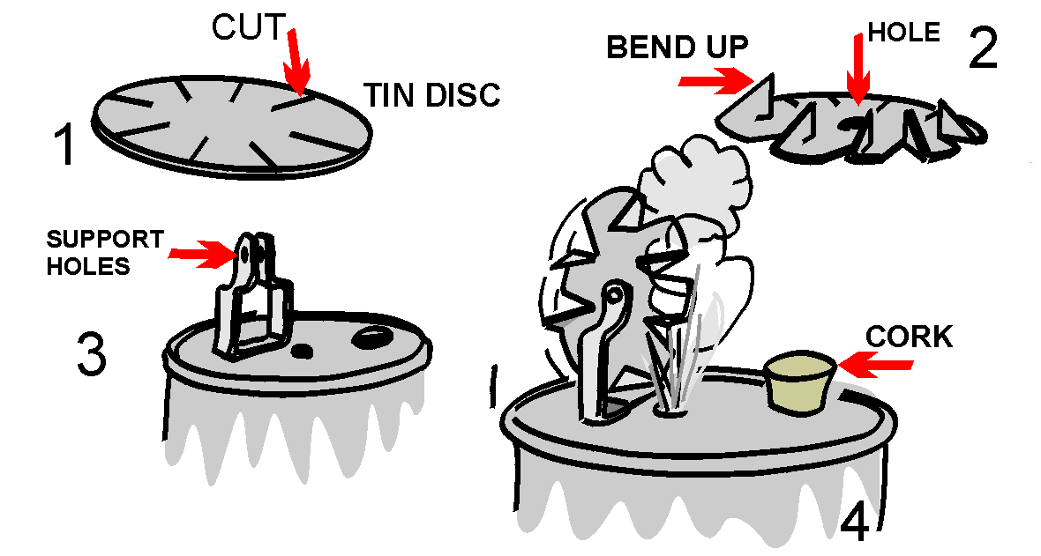
A Webelos Scout may get a graphic demonstration of the power of steam by building the simple steam turbine shown in this illustration. Materials needed are a tin can, a lid from a second tin can, a pair of tin snips, a sheet metal screw, a cork, a power drill, an extra piece of tin to make the support for the turbine wheel, a finishing nail, and a source of heat.
Assemble to look like the illustration.

Blueprint Symbols
Can be used in floor plans drawn for requirement 8 of the Webelos Engineer activity badge. Make a game of learning them by putting each one on a 3" x 5" card and using them as flash cards.
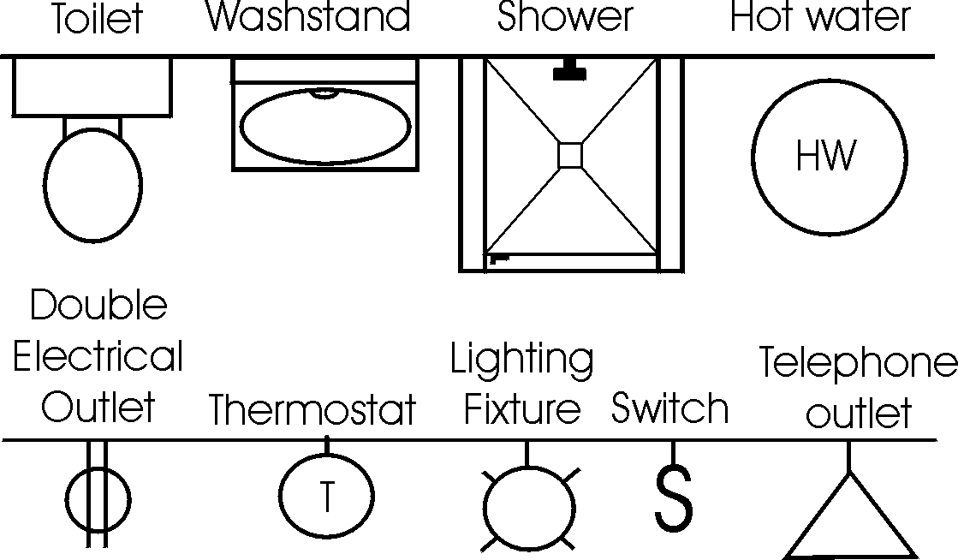

Paper Bridge Competition
Karen, Webelos Leader (and an engineer),
Pack 23, Suffern, NY
Materials:
2 rolls masking tape
2 stacks of newspaper (a good size Sunday paper will do)
4 chairs with backs
2 identical sets of books or blocks (for weight)
Divide the Den into two groups. Let an adult help each group if available. Give each group a roll of masking tape and a stack of newspapers. Set up the chairs in pairs about 4 feet apart. Each group must make a bridge using the materials provided that spans from one chair to the other.
After a set amount of time (15 to 20 min), see how much weight each bridge can support without failing. The bridges may be a truss, suspension, or cable stayed bridge, but must span from one chair to the other without touching the ground in between.

Gumdrop Truss Bridge
This is a fun project that illustrates the strength and rigidity of a truss bridge. You will need a box of round toothpicks and a couple of bags of inexpensive gumdrops (or spice drops). Scouts can work as pairs or individuals on this project. Each scout should start by assembling a single triangular panel using 3 gumdrops and 3 toothpicks. (It is important to notice the strength of the triangular shape.) From there they can extend the side panel of the truss by adding more toothpicks and gumdrops.
Once the single truss is about 4 panels long, the scouts can begin the second side truss. The two sides are then connected together by adding toothpicks between matching gumdrop node points. This short bridge span, which is about 8 inches long, will be very stiff and strong. Spanning the bridge between two stacks of books, or the like can test the strength. A cup full of pennies can be used to load the truss. After testing the strength, the scouts can extend the bridge length by adding more pieces. A second level of truss may be added for really long spans (2 ft or more). The scouts will enjoy testing out various different bridge configurations.

The Right "Man" (or Woman) for the Job!
Use a word from this list to fill in the correct answer.
Aeronautics Electrical
Chemical Physical
Computer Industrial
City Mechanical
Agricultural Civil
- An engineer who designs plants to make water safe to drink - __________.
- An engineer who designs machines in a factory - _________________.
- An engineer who tests new processes and checks old ones in a chemical plant - ________________.
- An engineer who plans new circuits and directs workers in an electrical plant - ________________.
- An engineer who designs and tests new space techniques - ________________.
- An engineer who designs and tests new techniques for new equipment for industry - ___________________.
- An engineer who designs and tests equipment for farmers and ranchers - __________________.

Bridges & Machines
Use a word from this list to fill in the correct answer.
Catapult Arch Bridge
Pulleys Suspension Bridge
Beam Bridge Levers
Plank Bridge Block & Tackle
Truss Bridge Pier Bridge
- A flat surface over two supports -
- A flat surface over three or more supports -
- A flat surface over an arched support -
- A flat surface with turned up edges -
- A bridge with sides made up of a series of triangles -
- A bridge that appears to hang from strong strung cables
- A pulley(s) and a rope or cable -
- A slingshot or other device used to project something -

Basketball Catapult
Instructions
- Base, backboard and hoop are made from a 1"x4" board.
- Drill holes in base and backboard 3/8" diameter and 1/2" deep.
- Cut a slot at a 15 degree angle in a cube block large enough for the handle of a plastic spoon.
- Cut hole for the hoop first; then finish cutting the hoop piece. (We used a slice of 2" diameter PVC pipe and screwed it into backboard.)
- Glue the hoop to the backboard; then glue dowel rod into backboard and base.
- Glue cube block to base and insert spoon into slot.
- Cut string and attach one end to dowel rod at base and the other end to any 1" sized ball (ping pong balls work well).

Rubber Bands & Engineering
Rubber Band Strength
One of the requirements for engineer is to make a catapult. This requires the use of a rubber band or two, or a piece of tire inner tube. The rubber band is "elastic" and it stretches, but then returns to it's original shape. Before using materials in building, engineers must know the characteristics. Does it expand or contract? Is it weak or strong? Does it burn or not?
You can try an experiment to learn more of the characteristics of rubber bands and other elastic material. Get a collection of different sized rubber bands. Measure them for length, width and thickness (if you can). Make a chart that shows this information and mark each rubber band clearly so you know which is which. (Using colored rubber bands is best.)
With each rubber band, attach one end to a cup hook that is screwed into a board. Attach the other end to a known weight. How far down does each rubber band stretch? Does its thickness change? Does its width change? Which rubber band is the strongest? Which rubber band is the weakest? How can you tell?

Rubber  Band | Original |  |  | Stretched
Rubber  Band | Length | Width | Thickness | Length | Width | Thickness

Even More on the Engineer Activity Badge
Boys have a natural interest in how things work. The Engineer Activity
Badge gives an introduction to how the big things in our lives work.
One of the purposes of Cub Scouting is "fostering a sense of personal achievement by developing new interests and skills" in boys. This activity badge probably does this more than any of the other badges.
Engineering is one of the most exacting of the professions and the badge includes projects that will give a boy an insight into some types of engineering.
One of the purposes of Cub Scouting is “fostering a sense of personal achievement by developing new interests and skills” in boys. This activity badge probably does this more than any of the other badges. Engineering is all about applied science, and it is one of the most exacting of the professions. This badge includes projects that give boys an understanding of this profession.
There are many types of engineers; chemical, electrical, civil, petroleum, mechanical and industrial are just a few. It usually takes a creative mind and attention to detail to be a good engineer. Through work on the Engineer Activity Badge, your Webelos Scouts will get an appreciation for engineering and what it takes to accomplish engineering feats.

Types of Engineers
- Aeronautical Engineering: Deals with the whole field of design, manufacture, maintenance, testing, and the use of aircraft both for civilian and military purposes.
- Astronautical Engineering: Closely related to aeronautics, but is concerned with the flight of vehicles in space, beyond the earth's atmosphere, and includes the study and development of rocket engines, artificial satellites, and spacecraft for the exploration of outer space.
- Chemical Engineering: Concerned with the design, construction, and management of factories in which the essential processes consist of chemical reactions.
- Civil Engineering: Perhaps the broadest of the engineering fields; deals with the creation, improvement, and protection of the communal environment; providing facilities for living, industry, and transportation, including large buildings, roads, bridges, canals, railroad lines, airports, harbors, and other constructions.
- Electrical Engineering/Computer Science: Divided broadly into the engineering of electrical power distribution systems, electrical machinery, and communication, information, and control systems.
- Geological & Mining Engineering: Includes activities related to the discovery and exploration of mineral deposits and the financing, construction, development, operation, recovery, processing, purification, and marketing of crude minerals and mineral products.
- Industrial or Management Engineering: Pertains to the efficient use of machinery, labor, and raw materials in industrial production.
- Mechanical Engineering: Covers the design and operation of all types of machinery and small structures.
- Safety Engineering: Concerned with the prevention of accidents.
- Sanitary Engineering: A branch of civil engineering that has acquired the importance of a specialized field due to its great importance for a healthy environment, especially in dense urban population areas.

Make Electricity with a Lemon Battery
Materials: Lemon, steel wool, copper nail, zinc nail.
- Scrub a copper nail and a zinc nail with a piece of wool until they are clean and shiny.
- Rinse the nails under the water faucet.
- Poke the pointed ends of the nails into the center of a fresh lemon. Spaces the two nails about
- 1” apart and leave 1/2” of each nail protruding.
- Take a small LED (light emitting diode) and touch the leads to the two nails. You should see a glow.
When I was a Cub Scout, we stuck out our tongue and touched the tops of the two nails and felt a tingle. What Happened? You have just made a simple chemical battery and the glow you saw or the tingle you felt on your tongue was electricity! Because the lemon contains acid and water, which reacts with the metals, zinc and copper, a slight electrical current was formed and it passed over your tongue from one nail to the other.

Unusual Catapult
Materials: Thin cardboard, colored pencils, long rubber band, scissors
Directions
- Draw two separate five sided shapes, tracing the pattern as shown.
- Cut out. Lightly fold back along dotted lines.
- Color each of the six separate sections a different color.
- Overlap the two shapes and loop the rubber band over every other corner to hold the two pieces of cardboard together. The rubber band should be stretched slightly but not too tight.
- When you let go of the cards, which should be laying flat on the table, the slightly stretched rubber band will contract which will cause your contraption to “leap” into a solid shape.
Why does this happen and is this really a Catapult? The energy in the stretched rubber band pulls the cardboard contraption into the shape. This illustrates what makes a catapult spring in the simplest way imaginable.
Explain to your Scouts that some substances, such as elastic or rubber, stretch when you pull them, but spring back into their original shape when released
Although most catapults “fling” or “throw” something away from them, this one uses the spring or force of the catapult to “throw its flat shape “up” into a ball or solid shape. Even though it is very different from a standard catapult, it nevertheless operates on the same principles, only in reverse.

SUGGESTED PATROL ACTIVITIES
- Have the boys find pictures of different bridges and put together a poster for the pack meeting.
- Visit a college engineering or architecture department.
- Invite an engineer or architect to visit the patrol meeting to talk about their job.
- Measure the dimensions of your meeting place and include the locations of doors and windows. Show how to sketch a simple floor plan with these measurements.
- Make a block and tackle and demonstrate its use.
- Make catapults and have a contest.
- Compare design and Construction of various kinds of bridges and make a model of one or more.
- Visit a construction site with a contractor. Ask him to explain the use of blue prints and the order of construction.
- Visit a power generation plant.
- Work on the Academics belt loop and pin for mathematics.

CATAPULTS ARE DANGEROUS
Be forewarned that like most machines, all catapults have the opportunity to be dangerous, even small ones. Catapults were originally invented with the intent to hurt people, so leaders need to be very safety conscious with boys around catapults. Be safe, so that mistakes won’t lead to injuries.

LEAF SPRING CATAPULT
Using wood scraps and an old ruler. Lay the ruler flat onto a larger board and nail another board over and inch of the end of the ruler. Then wedge a small board under the ruler to form the leaf spring catapult.
LEVER CATAPULT
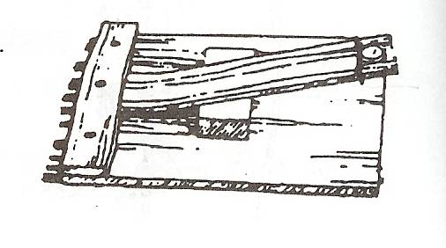
Catapult Experiment: Use ruler and rubber eraser or other soft projectile. Have boy strike the short end of the ruler balanced on a dowel. How far did the eraser go? Now have him try it with half the ruler over the edge of a table and hit it with the same force. Why is there a difference in the distance that the eraser flies?
MOUSE TRAP-A-PULTS
The spring and lever action of a mousetrap can be harnessed for many kinds of fun machines. Give the boys mousetraps, string, tinker toys or K-nex and have a contest to build and see how far their mousetrap contraption could throw a small object like a dry bean. Below is an example with the mousetrap pulling a lever that then throws the bean.
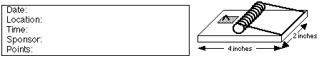

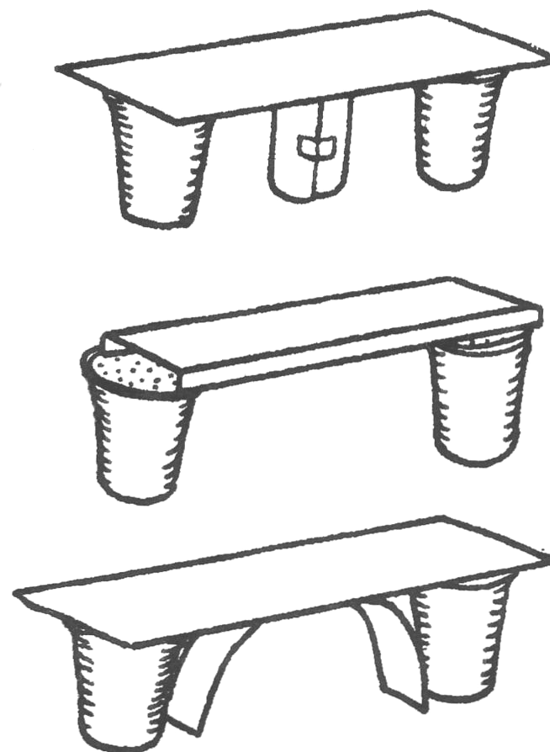
BUILDING CHALLENGES
PAPER BRIDGE CONTEST
Hand the Webelos each one sheet of 8½ x 11 paper, two foam cups, 4” of tape and a matchbox-sized car. Tell them to build a bridge that will support the toy car as it rolls across the bridge. They can cut or fold the paper into any shapes that they want. They may use small pieces of tape to help hold the paper in desired shapes but not to tape to the cups. This can be a group effort, team play or on an individual project. You can do something similar as a tower-building contest.
Strong Bridge Ideas:
- Cut a strip and roll it up. Use this as a center support.
- Fold two long edges of the card.
- Cut a strip and curve it under the bridge as a support.
- Cut three strips and sandwich one folded in a zig-zag.

TRUSS BRIDGES
You will need: Lots of mini-marshmallows, toothpicks, various weight objects.
- Give teams of boys an equal number of marshmallows and toothpicks.
- Between two equal-height objects (like tables) show them the distance that they must span with their bridge. Tell them that the contest will be to see how much weight their bridge can hold in the very center of the bridge
.
- The bridge must be at least one toothpick wide and you suggest that they use the marshmallows to connect the toothpicks.
- Tell them that the strongest shape is a triangle, so build a truss bridge that has lots of triangles in it.

PULLEYS, BLOCKS AND TACKLES
There are five kinds of basic machines that were discovered in ancient times. All complex machines are built out of some or all of these basic machines: wheel (with axle), pulley, wedge, screw and lever. This exercise will show the magic of how pulleys, and blocks and tackles can make lifting something heavy possible by exerting very little effort.
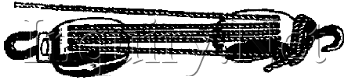
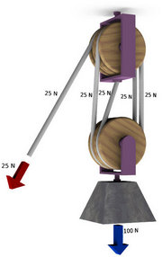
A pulley is a special kind of axle and wheel, where the axle is connected to some object, and a rope goes around the wheel. A block and tackle is formed by two pulleys that may each have several wheels, and a rope goes around both pulleys. Ropes and pulleys can be connected in many assorted ways to create different degrees of how easy it is to pull.
A simple “Come-along” can be made by tying a rope to a fixed object (like a tree), running the rope behind the object that you want to move, and pull on the rope while standing near the tree. You will only have to pull half as hard to make the object move, as if you tried to pull it directly, because the tree actually helps you pull. You can also achieve the same result by attaching a single-wheel pulley to the object that you want to move.
By using two pulleys, you may form a block and tackle. With pulleys that have enough wheels and enough rope, it would be possible for a Webelos Scout to move just about any heavy object that the rope and pulleys can support. The illustrations below show how to move more than what you normally are capable of pulling directly with a rope. The Mother Earth News website also has some excellent illustrations of blocks and tackles.

ELECTRICITY
All matter has electrons and when electrons move we see the effects of electricity. Metal and water are both good conductors of electricity. Metals like copper and aluminum are most often used to safely move electricity in appliances. Our bodies are also fairly good electrical conductors, because our bodies have a lot of water, which is why people have to be very careful around electricity.
Insulators are things that do not conduct electricity very well. Wood and plastic are two good examples of electrical insulators.
MAKE AN ELECTROMAGNET
Materials:
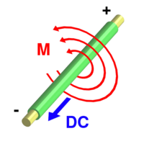
- Ten feet of 22-gauge coated copper wire
- 6-volt lantern battery
- 6 inch iron nail
- Steel paperclips
- Wire stripper and needle-nose pliers
- Gloves
Electromagnets take advantage of a phenomenon where electricity moving in a wire causes a magnetic field around the wire (shown left).
A single straight wire, with electricity flowing through it, however, has a very small magnetic field. But when you wrap that wire round and round about 50 times in a long neat coil, the magnetic fields from all of the wraps add together to form a strong magnetic field. You can also multiply the strength of the coiled magnetic field, and make the coils much neater, by wrapping the coil around a long piece of iron or steel (like a nail). The more tight and neat the wraps are, the better it will work.
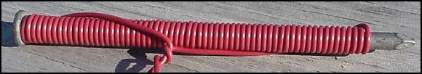
To make current flow through the wire, we need to make an electrical circuit. Strip a half inch of insulating plastic off of each loose end of the wire, and with the pliers curl the ends of the bare wires into U shapes. Scatter the paper clips on a table nearby. Put on a pair of dry, cloth gloves, because the wires may get hot when the current is flowing. Hook one bare wire onto one of the springs on the lantern battery. Now hook the other bare wire to the other spring connection on the battery and voila you now have an electromagnet that can pick up the paper clips and any other small ferrous objects. The electromagnet will work until the battery is drained or the circuit is broken.
Did you notice a spark when the second wire was connected to the battery? Notice how warm the wires get as the electrical current flows through them. Disconnect the wires while the electromagnet is holding paperclips and watch it drop them. Connect the circuit, pick-up paper clips in one place and move the electromagnet over a box, then disconnect a wire and drop the paperclips in the box. Continue this until all paperclips have been moved.

