Webelos Outdoorsman Activity Badge

Outdoors Group
An outdoorsman loves being outside. An outdoorsman knows how to cook outdoors – over a fire or over a camping stove. An outdoorsman also knows how to tie knots. An outdoorsman will follow the principles of Leave No Trace so that we can all enjoy the outdoors for a long time to come. Webelos Scouts will have fun learning about being an outdoorsman. Hopefully he will be able to apply the Leave No Trace ethic for years to come.

IDEAS FOR DEN ACTIVITIES
- Learn the principles of Leave No Trace and have the boys earn their Leave No Trace Awareness Award.
- Whip a rope.
- Have knot tying races with the rope they whipped.
- Practice outdoor flag ceremonies.
- Make individual First Aid kits.
- Go camping.

LEAVE NO TRACE PRINCIPLES
The Leave No Trace Principles of outdoor ethics form the framework of Leave No Trace's message:
- Plan Ahead and Prepare
- Travel and Camp on Durable Surfaces
- Dispose of Waste Properly
- Leave What You Find
- Minimize Campfire Impacts
- Respect Wildlife
- Be Considerate of Other Visitors

ACTIVITIES

KNOT EASY
Divide the den into two teams. Assign a team captain for each team. Give each team captain a 12-inch length of clothesline rope. At a signal, the captain ties a square knot in the rope and passes it to the next Webelos Scout in line. The second Webelos Scout unties the knot and passes it to the third Webelos Scout, and so on down the line. The first team to finish wins.
Variations
-Every other Webelos Scout ties a different knot that the Scouts have learned.
-Take a piece of rope and start with one knot and add a knot to the rope as it passes.
-Each Webelos Scout has a piece of rope and when he gets the rope from the previous Webelos Scout, he adds a knot to the chain of knots. It cannot be like any knots previously tied.

KNOTS GALORE
Give the team captains a 24-inch length of rope. At a signal, the captains tie a knot at one end of the rope; and second player ties a knot near the first, and so on down the tine. There should be a knot for every player on the team. After all knots are tied and number checked, it goes down the line again, with each player untying a knot until the rope is returned to its original condition.

KNOTTING CIRCLE
Webelos Scouts form a circle facing inward with their hands behind them. “It” walks around the outside of the circle, places a rope in someone’s hands, yells the name of a knot, then speeds off running around the circle. If the recipient succeeds in tying the knot correctly before “It” comes back, “It” must proceed again. Otherwise, recipient becomes “It” and previous “It” takes his place in the circle.

KNOT TRAIL
Tie several pieces of rope of varying thickness together, using several different knots (square knot, sheet bend, bowline, two half hitches, etc.). You may use a knot more than once. Tie one end of the rope to a tree with a clove hitch, the other end to another tree with a taut-line hitch. Ask each Webelos Scout to walk silently along the rope from one tree to the other and back. Then each boy makes a list of the knots used in the correct order.
Below: Square knot, Taut-line hitch, Clove hitch
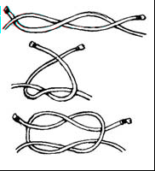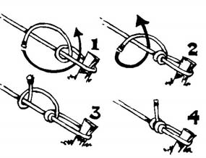
Plan a whole den meeting on the camping theme. Demonstrate how to set up a tent properly, including precautions on handling to avoid damage. Then divide the den into two teams and give each a tent bag. On signal they must race to set up the tents. Once both tents are up, allow boys to climb inside to have a secret meeting. Take off shoes first. Inside, they have ten minutes to plan a song or a short skit to entertain the other boys at their campfire. Ring a bell to call the boys out to the campfire. Choose one team to lay the firewood. Talk about fire safety. Have the boys circle around the campfire. Teams take turns entertaining each other. Leader gives closing and the other team put out the campfire properly. Take down the tents, sing taps and go home.

EDIBLE CAMPFIRE
Use this for a den activity to teach proper fire building techniques.
As boys are building their individual fires, explain why each step is important. After the fire is built, enjoy eating this treat!
Napkin – designates a cleared area
Miniature marshmallows – for fire circle
Small cup of water – to extinguish fire
Shredded coconut – kindling
Skinny pretzels – tinder
Fat pretzels – fuel
Candy corn – fire

HOW DO I USE IT?
While we teach the boys about the outdoors, we sometimes forget to help them think about how to use the camping equipment that they have in an emergency. This is a fun exercise to do. Here is a list of equipment a boy has been left alone with in a remote location:
Pail, pocketknife, flashlight, rope, large blue tarp, fishing pole, FM radio, whistle, compass, map
- If he were lost in the woods, which items might help him find his way back?
- Which items might be used to get help?
- Which items might be used to make yourself comfortable?
- Would your choices be different if you were lost for many months?
- If you had only one item, which would you choose? Two items? Three items?

COOKING

TIN CAN STOVE COOKING
Using the guidelines in the Cub Scout Leader How-to Book, make a Tin Can Stove and Buddy Burner.

TIN FOIL DINNER MEALS
Foil dinners are meals that cook inside the pouch of a piece of heavy-duty aluminum foil. Place your food on aluminum foil, seal it by folding the top and sides, and place the foil onto hot coals. Here are two simple ideas:
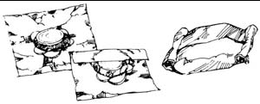
Hamburger Foil Dinner:
Place quantities of hamburger meat, sliced onion, potatoes, carrots and other vegetables on a piece of foil. Season with desired salt, pepper and other spices. Seal the foil and place on coals for approximately 15 minutes each side.
Tuna Noodle Foil Dinner:
Place quantities of precooked pasta, grated cheese, and drained tuna in the middle of the foil. Seal it and place on coals for approximately 10 minutes to warm the ingredients.
Always protect your hands when cooking foil packets – they’re hot! And when opening the packets, beware of escaping steam, which can burn you.

STUFFED POTATOES –
Core small potatoes and insert a small pre-cooked sausage or wiener into each. Wrap in foil and set in hot ashes to bake. Cook 45-90 minutes.

BANANA BOAT
Slit a banana lengthwise twice, being careful not to cut the lower skin. Peel back the skin, cut out and remove the fruit between the slices, and replace with peanut butter, mini marshmallows and chocolate chips. Close by replacing the skin. Wrap the banana in foil, and broil in hot coals for 8 minutes.

BAKED APPLES
Core an apple and wrap it in a square of aluminum foil. Add cinnamon sugar filling if desired.

More on the Outdoorsman Activity Badge
The Outdoorsman Activity Badge requirements are FUN, and give the Webelos a chance to learn new skills that will prepare him for Boy Scouting. Camping, outdoor cooking and fire safety are all part of enjoying living in the outdoors.

SUGGESTED PATROL ACTIVITIES
- Practice putting up different kinds of tents.
- Demonstrate how to make an improvised bedroll
- Practice building a fire for cooking and a campfire, and have a patrol cookout.
- Have a knot-tying contest or play knot-tying games to learn and improve skills.
- Study and learn fire safety rules including no flame lights in tents and no liquid starter for charcoal fires.
- Learn several cooking techniques, including the foil pack method.
- Contact a local Boy Scout troop and arrange to camp with them.
- Make camp gadgets and go camping
- Have a Scout visit a patrol meeting and show the boys his pack. Have him describe the different kinds of packs and what he carries in his.

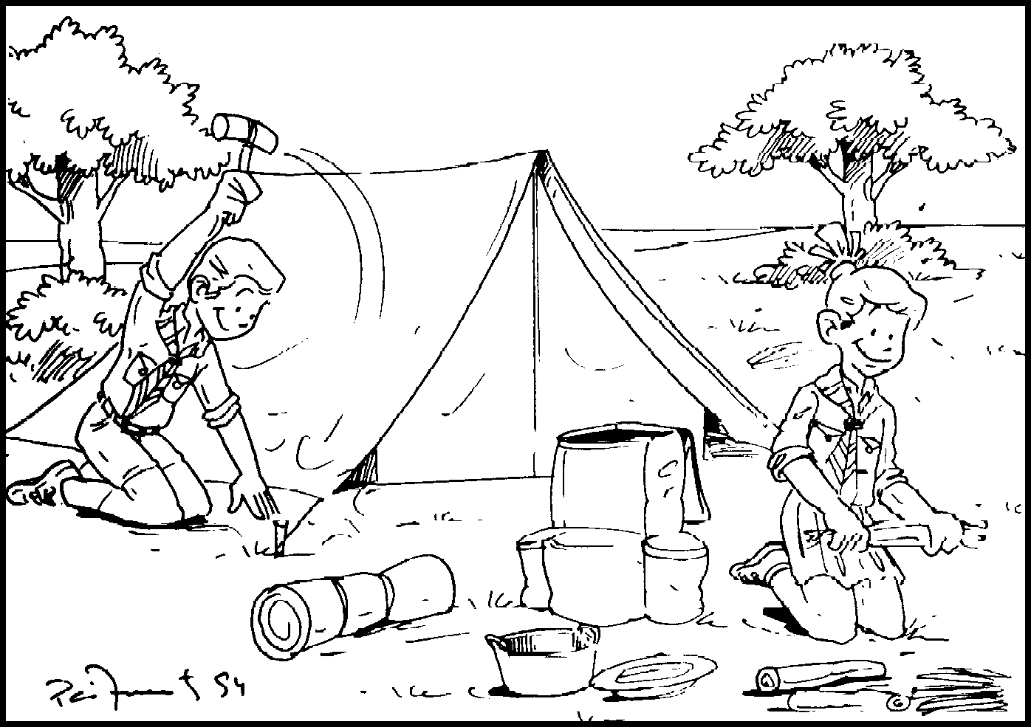
WHY DO WE CAMP?
The primary reason for camping is so that the boys learn conservation and respect for nature. Your example as a leader is very important. They should see in you the concern for our environment that they will learn. Make sure that they understand that it is best to leave a campsite in better condition than when you came. It is okay to pick up litter that you did not place there, etc.

UP AND DOWN
Plan a whole patrol meeting on the camping theme. First demonstrate how to set up a tent properly, including precautions on handling to avoid damage. Then divide the patrol into two teams and give each a tent bag. On signal they must race to set up the tents.
Once both tents are up, allow boys to climb inside to have a secret meeting. Take off shoes first. Inside, they have ten minutes to plan a song or a short skit to entertain the other boys at their campfire. Ring a bell to call the boys out to the campfire. Choose one team to lay the firewood. Talk about fire safety. Have the boys circle around the campfire. Teams take turns entertaining each other. Leader gives closing and the other team put out the campfire properly. Take down the tents, sing taps and go home.
Taps lyrics are “Day is done. Gone the sun, from the lakes, from the hills from the sky. All is well, safely rest. God is nigh.”

TEACHING KNOTS
Try to teach basic knots over an extended period. Do not try to teach them more than two knots in any given meeting. Most boys will start to get confused after the second knot. Master the square knot and clove hitch first, and then add the others.
Repetition and using them for a real purpose is the key to learning knots. Once you have introduced them, keep including the skills in various games and other activities. Using rope of two different colors helps some boys see more clearly how knots are correctly tied and lessens confusion. Boys will need individual attention in learning and demonstrating these knots; so try to get some help in watching them tie them. Your den chief would be good at this.
There are six taught in this activity badge. Be sure to teach them in practical situations so that they will know what to use them for! The uses of the required knots are listed in the Webelos Scout book along with the instructions. Use a lot of knot tying games (Webelos Leader Guide) to make it fun, and use ropes for other games as well.

HOW DO I USE IT?
Even though we teach the boys about the outdoors, we often forget to help them think about how to use the equipment that they have in an emergency. This is a fun discussion exercise to use with your boys. Here is a list of equipment the boy has been left alone with, in a remote location:
Pail Flashlight Large blue tarp
FM radio Compass Pocket knife
Rope Fishing pole Whistle
Map
- If he were lost in the woods, which items might help him find his way back?
- Which items might be used to get help?
- Which items might be used to make himself comfortable?
- Would your choices be different if you might be lost for many months?
- If he only had one of these items, which would it be? Two items? Three items? …

NO SLEEPING BAG? NO PROBLEM
Do you have to have a sleeping bag when you go camping? Certainly not, and during the warm months in many states (e.g. Texas), lighter sheets and blankets can be much more comfortable that a warm sleeping bag.
What is most important is:
- Provide a barrier between you and the ground that keep you dry if the tent gets wet. This can be as simple as a sheet of plastic.
- Provide some padding under you, so that the rocks and roots under you don’t keep you awake. An extra blanket or a closed cell foam pad will work nicely.
- No pillow is required. A cloth laundry bag or pillowcase holding your extra clothes makes a nice pillow at night, and your next day’s clothes are easy to find.
- Blankets are the best things to use as a sleeping bag substitute. Wool in the winter and synthetic in the summer can keep you toasty warm. A piece of plastic over the blanket and under your body can add to how warm it keeps you on a chilly night.
- Whether using blankets or a sleeping bag, it is more comfortable to have a sheet next to your body. Fold a twin-size sheet in half and safety pin it on the sides.

SUCCESSFUL OUTDOOR COOKING
It is important that Webelos are allowed to cook on their campouts. With a little bit of supervision for the sake of safety and health, the boys should be able to prepare their own breakfasts, lunches and dinners. Don’t be afraid to give them a chance to cook your food AND to clean up afterward. If they clean up, they will learn not to be so messy while cooking.

Simple breakfast items:
- Pre-mixed Pancakes, just add milk or water. Don’t forget the oil on the griddle.
- Dice potatoes and fry. For more flavor add salt, pepper, onions and bell peppers.
- Bacon, and this can provide cooking oil for the pancakes and potatoes.
- Boiled mini link sausages.
- Toast bread over a fire, with sticks holding the bread.

Simple lunch items:
- Keep simple quick and easy with sandwiches. Grilled ham and cheese sandwiches can add some challenge.
- Open a can of their favorite soup.

Simple dinner items:
- Foil dinners. Best if you use Extra Heavy Duty Aluminum Foil. Foil dinner success comes when the raw potatoes, vegetables and meats are cut very small, there is a lot of moisture in the food or added with barbeque sauce, and you carefully seal folded edges. Use a Sharpie marker to write names on the outside, and cook on edge over hot coals.
- Hotdogs on a stick over hot coals.
- Bake rolls in a Dutch oven or wrap dough on a stick over hot coals.
- Bake a fruit cobbler in a Dutch oven (the official Texas state cooking implement). Line the Dutch oven with heavy duty foil to avoid any clean-up.

The best way to work on the Outdoorsman Activity Badge is on a Parent-Son overnight campout. Policies of the Boy Scouts of America encourage one or two Father-Son overnights during the year when a boy is a Webelos Scout. This is not full-fledged Boy Scout camping---only a taste of what is to come when the boy joins a troop. After a Cub Scout becomes a Boy Scout, he will become proficient in handling himself in the woods. As a Webelos Scout, he should not be expected to completely master any of these skills--only to have a little fun in the woods.
Most Webelos cannot wait for the first campout. But some are really not ready for it when they go. Good planning and assistance from the parents is important to make the first campout away from home successful.
Make sure that new boys that have not camped have the back yard experience first. They will probably be in and out all night, but it will help raise their confidence.
If you are using state parks, call ahead for reservations. Most will save you a space if you send in the required deposit on time. Make sure you get permission to use private property, and fill out a Tour Permit to get clearance from the Scout Service Center. When you are planning, use these topics as brain teasers. Make sure you consider these for a successful campout.
- Adult assistance - Son and one, not more than two boys to one adult.
- Location - Distance, time and transportation
- Food - Dietary problems, weight, water, refrigeration, trash disposal.
- Cooking - Basic food groups. Keep it simple. Try it at home first.
- Sanitation - Safe water, proper dish washing, showers, hand washing, latrines.
- Safety - No hatchets, axes, or chain saws. Buddy system everything! Follow fire rules. Gas fuels - adults only!
- First aid - Medication for boys, allergies, nearest medical facility, good first aid kit (you can make it yourself).
- Activities- Activity Badges, Tracking, Hiking, Orienteering, Campfire, Swimming, Fishing, Knots.
- Plan B- Something to do if the above activities cannot be done because of weather, etc.
Camping
- Campsite - Watch for low areas that may be a runoff or stream if it rains. Check for dead branches overhead that may fall if the wind blows.
- Tents - Seams need to be sealed before first use. Practice set-up and teardown, in daylight and darkness, before the trip.
- Bedding - Make sure it’s suitable for the weather. Remind the boys to change into clean, dry clothes at night before bed, not in the morning.
Packing
- Use checklist in book.
- Have a “shakedown”; see what the boys pack early.
- Raingear (big plastic bags are cheep).
- Put things in small plastic bags. It keeps them dry and organized.

Homemade Mess Kit
Staple together two aluminum foil pie plates for thickness. Staple together two more. Use one double thickness pie plate for the top of mess kit, the other for the bottom. Fasten together on opposite sides with paper clamp. Tie a leather shoelace through hole in paper clamp. To make a strap to hang on belt or bicycle handlebar. This mess kit will hold a collapsible cup, and plastic fork and spoon.

Roasting Tools
Wiener or marshmallow roasting utensils are made from wire coat hangers, which have had the paint sanded or burned off. Handles are either pieces of wooden dowel or spools glued together. Be sure the holder is long enough so you can stand back from the fire when using it.

Hand washer
Materials needed:
- 1 large bleach bottle or milk jug
- 1 bar of soap
- Leg of old panty hose
- String and knife
- 1 roll of paper towels
- 1 sturdy stick and small twig
Directions:
- Punch a hole in each side of the bottom of a bleach bottle or milk jug.
- Run a string through one hole and out the other.
- Wrap each end of the string around the ends of a sturdy stick. (First slide the roll of paper towels onto the stick.)
- Bring ends of the string together and tie.
- Then hang over tree limb.
- Slip the bar of soap into the toe of the panty hose.
- Tie to handle of the bottle.
- Punch a small hole about 1 inch from the bottom and plug with a small twig.
- Remove twig to use.
- You may wish to tie the twig to the handle with strings so as not to lose it.

Den First Aid Kit
A number of kits are on the market, but as a Webelos den project, you can make one for the den. The first aid kit is best packed in a waterproof container such as a plastic refrigerator box. Here are some items that can be considered standard; soap, box of adhesive bandages (assorted sizes and waterproof), adhesive tape, sterile gauze pads (small and large), burn ointment, small scissors, tweezers, a packet of needles, safety pins, ammonia inhalant capsules, chopsticks, salt tablets, snakebite kit, poison ivy lotion, tablets for digestive upsets.

Trail Snacks
Have the boys prepare a trail snack to take with them. See recipes below:

Hiker's Nosebag This and That
Ingredients
1/4 lb. seeded raisins
1/4 lb. seeded raisins
1/4 lb. Cheese
1/4 lb. peanuts
1/4 lb. Chocolate
1/4 lb. chocolate bits
1 apple
Some favorite sugared cereal
Directions
Put all ingredients in a plastic bag)
Mix well
Eat and enjoy

Games

Map Concentration
Let the boys make sets of map symbols on index cards and play a game of concentration.

Clock Hike
Each boy picks a time, then using a compass with north as 12 o’clock, you simply hike a predetermined number of paces that the “time” dictates. Then use the next boy’s selected time for the new direction. Teaches a little of compass usage and provides some exposure to what they will get into in Boy Scouts.

Fulfilling Advancement Requirements
Webelos Handbook -- Aside from the fun the boys will experience on the overnight campout, they should complete enough requirements to earn the Outdoorsman Activity Badge by the time they return home.
In addition, certain requirements for other badges can be accomplished while on a campout. For example:
Geologist - Collect 5 geological specimens that have important uses.
Naturalist - Be able to identify the poisonous plants and reptiles in your area. Observe wild animals in their natural habitat. Describe what you saw and what they were doing.
Forester - Identify 6 forest trees and tell what useful wood products come from them.
Traveler - Make a list of 4 nearby trips. Act as navigator on one of them at least 25 miles long. Pack a suitcase for the trip. Check the First Aid Kit in the car.

Webelos Scouting is the bridge between Cub Scouting and Boy Scouting. The Outdoorsman activity badge is the pier that supports that bridge. In this badge, the Webelos Scout will receive a preview of the fun he will have in Boy Scouting. The best way to work on this badge is by doing a Webelos overnight campout. This is not a full-fledged Scout campout, but a taste of what is to come when a boy joins a Scout troop. After a boy becomes a scout, he will become proficient at handling himself in the woods. As a Webelos scout, he is not expected to master these skills.

PERSONAL CAMPING GEAR
You can check off your needs on the five fingers of one hand: sleeping, eating, being clean, being prepared, extras.

SLEEPING
You want to sleep well. To do this you must be warm. For your first overnight camp, one to three blankets will do. Eventually you will want a sleeping bag. Before you buy one, ask the advice of those who have been camping. Buy the best sleeping bag you can afford. A bag filled with polyester fiberfill is good. Down is better. If the winters are severe, buy a winter weight bag. Open it up for summer use. You also want to be comfortable. Many campers use a shoulder to hip length polyurethane pad. Others like an air mattress. You place it on top of a plastic ground sheet. For nightwear bring pajamas.

EATING
You want to eat. Here you’ll need an eating kit or separate knife, fork, and spoon. As well as a plate, cup, bowl, or a one man cook kit that includes all three.

BEING CLEAN
Bring soap in a plastic container, washcloth, toothbrush and toothpaste, comb and metal mirror, hand towel. Perhaps a plastic washbasin.

BEING PREPARED
Put in your pack a flashlight and a small individual supply of toilet paper wrapped in plastic. When you are not wearing them, outer clothing items go into your pack.

EXTRAS
You may want to take with you the Bible or prayer book of your faith. Plus a few favorite items you just can’t do without. Just remember not electronic games; boom boxes are camping to enjoy nature not to disrupt it.

KNIFE SAFETY
Facts every boy should know about knives:
- A dull knife doesn’t work and is, in fact dangerous.
- Dull blades cut more fingers than sharp ones.
- A camper should always carry a small sharpening stone in his pocket along with his knife. The knife and stone are partners and belong together.
- A sharpening stone is called a whetstone. One measuring 3” by ¾ “ is large enough to use and small enough to carry easily.
- A whetstone using water is more practical in camp then one using oil.
- Whetstones are made to provide a grinding surface. Fine stones are for knives while coarse stones are for axes.

POCKET KNIFE SAFETY CIRCLE
A pocket knife safety circle is similar to an axe yard only smaller and on an individual level. To establish a safety circle, grasp a CLOSED pocket knife in your hand, extend your arm and with the closed knife straight in front of you, rotate body to either side while continuing to extend the closed knife arm. No one or thing should be within this imaginary circle you have created. Also check your overhead clearance, as this is part of your safety circle.

A TYPICAL KNIFE
A pocketknife should have a good stout blade at least 3 ½” long. Here is a close up view of a typical knife:

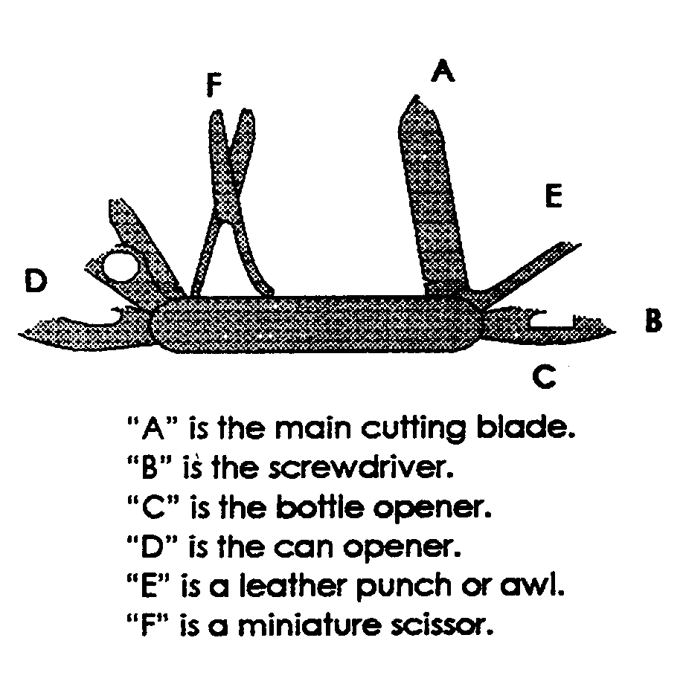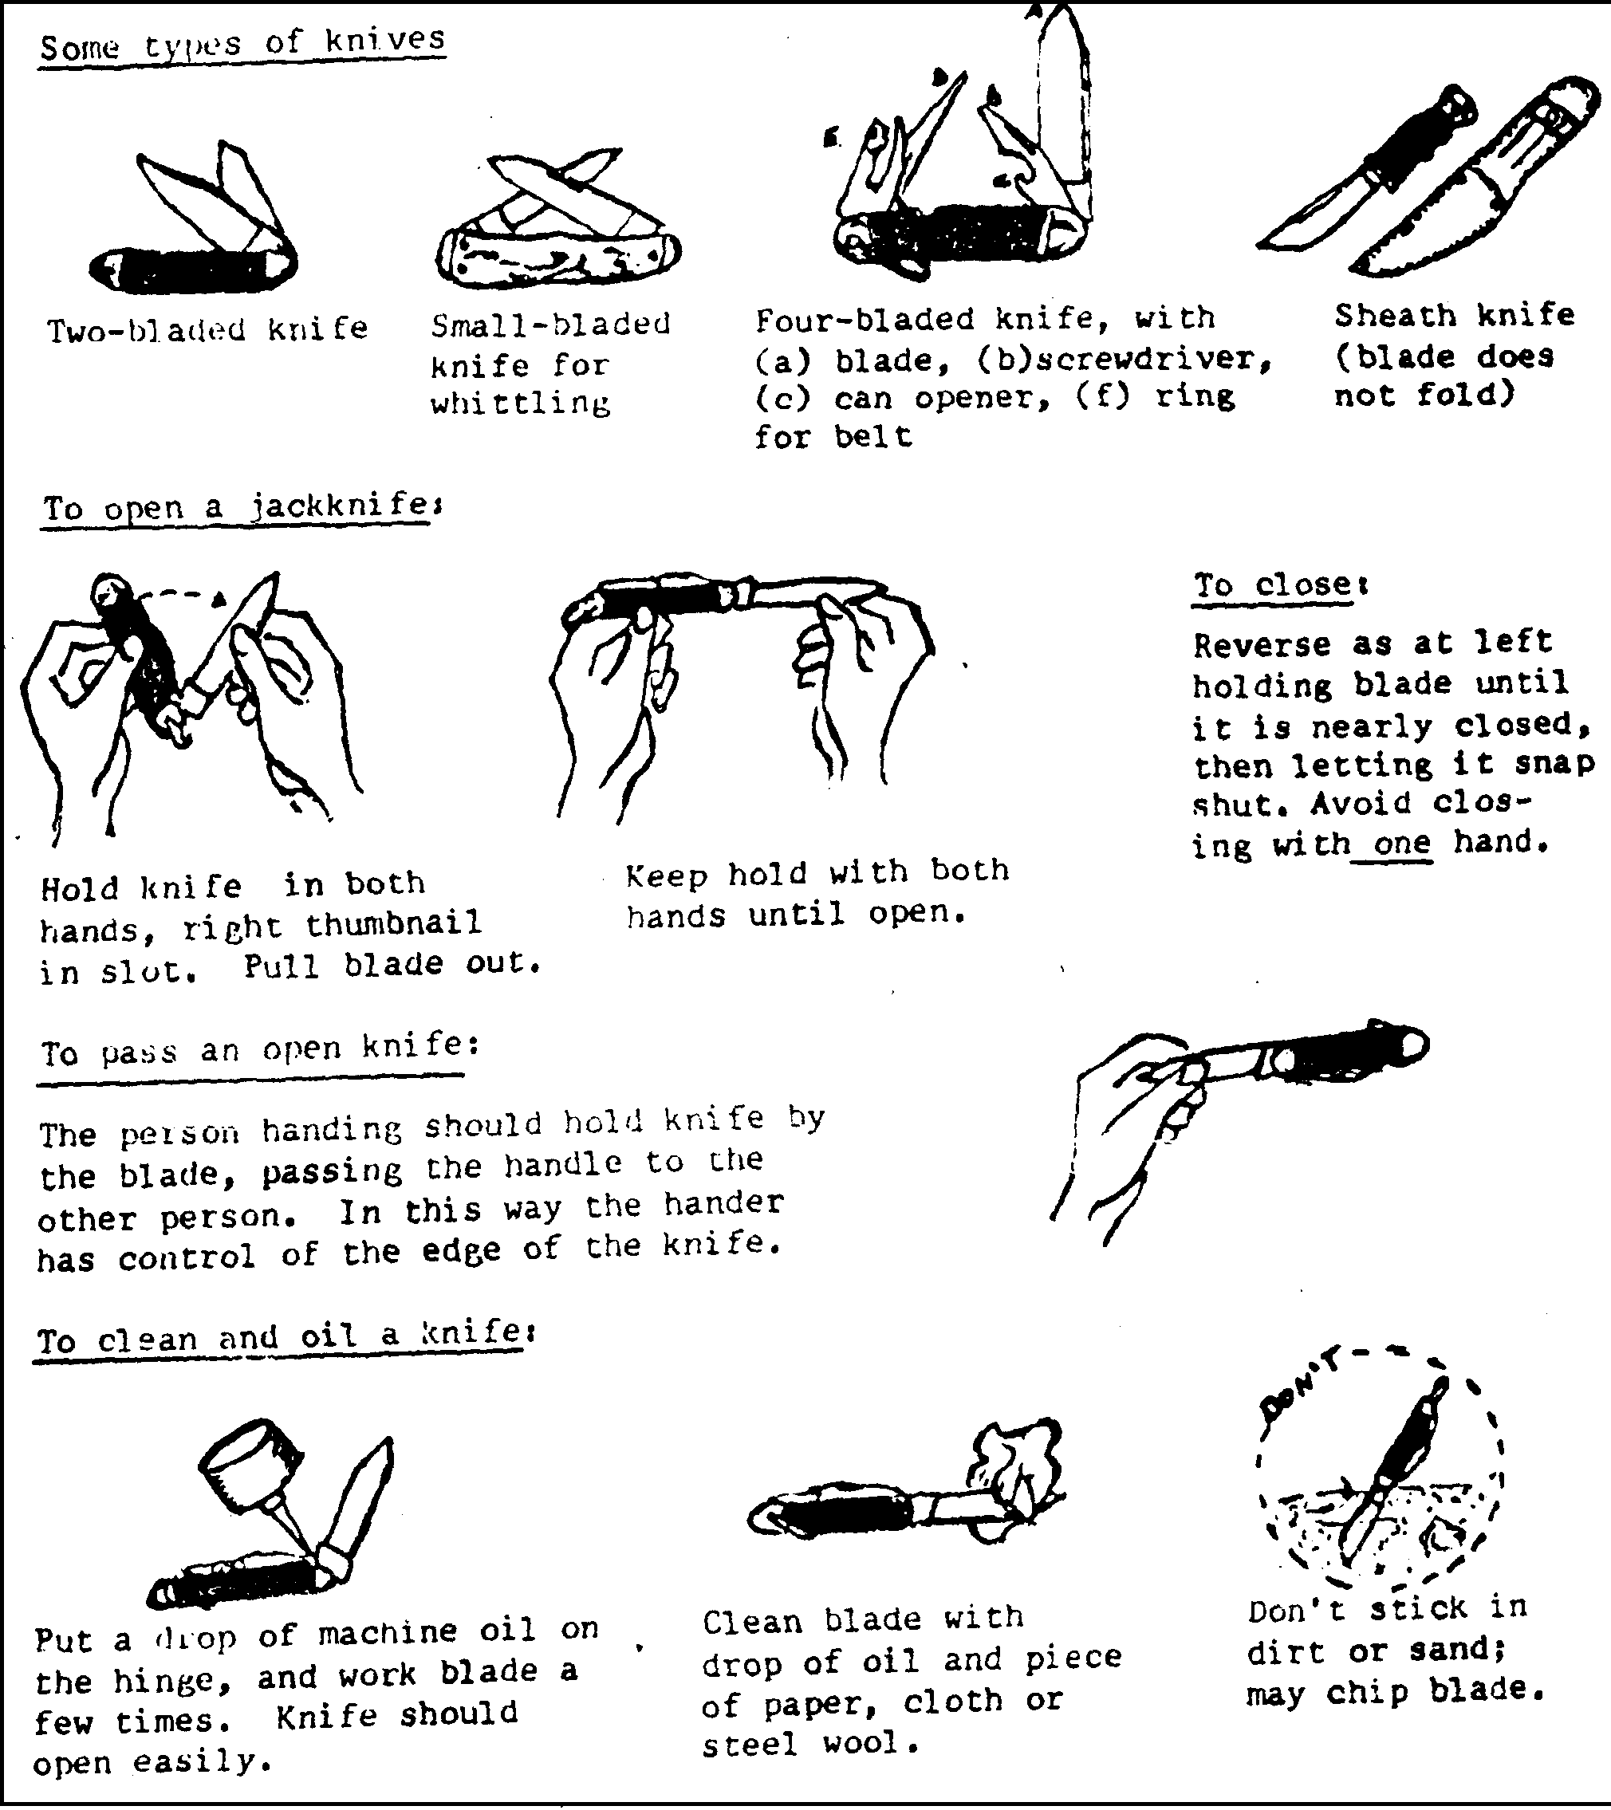

EASY CARVING/ WHITTLING
An easy way to teach boys to carve is by carving soap into a simple design. Fresh soap, especially Ivory soap which is ideal, may be too soft and crumble. To prevent crumbling open the soap up and let in air for about 5 - 10 minutes. These could be done will you explain the rules of using a knife to the boys. See, also, hint under “Whittlin’ Chit” in Den and Pack Activities. CD
Whittle away from you (until you are an expert)! Be sure that nothing (your leg, another camper, branches etc) are in the way of the sweep of your knife.

KNOTS
Knots are a very important part of Scouting. Begin now to learn them. Its lots of fun and you can make a display of those you have done. Put them on a wooden board, name them and frame the board for a permanent display.
These knot pictures may be better if you copy and enlarge them.

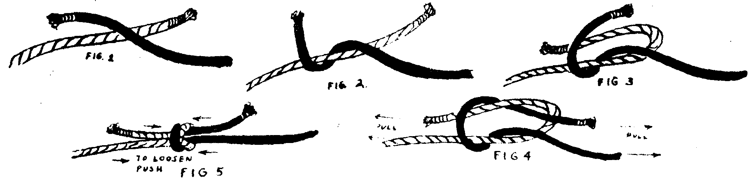
SQUARE KNOTS
This knot is used for joining two ends of a rope or string of approximately the same size or thickness. Use it to tie up a bundle or a bandage, to mend a shoestring, or to make a long rope from several small pieces.

SHEET BEND
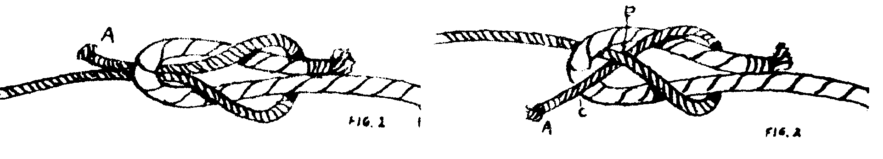
When you have two ropes that are not of the same thickness, a square knot will not hold them, but if you will give the square knot an extra twist, it will become a sheet bend, and will hold. This is one of several ways to make a sheet bend knot.

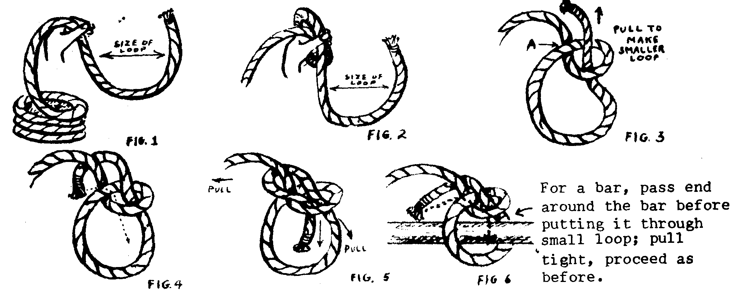
BOWLINE
Use this when you want a loop in the end of a rope. This loop will not pull tight, but will remain the size you made it. Use it to slip over a peg, or hook, or make the knot itself around a post or pole. It’s sometimes called the rescue knot.

MAKE A COMPASS
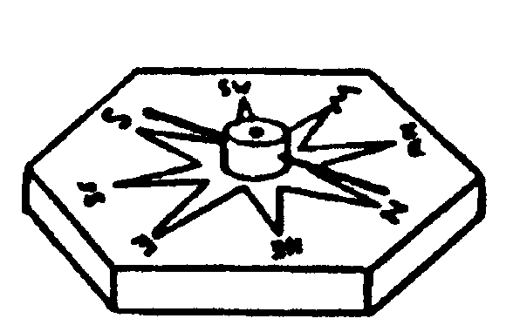
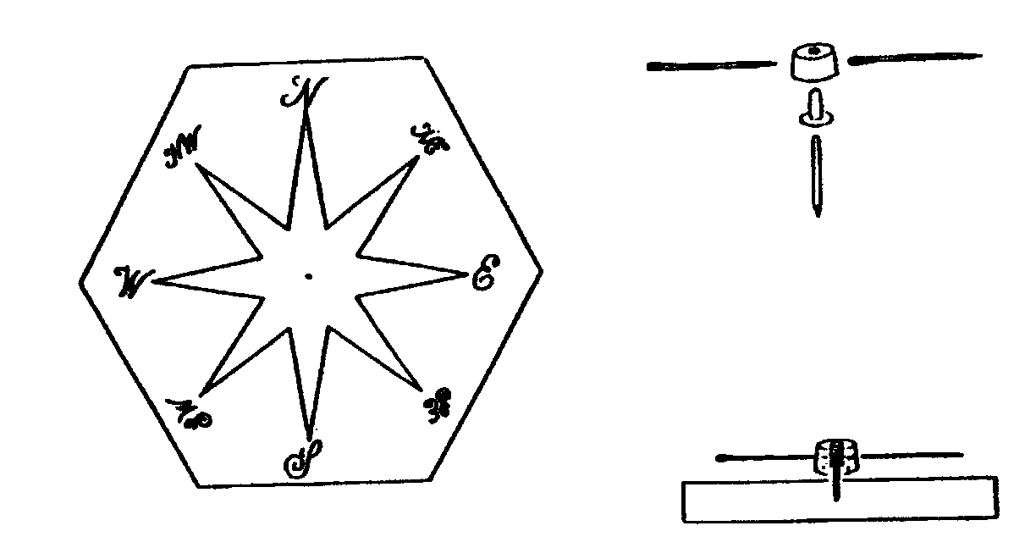
The face of the compass may be cut from ¼” plywood, ½” plywood, or ½” pine. The markings for the dial may then be applied with dark crayon, paint, or wood burning.
The needle for the compass consist of two 1 ½” darning needles which have been magnetized by drawing a magnet over them in ONE DIRECTION ONLY from eye to point. The two darning needles are then inserted in opposite sides of a piece of cork ¼” high and ½” in diameter, as illustrated.
The needle assembly is suspended by means of a lower portion of a leather rivet, which is inserted in the bottom of the cork disk as illustrated in drawing. Leather rivets of this type can be purchased inexpensively at most hardware or variety stores. A small nail that will not bend when inserted in the rivet is placed in the center of the compass dial, and the head is clipped off so that the nail extends approximately 3/8” above the wood surface. The protruding end of the nail should be rounded with a metal file to permit the needle assembly to swing freely.
After the wood block has been given a finishing coat of shellac or clear varnish and has dried thoroughly, the needle may be mounted on the nail. The compass needle will point North. Then carefully turn the block until the needle is in line with the point on the compass dial marked “N”.

SOME SAFETY RULES FOR OUTDOOR ACTIVITIES
Always have as first aid kit handy. If possible, have an adult trained in first aid and CPR attend pack functions.
Remember that adequate leadership and supervision help prevent accidents. Encourage boys to pair up in buddies to be aware of each other’s whereabouts at all times.
Have a plan for personal or natural emergencies (such as lighting storms, high winds etc.), which may occur during an outdoor activity. Know where emergency care can be obtained quickly. If possible, check out the location in advance for hazards.
Avoid such dangers as buildings in disrepair or under construction, fire hazards, stinging insects, poison plants, too-rough sports or games for age and size of boys. Accidents can be prevented.
Select a well-identified gathering place in the event the group is separated.
Always supervise when Cub Scouts are building fires and cooking. If the den is using a ground fire, clear a space 10 feet in diameter of all burnable materials. Stay away from low hanging branches. Use of chemical or liquid must be limited to adults.

HAND WASHING
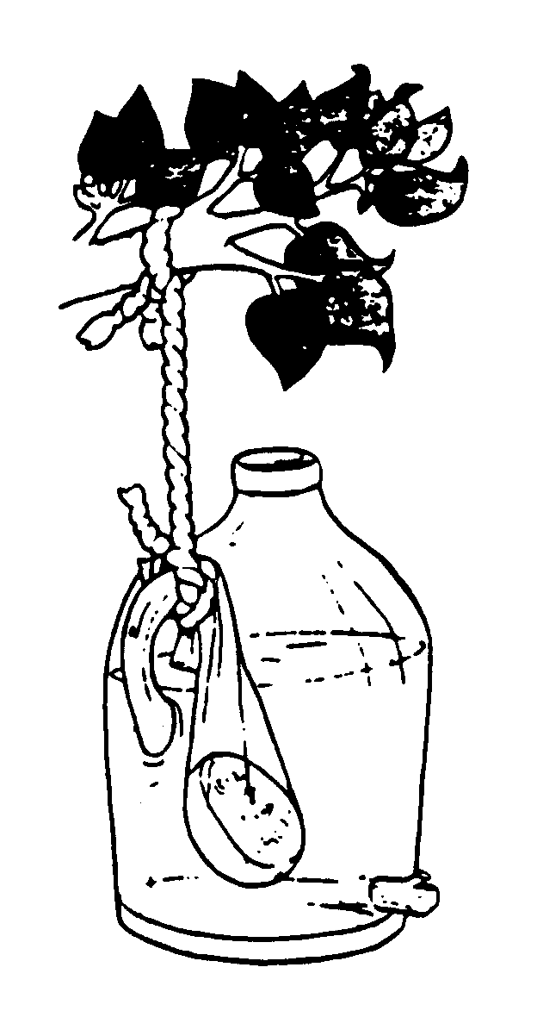
If running tap water is not available a simple hand-washing unit can be made from a plastic jug and a wooden dowel or twig. Make a small hole near the bottom of the jug. Use the twig or dowel to plug up the hole once you’ve filled the jug with water (a golf tee works very well). Place a bar of biodegradable soap in an old pantyhose leg and tie this to the handle of the jug. Now hang one of these hand-washing units near the kitchen. For better water flow, remove the cap from the jug

