Santa Clara County Council
University of Scouting
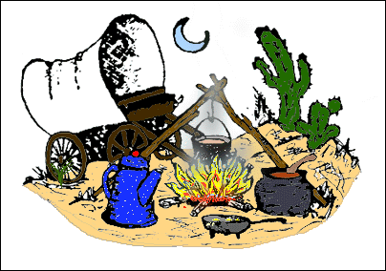
Welcome to
DOG Training Class

DOG stands for Dutch Oven Gathering
It’s where people who love to cook in Black Pot
get-together
And enjoy the art of Dutch Oven Cooking

For those of you who are new to Dutch Oven Cooking we hope this class helps to make using your Dutch Oven easier
And for those of you that have been cooking in Dutch Ovens for awhile
Please share your ideas and enjoy the gathering.
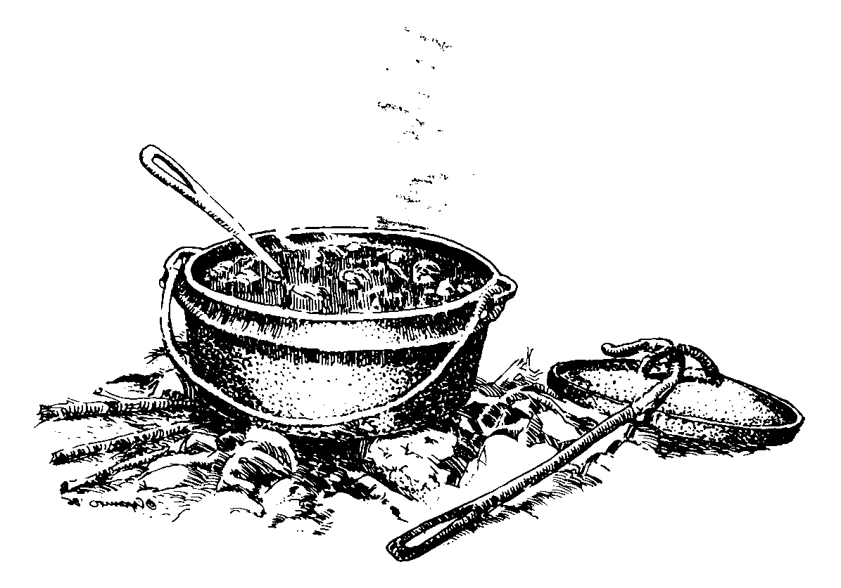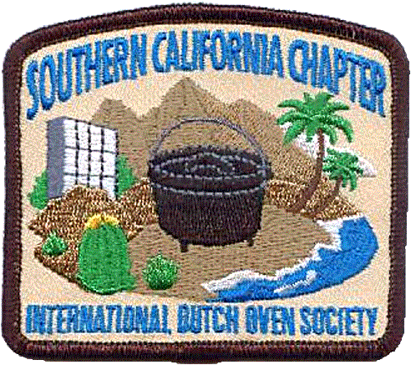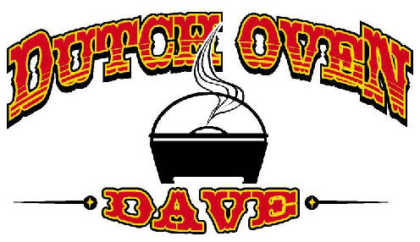
http://groups.yahoo.com/group/BADOGs/
www.LSDOS.com 1/4/2009 rev.
DUTCH OVEN TRAINING CLASS

- History of the Dutch Oven
- Are there different types of Dutch Ovens?
- Which Brand should I purchase?
- What size should I Purchase?
- What tools will I need?
- Why cook in a Dutch Oven?
- What can I cook in a Dutch Oven?
- What do I do next? Seasoning?
- Which Charcoal do you recommend?
- How do I regulate the temperature?
- How do I clean my Dutch Oven?
- How do I store my Dutch Oven?
- Bringing Cast Iron back to Life
- Safe Food Handling
- Stoves
- Links
- Stores
- Temp. Chart
- Pie Irons
- Recipes

Dutch Oven Cooking

History of the Dutch Oven
Black iron pots have been part of Americana starting with the early colonialists. So valuable were these cast iron pots, Mary Washington, mother of our first President, listed the “cast iron furniture” in her will. Black ironware was of grave importance to the day to day living of early colonialists. Many family journals and letters listed the cookware preserving life during the winter.

When Lewis and Clark started their journey to the Northwest Territory from 1803-1806, the Dutch Oven was listed as one of their most valuable pieces of equipment. The 200th Anniversary of this expedition has the general public interested in how these men survived such an arduous journey. A couple Dutch Oven companies have commemorated limited edition ovens to this historic event.

Just how did this camp cookware get the name Dutch Oven? One theory is early Dutch traders went from door to door selling the European imported cast iron pots. New England was home to many foundries, making cast iron items for every part of living. The Dutch traders peddled these items as the US expansion continued, thus giving more stock to the legend.

Another theory can be found in a book called “Dutch Ovens Chronicled, Their Use in the United States” by John G. Ragsdale (out of print). Ragsdale states that Abraham Darby traveled from England to Holland in 1704 to learn about Dutch casting methods in sand. The Dutch were casting brass parts in sand molds to mass produce vessels. When Darby returned to England, he experimented and patented a process to cast pots in dry sand. He mass produced these pots and exported them to the colonies. Ragsdale suggests that “Dutch Oven” comes from the process the Dutch were using to cast brass.

A common belief is that “Dutch Ovens” came from Pennsylvania Dutch settlers that used the black pots and kettles.

Regardless where the name originated, the Dutch Oven is part of outdoor cooking across the country. Hunters, campers, scouts, hobbyists, and even camp programs use Dutch Ovens as part of outdoor cooking.

Types of Dutch Ovens
  - Unseasoned Finish – You have to clean and season before you use it.
  - Pre Seasoned Finish – Factory Seasoned just clean and start cooking.
  - Ultimate Dutch Ovens – Used to cook over propane and many different uses.
  - Comb. Dutch Ovens – Has feet on lid and you can cook on it.
  - Bean Pots – Used to cook beans, chili and soup.
  - Regular and Deep Dutch Ovens – Reg. 3” to 4” / Deep 5” or more.
  - Oval – More option’s of things to cook.
  - Aluminum Dutch Ovens – Heats up faster, you have to watch your heat, cools down faster. You can wash it with soap and water.

Brands of Dutch Ovens
- Lodge – Made in U.S.A.
- Camp Chef- Made in China (Good Quality)
- Maca – Made in India and U.S.A. (Good Quality)
- Texsport - Made in China (Check before you buy)
- Stansport – Made in China ( Check before you buy)
- Harbor Freight – Made in China ( Check before you buy)

What size to purchase
- 5” - 1 to 2 person
- 6” – 1 to 3 person
- 8” – 2 to 3 person
- 10” – 4 to 6 person
- 10” deep – 6 to 10 person
- 12” – 12 to 14 person
- 12” deep – 16 to 20 person
- 14” – 16 to 20 person
- 14” deep -18 to 22 person
10.16” – 22 to 28 person

Needed Tools
- Charcoal Chimney – to put your charcoal in to light
- Leather Gloves - Pot holders or Pot Mittens / to protect yourself
- Lid lifter – to check food and turn oven and lid with
- Tongs – to move coal around
- Lid Holder – to set your lid on
- Table – to prepare your dish on
- Full Apron – To keep clean
- Stove – to start your coals and to make your coffee on
- Utensils – Spatula, wooden Spoons
- Whisk Broom – to clean off used coals
- Plastic Scraper – to get out stuck on food
- Paper Towels – To wipe out
- Small Scrub Brush – To clean out your DO with
- Dish Towel – To dry your hands with
- Small Shovel – To help put out fire with
- Bucket of Water – To put out fire with
- DO Bags- To transport your DO’s in

Why cook in a Dutch Oven
It’s Fun and the food tastes better

What can I cook in a Dutch Oven
Anything you cook in your kitchen at home you can cook in a Dutch
Oven. Yes anything.

How do I season my Dutch oven?
Be aware that using the kitchen oven to remove wax and season DOs
will cause a lot of smoke and you must have adequate ventilation.
Always position the DO and lid in the oven so that wax or seasoning
does not pool.
Wash new cookware with hot, soapy water and a stiff brush to remove
the wax coating the manufacturer puts on the DO to prevent rust
during shipment and storage, prior to sale. Some do not like to
scrub their DOs and burn the wax off in a self cleaning oven.
Rinse and dry completely, preferably over a campfire or in the oven
at home
Apply a thin coat of melted vegetable shortening (i.e. Crisco) to
the entire surface (including lid if applicable), both inside and
out.
Line the lower oven rack with aluminum foil (To catch any
drippings), and preheat oven to 350 °F. Some DO cooks use
temperatures of 425 to 450 °F. The higher temperatures have been
found by many to work much better.
Place cookware upside down on the upper oven rack, and bake for at
least one hour. The time also varies from cook to cook. Some heat
the DO for 1-3 hours.
Turn oven off and let cookware cool before removing from oven.
Store in a cool, dry place. If you have a lid for your utensil,
place a folded paper towel between the lid and the utensil to allow
air to circulate.
NEVER wash in dishwasher.
If your Dutch Oven develops a metallic smell or taste or shows signs of
rust, never fear. Wash with soap and hot water, scour off rust, and
re-season.
I use my Gas BBQ to do this and I do it at 425 to 450. I do this in
the evening, for about 1 to 2 hours, then let cool over night in
BBQ. Then do it again the next day, all over again. The only time
you use the soap is the first time. After that you use hot water to
clean out your DO. Dry it heat it up to 300 and put a light coat of
vegetable oil on it after that (like 2 tbls). But it doesn’t hurt to
reseason your DO every now an then.

Charcoal
There are many different makers of Charcoal (Kingsford, Royal Oak, Sams) Use whatever kind you like and stick to it (learn how long it take to start, how long it burns)

Regulate Temperature
There are many different ways to do this.
- Ring – Full ring top and bottom is about 350
- 3+ or - -take size of oven and double it, then take 3 from bottom and add to top and you will have about 350

Cleaning your Dutch Oven

First scrape out all of the food with a plastic scraper or wooden spoon. Next pour about a cup of warm water in the Dutch Oven, then use a scrub brush and scrub the bottom and sides. Pour out water check to make sure it’s clean. Add a little more water to rinse out. Wipe dry with a paper towel and pour a little oil into the bottom of the oven and wipe all over the inside of the oven and lid.

Storing your Dutch Oven

Store in a cool dry place with a paper towel draped out of the oven.
And store in a storage bag it helps to keep them clean and easy to transport.
Bringing Cast Iron Back to life

List of Equipment
1. A two to five gallon plastic (non metallic) container.
2. A two amp or larger automotive battery charger with an ammeter.
3. A moderately flat piece of iron, steel or preferably stainless steel.
4. A box of Arm and Hammer “Washing Soda” or “Baking Soda”.
5. A tablespoon measure.
6. One to five gallons of water.
7. A pair of kitchen type rubber gloves.
8. A kitchen or similar sink full of warm sudsy water.
9. A non metallic 3M type Scotch Bright Finishing Pad product #10144NA or 10119NA
10. A small tooth brush size stainless steel wire brush.

How to get started
1. The container can be any shape, size or configuration that is large
enough to hold your cast iron completely submerged. The key element here is
non-conductive (plastic) containers.
- Any power supply that provides a steady 6-24 volt dc current at 2 amps or larger will work. An inexpensive 10 amp battery charger with an ammeter is almost essential. With heavily rusted metal getting good contact to the cast iron is not easy, and the ammeter is the simplest way to tell if you have got it. Avoid using the little overnight trickle chargers.
- You need an anode for the (red) positive side of the battery charger. Best? Stainless steel is best because it deteriorates the slowest. However, most any steel or piece of iron will work. Its size in bulk is not as important as its size in surface area. Look for something about 5 inches square or what will fit your container and still not come into direct contact with your cast iron. The larger the surface area the more efficient your system will be.
- Add water one gallon at a time. After pouring each gallon into the container make a mark on the outside of the container for each gal of water you put in.
- Get yourself a box of Arm and Hammer "Washing Soda" or "Baking Soda." Using either "Washing Soda" or "Baking Soda" add about 1 tablespoon per gallon of water to your container. You now have an electrolyte solution.
- Although the solution becomes a nasty color and is filled with the residue of old rust you can continue to use it over and over again, provided you keep your anode clean.
- After adding water and Soda powder the water is hard on your hands. Wear the rubber gloves while working in and with the electrolyte. This is a general precaution. The electrolyte is not an acid nor is it seriously bad to contact your skin but precautions are always best.
- Put on your gloves and clean your cast iron in warm sudsy water using dish washing detergent. Remove any dirt, oil and grease that might retard the electrolysis.
- Clip the "positive" red lead of your battery charger to the object you've chosen for an anode and place it to the side or at one end of your container. It is not necessary that the anode be fully covered by the water but the more surface area that is available for the electrolysis the faster the process proceeds. Try to keep the red clip from your battery charger out of the solution to avoid it being eroded away with the anode.
- Clip the "negative" black lead of your battery charger to your cast iron to be cleaned and place it in the container. Be certain that you have a nice tight grip on the cast iron with the black "negative" clip. Make sure the cast iron is fully covered by the water.
- Check that the cast iron and the anode are not touching and have about 2 inches or more separation between them. If placed too close together the current on your charger will be higher than expected.
- Plug in your battery charger and note the amount of current indicated on the ammeter. Once you have applied power don't put your hands in the container. Always turn off the power before attempting to check your cast iron or make adjustments to your system.
- You will begin to see bubbles form on the cast iron and rise to the top. Small amounts of hydrogen are released as a result of the electrolysis. You will notice while using your system just how small this amount of gas is. However to avoid a concentration of hydrogen, never cover the container while in use. Although minute, the hydrogen is flammable and do not operate this system next to your water heater, stove or other open flame.
- Once the rust has turned to a dark gray or black it's time
to remove your cast iron and wash it in warm soapy water using the Scotch Brite pad and a small tooth brush sized stainless steel wire brush to remove the residue in the hard to get to places. If the cast iron comes completely clean you're done. If not, place it back in the container for another session. Dry your cast iron thoroughly and proceed to the next step.
- Freshly cleaned cast iron will immediately begin to rust again so it is important that you immediately season your cast iron.

Things to watch for
- If a brown or green "crud" begins to form and float to the top around the anode this perfectly normal. For as long as the anode lasts you will need to occasionally remove it and clean off the crud that forms on it.
- Do not leave your cast iron in the container any longer than necessary. Unless heavily rusted most cast iron cleans up in few hours.
- If the current is too high, increase the distance between the anode and your cast iron, reduce the amount of anode in the container (Lift it out slightly), reduce the operating voltage or increase the current range of the battery charger setting.
- If you don't see an immediate reaction beginning in your container when you plug in the battery charger, check all of your connections carefully. It can be difficult to get a good electrical connection on a heavily rusted piece of cast iron. This is where the ammeter on your battery charger comes in handy. You can tell at a glance if you have a good connection on your cast iron. The bubbling action should start immediately after power is applied.
- If the cast iron in your container appears to be eroding instead of de-rusting verify that you have the battery charger polarity correct. The cast iron must always be connected to the "negative" black terminal.
- As for the disposal of the nasty water after use, you can save it and continue using it by replenishing the water as it evaporates. Or, you can pour in on your lawn. The grass loves the iron rich water and does not seem to suffer from the other contents.

http://www.rickswoodshopcreations.com/Miscellaneous/Rust_Removal.htm

SAFE FOOD HANDLING

Food Safety While Hiking & Camping

Hiking and Camping in the outdoors can be a lot of fun. These activities can be just a Day Hike or a Week long Backpacking outing.
If the food is not Handled correctly, foodborne illness can be an unwelcome guest.

- Keep Hot Food Hot & Cold Food Cold
Most Bacteria do not grow rapidly at temp. below 40 degrees or above 140 degrees.
The temp. range in between is known as the “DANGER ZONE”. Bacteria can reach dangerous levels within 2 hr.
To enjoy the great outdoors, there are some food safety principles you must follow. The first is “Keep hot food Hot and cold food Cold”. Meat and poultry must be cooked to destroy the bacteria and keep at a temperature that is either too hot or too cold for the bacteria to grow. Traveling with food, bring a cooler with a cold source (ice or Dry ice). Make sure you have a stove or a campfire if you are going to be cooking.
- Keep Everything Clean
Cross-contamination is when you handle food and get juices transferred to other foods (by hands, dripping packages or utensils). Double wrap or place in plastic bags to prevent products from dripping on other food. Always wash your hands before and after handling food. Don’t use the same utensils for raw and cooked meats. If you are going somewhere that dose not have water, bring your own. Soap and water are essential to cleanliness; even disposable wipes are good to have.
- Food Safety While Hiking & Camping
If you are hiking for just a few hours a meal and a few snacks is all you need. Planning meals for a longer hike requires more thought and planning. You have to choose foods that can be transported safely and are light enough to carry in a backpack.

- Hot or Cold?
Since it is hard to keep food hot, it is best to transport cold food. Freeze or refrigerate the food the night before. Freeze some box drinks and they will thaw as you hike and keep your food cold at the same time.
- Clean
Remember to keep everything clean, so bring disposable wipes.

- Safe Drinking Water
Bring bottled water or tap water if you are not sure about the water supply where you are going. The safest way to make water usable is to boil it. Bring it to a rolling boil and continue boiling for 1 minute. An alternative to boiling water is to use purification tablets and water filters. Purification tablets do not kill all bacteria; you must use a water filter also. These filters must be 1 micron absolute or smaller. Over time purification tablets lost their potency, so keep a fresh supply. Water sanitizing tablets for dish washing can also be purchased (just don’t confuse the two).
- What Foods to Bring?
If you are backpacking for more than a day it gets a little more complicated. You can still bring your cold food for the first day, but you need you pack items that can last longer without being kept cold now. Like: peanut butter; juice boxes; canned tuna, ham, chicken and beef; dried soup and noodles; dehydrated foods; dried fruits and nuts; beef jerky and other meats; fruit drinks and powdered milk. Powdered mixes like pancakes or biscuits are easy to carry. Also pre package any other foods that you can and only take what you need.
- Cooking at Camp
After you have your menu, you need to plan how you are going to cook it. Are you going to cook over a campfire of on a Camp stove? Make sure you bring the equipment you need to do your cooking on and in (pots and pans). Leftover food should be burned or packed out with you.

- Use a Food Thermometer
If you are cooking meat and need to know when your food is done, use a digital thermometer. It can be tricky if you are cooking in the evening. A thermometer determines the temperature of food by averaging the temperature along the stem and should be inserted
2 to 2 ½” into the food. Be sure to clean it after each use.
- Keeping Cold
If you are “Car Camping” you don’t have as many restrictions. First you can bring a cooler. Remember to pick a cooler you can handle, Because when filled they can weigh 30 to 40#. To keep food cold you will need some kind of ice (block, cubes, gel-foam, Dry Ice). Pack food in reverse order. First food packed will be last food used.
(One exception: pack meat near the bottom to keep it cold and from dripping on other food) At the campsite cover the cooler with a blanket or tarp.
- Cleanup
Whether camping in an established site or hiking, you will be washing dishes or cookware, there are some rules to follow. Use soap sparingly, and keep it out of the rivers, lakes or streams, as it will pollute. Wash your pots and pans at your campsite not at the water’s edge. Dump dirty water on dry ground, well away from fresh water. Some camper use baking soda to wash with. Pack disposable wipes for hand and quick cleanups.
- Keep Your Cooler Cool
It is important to keep your cooler closed and out of the sun. If you can bring two coolers: one for drinks and snacks, and another for food. Pack your coolers with a few inches of ice.
- Keep Cold Foods Cold
Foods like lunch meats, cooked chicken, potato or pasta salad, should be kept in a cooler. Remember the rule:
hot foods hot, cold foods cold?
And the 2 hour rule: no food should be in the “DANGER ZONE” for more than 2 hours?
Of course, some foods don’t need to be in the cooler: fresh fruits, vegetables, nuts, trail mix, canned meat and Peanut Butter and jelly. (Once canned foods are opened, then put them in the cooler)

- General Rules for Outdoor Food Safety
Plan ahead: decide what you are going to eat and how you are going to cook it;
then plan what equipment you will need.
- Pack safely: use a cooler if car-camping or pack foods in frozen state with a cold source if hiking or backpacking. Keep raw foods separate from other foods. Never bring meat if you don’t have a way to keep it cold and safe.
- Bring disposable wipes or bio. Soap for hand washing and dish washing.
- Plan on carrying bottled water for drinking. Otherwise boil water or use purification tablets.
- Do not leave trash in the wild. Pack it in, Pack it out. Leave no trace.
- If using a cooler, leftover food is safe only if the cooler has ice in it. Otherwise discard leftover food.
- Protect yourself and your family by washing your hands before and after handling food.

Top 10 Reasons to Handle Your Food Safely

# 10: Safe food handling practices are the ones most likely to preserve food’s peak quality.

Keeping hot food hot and cold food cold inhibits growth of the microorganisms that can spoil your food or make you ill. Storage at proper temperature also retains the fresh appearance, pleasant aroma and agreeable texture that contribute so strongly to an enjoyable dining experience.

#9: Safe food handling lets you enjoy to the fullest the nutritional benefits of food. If you’ve taken the time to carefully select a variety of healthful foods, why not use them up--or properly preserve them for long-term storage—while nutrient levels are at their peak? Foods that must be discarded due to decay or temperature abuse nourish no one.

#8: The safest ways to handle food are usually the most efficient.

Don’t take chances in the name of saving time. Thawing meat and poultry products at room temperature and partial cooking are examples of practices which can seem like good ideas, But that may actually encourage bacterial growth by keeping food in the “DANGER ZONE” (40-140F) where bacteria multiply fastest. In the case of bacteria that produce heat-resistant toxins, this becomes a problem that further cooking can’t fix.

#7: Safe food handling is easy. You set a good example for others, including your children.

You are the last person to handle your food before it is eaten. You may be the last person to handle food before it is served to your family or friends. Take charge! Prevention of illness may be as simple as washing your hands—an often-neglected but VERY important act.

#6: Safe food handling inspires confidence and keeps peace in the family. Imagine: No more family feuds because someone handled dinner in a questionable fashion. And family or friends won’t call the Meat and Poultry Hotline begging to have food safety literature mailed to your address!

#5: Safe food handling can enhance your standing in the community. Food for a concession stand, bake sale or church supper must be carefully prepared. Many of those in your community are very young, elderly or suffering from health problems that affect the immune system. These folks are at risk for foodborne illness. Protect their health and the reputation of your organization.

#4: Safe food handling is the responsible thing to do.

Those for whom you prepare food deserve the best, and you expect no less from those who produce and prepare food for you. You are no less important than the manufacturer, government regulator, or grocer in assuring food safety. You are an important link in the farm-to-table chain.

#3: Safe food handling save money.

Foodborne illness cost billions each year in health care costs and lost wages. It’s hard to throw away food you know has been mishandled. But compare the cost of the food to the cost of a bad case of food poisoning, starting with the doctor’s bill!

#2: By handling food safely, you will spare yourself and your family from a painful bout of illness.

Bacterial, parasitic or viral illness caused by food is no fun, and it can have long-term consequences.

Should we fear food? No. Microscopic organisms have always been and will always be an important part of our world. But we must store foods properly, cook them thoroughly and keep our hands and work areas clean. Sometimes, what you can’t see can hurt you.

This brings us to the #1 reason to handle your food safely:
It may save a life.

Stoves

The increased popularity in nature pursuits, there has been much environmental impact on our lands. For this reason it is suggested to use fewer fires and more stoves for cooking. Campfires tend to leave a bigger impact on the natural environment and are discouraged especially in areas that have no designated campgrounds with fire rings already established.
There are two main types of stoves. They are determined by the fuel they burn. If you are traveling to higher altitudes and colder temperatures then white gas stoves are the best choice. They bring water to a boil fast and work well even in snow, although they do require priming, or warming up. Propane and butane fuel stoves take no priming and are much simpler to use. Not being able to work as effectively in higher altitudes and colder temperatures is a major draw back. Plus butane/propane stoves leave empty gas canisters that are non-refillable and usually are not recycled making for much more environmental damage.
 | White Gas Stoves | Butane/Propane Stoves
Advantages | Works well at high altitude  Works well in cold temperatures  Fuel canisters are refillable | Fuel canisters are readily available in U.S.  Easy to use, no priming  Cost Less
Disadvantages | Not all white gas stoves can use more than one type of gas, limiting its use when traveling  Requires priming | Less environmentally friendly  Does not work well in cold  Does not work well at high altitude

Dutch Oven Links

Lone Star Dutch Oven Society – www.lsdos.com

International Dutch Oven Society – www.idos.org

Bay Area Dutch Oven Gypsies – http://groups.yahoo.com/group/BADOGs/

Southern California Chapter, IDOS – www.socaldos.org

Western New York Chapter, IDOS – www.nydos.com

Lodge Manufacturing – www.lodgemfg.com

Camp Chef – www.campchef.com

Maca Supply – www.macasupply.com

Cee Dubs - www.ceedubs.com

Byrons Dutch Oven Cooking – http://papadutch.home.comcast.net

Dutch Oven Dave – www.dutchovendave.com

Dutch Oven Boxes - www.buffalowoodworks.com/dutch_oven_stuff.htm

Chuckwagon Supply - www.chuckwagonsupply.com

Steven Karoly Blog - http://roundthechuckbox.blogspot.com/

Dutch Oven Cooking - http://groups.yahoo.com/group/dutchovencooking/

Camp Cooking with dacapn - http://groups.yahoo.com/group/campcookingwithdacapn/

USDA – http://www.fsis.usda.gov/

Rust Removal – http://rickswoodshopcreations.com/Miscellaneous/Rust_Removal.hmt

Cast Iron Cooks of the West – http://castironcooksofthewest.blogspot.com/

Some Stores That Carry Cast Iron Dutch Oven’s
and Accessories

Mel Cotton’s
1266 W. San Carlos St.
San Jose, Ca. 95126
(408) 287-5994

REI ( online only)
400 El Paseo De Saratoga
San Jose, Ca. 95130
(408) 871-8765

Outdoor World
136 River St.
Santa Cruz, Ca. 95060
(831) 423-9555

South Bay Scout Shop
970 W. Julian St.
San Jose, CA. 95126
(408) 279-2086

Sportsman’s Warehouse
6640 Lonetree Blvd
Rocklin, CA 95765
(916) 782-9900

Bass Pro
1356 Bass Pro Drive
Manteca, CA 95337
(209) 825-8400

DUTCH OVEN CHARCOAL & TEMPERATURE CHART

Temp. | 8 inch |  | 10 inch |  | 12 inch |  | 14 inch |  | 16 inch
°F | Top | Btm. | Top | Btm. | Top | Btm. | Top | Btm. | Top | Btm.
300° | 9 | 4 | 12 | 5 | 15 | 7 | 19 | 9 | 21 | 11
325° | 10 | 5 | 13 | 6 | 16 | 7 | 20 | 10 | 22 | 12
350° | 11 | 5 | 14 | 7 | 17 | 8 | 21 | 11 | 24 | 12
375° | 11 | 6 | 16 | 7 | 18 | 9 | 22 | 12 | 24 | 13
400° | 12 | 6 | 17 | 8 | 19 | 10 | 24 | 12 | 27 | 13
425° | 13 | 6 | 18 | 9 | 21 | 10 | 25 | 13 | 28 | 14
450° | 14 | 6 | 19 | 10 | 22 | 11 | 26 | 14 | 30 | 14
500° | 15 | 7 | 20 | 11 | 23 | 12 | 28 | 14 | 32 | 15

If Baking, remove from bottom heat after 20-25 minutes.

If using a Deep Dutch Oven you will need to add more charcoal to the top. Because you have more air space to heat.

Rotate the Lid clockwise 1/4 turn and the Pot counter-clockwise 1/4 turn every 15 minutes.

Wind or Cold Temperatures may and usually will require additional charcoal.

Almost anything you can cook at home in or on your stove you can cook in a Dutch Oven. Use your imagination. Everything you cook always tastes better when you’re camping and eating in the Great Outdoors.

Have Fun and enjoy your Dutch Oven.

What is a Pie Iron

A Pie Iron is made from cast iron or cast aluminum, they are a two-piece pan with a long handle. To use it you fill one side with the ingredients and then close the second side on top of the first and then simply put into the campfire for about 4 minutes, turning occasionally. You can use Bread, pie dough or hit the counter biscuits. Butter 2 slices and place one slice, butter side down on the bottom pan, add the filling and then place the second slice butter side up and close.
Fruit Pie
Use any canned pie filling; apple, cherry, and peach are delicious. Place filling between your choice of bread as per our basic direction. Grill until golden brown. Sprinkle with sugar and serve.
Rocky Road Treat
Spread peanut butter on 2 slices of bread. Add one large marshmallow and one chocolate bar square between buttered bread slices/ Toast in cooker until bread is golden brown.
Pizza Pie
Place slice of pizza crust in cooker cavity, add tomato puree, green peppers, slivered garlic, oregano, mozzarella cheese and top with pepperoni. Cover with second slice of pizza crust. Grill 3 or 4 minutes on each side or until desired doneness is reached. English muffins or sliced bread or pita can be used in place of pizza crust.
Hot Ham and Cheese
Place slice of bread, buttered side down, into cooker. Place slice of ham and slice of cheese on bread. Add Dijon mustard and cover with remaining slice of bread, buttered side up. Close cooker, latch handles and grill to golden brown.
Sloppy Joes
Use canned, pre-cooked sloppy joe mix or make your own mix with hamburger, barbecue sauce and onion. (Meat must be precooked.) Place mix between buttered bread and cook over low heat until hot and toasty.
French Toast
Dip 2 bread slices into egg batter, place both slices into cooker, placing strawberry jam between bread slices. Toast until browned.
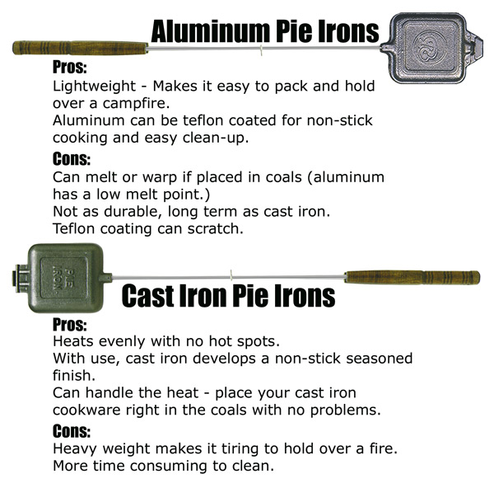

Peach Cobbler

For the Peach cobbler:
2 or 3 Cans 16 oz. size Sliced Peaches
2 tablespoons cornstarch
¼ cup all purpose flour
1 tablespoon Vanilla
1/2 cup Sugar
½ cup Brown Sugar
2 teaspoons fresh lemon juice
1/2 teaspoon ground cinnamon
1/8 teaspoon Ground Cloves
1/8 teaspoon Ground Ginger
4 tablespoons butter

In a 12” D.O. Mix everything together with full spread of coals under D.O., mix in the peaches last
Then remove from heat to add cake mix

For the Topping:

Betty Crocker Cake Mix (Cinnamon Swirl)
Or one box Yellow or White cake Mix and ¼ cup Sugar mixed with 2 tablespoons Cinnamon

Take cake mix and spread some over peach mix then sprinkle cinnamon mix over cake mix in layers
Take ¼ # butter cut into pieces and place on top of cake mix all over.

To Cook:

Arrange coals around the outside Bottom of D.O. (about 9 coals) also about 1 “out. Place 2 coals in the middle.
Arrange coals around top outside edge of D.O. (about 15) also put 4 more in the middle around the handle.
Every 15 min. pick up D.O. and turn clockwise ¼ turn then turn back the lid ¼ turn counter clockwise.
After cooking for 30 min. remove from bottom heat and cook for 15 more min. top heat only.

Let cool 15min., Dig in and enjoy.

Super Easy Beef Mac Dinner

2 lb. Ground Beef
½ c. Chopped Onion
1 (28oz.) can Diced Tomatoes
2 (8oz) can Tomato Sauce
1 ¼ tsp +-. Chili Powder
1 tsp. +- Salt
¼ tsp. +- Cayenne Pepper
1 (12oz) can Corn (undrained)
1 bag (16oz). Elbow Macaroni (uncooked)
1 c. +- Water
8 oz. Monterey Jack Cheese, shredded

In a 12” Dutch Oven, brown ground beef and onion (over full spread of coals): drain fat. Stir in diced tomatoes, tomato sauce and seasonings to your taste. Heat to boiling (over full spread of coals). Add corn, macaroni and water. Bring to boil (over full spread of coals).Reduce heat and simmer (9 coals under, 2 middle and 7 on outside edge) for 20 minutes until macaroni is tender. Stir and add water if needed you don’t want it to get to dry and burn. Sprinkle with cheese, cover for 5 minutes until cheese melts (place a few coals on lid to help melt cheese). Enjoy

This is from:
Barbara Anderson
of Southern California Chapter of IDOS
From the cookbook Sharing Our Favorites

Dutch Oven Biscuit Thing.

40 biscuits in a 10"
60 biscuits in a 12"
80 biscuits in a 14"
120 biscuits in a 16'

Buy Tube Biscuits. The kind you whop on the counter to open. Flakey
Biscuits work best. You can also do this with Cinnamon Rolls.
Melt ½ stick of Butter in the Dutch Oven first. Open Biscuits or Rolls and stand them on Edge, starting around the outside of the
Dutch Oven. Filling the Center in last. I don’t pull each biscuits
apart.
Place little pats of Butter over the Top of Biscuits or rolls before cooking. Remember to Rotate Lid & Bottom of oven often
to keep from burning. Bake at 350 Degrees. It takes about 45 min to
bake, Give or Take a Few minutes. Pass them out. Cheep way to
entertain a crowd. Server with Butter & Jelly or iceing. I do 40 in a 10" all the time.
Wishbone-Ks

Richard "cookiE." Smith
thecleanersstore@sbcglobal.net
1(408) 483-6825
Bay Area Dutch Oven Gypsies of the Lone Star Dutch Oven Society, Chapter Advisor
http://groups.yahoo.com/group/BADOGs/
Far North Member of Southern California Chapter of IDOS
IDOS Member
Advisor for Venturing Crew 501 of Los Gatos, Ca.
ASM for Troop 501 of Los Gatos, Ca.
Fox Patrol, Woodbadge WE3-31-07
Mel Cottons Sporting Goods Camping Department

