Webelos Scientist Activity Badge

Technology Group
A scientist tries to find out the laws of nature about the things that they study. Scientists spend much their time experimenting, asking questions and finding out the answers.

IDEAS FOR DEN ACTIVITIES
- Visit a weather station.
- Visit a chemistry or scientific department at your local college.
- Visit an emergency weather center.

EXPERIMENTS AND ACTIVITIES

BIGGEST BALLOON
Materials: Pop bottle, balloon, vinegar, baking soda
Instructions: Into each pop bottle put three tablespoons of vinegar, and into each balloon put two tablespoons of baking soda. At the word “go”, have each boy put his balloon on his pop bottle. When the soda mixes with the vinegar the balloon will expand. Have the boys tie off the balloons to see which is the largest. Do this outside!
(Vinegar combined with baking soda produces carbon dioxide gas.)

STATIC ELECTRICITY
Charge a plastic comb by rubbing it with wool, nylon or fur. Dip it into some crispy rice cereal. They will be attracted to the comb. But watch closely – one by one the bits will shoot off, as if shot from a gun. The same molecules that attracted one another are now opposing each other.

AIR PRESSURE EXPERIMENT
Materials: Two drinking straws, small bottle filled with water
Have a boy put both straws in his mouth, with one straw in the water and the other straw outside of the bottle. Now ask him to suck water out of the bottle. He can’t – because the air pressure in his mouth is equalized by the air coming in through the outside straw.

AIR PRESSURE EXPERIMENT #2
Materials: a strip of paper (4” x ½”), a piece of tape, a large bottle
Place the bottle approximately 2-4” from the edge of a table. Fold the paper ½” from the end and tape the folded end to the table about 3” behind the bottle. Blow directly at the bottle and watch what happens to the paper. Try varying how hard you blow. What does the paper do?
If you blow just hard enough, the paper will flutter... even though it is hidden behind the bottle! Moving air does not follow a straight line (like light waves) and will bend around curved surfaces. Your breath is deflected by the bottle by some of the air bends around the bottle hitting the paper.

INERTIA DEMONSTRATION
Materials: Glass jar, wooden hoop, coin, see comments for other suggestions
Procedure: Balance the hoop over the mouth of the jar. Balance the coin on top of the hoop. Now, sharply strike the side of the hoop, the coin will fall into the jar.
Hints: An embroidery hoop works well for this demonstration. Hit the hoop on the side far away from you exactly ½ way from top to bottom. A narrow mouth jar works best because there is less “lift” to the coin as the hoop is knocked out.
Comments: If the hoop is knocked out quickly the inertia of the coin prevents lateral motion. This is very dramatic when dropping a dime into the neck of a 2 liter bottle off of a 10” hoop. (This can be done if you fill the bottle ¾ full of water so the inertia of the water keeps the bottle steady and the coin is exactly on top of the hoop.) Try hitting the hoop with a ruler for better control. It probably won’t make it every time, but practice makes better!

INERTIA DEMONSTRATION #2
Materials: Brick, stick, string (about 2 feet)
Procedure: Tie one end of the string around the middle of the stick for a handle. Tie the other end of the string to the brick. Slowly raise the brick. Now, repeat pulling the string fast enough to break the string.
Hints: Using a handle to pull string will prevent string cuts to the hand. Use a very weak string or even sewing thread to prevent flying bricks. String should be just long enough to reach from the floor to just below the shoulder height of the puller.
Comments: On a slow pull, the inertia of the brick is overcome gradually and the string won’t break. On a fast pull, greater force is applied to the string and it breaks. Acceleration is greater when you pull faster.

INERTIA DEMONSTRATION #3
Swing a pail of water back and forth at arm’s length. After a few times, swing it over your head in a full circle. What happened? Why?

PASCAL’S LAW DEMONSTRATION
Materials: 2 liter plastic bottle with screw on cap, medicine dropper, water
Fill 2 liter bottle level full with water. Fill medicine dropper nearly full with water and put medicine dropper in the bottle. Tightly close the cap of the bottle. When you squeeze the bottle, the dropper will sink, release the bottle and the dropper will rise.
Comments: The tricky part of this is getting just the correct amount of water in the medicine dropper. You can check it before putting it in the bottle by floating it in a pan of water. It must just barely float. If it floats too high, add more water to the dropper. If it sinks, take some water out of the dropper. There must always be some air in the rubber cap for it to work so if you use a plastic dropper you may have to put a few BBs in the dropper for “ballast.” Glass droppers are usually heavy enough without adding BBs. The higher the dropper floats, the harder you have to squeeze to make it sink. When the dropper is added to the full bottle, some water will overflow; it is important that the only air in the bottle is in the rubber cap of the dropper. If you tip the bottle upside down, the air bubble will escape from the dropper and it will permanently sink. If this happens, just start over.

BERNOULLI’S PRINCIPLE
Materials: 3” x 5” index card
Slightly bend the card lengthways (so that it forms an arc) and lay it on a table. Try to overturn the card by blowing underneath it. No matter how hard you blow, the card will not rise from the table.
The pressure of a gas (in this case, air) is lower at higher speed. By blowing under the card, you create a lower pressure underneath so that the normal air pressure on top of the card actually presses the card to the table! The harder you blow, the more the air pressure on top presses down! This is a principle used in flying airplanes.

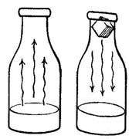
FOG
Materials: hot water, bottle, ice cube
Fill a bottle with hot water. Then pour out most of the water. Leave about 1” of water in the bottom of the bottle.
Hold the bottle to the light. Notice the streams of vapor rising from the bottle.
Put an ice cube in the bottle opening. Hold the bottle toward the light. Notice the thin streams of vapor moving down into the bottle. This is fog.

BALANCE ‐ SPLASH
When a boat is over loaded, it will turn over and everyone gets wet. Make and play this game, but you won’t get wet.
Materials: small box that pudding or gelatin comes in, long pencil, several pennies or dimes per boy
1. Close the emptied box and tape the ends shut.
2. Cut off one of the large sides of the box. (See figure 1).
3. Take the large side just cut off and cut it as in figure 2 so that it can fit inside the rest of the box as in figure 3.
4. Cut out on the narrow sides two notches as shown in figure 4.
5. Tape the cut out large side to the pencil. (See figure 5). Turn the pencil over and place in the notches of the box. (See figure 6).
6. You’re ready to play.
Have each player take turns in putting a penny (or dimes – they’re lighter) on the deck. Keep the pennies close to the pencil. When the deck spills the pennies into the box, the game is over. Another way to play is to have each player put his pennies on one at a time and then the winner would be the one who balances the most pennies. Do not use the other hand.

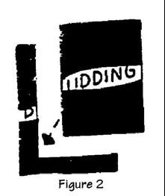
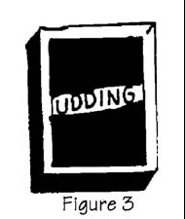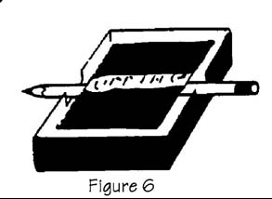

More on the Scientist Activity Badge
Remember the Scientist Activity Badge is a "doing" badge, not a "watching" badge.
For best results, follow this procedure:
- Demonstrate the experiment.
- Explain the experiment.
- Ask questions to test understanding.
- Allow Webelos to do tile experiment.
- Have each boy log the experiment.
- Have each boy explain tile experiment.
- Ask again for questions

What does a scientist do?
A scientist studies things to learn how they behave and why.
Scientists try to find out the laws of nature about the things they study. People can use these rules or laws in making things.
While working on this activity badge, you will learn a few of the main ideas in physics. Physics is a science with several branches.
One of these branches will be weather. You can learn a little about weather in these activity badge requirements.
Another branch of physics is called optics. You will have a chance to learn something about sight and find out how your eyes work.
Scientists learn a lot by experimenting or trying things out. Try things for yourself.
Scientists take nothing for granted.
They may be sure an idea is true, but they always test it, if possible, to make certain they are right.

Scientists And Engineers
Aren't they the same thing? Not quite. Though they use many of the same ideas and methods, scientists and engineers are somewhat different.
What do scientists want? Scientists want to know how the universe works. They may see it as an enormous jigsaw puzzle to solve for its own sake. Some things they find are useful right away, others not (though much of what scientists have found in the past has turned out to be useful in some way). Though they certainly want to help people, their major goal is understanding, not usefulness.
What about engineers? Engineers try to use the facts of science and math to do things that are useful to people. Many engineers are designers -- designing the many products that we use in the world, from computers to cars to camera lenses.
What do they have in common? Quite a few things, actually. Scientists and engineers both use the facts and methods of science, and both often use MATH and COMPUTERS in their work.

Activities

PENDULUM PHENOMENON: An Optical Illusion
Fasten a white disc, 3/4-in diameter on a 3 foot piece of white thread. Have someone hold the thread so the disc can swing like a pendulum. Start the disc swinging in a perfectly straight line and view it from a distance of three feet against a plain wall. Notice how the disc swings in a line like a pendulum. Hold a sunglass lens over one eye. Observe the path of the swinging object again. The movement will no longer be in line but in a circle. If you switch the lens to the other eye, the movement will appear to be in the opposite direction.
Principle demonstrated: Shows how important it is for the eyes to receive similar images.

HYDROMETER
This measures the density of a liquid. An object can float in a liquid only if it is less dense than the liquid. Prove this by placing a fresh egg in a glass of water. The egg will sink. Then add 1 tablespoon of salt to the water and the egg will float. Try sticking a thumbtack into a pencil eraser and place the pencil in water, point up. Mark the waterline on the pencil. Add salt to the water. The pencil will ride higher in the water. WHY? BECAUSE SALT WATER IS MORE DENSE!

PASCAL'S LAW
"The pressure of a liquid or a gas like air is the same in every direction if the liquid is in a closed container. If you put more pressure on the top of the liquid' or gas. the increased pressure will spread all over the container."
A good experiment to demonstrate air pressure is to take two plumber's force cups (plumber's friend) and force them firmly against each other so that some of the air is forced out from between them. Then have the boys try to pull them apart.
When you drink something with a straw, do you suck up the liquid? No! What happens is that the air pressure inside the straw is reduced, so that the air outside the straw forces the liquid up the straw. To prove this fill a pop bottle with water, put a straw into the bottle, then seal the top of the bottle with clay, taking care that the straw is not bent or crimped. Then let one of the boys try to suck the water out of the bottle. They can't do it! Remove the clay and have the boy put two straws into his mouth. Put one of the straws into the bottle of water and the other on the outside. Again he'll have no luck in sucking water out of the bottle. The second straw equalizes the air pressure inside your mouth.
Place about 1/4 cup baking soda in a coke bottle. Pour about 1/4 cup vinegar into a balloon. Fit the top of the balloon over the top of the bottle, and flip the balloon so that the vinegar goes into the bottle. The gas formed from the mixture will blow the balloon, up so that it will stand upright on the bottle and begin to expand. The baking soda and vinegar produce C02, which pushes equally in all directions. The balloon that can expand in all directions with pressure, will do so as the gas is pressured into it.
For this next experiment you will need: A medicine dropper, a tall jar, well filled with water; a sheet of rubber that can be cut from a balloon; and a rubber band. Dip the medicine dropper in the water and fill it partly. Test the dropper in the jar - if it starts to sink, squeeze out a few drops until it finally floats with the top of the bulb almost submerged. Now, cap the jar with the sheet of rubber and fix the rubber band around the edges until the jar is airtight. Push the rubber down with your finger and the upright dropper will sink. Now relax your finger and the dropper will rise. You have prepared a device known as a 'Cartesian Diver'. The downward pressure on the rubber forces the water up into the bottom of the diver, compressing the air above it, producing the effects of sinking, suspension and floating, according to the degree of pressure applied.

DANCING RAISINS
Fill a 12 ounce glass three fourths full of water. Add a tablespoon of baking soda and stir until clear. Drop raisins into the glass. Pour vinegar into the glass. Use as much vinegar as it takes to make the raisins come to the top of the water. Bubbles will appear, and the raisins will "dance."
Mixing vinegar and baking soda together forms a gas called carbon dioxide. Bubbles of carbon dioxide stick to the sides of the raisins, act like air bags, and float the heavy raisins to the surface. At the surface the bubbles break, the raisins sink again, and the process starts all over.

CHARCOAL CRYSTAL GARDEN
This is the classic way I did it when I was a wee lad. Colorful, small, delicate crystals grow on a charcoal or brick surface. You can also use pieces of sponge, coal, or crumbled cork to grow the crystals on. Crystals are formed because the porous materials they grow on draw up the solution by capillary action. As the water evaporates on the surface, deposits of solids are left behind, forming the crystals. As more solution is drawn up, it passes through the crystals that have already formed, depositing more solids on their surfaces, causing the crystals to grow.

FLOATING EGG SALTY MAGIC
The salt water of the seas is much denser than the fresh water of rivers and lakes, and therefore it is easier to float in the ocean. Show this by filling two glasses half full of water. In one of them, mix in about 10 heaping teaspoons of salt.
Try floating an egg in each glass. In which glass does the egg float?
Now take the eggs out of both glasses. Carefully and slowly, pour the fresh water into the salt water glass. Gently lower an egg Into the water. It should float (remain suspended) at the salt water level

BERNOULLI'S PRINCIPLE
MATERIALS:
two Ping-Pong balls,
two feet of thread,
some mending tape and
a drinking straw.
PROCEDURE: Tape each ball to an end of the thread. Hold the center of the thread so that the balls dangle about one foot below your fingers and about one or two inches apart. Have the boys’ blow through a straw exactly between the balls, front a distance of a few inches. Instead of being repelled, the balls will be attracted to each other.
EXPLANATION: The air current directed between the Ping-Pong balls reduces the intervening air pressure. Stronger pressure from the far sides pushes the balls together. The strength of the air from the straw will determine how close the balls will come

FOAMING FOUNTAIN
Place two teaspoonfuls of baking soda in the bottom of a quart glass bottle. Drop a burning match into the bottle. It will continue to burn. Next pour four teaspoonfuls of vinegar on top of the baking soda, being careful not to pour directly onto the match. Watch what happens. The seething, foaming mass is carbon dioxide, released from the soda by the vinegar.
What happens now to a lighted match? Why? Is carbon dioxide gas heavier than air? Than oxygen? Tip bottle slowly over it lighted candle. What happens? The heavy gas can even be poured so the flame flutters and may go out. This is the principle behind some fire extinguishers.

BATTERY
Alessandro Volta, an Italian physicist, produced electricity by chemical reaction in 1800. He did this with a device that became known as a voltaic cell. It was the first wet cell battery. Volta's battery was made with pairs of zinc and silver pieces. The electric current ran from the zinc to the silver through pieces of board soaked in salt water. You can make your own simple voltaic cell.
MATERIALS:
piece of copper wire
fresh lemon
paper clip.
PROCEDURE:
Straighten out the paper clip and copper wire. They should be about the same length.
Thrust both wires deep into the lemon. They should be side by side, but not touching.
Put the free ends of the wires to your tongue. The slight tingle and metallic taste you feel is due to the passage of electrons through the saliva on your tongue. The acid in the lemon acted as an electrolyte. An electrolyte is a substance that is not metal that carries electricity. The chemical reaction caused electrons to build up on one of the wires and decrease on the other wire.
CONCLUSION:
When you put the free ends of the wires to your tongue, you closed the circuit between the two wires. Electrons flowed from the wire with more electrons, through your saliva that acted as a conductor, to the wire with fewer electrons. The entire system of lemon, wires, and saliva is a simple battery. It is similar to the first battery made by Alessandro Volta.

ATMOSPHERIC PRESSURE
We live under a blanket of air called the earth's atmosphere. The air in the atmosphere exerts pressure of almost fifteen pounds per inch on every surface of earth.
Hanging Water - Fill a glass to overflowing and lay a piece of cardboard atop it. Support the card with one hand, turn the glass upside down, and remove your hand from the card. The card does not fall. It remains on the glass and allows no water to escape. Why? The air pressure from below the cardboard is greater than the pressure of the water above and presses the card tightly against the glass.

THE BEAUFORT WIND SCALE
The Beaufort Wind Scale was originally devised by Sir Francis Beaufort to describe wind speed in chart form. By watching the effect of wind on objects in the neighborhood, it is possible to estimate its speed.
Copy the scale on a large sheet of cardboard and hang it in your den meeting place.

#  0  1  2  3  4  5  6  7  8  9  10  11  12 | Title Effect of Wind  Calm Smoke rises vertically  Light Air Smoke drifts  Light Breeze Leaves rustle  Gentle Breeze Flags fly  Moderate Breeze Dust, loose paper  raised  Fresh Breeze Small trees sway  Strong Breeze Difficult to use umbrellas  Moderate Gale Difficult to walk  Fresh Gale Twigs break off trees  Strong Gale Slight damage to roofs  Whole Gale Trees uprooted  Storm Widespread damage  Hurricane Devastation | MPH  < 1  1 - 3  4 - 7  8 - 12  13 - 18  19 - 24  25 - 31  32 - 38  39 - 46  47 - 54  55 - 63  64 - 75  Above 75

WHAT'S IN A CLOUD?
Greater St. Louis Area Council
This activity will help you understand how clouds form and what is inside them.
Materials: Two small clear plastic cups, flashlight (optional), magnifying lens
Fill one of your plastic cups 1/3 full of hot water.
Take the second plastic cup and place it upside down on the first cup. Make sure the rims meet evenly and the cups are sealed.
Observe what is happening in the cups. Turn the lights out and use a flashlight to observe your cloud. You may also get a better view using a magnifying glass.
A cloud contains billions of tiny water or ice droplets that form around dust or salt. Clouds form when water vapor (a gas) changes into liquid and warm or cold air meet. In this activity, the warm moisture-saturated air in the bottom of the cup moved upward and met the cooler air at the top of the cup.

STATIC ELECTRICITY
Greater St. Louis Area Council
This activity will create static charges from a variety of materials.
Materials: Rice Krispies, 2 balloons, paper plate wool cloth, pepper, salt.
Inflate one balloon, knot it, rub it on your heard or with a wool cloth, and try to stick it on a wall. Observe what happens.
On your paper plate make a combined pile of salt and pepper. Then, rub the already inflated balloon with the wool cloth and place it just above the salt and pepper. Observe what happens.
Put 6-12 Rice Krispies inside the second balloon, inflate it, and knot it. Then rub it with the wool cloth, touch one of your fingers to the balloon where the Rice Krispies are, and observe what happens.
Rubbing the balloon on your head or with a wool cloth creates a negative charge. The wall which has a positive charge attracts the negatively charged balloon, allowing the balloon to stick to the wall. The same thing occurs with the balloon and the pepper. The Rice Krispies jump inside the balloon because the balloon has been given a negative charge from the wool cloth. As your finger approaches the balloon it picks up a positive charge through magnetic induction just like the Rice Krispie and the two like charges repel each other.

CRYSTALS
A crystal is a special kind of rock. Different crystals have different beautiful shapes and colors.
What you'll need
- Your magnifying glass
- Table salt
- Epsom salt
- Honey jar
- Measuring cups and spoons
- Paper cut into circles
- Scissors
- Pencil
- String
- 1 3/4 cups of sugar
- 2 or 3 paper clips
- A glass jar or drinking glass
- Your science journal
What to do
Use your magnifying glass to look for crystals.
Inspect:
- The table salt and Epsom salt;
- The honey jar (particularly if it’s been open awhile)
- The walls of the freezer (if not frost-free).
Draw pictures of what you see in your science journal.
Do all of the crystals look the same?
If not, how are they different?
Try dissolving salt crystals and forming new ones: Dissolve 1 teaspoon of salt in 1 cup of water.
Grown-up alert! - Heat the mixture over a low flame to evaporate the water. What's left?
What shape are these crystals?
Snowflakes are made of ice crystals and are beautiful, but they are hard to see clearly.

YOU CAN MAKE PAPER SNOWFLAKES.
Take a circle of paper (use thin paper) and fold it in half. Then fan fold it into thirds.
Make cuts along all the edges. Unfold them.

GROW ROCK CANDY CRYSTALS FROM DISSOLVED SUGAR.
Pour a cup of boiling water into a dish
Grown-up alert!
Add 1 3/4 cups of sugar.
Stir until the sugar is completely dissolved.
Prepare a jar or glass as shown.
Wash the paper clips and use clean string.
When the sugar water is cool, pour it into the jar and
Put the jar where no one will move it.
Hang the paperclips in the water (may need weights)
Put the pencil on top of the jar.
Some crystals may form in a few hours. Some may grow to be half an inch on each side. To save them, take them out of the water and keep them dry.
But they may disappear-they are good to eat.
When certain liquids and gases cool and lose water, crystals are formed. Crystals are made up of molecules that fit neatly together in an orderly package. All crystals of the same material have the same shape, regardless of the size.

ATTACK OF THE STRAWS
Can a paper straw go through a raw potato? Here's an easy way to learn about inertia and momentum.
What you'll need
- A raw potato
- One or more paper straws
- Your science journal
What to do
l Put a potato on the table or kitchen counter and hold it firmly with one hand, making sure the palm of your hand is not underneath the potato.*
2 With a fast, strong push, stab the potato with the straw.
3 What happens? Did the straw bend? The straw should go into the potato. If it didn't, try again with another straw--maybe a little faster or harder.
*If the potato is old, soak it in water for about half an hour before trying this activity. An object remains at rest (the potato, in this case) or keeps moving (the straw, in this case) unless it is acted upon by some external force.

THIRSTY BIRD
Materials: a plastic pop bottle (about l/2 liter), plastic eyedropper, a bucket of pea gravel small enough to drop into the bottle, water supply. (Hint: glue a string on the eyedropper, near either end, so that it can be retrieved if it falls into the bottle.)
Preparation: Sink the empty bottle, with neck exposed, in a bucket of gravel. Partially fill the bottle with water, but leave the water level just too low to be reached with the eyedropper. Remove the water supply. Read the following:
"A jar (point to the pop bottle) is partly buried in the ground. Rains have partially filled the jar with water. A very thirsty bird has found the jar, but the neck of the jar is so small that only the bird's beak (show the eyedropper) can fit down into it. The jar is stuck too firmly into the ground for the bird to tip it over. Can you show the bird how to get a drink?"
Encourage the boys to discuss the problem, to offer solutions. If the boy's seem to be making no progress after a few minutes, read the following:
Do you think that a bird could pick up a piece of this gravel in its beak? Why does putting gravel into the bottle raise the level of water in the bottle?

Optical Illusions
Is it moving and shimmering?
Look at the spiral illusion for a while and it will appear to be shimmering and moving.
Also: Follow the outermost groove and watch it change from a groove to a hump as you go around the wheel.
Stare at the black light bulb for at least 30 seconds. Then immediately stare at a white area on a sheet of paper. You should see a glowing light bulb!

SUBMARINES
Demonstrate the basic principle of the submarine as follows:
- Put a two-hole rubber stopper in the mouth of a small, wide-mouthed bottle. In the first hole, insert one end of a piece of glass tubing bent to serve as a siphon. In the other hole, place a piece of straight glass tubing with a rubber tube attached to the free end.
- Place the battle in a large jar or basin filled with water with the free end of the bent tubing in a second jar of water at a higher level. By sucking on the rubber tubing and siphoning water into the bottle, you can make it sink. By blowing water out. you can make it float again.
- Explain that the submarine submerges by filling its water tanks and rises by blowing them out with compressed air.

EGG IN A MILK BOTTLE
Putting an egg inside a milk bottle with an opening smaller than the size of the egg is not impossible. To accomplish this trick, place a hard-boiled egg in a jar containing some strong vinegar and allow it to stand for twenty-four hours. If the shell is still hard, place it back in the vinegar for another twenty-four hours. The acetic acid in the vinegar will dissolve the hard portion of the shell so you can force the egg into the milk bottle.
The trick is to get it in and out without touching it. Drop a burning straw or match into the bottle and quickly place an egg on the bottle opening. The egg should drop into bottle as soon as flame uses up oxygen and air pressure outside pushes it in. To get the egg out, blow hard into the bottle, then tip it up so egg will drop into neck. If you blow hard enough, the pressure inside should pop egg out.

FROSTED GLASS
Add Epsom Salts to a saucepan half full of boiling water until no more will dissolve. Pour in a few drops of liquid glue. Next apply the hot liquid to the glass you wish to frost using a small brush. The liquid will begin evaporating almost immediately and form crystals which give the glass a frosted appearance.

THE OBEDIENT EGG
Use two quart-size fruit jars for this trick. Fill one three-fourths full of water. Fill the other jar with a strong salt solution made by dissolving as much salt as possible in 1 1/2 pints of water.
Place an egg in the plain water and you will see it sink. Put it in the salt solution and it will float. By placing the egg in the correct solution you can make it obey your commands of "float" or "sink".

AIR CURRENTS
- Hang two apples about 1 1/2" apart. Blow between them - as hard as possible - you will discover that the force of breath alone won't blow them apart. Instead it will cause the apples to bump together.
- Take a small wad of paper (should be a little over 1# square) and Put it about 1" inside me neck of an empty soda bottle. Now lay the soda bottle on its side and blow into the bottle. You would think that the paper would be blown into the bottle. but it will come flying out.
- Get an ordinary kitchen funnel and blow into it while holding a lighted match opposite me corner of the funnel. Your breath will blow the flame toward the funnel instead of blowing it out or away from you.
- Line up three glasses. Hold your mouth about 2" in front of the first glass and a lighted match behind the last glass (about 2" from it). When you blow you will be able to blow the match out.
- How does an airplane lift? Take strip of paper 2" wide and about 5" long. Fold it an inch from one end. Hold the paper with your forefinger and thumb so that the fold is about an inch or two from your mouth. Blow as hard as you can over top of the paper. You reduce the pressure on the paper, allowing it to rise.
- Sink a ship below the water line without getting it wet... make a ship by putting a sail on a cork. Float the cork in deep pan of water. Turn a glass upside down and push it down. The ship will go to the -bottom of the glass but the sail will be dry.
- Fill a glass with water and place a coin behind it. Now try to look at the coin through me top of me glass so that you can see the coin through the water and the other side of the glass. You won't be able to see it.
- Blow up a balloon and tie it tightly. Hang it in a window. When the air gets cooler the balloon will shrink; when the air gets warmer the balloon will get larger. Warm air takes up more space that cold.
- Put a deflated balloon over the neck of a soda bottle. Set the bottle in a pan of very hot water. The balloon will inflate and stand straight up.
- Stuff a dry handkerchief in the bottom of a glass (snugly). Fill a large bowl with water. Plunge the glass straight down (open end down), below the surface of the water. The handkerchief will remain dry.
- If you have a can with a screw on top you can do an exciting experiment. You will need a clean salad oil can of the rectangular type. Remove the cap and pour in a glass of water. Heat the can until steam pours from the opening. Using pot holders quickly place the can in the sink and quickly screw on the top tightly. Run cold water over the can. The can will buckle and collapse.

MAKING SECRET INKS
The juice from an onion or lemon makes good invisible ink. Using a clean pen and me ink. Write on a piece of blank paper. Make sure your lines are clear and heavy. When me paper dries, it will be blank. However, if you heat the paper carefully over a light bulb, me writing will appear in distinct brown lines that will not fade.

A FOAMING FOUNTAIN
Place two teaspoonfuls of baking soda in me bottom of a quart milk bottle. Drop a burning match into me bottle. It will continue to burn. Next, pour four teaspoonfuls of vinegar on top of me baking soda and watch what happens. The seething, foaming mass is carbon dioxide released from the soda by the vinegar.
What happens now to a lighted match? Why? Is carbon dioxide gas heavier than air? Than oxygen? Tip bottle slowly over a lighted candle. What happens? The heavy gas can even be poured so flame flutters and may go out. What common objects in most schools use this scientific principle? Fire extinguishers are a good example.

FLOAT A NEEDLE
Water has a skin. Put a needle across the lines of dry fork and lower it slowly to the surface but not touching. Gently let the needle roll off the fork onto the skin of the water. A drop of soapy water on the surface will break the skin of the water and the needle will sink.

TENSIONS
Fill a glass to the very brim with water. Start dropping in a variety of small metal objects. The water will not overflow but will raise above the glass. You will be amazed at the number of objects you can put in the water.

MAGNETS
Make a magnet by rubbing a large needle or small nail along the pole of a magnet, being sure to go in one direction only. The needle is now a magnet. If you strike the needle sharply or heat it you then distribute the molecules in a different pattern and it will no longer be magnetized.

LIGHT
Hang a nail suspended on black thread inside a bottle. With a magnifying glass focus rays of sunshine onto the black thread holding the nail. The thread will bum and the nail will drop. Now try it with white thread - it won't work.

HEAT
Place a rubber band against your lips. Then hooking index fingers through both ends of the rubber band, pull ends apart quickly. It feels warm but when you relax the rubber band again, it feels noticeably cooler to your lips.

STATIC ELECTRICITY
Charge a plastic comb by rubbing it with wool, nylon or fur. Dip it into some Rice Krispies. They will be attracted to the comb. But watch closely - one by one the bits will shoot off. They will start to fly off as though shot from a gun.

THE FOG MACHINE
Use a plain glass gallon jug, a stopper to fit it and a bicycle pump. Put a small amount of water or alcohol (which works better) in the jug. Bore a hole through the stopper in the mouth of the jug. After a few strokes of the pump, remove the stopper quickly. There will be a loud pop and you will see that a cloud will form in the jug. To get "fair weather", all you need to do is replace the parts as they were, and pump air back into the jug. The reason the cloud was formed is that in pumping air into the jug, the temperature was raised, making it possible for the air to hold more moisture. When the top was removed, the air expanded and cooled. This cool air could not hold as much moisture, thereby forming a cloud.

Even More on the Scientist Activity Badge
A scientist studies things to team how they behave and why. Scientists try to find out the laws of nature about the things they study. People can use these rules or laws in making things. While working on this activity badge, you will learn a few of the main ideas in physics. Physics is a science with several branches. One of these branches will be weather. You can learn a little about weather in these activity badge requirements. Another branch of physics is called optics. You will have a chance to learn something about sight and find out how your eyes work. Scientists learn a lot by experimenting or trying things out. Try things for yourself. Scientists take nothing for granted. They may be sure an idea is true, but they always test it, if possible, to make certain they are right.

Speakers
Lab Technician Researcher Zoologist
Optometrist Ophthalmologist Nuclear Physicist
Weather Forecaster Nurse X-Ray Technician
Science Teacher

Pack Meeting
- Honor your Pack leaders by making up some "Scientific Awards." Cut them out of poster board. For example:
  - Gravity is a heavy subject. (Shape of the Earth)
  - Stars are night lights that don't run up bills. (Stars)
  - Astronomers are far-sighted. (Glasses with big eyeballs)
  - Chemists really, stir things up! (Beaker with bubbling mix.)
- Science Fair: Set up and hold a science fair during your Pack meeting. Show some of the simple experiments you have been doing in your Den meetings.
- Display items that you have made.

Den Activities
- Talk about the various branches of science and how they differ.
- Do the atmospheric pressure tests or balance tests in the Webelos Book.
- Make Fog.
- Make Crystals.
- Do the inertia experiments in the Webelos Book.
- Visit an eye specialist and learn how the eyes converge and find out what the various eye tests measure
- Invite a local weatherman to your Den meeting to talk about the climate during the year. How is weather different in
- the Southern Hemisphere?
- Have a slow-motion bicycle riding contest to illustrate balancing skills.
- Plan a scientific experiment to be demonstrated at the Pack meeting.
Field Trips
- Visit an eye specialist and learn how the eyes work.
- Visit the control tower of the Metropolitan Airport or visit a Municipal Airport.
- Learn about the principles of fight for an airplane and look at all the control dials.

INERTIA
Inertia is the tendency of a thing at rest to remain at rest and a thing in motion to continue in the same straight line.
Get a small stick about 10-inches in length and the diameter of a pencil. Fold a newspaper and place it near the edge of a table. Place the stick under the newspaper on the table and let about half the stick extend over the edge of the table. Strike the stick sharply with another stick. Inertia should cause the stick on the table to break into two parts.

PASCAL'S LAW
Materials:
- Rubber balloon
- Several pins with large heads
- Roll of plastic tape
Inflate the balloon and affix little squares of plastic tape to it. Stick each pin through the center of the tape and to their amazement, the balloon will not burst. When you remove the pins, the balloon still will not burst.
What happens: The adhesive substance on the tape acts like a self healing automobile tire, adhering to the pin as it is pressed inward. When the pin is removed, the adhesive is forced outward by the air pressure from within the balloon, atomically sealing the tiny pinholes.

MYSTIC MATCHES
Put several matches in a bowl almost full of water, making a shape like a star.
Stick a pin into a small piece of soap.
Gently dip the soap into the water at the center of the star of matches, taking care not to disturb them. The matches will all move away from the soap.
What happens: When you dip the soap in the water a little of the soap dissolves. The surface tension of the clean water is stronger that that of soapy water, so the clean water around them pulls the matches outward.

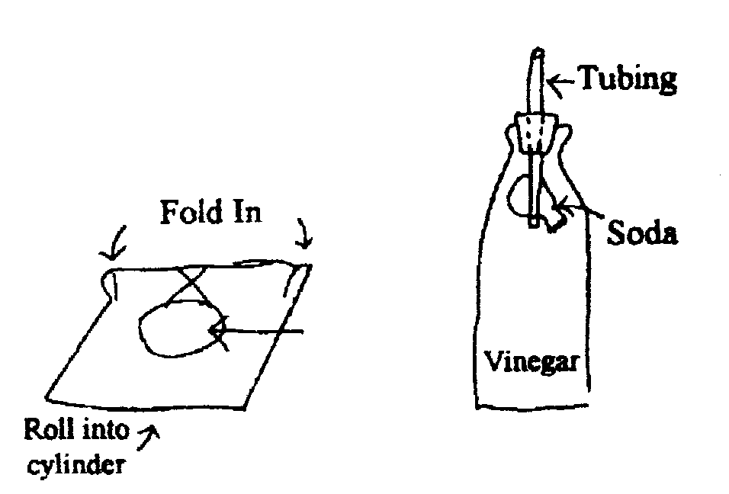
MAKE A FIRE EXTINGUISHER
Materials:
- 1 or 2 quart bottle with stopper to fit
- 3” of ½ “ glass, metal or plastic tubing (Tube from an old Windex bottle can be used)
- Baking soda
- Vinegar
- Facial tissue
Instructions:
- Drill hole in stopper and insert tubing
- Wrap soda in tissue and attach tissue to tube with rubber band
- Fill bottle one half full of 1 part vinegar and 1 part water
- Insert stopper in bottle with soda inside bottle, but not touching vinegar solution
- To operate, tip bottle upside down, soaking the tissue paper with vinegar

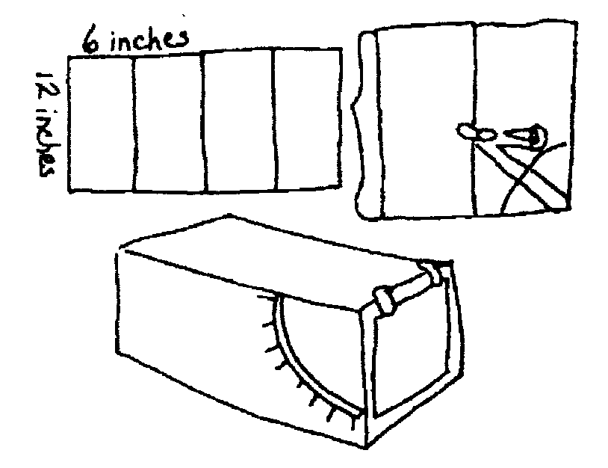
RECORD WIND SPEED
To see how fast or slow the wind blows, make an anemometer (a wind speed measurer)
You will need - stiff cardboard 24” x 12”
- Measure four 6” widths with a ruler, and draw pencil lines with scissors.
- Set a compass to 4” and draw an arc on the cardboard as shown.
- Cut out a narrow slot along the arc.
- Mark numbers at equal intervals along the slot.
- Fold the cardboard inward along the scored lines.
- Put cellophane tape along the two edges and along all the folded edges.
- Cut a piece of paper 4 ¾” square and tape it to the end of the box as shown. Take the anemometer outside and point the flap toward the wind. Each night and morning, record the level that the flap reaches

BOILING ICE
In a heatproof jar with lid, boil a half-inch of water with the lid on loosely so some of the steam can escape. Then tighten the lid and turn jar over. Put an ice cube or two on the jar bottom. In a moment the water will boil again.
What happens? The air pressure has been reduced in the jar by the ice condensing the water vapor inside. The boiling point of a liquid depends on atmospheric pressure.

BALLOON AND CAN RACE
Each team will need a balloon for every Webelos and a fruit can for each team. Each team will have a chair on each end of the room. Each team is divided with half of the team behind each of that teams chairs. The can is placed on a chair.
One boy holds the balloon in the can and blows it up enough to make the can stick on around the balloon. He then carries the balloon, with the can hanging on, to the other chair. He then deflates his balloon and the next boy inflates his own balloon and carries it and the can back to the original chair. The first team to switch locates wins.

EXPERIMENTS IN AIR PRESSURE

Shooting Back
Place an empty soda bottle on its side. Put a wad of paper in the neck and try to blow it in. It comes back out.
Why? When you blow into an enclosed space like a bottle, you increase the air pressure inside. Since pressure will equalize when it can, the air rushes out of the bottle, taking the wad of paper with it.

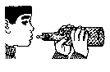
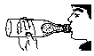
Balloon in Bottle
Place a deflated balloon inside a two-liter bottle, with the lip of the balloon over the top of the bottle. "Cry to blow up the balloon.
What happens? Air pressure inside the bottle increases as the balloon takes up space, so air pressure is fighting against you. To inflate the balloon, you would need to compress the air trapped between the balloon and the bottle. To compress air requires force. The human lungs are not strong enough to inflate the balloon and to compress the trapped air.

Making Air Work for Us
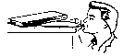
Use a balloon to pick up a glass -- Place a deflated balloon in a glass. Blow up the balloon until it is tight around the edge of the glass. Hold the end of the balloon shut and pick up the glass.
Use a balloon to lift books -- Place a deflated balloon under a stack of books. As you blow the balloon up, the books will rise. A hydraulic lift is based on this principle.

EXPERIMENTS IN ATMOSPHERIC PRESSURE
We live under a blanket of air called the earth's atmosphere. The air in the atmosphere exerts pressure of almost fifteen pounds per inch on every surface on earth.

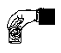
Diving Bell
Place a piece of crumpled paper in the bottom of a glass or tin can. Turn the glass upside down and submerge it in a bucket of water. The paper will remain dry. Why? The air, which filled the "empty" space in the glass, stopped the water from entering.

Hanging Water
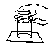
Fill a glass to overflowing and lay a piece of cardboard atop it. Support the card with one hand, turn the glass upside down, and remove your hand from the card. The card does not fall. It remains on the glass and allows no water to escape. Why? The air pressure from below the cardboard is greater than the pressure of the water above and presses the card tightly against the glass.

Wedged Glasses
Place two glasses together with a piece of wet construction paper between them. Burn a candle in the bottom glass. The glasses become "welded" together. Why? The flame uses up the oxygen in the bottom glass, so the pressure is now lower in this glass.

Auto Gyro
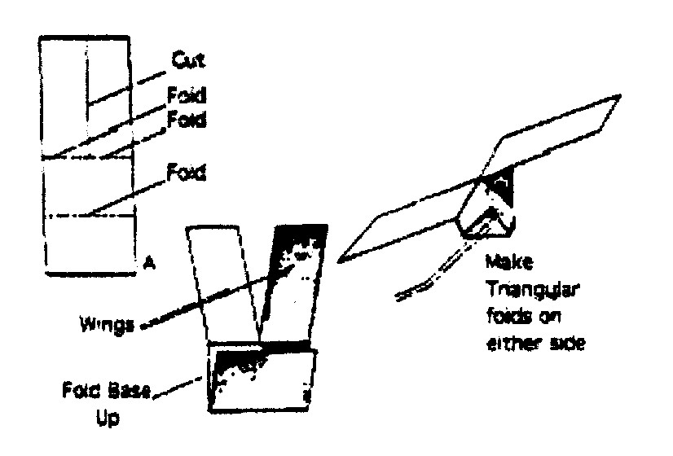
Materials: Paper 3 1/2" wide by 8 1/4" long
The principle of the Auto Gyro can be easily demonstrated by making one as shown in the sketch.
- Using a piece of paper 3 ½" wide by 8 ¼” long, cut down the center of the paper 4" and then fold the cut sections to opposite sides as shown, to form the two wings.
- Fold the balance in halt: and then make two triangular folds to the midline and your Auto Gyro is ready.
- Make two other Auto Gyros basically the same as the first one, but shorten the wing length from four inches to three inches on the second one and to two inches on the third one.
Try flying from the same height and observe how each model reacts. Does any thing seem to slow their descent'? What actually makes it spin'? Note the order in which the three models reached the ground. Are wing size, air resistance, and rate of descent related?

Spinner Scope
Materials:
- Paper plates
- Scissors
- watercolor markers
- pushpin
- unsharpened pencil with eraser top
Instructions:
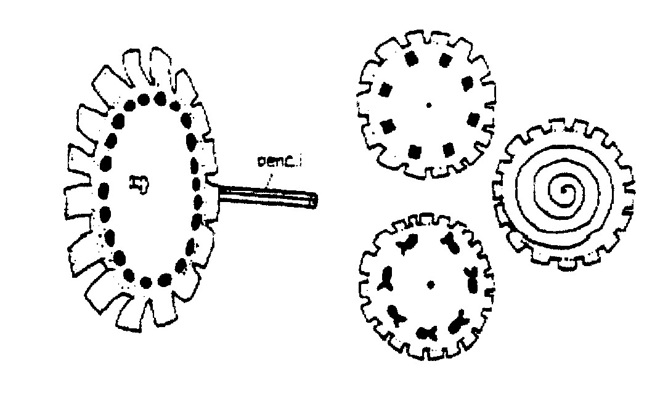
- Cut out notches around edge of plates as shown.
- Draw a design on each plate with markers. Draw a spiral, small circles close to each other, or a simple object, such as a fish.
- Poke a pushpin through center of plate, then into eraser end of pencil.
Stand in front of mirror. Spin pencil between hands as you peer through the notches. Each design will produce a different optical illusion as the spinning elements appear to merge.

