Webelos Sportsman Activity Badge

Physical Skills Group
A sportsman is someone who has played many games and has played all kinds of games. He plays by the rules and does his best. If he wins, he compliments the losers for the fine game they played. If he loses he accepts the fact and should find out why. Maybe he can win the next time.

IDEAS FOR DEN ACTIVITIES
- Have combined parent/son ball games or tournaments like golf, table tennis, bowling or volleyball.
- Learn sports etiquette along with the normal playing rules of all games.
- Use the Cub Scout Sports program...belt loops and pins.
- Visit a bowling alley and bowl a few games.
- Go ice or roller skating.
- Play a round of miniature golf.
- Invite a referee or coach and have them talk about being a Sportsman.

ACTIVITIES AND GAMES

TUFF SPORT
Want to give your Webelos Scouts the idea of “Good Sportsmanship?” Pick any really easy game to play like Red Light, Green Light. Leader is the light. Make it so that nobody wins. Usually after a short time they will start to complain about being too hard, not fair, no one can win. That’s a great opening for a sportsman-like conduct, good loser vs. bad loser discussion. It’s not just winning but playing and how you play. Then continue to play the same game in the same way.
They should laugh a little longer this time.

SPORTSMANSHIP
A real sportsman follows these rules in each game, but also in his life. Good sportsmanship is part of good citizenship. For example, losing class election gracefully. The “Spirit of Good Sportsmanship” means being modest in victory as well as accepting defeat gracefully after trying your best.

MARBLE GOLF
Set up this game and practice playing it for a future den or pack marbles tournament. For holes, bury baby food cans to the brim in the earth. Flags are paper triangles glued to craft sticks. Add water hazards and sand traps as you wish. Shots are taken in the approved knuckles down way for regular marbles. Winner is the Webelos who takes the fewest shots to get all the way around.

ULTIMATE IN 10 SIMPLE RULES
The Field: A rectangular shape with end zones at each end. A regulation field is 70 yards by 40 yards, with end zones 25 yards deep.
Initiate Play: Each point begins with both teams lining up on the front of their respective end zone line. The defense throws (“pulls”) the disc to the offense. A regulation game has seven players per team.
Scoring: Each time the offense completes a pass in the defense's end zone, the offense scores a point. Play is initiated after each score.
Movement of the Disc: The disc may be advanced in any direction by completing a pass to a teammate. Players may not run with the disc. The person with the disc (“thrower”) has ten seconds to throw the disc. The defender guarding the thrower (“marker”) counts out the stall count.
Change of Possession: When a pass in not completed (e.g. out of bounds, drop, block, interception), the defense immediately takes possession of the disc and becomes the offense.
Substitutions: Players not in the game may replace players in the game after a score and during an injury timeout.
Non-contact: No physical contact is allowed between players. Picks and screens are also prohibited. A foul occurs when contact is made.
Fouls: When a player initiates contact on another player a foul occurs. When a foul disrupts possession, the play resumes as if the possession was retained. If the player committing the foul disagrees with the foul call, the play is redone.
Self-Officiating: Players are responsible for their own foul and line calls. Players resolve their own disputes.
Spirit of the Game: Ultimate stresses sportsmanship and fair play. Competitive play is encouraged, but never at the expense of respect between players, adherence to the rules, and the basic joy of play.
REFEREE SIGNALS – BASEBALL, BASKETBALL AND SOCCER

More on the Sportsman Activity Badge
Sports are high on the list of favorites of Webelos-age boys. Most members of your patrol will show real interest in the Sportsman badge. Chances are the boys spend much of their leisure time in organized sports and loosely organized neighborhood games. Some of them probably already know enough about rules, scoring, and techniques of play for several sports and can pass those requirements immediately. But that’s not really enough. On of the prime purposes of the Scouting program is to encourage good sportsmanship and pride in growing strong mind and body. If the boys learn all the skills and rules involved in every sport this month, but don’t get an inkling of what good sportsmanship means, then everyone has wasted their time, including the den leader. Sportsmanship is important whether you win or lose.
Suggested Patrol Activities
- Invite a referee or official to your patrol meeting to teach signals and talk about teamwork, fair play and sportsmanship.
- Hold a parent/son sports tournament, such as bowing, tennis, volleyball, archery, etc.
- Have a patrol board game marathon. Provide treats and boys bring their favorite board games to play. Allow time for rotation to different games.
- Have Webelos figure out a football, soccer or basketball play and diagram it. Local high school or little league coaches are sources of assistance.
- Go roller-skating or ice-skating.
- Visit an archery range and receive instructions on safety and procedures.
- Play some backyard games such as horseshoes, croquet, volleyball or badminton.
- Visit a sports shop and talk with the owner about selecting equipment.
- Have a patrol outing to a sports event.
- Hike around a golf course. Explain rules of etiquette and play to boys first so as not to disturb players.
- Watch a pro or college game on TV and have the boys practice the officials’ signals.
- Earn Sports belt loops for 2 sports that are new to the boys.

BALLOON VOLLEYBALL
You will need
1 - large inflated balloon and
1 - long piece of string.
- Divide boys into two teams
- Seat them on the ground in volleyball positions.
- The net is the string fastened between two trees, poles or attached to the walls for indoor use.
- The balloon is put into play by a serve
- Normal volleyball rules apply, except that the players cannot move from their seated positions on the floor or ground.

BALL OVER
You will need a ball about volleyball size. Draw a line. One team on each side of the line. Players cannot cross the line. The leader with a whistle is blindfolded or stands so he cannot see players. When he blows the whistle, the ball is put into play.
Object of the game
To keep the ball in the opposing team’s territory. When the leader blows the whistle again, a point is counted against the team on the side where the ball was when the whistle blew.

THE PENALTY BOX
Match the Officials’ Signal Calls to the correct sport.
FOOTBALL BASKETBALL BASEBALL SOCCER HOCKEY
In which of the above sports would an official call -
Pass interference  Illegal Dribble  Technical Foul  Holding the Face Mask  Kneeing  Time-in  Slashing  Time-out  Charging  Fair Ball  Offside  Substitution  Ball  Hooking  Corner Kick | Incomplete Pass  Strike  Touchdown  Penalty Kick  Out  Delay of Game  Holding  Clipping  Foul Ball  Safe  Unsportsmanlike Conduct  Traveling  Tripping  Illegal Motion  Foul

INDOOR BASEBALL GAME
You will need
- 1 - large sheet of cardboard (can be any size so long as it is square).
- Marking pens,
Using the pens, draw a baseball diamond like one shown. Mark home plate and the three bases. Outside of the baselines write as shown: home run, strike, single, out, double, ball, triple and out.
Draw pitcher’s mound in the center. Cut a bat shape spinner from cardboard. Punch small hole in bat and center of pitcher’s mound. Attach bat with a paper brad to pitchers mound. Be sure that the hole is not too small or too large, needs to be large enough for the bat to spin freely. Follow regular baseball rules when playing. Keep score. Each player keeps his turn until he has three outs.
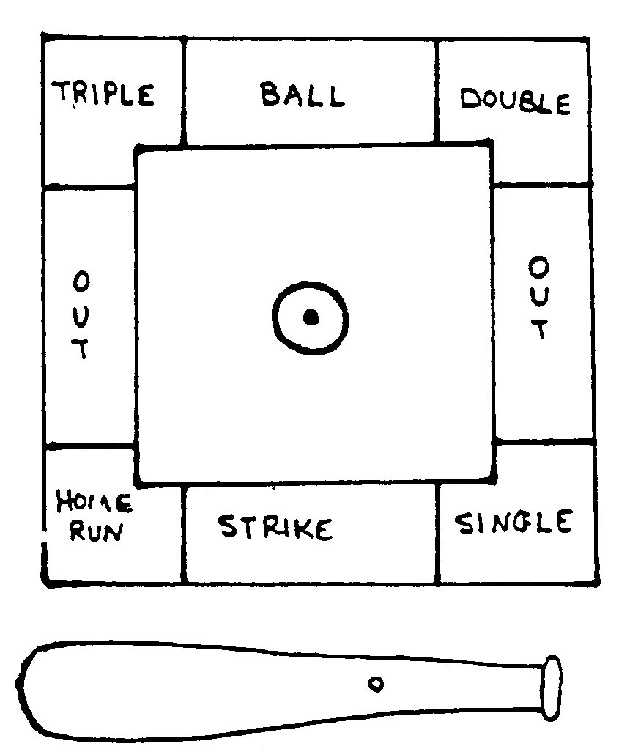

TOUGH SPORT
Want to give your Webelos Scouts the idea of “Good Sportsmanship?” Pick any really easy game to play like Red Light, Green Light. Leader is the light. Make it so tough that nobody wins. Usually after a short time they will start to complain about being too hard, not fair, no one can win. That’s a great opening for a sportsman-like conduct, good loser vs. bad loser discussion. It’s not just winning but playing and how you play. Then continue to play the same game in the same way. They should laugh a little longer this time.

Sports are high on the list of favorites of Webelos age boys. You can be certain of instant interest by most members of your den. Chances are that they spend much of their leisure time in organized sports and loosely organized neighborhood games. Some of them probably know enough already about rules, scoring, and techniques for several sports so that they could pass the badge requirements easily.
But that’s not really enough. One of the prime purposes of Cub Scouting is encouraging good sportsmanship and pride in growing strong in mind and body. If your boys learn all the skills and rules involved in every sport this month, and don’t get an inkling of what good sportsmanship means…then the den, and you, have wasted your time.
Agree on the importance of learning sportsmanship. What does that mean in practice? It means that the least skilled gets just as much instruction and encouragement as the best athlete. It means that the better athletes learn not just to tolerate the awkward boy, but learn to help him. It means that all boys can win and loss with grace and good sportsmanship.
Your own example will help to achieve these goals. Put stress on the fun of the game, not on the winning. When you have den competitions, make up the teams so that the strength is about even. If you let boys choose teammates, there is a good chance that most of the best players will wind up on the same team. Encourage the less skillful players. Discourage others from belittling them. Sports in a Webelos den should be fun for all the boys.

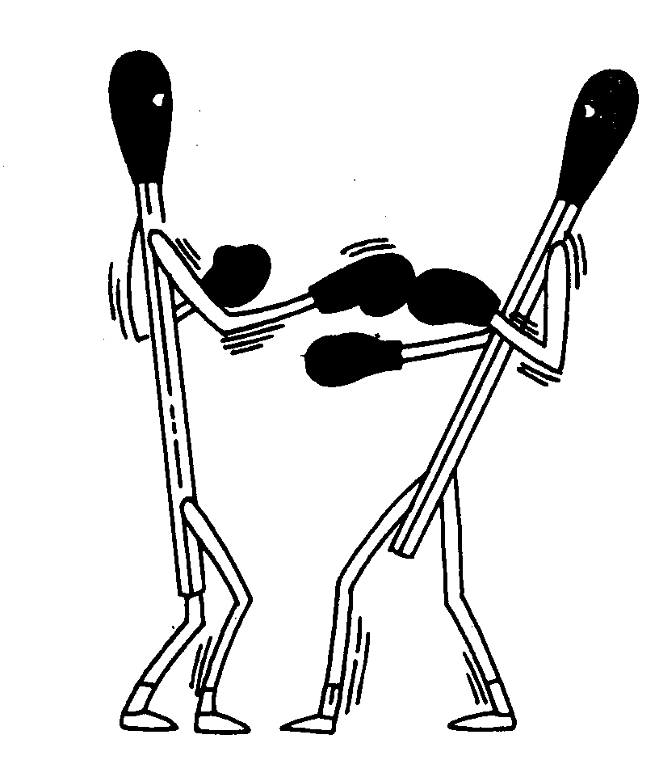
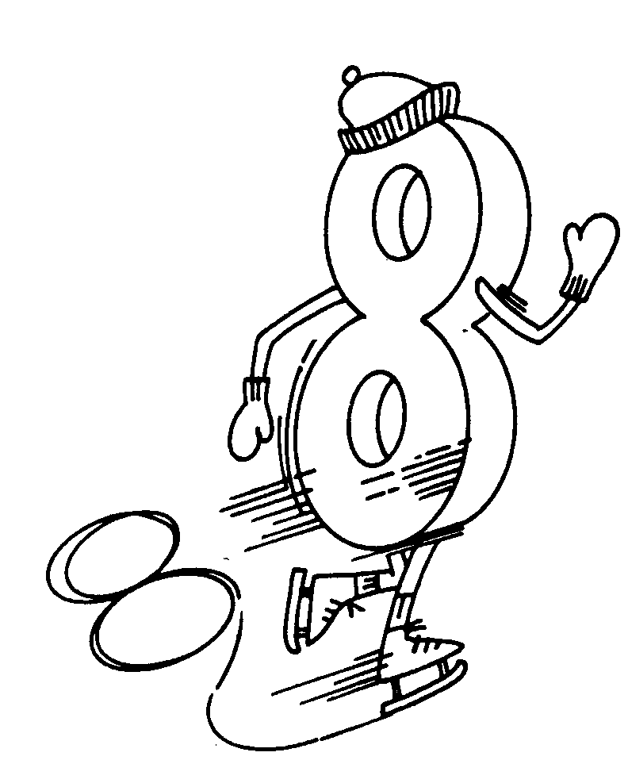
WHAT ARE WE???
ANSWER :Boxing match, figure 8 skating

Den Meeting Ideas
- Demonstrate the signals of baseball and have the boys do them
- Hold parent/son bowling contest
- Discuss the rules and regulations of various sports
- Attend a high school, college or professional sporting event
- Have a Sports Sunday and watch a pro game on TV (combine with a backyard tailgate cookout)
- Have a fishing derby
- Play miniature golf
- Have a referee talk to the boys about the rules of his sport
- Walk a golf course and observe play (get permission first!)
- Have archery practice using targets against bales of hay
- Visit a tennis court or racquet club
- Have a high school coach come and talk about what it takes to become a good athlete

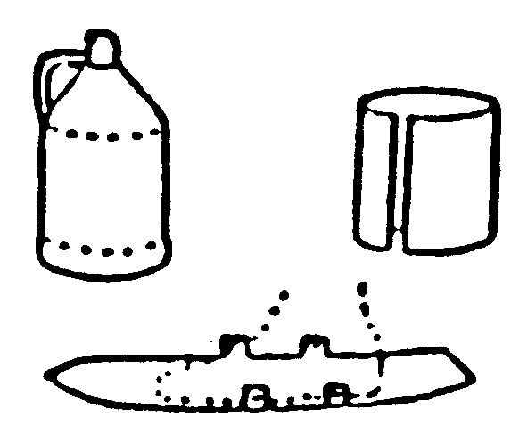
SKI-SKATE TAG
For a pair of shorty skis, remove top and bottom of two gallon plastic bottles. Cut down seams and flatten into strips, curved at the ends. Stand on center of the plastic and mark width of shoe at the widest point. Mark small tabs on each side of foot and a second pair of tabs near ankles. Cut plastic to the width of foot with tabs attached. Trim skis to a point at the front. To fasten skis to shoes, punch holes in tabs. Bend tabs up and lace with ribbon or cord, lacing over tops of shoes and around ankles.

SOCCER BALL NECKERCHIEF SLIDE
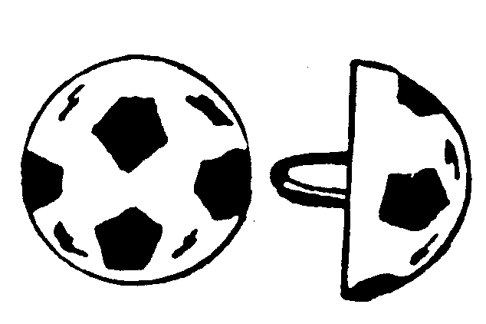
Materials:
- Ping Pong ball
- Plaster
- Pop top ring or small ½” PVC pipe ring
- Black acrylic paint
Directions:
Cut a ping-pong ball in half. Fill the half of ball with plaster and Insert pop-top or PVC ring for slide. Decorate with black paint.
The same idea can be used to make a Basketball, etc.

