Pollution Solution
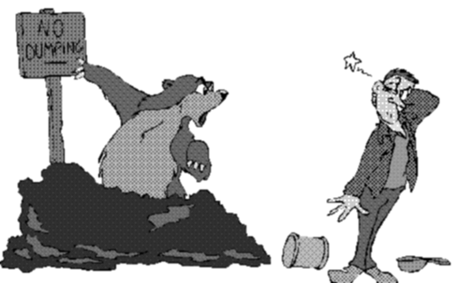
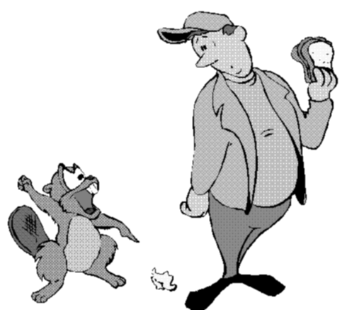

REDUCE
REUSE
RECYCLE



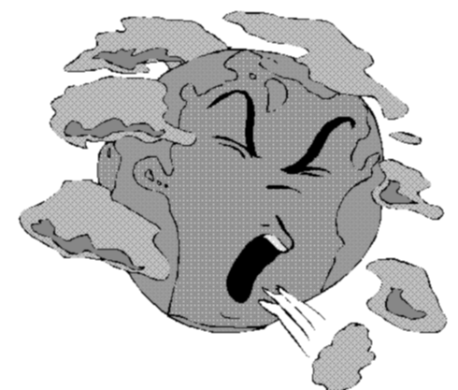


APRIL 1999

REDUCE, REUSE, RECYCLE

REDUCE
Organize a pack or den bicycle day. Discover the fun of riding bikes together in the nature.

Take public transportation--city bus, light rail, Bart or Caltrain--on a den outing. Take a sack lunch (in a reusable container, of course). At lunch time have a show-and-tell on the packaging of the commercial food items like cookies and drinks--can it be reduced? What should we do with the remains of the lunch like empty soda cans and banana peels?

REUSE
Organize the pack giveaway project for those items families no longer could use. Many churches, charities, and organizations are grateful for donations of used clothing, books, toys and housewares that are clean and in good condition. Collect items at the den or pack. If some items need fixing, have boys help repair them; there usually are some handy people among parents.
Some charity organizations have drop-off places in supermarket parking lots for giveaway items. Goodwill and Salvation Army are two large organizations that may take your giveaways. Call ahead.

Participate in the Council’s Goodwill Good Turn Day. It is normally scheduled sometime in April.

Or have a garage sale or flea market to raise some money for the World Friendship Fund (See Program Helps 98-99 CUB 1 DEC, Cub Scout Leader Book pp. 6-4 to 6-5) or for a special pack activity. There are a few ways to do this. One is to ask families to donate items to the pack and have one gigantic garage sale with advertising, etc. The other is to have a flea market, each seller paying fees to participate. Either way, don’t forget to file the Unit Money-Earning Application form ahead of time. (The form is available at the Council Service Center. The form is copied on pp. 17-25 and 26 of the Cub Scout Leader Book; please read the checklist on p. 17-26.)

RECYCLE
Organize a pack recycle program. Collect recyclable material and take it to a recycling center. (If your pack does this for profit, you need to file the Unit Money-Earning Application form.)
Visit a local recycling facility
Call your city office and ask if a speaker can come to the pack to talk about the city’s recycling program.
Have the director of a landfill come and talk to the pack.

FIELD TRIPS (For details, please refer to the Field Trip section at the end of this book.)
The Recyclery (BFI), San Jose
Observatories--observatories are very much concerned with pollution in the valley because they need clear sky to see the stars.
Foothill College Observatory, Los Altos
Lick Observatory, Mt. Hamilton
Note: There is at least one paper recycle company in the valley but because of safety precautions they do not offer tours other than to school groups.

HOW MUCH TRASH?
How much trash does one boy throw away in one day? Give each of the boys a plastic garbage bag that they have to carry with them for a whole day. Instruct them to put all the trash that they create into their bag. Do it the day of the den meeting and have them bring the bags with them. (Preferably on a nice spring afternoon when you can do it outside!) Have them take a look at what they have collected and see if there is anything that they can reuse or recycle. Talk about ways they can produce less trash.

POLLUTION SOLUTION GOOD TURNS

CONSERVATION PROJECT
Check with local conservation office for a pack project.
Ask at the Council Service Center what your pack can do for the Chesebrough Scout Reservation.

LITTER CONTROL
Make little bags for family’s and neighbor’s cars or boats. Distribute litter bags at a cooperating service station or store for those who want them. A pack can use medium-sized grocery bags and stencil their own names on them.
Pick up litter in the neighborhood, school, church, park, etc.
Adopt a park, creek, lake or roadside rest and keep it litter free on a long-term basis.
Decorate trash containers for school, park or other spots.
Participate in a beach or waterfront cleanup. Record the items collected and determine the possible harmful effects to wildlife.
Note on Litter pick-up: Provide each boy with rubber gloves and tell them to use gloved hands to pick up trash. Please remind the boys not to pick up any used or unused drug paraphernalia if they encounter it.
To Adopt a Creek - call Clean-a-Creek Hotline 265-2607 ext. 2049, Santa Clara Valley Water District.

RECYCLING
Organize or participate in a recycling program in the neighborhood.

PUBLIC AWARENESS PROMOTION
Arrange a natural resources awareness program. Invite natural resource professionals such as wildlife biologists, soil conservationists, foresters, or conservation officers to speak to your pack.
Make Outdoor Code posters to put up in school and explain the Code to others.
Make anti-litter posters (make sure you take them down after a certain period).
Make a conservation display for school.
Have a “Fight Litter” parade with boys carrying signs urging the public to “stash the trash “ or “Don’t be a litter bug.”
Develop a plan to educate the public about the dangers to wildlife posed by the littler problem.
Collect all the trash in a selected area and exhibit the trash for a day where everyone can see it (and discard the trash later).

PLANT CARE
Plant (Get permission from the land owner--church, school, park, etc.)
shrubs to provide cover for wildlife,
grass seed on bare ground to prevent erosion,
tree seedlings for shade, landscaping or ground cover.
Plant and maintain a flower garden.

ANIMAL CARE
Build and set out bird boxes, feeding stations, or birdbaths in backyards.

A PARTY FOR THE PLANET

April 22 is Earth Day. It is a time to pay special attention to the environment and how Earth’s living things depend upon one another. The first Earth Day was held in 1970.

+ Have a small party (maybe dessert?) at the den meeting.
+ Make invitations, place mats and place markers from reusable materials.
+ Use clean plastic yogurt cups or butter tubs for cream cups; rinse them out later for guests to take home party favors.
+ Use clean containers of all kinds for drinks--peanut butter jars and jelly jars are great.
+ Have the boys bring “real” plates, cups and utensils for their use. They don’t have to match--the Earth is full of all kinds of textures, shapes and colors!
+ If you use plastic plates, cups and utensils, buy sturdy ones and reuse at other parties.
+ Use cloth napkins; cut old fabric, fray edges decoratively, use permanent markers to decorate them; let the guests decorate them and take them home as favors.
+ Decorate the room with posters on Earth, conservation, animals and plants.
+ Make a centerpiece from nature--shells, driftwood, fruits and vegetables that are in season.
+ As a party game, have a paper airplane contest with recycled paper and recycle it later.
+ As a party activity, make crafts with leaves, seeds or other nature items, or reusable materials.
+ Have a “recycling contest” to design a sculpture out of reusable materials.
+ Make up genius kits from reusable materials (Each boy makes something from identical kits--they must use at least part of each item. Have a nature-related theme for the project.)
(adopted from Best Kids Love-the Earth Activity Book)

CUB SCOUT WORLD CONSERVATION AWARD

The World Conservation Badge was launched in 1974 and is now in use in over 40 countries. This is a great month to start working on the requirements for this badge. This badge is earned only once as a Cub Scout. A copy of the application with requirements for Wolf, Bear and Webelos Scouts is attached. When the boys complete the requirements, copy that page, fill them out and turn in at the Scout Shop where you purchase the badges. (also see the Cub Scout Leader Book, p. 10-4) The patch is worn as a temporary patch on the right pocket.

CONSERVATION GOOD TURN AWARD

The Conservation Good Turn program is an opportunity for a Scouting unit (packs, troops, teams and posts) to join with conservation or environmental organizations (federal, state, local, or private) to carry out a conservation Good Turn in their home communities. The Scouting unit contacts a conservation agency and offers to carry out a Good Turn project. Working together in the local community, the unit and the agency plan the details and establish the date, time, and location for carrying out the project. Obtain a brochure at the Council Service Center for more details. Cub Scouting conservation projects should involve the entire Cub Scout pack, each den, adult leaders, and family members. Suggested projects are similar to those listed above under “Pollution Solution Good Turns.” The patch is worn centered on the right pocket.
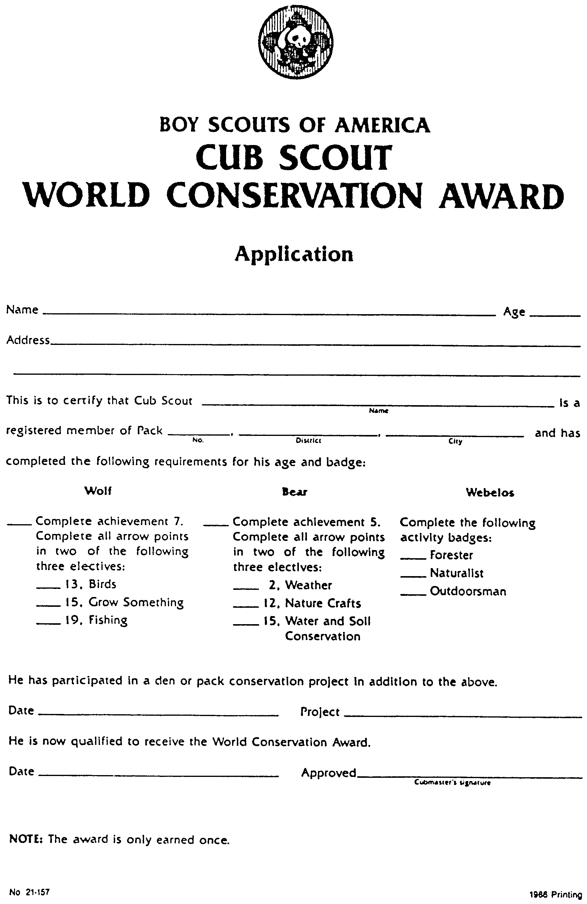
CLEAN UP

Help the Cub Scouts clean up their neighborhood.
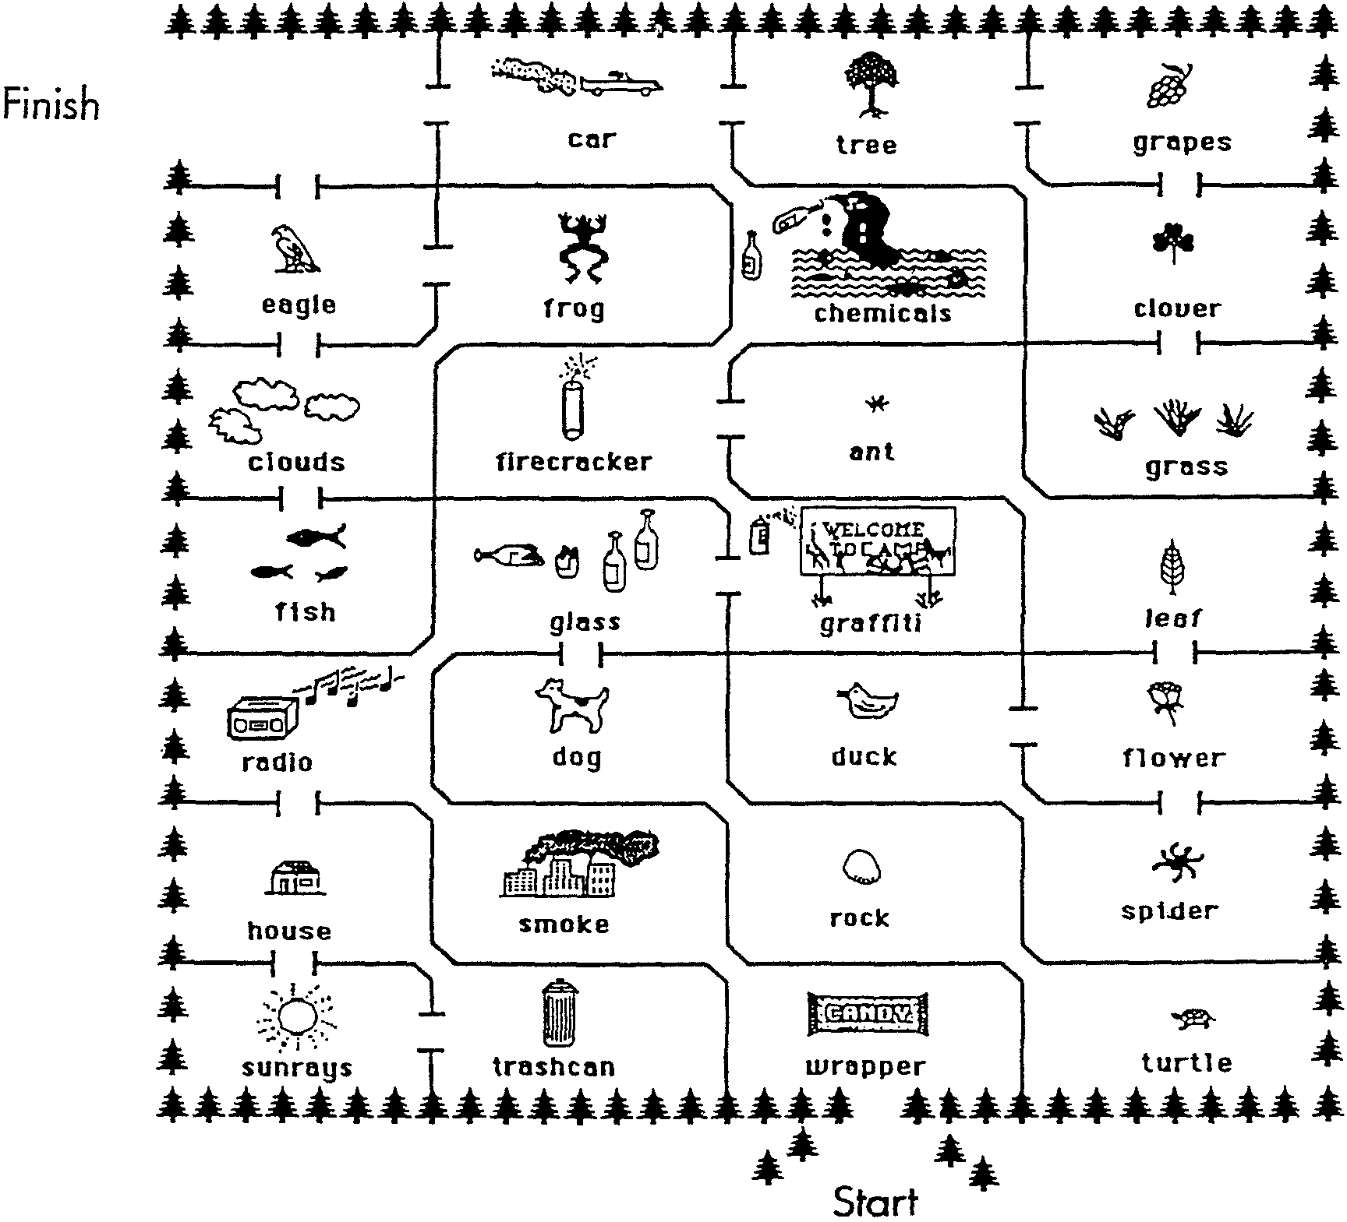

RECYCLE WORD FINDER

Find PLASTIC, ALUMINUM, PAPER, GLASS, PARKS, EARTH, RECYCLE, SCOUTS

M R N W H M S G P
R A S C O U T S A
T E H J K N O P R
P A C M J I T S K
L R O Y K M R Z S (from Great Salt Lake Council 1998)
A T X R C U Y M W
S H B Q G L A S S
T E M O A A E K J
I S P A P E R Y I
C A E U L V T W M

CLEAN BAY

What is the secret message? Circle the odd numbers and put circled letters in order in the spaces below.

1-K 2-W 3-E 4-A 5-E 6-X 7-P 8-M 9-B 10-Q 11-A 12-R 13-Y 14-N 15-C 16-T 17-L 18-P 19-E 20-V 21-A 22-B 23-N 24-D 25-W 26-F 27-A 28-H 29-T 30-G 31-C 32-J 33-H 34-A 35-W 36-N 37-H 38-K 39-A 40-Z 41-T 42-M 43-Y 44-E 45-O 46-B 47-U 48-R 49-P 50-U 51-U 52-L 53-T 54-E 55-D 56-K 57-O 58-Z 59-W 60-S 61-N 62-O 63-T 64-I 65-H 66-M 67-E 68-P 69-D 70-L 71-R 72-I 73-A 74-A 75-I 76-O 77-N 78-Y

__ __ __ __ __ __ __ __ __ __ __ __! __ __ __ __ __ __ __ __ __ __ __ __ __ __ __ __ __ __ __ __ __ __ __ __ __ __ __.
-Sunnyvale Water Pollution Control Plant

TRASH QUIZ

What happens to the trash after you put it out to be collected? To find out, go through the questions below and follow the directions.
1. The average American gets rid of more than four pounds of trash each day. Where does most of that trash go?
a. It gets recycled. (GO TO 10)
b. It gets burned to make electricity. (GO TO 13)
c. It gets dumped and buried. (TO GO 3)

2. What do Americans throw away the most of?
a. Plastic bottles (GO TO 11)
b. Paper and cardboard (GO TO 7)
c. Food waste (GO TO 4)

3. You’re absolutely right! Most of our trash is dumped into places called landfills, where it is covered with layers of soil and more trash. (NOW GO TO QUESTION 2)

4. Food waste is only a small part of what Americans throw away. (TRY QUESTION 2 AGAIN)

5. Surprise! The hot dog wouldn’t be gone. (TRY QUESTION 9 AGAIN)

6. What is the best way to cut down on our trash?
a. Buy less stuff. (GO TO 14)
b. Recycle paper, plastic, glass, and metal. (GO TO 14)
c. Reuse things as many times as possible (GO TO 14)
d. Buy products made with recycled materials. (GO TO 14)

7. Right! Paper and cardboard that haven’t been recycled take up the most space in trash--about one-third of all the things people toss out. (GO TO QUESTION 9)

8. Yes, the hot dog would still be there! A hot dog won’t rot unless it gets plenty of air and water. But in a landfill, it gets buried right away when more stuff is dumped and packed down on top of it. Then air and water can’t get to it. (GO TO QUESTION 6)

9. If you buried a hot dog in a landfill and dug it up 20 years later, what would you find?
a. Nothing--it would have rotted completely. (GO TO 5)
b. A mushy mess. (GO TO 12)
c. A hot dog. (GO TO 8)

10. Good answer, but not the right one. We Americans recycle only about one-fifth of the stuff we get rid of. (TRY QUESTION 1 AGAIN)

11. Whoops! Plastic bottles make up about one-fifth of the trash at landfills, but something else takes up even more space. (TRY QUESTION 2 AGAIN)

12. Sorry, no mushy mess. (TRY QUESTION 9 AGAIN)

13. Only about one-sixth of what we throw away gets burned. TRY QUESTION 1 AGAIN)

14. Trick question! All FOUR answers are right.
- by Jan Wilkinson (Ranger Rick 95)
THREE R’S FOR PLANET EARTH

C.S. #1: Gimme an R for REDUCE!
C.S. #2: Walk or ride a bicycle when you can.
C.S. #3: Turn off the light you when you leave a room.
C.S. #4: Before you buy something, ask yourself if you really need it.

C.S. #1: Gimme an R for REUSE!
C.S. #2: Use a cloth towel, instead of a paper towel.
C.S. #3: Donate old toys to a thrift shop or a homeless shelter.
C.S. #4: Use an empty milk carton for a bird feeder.

C.S. #1: Gimme an R for RECYCLE!
C.S. #2: It takes less water to make newsprint from old newspapers than from trees.
C.S. #3: Every time you recycle a soda can, you save enough energy to run a TV for three hours!
C.S. #4: Recycled plastic is used to make toys and filling for sleeping bags.

C.S. #1: Reduce what you use.
C.S. #2: Reuse what you can.
C.S. #3: Recycle the rest.
C.S. #4: Three Rs for Planet Earth!

BEAUTIFUL AMERICA
Seven boys line up, each holding a card with one of the letters printed on it.

A America abounds in beautiful sights;
M Making it beautiful is one of our rights.
E Each of us is proud of our U.S.A.,
R Rolling hills and lakes in which we can play.
I Instead of littering and spoiling our land,
C Crusade to keep America beautiful and grand,
A And then we can always be proud of our land.

CHEERS
LITTERBUG CHEER: “Crackle, Clatter, Dump.” (Repeat three times) “Don’t be a litterbug. Pick them up!!!!”

BIG THUMB: Hold out a hand at arms length, make a fist with the thumb up. Variation: Add, “GREAT JOB!”

FLOWER APPLAUSE: Like a flower blooming, slowly rise part way out of your chair. Look around, then stand up quickly and yell, “SPROOONG!”

CONSERVE EARTH’S WONDERS
This ceremony calls for a flannel board. The board can be made in a den meeting. The boys like the boards well enough that many will want to make one for their room.

TO MAKE THE FLANNEL BOARD: Cover a large piece of plywood or heavy cardboard with light green cotton flannel available at fabric stores. Stretch tightly across the board and thumbtack to the back. Bind edges with green tape. Paste small piece of sandpaper on back of large cut-outs to make them stick better. Flannel boards can interpret countless subjects. In the ceremony below, names of cut-outs are printed in capital letters.

C.S. #1: We believe in the wisdom of nature’s design. (SUN and LARGE TREE)

C.S. #2: We know that soil, water, plants and wild creatures depend upon each other and are vital to human life. (POND, CLUMP OF VEGETATION, RACCOON)

C.S. #3: We recognize that each living thing links to many others in the chain of nature. (FISH and DRAGONFLY)

C.S. #4: We believe in studying the patterns of outdoor life. (BOY SITTING ON HILL WITH BINOCULARS)

C.S. #5: We condemn no wild creature and work to assure that no living species shall be lost. (OWL IN TREE, and SNAKE BY ROCK)

C.S. #6: We believe that every generation should be able to experience places where primitive nature is undisturbed. (BOY AND GIRL or A FAMILY)

C.S. #7: We dedicate ourselves to opening the eyes of young and old, that all may enjoy the beauty of the outdoor world, and to share in conserving its wonders forever. (CUB SCOUT EMBLEM)
(Adapted from Audubon Philosophy)

G-A-R-B-A-G-E CLOSING
G Great mounds of trash,
A All heaped up high,
R Ruin the beauty of Earth.
B Be aware of recycling.
A All of us count.
G Get started today.
E Earth is ours to care for.
THE WORLD CONSERVATION CODE CLOSING

I will respect all living things, for each is a link in the chain that supports life on earth.
I will take from nature only what can be replaced, so no species will disappear.
I will not pollute the air, soil or water.
I will not buy products created from endangered animals, plants or forests.
I will keep my neighborhood clean and will respect the environment wherever I go.
I will call attention to cases of pollution and any other abuse of nature.
I will support organized groups and officials defending nature.
I will not waste fuel or energy supplies.
I will set an example of good conservation conduct and show others why it is important for everyone to do so.
I will rejoice in the beauty and wonder of nature all the days of my life.
(Proposed by WWF - World Wide Fund For Nature)

CONSERVATION - CLOSING

What a terrible world in which to be
If there were no trees for us to see;
No birds to please us all day long
With brilliant color and beautiful song;
No fish to swim in pond or brook;
No bubbling spring in a shady nook;
No fireflies bright on a summer night
Filling the darkness with twinkling light;
No stately buck with doe and fawn
Standing so proudly in the mist-filled dawn.

But God has given us, unselfishly,
A wonderful world, with gifts so free;
The leaves of spring, so fresh and new;
The grass so green, the sky so blue;
The soothing rain, the warmth of sun;
The twilight’s magic when day is done;
The thunder of a waterfall.
The majesty of a pine tree, tall.
All these, and more, both great and small,
The Lord has given, to share with all.
And as we study each plant and flower
Or find a nest in a leafy bower,
When listening to the sounds of night
Or bathed in morning’s early light
May each of us, throughout each day,
Truly appreciate Nature’s way
And help to guard her treasures rare
By protecting them with patient care
So that we’ll never have to fear
The loss of them in a future year.
-John S. Hill

OUTDOOR GOLDEN RULE!!
Take nothing but pictures, and leave nothing but footprints.

O GOD, WE THANK YOU

O God, we thank you for this universe
And for the earth you have given us as our home;
For its vastness and its riches,
And for the abundance of life which teems upon it,
and of which we are part.
We praise you for the arching sky and the blessed winds,
For the driving clouds and the constellations on high.
We praise you for the salt sea and the running water,
For the everlasting hills, for the trees,
and for the grass under our feet.
We thank you for our senses,
by which we can see the splendor of the morning,
and hear the jubilant songs of love,
and smell the breath of springtime.
Grant us, we pray to you, a heart wide open to all this joy and beauty...
(from Let’s Celebrate)

See Staging Den and Pack Ceremonies for: Conservation Closing Thought
(October, p. 32). “Outdoor Code--Responsive Reading” (pp. 44-45)
“Conservation” (p. 49), “Conservation” (p. 120)

ADVANCEMENT CEREMONY IDEAS

If your pack has a guest speaker like a conservation officer or a city official, have that person help the Cubmaster to hand out the awards.

Paint a Recycle symbol on a cardboard box and the sign “Super Cub Scout Recycling Machine.” Attach a crank or a switch. Place the awards in the box ahead of time.
At the meeting ask each Cub Scout receiving an award to put a stack of computer paper or newspaper in the box. Crank the handle or “turn on the switch”--with a sound effect--and take out an award.

WORLD CONSERVATION AWARD

Personnel: Cubmaster, Assistant Cubmaster, Den Leader
Equipment: World Conservation symbol (enlarged or wood-burned)

Cubmaster:
In his last letter to Scouts around the world, Lord Baden-Powell, the founder of Scouting, wrote, “Try to leave the world better than you found it.” Tonight, we are honoring Cub Scouts who have fulfilled Baden-Powell’s request.

Assistant Cubmaster:
In an age when Nature is being used up faster than it can replenish itself, these Cub Scouts have helped to stop that trend.

Den Leader:
They have worked hard to fulfill the requirements of the World Conservation Award. They have completed achievements and electives related to the outdoors in addition to completing a den conservation project.

Cubmaster:
This award may be earned only once as a Cub Scout. The badge worn on his uniform tells everyone that he helped to make the world better for all of us.

Will the following Cub Scouts please come forward? (Scouts come forward and are awarded badges.) Thank you for what you have done for all of us.

FUN WAYS TO SAY THANK YOU
Big Band-Aid: For the leader who always seems to fix anything
Broom: For someone who sweeps all the mistakes away
Bundle of Newspaper: “Thanks a Bundle”
For the newspaper drive chairman
Crushed Pop Can: “Thanks for having a crush on Scouting”
Globe: “We think the WORLD of you!”
Packet of Seeds: “Thanks for helping Pack ___ grow”
For someone who helped with recruiting members.

GROWN-UPS ARE JUST RECYCLED KIDS--STAY YOUNG AT HEART

CUB SCOUTS IN THE WOODS

Sparrow(s): “Chirp, chirp”
Snake: “Sssssssssss”
Squirrel: “Chatter, chatter”
Rabbit: “Hippity, hoppity”
Tree(s): Stand up and sway
Cub Scout(s): “Do your best”

A flock of SPARROWS swooped into the woods and settled on the branch of a TREE. Their chirping quickly caught the attention of the animals in the forest. The RABBIT and the SQUIRREL came close to listen to the news. The SNAKE pretended he didn’t care.

“It’s terrible news!” said one of the SPARROWS. “That pack of CUB SCOUTS is coming to spend the day again.” “Oh, no!” sighed the TREES. “Last time they came we lost branches and leaves. Two of them built a fire so close to us the oak TREE almost caught fire.”

The RABBIT’s ears had positively frozen in place when he heard the words CUB SCOUTS. “I had to run for my life. They chased me until I was about to pass out.” The SQUIRREL almost fell off the branch he was sitting on and the SNAKE forgot that he was pretending not to hear. “CUB SCOUTS,” the SNAKE hissed. “Why do they have to come here! Last time, they caught me and tried to put me in a bag to take me home with them. I barely escaped with my life.”

“They are coming tomorrow,” chirped the SPARROWS. “Tomorrow,” sputtered the SQUIRREL. “I’ve got to gather acorns before they come and take them all.” The RABBIT hopped off muttering about how he could reinforce his home. The SNAKE just lay there trying to think of hiding places.

The next day dawned clear and pretty, and the CUB SCOUTS, their parents and their leaders arrived. The TREES rustled, the RABBIT trembled, the SNAKE hid, and the SQUIRREL jumped to the highest branch and stayed there as quiet as he could.

Then they all saw an amazing thing. The CUB SCOUTS started picking up all the trash and putting it in big plastic bags. Some of the boys saw the SQUIRREL. They pointed at him and told the others what he ate. Some of the CUB SCOUTS gathered a pile of acorns and left it under the TREE. The SNAKE was hiding beside his favorite log. He looked pretty much like one of the old branches, but one of the sharp-eyed CUB SCOUTS spotted him. They came close to him quietly, looked at him and talked in a whisper. They did not try to catch him. The SNAKE couldn’t believe it. Some of the CUB SCOUTS tried to break a branch off a TREE but other boys told them that it was not a good idea. That evening the SPARROWS returned to see how the day had gone. They couldn’t believe how clean the forest looked with all the trash gone. The RABBIT told them, “The CUB SCOUTS picked up all the trash.” The TREES and animals were glad the CUB SCOUTS had come.

THE LITTER BUG

Paper: “Crackle, crackle”
Can(s): “Clatter, clatter”
Trash: “Dump, dump”
Litterbug(s): “Toss and Throw”

God put bugs in this world for many a reason,
He made them to live in every kind of season.
But the pesky LITTERBUG with his PAPER and CAN
Was made through neglected TRASH by foolish man.

To keep our land beautiful, get rid of that LITTERBUG,
So beach goers can again lounge on a clean, sandy rug.
Because of this pest, we must all walk around
In PAPER and CANS and TRASH on the ground.

Just who are these LITTERBUGS who mess up our land?
Do you ever really see them toss that PAPER or CAN?
Quite often the LITTERBUG is a sneaky guy,
And in dumping his TRASH he is very sly.

So most of the time it just appears there,
As if it had dropped right out of thin air.
Could it be we are so used to throwing things there,
That we dumped the PAPER and CANS without being aware?

Without even thinking when we toss TRASH and waste,
We could be a LITTERBUG in all of our haste.
So when you unwrap that gum or candy,
Don’t throw down the PAPER just because it’s handy.

Next time stop and think when a pop CAN you toss,
‘Cause if you’re a LITTERBUG, it’s also your loss.
If every single person would take note of his habit,
That pesky LITTERBUG, we could certainly nab it.

Then that terrible bug we could surely stamp out,
With no more PAPER or CANS or TRASH about.
To keep our land beautiful we must all do our part,
By taking care of our TRASH properly from the start.

If you mix oxygen with nitrogen, soot, smoke and exhaust fumes, you will get ordinary city air.
THE CONVERSATION OF THREE LITTERS

Cast: 3 Cub Scouts in uniform; businessman; boy; 3 Cubs to be litter
Prop: Large box with “Litter basket” painted on it (large enough to hold 3 boys).

(The business man walks across with Litter #1 and drops it in middle of stage. Litter #1 rocks back and forth as if being blown in wind.)
(Boy walks across with Litter #2 and drops it in the middle of stage.)

Litter #1: Now I have someone to talk to.
Litter #2: Did you see the fellow that dropped me?
Litter #1: Yeah, what about him?
Litter #2: Well, he could have put me in the basket--it’s marked “Litter.”
Litter #1: Shh-h-h-h. Here comes someone.
(Uniformed Cub Scout walks across with Litter #3 and drops his litter in the basket.)
Litter #1: Did you see that?
Litter #2: Yeah, he put it in the basket.
Litter #1: I wonder how it feels to be there.
Litter #2: Let’s ask him. Hey, you!
Litter #3: Yeah? What do you want?
Litter #2: We want to know how it feels to be in that basket.
Litter #3: Great. You don’t get bumped and pushed all over the place.
Litter #1: That sounds great.
Litter #2: I wish someone would come along and pick us up and put us in the basket.
Litter #3: Don’t worry. Someone will.
(2 uniformed Cub Scouts enter.)
Cub Scout #1: This is the month we are studying pollution solutions.
Cub Scout #2: That means we should keep the litterbugs under control.
Cub Scout #1: So let’s do our part.
(They pick up Litters #1 and #2 and put them in the basket)
Litter #1: This feels great.
Litter #2: Yeah, I’m glad those Cub Scouts came along.

RUN-ONS

Cub #1: How much dirt is in a hole six feet long by thirteen feet wide?
Cub #2: None. A hole is empty.

Cub #1: What’s the ozone?
Cub #2: The place in the alphabet between N and P.

Cub #1: If the Earth is round, why don’t we fall off?
Cub #2: It’s because of the Law of Gravity.
Cub #1: Yeah, that’s right!
Cub #2: But what happened before the law of gravity was passed?

THE RECYCLE MACHINE
Cast: 4 Cub Scouts; one hiding in the “machine”
Props: Large box; old and new pocket knives; old and new paperback books; old and new pencils; “Reject” sign

Jack: Hey look, guys, a recycle machine!
Jim: Let’s try it out. (turns on switch)
Bob: Let’s see what it does with this rusty, old pocketknife.
(Drops it into machine. The machine makes noise and shakes; then out comes a new, shiny pocketknife.)
All: Wow, it works! Fantastic!
Tom: Maybe it can recycle this old, torn book.
(Drops it in. The machine shakes and rattles and turns out a new paperback.)
Jim: That’s really great! Here, machine, here’s an old, broken pencil for you.
(Drops it in. The machine performs, giving out a new one.)
Bob: It’s your turn, Jack.
Jack: I wonder how this thing works.
(Steps up, peers inside and falls in.)
Jim, Bob, Tom: Oh, no! What should we do? (all look worried)
(The machine stays quiet and then rattles. It finally makes a very loud noise and out pops Jack. A sign on him reads REJECT.)
Tom: Look! He has a sign around his neck. It says “REJECT.” A Cub Scout's spirit is too strong and durable to ever be worn out!
Jack: Remember, to help save our Earth, follow this motto--
All: Reduce, Reuse, Recycle!

How long does it take for some objects to decompose?
Cotton Rag 1-5 months
Wool shirt 1 year
School paper 2-4 weeks
Tin can 100 years
Painted wooden stake 13 years
Aluminum can 200-500 years
Plastic milk jug 100 years and up
Glass bottle 1,000 years and up
Cigarette butt 1-5 years
Plastic film canisters 20-30 years

See Cub Scout Leader How-to Book for: Skit “Energy Savers” (p. 4-8)
Puppet play “Litterbugs Beware” (p. 5-4)

CLEAN-UP TREASURE HUNT

Conduct this treasure hunt on your school grounds or in your neighborhood. Not only will you have fun looking for the items listed, but you will pick up litter as well.

1. Divide the group into teams of two or more.
2. Give each team two trash bags, gloves for each boy, a pencil and a copy of the Wanted list.
3. Set a time limit.
4. Spread out and search for the items on the list.
5. As you find items, check them off the list, and carefully pick them up and place them in one of the bags.
6. Put any unlisted litter you find in the other bag.
7. When time is up, see which team has found the largest number of listed items and declare this team the winner.
8. Sort all the litter into boxes labeled glass, metal, paper, plastic and organic.
9. Dispose of this litter properly. Return, reuse, or recycle what you can. Discard the rest by placing it in the garbage can. (Don’t forget to discard the gloves you used.)

WANTED:

a ball-point pen
a bottle cap
a broken crayon
a candy wrapper
a lunch bag
a paper clip
a pencil
a piece of clothing
notebook paper
a rubber band
a blue object
a red object
a yellow object
something lost
something glass
something metal
something plastic
something round
something square
a leaf or twig

LITTER SWEEP RELAY

Divide the group into two teams and give each team a broom and a small pile of newspaper balls. On signal, the first boy on each team sweeps the trash to a certain point and back. The next team member then takes over, and so on until all have run.

RECYCLE SORTING GAME

You will need four containers like large cardboard boxes, and items to be recycled (avoid glass). Mark the containers PLASTIC, PAPER, ALUMINUM, OTHER METAL. From a distance, depending on the age, boys are to throw the recycle items into their appropriate container. Give 1 point for each item landing in its appropriate box. This game can be played as a relay race with two sets of boxes and recycle items. The team that throws more accurately is the winner.

NEWSPAPER THROW

Divide the group into two teams. Divide the playing area in the middle with some marker (piece of string). On the word “go” everyone wads up sheets of newspaper into balls and tosses them into the other team’s area. Of course you are also throwing back the ones they throw. Time the event (e.g. 3 minutes). The team with the least number of newspaper balls on their side wins.

SAVE THE CITY

The object of this problem is to transport a radioactive isotope (tennis ball) from start to finish in a relay fashion over a number of obstacles without letting the isotope touch the floor (reverses the ionization of the supports in the floor causing it to decompose), or touch any body part (gruesome damage to the body part). The only material that can touch the isotope is the special transporter (gallon milk carton or two-liter bottle with bottom cut out). The isotope must make contact with the inside of everybody’s transporter during the move (i.e. the ball must be transported from jug to jug). Establish a deadline for completion so the city may be saved in time.

CUP UP--CLEAN UP

You will need some paper plates and several paper cups. In advance glue the bottom of a paper cup to the center of a paper plate to make a “scoop.” Scatter paper cups (after using them for a picnic or something) all over the ground. Give each player a “scoop.” A player must hold this in one hand and keep his other hand behind his back. At the word “go,” he crawls on his knees to the area where the cups are scattered. Holding the cup portion of his scoop downward, he tries to pick up as many cups as he can by fitting his scoop over the bottoms of the cups on the ground. Whenever he drops a cup, he must start over. The person who collects the most cups in a given amount of time is the winner and the best “picker-upper.”

BAGMAN TOSS

Recycle those grocery bags. You will need two grocery bags. On one side of one bag, draw 2 small circles for eyes and a larger circle for the mouth. Cut out the inside of each circle, being careful not to cut through both sides of the bag. Fold the top of the bag down about 1" and staple along the fold. Cut the other bag into strips about 1/2" wide and roll into loose balls. Round off the ball by wrapping with tape. Be sure the balls are small enough to go through the holes. Make at least 5 balls. Sit the “bagman” on the floor or table. Toss the paper balls from 2 to 3 feet away. Mouth is worth 5 points, each eye is 10 points.
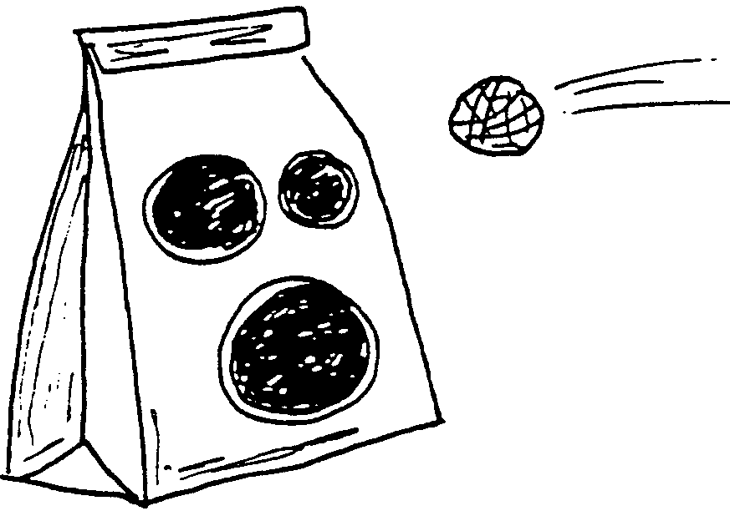

PICKING UP LITTER
(Tune: I’ve Been Working on the Railroad)

I’ve been picking up the litter,
All the live long day;
I’ve been picking up the litter,
Just to have a place to play.
Can’t you see the litter basket
Sitting on the sidewalk there?
Every little bit will help us,
If you just show you care.

Won’t you pick it up?
Won’t you pick it up?
Won’t you pick it up today?
Help us clean it up.
Help us clean it up.
Help to clean the U.S.A!

LITTERBUGS BEWARE
(Tune: Auld Lang Syne)

We are the folks who hunt the bugs,
That litter up our streets,
With papers, bottles, old tin cans,
And wrappers off their sweets.

CHORUS
No litterbugs,
No litterbugs,
No litterbugs for us.
Let’s start today to do our share
No litterbugs for us.

We want to keep our playground clean
Without a lot of fuss,
Let’s start today to do our share
No litterbugs for us.

CHORUS

THIS EARTH
(Tune: This Land is Your Land)

From the Russian Border to a New Yorker.
The Chinese Great Wall, rainy forest.
A bit of heaven a-spinnin’’ free.
(Yes!) This Earth is home for you and me.

We breathe the same air, under the same sun.
The same rain gives life to everyone.
Birds a-flying, fish a-swimming.
(Yes!) This Earth is home for you and me.

Earth is round, for a reason.
Helps us all be on a center stage.
See each other as Sister and Brother.
(Yes!) This Earth is home for family.

We eat the same food, a little bit different.
Wear the same clothes, but don’t look the same.
Our skin might be a shade of color.
(Yes!) Earth is the same for you and me.

What we do in our own country.
Makes a difference somewhere else.
So how we care for air and water,
Makes Earth alive for you and me.

In this Garden that we call Earth,
God gave us all our gift of birth.
Got a feeling it’s time for healin’
This Earth is home for you and me.

This Earth is your Earth.
This Earth is my Earth.
From North to South pole
We feel it’s great worth.
Form ozone layers to the deep blue sea,
(Yes!) This Earth is meant for you and me.

TWO NEWSPAPER BUNDLERS
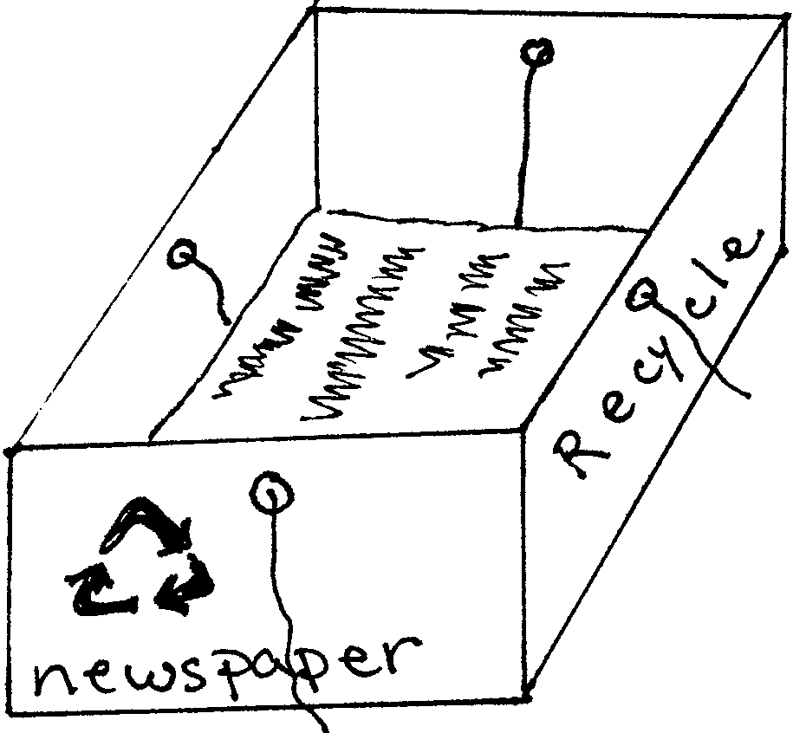
CARDBOARD BIN
You will need: Large cardboard box; Leftover latex house paint; Permanent markers; Cord; Scissors

1. Paint the box with latex paint to give it more strength. Decorate it with markers.
2. Punch holes in the four sides centered and near the top of the box.
3. Place the cords across the inside of the box and up through the holes.
4. Pile in the newspapers each day. When the box is full, pull the loose ends of cord from the holes and tie securely to bundle. Slide the bundle out of the box.

WOODEN BUNDLER
You will need: 16" x 18" plywood; 8 medium sized dowels (each about 6" long); 8 large wood screws for the dowels
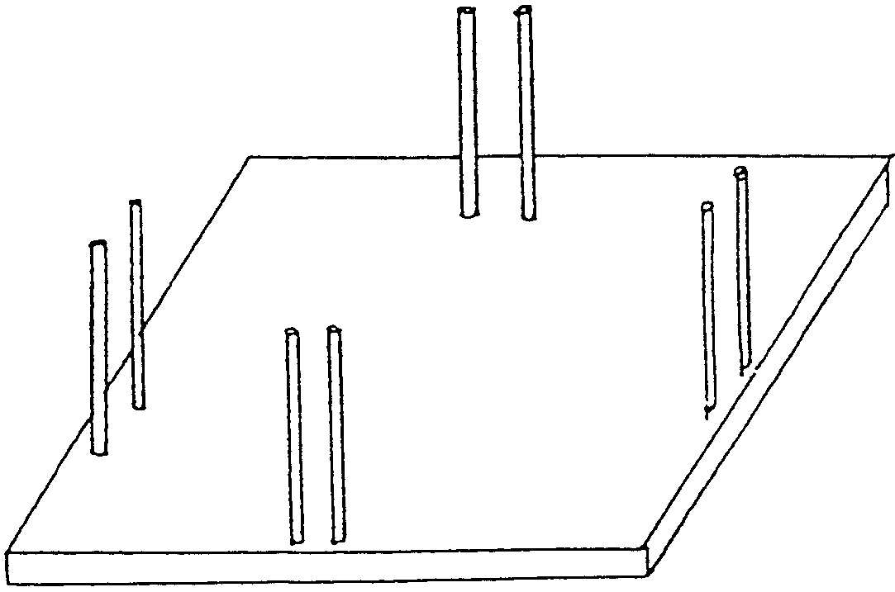

1. Mark eight holes in the plywood base for screws to secure the dowels. The screws should be positioned at the edge of the board about one inch apart and one inch in from the edge. Two dowels per side.
2. Before stacking the papers, cut 2 strings about 3 feet long. Place the strings on the board between the dowels. The middle of the strings should cross in the middle of the board.
3. Lay the papers, neatly stacked on the board. Press them down and pull up the strings around the stack. Tie the strings using a secure knot.
4. Lift a neat, secure bundle and stack until recycle day.

Paper or plastic? What’s the smart decision? There’s trouble with both choices, actually. Paper produces PCBs and other serious pollutants when it’s made. Plastic is a problem on the other end, when you throw it away. Most plastic is non-biodegradable, and clogs landfills. So, ask the cashier if the supermarket takes back used plastic bags for recycling. If it does, choose plastic. If not, choose whichever you can make the most use of at home. The best solution is to bring your own bags! Canvas, cloth or mesh bags are inexpensive and can be washed and reused again and again.

CAN CRUSHER
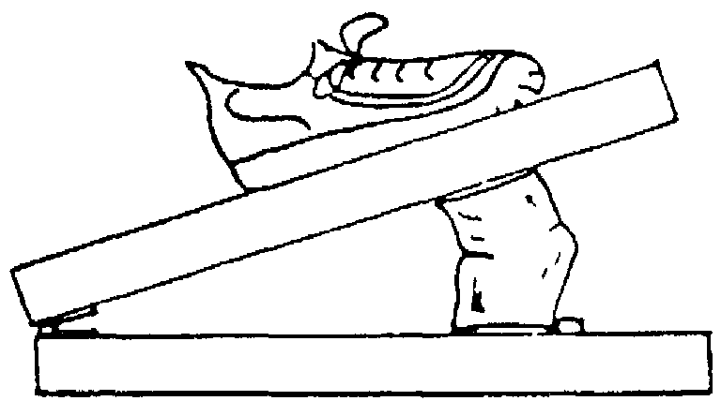
You will need: 1 piece of 2" x 8" wood, cut 2 feet long; 1 piece of 2" x 4" wood, cut 2 feet long; 1 heavy-duty door hinge; 6 flat-head screws; 1 lag bolt 1/4" x 1-1/2"

1. Position each hinge plate on the board as shown. Note that the hinge-pin loops extend beyond the board edges. Be sure the countersunk screw holes are facing upward. Mark the hole locations. After drilling, screw the plates in place.
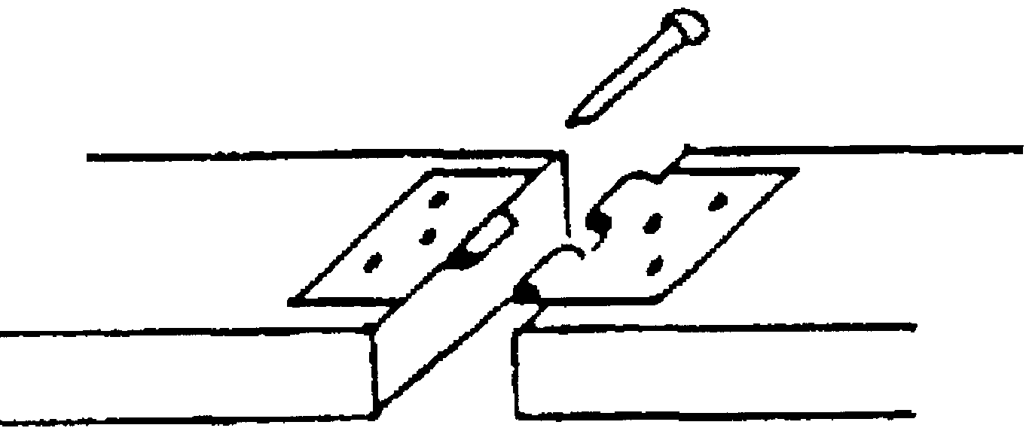
2. Drill 5 holes down the center of the base board for the lag bolt. Start the holes 7" from the hinge and space 1" apart. The purpose of the lag bolt is to prevent the cans from sliding when pressure is applied.

PLANET EARTH

This earth is made from a balloon. Because your balloon probably won’t create a perfectly shaped sphere, it is going to be even more scientifically accurate because our planet isn’t a perfectly shaped sphere, either!


You will need: Good quality balloon; Recycle white paper; Flour; Paints; Tissue paper (bright blue, green and brown); Mug; Fishing line or string.

1. Tear paper into one inch strips.
2. Mix flour with water to make glue.
3. Blow up the balloon.
4. Cover the balloon surface with three or four layers of paper strips dipped in the glue mixture. Use a mug to support the balloon while you work, so it won’t roll around . Allow it to dry. (This is a two-meeting project.)
5. Paint in the continents and oceans with appropriate colors. OR
6. Tear tissue papers into small pieces. Dip the tissue papers in the glueand water mixture and then layer them in the appropriate places. Use the brown and green colors for continents and the blue for oceans. Then cover with a layer of more tissue pieces. This method creates a more “abstract” looking earth since tissue paper colors run and blend with each other to some extent.
7. When dry, coat with an acrylic spray and hang with fishing line.

JUG BIRD FEEDER
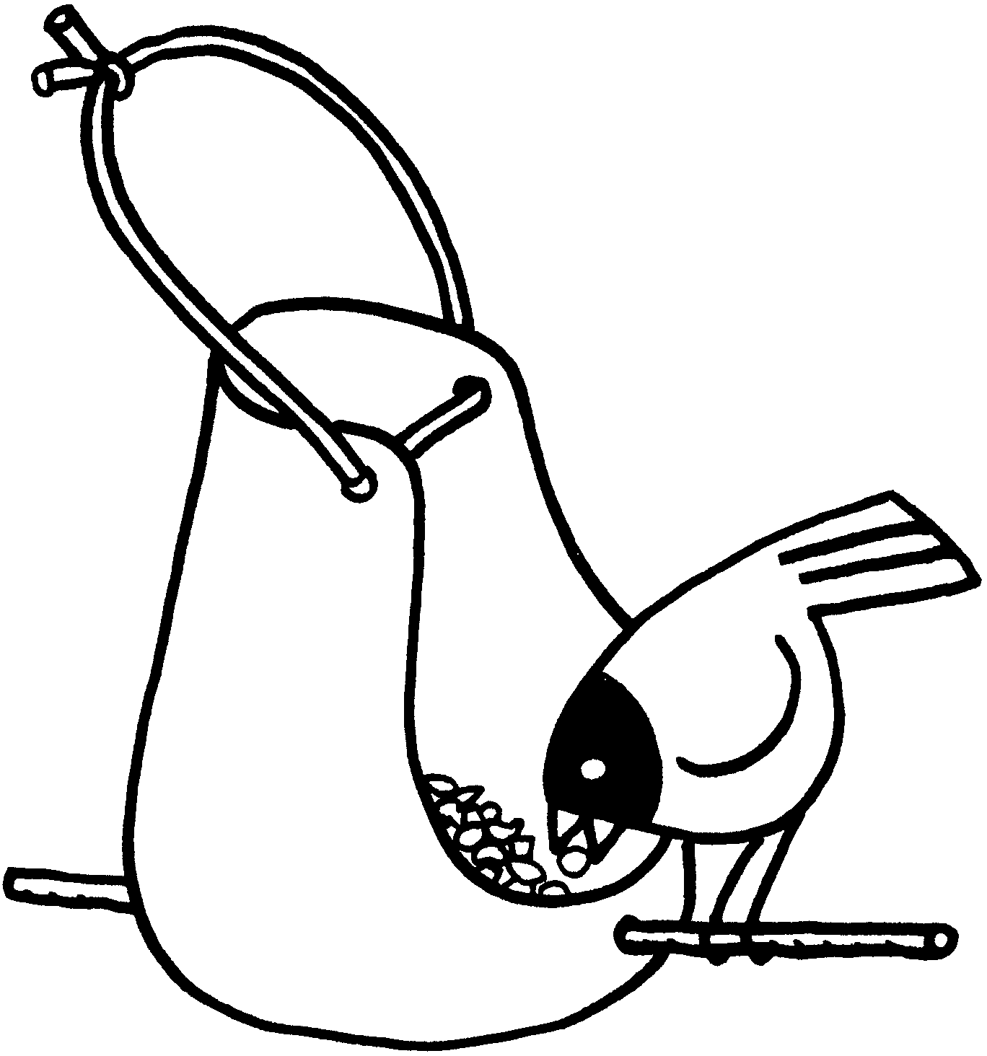
You will need: Gallon plastic jug; Wire, string or leather strip, 12" long; Stick or dowel, about 12" long; Permanent markers (optional)

1. Cut away the sides and top of the jug, leaving a base of about 1 1/2".
2. Poke 2 holes in the plastic with a nail, using scissors or a knife to enlarge the hole if needed.
3. Decorate the feeder with markers, if desired.
4. Push the stick through the holes, so it pokes out both sides to give the birds a perch.
5. Poke 2 holes through the top and insert the wire or string.

BERRY BASKET BIRD FEEDER

You will need: 2 plastic berry baskets; 2 slices of bread; Peanut butter mixed with shortening; String; Birdseed.
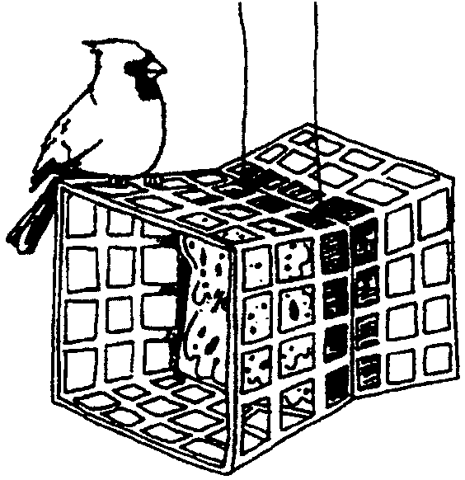

1. Tie the baskets together, bottom to bottom.
2. Spread the peanut butter and shortening mixture on both sides of the bread. Dip in birdseed.
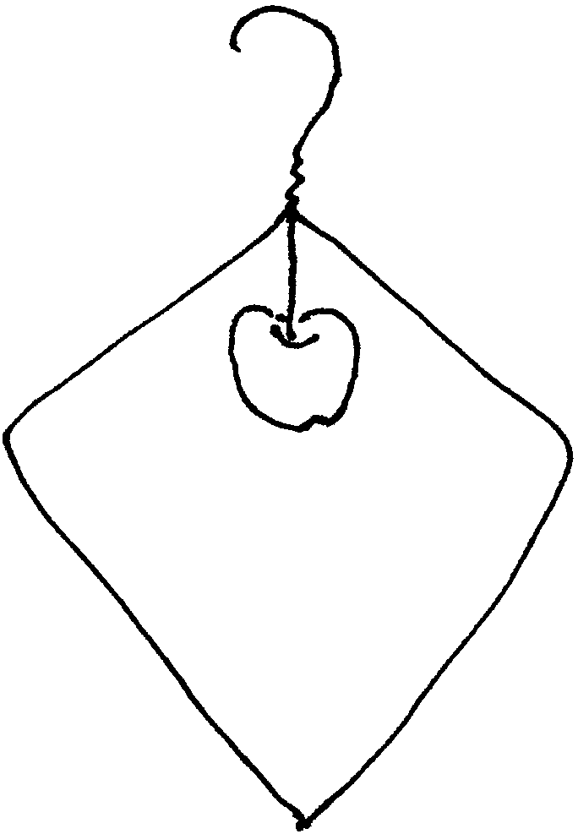
3. Put a slice of bread into the bottom of each of the berry baskets.
4. Hang the baskets with the string.

COAT HANGER BIRD FEEDER

You will need: One wire coat hanger; Pliers

1. Unbend coat hanger. Leave the hook and the squiggly end that wraps around below the hook as they are. Straighten out all the rest.
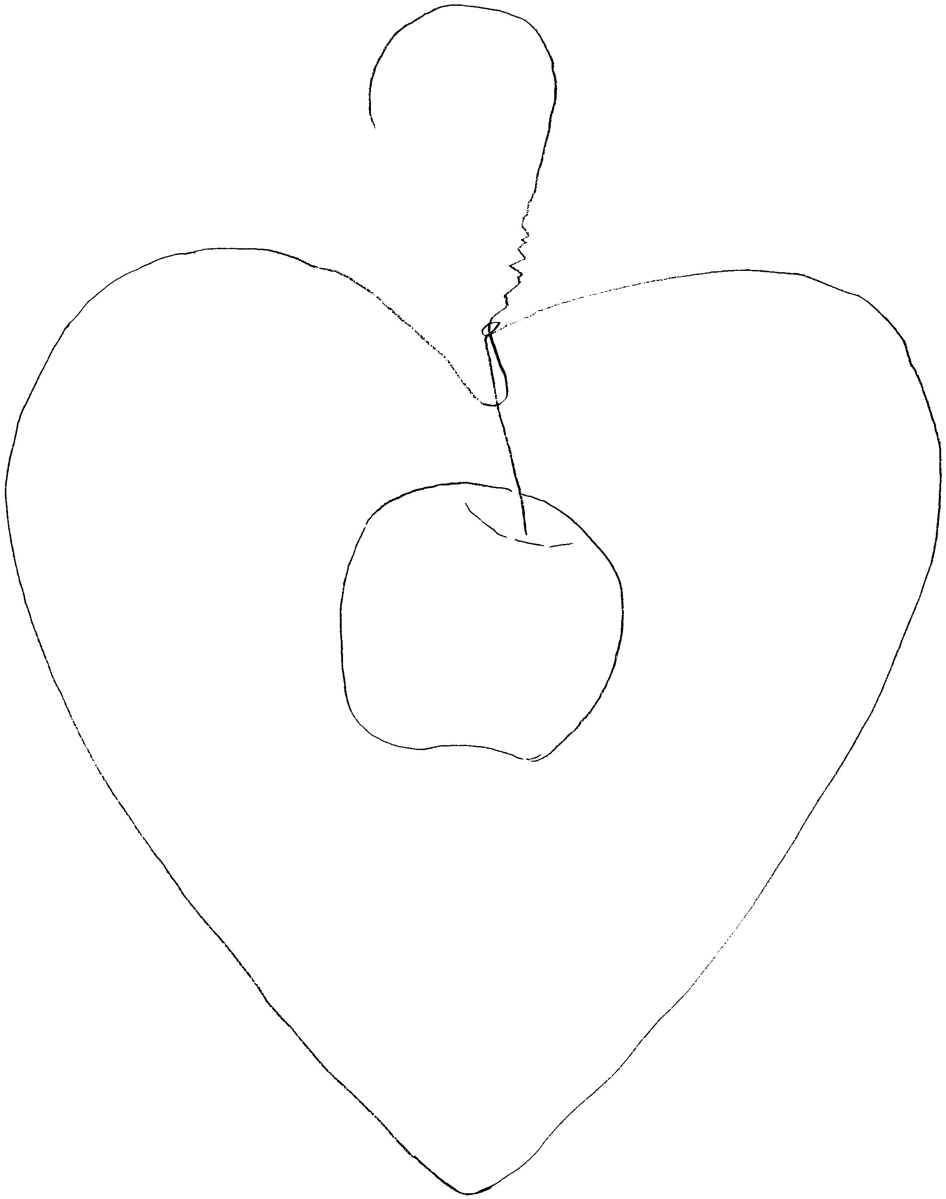
2. Beginning just below the hook, shape the wire into a simple shape. Close the wire shape by wrapping around the squiggly end, leaving about 4" of the end.
3. Bend the squiggly end straight down.
4. Place a piece of fruit on the squiggly end and hang the feeder outside.

Experiment with different fruit to see what the birds in your yard prefer.
(from Kids Crafts)

For more bird feeder designs, see Cub Scout Leader How-to Book, pp. 3-23, 3-37, 8-12 to 8-14.
“RECYCLED” GARDENS

Don’t throw away carrot tops, beet tops, grapefruit seeds, old potatoes or avocado seeds!
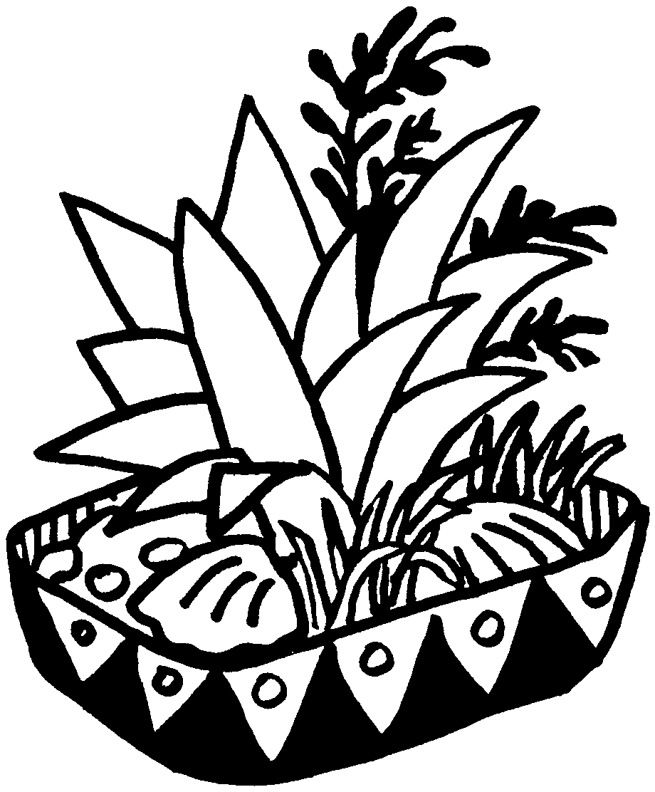
DISH GARDEN
You will need: Used, large plastic jug; Your choice of vegetable or fruits (see below); Birdseed; Charcoal briquettes; Sand and water.

1. Trim the jug so that you have a planting bowl about 1" high on the sides.
2. Decorate with permanent markers, if you wish.
3. Crush charcoal briquettes and sprinkle at the bottom of the bowl to prevent the soil from turning moldy.
4. Fill the bowl with moist sand.
5. Decide which plants to grow, selecting from the list below. Plant your choices following their directions.
6. Soak birdseed overnight and scatter around the plant.
7. Keep the sand moist, but not too wet.
8. Keep your garden in a sunny spot.

Carrots: Carrots must be started in water. Cut the carrot tops off, leaving about 1" of carrot below the top. Set the tops in a bowl of water until they begin to sprout new leaves on top. Then transplant to your garden.

Beets: Cut the tops off. Trim the leaves off and plant the top in the sand.
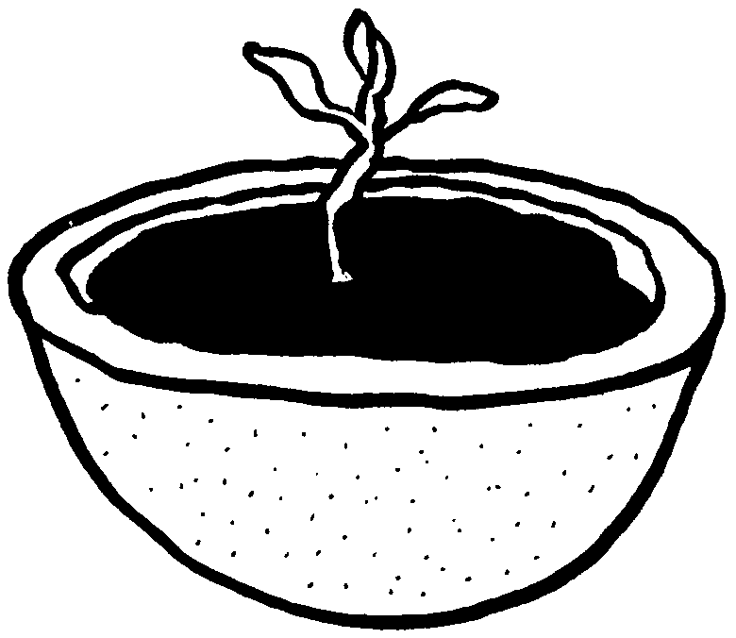

Grapefruit: Soak the seeds overnight, before planting in the moist sand. (Grapefruit shells , filled with potting soil, make interesting pots for the plants themselves.)

Potato: Cut into sections, each with an eye or two, and plant.

Pineapple: Cut off the top 2” of the fruit. Let it dry for 2-3 days, and then plant it in the moist sand.

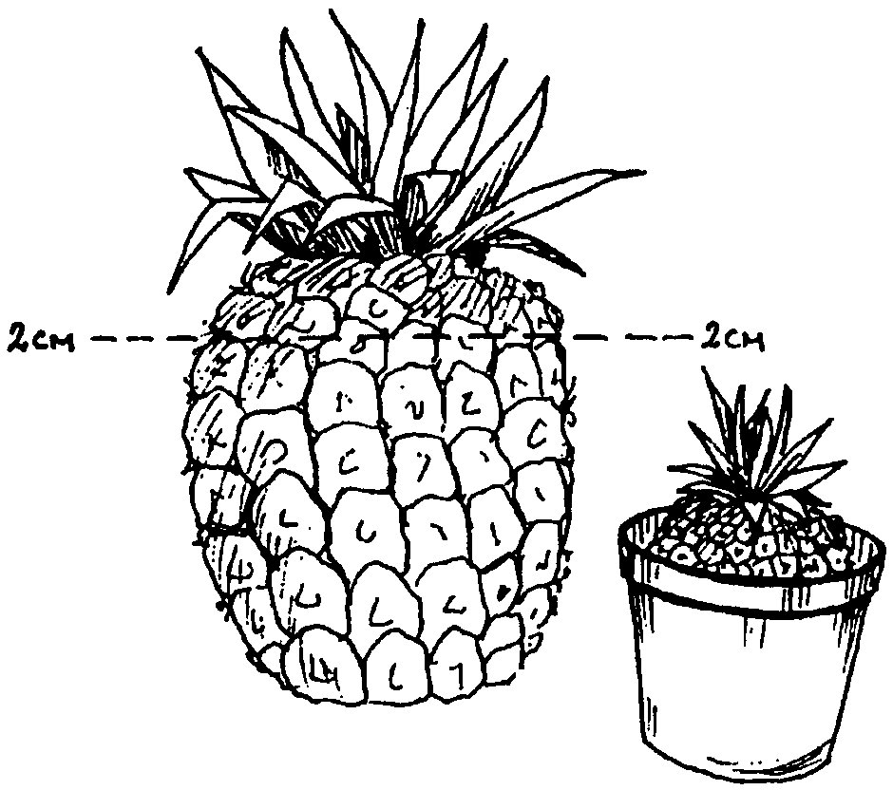
NOTES ON PINEAPPLE
Save the top of a very ripe pineapple and place it on a plate with water on it--or in a pot with potting soil in it. If the pineapple is ripe enough, you will soon have a pineapple plant.

“RECYCLED” GARDENS (continued)
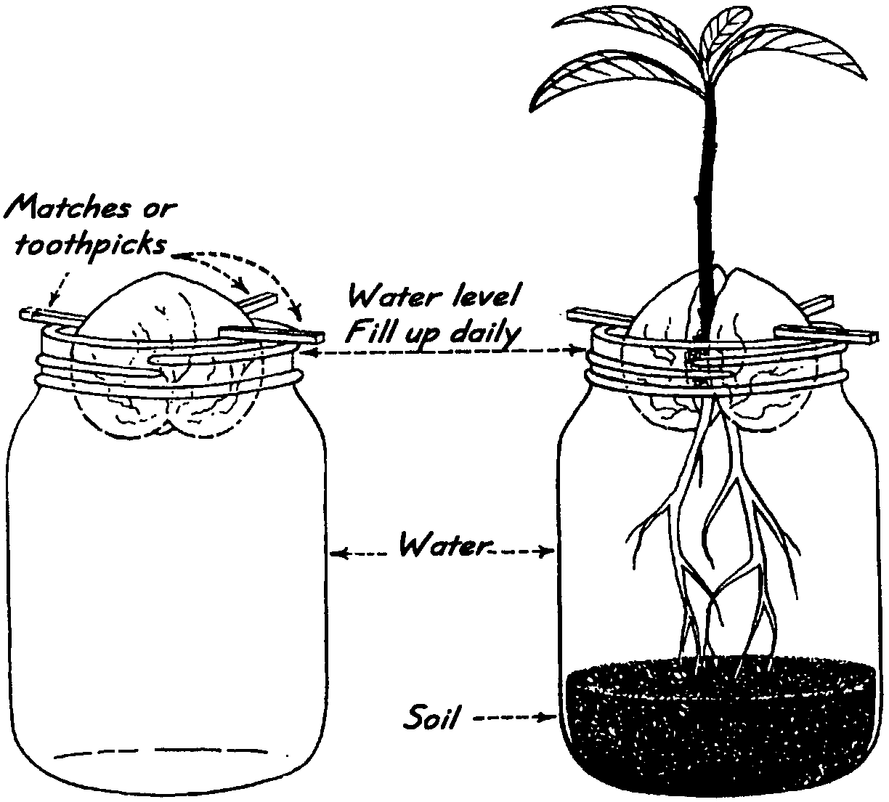
AVOCADO
Remove the seed carefully out of a very ripe avocado. Stick three toothpicks into it so it can be suspended flat end down in a glass jar. It should just touch the water.
Keep in a light place. Watch the root develop first. After top growth starts (this takes about a month), cut off the tip of the growth so that the plant branches out. Plant in a pot containing good soil.
Note: You can also plant the seed directly in a pot but then it is not possible to study how the root and stem begin to develop.

SHRINK ART

Recycle your plastic and make sun catchers, pins, magnets, key chains, ornaments, etc.

You will need No. 6 type plastic (Many plastic food lids are of type 6).

1. Put a design on the plastic. You may want to trace a picture or draw something original. Color with permanent markers or colored pencils. (If the plastic doesn’t take your pencil or marker, sand with extra fine sandpaper in both directions.)
2. If you want a hole in it, punch it now, using a regular hole punch. Cut out your design.
3. Put in a toaster oven on a piece of aluminum foil under TOAST. Have fun watching your plastic shrink. Depending on how hot the oven is, it will start shrinking in 25-30 seconds. (The plastic could be shrunk in a regular oven set at 275 to 300 degrees.)
4. The plastic will shrivel and eventually flatten out. It is done when it gets flat.
5. Take it out and flatten with a pot holder until it cools. If your pieces are not completely flat, you can put them back into the oven. You could even add more color to your piece if you find it needs more, then heat it up again.
6. The colors will be more intense than when you started. If you didn’t use permanent inks, spray the piece with a sealer now.

LITTER BARREL NECKERCHIEF SLIDE

Use a film canister. Cover the canister with vinyl tape or paint as desired (Green is a suitable color). Add the words “Litter,” “Pitch In,” or “Don’t be a Litterbug” on the outside. Attach a piece of 1/2" PVC pipe onto the back.
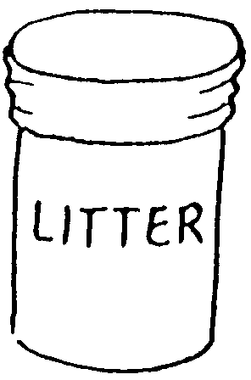

This slide will even hold small bits of real litter!

See Cub Scout Leader How-to Book for:
“Litter Bag” (p. 3-31)
“Plastic Bottle Terrarium” (p. 3-38)
“Make a Terrarium for Plants” (p. 8-9)
“Sealed World” (p. 8-9)

SPROUTING NECKERCHIEF SLIDES

You will need: Film canister; Cotton balls; Alfalfa seed or grass seed; 1/2" PVC pipe; Small piece of paper and markers; Glue gun or craft glue.
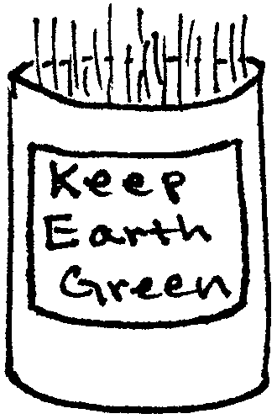

1. Wash the film canister thoroughly and dry.
2. Write your message or draw an earth-friendly picture on a small piece of paper and glue the paper onto the front of the canister.
3. Place cotton balls in the canister half way. Scatter seed and drench the cotton balls.
4. Attach a section of PVC pipe, keeping the canister upright.
5. Keep your seeds watered.
Alfalfa--keep it away from sunlight. The slide will be ready to be worn within a week. This slide will last only 2-3 weeks. (You can eat the sprouts.)
Grass seed--keep in a sunny place. The slide will take 7-10 days to be ready. If grass gets too long, trim it. Later you could transplant the grass in your yard.
6. To wear: Drain the canister--plant and cotton ball will not fall out. After wearing it, water again.

Note: Mixed bird seeds are not good for this project since plants will not grow at the same rate.

A PANDA MASCOT--THE CONSERVATION SYMBOL
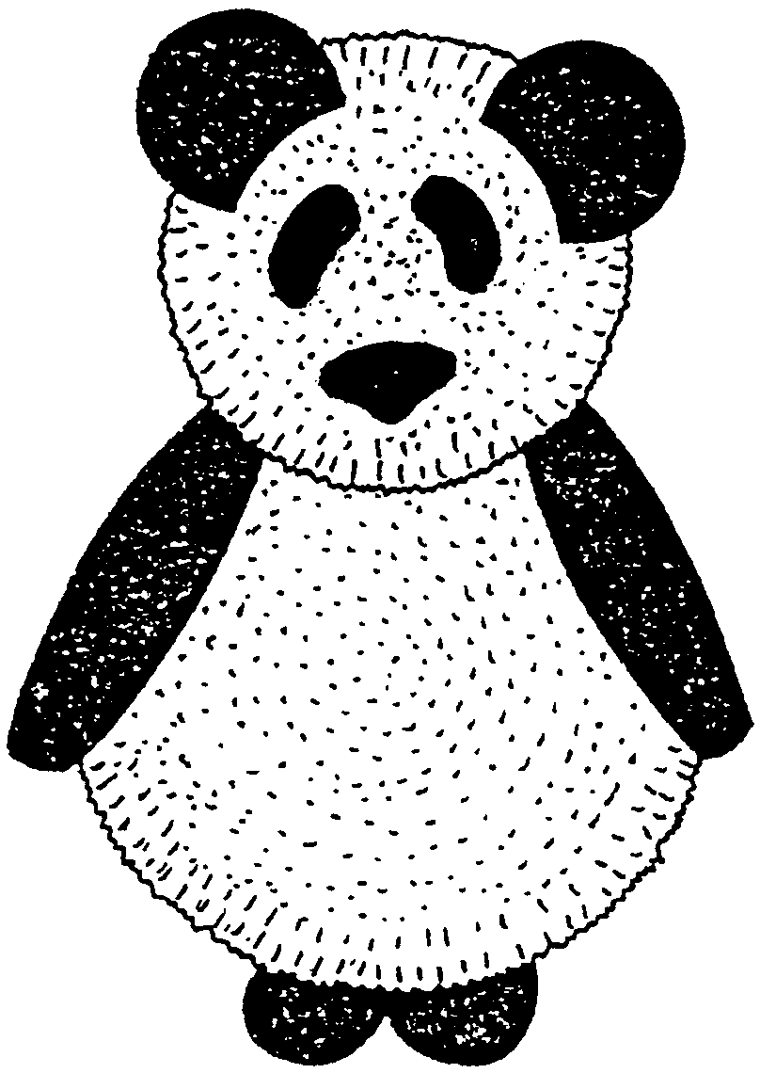
Make two pompoms from white yarn. One should be slightly smaller than the other. (Or use store-bought pompoms.) Cut out ears, eyes and nose from black felt and feet from black cardboard. Glue pieces together.

To make a pompom:
1. Cut two discs about 5 cm across from strong cardboard.
2. Cut a hole in the middle of each disc.
3. Put the discs together and wind yarn around and around through the center hole until the covering is very thick and even.
4. Insert a blade of scissors between the two discs and cut carefully around, making sure the yarn is not pulled out.
5. Put a piece of yarn between the discs and tie tightly.
6. Pull off the discs, fluff up the ends of the yarn and you have a pompom.
7. Trim the discs for the second pompom.

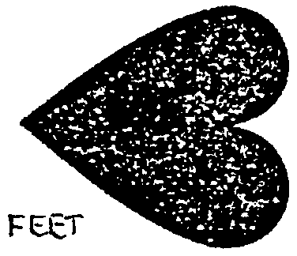
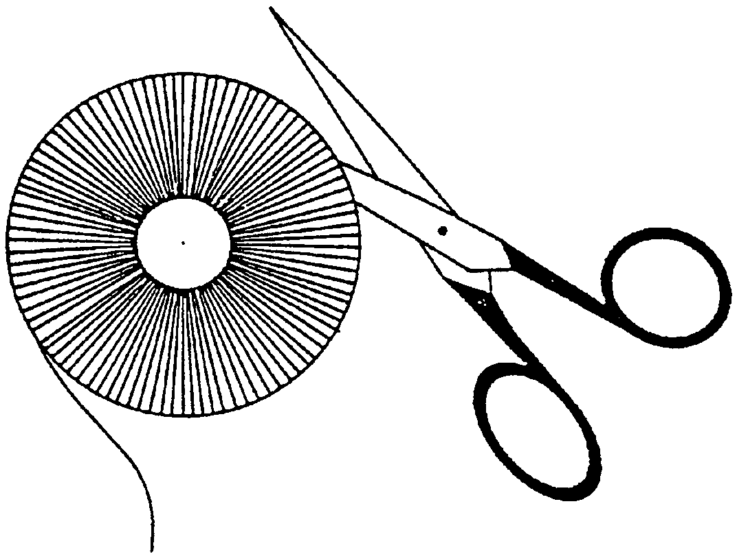
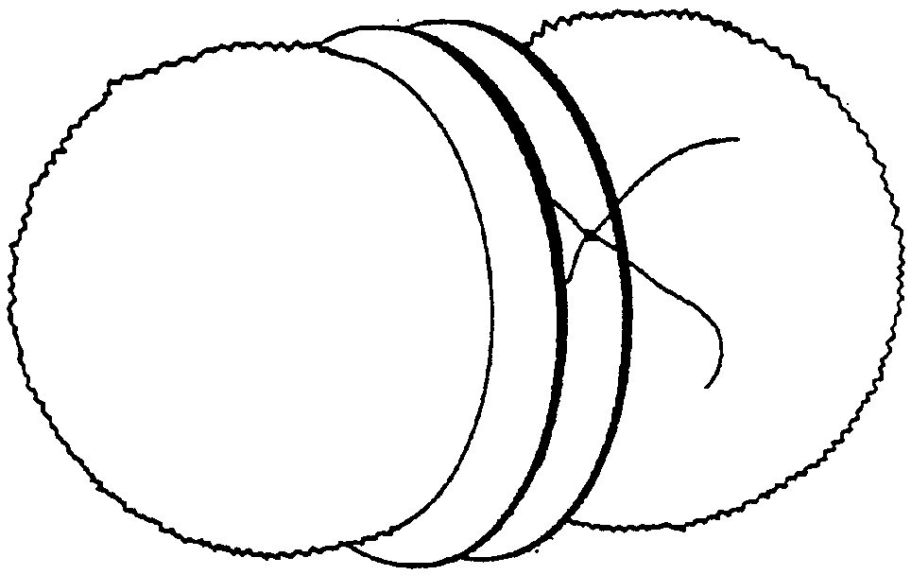

DIRT CUPS

2 cups cold milk
1 package (4-serving size) Jell-O Instant pudding, chocolate
3 1/2 cups (8-oz) Cool Whip, thawed
1 package (16 oz) Oreo cookies, crushed
8 to 10 8-oz cups
Gummy worms

1. Pour 2 cups of cold milk into bowl. Add pudding mix. Beat with wire whisk until well blended, about 2 minutes. Let pudding stand 5 minutes.
2. Stir Cool Whip and 1/2 of the crushed cookies into pudding very gently with rubber spatula until mixture is all the same color.
3. Place about 1 tablespoon of the remaining crushed cookies into bottom of each cup.
4. Fill cups about 3/4 full with pudding mixture. Top each cup with the rest of the crushed cookies. Put cups into refrigerator to chill until set, about 1 hour.
5. Add gummy worms.

TASTY BIRD NESTS

2 large shredded wheat biscuits
1/4 cup coconut
1 Tbsp brown sugar
1/4 cup margarine, melted
Fruity Bird Eggs--red or green grapes, blueberries, strawberries, melon balls, drained canned fruit
Yogurt (optional)
Muffin tin

1. To make the nests, in a mixing bowl crumble shredded wheat biscuits with your fingers. Stir in coconut and sugar. Pour in the melted margarine. Stir everything together.
2. Line 6 muffin cups with foil pieces. Press the shredded wheat mixture onto the bottom and up the sides of the foil-lined cups. Bake in a 350 oven about 10 minutes or till crisp. Cool the nests in the cups.
3. Remove the nests from cups by lifting up on the foil. Carefully peel the foil off nests. Fill the nests with Fruity Bird Eggs. If desired, top the fruit with a spoonful of yogurt.

Makes 6 bird nests

GUMMY RAINDROPS

1/4 cup cranberry, apple, or grape juice Makes about 36 raindrops
1 envelope unflavored gelatin
1 Tbsp sugar

1. Place the fruit juice in a small saucepan. Heat over medium heat until it boils. Remove the pan from the heat.
2. Immediately sprinkle the gelatin on top of the juice. Stir the mixture until the gelatin dissolves.
3. Cover a cookie sheet with waxed paper. Spoon the gelatin mixture onto the cookie sheet in 1" raindrops. Allow them to cool slightly and then sprinkle lightly with sugar.
- Cool on the cookie sheet for 10 more minutes. Peel the raindrops from the waxed paper.

RECYCLED CRAYONS

If you have bits and pieces of old crayons that are too small to work with, you can make brand-new round ones.

You need: Old crayon pieces; Miniature muffin pan; Aluminum foil.

1. Peel the paper off all the crayons. Divide the crayon pieces into color families. For example, put pieces of red, pink, maroon, and burgundy crayons in the red group.
2. Preheat the oven to 200. Line the cups of a miniature muffin pan with pieces of aluminum foil. Let some of the foil extend beyond the top of each muffin cup. Put the crayon pieces from one color family in each cup. Put the muffin pan into the oven for 10 minutes. Remove the pan and set it aside to cool for 30 minutes.
3. When the crayons are cool to the touch, pull the aluminum foil out of each muffin cup and peel it away from the circular crayon.

For a really fun new crayon, try using two or three colors in one muffin cup, like blue and green, or yellow, orange and red. Don’t combine more than three colors or you’ll end up with muddy color.

SIDEWALK PAINT

This paint is non-toxic and biodegradable.

1 cup water
1 cup powdered milk
1/4 tsp food color

Put the three ingredients into a jar. Stir thoroughly. Make several colors.
Note: Paste food color for cake icing will give especially glorious colors of paint.

Use assorted sizes of paintbrushes and sponges to draw on the sidewalk.
Ask the Cub Scouts to decorate your driveway or sidewalk with pictures of the world without pollution. Next rainstorm will wash away the artwork.

