Splish, Splash!

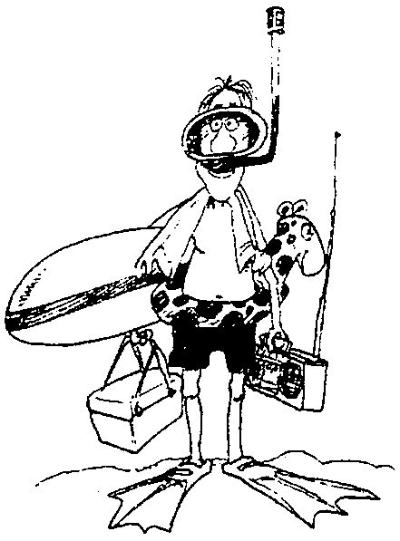

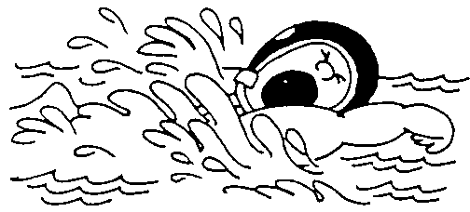

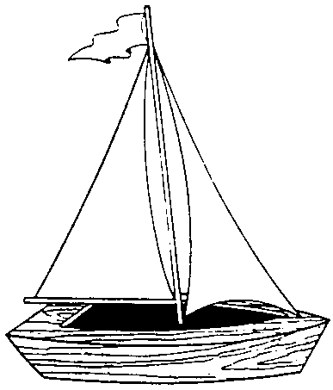

AUGUST 1999

BEACHLESS BEACH PARTY

You may want to combine this with a Raingutter Regatta and/or family picnic.

PREPARATION
You should have two or more beaches, depending on the size of your group. For the pack meeting, each den can have a beach--part of the decorations can be done at the den meetings. If this beach party is for the den only, each family can have a beach, or combine families. Name the beaches like Palm Beach, Santa Cruz Beach, Waikiki Beach, etc. Decorate the beaches--use your imagination. You may want to set a theme for your beach, such as palm leaves for Palm Beach. Arrange some chairs, umbrellas. If the meeting is held outside, add benches and picnic tables.

GAMES (Add more of your own. See the games section for this month.)
Swimming Race
One player from each beach. Each player should have before him a deep pie pan filled to the brim with water, with four or five Lifesavers at the bottom. He must get these candy pieces out with his mouth. His hands must be behind him.

High Dive
One player from each beach. Each is provided with a pitcher of water. On the floor at their feet is an empty tumbler. The player has to stand and try to fill the tumbler. The player who gets the most water into the tumbler wins. In case of a tie, time is taken into consideration.

A Clam Dig
This is a team game. A box of sand will be necessary. Hide 10 peanuts in the sand for each team. Give each team a spoon and a bowl. Give a signal to go, first players run across the room to the sand pile, dig out the peanuts, put them in their bowls, and return. Each player can dig only one “clam” at a turn.

Sailboat Race
Stretch as many strings across the room as you have teams. On each string, place a paper cone. Each player is a to blow his boat from one end of the string to the other end. He then pushes the cone back with his hand to the starting point for the next player. The game proceeds in a relay fashion.

Snorkel Race
You will need a pair of old swimming flippers for each team. If you can’t find them, use pairs of large size shoes and limit the race to children. Set a turning point at a short distance for each team. Run the course in a relay fashion.

ANNUAL PACK PLANNING CONFERENCE

It’s time to plan the pack’s program for the coming year. Pick up your unit’s Program Packet at this month’s Roundtable. Cub Scout & Webelos Scout Program Helps 1999-2000 should be available at the Scout Shop sometime during the summer.

DEN AND PACK ACTIVITIES

Raingutter Regatta
For suggestions, see Cub Scout Leader How-to Book, pp. 9-47 to 9-48.

Pirate Picnic
For suggestions, see Cub Scout Leader How-to Book, pp. 9-9 to 9-10.

Water Carnival
For suggestions, see Cub Scout Leader How-to Book, pp. 9-15 to 9-16.

Fishing Derby
For suggestions, see Cub Scout Leader How-to Book, pp. 9-16 to 9-18.

Field Trips (Refer to the Field Trip section for details)
Monterey Aquarium
Tide pools--Natural Bridges State Beach has great tide pools. If you request in advance, rangers can arrange a tour on a low tide day, if possible, and give your group a tour. They are very good with children. And the tour is free! Afterward play at the beach!

BACKYARD WATER FROLIC

Have a den backyard water day. Include parents and siblings. Make sure children bring swim suits or changes of clothes, and towels.
Set up one area in the backyard for a water war, one for sprinklers and hoses, and one for a water slide. For the water war, you’ll need squirt guns, basters, squirt bottles, plastic pails, and sponges. Set up the hose and sprinkler in another area. If possible, poke holes in an old garden hose so there’s lots of spray to run through. Make a slippery water slide by cutting several large plastic garbage bags open to form long rectangles and taping them together with waterproof tape. Place the “slide” on the lawn, preferably on a gentle incline. Set a hose at one end to create a rush of water.
Let the kids start off with a water war. Divide them into teams. At the signal “Go!” they can squirt the water guns, throw the sponges, or even haul around the pails full of water to get their opponents soaking wet. Include parents--Children will love soaking adults. (Of course you soak them too.) Caution children to avoid squirting in the face.
Let the kids give the water slide a try. To prevent long lines at the slide, divide the kids into teams and have one team play in the sprinkler and the other on the slide. Switch after a time.
For a snack, serve watermelon. Can they guess how many seeds are in it? Have a watermelon seed spitting contest--see who can spit the furthest or most accurately. By the end of snack, kids will be sticky--they can run through the sprinkler again.

SPLASH IN CUB SCOUTING FUN AT THE ROUNDTABLE

SCRAMBLED WATER

When you unscramble the following words, you will know eight kinds of bodies of water.

KEAL NECOA YOUBA
DROJF FULG GOANOL
NOPD VERIR

Answers: Lake, ocean, bayou, fjord, gulf, lagoon, pond, river

UNDERWATER WORDS

How many words can you make from the letters in the word UNDERWATER?
Who can make most words? How about the longest?
(At least 80 are possible! Probably even more.)

WHAT IS IT?

First you need water, then one windy blow; next jump on board and away you go!

SAFE SWIM OPENING

Arrangement: Make card for each letter. Write the line for each boy on the back. The boys can carry water activity toys such as innertubes, balls or snorkeling equipment.

S S is for Scouts, we have fun.
A A is for Activities, out in the sun.
F F is for Friends, your buddies in the pool.
E E is for Excitement, but keep your cool.

S S is for Safety, that must come first.
W W is for Water, not only for thirst.
I I is for Instructions we follow with care.
M M is for Merriment we all love to share.

Putting them all together and we have SAFE SWIM.
Let’s be safe and we will all win.

CUB SCOUT FISH OPENING

Arrangement: 8 Cub Scouts holding cardboard pieces, which make a fish when put together. Each part is lettered, so that all together they spell CUB SCOUT, C being the head of the fish and T the tail. Each boy’s lines are written on the back of his card.

(Boys enter one at a time and repeat their lines in order.)

C.S. #1: C is the part we build on. It stands for COURTESY in Cub Scouting and all through life.

C.S. #2: U is next. This part stands for UNITY, because united we are strong.

C.S. #3: B is the next added. That stands for BRAVERY in all our thoughts and all our deeds.

C.S. #4: S is next and that stands for SAFETY. We learn it and use it.

C.S. #5: C adds some more and it stands for CHURCH--the one of your choice.

C.S. #6: O is building it stronger, and it stands for OUTDOOR life which is full of fun and adventure.

C.S. #7: U is near the finish and it stands for UNDERSTANDING, something that all our families have.

C.S. #8: T is the tail that guides us. It stands for TRUTH in all things.

All: Will everyone rise and please join us in the Pledge of Allegiance?

WATER 101 OPENING

Arrangement: Cubmaster is dressed in a long laboratory coat and slacks that are easy to remove, holding a clipboard, and carrying a briefcase. (He is wearing beach clothes underneath the slacks)

Cubmaster: (Very seriously)
Welcome to our Water 101 college pack meeting. I am Professor Cubmaster and I hope that you are all prepared to listen closely and take notes. We are here today to learn about a very important substance--H₂O, otherwise known as water. Now the first thing we will study is the molecular structure...

Pack Committee Chair: (Runs in to interrupt Cubmaster)
Excuse me, Professor, but today’s pack meeting is Splish, Splash. We are supposed to have fun with water, not lecture in Water 101.

Cubmaster:
Oh, but I’m sure my secretary told me about a Water 101 lecture I was to give today. (Consults pocket calendar.) How embarrassing. That’s next week. Luckily, every good Scouter comes prepared for nearly everything. Excuse me a moment. (Cubmaster goes away and comes back in beach-going clothes. He opens his briefcase, pulls out sandals, a beach towel, snorkel and fins. He also takes out a small water squirter and squirts the committee chair.) Today we are going to have water activities. It’s going to be fun! Who’s ready to join me??

SPYGLASS FLAGS OPENING

A den of Cub Scouts, dressed in pirate costumes come to the front. There is a container in front with a sign that says “sea water waves” to indicate they are out at sea. One Cub is carrying a spyglass and one Cub is carrying a pirate flag. The pirate flag is held high to show that they are proud of it. The Cub with the spyglass points it toward the audience and looks around. At the rear of the room, a color guard is waiting to present the American and pack flags. The Cub gets a look of surprise on his face as he looks through the spyglass and sees the color guard. He excitedly shows some of the other pirates and they take turns passing around the spyglass.

In unison they say: Did you see that? They have TWO flags, and they’re REALLY beautiful flags, too!

The Cubs all look down at the little pirate flag in disgust. The Cub Scout holding the pirate flag tosses it into the “sea.” All the pirates run off as the Cubmaster comes walking out.

Cubmaster: Please stand for the presentation of the colors and join in the Pledge of Allegiance while Den ___ presents the great flag of our country and the pack flag.

NET CLOSING

Form a net by clasping hands in any criss-cross design making sure everyone is caught in the net (part of the net). Boys shake each other’s hand that they are holding and say “Do Your Best.”

LIFE IS LIKE A RIVER - CLOSING THOUGHT

As we go through life, let us be ever reminded that life is like a river rushing to the sea, flowing sometimes slow, sometimes fast and yet able to go in different directions. As the water flows, it may stumble but yet continue to flow until it eventually finds its way again. The water may run clear and clean or dark and dirty. And so it is in life, except you are given the choice to choose which direction you will go. Choose wisely.

“WORK WHILE YOU WORK” CLOSING

Tonight we’ve had a lot of fun at our “Splish, Splash” pack meeting. Here’s a thought to take home with you.

Work while you work, play while you play;
One thing at a time, that is the way.
All that you do, do with all your might;
Things done halfway are not done right.

Now Cub Scouts, go out and do your best!

MAKE A FEW WAVES - CLOSING THOUGHT

When fog prevents a small-boat sailor from seeing the buoy marking the course he wants, he turns his boat rapidly in small circles, knowing that the waves he makes will rock the buoy in the vicinity. Then he stops, listens and repeats the procedure until he hears the buoy clang. By making waves, he finds where his course lies. Often the price of finding these guides is a willingness to take a few risks, to “make a few waves.” A boat which always stays in the harbor never encounters danger, but it also never gets anywhere. I challenge each of you to make waves and diligently seek your goals in life. Set your sails for new and exciting horizons.

Minds are like a parachute; they only function when they are open.

FUN WAYS TO SAY THANK YOU

Buoy: “Thank you for helping us to stay on course.”
Cone for Ice Cream: For the person who can lick any job.
Faucet Handle: “You’re turned on to Cub Scouting!”
Lifesaver: You have been a lifesaver in our pack.
Sailboat: For the pack Raingutter Regatta Chairman
Sun: “You are a bright light in our pack”
For Summertime Pack Activities Chairman

FISHING ADVANCEMENT

Arrangement: Set up a partition as seen in the fishing game at a children’s carnival. Make a fishing pole out of a dowel with string tied on it. Attach a clothespin at the end of the string. During the ceremony, each boy will be “fishing” for their awards. Adults will attach his award to the clothespin on the other side of the partition.

Cubmaster is dressed like a fisherman. He calls boys and parents forward. In order to earn their “fishing license” boy need to perform some tasks such as reciting the Cub Scout Motto, using the Cub Scout handshake, or, if the whole den is receiving the same award, yelling their den yell.
After earning fishing license, each boy goes “fishing.”

APPLAUSES

SURF BOARD: Pretend to be riding a surf board, run it onto the beach, jump off, spread arms wide, say “Success!”

DIVER’S CHEER II: Same as above, but jump off and say “Kersplash.” “Perfect!”

THE WAVE: Start with one side and let the wave go around the room twice.

SEAL OF APPROVAL: Elbows together and clap hands straight out and bark like a seal.

SWIMMING: Pretend to swim using the breast stroke, clap hands together as you put your arms forward.

See Staging Den and Pack Ceremonies for “The Six Ships of Scouting” (pp. 54-55)

SHIPS! SHIPS! SHIPS! ADVANCEMENT

Arrangement: The Cubmaster has eight large cut-outs of different kinds of ships (battleship, rowboat, canoe, frigate, submarine, etc.).

There are many kinds of ships in Cub Scouting, just as there are many ships that sail the seas. Here are some of the ships in Cub Scouting.

WORKMAN-SHIP: This ship is neat and clean. When you do your best with the arts and crafts you make in den meetings, your workmanship shows.

FRIEND-SHIP: This is one of the best ships of Cub Scouting. You meet new boys and learn to get along with those in your den. Would the following boys please come forward? They are the new Bobcats in our pack. (Present the badges.)

SPORTSMAN-SHIP: This ship is fair and square. At den meetings you put this into practice when you play games. Congratulate each other often.

FLAG-SHIP: This ship proudly carries our country’s flag. In Cub Scouts we proudly fly our American flag at den meetings and at pack meetings. Would the following boys please come forward? They are the new Wolves in our pack. (Present the badges.)

SCHOLAR-SHIP: A very important ship in the sea of education. In Cub Scouting you learn many new things when working on achievements.

FELLOW-SHIP: Cub Scouts come to den meetings every week to work together, to play together and to have fun! Would the following boys please come forward? They are the new Bears in our pack. (Present the badges.)

LEADER-SHIP: Everyone wants to board this ship. As Cub Scouts you take turns acting as denner. This helps you practice leadership with your friends.

TOWN-SHIP: This ship is named for (city), our hometown. We are happy to live here with our families. I hope you will always remember this is where you started in Cub Scouts. Remember your leaders and your friends here. Would the following boys please come forward? They are the new Webelos in our pack. (Present the badges.)

(Pointing to all the ship cut-outs) These are the ships in Cub Scouting. Keep your fleet sturdy and strong. The ships you launch here in Pack ___ will sail many seas and weather many storms, and they will last your whole lifetime!

THE ADVENTURE UNDER THE SEA

George: “Do your best”
Treasure: “Gold, gold”
Swordfish: “Stab, stab”
Tuna Fish: “Sing, sing”
School of Fish: “Readin’, writin’, ‘rithmetic”

Let’s pay a visit to GEORGE. GEORGE is a Cub Scout and he is also somewhat of a dreamer, like many boys are. One day GEORGE was lying on the beach, day-dreaming about what life must be like under the sea. He knew there must be buried TREASURE, and many a SCHOOL OF FISH swimming around, even some SWORDFISH.

So GEORGE decided it was time to take a trip down under the sea and find out these things for himself. Slowly, GEORGE swam down into the sea, looking all the while for buried TREASURE. He saw a SCHOOL OF FISH. Then a SWORDFISH or two came swimming by. He even saw a TUNA FISH. GEORGE wondered what the TUNA FISH was doing. To his amazement the TUNA FISH was singing, of course, for carrying a tune was its favorite activity.

A SCHOOL OF FISH were swimming by, minding their own business when they were attacked by some bully SWORDFISH. The TUNA FISH just kept singing his tune, which made the SCHOOL OF FISH mad. “Help us!” they cried, swimming faster and faster around the TUNA FISH. But the TUNA FISH just kept on singing. “He won’t help you,” sneered the SWORDFISH. “Everyone knows TUNA FISH is just a big chicken of the sea!”

GEORGE looked around. Somebody help the poor fish! He realized he was the only one who could help them. The TUNA FISH was just interested in singing. GEORGE grabbed the tail of one of the bully SWORDFISH as he swam by. “En garde!” he yelled to the bullies as he brandished the poor unsuspecting SWORDFISH like a pirate’s sword. The SWORDFISH had never seen anything like this. They really didn’t want to fight, so they swam away as fast as their little SWORDFISH fins could carry them.

The SCHOOL OF FISH swarmed around GEORGE. “You are our hero!” they sighed. “It was nothing,” said GEORGE. “I always try to help out when I can. Do a good turn daily is the motto I live by.” The SCHOOL OF FISH began swimming around GEORGE, turning every which way. “What are you doing?” he asked. “Good turns!” shouted the fish. “That’s the motto we live by too!” GEORGE laughed. Maybe he hadn’t found any buried TREASURE today, but he’d done his good turn and found the best TREASURE of all. He made some new friends.

FISHERMAN’S LUCK
Fisherman: “Great day for fishing”
Fish: “Bubble, bubble”
Worm: “Wiggle, wiggle”
Reel: Everyone pantomimes reeling in a fish

Once there was a FISHERMAN who went fishing on a sunny August day. He was hoping to catch a big FISH. He found a nice spot on the bank of the river. The FISHERMAN put the REEL on his rod, and a WORM from a can on his hook and started to FISH. He patiently waited and waited, but no FISH came to eat the WORM on his hook. The FISHERMAN decided to leave his hook in the water, prop up his rod with a stick and take a walk. When he came back, the rod was bending over, and the FISHERMAN was sure that he had caught a big FISH.

The FISHERMAN wound in the REEL, but he found only a stick on his hook. The WORM was gone. So the FISHERMAN put another WORM from the can on the hook and left his rod propped up on a stick again. This time when he came back, the FISHERMAN found the rod was bent over and he was sure he had caught a big FISH. But when he wound in the REEL, he found a tin can on his hook and the WORM was gone.

The FISHERMAN put another WORM on his hook, propped up his rod on a stick, closed his eyes and went to sleep. He dreamed of big, big FISH...hundreds of FISH, jumping out of the water. When he awoke, his rod was bending over again, but the FISHERMAN said to himself, “It’s probably another stick or tin can,” but when he wound in the REEL, there was a beautiful big FISH on the hook. Just what the FISHERMAN wanted.

RUN-ONS

Cub 1: Why do fish have schools?
Cub 2: So the buoys and gulls can get an education.
Cub 1: Do they have Scouts too?
Cub 2: Sure Buoy Scouts and Gull Scouts.
Cub 1: What do buoy scouts do?
Cub 2: Make sure the coast is clear.

THE SPRINKLER

Boy #1: (Looking around for something) I just can’t find it.
(Doorbell or knock is heard. He answers the door.)
Boy #1: Hi, come in. I just can’t find it.
Boy #2: Wow, I’m all wet. I had to run through your sprinkler.
What are you looking for?
Boy #1: I lost my parakeet.
Boy #2: I’ll help you look. (Looks.) Now where did you lose him?
Boy #1: Oh, he flew out the open window.
Boy #2: Out the window? Then why are we looking for him in here?
Boy #1: Because the sprinkler is on and we’d get wet outside.

GONE FISHING

Cast: Dad, Mom, Jimmy, Johnny, and Jerry.
Props: A large box containing lots of fishing gear--tackle box, fishing pole, waders, etc.

Dad: (Coming in from work) Oh boy! My new fishing gear is here! Did I get everything I ordered?
Mom: I think so, but you’d better check and make sure.
Dad: Let’s see...my new waders, my new casting rod and reel. And my new lures...500 assorted lures. I now own the most advanced technology for catching fish that money can buy!
(Jimmy and Johnny enter.)
Jimmy: You got your new fishing gear! When are you going fishing, Dad?
Dad: Just as soon as I put on my jeans and my new fishing jacket.
Johnny: Can we go, Dad? Can we?
Dad: Why sure, boys. I can teach you fellahs all about fishing in the great outdoors. By the way, where’s your brother?
Mom: I haven’t seen him in a while.
(Jerry enters carrying an extremely long string of cardboard fish.)
Jerry: Hi Dad! Look what I caught!
Dad: Where did you get those?
Jerry: Fishing.
Dad: With what?
Jerry: With a stick and a bent safety pin for a hook.
Dad: A safety pin? (Looks at his pile of equipment.) Get me a stick! I’m going fishing with you!

See Cub Scout Leader How-to Book for a puppet play “The Pirates’ Big Decisions” (p. 5-5)

THE FISHING TRIP

Cast: 4 to 8 Cub Scouts.
Props: Fishing gear, a small row boat or cardboard silhouette of a boat, and a sign that says “boat dock.”

The scene starts with the boat about 10 feet away from the boat dock. The Cub Scouts and their Den Chief are on their way to go fishing. The first Cub Scout stops at the dock, then walks out across the water and gets in the boat.

Boy #2: Hey, wait for me! (He walks out to the boat.)
Den Chief: Oh well... (Steps into the water and pretends to fall in and drags himself back to the shore.)

Boy #3: Hey wait up. Here I come. (Walks out to the boat.)

The Den Chief tries and fails again. The sequence continues until all the boys are in the boat and only the Den Chief remains on shore.
Finally one of the Cub Scouts says: “Should we tell him where the rocks are?”

RUN-ONS

Boy 1: Why do you keep doing the backstroke?
Boy 2: I just had lunch and I don’t want to swim on a full stomach.

Fisherman #1: I went fishing last night and caught a fish 3 feet long.
Fisherman #2: I went fishing last night, too. I pulled out a lantern that was still burning.
Fisherman #1: Aw, come on, how could a lantern still be burning if it was under the water?
Fisherman #2: Well, you cut 2 feet off your fish and I will blow out the lantern.

Cub 1: They say that swimming is one of the best exercises for keeping the body slim and trim.
Cub 2: Yeah. Right!
Cub 1: Why do you say that?
Cub 2: Well, did you ever see a whale?

Cub 1: What is the first thing the fisherman caught after running to the river?
Cub 2: His breath!

Cub 1: Do you know what sea monsters eat?
Cub 2: Sure. Submarine sandwiches!

Cub 1: What ship is always managed by more than one person?
Cub 2: A partnership

Cub 1: What do you call a baby whale?
Cub 2: A little squirt.
‘BOYS IN THE WATER’ GAMES

COLORS
Determine the boundaries. Begin at one end, where the player who is “It” stands. The safe zone is at the other end. “It” stands facing away from the water, on the shore. The other players stand in the water or tread water in a line close to “It.” Each of the players in the water thinks of a color and whispers it to a neighbor who is on the honor system and keeps it secret. Don’t let “It” hear the color. “It” starts by calling out colors: “Red, blue, turquoise...” Those in the water listen for their colors, and when they hear theirs, they have to swim quickly out to the safe zone. As soon as “It” hears someone move in the water, he turns around, jumps in and tries to catch the fleeing player or players. If a player is caught before reaching the safe zone, that player becomes “It.” Instead of colors, try cars, baseball teams, animals, etc.

UNDERWATER GOLF COURSE
You will need 9 empty plastic bottles with handles and caps, 9 heavy rocks, 9 golf balls, a net or cloth bag, and a pail. With a marker, number bottles from 1 to 9 (make sure to remove the labels). Attach to the handle a piece of rope long enough to reach the bottom. Tie on a rock as an anchor. Set up the golf course in the water, spacing each “hole “ about 16' apart . Place a golf ball beside each anchor rock. Now the course is set. The object of the golf game is to swim the course with a net bag as fast as possible, gathering all nine golf balls in the bag. Swim to shore and drop them in a pail. Time each swimmer and see who can do it the fastest.

T-SHIRT RELAY
Divide the group into two teams. Have a large T-shirt for each team. Each team member must put on the shirt before swimming his lap in a relay race. It doesn’t matter if the shirt is on inside out.

GOLD RUSH
Scatter pennies or iron washers painted gold in water between knee and waist depth. On signal, players try to get as many “gold nuggets” as they can within a specified time.

TOUCH
Divide group into two equal teams and line them up in parallel lines about 6' apart. The leader calls out the name of an object that is the same distance from both teams--a ball, diving board, edge of the pool, etc. In a relay fashion, all players swim or run to touch the object and return to their places. First team back gets one point.

FROGS IN THE SEA
This is a good game which can be played at a den meeting or in shallow water. Players form a circle around one or more players who sit with their feet crossed. The players in the circle skip (if on land) or walk (if in water) close to the frogs and try to tap them on the head as they repeat the words, “Frog in the sea can’t catch me.” The frogs try to tag the players without rising or uncrossing their feet. If a player is tagged, he changes places with the frog that tagged him.

‘PLAY WITH WATER’ GAMES

STATUES ON THE WALL
This is a fun backyard game. Have the Scouts stand against a brick wall (the side of a house or building). Stray water from a water hose on them and all around them. When they move away from the wall, it will have the outlines of their bodies on it. Stand back and try to guess what the shapes look like. Make up a story to go along with the shapes.

FIFTY YARD SWIM
Each boy hops on one foot carrying a paper cup of water. First one over the finish line with the most water in his cup wins.

BAILING OUT THE SHIP
Divide den into two teams. Each team has a container of water at the starting line, one spoon, and an empty cup. The cup has a line marked about 1" from the bottom. Place it about 20 feet away. Each player takes turns carrying a spoonful of water from the team’s container to its cup. The first team that can fill their cup to the line is the winner.

SPOONFUL OF WATER
Have the boys line up in teams. Give each team member a plastic spoon (except the team captain). Give the team captain a full cup of water. The first Cub steps forward to the captain and hands him his spoon. The captain feeds the Cub a “spoonful of water,” then hands him back his spoon. The Cub goes to the end of the line. The next Cub steps forward to the captain and hands him his spoon. The captain continues feeding each Cub a “spoonful of water” until the water in the cup is gone.

WATER BALLOON BOUNCE
You will need a tarp, sheet or blanket for each team, or teams can take turns. Players hold the tarp at the edges. 3 water balloons are placed in the center of the tarp. By quickly snapping the edges of the tarp outward the balloons are tossed into the air. A point is scored each time the balloons are successfully tossed and recaught. Balloons must go up at least 8 feet in order to score a point. The game ends when a balloon breaks or is dropped. The team that makes the greatest number of successful tosses is the winner.

QUARTER DROP
Have the Scouts from 2 teams. For each team, place a gallon jar 2 to 3 feet in front of the line. Fill each jar with water and place a smaller glass jar in the bottom of the gallon jar. Have each boy try to toss a quarter or iron washer into the jar and into the smaller jar. The team with the most quarters in the smaller jar wins.

SINK THE BOAT
Provide a bucket filled with water and float a small pie plate on it. Have boys stand back about 5 feet and give them 5 small balls made of aluminum foil. (Foil is easy to retrieve because it floats.) Boys take turns throwing 5 balls. Give points for each ball that lands in the pie plate and stays there when thrown from the starting line.

GAMES WITHOUT USING WATER

SUBMARINE DIVE
Draw ahead of time a number of 18" circles with sidewalk chalk. These are submarines. There should be one less submarine than the number of the boys. The Cubs hop, walk or run around the play area according to the directions given by the leader. When he calls “Submarine Dive,” each Cub tries to get into a submarine. The one Cub who is left out stays on a submarine for the next game and so gradually, the submarines become occupied. The winner is the one who gains the last vacant submarine.

BOAT RACE
With a stick for each team, relay teams push an object around two markers and back home. The harder the object is to control, the better. Use spoons, balls, balloons, or lemons (they don’t roll straight). As a variation, pretend you are the wind and blow the boat around the course.

PASS THE LIFESAVER
Form two lines. Give each boy a soda straw to hold in his mouth. On signal, a Lifesaver is passed from one boy to the next using the straws. No hands are allowed. Continue this until the last boy in line has it. Have more Lifesavers ready for the boys to enjoy at the end of the game.

FISHING DERBY
You will need magnet on a string, metal washers of different sizes and colors for different values. Draw a large circle on the floor. In this circle scatter metal washers. Divide players into equal sized teams--two or more. One player from each team wears a blindfold, is given a magnet on a string and directed by his team. On signal, the blindfolded players are directed into the circle by their team who try to get them to “catch” one of the more highly valued washers. He returns to his team with the washer. Another player is blindfolded and takes his turn. This continues until all have had a turn. The winner is the team with the highest point count as determined by the washers they “caught.”

FISHING GAME
Give each player a soda straw. On the floor place 15 or so paper fish. Fish are caught by suction. See who can catch the most fish. Play this game in a relay fashion, having a “fish pond” some distance away from the starting line.
BAIT CASTING
Use a fishing pole with reel and a 2-inch piece of dowel or broom stick at the end of the line as a lure. Mark four or five targets, each about three feet in diameter and about 10 feet apart. Give each player two casts per target. Score one point for each hit.

For more water games, see Cub Scout Leader How-to Book, pp. 2-44 to 47.

SUMMER FUN IN THE SUN
(Tune: My Bonnie)

There’s camping and fishing
and swimming
And soccer and baseball leagues
too.
And if you get up really early
You’ll enjoy a trip to the zoo.

CHORUS:
Fun in the sun, fun in the sun
For Cubs it’s a natural thing to do
Fun in the sun, fun in the sun
But plan in for safety first, too.

A water fight’s great in the summer
With water balloons galore.
But it’s better to go to the park, ‘cause
In the house it can mess up the floor.
CHORUS

Water skiing is sure fun each summer
And boat rides are much fun to take
But go over the rules for boat safety
Or they’ll be pulling you out of the lake.
CHORUS

SOAP AND TOWEL
(Tune: Row, Row, Row Your Boat)

Soap, soap, soap and towel
Towel and water, please.
Busily, busily, busily, busily
Scrub your dirty knees.

HI, HO, WATER TIME FUN
(Tune: Hi, Ho, Nobody Home)

Hi, ho, water time fun
Take boys and water and they will have fun
And they will be oh, so happy
Hi, ho, water time fun.

See Cub Scout Songbook for:
“There Were Three Jolly Fishermen”
“Be Kind to Your Web-Footed Fiends”
“Row, Row, row Your Boat”
“The Swimming Hole”
SHIPWRECKED CUB SCOUTS
(Tune: Gilligan’s Island Theme)

Our pack set sail on the sea one day,
In search of coins of gold.
A group of hearty Cub Scouts,
And leaders true and bold.

The weather started getting rough,
The tiny ship was tossed.
If not for the courage of our Cubmaster,
The whole pack would be lost.

Our boat touched ground on a rocky isle
And up walked a tall old man.
He tossed a towel to dry us off,
And raised high his right hand.

He said, “You’re a sharp pack of Cub Scouts,
Your courage brave and sure,
To sail out on a sea like this
On a Scouting adventure.”

He gave directions to get home.
We set sail with good cheer.
We reached home with the setting sun,
And tied up to the pier.

We looked in the bottom of the boat
And saw the old man’s towel.
His name was stitched along the hem,
The name was Baden-Powell.

SKIN DIVER’S SONG
(Tune: Sailing, Sailing)

Diving, diving, into the deep blue sea,
And many a fish we’ve scared away
On that you will agree.

Diving, diving, into the ocean blue,
With flippers, and mask and oxygen gas
We’ll have adventures true!

POPSICLE STICK LOG RAFT
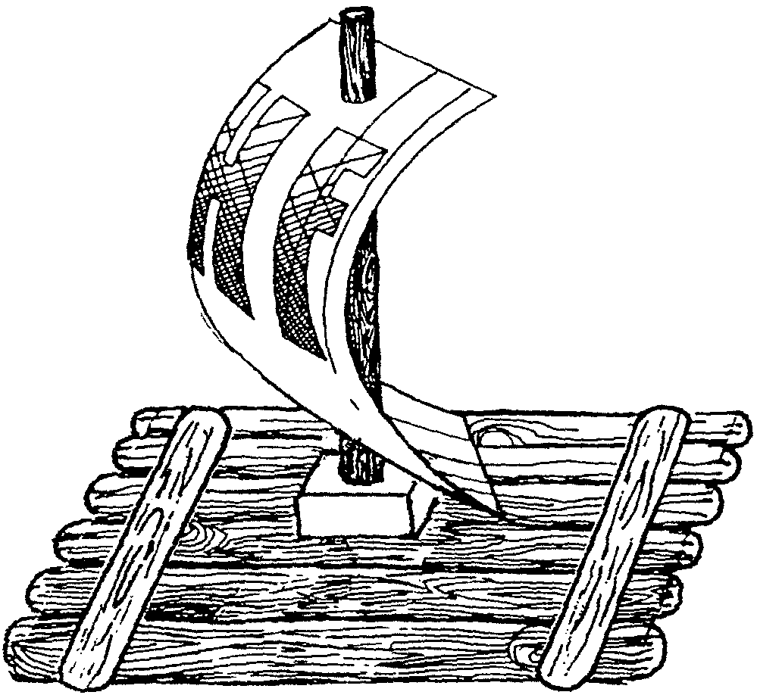
You will need: Eight large craft sticks (tongue depressors); One 3/4 x 1 1/2 x 1 1/2 wood block; One dowel for a mast; One sheet of white paper; Yellow wood glue; Permanent markers.

1. Place six tongue depressors together. Cut two sticks to fit the width of the six sticks.
2. Glue the shortened sticks near the ends of the raft.
3. Drill hole in wood block for the mast.
4. Glue the block in the center of the raft. Glue in the dowel piece.
5. Cut sail from white paper. Make holes for mast. Decorate the sail with permanent markers.
6. Attach the sail to the mast.
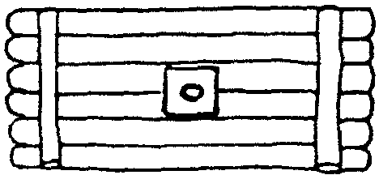

BALLOON-POWERED BOAT

You will need: 1/2 gallon milk carton (need 1/2 for each boat); A drinking straw that bends; Heavy duty tape; A long balloon; Scissors; A nail.
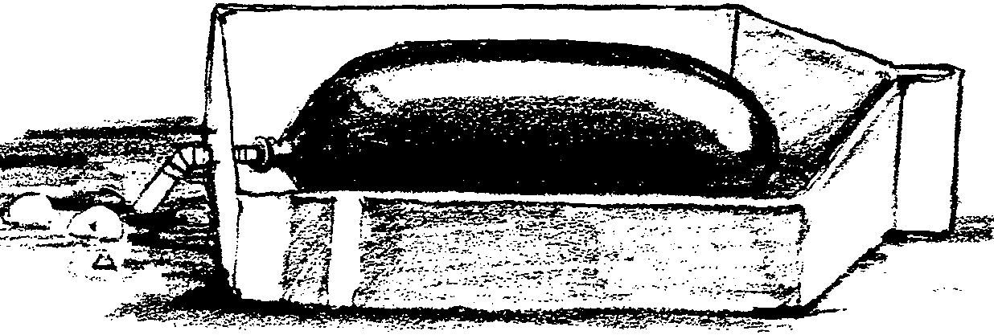

1. Cut one side from the carton to make the boat.
2. Trim the straw so the part that bends is exactly in the middle. The straight parts should be about 2 inches each.
3. Tape one end of the straw inside the balloon. Secure the tape tightly but don’t collapse the straw.
4. Using the nail, poke a hole in the bottom of the carton (the stern of the boat).
5. Insert the balloon straw “ari jet” through the hole in the stern. Pull the straw through and bend it at a ninety degree angle.
6. Blow up the balloon. Then hold the end of the straw with a finger. Launch the balloon boat in the water.

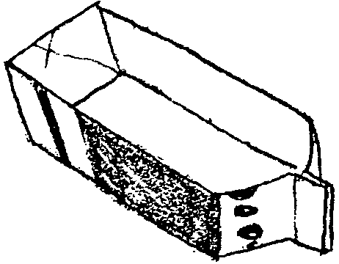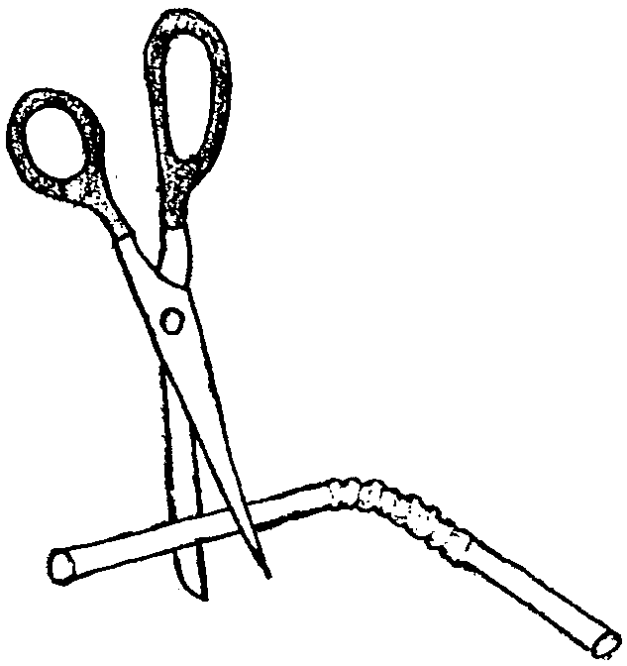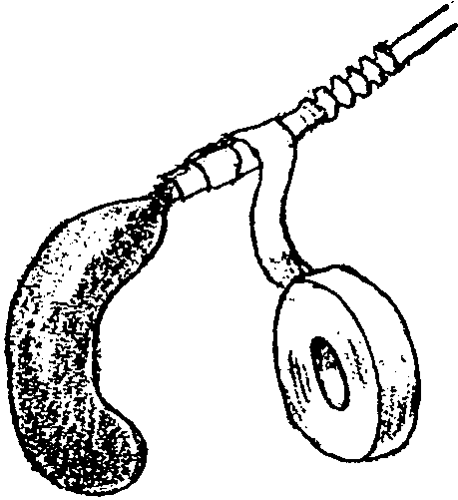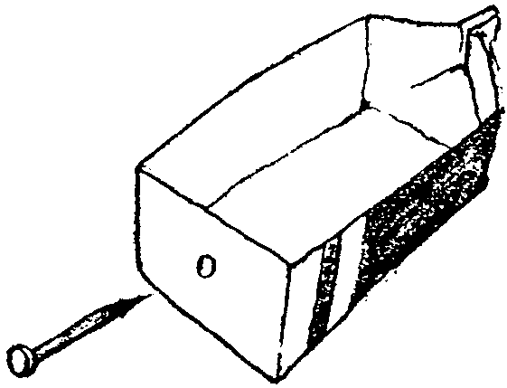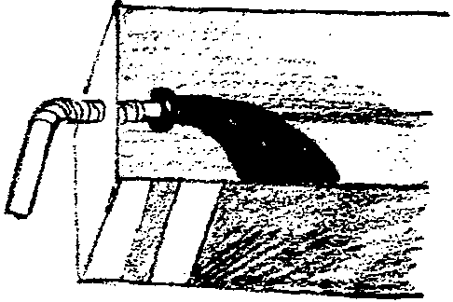

MOTORLESS BOAT

A tub-time toy that doesn’t need batteries. It does move on its own.

You will need: Waxed cardboard (e.g. milk or ice-cream cartons, butter boxes); Scissors; Pencil; Ruler; Water proof tape (duct tape or strong packing tape); Bar of Ivory soap.

1. If you are using cardboard from food container, wash out the carton well.
2. Cut a 2" by 3" rectangle out of one side of your carton. Find the center of a short side of the rectangle, then use a ruler to mark a straight line from this center point to the corners at the opposite end. Fold up along these lines.
3. Tape up the end of the boat with the waterproof tape.
4. Cut a very small wedge from the soap. Then cut a hole in the back of your boat, making it smaller than the wedge.
5. Put the boat in a half-full sink, bathtub or other quiet water. Place the soap wedge into the hole in the boat so that the point of the wedge is toughing the water. The rest of the wedge sits on top of the boat. Now watch your boat move forward.

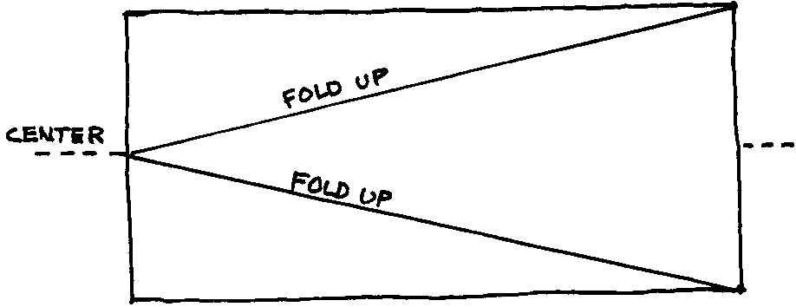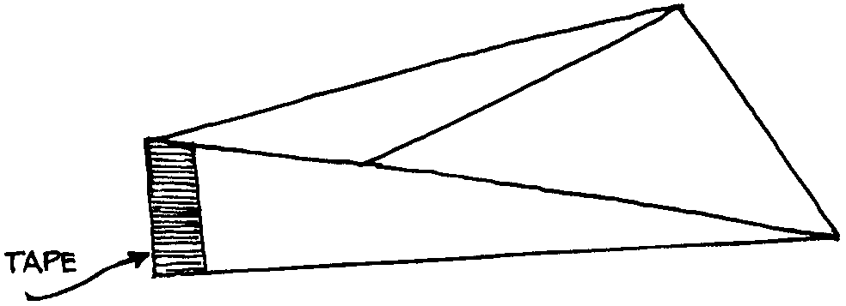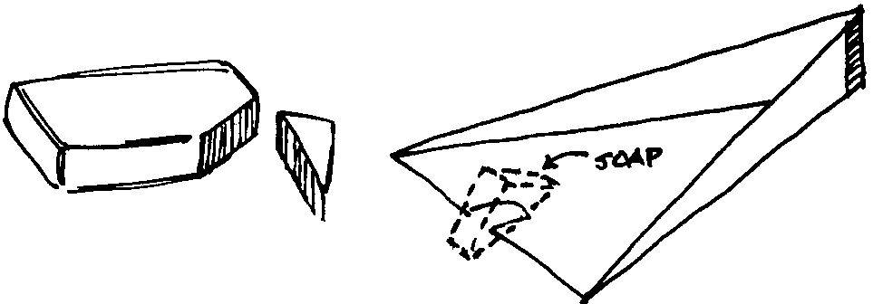

SOAP ON A ROPE

You will need: 2 cups soap flakes*; 1/2 cup hot water; Egg beater; Food coloring; About 1 yard of cord or thick yarn.

*Grate soft white soap into flakes. Ivory works well.
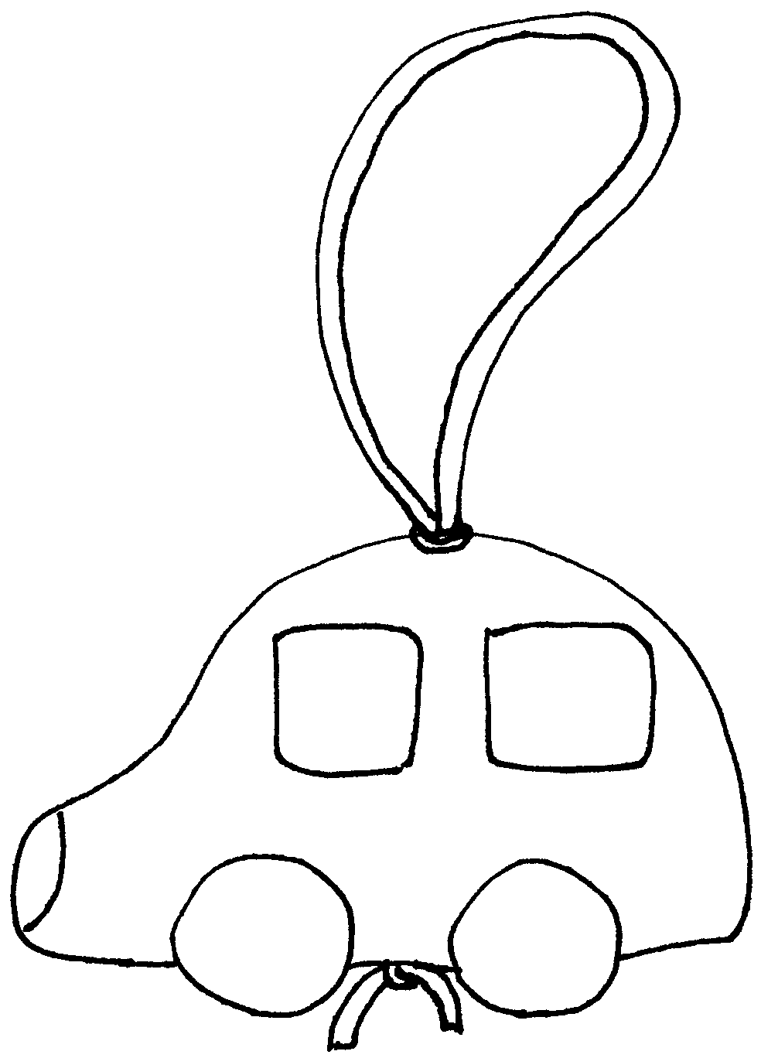

1. Pour soap flakes and water into a bowl. Add a few drops of food coloring, if desired. Beat until evenly mixed.
2. Gather the mixture in your hands. Press it into a firm glob.
3. Knot the ends of the cord together with a large knot.
4. Form the soap glob around the cord just above the knot. Squeeze the glob so it hangs securely from the cord.
5. Form into a special shape (keep it simple).
6. Let the soap dry for several days.
7. Tie another knot just where the cord comes back out of the soap.

SAND CANDLES
Candle making seems to be complicated. Actually it is not. I have worked with Wolves and Bears making all sorts of candles. Sand candles are always the kids favorite type of candles.

You will need: Sand; Flowerpot or similar sized container; Wax block or household paraffin (approximately 1/4 lb. for each candle); Candle wicks (craft store) or waxed string; Empty can with the label removed; Small pebble; Crayons (optional).

1. MELT WAX: Break up the wax and put pieces in the empty can. Fill a small pot 1/3 full of water, put the can in the pot and the pot on the stove over low heat. If you want colored candles, put a piece of crayon in the melting wax. While the wax melts, prepare the candle mold.
2. MAKE MOLD: Fill the flowerpot with MOIST sand. Dig out the candle shape--use your hand or press an object into the sand like a small rubber ball or a small can. Important: You are making the candle upside down. To make the candles like strange sea creatures, make large or small holes in the sand jutting out from the basic candle shape (use your finger or a pencil).

3. PLACE WICK: When the mold is finished, tie a pebble to the end of a strand of the wick and embed the pebble in the sand at the bottom of the mold as shown. Wind the other end of the wick around the pencil and balance on top of the flowerpot. Make sure the wick is straight.

4. POUR WAX: Pour the liquid wax into the mold carefully. In a few minutes the wax will sink a bit--pour in more wax to make it level (this will be the bottom of the candle). Let the wax cool completely.

5. FINAL STEPS: To unmold, turn the flowerpot upside down. The sand will come out in a hunk in your hand. Carefully remove the candle. Brush off as much sand as possible. Let dry and brush off again. A very thin coating of sand should remain on the candle surface.
VARIATIONS: Instead of poking small holes, keep the moist sand walls smooth and embed pretty pebbles and sea shells (shell’s outside to the sand). Or how about making candles right-side up? You need to keep the bottom of your sandy pit flat but you don’t have to embed the wick in the sand..

NO CARE AQUARIUM
You will need: Two 9" paper plates; Small amount of sand or aquarium gravel; Two shades of green construction paper; 8" square of clear sandwich wrap; Glue; Scissors.

1. Cut center out of one plate and glue clear sandwich wrap on inside.
2. Cut a circle of green construction paper and glue it inside the other plate.
3. Spread a light coat of glue over a 1” strip at the bottom of the green circle. Sprinkle sand over the glue. Let dry and shake off excess sand. Optionally, you may want to use aquarium gravel (you will need more glue for gravel).
4. Draw several fish or cut out some pictures of fish from a magazine. Glue them above the sand on the green circle. Use lighter shade of green for seaweed. A few wavy lines made with a dark green marker will make the water look as though it’s moving.
5. Staple the plates together or sew them together with colored yarn.
6. Now you can see the aquarium picture through the clear sandwich wrap.

VARIATION: In place of clear wrap, use clear blue cello wrap (used to wrap fruit baskets and the like, available at a craft store). You will not have to use the construction paper circle.

FISHING GAME
This is probably too simple to be called a craft, but the game is fun. Make a lot of fish and have your fishing derby.

FISHING POLE
Tie yarn or string to a dowel or stick. Bend a paper clip for a fishing hook.
FISH
It’s better to use stiff paper. Hold paper in half. Draw a fish. Cut a hole close to the head end of the fish.

Scatter fish (standing) on the floor and go fishing.

SAND PAINTING
Do this outside where you don’t mind the sand.
Designs should be simple. Younger boys may want to outline their designs with sand rather than filling it. How about writing their names with sand?

You will need: Sand; Several plastic containers with lids; Food Coloring; Newspaper; Heavy tag board or cardboard; Pencil; Glue.

1. Put sand in the plastic containers and add a few drops of food coloring--a different color for each container.
2. Cover and shake the containers or stir until the sand is completely colored.
3. Spread the colored sand out on newspaper for a few minutes and let it dry while you color more. (Try combining primary colors.)
4. Using the pencil, draw a design on the tag board or cardboard.
5. Spread glue on the outline of the design.
6. Cover the outline with one color of sand. Shake the excess sand back into its container.
7. Spread glue onto another area of the design, and then fill it in with another color of sand. Repeat until the entire design is complete.
8. Allow to dry (about an hour). Attach a small piece of string like a loop on the back and hang on the wall.

LAYERED SAND JAR

You will need: A variety of colored sands (see the craft above); Nicely shaped clear jar (not too big) with a lid; Funnel.

1. Spoon a layer of colored sand into the jar. Or pour the sand through a funnel into the jar. Gently tap the jar to make the sand level if you want flat layers.
2. Continue adding layers of different-colored sands until you reach the top.
3. Screw the lid on tightly.

BEACH BALL NECKERCHIEF SLIDE
You will need: One half-ball-shaped wood piece 1 1/2" diameter* (available at a craft store); Acrylic paint or permanent markers; 1/2" section of 1/2" PVC pipe; Thick craft glue or low temp glue gun.

*If you cannot find half-ball shapes, cut a wooden ball in half. Be careful, it is small and craft wood shapes are usually hardwood. Adult should do this.

1. Paint the wood piece like a beach ball. (If you are using markers change the color scheme shown below.)
2. Let it dry. Glue the PVC pipe section onto the flat side of the 'beach ball'.

ROPE NECKERCHIEF SLIDE
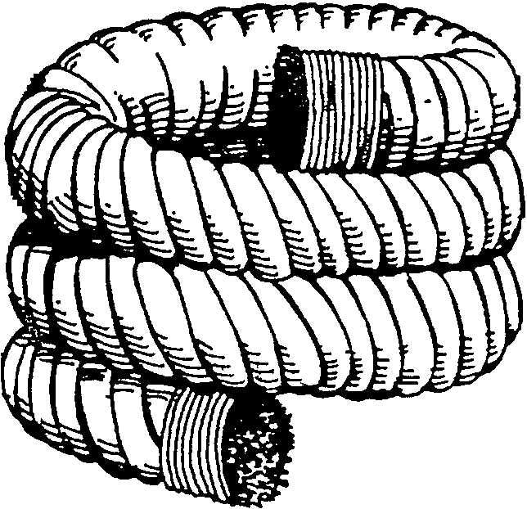
You will need a piece of rope about 8-inches long.

Whip both ends of the rope (Bear Achievement 22).
Lay a bead of low temp glue along the rope and coil the rope in a circle. It may be easier if you wrap the rope around a 1/2" dowel, being careful not to glue the rope to the dowel.

BUOY KEY RING
It floats, so it’s a good gift for anglers and boaters.

1. Drill a hole through the middle of a cork.
2. Insert a large plastic coated twist tie through the hole in the cork.
3. Thread the key onto one end and securely twist the ties together.
4. Test for buoyancy in a sink filled with water. If it sinks, try a larger cork or add another one.

SPLISH SPLASH SLUSHIES

2 12 oz cans of frozen juice concentrate, thawed, any flavor
1 32 oz bottle clear soda (7-Up, ginger ale, or Mountain Dew)
Small paper cups or zip-top freezer bags (sandwich size).

1. Mix together the thawed juice concentrate with the soda.
2. Ladle 1/2 cup of the mixture into each paper cup or zip-top bag.
3. Place in the freezer for at least 30 minutes.

Makes approximately a dozen treats.

DREAMSICLES

1 6-oz can frozen juice
2 cups plain yogurt
1 tsp vanilla
1 envelope unflavored gelatin
1/2 cup very hot water
1 banana
10 strawberries
8 small paper cups
8 popsicle sticks

1. Mix the yogurt, fruit juice and vanilla in a big bowl.
2. Dissolve gelatin in the hot water.
3. Add the gelatin to the vanilla, yogurt and fruit juice and stir.
4. Mash up the fruit and mix it in with the rest of the stuff.
5. Pour the mixture into eight small paper cups. Cover each cup with foil. Poke a popsicle stick through the center of the foil on each cup.
6. Freeze for 4 hours or until frozen hard.
7. Peel off paper cup and EAT!!

8 servings.

QUICK FRUIT DIP

This tastes good on a sunny day. And it’s easy to make too.

1 cup plain yogurt
2 Tbsp brown sugar
Fruit (apple wedges, strawberries, grapes, banana slices, pineapple chunks)

Mix the yogurt and sugar in a small bowl.
Serve with any of the fruit above!

ICE CREAM SANDWICHES

1 pint ice cream
12 large or 20 small cookies
Sprinkles

1. Remove the ice cream from the freezer and put in the refrigerator for about 10 minutes, until it softens slightly.
2. While the ice cream softens, put the sprinkles on a piece of waxed paper.
3. Remove the ice cream from the refrigerator. Place a large scoop of ice cream on top of 6 large cookies (or 10 smaller cookies). Then press another cookie on top.
4. With a tablespoon, smooth the sides of the ice cream sandwich. Then roll the sides in the sprinkles. Serve right away, or wrap the sandwiches individually in waxed paper or plastic bags and place them in the freezer until you’re ready to serve them.

Makes 6 to 10 sandwiches.

SAND DOLLARS (cookies)

DOUGH:
1/2 cup (1 stick) butter, at room temperature
1/2 cup sugar
1 large egg
1 tsp almond extract
1/4 tsp salt
1 1/2 cups all-purpose flour
TOPPING
1 large egg white
1/4 cup sliced almonds

1. Put the butter and sugar in a mixer bowl. Using an electric mixer, beat them on medium speed until the sugar and butter blend together into a soft ball.
2. Break the egg into the batter. Add the almond extract and salt. Mix until blended.
3. With the mixer on medium speed, add the flour a little at a time. When all the flour has been blended, the dough should look crumbly.
4. Turn the dough out onto a clean surface. Knead the dough until it is smooth and shiny, 3 to 5 minutes. (Kids like kneading the dough.)
5. Shape the dough into a thick log and wrap it in a piece of plastic wrap. Refrigerate for 1 hour.
6. After the dough is chilled, place an oven rack in the center of the oven. Preheat the oven to 350.
7. Unwrap the dough on a cutting board. Using a knife, carefully cut the log into 1/2-inch-thick slices. Put the slices about 1 inch apart on the cookie sheet.
8. Put the egg white into a bowl. Beat the egg white with the electric mixer until it’s very foamy and white. Use your finger to rub egg white over the top of each cookie. (Wash your hand afterward.) Sprinkle the tops with the almonds.
9. Bake until the cookies are golden, about 10 minutes.
10. Cool on a cooling rack.

Makes 36 cookies.

