Holiday Magic

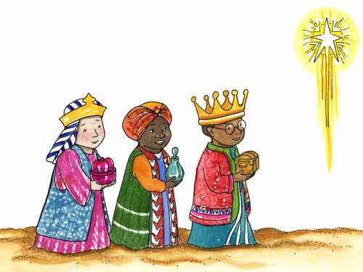

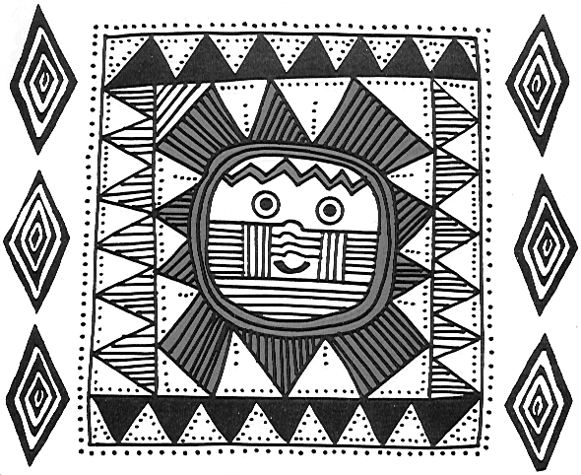

DECEMBER 1999

DEN AND PACK SERVICE PROJECTS

The words, “I PROMISE TO DO MY BEST...TO HELP OTHER PEOPLE” in the Cub Scout Promise will be very real and meaningful to a Cub Scout when he is given the opportunity to put them into action. Some boys will tackle the goodwill bit on their own, but usually a boy needs some encouragement and guidance in order to make these words become a reality in his life. Offer suggestions, give explanations and provide guidelines for the Cub Scouts so that when a project is undertaken, either on an individual, den or pack basis, the boys will get that genuinely warm, wonderful feeling that comes from helping someone else. And then when they repeat the Cub Scout Promise, these words will be more meaningful and real to them.

There are scores of service projects for the Cub Scouts, and any time is a good time to put your project into action. Remind the boys that a service project is not limited to the holiday season, even though the holiday season is an excellent time to begin. Many organizations need help throughout the year. (For service projects for other times of the year see Cub Scout Leader Book, pp. 9-10 to 9-11)

Here are some ideas for dens and packs. No doubt you and your boys will be able to think of many more useful service projects. Churches, charitable organizations, City Hall and your chartered organization can give you ideas as well.

Participate in the Christmas Wish Tree Program for homeless children and families at the Family Living Center, home of Pack 99. Flyers will be available at the Council Service Center and at your district roundtable in November.
Collect money or have a fundraising project such as recycling, and contribute toward the World Friendship Fund. The World Friendship Fund is administered by the Boy Scouts of America to help struggling Scouting associations in other lands. (More on this in the Cub Scout Leader Book, pp. 6-4 to 6-5)
Collect clothing, toys, books, school supplies and canned goods for shelters for needy families.
Make Christmas tree decorations or trays of favors for nursing homes.
Visit, put on a skit, sing songs at day care centers and nursing homes.
Read books to small children at day care centers; make friends with small children.
Save money from recycling, buy a tree, trim it for a needy family. (Contact an adopt-a-family program)
Make games or puzzles for the shut-ins, day care centers or needy families.
Collect and repair toys for the Toys for Tots or a similar program.
Collect books and magazines for needy families, send them with homemade bookmarks.
Make bird feeders, string popcorn and cranberries and hang them where the shut-ins may watch the birds come to feed. Provide extra bird food.
Help elderly person or shut-ins to decorate their home for Christmas. Be sure to help them take down the decorations after Christmas.
Do yard work for the elderly or shut-ins
Clean up the grounds, plant flowers for the chartered organization.
Do yard work regularly during the month for a church or temple.

Please note: Most institutions have guidelines for visitors or gifts; so be sure to check with them before you undertake a project. When you are visiting a place that is normally isolated from the outside world, like a nursing home or convalescent home, please be careful about taking children who have severe colds. Many of their patients/residents are susceptible to outside germs.
REINDEER SEARCH

Help Santa look for his nine reindeer. The reindeer’s names are: DASHER, PRANCER, COMET, DONNER, DANCER, VIXEN, CUPID, BLITZEN, and RUDOLPH.

R D U C P S V C K J
S O C P O I O U B W
O H U R E M K X L O
O P P N E Z T I L B
L L I T C N A V R E
L O D P R A N C E R
I D A N C E R O Z T
M U C R X H J M D G
P R E I P O Z T U D
B V V R E H S A D N

AMAZING STAR

MAKE A STAR

Move only 4 dots and make a six-pointed star.

Solution


HOLIDAY SPIRIT

Unscramble the words and phrases for holiday spirit.

1. REECH
2. PAPYH ENW AREY
3. ACEEP NO RATHE
4. FIGTS
5. ALDCNSE
6. DOGO LIWL
7. ERGTENIG RACSD
8. NAHHUKAK
9. MISSEL
10. NKAZAAW
11. CERADOITNSO
12. GIMAC
13. NOITARBELEC
14. REMRY TRISSAMCH
15. LYIFMA INGTHGAER

Answers: 1. cheer; 2. Happy New Year; 3. peace on earth; 4. gifts; 5. candles; 6. good will; 7. greeting cards; 8. Hanukkah; 9. smiles;
10. Kwanzaa; 11. decorations; 12. magic; 13. celebration; 14. Merry Christmas; 15.family gathering

CHRISTMAS TOWNS

If you’d like to have your Christmas cards postmarked from one of these towns, send your cards all in one package, stamped of course, and address it to the postmaster there. Write “postmark request” in the lower left hand corner on the front of the package.

Bethlehem, GA 30620
Mistletoe, KY 41351
Noel, MO 64854
Rudolf, OH 43462
Silver Star, MT 59751
Christmas, FL 37209
Nazareth, MI 49074
North Pole, AK 99706
Santa Claus, IN 47579
Wiseman, AR 72587

HOLIDAY PLEDGE OF ALLEGIANCE

Arrangement: The Pledge of Allegiance is sung to the tune of “Joy to the World.” Lines between the Pledge lines are read. This is a good opening for a Webelos den--whole den sings with one Webelos Scout reading the line. Or it may be done by an adult singing with a den of boys reciting the lines.

I PLEDGE ALLEGIANCE
At this joyous time of year
TO THE FLAG
A symbol of unity, as Christ is a symbol of peace
OF THE UNITED STATES OF AMERICA
A land chosen above all others
AND TO THE REPUBLIC FOR WHICH IT STANDS
Made of hard working, up-standing citizens
ONE NATION UNDER GOD
Who shared His Son with us
INDIVISIBLE
A nation united through love
WITH LIBERTY AND JUSTICE FOR ALL.

Please repeat the pledge with us.

CHRISTMAS OPENING

C is for Caring--the caring for others during the holidays and all year round.
H is for Helping--helping others is part of the Cub Scout Promise.
R is for Remember--remembering people who have helped us in the past.
I is for Imagine--imagine a world of people helping others.
S is for Sharing--the sharing of yourself.
T is for Time--taking the time to care.
M is for Many--the many opportunities we have to show our Scouting spirit.
A is for Always--we always do our best.
S is for Spirit--the spirit of giving, the giving of ourselves to others.

YULE LOG OPENING

Props: Yule log, three candles in the log, a fourth candle to be used as a lighter.

Cubmaster: The Cub Scouts of den ____ want to light our Yule log that will burn throughout our meeting tonight, and offer to you their holiday wishes.

C.S. #1: (Light candle) This wish is for all your dreams to come true.
C.S. #2: (Light candle) This wish is for peace for all the children of the world.
C.S. #3: (Light candle) This wish is for a year where everything goes well for those we hold dear.

FLAG MAGIC

Equipment: 1 cup red paper bits, 1 cup blue paper bits, 1 cup white paper bits, 1 cup stars or glitter, large pot, flag, magic wand and spotlight.
Arrangement: 6 Cub Scouts form a semi-circle around large pot. Flag is folded and hidden in pot. Each Cub Scout is holding an ingredient which he adds at the proper time.

C.S. #1: We are going to show magic, really special and grand
And create for you something that is the greatest in the land.
C.S. #2: First we’ll put in a heaping cup of red for courage true.
(Toss cup of red paper bits into pot.)
C.S. #3: Then we’ll add for loyalty, a dash of heavenly blue. (Adds blue paper bits.)
C.S. #4: For purity, we will now sift in a layer of snowy white. (Add white paper bits.)
C.S. #5: We’ll sprinkle in a pinch of stars to make it come out right. (Add stars or glitter.)
C.S. #6: We will stir and stir, then you will see, that what we have created is...
(Stir lightly with magic wand).
ALL: GOLD GLORY (Reach in and pull out flag)
C.S. #1: Our flag is the most beautiful flag in the world. Let us always be loyal to it.
C.S. #2: To show our allegiance true, please join me in the Pledge of Allegiance.

CUB SCOUT SPIRIT

C.S. #1: December is a fun time of the year. It is a time for giving and sharing.
C.S. #2: As we gather for the last pack meeting of 1999, let us remember the good times.
C.S. #3: Let us end this year with new determination to keep the Cub Scout Spirit going.
C.S. #4: As we begin our program tonight, let us keep in mind the true holiday spirit.
C.S. #5: Remember, to give of yourself is more important than any gift you can buy.

Cubmaster: Please stand for the Pledge of Allegiance.

LIGHT OF SCOUTING

Arrangement: As each Cub Scout speaks, he will light his candle.

C.S. #1: This is the light of Scouting--it radiates enthusiasm. As light brings out the sparkle in diamonds, enthusiasm brings out the sparkle in Scouting.
C.S. #2: This is the light of Scouting--its energy gives us the strength to do our best.
C.S. #3: This is the light of Scouting--it touches everyone. Remember the brotherhood we share together in this place.
C.S. #4: This is the light of Scouting--it brightens the way of the path we will follow.
ALL: Feel the warmth from the glow of the light. May it warm you heart.

SPIRIT OF CUB SCOUTING - OPENING AND CLOSING

Arrangement: Extinguish room lights. The Cubmaster lights a large candle.

This candle is the spirit of Cub Scouting which burns in all our hearts. In this season of Christmas, Hanukkah and Kwanzaa, it is just one of many candles for this is the season of lights. It is a time when the days are short and the nights are long, but somehow the world seems brighter.

Thousands of homes burn candles to light the way for the Christ Child. Thousands more burn candles to commemorate the miracle of the oils of Hanukkah. And thousands yet will light candles of Kwanzaa. Each of those candles also represents the spirit of goodwill among men.

Cub Scouts has such a candle. It is called the spirit of Cub Scouting. We strive to keep this light lit year-round as we live in the Cub Scout Promise and the Law of the Pack. Please stand and repeat them with me. (Lead Promise and Scout Law) We will leave our Cub Scout spirit candle burning throughout this meeting to remind ourselves of our ideals.

CLOSING
Now our meeting is ending and we must blow out the candle of the spirit of Cub Scouting. But let us silently pledge to keep the ideals it represents ever burning in our hearts. Good night, Cub Scouts.

“THE MAGIC OF CUB SCOUTING” - CLOSING

To take a little boy and help him grow into a man -
That’s magic.
To teach him how to make things and let him know he can -
That’s magic.
To watch him learn the Promise and apply it in his life -
That’s magic.
To see him grow in mind and body, overcoming strife -
That’s magic.
To watch his family beam with pride at everything he’ll do -
That’s magic.
And to love him even if things don’t go as he wanted them to -
That’s magic.
And as his Scouting leaders we also beam with pride,
Because we know he’s learning and growing up inside.
That’s Cub Scout Magic.
--Joalene Whitmer

IT’S ALWAYS MAGIC WITH CUB SCOUTING

CHRISTMAS IS A TIME... CLOSING

Three Cub Scouts read the first three lines. The audience joins in the singing. Have the song written large on a poster board so everyone will look up and sing (rather than looking down at song sheets in their hands.)

C.S. #1: Christmas is a time for GIVING!
C.S. #2: Christmas is a time for SHARING!
C.S. #3: Christmas is a time to THINK OF OTHERS!

Song: (Tune: Jingle Bells)
Giving time, sharing time, fun for everyone.
Scouters know that Christmas is
The time for deeds well done.

Giving time, sharing time, let us all take part.
Join with Cub Scouts everywhere,
Give gifts from the heart.

MAGIC WORDS CLOSING

Cubmaster: There is a very special kind of magic. This magic will open the coldest heart and win wonderful friends for us.

(Cub Scouts come on stage, each one carrying a different sign. Examples are:)
Please
Thank you
Pardon me
Excuse me
You’re welcome
How nice you look
I admit I made a mistake

Cubmaster: Simple words, but important words that tell someone else that you are appreciative, courteous and thoughtful. Add kind deeds to the magic of words, and the possibilities are unlimited.

A smile happens quickly, but the memory of it lasts a long time.

FRIENDSHIP PINS - CLOSING

Boys wear friendship pins. Each boy holds up a round piece of construction paper in the specified color when he reads his lines which are written on the back. At the end, you could give each Cub Scout in the audience the gift of a friendship pin. (see Craft section)

Yellow in friendship is like warmth from the sun.
It’s a new day dawning and hours of fun.

Our friendship is like a bird that soars very high,
That is why the light blue bead represents the sky.

Friendship spreads like the trees when they’re tall,
The green bead should be special to us all.

Friendship blooms like a rose when you’ve done a good deed,
And on your pin you will find that bright red bead.

Dark blue is the color of the sea where it’s deep,
Friendship with depth is a treasure we’ll always keep.

We’ve touched the sky, the sun, and a tree.
We’ve touched a rose and the deep blue sea.

Between all of these there flies the white peace dove,
And with our friendship in Scouting we begin worldwide love.

ONE LITTLE CANDLE - CLOSING

It is better to light just one little candle
Than to stumble in the dark,
Better far that you light one little candle,
All you need is a tiny spark.
If we’d all say a prayer that the world would be free,
What a wonderful dawn of the new day we’d see.
And if everyone lit just one little, one little candle,
What a bright world this would be.

CLOSING THOUGHT

Christmas is a time for sharing.
Christmas is a time for caring.
Christmas is a time for showing.
Christmas is a time for giving.
Christmas is a time for living.

Christmas is the time for you and me,
To be the best that we can be.
So, when we leave, let’s always try
To keep Christmas in our hearts as the days go by.

THE MAGIC TREE ADVANCEMENT

Equipment: Undecorated Christmas tree, gold paper stars for ornaments for each Cub Scout, several unbreakable ornaments attached to invisible thread.

This is our pack Christmas tree. It looks pretty ordinary, doesn’t it? But this tree is very difficult to decorate. Ordinary ornaments won’t stay on it no matter how carefully they are hung. (Hang an ornament or two. As you turn away, pull the thread and the ornaments will fall.)

This tree can only be decorated by the advancements of Cub Scouts. Each advancement becomes a gold star. Watch how beautiful our tree becomes.

(Call each boy to receive his awards.
Give him a gold star to hang on the tree for each advancement or arrow point.)

Look how our tree sparkles with advancements, just as the lives of these Cub Scouts sparkle with new skills and knowledge.

CANDLELIGHT ADVANCEMENT

Equipment: One large candle; one candle holder and candle for each family whose son is receiving an award.

This is a special season. We celebrate the birth of Christ, the light of the World, Hanukkah, the Festival of Light, and Kwanzaa. Tonight we celebrate the Light of Cub Scouting by recognizing the achievements of these boys. (Dim the lights and call names. As each family comes forward give them a candle and have them light it from the large candle.) The light of these Cub Scout achievements and the pride of their families light up this stage. When they leave here that light will be spread throughout this pack and our community.

ADVANCEMENT IDEAS

Display awards on Christmas tree. Santa (or elf) comes to present awards.

Have a large bell to 'ring out' the next boy’s name to receive his award. Put award on a picture of a bell and write:
Bells are ringing night and day
You’re a Cub Scout who goes all the way
Congratulations on earning your _____.

Wrap a few large boxes with colorful wrap, one for each den. Place awards in them. Have the den leader come up and unwrap gift and then present those awards. Staple awards to a picture of a present and write:
The awards you earn are gifts you give to yourself.
Congratulations on earning your _____.
OR
Couldn’t keep it under wraps any longer.
You are a gifted Cub Scout. Congratulations on earning your _____.

FUN WAYS TO SAY THANK YOU

Sprite Bottle: “May your days be Merry and Sprite!” (For an extra special thank you, attach microwave popcorn and video gift certificate.)
Santa’s Helper Award: To thank Christmas party helpers. Purchase a plain glass ornament, and print your message with paint pens or permanent markers.
Do-Re-Me Award: To thank the pack caroling organizer. Make a musical note from wood, paper or cardboard.

APPLAUSES

SANTA APPLAUSE: Rob your stomach while saying’ HO, HO, HO, Merry Christmas.

RUDOLPH APPLAUSE: Put your thumbs to your head with fingers up, forming antlers. Wrinkle your nose while saying, “Blink, blink, blink, blink.”

SLEIGH APPLAUSE: Bob up and down on chair like riding in a sleigh and say, “Tinn-g-ling” three times.

TINY TIM APPLAUSE: “God Bless Us Every One!”

WORKING ELF: Pick up hammer and say, “Hammer, hammer, hammer, Nail, nail, nail. Glue, glue, glue, Build, build build.”

SANTA DECORATES THE TREE

Santa: “Ho-ho-ho!”
Icicles: “Sparkle, sparkle”
Snow: “Flaky, flaky”
Star: “Twinkle, twinkle”
White: “As snow”
Elves: “Tee, hee, hee!”
Reindeer: “Clip, clop”

Once upon a time, long, long ago, SANTA was decorating his first Christmas tree. SANTA hung ICICLES on some branches and SNOW balls on others. In between, he hung SNOW flakes. On top, SANTA placed a STAR.

SANTA stood back to admire his tree. Something was missing! The STAR twinkled and SNOW flakes glistened. The SNOW balls and ICICLES hung beautifully. The problem was that everything was WHITE!

SANTA called his REINDEER and asked them what to do. The REINDEER thought and thought. REINDEER are very good at flying, but Christmas trees were too hard. They just couldn’t figure out how to fix SANTA’S WHITE tree.

SANTA called his head ELVES. “What can I do with this WHITE tree?” he asked. The ELVES thought and thought. Even though the head ELVES were the very smartest ELVES in the workshop, they just couldn’t figure out what to do with SANTA’S WHITE tree.

SANTA, the REINDEER and the head ELVES stood looking at the WHITE tree with the STAR on top, the ICICLES, the SNOW balls and the SNOW flakes. They thought and thought. While they were thinking, a very young ELF came in carrying several buckets of paint from the store room. This young ELF had never seen a tree with a STAR on top and decorated with SNOW balls, ICICLES and SNOW flakes. The young ELF thought it was the most beautiful thing he had ever seen! The young ELF was fascinated by the STAR, the SNOW balls, the SNOW flakes and the ICICLES. Just then he tripped over his paint buckets!

The paint buckets went flying through the air and spilled all over the tree. The head ELVES were embarrassed by the clumsy young ELF and began to scold him. The REINDEER were frightened by the clatter and hid in the corner. The young ELF began to cry because he ruined SANTA’S beautiful tree.

SANTA looked at the tree. It wasn’t WHITE anymore! The ICICLES were silver, the SNOW flakes and SNOW balls were red, blue and green, and the STAR on top glistened with gold. SANTA was delighted with the beautiful colors on the tree. He picked up the young ELF, gave him a big hug and made him head ELF in charge of Christmas trees!

SANTA’S WORRY
(by Val Chatwin)

Santa: “Ho, ho, ho!”
Boy(s): “Who me?”
Scoutmaster: “Busy, busy, busy!”

One year, right after Christmas, Mrs. Santa was worried, things were odd.
Toys for next year needed planning, the reindeer walked around unshod.
Mrs. Santa wrung her hands in frustration, something was bothering the jolly old elf.
Depression? Tendinites? Carpel tunnel? He wasn’t his jolly old self.

Finally one day it came out. His worry? The kids of this age.
All they wanted for Christmas were shooting toys, electronics of battles and wars to wage.
Then a knock came at the door (most unusual up here at the Pole).
It was a BOY in tan and green clothes, “Selling tickets with my patrol.”

“A ticket for what?” SANTA asked. “And come in out of the cold!”
“For Scout Expo,” the BOY replied. “You haven’t ever been told?”
“What is it?” SANTA asked the BOY. “A gathering to show skills and events.
It’s fun. We’re building a rope bridge and staying all night in a tent.”

Building? Camping? Learning skills? SANTA thought there was hope at last!
“And what organization are you in?” SANTA asked with flabbergast.
“The Boy Scouts of America. We meet once a week,” he explained.
Then he wanted to be on his way. “Are you buying a ticket...or two?” he exclaimed.

“Of course.” SANTA got out his wallet. “Before you go, where are your meetings?”
“At the Air Force base.” Then he looked sad. “But our SCOUTMASTER is leaving.”
All this was too much for SANTA to understand. “Can I come?” he asked a bit faster.
“Sure! There are some other parents who attend, but none wants to be our SCOUTMASTER.”

So SANTA found when the next meeting was and went there, of course incognito,
He was impressed with what was taught, there wasn’t a thing he would veto.
Sure enough the SCOUTMASTER was moving, transferred away and leaving the troop.
And none of the other parents had time to handle the group.

Plans were all made for the following week, so SANTA said he would come and lead.
“But only this once.” He would try it. He wasn’t sure he could succeed.
The week after that was the Klondike--SANTA was expert at that!
He helped the BOYS build a wonderful sleigh. (Are you surprised at that?)

Then the chairman knocked at his door. “Wouldn’t you please take over the troop?
It would only take about an hour a week.” They knew he was no nincompoop!
The next meeting the faces of the BOYS were wonderful pleasure to behold.
SANTA has always been good with kids, even though he’s a little bit old.

And his troop doesn’t even realize that when he comes to a meeting
He has reindeer for horsepower...he is still pretty good at secreting.
So that’s how SANTA became SCOUTMASTER. Now he hardly has time to make toys,
But he’s awful happy, knows there’s hope for the world because of Scouting BOYS.

See Cub Scout Leader How-to Book for “The House Where Santa Claus Lives” (pp. 6-4 to 6-5)
MAGIC IN A SMILE

(Boy #1 is trying a magic trick. The other boys are watching. Boy #2 enters, watches, then asks:)

Boy #2: What are you doing?
Boy #1: I’m a magician!
Other Boys: Yeah, he’s doing magic tricks.
Boy #2: Oh, really? (Watches, then asks) Why are you doing magic tricks?
Boy #1: I like to do magic tricks because that makes people happy and when people are happy they smile and I like to see people smile.
Boy #2: I can make magic!
Other Boys: Oh, sure! No you can't.
Boy #2: Yes I can, but I need all of you to help with this magic trick. (Leaves)
Boy #1: I didn’t know he knew how to do magic tricks.
Boy #3: I’ll bet he doesn’t know any magic.
Boy #4: He probably won’t even come back.
Boy #5: He’s just showing off.
Boy #2: (Enters with gardening tools)
Other Boys: Gardening tools?
Boy #5: You call that magic?
Boy #2: No! But with your help and these tools we can make magic.
Other Boys: Oh, sure! Gardening tools aren’t magical. How can they make magic?
Boy #2: You said magic makes people happy, didn’t you?
Boy #1: Yes, but...
Boy #2: You said you like to make people happy so they will smile, didn’t you?
Boy #1: Yes, but...
Boy #2: Well, if we take these tools over to Mrs. Robinson’s and clean her front yard, I’ll bet she would be happy and she would smile the biggest smile you have ever seen.
Boy #3: Say, I think you have got magic. I’ll rake leaves.
Boy #4: I’ll go and get a lawn mower. I’ve always wanted to do magic tricks!
Boy #5: Me too! I’ll prune her shrubs. I really like Mrs. Robinson. I’d like to see her smile. (Boys agree and start to leave)
Boy #1: Hey, what about my magic?
Boy #3: We all want to try (boy’s name) magic.
Boy #1: Oh, well, I guess I’ll go too. Hey, wait for me!

KNOCK KNOCK

Knock, Knock!
Who’s there?
Aretha.
Aretha who?
A wreath’ll look nice on your door.
Knock, knock
Who’s there?
Pizza.
Pizza who?
Pizza on Earth, good will to men.

See Cub Scout Leader How-to Book for
“The Animals’ Christmas Story (shadow puppet)” (p.5-22)
GETTING READY FOR CHRISTMAS

This skit is an ideal way to introduce a Christmas program or a visit from Santa. The time is late on Christmas Eve, and the scene is Santa’s workshop. No scenery is needed, except a sign that says “Santa’s Workshop.” The workshop is a jumble of toys, wrapping paper, ribbons, and the specified presents with name tags on them. Each couplet may be recited by a different elf, or have just a few recite several couplets each. You can have as many as twelve elves, or as few as two. You’ll also need a Santa, unless the optional ending is chosen. The elves each wear a stocking cap and a sign saying “elf.”

Elf #1: (Looks at audience) Here are Santa’s elves, and it ought to be clear
We’ve been making toys during most of the year.
Elf #2: (Ties a bow) A ribbon bow here, tied round this bear’s neck,
The toys all await the important last check.
Elf #3: (Waves a long list) Right here is a list of the good girls and boys
Who will be receiving these wonderful toys! (Gives list to the next elf)
Elf #4: (Checks list) A bike just for Greg--but something’s amiss!
He’s eleven years old, much too big for this! (Points to tricycle)
Elf #1: Phil wants a fire engine as swift as a fox
But inside there is a jack-in-the-box (Looks at gift)
Elf #2: And Shaun will think we are really outlandish,
These soldiers tagged for him--why, they only speak Spanish!
Elf #3: On the rest of the gifts, are the names all straight?
We’ve got to do something--before it’s too late!
Elf #4: There isn’t much time, so lend me a hand
Switch all of the name tags--or we’ll all be canned!
(The elves quickly change tags and rearrange gifts as the skit continues)
Elf #1: Come and work quickly, there’s no time for play. (Points off stage)
Look there, out that window--I see Santa’ sleigh!
Elf #2: (Points to list) Stop all the talking and get out that list,
See if there’s anything we might have missed.
Elf #3: (Checking the list) Our problem’s corrected--it looks like we’re through,
We sure are lucky our boss never knew.
(There is the sound of footsteps offstage.)
Elf #4: I think Santa’s come--hear his steps on the snow?
And I heard him say, “All you reindeer! Now, whoa!”
Elf #1: Well, all is in order and thus ends our rhyme
We finished our work in the St. Nick of time!
All Elves: And now here he is, the star of our show,
The jolly old gent who says,
Santa: (Walking on stage) HO! HO! HO!
(optional ending:)
All Elves: Our skit is all finished--it’s time that we go
And let all of you get on with YOUR show!

SNOWBALL RELAY

Divide players into teams. Teams line up behind a starting line at one end of the room. Each team is given a simulated snowball of either cotton or styrofoam and a piece of cardboard. On signal, the first player of each team tries to move the ball across the floor and back by fanning it with the cardboard. (If the room is large, mark a turning point.) Player then gives cardboard to next team member. Game continues until all team members have fanned the “Snowball.” The first team to finish is the winner.

GOOD SAMARITAN

You will need one bean bag (or sock ball) per player and one box per team. Divide the group into four teams, spaced equidistant from each other. Each team has their box placed near them, with each member’s bean bag in the box. The bean bags represent wealth. On the signal to begin, each player takes one bean bag at a time to one of the other teams. Bean bags must be placed, not thrown, into boxes. Players continue placing their wealth in the other’s boxes for a specified amount of time (2 minutes). On the stop signal, the Cub Scouts will return straight home. Team with the fewest bean bags will be declared the best Samaritans.

THE RED AND THE GREEN

This is a fast moving game. One player, chosen to be Santa Claus, stands on a chair or stool where he can easily be seen. He holds behind his back a piece of cardboard colored green on one side and red on the other. The rest of the players are divided evenly into the reds and the greens. They wear crepe paper bands on their arms to show their color. Suddenly Santa Claus shows one side of the cardboard. If it is red, the reds must stoop down before the greens can tag them. If it is green, the greens must stoop down before the reds can tag them. Santa Claus keeps showing different sides of the cardboard until one side is completely tagged out.

STAR RACE

This game may be played by teams or individuals. Each player needs a construction paper star and a half a straw. Set up start and finish lines. Line up players on start line. Place star on the floor in front of each player. Players must inhale on straws to lift stars and walk across room to deposit them at finish line. If the star drops, player must retrieve it by straw only and continue with game.

KRIS KRINGLE RELAY

Boys line up in teams, relay fashion. Each team has two shoe boxes or large paper bags, representing Kris Kringle’s boots. On signal each player places his feet in the “boots” and shuffles up to and around a chair at the opposite end of the room. He shuffles back to the starting point, where the next player takes over.
SITTING ON A SNOWBALL

Give each player a paper plate. It is a snowball. Holding the snowballs over their heads, the boys form a circle and while Christmas music is playing, walk around. As soon as the music stops, they must put their snowball on the floor and sit on it so it is completely out of sight on the sides and the back. Any player whose snowball is visible at his side or back is eliminated.

GIFT WRAPPERS

You will need one box, wrapping paper (pre-cut), tape, ribbon and a bow for each team. Divide the group into teams of two. Each team races to wrap the present. Each player must have one hand behind their back. Have a judge to decide the winner.

WHAT’S WRONG WITH CHRISTMAS

This is a good quiet game for a den meeting. On a table or tray, place a number of Christmas type objects, such as candy cane, bell, sprig of holly, etc. Scatter through these a number of objects which are not a part of Christmas, such as plastic egg, green shamrock, red heart, etc. Cover all objects until time to play the game. Then remove the cover and give Cub Scouts one minute to look at all the objects. Recover and give each boy a pencil and paper. Ask them to write down all non-Christmas items. Cub Scout with longest correct list is the winner.

PEPPERMINT PICKUPS

This is a Christmas version of pickup sticks. In the center of a table, place about a pound of hard candies. Give each player two peppermint sticks or candy canes. When it is his turn, he picks up a candy from the center pile with a peppermint stick in each hand and places it in front of him (if you’re using candy canes, it’s up to the boy which end to use). He must pick up the candy, one at a time, without moving any other candy in the pile. Not as easy as it sounds! If the candy in the pile is moved, the player loses his turn. The boy with the most candy wins.

GREETING CARD PUZZLES

Cut several old greeting cards into irregular pieces to form puzzles. Mix them all up. Give them to the boys and ask them to put the cards back together.

The blue of heaven is larger that the clouds.

CHRISTMAS SPIRIT
(Tune: Auld Lang Syne)

Should Christmas spirit be forgot
When Christmas is no more?
Should Christmas spirit be forgot
And locked behind the door?
When holidays are out of sight
And merry songs are few,
Let’s keep the Christmas spirit bright
And strong the whole year through!

We feel the warmth of brotherhood
When Christmas time is here.
We think of ways of doing good
And spreading Christmas cheer.
When holidays are out of sight,
Should brotherhood be too?
Let’s keep the Christmas spirit bright
And strong the whole year through!

WHEN YOU’RE HELPING
(Tune: When You’re Smiling)

When you’re helping
When you’re helping
The whole world smiles at you.
When you’re helping
When you’re helping
The sun comes shining through.
For when you see boys with purpose in life
They will help you in stress and in strife.
So keep on helping
‘Cause when you’re helping
You help your own self too.

SANTA
(Tune: Bingo)

There is a jolly jolly man
And Santa is his name-O
S A N T A (clap 5 times in rhythm) (3x)
And Santa is his name-O

HOLIDAY MAGIC
(Tune: Up on the House Top)

Holiday Magic is in the air,
Whimsical feelings I feel every year.
By helping others without being told
All for the magic that I behold.

Ho Ho Ho I’ll shovel snow
Ho Ho Ho to the store I’ll go
OOOHHH Holiday Magic
Click Click Click
By helping others does the trick.

RING THOSE BELLS
(Tune: Jimmy Crack Corn)

Ring those bells and turn around (3x)
For Christmas time has come.

Ring those bells and
stomp your feet (3x)
for Christmas time has come.

Ring those bells and
clap your hands (3x)
For Christmas time has come.

Ring those bells and do all three (3x)
For Christmas time has come.

YOU’RE A WINNER
(Tune: If You’re Happy)

You’re a winner when you’re helpful
And you’re true.
You’re a winner when you’re helpful
And you’re true.
You accomplish quite a lot,
Cause the Scouting spirit’s in you.
You’re a winner when you’re helpful
And you’re true.

THE FIRST DAYS OF WINTER
(Tune: The Twelve Days of Christmas)

On the first day of winter,
My best friend said to me,
(Put arm around shoulder of person next to you)
“Let’s sit by the crackling warm fire.”
(Sit down, rub hands to warm them)

On the second day of winter,
My best friend said to me,
(Put arm around shoulder of person next to you)
“Please take a cookie,
(Pretend to eat)
And let’s sit by the crackling warm fire.”
(Sit down, rub hands to warm them)

3. Have a cup of cocoa.
(Pretend to drink)

4. Take off your coat.
(Take off big heavy coat)

5. Let’s go inside.
(Motion friend to come with you)

6. My feet are chilly.
(Stomp feet)

7. Your nose looks red.
(Rub nose)

8. Our gloves are wet.
(Shake both hands and make a face)

9. Let’s throw some snowballs.
(Throw snowballs)

10. We can build a snow fort.
(Pretend to build a fort)

11. Try my new sled.
(Pretend to slide down a hill)

12. How I love winter.
(Jump up and down)

IT’S TIME TO SAY “HAPPY NEW YEAR!”
(Tune: The Bear Went Over the Mountain)

It’s time to say, “Happy New year!”
And say “Good-bye” to the old year.
It’s time to make resolutions,
A better person to be!
A better person to be!
A better person to be!
It’s time to make resolutions,
A better person to be!

It’s time to throw some confetti,
And have some fun at a party!
And when the clock strikes midnight,
The old turns into new!
The old turns into new!
The old turns into new!
And when the clock strikes midnight,
The old turns into new!

Eat black-eyed peas for good luck,
As your bad habits you will shuck.
Watch football games on the TV,
See who the champ will be!
See who the champ will be
See who the champ will be!
Watch football games on the TV,
And see who the champ will be!

JOY TO OUR CUBS
(Tune: Joy to the World)

Joy to the World, our Cubs are here,
Let all the world rejoice.
Their badges they have earned today,
Award them now without delay.
Let the pack all give a cheer (Hooray!)
Let the pack all give a cheer (Hooray”)
For those Cub Scouts who advanced today.

See Cub Scout Songbook for
“Santa’s Coming”

FRIENDSHIP PIN AND NECKLACE

Make these pins and give to friends and family with a copy of the poem (see Ceremony in this month). Wear on clothes. Wear on shoe laces.

Colors of beads you need: Yellow; Light blue; Green; Red; Dark blue; White.

Open a safety pin and slide beads on the pin. You sould have room left on the pin so it can be attached to clothing.

FRIENDSHIP PIN NECKLACE:
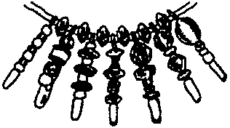Make several pins and hang from string.
Instead of string, use a white shoe lace. Decorate (e.g. stripes) the shoe lace with markers in the friendship colors. Then hang several friendship pins with spacer bead(s) in between.
You may want to make pins with different kinds and colors of beads. Hang these with the friendship pin in the middle.

FRIENDSHIP BEADS NECKLACE:
Make your own friendship beads and hang them from a string. Use the Salt Dough or Baker’s Dough listed in the November Craft section. Make beads and color them after they have hardened.

TUBE GIFT WRAP

This is an inexpensive way to wrap a small gift. Also the sturdy side of the tube will protect gift from being crushed on the way home from the den meeting.

You will need: Sturdy cardboard tube (about 3" diameter, 3-4" in length); Holiday wrapping paper; Cellophane wrap (the type fruit baskets are wrapped in) or Kitchen food wrap; Ribbon; Tissue.

1. Wrap the gift in tissue paper.
2. Cover the outside of the tube with wrapping paper.
3. Cut cellophane. (Cellophane piece should be big enough that when you place the tube standing in the center, you have double the height of the tube in all directions.) If you are using kitchen wrap, lay two pieces down in a cross.
4. Place the tube in the center. Place the gift in the tube.
5. Gather up the cellophane and tie with the ribbon close to the tube.

FOAM TRAY BLOCK PRINT
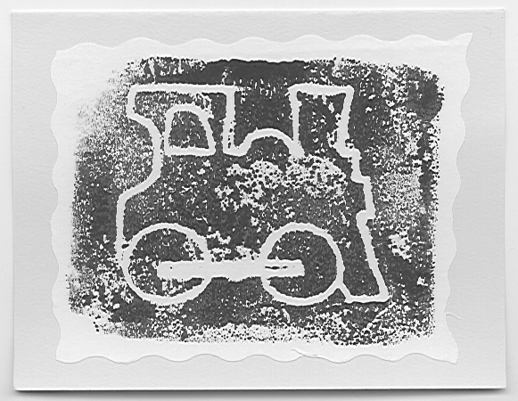
Make your own design on a piece of foam tray and decorate wrapping paper or make greeting cards.

You will need: Styrofoam meat trays with smooth bottoms; Thick water-base paint*.

1. Remove the sides of the tray. Cut the foam to the desired size.
2. Draw a design on a sheet of light-weight paper the same size as the foam piece. For best results, make your designs simple. (You may skip this step and draw directly on the foam. Remember the design will be reversed.)
3. Place the paper with its right side toward the bottom of tray and tape it.
4. Trace the design with ball-point pen.
5. After tracing, remove paper. If indentation is light, re-trace to make clear indentation.

Two ways to use the block:
1. Use it just like a stamp. This method is better if you are printing on a large surface like wrapping paper.
2. Roll paint onto the foam piece with brayer. If you don’t have a brayer, use paper towel or wide brush to spread the paint over the surface, taking care not to fill the grooves with paint. Place a piece of paper on the inked surface, rub over the paper lightly with your hand, being careful not to move the paper.

If you want a fancy card, make a print on typing paper, cut around the print with zigzag scissors and paste that onto colored stock paper.

*Note on ink. You can use any water-base paint as long as it’s thick so that it does not run into the grooves. Finger paint works well. To thicken tempera paint, add cornstarch, flour, or a small amount of dish-washing soap.

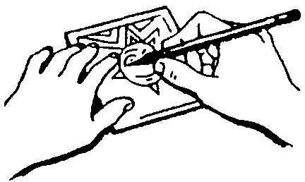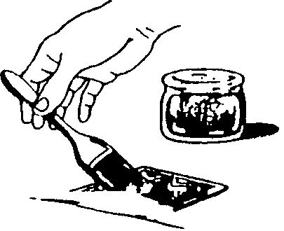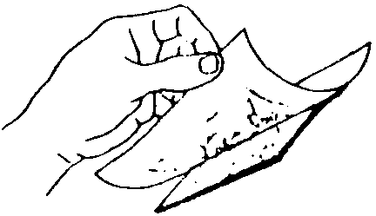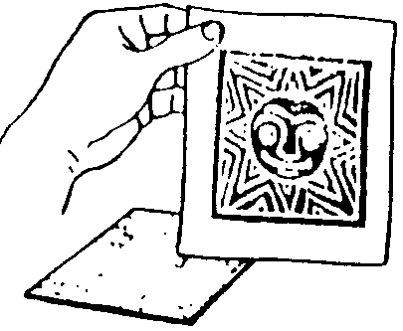

GLITTER STARS

WITH GLUE:
You will need: Glitter (assorted colors); White glue (Elmers works fine); Wax paper.

1. Draw star on waxed paper with glue. Make the glue lines thick. (It may be easier if children drew their stars on white paper with pencil. Cover the paper with waxed paper and trace the star with glue.)
2. Sprinkle the glue star with glitter. Make sure you cover the glue completely. Let the glue dry overnight (or until next den meeting).
3. Remove the excess glitter. Peel the waxed paper carefully away from the glitter star. Work from each point toward center.
4. Attach string to hang.

WITH POPSICLE STICKS:
You will need: Five popsicle sticks; Paint (water base); White glue; Glitter.

1. Make a popsicle stick star. (For the pattern see July Craft section).
2. Color glue by adding a small amount of paint. Mix well.
3. Paint the star and immediately sprinkle with glitter. Do the same for the other side when the glue-paint is dry. (Or paint and glitter both sides at once and hang the star to dry.)

The popsicle stick star will look pretty with just glitter without paint too.

POPSICLE REINDEER

You will need: 3 popsicle sticks; 2 wiggle eyes; 2 small bells; 1 red pompom; Ribbon; Glue.
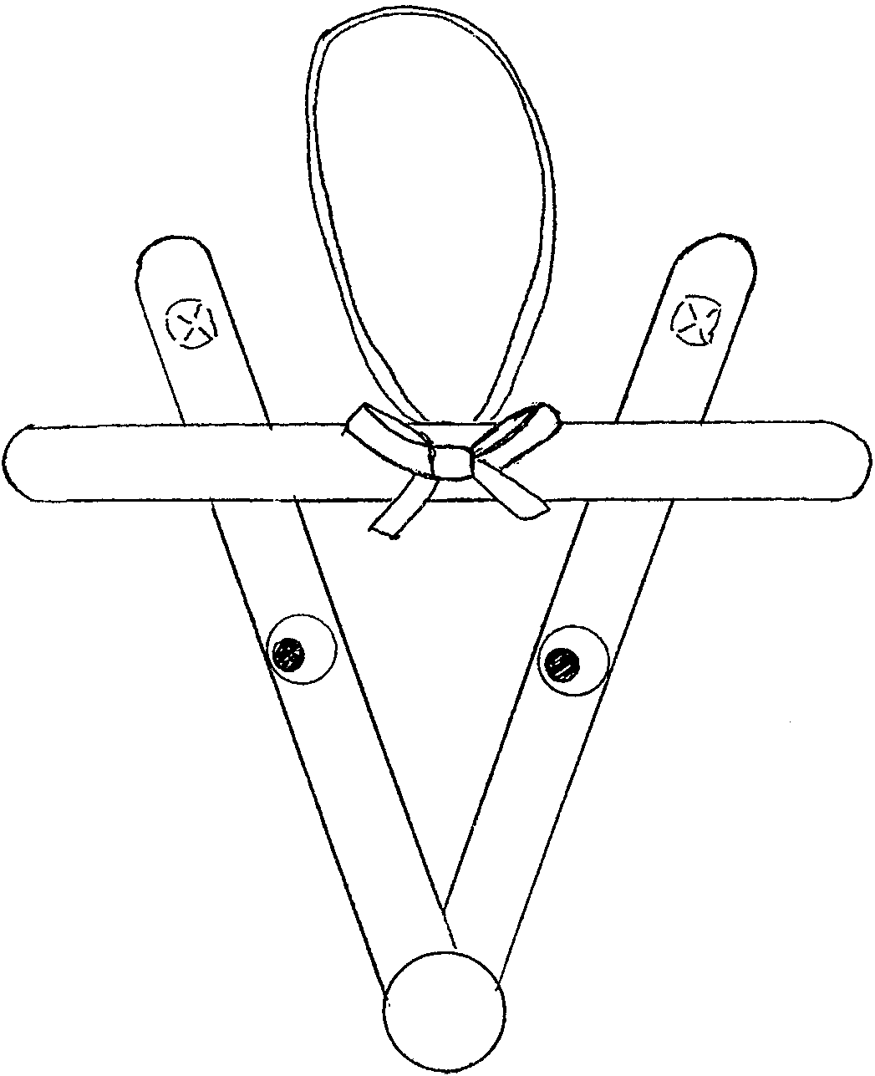
1. Glue popsicle sticks together as shown.
2. Glue eyes and nose.
3. Glue bells on the “antlers.”
4. Make ribbon into a loop and glue it to the back of head. (Try using 2-3 ribbons together.)
5. You may want to glue a bow to the head.

GLITTER “STAINED GLASS” ORNAMENT AND CANDLE JAR
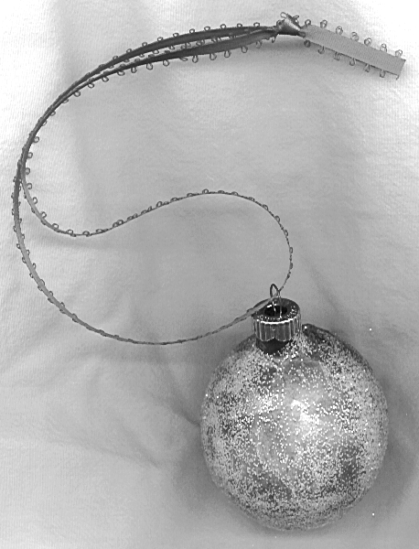
Recycle glass ball ornaments and baby food jars. This is really pretty and easy to do.

ORNAMENT
You will need: Glass ball ornament (any color or clear glass); Colored tissue paper in 3-4 colors; White glue (Elmers); Fine “crystal” glitter (white or pearl white); String.

1. Attach a piece of string to the top of the glass ball.
2. Cut tissue paper in any shape but not much longer than 1".
3. Mix glue with about an equal amount of water.
4. Apply a small amount of the glue mixture onto the ball, close to the top. Stick on a piece of tissue, making sure the tissue piece gets wet but not dripping. Apply another tissue piece overlapping with the first.
5. Keep applying tissue pieces. Colors will run, blurring the edges of individual tissue pieces. As you go along, hold onto the ball at the top.
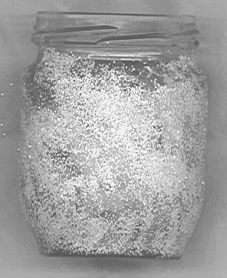6. When the entire ball is covered, shake glitter generously over the ball. (Make sure you catch the excess with a sheet of paper so you can reuse it.) Cover the ball with glitter. Avoid touching the surface.
7. Hang the ball by the string to dry. When it’s dry, replace the string with ribbon.

CANDLE JAR
Do the same to the side of a baby food jar or a similar jar. Avoid gluing tissue pieces to the top edge of the jar.
When dry, place a tea candle inside the jar.

CALIFORNIA “SNOWMAN”
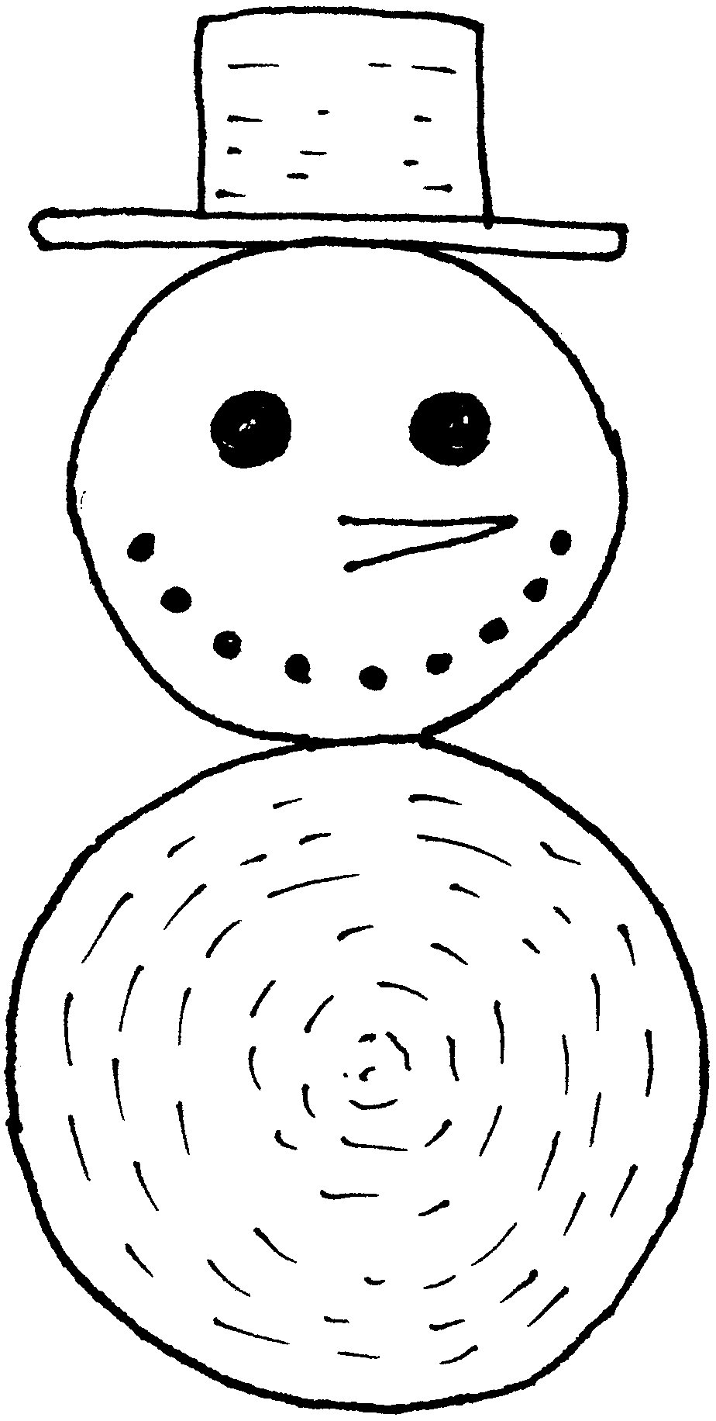
This “snowman” is made with four wooden circles of different sizes. The largest one will be the body. The second largest is the head. The hat brim is a thin slice of wood. A small, thick slice is the hat. Draw eyes and mouth with black marker. Make an orange nose from small piece of construction paper.

STAINED GLASS PICTURES

You will need: Plastic food wrap; Permanent markers (black and assorted colors); Aluminum foil; Paper plate (any size but not a thin one); Tape.
1. Draw a stained glass design, the size of the paper plate bottom. (Or use the one below. Small children’s coloring books often have simple drawings you could use.) Tape the design on a smooth table top.
2. Stretch a piece of plastic wrap over the design and tape in place.
3. color the design using permanent markers. When the design is complete, trace all the black lines using the black marker.
4. Take a piece of foil, larger than the plate, crumple carefully and smooth it out somewhat.
- Spread the foil over the bottom of the plate, folding the excess over the edge. Tape in place.
6. Spread the plastic wrap with the finished picture over the plate, folding the excess over the edge. Tape in place. Wrinkled foil surface makes the plastic wrap look like “stained glass.”

JIGSAW PUZZLE PIECE PIN, ORNAMENTS, SLIDES
You will need: Jigsaw puzzle pieces; Thin but stiff cardboard pieces; Glue; Clear sealer.
Additional material: A pin back and any small “jewel” pieces desired (beads, “crystal,” charm pieces, etc.); Section of 1/2" PVC pipe; String or ribbon.

1. Cut a cardboard base, any size desired. (But remember, the final product will be larger than the base.) For ornaments, try tree, bell, or wreath shape.
2. Glue layers of puzzle pieces to the cardboard, making sure you go over the edge of the base. Glue about three layers.
3. Apply clear sealer. Wait till dry.
4. Optionally for pins, glue on beads or other jewel pieces.
5. Glue a pin back onto the back, for a pin or a PVC pipe section for a slide. Attach string or ribbon for an ornament.

CANDY CANE REINDEER

You will need: Candy cane; Brown pipe cleaner; Two wiggle eyes; One pompom; Ribbon; Glue.

1. Fold the pipe cleaner in half and loop it around the candy cane. Twist until secure. Make the “antlers” by wrapping two ends of pipe cleaner around a pencil, one end at a time.
2. Glue wiggle eyes and nose.
3. Tie ribbon around the “neck.”
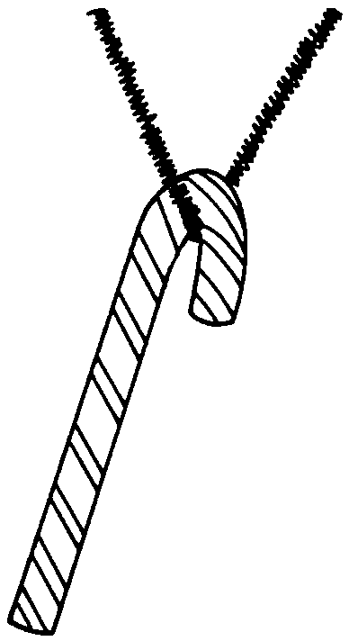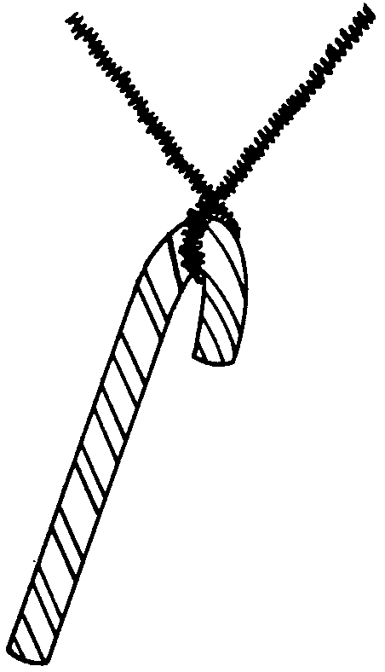

“BIG HEART” SANTA NECKERCHIEF SLIDE
Make one for your neckerchief. Make another and attach a pin back for Mom.

You will need: Wooden heart (about 2 1/4" across the top); White pipe cleaner; “Bumpy” pipe cleaner; One small white pompom (about 7mm); One small red pompom (5mm works fine); Two half round balls (5mm) or small beads for eyes; Section of 1/2" PVC pipe or a pin back; Red permanent marker (one with a wide tip works best); Craft glue or glue gun.

1. Turn the heart upside down. Color the top portion red for the hat. Don’t forget to color the edges of the wood piece.
2. Cut two sections of the “bumpy” pipe cleaner. Glue one on each side of cheeks, from the “chin” to the bottom of the hat.
3. Cut a section of straight pipe cleaner and glue it at the bottom of the hat. Wrap the excess around to the back.
4. Glue the white pompom at one of the corners just above the straight pipe cleaner.
5. Glue the red pompom for the nose and two beads for the eyes.
6. Glue the PVC section on the back.

This can be done using smaller hearts. Wrap excess pipe cleaner pieces for the beards onto the back.

PEPPERMINT NECKERCHIEF SLIDE
You will need: Wooden disk; Red and white paint; Cellophane; Section of 1/2" PVC pipe.

1. Paint the disk with red and white swirls.
2. Wrap in cellophane.
3. Glue on a PVC pipe section

RUDOLPH NECKERCHIEF SLIDE
You will need: Large cork; 1/2" PVC pipe; Small twigs or brown pipe cleaners; Brown felt; Tiny red pompom; Wiggle eye or beads.

1. Cut a large cork in half lengthwise. (Or you can leave it whole.)
2. Glue small twigs or pipe cleaner pieces for antlers.
3. Cut ear shapes out of felt and glue them on the back of the cork.
4. Glue a tiny red pompom for the nose.
5. Glue wiggle eyes or beads for eyes. Optionally, draw eyes with fine-tip markers.

CARAMEL MARSHMALLOW TREAT

1 lb Kraft caramels
1/2 cube margarine
1 can Eagle brand sweetened condensed milk
Rice Crispies
1 package large marshmallows.

1. Stir in a double boiler caramels, margarine and condensed milk until melted.
2. Dip marshmallows in caramel mixture with fork, roll in rice crispies and cool.

GUMDROP TREES

1 tbsp shortening
4 cups puffed oat cereal
3 tbsp butter or margarine
3 cups miniature marshmallows
1/2 tsp vanilla
Gumdrops

1. Grease cookie sheet with shortening. Empty puffed oat cereal onto cookie sheet.
2. Heat miniature marshmallows over low heat. Stir constantly until they melt.
3. Remove from heat and stir in vanilla.
4. Pour mixture over cereal and stir with tablespoon until entirely coated.
5. Butter your hands and shape the coated cereal into 6 Christmas trees.
6. Cut gumdrops with scissors and decorate trees with the slices.

RUDOLPH ANTLERS

These can be made in a jiffy, but need to be chilled. Make a few ahead of time so the boys can taste it. Make a batch (or two) together and send theirs home to be refrigerated.

1 6-oz package semisweet chocolate pieces
1/2 of a 6-oz package butterscotch pieces
1 3-oz can of chowmein noodles
12 Maraschino cherries, halved

1. Melt chocolate and butterscotch pieces together in a medium saucepan over low heat, stirring occasionally. Remove the pan from the heat. Stir in chowmein noodles.
2. Line a cookie sheet with waxed paper. Using two teaspoons, shape about 1 tablespoon of the mixture into a v-shape cookie about 2 inches wide to resemble antlers.
4. Press a cherry-half in the center of each. (Make sure you press the cherries securely.)
5. Chill cookies on the cookie sheet in the refrigerator for 1 to 2 hours or till cookies are firm. Store the antlers in the refrigerator in a covered container up to 5 days.
Makes 24

