Trails, Treks, and Tracks

JUNE 1999
WATER SAFETY

Summertime is a great time to take the pack or den to outdoor activities. Before you take your pack or den out for any water-related activities, please read:
Safe Swim Defense
Home Swimming Safety Rules
Water Rescue
Safety Afloat
in Cub Scout Leader Book, Chapter 12, pp. 2 to 5.

Safe Swim Defense and Safety Afloat are also available in pamphlets at the Scout Shop. The pack may want to purchase them for its leaders.

Most cities offer recreation swimming at their pools with qualified lifeguards on duty. Call your city’s Parks and Recreation department or Community Services office for specific locations, hours and fees. Some YMCA's contract pools (usually high school) for non-members outside their normal facilities for more affordable fees during summer. Call the YMCA near you for more information. Some pools require you to let them know ahead of time if you are planning to bring a large group of children so that they can arrange to have more lifeguards on hand.

HUG-A-TREE AND SURVIVE

What do boys do when they get lost in the woods? Do they know? Even if they know, learning again does not hurt. And this is a fun and friendly way for children to learn.
A volunteer presenter from HUG-A-TREE and SURVIVE can come to your pack meeting to talk to the boys about survival. It is an assembly program for children on how not to get lost, how to stay comfortable if they do get lost, and how to be spotted and found. It’s a very good program and free! Call (408) 475-0432 for a South Bay presenter.

Many of the volunteers are also volunteers for the California Rescue Dog Association. When contacting local presenters, ask if they are CARDA members and, if so, if they could bring their dogs. The boys will love it and so will the parents.

HIKE IDEAS AND HIKING GAMES

Boys are fascinated by everything in nature. Take advantage of summertime and take your den or pack on a hike. Hikes do not mean you have to go to the hills or woods; you can have fun hikes anywhere, even in the middle of a big city. Some hike ideas and hiking games are listed on pages 8-3 to 8-6 of the Cub Scout Leader How-to Book. Here are a few more ideas and games. Try a few ideas at one outing. (To make plaster casts of animal tracks, see pp. 3-40 to 41 in the Cub Scout Leader How-to Book.)

MONOGRAM HIKE:
Find three or more objects beginning with your initials.

HIKE IDEAS AND HIKING GAMES (continued)

TREE HIKE:
See how many different kinds of trees you can find. Get descriptions of bark, seeds, leaves, etc.
BIRD WATCHING HIKE:
Describe the birds they see; size, coloring, beak type, where they are. Take a bird identification book or someone who knows birds.
INDIAN HIKE:
Practice walking like Indians, as quietly as possible, in a single file.
SOUND HIKE;
Hear and identify all sounds heard along the way.
WATER HIKE:
Follow a stream or brook. Look for all sorts of water life such as ‘skater’ bugs, tadpoles, fish, etc.
HOMES HIKE:
Look for nature’s homes, like nests, holes, spider webs, etc. (Don’t disturb them! Don’t put your hand in a place you can’t see, either.)
MAP HIKE:
Make a sketch of your route as you proceed.
CURIOSITY HIKE:
Find some odd or curious object along the way, such as bark, stone, stick, etc. By using your imagination, tell what the object represents.
RAINBOW HIKE:
Find and list as many colors in nature as possible. Especially good after a rain.
COLORS HIKE:
Give each boy a list of colors to try and locate on the hike. The items can be collected or simply noted, depending on the area you are in.
CRAFT HIKE:
Collect nature items to work with later in crafts projects. Rocks can be turned into animals, leaves can be used for splatter painting, dried weeds, flowers, pods, seeds and the like can be glued into nature pictures. (Check with the park first to see if you can take anything out of the area.)
ONCE AROUND THE BLOCK:
Hikers go “once around the block (or a short distance)” then their observations are tested. Who has seen the most round things? What kinds of trees were seen? What did you see that was orange? etc.
A WONDER-FULL HIKE:
At each destination point or rest stop, each hiker tells of the “most wonderful” thing he saw on the way. Stops can be as frequent as you desire.
STOP AND SPOT HIKE:
While hiking the leader stops and says, “I spot a _____,” naming a familiar object. Everyone in the group who sees the object raises his hand. This is a good observation game.
BLINDFOLD HIKE:
Divide boys in pairs. Have one blindfolded. The other leads him a short distance, quietly and slowly. Encourage the blindfolded boy to listen, smell and feel the surroundings. Trade places.
TREASURE HIKE:
A trail laid with treasure at the end.
SEALED ORDERS HIKE:
Group lays trail using notes that give directions of how to go and what to do on the way.
HIKE IDEAS AND HIKING GAMES (continued)

TRACKING & TRAILING HIKE:
A variety of trail signs are laid down by the first group which indicates a trail for the second group to follow.
ALIEN HIKE:
Advance preparation is needed. You will need to set up about 10 odd sites for them to discover. Examples: Put a pine cone on an azalea bush, a rose in an apple tree, a large maple leaf in a fir tree, etc.
SMELL WALK:
Sniff your way around the block. Write down the odors you recognize. (Did the smell make you hungry? Happy? Alert? Afraid? Angry? Nervous? Sad?)
SHADOW WALK:
Walk only in the shadows. This may require some jumping. (Don’t plan this walk at noon since that is when shadows are shortest!)
FAMILY SPECIAL:
Have Cub Scout-parent hikes. These are especially fun in the evenings, but should be kept short. Big and little sister/brother hikes are fun, too.
COME TO YOUR SENSES:
Hike, stopping often to see, hear, feel, smell, and, with caution, taste things along the way. Feeling is a special delight. Touch the bark of trees, moss, flower petals. Sniff the air for new smells. Listen for sounds.
TEXTURE COLLECTING:
Using one color crayon, fill a piece of newsprint paper with rubbings found on a hike. (Rubbing--Place paper on the object, e.g. bark, and rub the flat side of the crayon across the paper, picking up the texture of the tree.) Try rocks, streets, sand and grass. Try drawing a picture with large spaces beforehand and filling in with rubbings.
EVENING HIKE:
Find North by stars. Learn to recognize some constellations. Tell stories about them. Try flashlight signaling.
DETECTIVE HIKE:
Spot and list all evidence of man in nature (litter, footprints, fire scars, chopped trees, etc.). What litter you may find, pick up and dispose of properly.
MEMORY HIKE:
This is partially played after a hike or trip to the zoo or park. During the outing, tell the boys to observe everything very carefully so they can make a list of all that they have seen. Just after the outing, hand out paper and pencils and have the boys make their list. See who was most observant.
SOCK WALK
This is best done when weeds have ripe seeds. Pull old large wool socks on over the shoes and walk through the weeds in a field. Take off the socks and examine them with a magnifying glass to see what seeds were picked up. How are they attached to the sock? You might try planting the seeds to see what kind of plants come up. If the sock is really old and not reusable, put it on a meat ray, keep it moist and see what happens.

CAMPFIRE MAZE

OUTDOOR CODE OPENING

Each Cub Scout should have a candle to light from a central candle (a leader or narrator may refer to it as the Spirit of Nature, the Conservation Candle or some other appropriate name). Each lights his candle and reads the following statements. (You may want to write additional lines if there are more participants.)

C.S. #1: We have been observing and studying nature’s treasures.
C.S. #2: We will help to maintain nature’s balance.
C.S. #3: We will help and learn from nature’s resources.
C.S. #4: We will help to maintain nature’s resources.
C.S. #5: We will protect them from harm.
C.S. #6: We will follow the laws of nature.
C.S. #7: The Outdoor Code:
(all seven Cub Scouts read)
As an American, I will do my best to--
Be clean in my outdoor manners,
Be careful with fire,
Be considerate in the outdoors,
Be conservation minded.

Safety tip: Foil muffin cups or a circle of cardboard around the candle base will make it look better and prevent wax from dripping on hands and floor.

See Staging Den and Pack Ceremonies, pp. 44-45, for “Outdoor Code--Responsive Reading.”

STAY ON THE RIGHT TRACK - TAKE TRAINING

To touch the past, touch a stone.

To touch the present, touch a rose.

To touch the future, touch the mind of a Boy.
CAMPFIRE OPENING AND CLOSING

Equipment: One large candle and 14 small candles, 7 of which have foil cupcake cups to catch hot wax (see page 5 above); one orange bead for each pack member; a coffee can and another container larger than the can, for the “campfire”; 7 index cards, each printed with lines for Cub Scouts to read; tape
Personnel: Cubmaster and 7 Cub Scouts
Arrangement: Place the orange beads in the coffee can and put it in the larger container. Tape the seven remaining small candles in a semicircle around the top edge of the large container. Each Cub Scout has a candle with a wax guard on it and a card with his part written on it. These Cub Scouts stand in a semicircle behind the campfire.

OPENING
CM: Welcome to our pack meeting campfire. This large candle I am holding represents the spirit of Cub Scouting. We use it to light the others to add to the brightness of our campfire. (As each Cub Scout reads his part, Cubmaster lights both the Cub Scout’s candle and one of the candles taped to the container.)
C.S. #1: I am light. As I am added to the campfire, my flame allows us to see new chances to be helpful to others.
C S. #2: I am friendship. My flame teaches us how to be a friend to other people.
C.S. #3: I am restraint. My flame reflects off the stones that surround the campfire, thus keeping the fire in check. When I am added to the campfire, we learn to keep our tempers and our tongues in check.
C.S. #4: I am the rising smoke. As I rise from our campfire, our eyes turn skyward and we envision God.
C.S. #5: I am love. My flame makes the campfire burn brighter and lovelier. Love grows toward parents and families when it is returned, and it makes our own lives more joyful.
C.S. #6: I am fun. My flame jumps and leaps with sheer pleasure. When I am added to the campfire, we see the joy and fun of Cub Scouting.
C.S. #7: I am the Scout spirit. My spirit is the brotherhood of Cub Scouts and Boy Scouts all over the world who are preparing themselves to become good citizens.
CM: We have learned that the things Cub Scouting offers us can make our campfire stronger, brighter, and more beautiful. Now before we continue our pack meeting, I ask all Cub Scouts to reach deep into the campfire and take a glowing ember. You will need it for our closing ceremony. (The boys each take an orange bead.)

CLOSING
CM: After our opening ceremony tonight, each of you took a glowing ember from our campfire as a token of our friendship. Please take it out now, hold it at arm’s length, and look at its glowing light. (Pause) Now may the Cub Scout spirit that is captured in your ember sustain you until we meet again.. Goodnight and good Cub Scouting.

NATURE’S SECRETS OPENING

Equipment: Acorn; pine needles; feather.
Personnel: 4 Cub Scouts; Cubmaster dresses as Akela.

Akela (to 4 Cub Scouts): To test your manhood, I send each of you out into the earth’s vast high country to bring back one of nature’s secrets.
(Cub Scouts exit and return.)

Akela (to C.S. #1): What secret have you brought and where did you find it?
C.S. #1: Akela, I return with great hunger, thirst, and a painful sunburn. I learned that a young brave must plan ahead.

Akela (to C.S. #2): What lesson have you brought and where did you find it?
C.S. #2: Akela, I searched the hills and forests and bring an acorn. Just as a mighty oak grows from a small acorn, if I have faith in myself, I can become strong.

Akela (to C.S. #3): What secret did you bring?
C.S. #3: Akela, I climbed high into the distant mountains where the snow is still deep, and the air is cool. I bring green needles from the giant pine trees. Just as the pine needles remain green throughout the year, a brave should always remain true to Cub Scouting--Do Your Best.

Akela (to C.S. #4): What treasure have you brought and where did you find it?
C.S. #4: Akela, I traveled to the top of the mountains. From my high perch, I saw the wonders of God’s creations. I saw the eagle as it soared high and free in the blue sky. I bring an eagle’s feather--a reminder of freedom and the vision we must have to protect and cherish it.

Akela (to the audience): These braves have learned well. Nature shared her secrets with them. It is now their responsibility to live what they have learned, to plan ahead, to have faith, to remain true to Scouting, and to cherish freedom. Will everyone now please stand and join me in repeating the Pledge of Allegiance and the Cub Scout Promise?

CHEERS

FOIL DINNER CHEER: “Sizzle, Sizzle, Sizzle, MMMMMMMMMMM Yummy”

MARSHMALLOW: Put your marshmallow on a stick, hold it over the fire. It catches fire. Hurry and blow it out. Cool it. And say, “Just right!”
HIKING AND THE FLAG - OPENING

Personnel: Cubmaster, Assistant Cubmaster, 2 den leaders
Equipment: Camping gear and outfits for each of the participants; 1 pair of binoculars; American and pack flags.
Arrangement: The flags are in front of the audience. The group of participants are off to one side and slowly walk through the audience to the front.

(Everyone starts walking slowly.)
CM: It sure is nice to be here in the outdoors. All these trees, animals and fresh air.
ACM: (Looking through binoculars)
Hey, I think I see a big red bird up there!
(DL #1 takes the binoculars while everyone continues to walk slowly to the front.)
DL #1: Here, let me see. Naw, it’s a huge white bird of some sort.
(DL #2 takes the binoculars while everyone continues to talk slowly to the front)
DL #2: Boy, you don’t know what you are talking about. It’s not red or white. It’s big and blue, and...what’s this?!?! It has stars!
(Cubmaster takes the binoculars and everyone stops.)
CM: Here, let me see what you are all talking about. (Looks through the binoculars.) Come on you guys. (Motions everyone to follow as they walk up to the front.) It’s not a red bird, or even a white bird. What you were looking at is our nation’s flag. (Turns to audience.) Will you please stand and join us in the Pledge of Allegiance?

OUR FLAG - OPENING

8 Cub Scouts are lined up across the stage, holding the props described below.

C.S. #1: (Holds up picture of US flag.)
The flag of our country means much to all.
C.S. #2: (Holds up large paper or cardboard star.)
With a star for each state whether large or small.
C.S. #3: (Holds up red and white crepe paper streamers.)
With thirteen stripes of red and white.
C.S. #4: (Holds up map of first thirteen colonies.)
Representing the 13 colonies who for freedom did fight.
C.S. #5: (Holds up star in one hand and large piece of blue paper in other.)
Put the fifty stars on a field of blue.
C.S. #6: (Holds up white poster which has red crepe paper stripes on it.)
Adding the red and white striped field, too.
C.S. #7: (Holds up small American flag or picture of it.)
There you have the flag of our land.
C.S. #8: To our Old Glory, let’s salute with heart and hand.
(One of the boys steps forward and asks audience to rise and join in Pledge of Allegiance.)

OBSERVE FLAG DAY ON JUNE 14.

OUTDOOR EVENING FLAG CEREMONY

Whenever a country has sent out explorers and discovered new lands, the first thing they did was plant the flag to claim the area. Modern day explorers do the same as a symbol of their accomplishment and also as a statement of their loyalty to their country. When Neil Armstrong landed on the moon and stepped down on its surface for the first time, he had a flag with him which he planted in the soil. The flag looks a little different. It is made out of metal, but it is still there. Every time you look at the moon in the sky, remember that if you could see that far, you would be able to spot the American flag that is still there.

Tonight we will look up to the moon and salute to that flag. Please join me in the Pledge of Allegiance.

CAMPFIRE CLOSING

Cubmaster:
As we prepare to leave today, we will put out our campfire. We will carry with us this memory as well as the memory of the things we have learned and the good times we have had this day in Cub Scouting.

“SET YOUR COURSE” - CLOSING

Arrangements: 9 Cub Scouts each hold one letter of the word CHARACTER.

C.S. #1: When you hike with a compass, you stay on course; otherwise you may get lost. There is another kind of course that is even more important than that.
C.S. #2: That is the character course.
C.S. #3: Your characters are being formed right now.
C.S. #4: By what you do and by what you don’t do.
C.S. #5: Many of your actions will be influenced by others.
C.S. #6: Try to set your own course.
C.S. #7: Make up your mind that you will live always by the Cub Scout Law.
C.S. #8: Then follow through with it.
C.S. #9: Go to the top of Character Hill.

TRAIL TO GREAT CUB SCOUT PROGRAM--TRACK TO THE DISTRICT ROUNDTABLE

SHARP KNIFE CLOSING

Cubmaster (showing a pocketknife):
Cub Scouts, this is an ordinary pocketknife. Maybe you own one. If you don’t, you probably will want one when you get into Boy Scouting. It’s a very useful tool around camp. If! Do you know what the “if” is? If you keep it clean and sharp.

If you let a knife get dull and rusty, it’s not only useless, it’s dangerous because it won’t be able to do what you want it to do. It’s very easy to cut yourself when you try to force a dull knife to do something it can’t do.

The same idea applies to our bodies. If our bodies are clean and sharp--if we are really fit--we won’t become dull and rusty like a knife that has not been given good care. That’s why we exercise and play strenuous games. And that’s why you want to keep your body fit now and in the years to come. Will you do your best?

Please give the Cub Scout motto. (The boys shout, “We’ll do our best!”)

PATRIOTIC CLOSING

Did you ever think of just what makes up our country’s flag? Yes, there are stripes, a patch of blue, and some five-pointed stars--but they are just pieces of cloth.
However, when the 13 stripes of alternate red and white, representing the thirteen original states, are put together and the field of blue is in place with the stars, representing the “constellation” of 50 states--all securely held together by thousands of stitches--then we no longer have pieces of cloth and patches, but the flag of the United Sates, the emblem of our country.
I think that all those stitches represent us--”we, the people”--that every one of us is represented in the flag by a stitch holding the flag together. And as long as we are strong, holding steadfastly to our job of being good American citizens, our country will remain “one nation under God, indivisible, with liberty and justice for all.”
All of you know what would happen to a flag if some of the stitches failed to hold. The flag would fall apart or unravel. That is exactly what can happen to our country if we do not try to be good Americans. Our America can lose its “Oneness.”
Let’s say, “We will not let that happen.” We will all of us, on this day and every day, continue to do our best, to help others, and to show by our actions that we are worthy of our country.

PRAYER OF THANKS

We thank You, O God, for this day, for morning sun and evening star; for flowering of trees and flowing of streams, for life-giving rains and cooling breeze; for the Earth’s patient turning, the changing of the seasons, the cycle of growth and decay, of life and death. When our eyes behold the beauty and grandeur of your world, we see the wisdom, power and goodness of its creator. We awake and, behold! It’s a great day! Amen

CUB SCOUT TRAIL ADVANCEMENT

Arrangement: Awards are attached on the back of paw prints (Tiger, Bobcat, Wolf, Bear, use Webelos sign for the Webelos); Paw prints are visible on walls and other part of the room, grouped by the rank.

Cubmaster:
The Cub Scouts of our pack have been hiking and having outdoor fun this month. As they have been finding new things to do along the way, many achievements have been completed along this Cub Scot trail. The only problem is that these awards have been left out on the Cub Scout Trail where they were completed. So my trusty hiking buddy and myself are going to have to hit the trail ourselves in search of tonight’s awards.
(Cubmaster and Assistant Cubmaster begin scouring room, looking with binoculars, holding hand to brow as if to look ahead. They stop and point to Tiger Paws.)

Ah ha!! We have found evidence of Tiger prints along the Trail. This must mean that we have some Tiger Cubs who have completed a Big Idea this month with their Tiger Cub Partners. Will the following boys and parents please come forward? (Present Tiger Paws.)
(Leaders continue on search until coming to Bobcat paw prints, Wolf paw prints, Bear paw prints, and Webelos “paw prints.” Rank ceremonies for each could be as follows.)

The Bobcat has alert ears and his movements are swift and sleek. We have several Bobcats here tonight who swiftly tracked the seven steps of what it takes to be a Cub Scout. Would the following boys and their parents come forward?

The Wolf is an animal of intelligence and loyalty. He has learned about his country and his home to which he will remain loyal. He has also leaned many ways of nature and new skills to help Mother Earth stay healthy. Would the following boys and their parents come forward?

The Bear has always been the symbol of strength. The bear has learned many ways to use his strength to improve his body, his mind and his environment. He has done this by continually exploring new ideas and learning new skills. Would the following boys and their parents come forward?

Webelos may not be named after an animal but it does stand for something special. Webelos means “We’ll be loyal Scouts.” These young men have traveled far and have learned much. They have learned to take care of the environment. Webelos are apprentice outdoorsmen, foresters, geologists and naturalists. And they will keep learning on their trail to Boy Scouts. Would the following boys and their parents come forward to be awarded the rank of Webelos?

It is possible to climb the highest mountain - one step at a time.
BOBCAT CAMPFIRE INDUCTION

Equipment: Artificial campfire; stick for each Cub Scout receiving a badge; Bobcat badges (attached to safety pins)

(Cubmaster calls the Bobcats and their parents forward and asks them to form a semicircle behind the fire, with the parents behind the boys.)
Cub Scouts, you have learned the things a boy must know to join our pack. Will you show that now by making the Cub Scout sign and repeating the Cub Scout Promise? (Leads the Promise.)

Parents, we welcome you into our pack, too. You know that you have a role in Cub Scouting as a guide in your son’s advancement and as a participant and helper in the pack’s activities. If you accept this responsibility, please say, “We will.” (Parents give assent.)

This campfire represents the warmth of membership in our pack. Bobcats, please show that you wish to join in that warmth by adding your stick to the fire. This symbolizes that you want to do your best and be a friend to the others in the pack. (The boys place their sticks in the campfire.)

Now, parents, I will give each of you the Bobcat badge to pin on your son’s shirt.
Congratulations.

FUN WAYS TO SAY THANK YOU

12-inch Ruler: “Thank you putting your best foot forward.”
Compass: “Thanks for leading the way. You have done so much for our pack.”
Extra Gum: “Because you ‘chews’ to go the ‘extra’ mile.”
Knot: “Thanks for tying the pack program together.”
Paw: “Thanks for lending a hand.”
Railroad Track: “You’re on the right track.”
Stick: “Thanks for sticking by the pack.”
Walking Stick (made from a dead branch): For organizing a pack hike.
Wheels: “You helped keep the pack going!”
Automobile: “‘Auto’ be a nice day because of you.”
Car: “You’re always driving in the right direction.”
Foot Prints (bare or shoes, on paper or shirt): “Thank you for hiking that ‘extra extra’ mile!”

RUN-ONS

An exhausted hiker stumbled into another hiker in the woods.
1. Am I glad to see you. I’ve been lost for two days.
2. Don’t get too excited. I’ve been lost for two weeks.”
LET’S CLIMB A MOUNTAIN

This is a repeat-after-me and do-as-I-do audience participation stunt.

Want to climb a mountain? Then just say what I say and do what I do. All set? Let’s go!
I think I’ll climb a mountain. (Audience repeats this and following phrases.)
Let’s pack. (Put imaginary things into imaginary pack and throw over shoulder.)
Out the door! (Single clap to indicate banging of door.)
Down the street! (Marching claps with both hands against thighs.)
Awfully big town. (Continue marching.)
In the country at last! (Speed up march.)
Here’s a river. (Continue marching.)
And here’s the bridge. (Pound fists against chest in marching tempo, then continue with open hands against thighs.)
Here’s a field. (Resume ordinary marching.)
Let’s cut across. (Swish palms together.)
Here we are at the foot of the mountain. Let’s start climbing. (Clap thighs more slowly.)
Here’s a mountain stream. (Stop clapping.)
No bridge, so we’ll have to jump! (Fast clapping on thighs, then both arms up and down again to indicate long jump. Resume marching. Then slow down, stop, start again, show uncertainty.)
Lost! (Several slow marching stops and starts.)
There’s a tree, let’s climb it and look around. (Fast clapping to indicate run to tree, then arm motions for climbing. Then hand to forehead and peer in several directions.)
Still lost. (Make slow climb down the tree, then several hesitant marching starts and stops.)
Look, there’s a cave! (Fast clapping for run to cave.)
This side is cold. (Feel with hand against imaginary side.)
This side is wet. (Feel other side.)
There’s a light! (Point with one finger into cave.)
“There’s another light! (Point in same direction.)
They are eyes! It’s a bear! (Rapidly reverse actions: coming down mountain, jumping stream, swishing palms across field, over bridge, through streets, ending with a loud clap for door closing back home.)
Back home! Safe at last! But wasn’t that a great climb?

TONGUE TWISTERS

Nat’s knapsack strap snapped.
Sam’s sock shop stocks short spotted socks.
Pick up six pick-up sticks quickly.

THE TALKING WOODS

Bees: “Buzz-buzz”
Frog: “Ribit-ribit”
Ant(s): “Chomp-chomp”
Mosquitoes: “Bite-bite”
Woods: All sounds together

One day John and Robert decided to go for a walk in the WOODS. The packed a lunch and started off.
The WOODS seemed very busy that day. They heard some BEES buzzing as they gathered nectar for making honey. As they walked along the stream bank, a FROG jumped out in front of them, and they started to chase it. The FROG jumped into a nearby pond where the MOSQUITOES were very busy enjoying the water.
By this time the boys were getting hungry so they sat down under a big tree to enjoy their lunch. It wasn’t long before they were joined by a nearby ANT community out looking for lunch themselves. It was getting late when they finished their lunch so they started for home. As they walked back through the WOODS, they listened to all the wonderful sounds. The BEES, the MOSQUITOES, the FROGS and the ANTS.
They were very tired when they got home but they had a great time in the WOODS.

RUN-ONS

Hiker 1: Watch out. There’s poison oak.
Hiker 2: Don’t touch it. You’ll be itch hiking!

Where does an 800 pound black bear sleep?
Anywhere it wants.

What is the only wild animal you are allowed to feed?
The mosquito.

Boy 1: (running on stage) They’re after me! They’re after me!
Boy 2: Who’s after you?
Boy 1: The squirrels. They think I’m nuts.

1. (pointing to the sky) Is that the sun or the moon up there?
2. I don’t know. I’m a stranger here myself.

WILD SLIMER
(by Russell Butler, Great Salt Lake Council)

C.S. #1: We are supposed to be learning how to do tracking today. Do you guys know how to track?
C.S. #2: I have never done any tracking.
C.S. #3: Me neither.
C.S. #4: I have. I once tracked a wild slimer for six hours.
C.S. #1: What happened?
C.S. #4: I tracked the slimer north for two hours.
C.S. #2: Then what happened?
C.S. #4: Then he turned west and I tracked him for another hour.
C.S. #3: What happened next?
C.S. #4: For the next three hours the slimer back tracked on himself, circled around and finally ended up going south.
C.S. #1: Wow, how far did you end up tracking the wild slimer?
C.S. #4: About three feet, snails get tired after that.

DIRTY SOCKS

About a 5 on the Gross chart.

Need: 4 Cub Scouts; One large can (gallon can) with water placed in the center of the stage; A pair of socks in the can; 3 mugs.

C.S. #1 (Walks to can carrying his mug. Dips his mug in and brings it up to his lips for a drink.)
“This camp coffee is getting worse!”

C.S. #2 (Walks to can carrying his mug. Dips his mug in and brings it up to his lips for a drink.)
“This camp tea is getting worse!”

C.S. #3 (Walks to can carrying his mug. Dips his mug in and brings it up to his lips for a drink.)
“This camp chocolate is getting worse!”

C.S. #4 (Walks to can, dips his hands in and takes out a pair of wet socks. As he wrings them out, he says)
“I thought that would get them clean!”

MOSQUITOES

Scene: Use two people to form a London Bridge type tent.
Cast: Any number of boys

Boys are out on a camping trip:
“Hey this is a good spot, let’s pitch a tent here!” (Goes out and gets two people to form a tent)
“Oh, wow, that’s great.” (Any appropriate comments)
“I’m ready for bed. I think I will sleep outside in the beautiful mountain air. You guys go ahead and sleep in the tent. I’m going to sleep under the stars.” (Use “we” if more than one)

Indoor group: “All right, go ahead, but don’t bother us if you get scared.”
Outside group: “Oh, we won’t. It’s going to be great!”

(All settle down to sleep when a giant band of mosquitoes come into camp. Mosquitoes have arms extended in front to represent stingers)

Mosquitoes: “Buzz, buzz, buzz, wow, a yummy meal”
(Run over and attack boys sleeping outside)
Outside group: “Help, help, we’ve been bitten by giant mosquitoes.”
(They all jump up and run in to wake up the others)
Indoor group. “Oh, go back to bed. We told you not to bother us!”

(Boys go back to bed. Just when they get to sleep, the mosquitoes come back)
Mosquitoes: “Hey, those guys were so yummy let’s have another bite, buzz, buzz, buzz.”
(Run over and attack boys sleeping outside)

Outside Group: “Help, help! We got bitten by the giant mosquitoes again, Let us sleep with you.
(They all jump up and run in to wake up the others again)
Indoor group: “No way. You sleep in here. We’ll go out there.”
(Everyone agrees)

(Just as everyone is asleep the mosquitoes return. They go to bite the outdoor sleepers, then change their minds.)
Mosquitoes: “No, not them. We’ve got them twice already. Let’s get the ones inside the tent, Buzz, buzz, buzz.”
Indoor group: Help, Help!!

TRAIL GAME
Do this in back yard or playground. Divide the den into two groups. First group lays the trail and the other group has to see if they can follow it all the way to the end. Before the game have the boys figure out the trail code together so that they all know what the signs mean. Let the trail layers finish laying it on the ground before the trackers set off.

Below are Scout trail signs. Scratch them on the ground with a stick. The circle with a dot says, “This is the end of the trail” as well as “I have gone home.” It is placed on Baden-Powell’s grave stone.

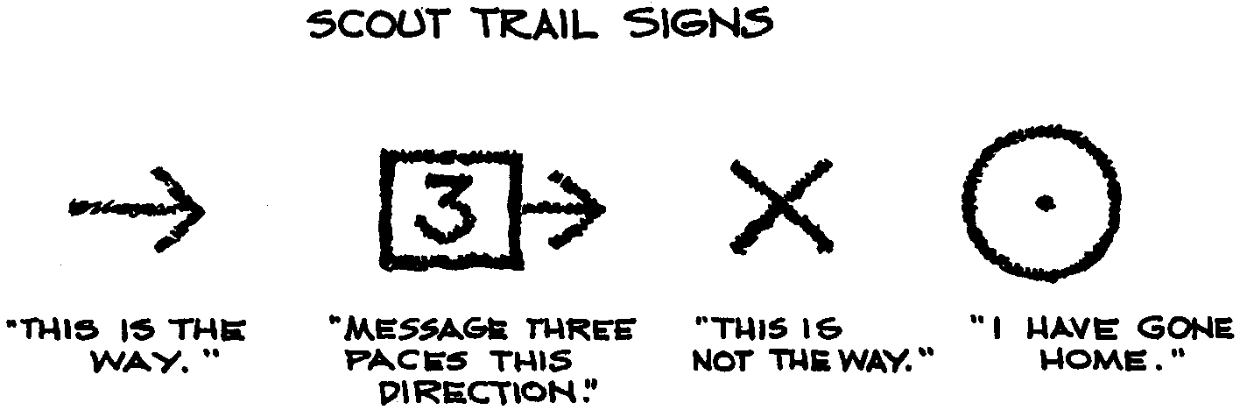

ROPE WALK

This is played outside. The players except the leader and the guide stand single file in two staggered lines, all facing in the same direction. They are blindfolded. A rope is run between the two rows and each player grasps it with his nearest hand. The leader gives directions as he pulls on the rope and the players follow. The guide assists the players as each one comes to a place where he is to twist and turn, wind and unwind, jump, skip, hop, step up, step down or side step. The leader may say the players are entering a jungle when he brushes past a hedge, that there is a water fall nearby when they hear a water fountain or a hose running. He may say they are in a tunnel when they walk very close to a building.

NATURE KIM’S GAME

On an outing or in the backyard, gather (without boys’ seeing you) about 10 common natural objects such as rocks, seeds, and pine cones. Lay the objects out on a handkerchief and cover them with another . Call the boys close around you and tell them that you will lift the cover for 25 second and to take a good look. After 25 seconds, cover and have the boys list the objects under the cover.

STEAL THE CONE

The object of this game is to steal a pine cone without being caught. Choose one boy to guard the cone. He is blindfolded and sits down cross-legged behind, but not touching, the cone. Other players sit quietly about 10 feet away opposite the cone guard. They take turns, one at a time, sneaking up to the cone. When the cone guard hears someone sneaking up to the cone, the guard must point toward the noise heard. If the guard points directly at the approaching player, then that player is out. The player who succeeds in stealing the cone becomes the next cone guard. Variation: Instead of taking the cone away, how about placing the cone in front of the blindfolded person without being caught?

STAY ON THE TRAIL

This is a team relay game. Each team has a yardstick laid across the tops of two chair backs, with a penny on the yardstick. A Cub Scout stands facing the yardstick with a straw in his mouth and pushes the penny to the other end of the yardstick without touching the yardstick or the penny with his hands. If the penny falls off, the player has to go back to the end of his team. The team that finishes first wins.

FLASHLIGHT TAG

This game is played in the dark. You play a simple game of tag, but you are using a flashlight if you are “it.” Instead of touching someone and making them be “it,” you point the beam of light at them. If they are “hit” with the beam, they become “it.” The others are allowed to run, jump, duck, dive... anything but hide to keep from being hit with the beam of light. In this game, there is no “base.”

TONGUE TWISTER SONG
(Tune: Battle Hymn of the Republic)

A busily buzzing bumble bee was busily buzzing by.
A busily buzzing bumble bee was busily buzzing by.
A busily buzzing bumble bee was busily buzzing by.
A busily buzzing bumble bee was busily buzzing by

CHORUS:
They were only playing leapfrog.
They were only playing leapfrog.
They were only playing leapfrog.
As a busily buzzing bumble bee was busily buzzing by.

Other verses as desired or needed:
A speedy spider spied a spider on a spindly spider’s back.
CHORUS: They were only playing leapfrog.

One hedge hog edged up on the hedge while another hedge hog edged down.
CHORUS: They were only playing hedge hop.

One fleet fly flew up the flue while another fleet fly flew down.
CHORUS: They were only playing flue fly.

One sly snake slid up the stake while another sly snake slid down.
CHORUS: They were only playing serpent.

One big black bear backed into a bush while another big black bear backed out.
CHORUS: They were only playing bear back.

One tiny turtle tumbled into the tank while another tiny turtle tumbled out.
CHORUS: They were only playing tip tank.

One tall turkey tore up the tree while another tall turkey tore down.
CHORUS: They were only playing tree tag.

One fat frog flopped on the float while another fat frog flopped off.
CHORUS: They were only playing frog float.

One speedy fat bear tumbled into the stake while another sly fleet turkey flopped down.
CHORUS: That’s the way we sing in Scouts.
CUB SCOUT TAPS

Sun of Gold
Sky of Blue
Both are gone
From our sight
Day is through
Do your best
Then to rest
Peace to you.

Sun is set
Shadows come
Time has gone
Cubs must go
To their home
All is true
To the promise
That they made.

As we close
Each Cub knows
What it means
To be fair
To be true
To be proud
Of the Gold
And the Blue.

See Cub Scout Songbook for:
“Akela’s Trail”
“I Love the Mountains”
“I’m Happy When I’m Hiking”
“The Happy Wanderer”
“We’re on the Upward Trail”
“‘Round the Campfire”
“Taps”
“Cub Scout Vespers”
“Scout Vesper Song”

MY FAVORITE CUB THINGS
(Tune: My Favorite Thing)

Hiking in summer and snowballs in winter.
Working with wood till my hand’s full of splinters.
Sitting round campfires and starting to sing.
These are a few of my favorite things.

Bringing snakes home to show to my den leader.
That’s the best way to show her that I need her.
She screams, “A snake to our meeting don’t bring.”
It’s sure not one of her favorite things.

HIKE ALONG
(Tune: This Old Man)

Hike along, hike along,
Lift your feet up off the ground,
And we’ll hike and sing this happy little song,
As we go a hiking on.

OUT IN NATURE
(Tune: Clementine)

Out in nature, out in nature
You will find your summer’s fun;
If you look at what’s around you,
You’ll have fun till day is done.

After sunset, watch the stars shine,
Nature’s wonders you can see;
Mother Nature’s backyard’s endless,
Always there for you and me.

Did you ever watch an ant work?
Have you listened to the bees?
Have you watched birds build their nests high,
And been thankful for the trees?

If you’ll just look all around you,
Many new things you will find.
If you’d only realize it,
They were right there all the time.

HIKING
(Tune: Caisson Song)

Over hill, over dale,
We will hit the Cub Scout trail,
As the Cub Scouts go hiking along.
In and out, all around,
You will never see us frown,
As the Cub Scouts go hiking along.

And it’s high, high, hee
The Cub Scouts are for me,
Shout out your name and shout it strong,
Where’re we go, we will always know,
That the Cub Scouts go hiking along.

SONG OF MY SHOES
(Tune: Battle Hymn of the Republic)

My shoes have seen the glory of the growing of a Scout.
My shoes have been in water steppin’ in and steppin’ out.
My shoes have hiked through forests to the top of the mount;
My shoes are wearing out!

Groovy, Radical, and Awesome (repeat 3x)
My shoes are wearing out!

My shoes have seen the bottom of the dirty fishy creek,
My shoes have been all covered with the gooey muddy cake,
My shoes have seen the same ol’ socks for seven days this week,
My shoes do really stink!

Groovy, Radical, and Awesome (repeat 3x)
My shoes do really stink.

My shoes are torn and tattered climbing fences packed in rust,
My shoes are stained and spattered with some yucky insect guts,
My shoes are oozing slime and fill my mom with disgust,
My shoes have bit the dust!

Groovy, Radical, and Awesome (repeat 3x)
My shoes have bit the dust!

TWIG FRAME FOR THE OUTDOOR CODE
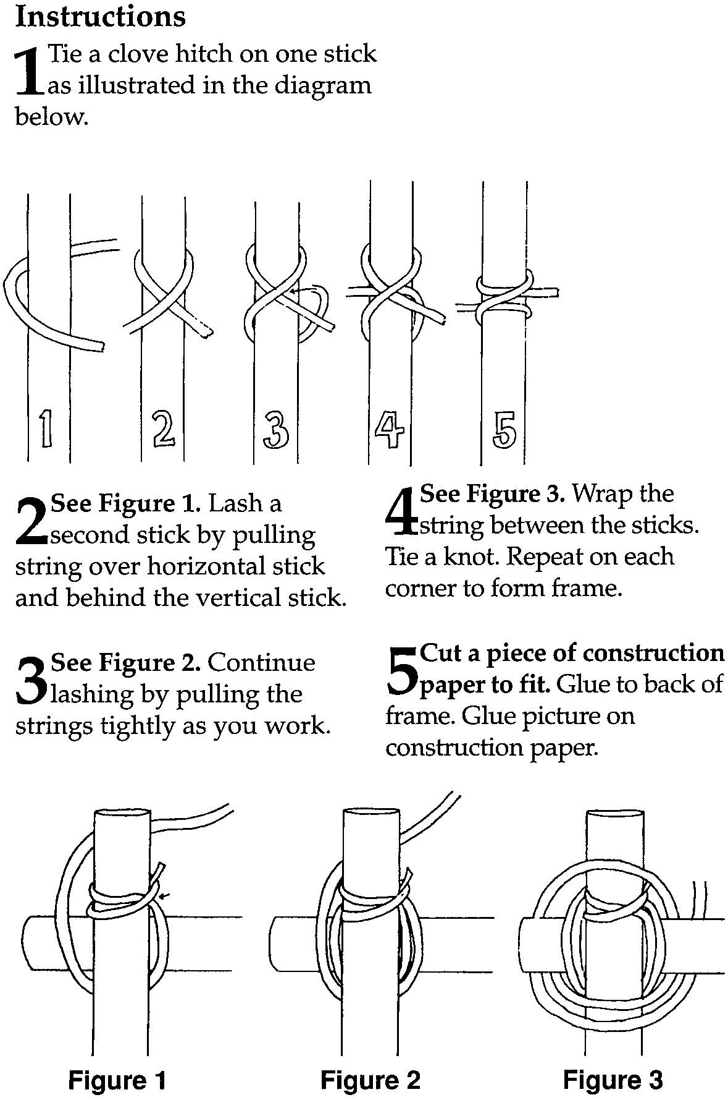
Find 4 sticks of similar length. You can make this frame any size but sticks longer than 12" may be hard to manage. Tie or lash four sticks together into a frame. (Younger boys can glue them.) Cut a piece of stiff paper like cardstock to the size of the frame, making sure you have enough room to glue it to the sticks. Write or paste a copy the Outdoor Code on the paper and glue to the back of the frame. Or glue a picture on stiff paper and use this as a picture frame.

MAKING FOOTPRINTS

This is rather messy. Better done outside.

You will need: Old white sheet; Different color of paint; A wash tub; Newspaper; Aluminum foil pan 1/2" to 1" deep.

1. Put paint in foil pan only a little at a time. Have each boy take his shoes and socks off.
2. Lay out sheet. Put paint container on newspaper on one side of the sheet. Place wash tub with water on the other side of the sheet.
3. Let boys, one at a time, put their feet in paint and walk across sheet, making sure not to walk on anyone else’s footprint. Have them step in wash tub and wash their feet.
4. Let sheet dry and then have parents guess which footprints belong to their son.
Note: To prevent paint from dripping everywhere, you may want to put a piece of thin sponge in the foil pan and pour paint, a little at a time, on the sponge.

Use acrylic paint and use the sheet as a den picnic table or ground cover.
Use a sheet of paper for each boy. Have each boy print only one pair of footprints. Write the date.
Use a long sheet of paper, one for each boy. Everyone prints one set of footprints on all the sheets. Sign their name. Now everyone has his Den’s feet feat!

OUTDOOR TIC TAC TOE

You will need: Square concrete stepping stone; 8 rocks (not too large--these are tic tac toe pieces to be played on the stepping stone); Outdoor paint or acrylic paint; Paint brushes.

1 Wash the stepping stone and the rocks and let them dry.
2. On the stepping stone, draw in a dark color the tic tac toe game lines. Decorate the edges as desired.
3. Divide rocks in two groups of five. Paint rocks in one group similar to one another. Paint rocks in the other group in a design and color scheme different from the first group.
4. Optionally add a coat of sealer to the rocks and the stepping stone.

CALL OF THE WILD

This is not much of a craft but will be fun to play with. Take a few popsicle sticks and rubber bands on your next hike.

You will need: 2 clean and dry popsicle sticks; A long, wide blade of wild grass or a length of broken cassette tape; A rubber band.

Sandwich a blade of grass between the two popsicle sticks. Secure one end by wrapping the rubber band around it. You may want to decorate the outside of the popsicle sticks with permanent markers.

HOW TO PLAY: Pinch the open end and blow through the caller as if playing a harmonica.
To attract wildlife, sit quietly and blow into the caller repeatedly at the same rhythm and pitch as a baby crying, “Waaa waaa waaa.” See what it attracts.

FROG NOTE HOLDER
You will need: 13 large craft sticks; Cardboard for backing; Paint; Clothespin; Scrap felt; Short piece of string.

1. Cut out a piece of cardboard the width of two craft sticks and the length of one (or slightly smaller).
2. Glue two craft sticks to the cardboard (body). Glue two more on top of them, though slightly lower leaving space for eyes.
3. Cut out felt fingers and cut one craft stick in half for the feet.
4. Glue the rest of the frog together as shown. Glue on the clothespin.
5. Paint. Eyes can be painted or use wiggle eyes.
6. Attach a piece of string on the back behind the eyes to hang the frog.

TONGUE DEPRESSOR “MAGNIFYING GLASS”

You will need: Two tongue depressors (fat craft stick, 3/4"); Lens from a throw away camera WITHOUT a flash unit*; Tape; Markers

Tape two tongue depressors together and drill a 5/16" hole through both at one end of the sticks. Take the sticks apart. Place the lens in the hole and sandwich it between the sticks. Careful, without moving the lens, tape the sticks together. Decorate with markers if desired.

*NOTE: Please do not take apart a camera with a flash unit. You can get shocked!
To obtain enough lenses for your den, ask at a camera shop or discount store that process films. They sell empty units back to the manufacturers but many will donate a few to Cub Scouts.

NATURE DEN DOODLE
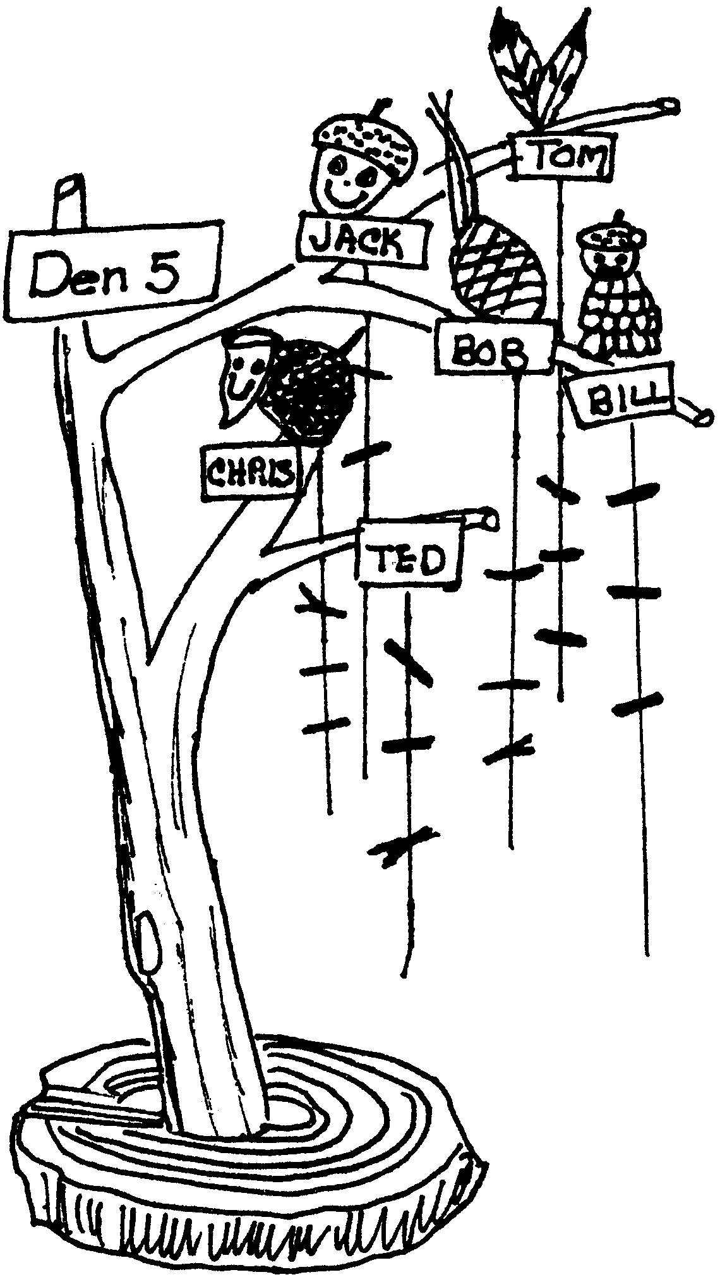
How about a den doodle using materials from nature? This tree can have almost any number of strings on which to hang record markers. Make one for the den with the boys.

The tree is a piece of limb with several branches growing from it. The base can be made of a solid section cut from a firewood log or clay or other material.
For recording achievements, tie on a piece of string for each boy and place his name at the top of it. Each time a boy completes an achievement, tie a thin twig to his string.
To make a tree more personal, have each boy choose an item from nature and glue it at the top of his string.

HIKING STAFF

Staffs act as a third leg to give more balance and support while hiking.

Go on a hike to find a sturdy stick about shoulder length. Cut off the excess branches. Use a knife and a wood file to remove the bark. Sand and file the staff until it is smooth. It would be real fun for each Cub Scout to collect signatures and drawings from his Cub Scout friends and leaders on the stick. Use acrylic paint or permanent markers. Varnish the finished product before using it.

TRAIL SIGN NECKERCHIEF SLIDE

You will need: One 3" circle of wood, plaster, foam, or leather; Seeds; Glue; One 1/2" section of 1/2" PVC pipe

1. Go on a seed finding hike.
2. Using the seeds, create a trail sign.
3. Glue the seeds in place.
4. Attach the PVC pipe to the back to form the loop.

WOOD ROUND SLIDE

You will need: Wood round; 1/2" section of 1/2" PVC pipe

With this project it might be fun for the boy to try to find a wood round that not only represents the age of the tree but also his age at the time he is making his slide. Have the boy cut and sand his wood round. Coat to preserve the wood. Attach the PVC section on the back.
PINE CONE SLIDE

Go on a pine cone finding hike. Find a closed cone about 3" long. Attach on the back a piece of pipe cleaner or PVC pipe.

PLASTER FOOT OR HAND CAST

You will need: Shoe box; Sand; Plaster of paris; Foil; Wire; Beads; Feathers (optional); Permanent marker.

1. Line the inside of the shoe box with foil. Fill half way with sand.
2. Sprinkle the sand with water, just enough so it holds together and takes an imprint.
3. Place your foot or hand in the sand and press firmly.
4. Mix plaster, following the directions on the package.
5. Pour the plaster into the imprint in the sand.
6. After it has set, but not too hard, poke 2 holes in the top two sides of the imprint. Don't take the plaster out.
7. When the plaster is completely dry (or at the next den meeting), brush sand off and place the wire in the holes, threading on the beads. Stick feather into bead with a little dab of glue at the tip.
8. With a marker, write what you would like on the imprint.

POWER BARS

3/4 cup (1 1/2 sticks) butter, plus 2 tsp. for the pan, at room temperature
1/3 cup packed brown sugar
1/4 cup all-purpose flour
1 tsp. vanilla extract
5 cups unsweetened granola

1. Place an oven rack in the center of the oven. Preheat the oven to 375.
2. Using a paper towel, spread the 2 teaspoons of butter evenly over the bottom and sides of a 9" baking pan.
3. Melt 3/4 cup butter in a small saucepan over medium heat. (Don’t let it burn.) Pour it into a mixing bowl.
4. Add brown sugar, flour, and vanilla to the butter and stir thoroughly.
5. Add granola and stir very well to coat all the granola with the butter mixture.
6. Spoon the granola mixture into the baking pan. Press it flat.
7. Bake in the oven until the top is golden brown, 15 to 20 minutes.
8. Place the pan on a cooling rack and let it cool completely, at least 30 minutes.
9. Cut the granola in the pan into 4 strips lengthwise and 3 strips crosswise. Remove the bars from the pan with a spatula.

Makes 12 bars.

MICROWAVE S’MORE CONE

1 sugar cone
1 caramel cube
15 chocolate chips
1 large marshmallow
drinking glass

1. Place the cone in a drinking glass (point end down).
2. Put the caramel and chocolate chips in the bottom of the cone.
3. Microwave on high for 15 seconds.
4. Add the marshmallow and cook another 15 seconds. Watch what happens to the marshmallow!

QUICK ENERGY SNACKS

3 or 4 graham cracker squares
1 cup powdered sugar
1 cup crunchy peanut butter
1/2 cup instant nonfat dry milk
1 package (6oz) semisweet chocolate chips
3 Tbsp water

1. Crush graham crackers on sheet of waxed paper.
2. Mix remaining ingredients thoroughly in medium bowl. Shape teaspoonfuls of the mixture into 1" balls.
3. Roll balls in graham cracker crumbs until coated. Put the coated balls on ungreased cookie sheet. Refrigerate about 20 minutes or until firm.

Makes 30 snack balls.

