Gateway to the Orient




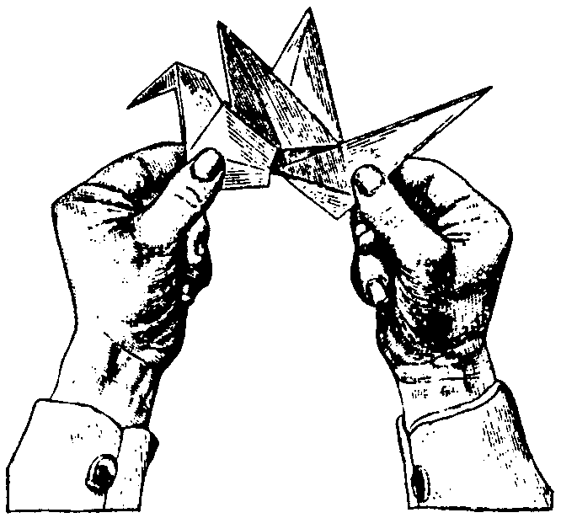

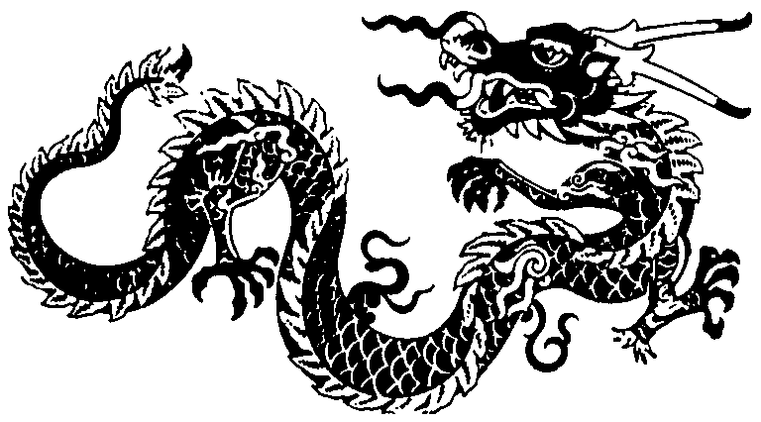

MARCH 1999
DEN AND PACK ACTIVITIES

FIELD TRIPS (For details, please refer to the Field Trip section)
Hakone Japanese Garden, Saratoga
Japanese Friendship Tea Garden, San Jose
San Jose Japan Town, mostly on Jackson street between 3rd and 6th
San Francisco Chinatown

TRY ORIENTAL FOOD
Visit your neighborhood Oriental grocery stores with the boys, buy some snacks and eat it at the den meeting. (Asian snacks are also available in most large supermarkets like Safeway)
Have a den family outing to an Oriental restaurant.
Have a Chinese takeout at the den meeting.
Learn to use chopsticks:
Eat some of the food above with chopsticks.
Try to pick up some snack with chopsticks.
(Disposable chopsticks are available at most large supermarkets, and also places like Smart and Final.)

HOW TO USE CHOPSTICKS (for a right-handed person)
1. Rest the upper half of one stick between your thumb and forefinger on your right hand. Hold the lower half of the stick firmly against your ring finger.
2. Hold the second chopstick as you hold a pencil.
3. To work the chopstick, keep the first stick stationary. Move the second stick up and down to pick up your food.

SPECIAL GUESTS
Have a guest from Asia: Is anyone from your den from Asia? Know someone from Asia?
Ask the guest to talk about a child’s life in the country he is from.
Can he bring some traditional toys from that country?
Can he teach your den some traditional games?
Can he teach your den some words in his native language? (Wolf Elective 22)
Can he teach the boys how to write their names (phonetically) in that language?
(Children are fascinated to see their names written in foreign letters.)
Have a guest who has been to Asia or has hosted students from Asia.
Ask the guest to bring some souvenirs and photos to show to the boys.
The guest could tell the boys his experience in a different culture (Keep it positive).

GO TO THE LIBRARY
Check out some children’s story books. Choose one or two and read at the den meeting.
Check out some children’s music tapes. Play it at the den or pack meeting.
COUNT TO TEN AND SAY A FEW WORDS

 | KOREAN |  | CHINESE | note* | JAPANESE
1. | 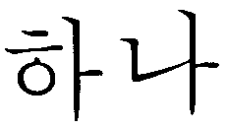 | hah-NAH | yee |  | ichi (ee-chee)
2. | 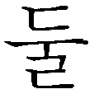 | tool | uhr |  | ni (nee)
3. | 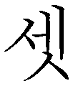 | set | sahn |  | san (sahn)
4. | 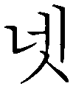 | net | suh |  | shi (shee)
5. | 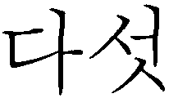 | TAH-sut | woo |  | go (go)
6. | 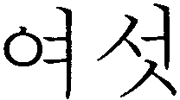 | YEH-sut | lyo |  | roku (ro-koo)
7. | 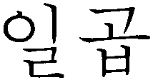 | ill-GUP | chee |  | shichi (shi-chee)
8. | 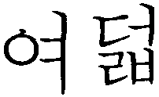 | yeh-DUL | bah | 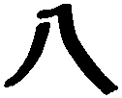 | hachi (hah-chee)
9. | 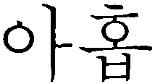 | AH-hope | jo | 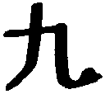 | ku (koo)
10. | 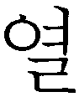 | yul | shur |  | ju (joo)

* Note: Chinese and Japanese use the came characters for numbers.

VIETNAMESE
Hello  Ong mang zoi khon
Thank you  Cam on new
Good-bye  Hen gap lay

KOREAN
Hello (on meeting) Annyong (an-young)
Hello? (on phone) Yobaseayo (yo-boh-seh-yo)
Thank you Kamsahamnida (kam-sa-ham-nee-dah)
Good-bye Annyonghikasaeyo (an-young-hee-keh-seh-yo)

JAPANESE
Hello (daytime) Konnichiwa (kon-nee-chee-wah)
Hello (evening) Konbanwa (kon-bahn-wah)
Thank you Arigato (ah-ree-gah-toh)
Good-bye Sayonara (sah-yoh-nah-rah)

Gateway to Scouting Fun--Attend District Roundtable

JAPANESE CREST MAZE



GO FLY A KITE
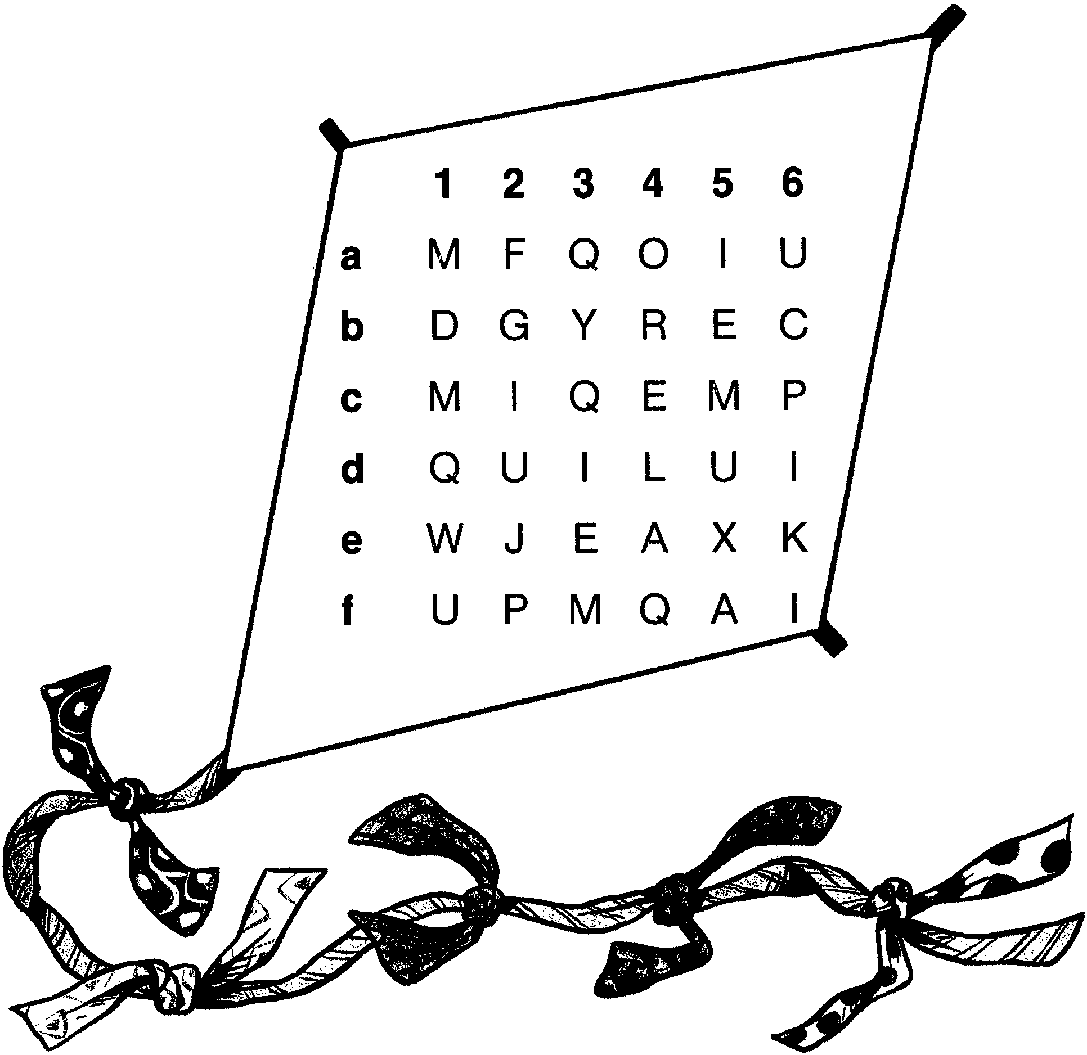
What kind of paper makes the best kites? Follow the directions below. Then unscramble the leftover letters to find the answer.

1. Cross out the M’s and Q’s.
2. Cross out the vowels in Column 4.
3. Cross out the letters in Row b that come before H in the alphabet.
4. Cross out the consonants in Row e.
5. Cross out the I’s and U’s.

Answer: __ __ __ __ __ __ __ __!

“HELLO” OPENING

The theme for this month is “Gateway to the Orient.” We played games from Korea and Vietnam. We made crafts from China and Japan. And we learned a few words.

In Tagalog It’s “Kumusta Ka”
In Chinese It’s “ni hao”
In Japanese It’s “konnichiwa”
In Vietnamese It’s “Ong mang zoi khong”
In Korean It’s “Annyong”
In English It’s “Hello”

It’s the first word you use to make friends. Welcome to the pack meeting.

GATEWAY TO THE ORIENT

G is for Gathering of friends and families
A is for Adventure
T is for Teamwork
E is for Enthusiasm
W is for the World
A is for Appreciation
Y is for Youth

T is for Tradition
O is for Opportunity

T is for Trust
H is for Harmony
E is for Encouragement

O is for Outdoor
R is for Respect
I is for Imagination
E is for Excitement
N is for Nature
T is for Tomorrow, the future for all of us.

CUB SCOUT PROMISE OPENING

In Indonesia a Cub Scout says: “I promise to do my best to do my duty to God and the Republic of Indonesia, to follow the family rules, and to do Good Turns everyday.”

In Taiwan a Cub Scout says: “I’ll obey my elders, help others, tell no lies and will not be afraid of any difficulty.”

In Japan a Cub Scout says: “I promise to do my best and to follow the Law of the Cub Scout pack.

Now we are going to repeat American Cub Scout Promise. Please stand and make a Cub Scout sign. (Repeat Cub Scout Promise)

“WORLD BROTHERHOOD” OPENING

Personnel: Cubmaster or Webelos Scouts closest to graduation to a troop.
Arrangement: Can of Sterno wrapped in aluminum foil and placed in a metal bowl on a tripod. Arrange Webelos Scouts or den chiefs to take turns guarding the flame during the meeting.

Narrator: It has become tradition at international events to have a small flame of world brotherhood burning throughout that event. The flame reminds us of Cub Scouting’s ideals and how they bind us in brotherhood with Scouts all over the world.

Throughout our meeting the flame will be guarded by Webelos Scouts (or den chiefs).

Now I shall request Webelos Scout ________ to come forward and light the flame of world brotherhood.

(As boy lights flame, say the following prayer)
O Divine Father, we have kindled this flame as a symbol of brotherhood among Scouts of all nations. We pray that the flame of brotherhood will light the minds and souls of all mankind, that peace and harmony will prevail and Your will be done on earth as it is in heaven. Amen.

Now will all Cub Scouts please make the Cub Scout sign and join me in the Cub Scout Promise.

“THANK YOU” CLOSING

In Vietnamese It’s “Cam on new”
In Korean It’s “Kamsahamnida”
In Japanese It’s “Arigato”
In Chinese It’s “Xièxie”
In English It’s “Thank you”

Thank you for coming tonight. Goodnight everyone!

“WORLD BROTHERHOOD” CLOSING

This month we have learned about peoples in the Orient. To understand people, we need to learn how they live, how they play, what they make, what they wear, and what they eat. Fears and misunderstanding come from lack of knowledge. Through Cub Scouting and World Brotherhood of Scouting, boys can become more understanding. (If the flame of Brotherhood was lit, extinguish it at this moment.)

“ROOM FOR FLIGHT” CLOSING THOUGHT

Do you sometimes feel that your life is so crammed with necessary duties and obligations that the luxury of a quiet hour of letting your mind roam is almost impossible to find?

Someone once asked an old Japanese artist why he had painted a certain picture--a few birds in the branches of a tree in a small space in the left-hand corner of the canvas. “Why didn’t you use the whole canvas?” the visitor asked.

The artist replied simply, “Because the birds need space in which to fly.”

Minds also need room for flight.

A KOREAN LEGEND CLOSING THOUGHTS

This is a Korean legend about a warrior who died and went to heaven.

“Before I enter,” he said to the gatekeeper, “I would like you to take me on a tour of hell.”

The gatekeeper found a guide to take the warrior to hell. When he got there he was astonished to see a great table piled high with the choicest foods. But the people in hell were starving. The warrior turned to his guide and raised his eyebrows.

“It’s this way,” the guide explained. “Everybody who comes here is given a pair of chopsticks five feet long, and is required to hold them at the end to eat. But you just can’t eat with chopsticks five feet long if you hold them at the end. Look at them. They miss their mouths every time, see?”

The visitor agreed that this was hell indeed and asked to be taken back to heaven post-haste. In heaven, to his surprise, he saw a similar table laden with very choice foods. But the people were happy--they look radiantly happy.

The visitor turned to the guide. “No chopsticks, I suppose?”

“Oh, yes,” said the guide, “they have the same chopsticks, the same length, and they must be held at the end just as in hell. But you see, these people have learned that if a man feeds his neighbor, his neighbor will feed him also.”

There are no "Seven Wonders of the World" in the eyes of a Cub Scout; there are seven million.

AIRMAIL ADVANCEMENT

Place rank badge (attached to a safety pin), certificate, and parent’s pin in an airmail envelope. Make one for each boy and address the envelope to him. (If you have a large group, put badges, certificates and parent’s pins for the rank or den in a global priority mail envelope.) Embellish the envelops with stickers that look like stamps.

Start out the ceremony with something like:
“I have a stack of air mail that just arrived from the Orient. When I call your name, would you come up with your parents to receive your mail?”

Hand each boy his envelope. When all have received theirs, ask them to open it and see what’s inside. Ask them to hand their badge to their parents so they can pin them on the uniform. The boys then attach the parent’s pins on their parents clothes. (it helps if parents hold the envelopes for the boys at this time.) Then they all bow to each other. Congratulate them all.

FORTUNE COOKIE ADVANCEMENT

Preparation: Purchase fortune cookies for each of the boys. Hand-write in small print or use a printer with condensed print so the message can be small enough to fit on a strip to be placed in the cookies. Use messages like: “Congratulations - You are a Wolf!” “You are a hard worker - You have earned a Bear Badge!” “We’ll be loyal Scouts it’s true and so have you been.”
Put fortune cookies into microwave, one at a time, for about 20-30 seconds. Warm cookie will be pliable enough to pry open. Quickly remove the original strip of paper and slip your own fortune in; press back into closed position before it hardens again. Keep cookies for different ranks separate.

CUBMASTER: We have had a wonderful year full of hard work and good fortune. Will __________ please come forward? You have made many wise choices as a Cub Scout that have brought you here tonight. Please choose your new fortune and read it to the audience...”

(Note: Fortune cookies are an American invention and were introduced to China by Chinese Americans.)

FUN WAYS TO SAY THANK YOU

Compass: “Thank you for leading the way. You have done so much for our pack.”
Fan: “You are Fan-tastic.”
For someone who is the greatest Scouting fan.
Gate (toy, picture or drawing): “You have opened the gateway to Scouting for so many boys!”
Globe: For someone who is the world’s best ______________.
Fortune Cookie: “We are fortunate to have you in our pack.”
Spices: “You really add spice to our program.”
Tea bag: “You are Tea-rific.”
Thyme: “Thank you for all your time.”

THE TIGER AND THE DRIED PERSIMMONS

The Koreans tell many tales about their legendary tiger. Here is one of them.
(Dried persimmons are a sweet delicacy in Korea, China and Japan.)

Tiger: “Rooooar!”
Mother: “Now, now”
Baby: “Waaaaaaaa!”

One evening, the TIGER awoke from his nap feeling especially hungry. So he decided to come down from the mountain to seek a meal in the village below. The very first farmhouse he came to had a cowshed attached. Right away, the TIGER began to drool. He knew what a cowshed meant--a fat juicy ox.

The TIGER crept up to the doorway and looked inside. His dinner was sleeping peacefully. He was just getting ready to try a bite, when suddenly he heard a piercing cry!
The TIGER ran outside the shed before the ox awoke and hid beneath one of the farmhouse windows. A second blood-curdling howl came trumpeting through the walls. Cautiously, the TIGER peeked inside. There he saw a MOTHER trying to quiet her BABY.
“Shhh!” the MOTHER hissed. “You’ll wake up GrandMOTHER.”
But the BABY only screeched louder.
“Shhh!” the MOTHER begged. “There’s a big snake outside!”
But the BABY only screeched louder.
“Shhh!” the MOTHER pleaded. “There’s a big, big TIGER outside!”
“What an amazing creature!” thought the TIGER. “That MOTHER knows I’m here without even seeing me.”
And the BABY still screeched louder.
“What fearless creatures these humans are!” marveled the TIGER. “Not even their tiniest BABIES are afraid of me.”
“You must stop crying now!” exclaimed the poor MOTHER. “I will get a persimmon to quiet you.”
To the TIGER’s amazement, the BABY didn’t utter another peep.
“What a fearsome creature a persimmon must be!” thought the TIGER. “If there’s one around here, perhaps it is time for me to be getting home.”
Quickly, the TIGER made his way back up the mountain. Inside the farmhouse, the BABY sucked happily on a tasty, dried persimmon.

HOW THE CHINESE ZODIAC STARTED

Instead of dividing the audience into different groups, have the audience make the sound for each animal. For ANIMAL(S) the audience can make any animal sound he chooses.

The New Year was drawing near and twelve ANIMALS were arguing because each one wanted the year to be named after himself. You can just imagine the commotion as TIGER, DRAGON, SNAKE, HORSE, RAM, MONKEY, OX, ROOSTER, RABBIT, DOG, PIG, and RAT argued and argued.

The DRAGON and the TIGER argued over which one of them was the fiercest. “This should be called the year of the DRAGON because I can create storms,” roared the DRAGON. The HORSE came galloping in. “No, it should be called the year of the HORSE, because I can run fastest.” The proud ROOSTER was preening himself. “No, you are both wrong. It should be called the year of the ROOSTER because I am the most handsome.”

All the ANIMALS disagreed with ROOSTER. There was such a noise of roaring, hissing, neighing, bleating, chattering, barking, grunting and squeaking that the gods were disturbed.

The gods appeared in the sky and demanded to know what all the noise was about. “What are you arguing about?” asked one of the gods. All the ANIMALS tried to answer at once. The noise was deafening. “Be quiet, at once!” ordered the gods. “You all have very bad manners.” The ANIMALS were ashamed of themselves. They politely explained one by one what they had been arguing about. Each ANIMAL explained why he was the most important and why the New Year should be named after him.

The gods thought hard about the problem and decided to involve all the ANIMALS in a race. “Can you see the big river?” asked the gods. “You can all race across the river and the first ANIMAL to get to the other side will have the New Year named after him.”

All the ANIMALS agreed to the race; secretly each one thought he would be the winner. They lined up along the bank. “Ready, steady, go!” shouted the gods. There was an enormous splash as all the ANIMALS leapt into the water.

The race was very close to start with as HORSE, DRAGON, TIGER, and OX swam neck and neck. However OX was the strongest swimmer and he began to take the lead. RAT was not a very strong swimmer but he was very cleaver. As soon as he saw OX take the lead, RAT thought “He’s not going to beat me. I have a plan.” RAT swam as fast as he could and just managed to grab hold of OX’s tail. He carefully climbed onto OX’s back without OX noticing him. OX looked around but did not see RAT on his back. “I’m going to be the winner,” thought OX, “I am well ahead of the other ANIMALS, no one will catch me.” OX slowly and confidently waded the last few meters to the bank but clever RAT leapt over his head and onto the bank first. “I’m the winner, I’m the winner,” squeaked RAT. The OX was so surprised. “Where did you come from?” he asked RAT.

The gods declared clever RAT the winner and named the New Year after him. “Next year will be the year of the OX because OX was second.”

One by one the other ANIMALS reached the bank. TIGER was third, RABBIT was fourth, DRAGON was fifth, HORSE was sixth, SNAKE was seventh, RAM was eighth, MONKEY was ninth, ROOSTER was tenth, DOG was eleventh, and PIG was twelfth and last. “You have all done well,” said the gods. “We will name a year after each one of you, in the same order that you finished the race.”

All the ANIMALS were exhausted but quite happy with this decision because they didn’t need to argue any more.

This year (1999) is the year of Rabbit and the Chinese New Year started on February 16.
The Chinese New Year depends on the phases of the moon and usually occurs between the middle of January and the middle of February.

Can you figure out which year you were born?

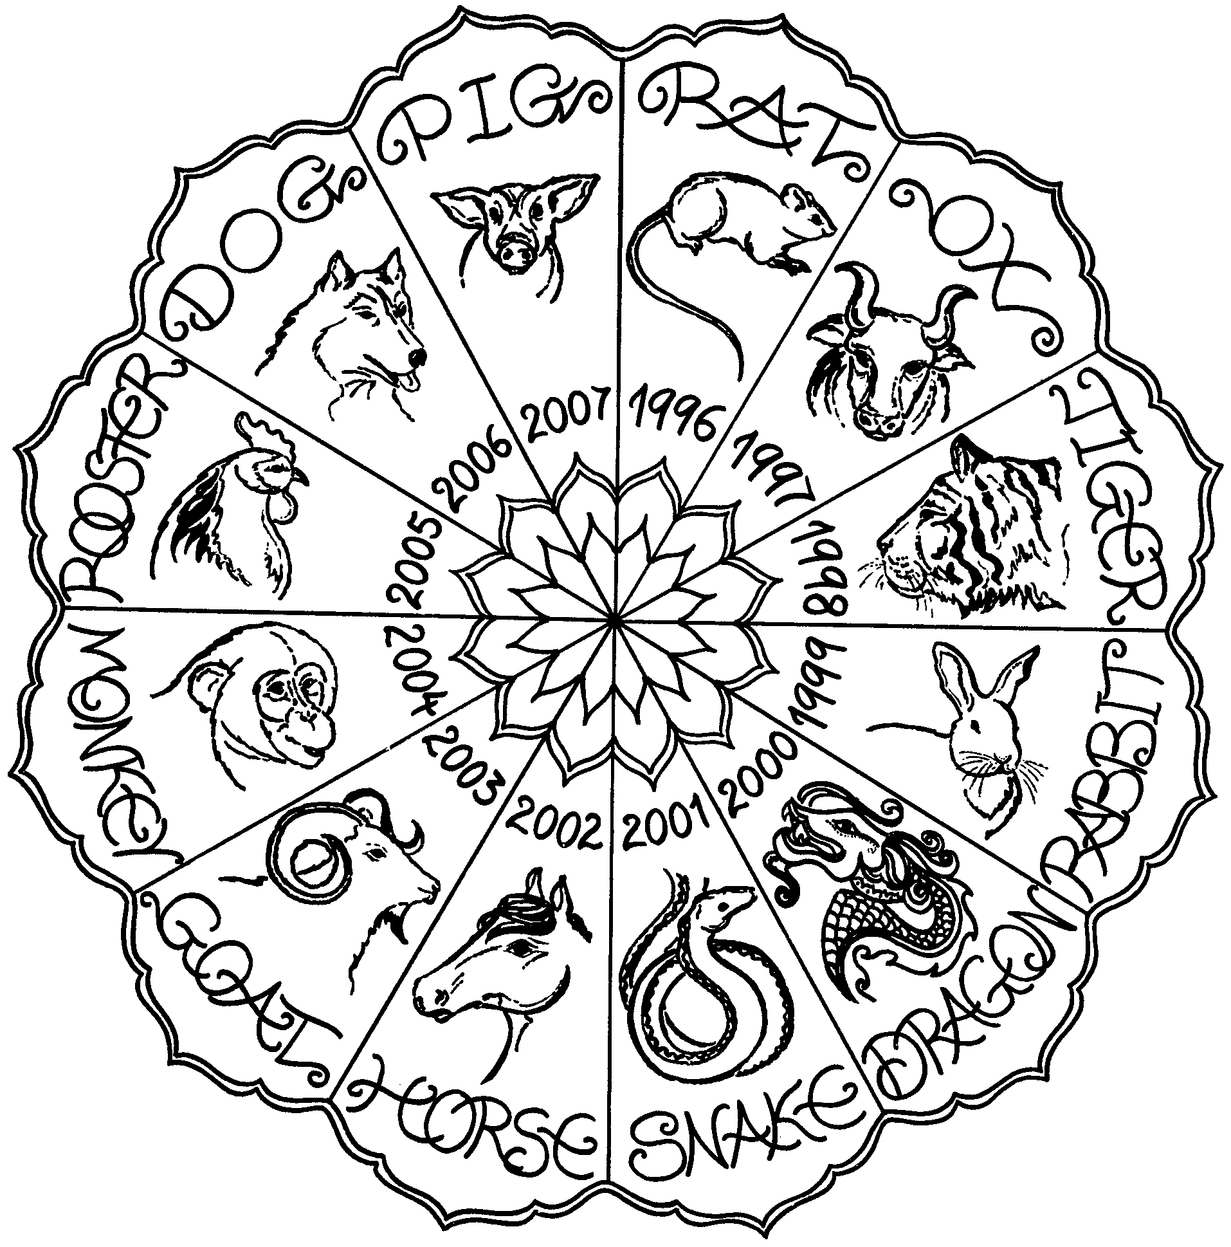
(Chart from Festivals Together by Fitzjohn, Weston & Large)
THE ERRAND FOR THE CENTIPEDE
(An old story from Japan)

Narrator: Long, long ago in the nation of bugs, the emperor of the bugs became very sick.

Bug 1: The Emperor is very sick. We should get the doctor.
Bug 2: We should send someone who can run fast.
Bug 3: Who is fast?
Bug 1: Let’s ask Centipede. With all his feet, he’s bound to be fast.
Bugs 2 & 3: That’s a great idea.

Narrator: So they asked the centipede. Meanwhile, the bugs took turns taking care of the Emperor and waited for the doctor. They waited and waited. They decided to go and see if Centipede was back from his errand.

Bug 1: I see Centipede is back.
Bug 2: Yes, he is taking his shoes off.
Bug 3: Centipede, Centipede, where is the doctor?
Bug 1: Is he coming soon?

Centipede (from the offstage): Can’t you see I’m in a rush. I still have half the shoes to put on.

Note: In Japan people take shoes off to go inside the house.

TANGRAM PEOPLE


For tangram patterns, see p. 20
WHY THE SUN SHINES WHEN THE ROOSTER CROWS
(A tale from southern China)

This is a puppet play. Make stick puppets (cardboard figures attached to sticks) and move them as narrator reads the script. Boys take turns being narrator. Control the room light accordingly.

Stage: Have a tall mountain at one side of the stage.
Puppets: 4 medium suns, 5 small suns (can be placed on one stick) 1 large sun, elders (can be placed on one stick), Oppopolo the giant (holding his bow and arrow), nightingale, thrush, lark, blackbird, rooster. Puppet for the main sun should have two sides, one with a smiling face, the other frowning. The elders should have smiling side and frowning side.

“Once upon a time, the earth was surrounded by many suns. To the east shone one sun, another in the west; there was one in the north and one in the south. And in between there were five smaller suns! There was also the sun we know today in our sky.”

“As you can well imagine, the earth was scorched. No grass could grow, and people were too hot and tired to work or sleep. So one day the wise elders of the world met to think what to do. They decided to ask the giant Oppopolo to shoot down the suns so that the poor earth could feel coolness.”

“Oppopolo lived on top of the highest mountain and was as tall as ten ordinary men. His body was strong and his eyes flashed with bravery. The elders climbed the mountain with their request and the giant agreed to help.”
(clear the stage)
“So it was that the very next day when the first sun rose over the horizon, Oppopolo took his mighty bow and shot it down. The people cheered with joy (puppeteers can cheer). (raise other suns) Another speedy arrow brought down the second sun, then the third, fourth, fifth and more. At first the people danced with glee. But by the time the ninth sun fell, they became rather worried, for the tenth sun had watched everything, and hidden himself behind the mountain. The earth was dark as night and cold as winter ice.”

“Stop, Oppopolo, stop!” cried the people. They begged for the remaining sun to return but he refused to leave his safe hiding place!”

“It was decided that someone must plead with the sun, but as he might now fear a human, a bird would be sent instead. First the nightingale went as messenger, singing sweetly. The sun refused to listen. Then the thrush tried, and the lark, and the blackbird. But it was no use. At last the rooster was asked if he would try. “All right” he replied. “But I can’t sing. All I can do is crow.”

“The rooster lifted his neck and crowed loudly (crow). When he did this, the sun didn’t recognize the noise, and as it came again the sun peeped out, curiously. As his light appeared from behind the mountain, the birds, animals and people all shouted and sang with joy (cheer)! The sun was pleased, and felt bold enough to show himself in full. So, to this day, the sun hides at night until the rooster’s crow tells him it is safe again to come out!”
MUD TURTLES

China. Players take off their shoes and place them in a pile inside a circle about two yards in diameter. A Mother Turtle is appointed to guard these “eggs” and keep them inside the circle. She can sit on them, sprawl over them or put a pair on her feet. The other players (turtles) try to get their own eggs out of the circle without being tagged by a hand or foot of Mother Turtle.

ONI TO KAERU (OGRE AND FROGS)

Japan. In a large playing area, mark the outline of a long, rather narrow lake with many peninsulas and necks of land. One player, the Ogre, must stay out of the lake. All other players are Frogs and must stay in the lake. The Ogre tries to capture a Frog by tagging him; he may jump from peninsula to peninsula but he may not get in the water. When a Frog is captured, he must get out of the lake. The last Frog tagged becomes the Ogre for the next round.

HANDKERCHIEF GAME

Cambodia and other countries. It is best if you have ten or more players. Only player is “It.” The other players sit in a circle, facing the center. “It” walks around the outside of the circle carrying a handkerchief or scarf knotted at one corner. He stealthily drops the handkerchief behind a player, who must pick it up and race “It” around the circle. Both players try to claim the empty place in the circle where the player was sitting. The player who is left out of the circle at the end of the race becomes “It” for the next round.

DAKPANAY

This is a tag game from the Philippines. Make three small circles on the ground, each with room for one or two players to stand in. Also make one large “rest circle.” One player is the Chaser, the rest are circle players. The Chaser must stay outside all circles; the others may run between circles. As soon as the Chaser comes near, the circle players run to another circle to avoid being tagged. When a player is tagged, he becomes the Chaser.

CALLING THE CHICKENS

China. One player is blindfolded and plays the part of the owner of a flock of chickens. The blindfolded player calls to the others, “Come home, my little chickens, come home.” Then all the other players must run forward, and each one must touch the blindfolded player without being tagged. The first chicken to be tagged becomes the next owner.

ROCK PAPER SCISSORS
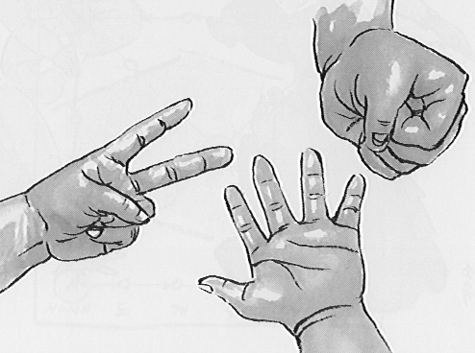
Rock Paper Scissors are played in many countries around the world, especially in Asia. The rule is simple: Scissors cut paper; paper covers rock; rock breaks scissors

In Japan “Jan Ken Po” is often used to settle a tie or decide who will be “It” in a game. It may be played by three or four players as well as two. With more than two players, players are eliminated as game goes on. If all rock, paper and scissors appear at the same time, another round is played.

Jan Ken Po may be played on the staircase. Up to 4 players line up at the bottom of the stairs and play Jan Ken Po. If a player wins with paper, he goes up 5 steps; 2 steps for scissors and 1 step for winning with rock. Winner is the player who reaches the top of the stairs and comes down again first.
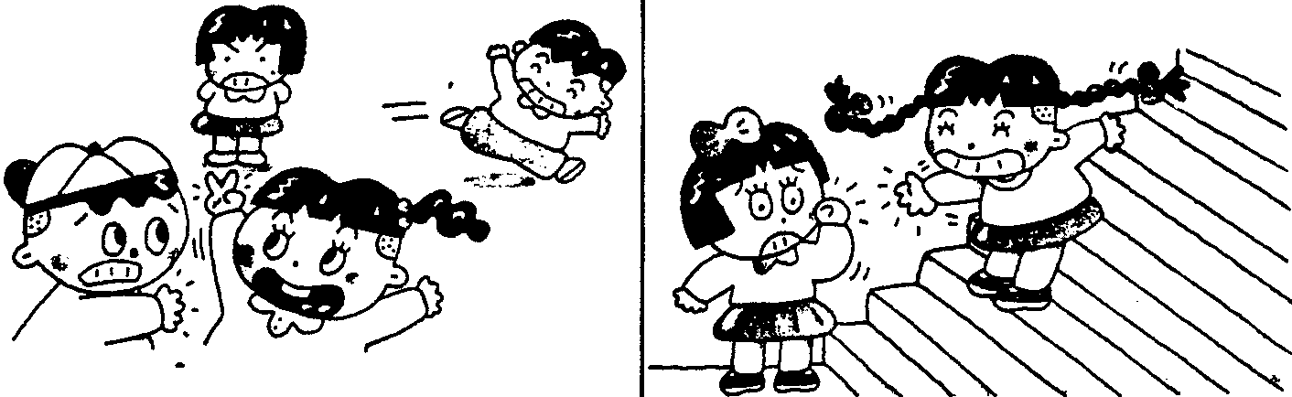

Walking Jan Ken Po. Played like the staircase Jan Ken Po. This may be played individually or with two teams of two. One team member plays Jan Ken Po, the other takes steps accordingly. The team that reaches the destination first is the winner.

Foot Jan Ken Po. Use feet instead of hands. Feet together is rock, feet apart is paper, and one foot in front of the other is scissors. Stand at the rock position, chant “Jan ken po,” and at “po” you move your feet.

In KOREA, “Kawi, Pawi, Po (scissors, rock, paper)” has another purpose as well. Students taking the same route home from school will often play it to decide who is going to carry everyone’s book bags home. Since Korean students get plenty of homework, the loser can get stuck hauling quite a load! When you play this game, chant “Kawi, pawi, po.”

GOMOKU NARABE

Japanese children play this using GO game equipment. This is like Tic Tac Toe, but instead of “three in a row,” it’s “five in a row” You will need black and white game pieces and a sheet of grid paper that has at least 10 by 10 grids. Game pieces are placed on the intersection of the grid, not in the square. Two players take turn placing one game piece at a time. The object of the game is to have five of your color horizontally, vertically or diagonally. Prepare several sheets of grid paper and plenty of games pieces, and have a tournament at the den meeting.
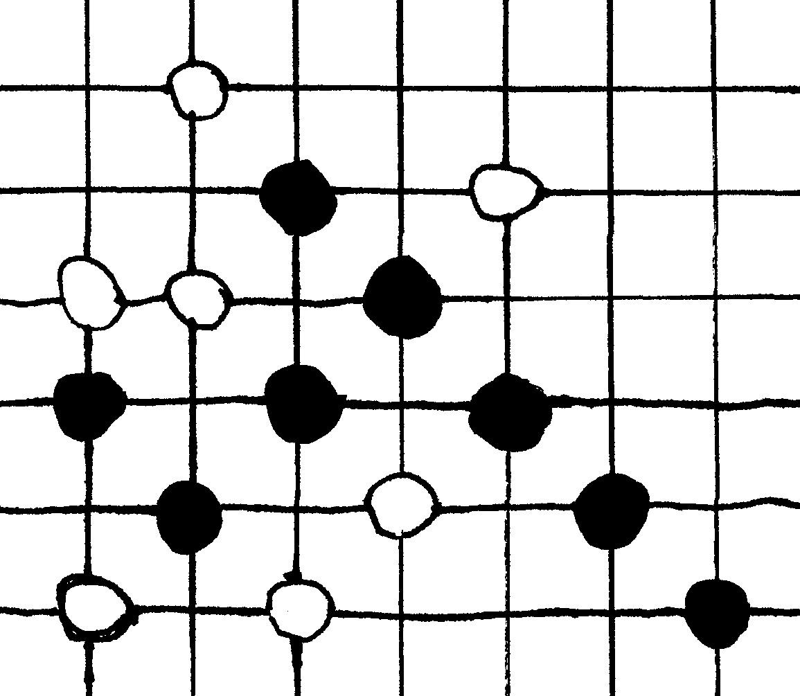

LAME CHICKEN

China. Divide den into two teams and give each team 10 sticks about 10 inches long. The sticks are placed about 10 inches apart like the rungs of a ladder. On signal the first boy in each team hops on one foot over 10 sticks, one at a time. He then reaches down (still on one foot) and picks up the 10th stick and hops back over the other 9 to his team. The second boy then begins, hopping over the 9 sticks, picking up the 9th and returning. Continue until all have raced. The last boy in line hops over all remaining sticks and then picks up all of them as he hops back to the finish line. If a player steps on any stick, he must start over from the starting line. First team through wins.

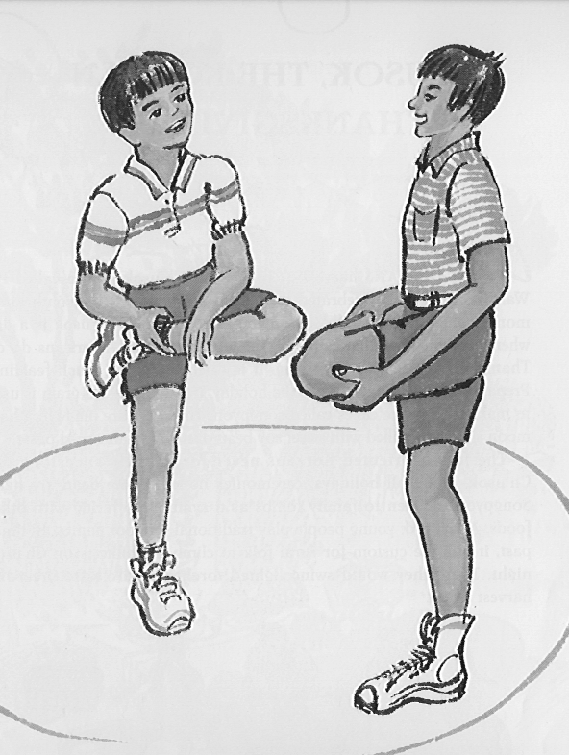
TAK SSAUM

This is a balancing and “wrestling” game from Korea. It must only be played on a grassy lawn or on a gym mat. This game requires two boys to play, and others to cheer. Each opponent begins by standing on one leg and bending the other leg in front, so he can hold onto the foot of that leg in his opposite hand. At the starting signal, the contestants begin to bump against each other until one the them falls. The boy left standing is the winner, who may now face another opponent. (Please note, match the boys who are similar in size) (from Look What We've Brought You From Korea by Phillis Shalant)

HANA, HANA, HANA, KUCHI (nose, nose, nose, mouth)

Japan. Divide into two sides, which sit facing one another. The captain for one side stands up and says, “Nose, nose, nose, mouth.” On the first three words he taps his nose, while on the fourth, instead of tapping his mouth, he touches some other feature, such as his ear. The idea of the game is for the players of the opposing side to do what the captain says and not what he does. Players who make mistakes are eliminated. Two teams take turn. This game may also be used as a circle game with no sides. In this case all players would follow the commands of the leader.

MULTIPLES

Taiwan. This is a game for older children. Players sit in a circle and agree on a figure between 1 and 10. They then start counting round the circle from 1. If the agreed figure is seven, each time the number being called includes seven or is a multiple of seven, the player keeps quiet and clasps his hands together. Every time anyone makes a mistake a point is counted against him. When the boys become good at this game, add one or two other numbers, so they will have to stay alert not to get caught with numbers four, six and eight going on at once. For one number the player clasps hands. For the second number he will put both hands above his head. For the third number he can nod his head. Most players will find thinking of two numbers at once difficult enough.

See more games in the Song and Craft sections of this month.
If it’s difficult to sing these songs in their original language, sing them in English.

FONG SWEI (After School)
China

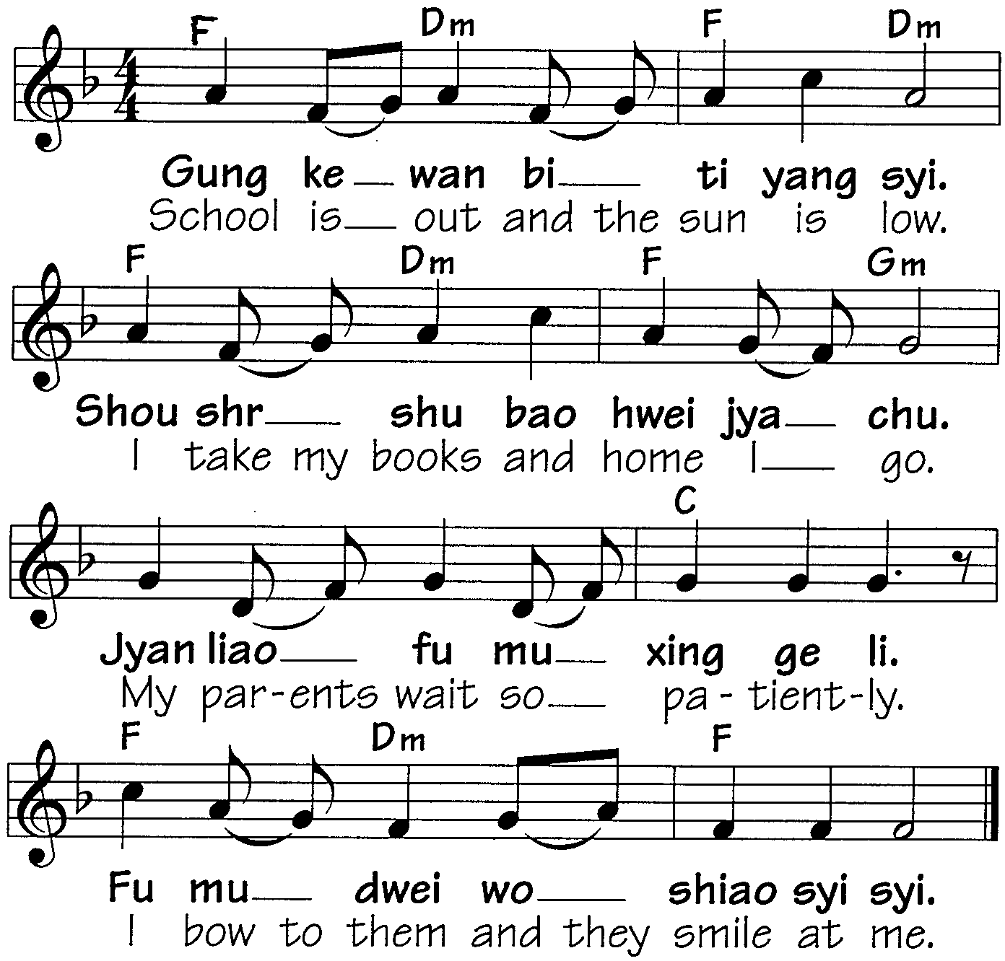

ARIRANG
Korea

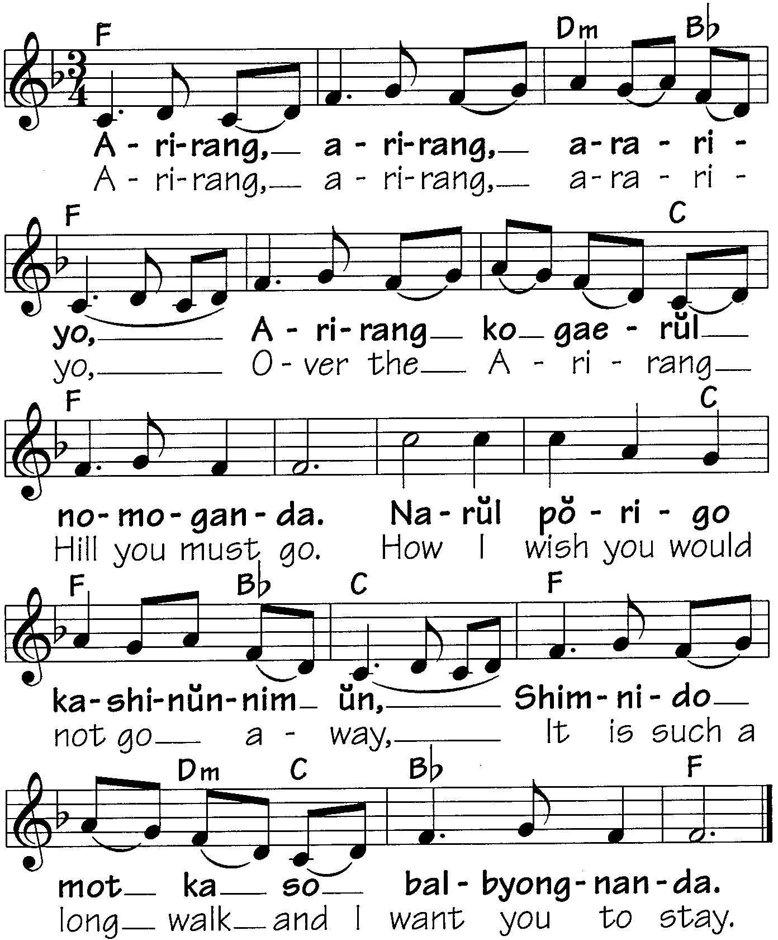

POK AMAI, AMAI (Clap Together)
Malaysia

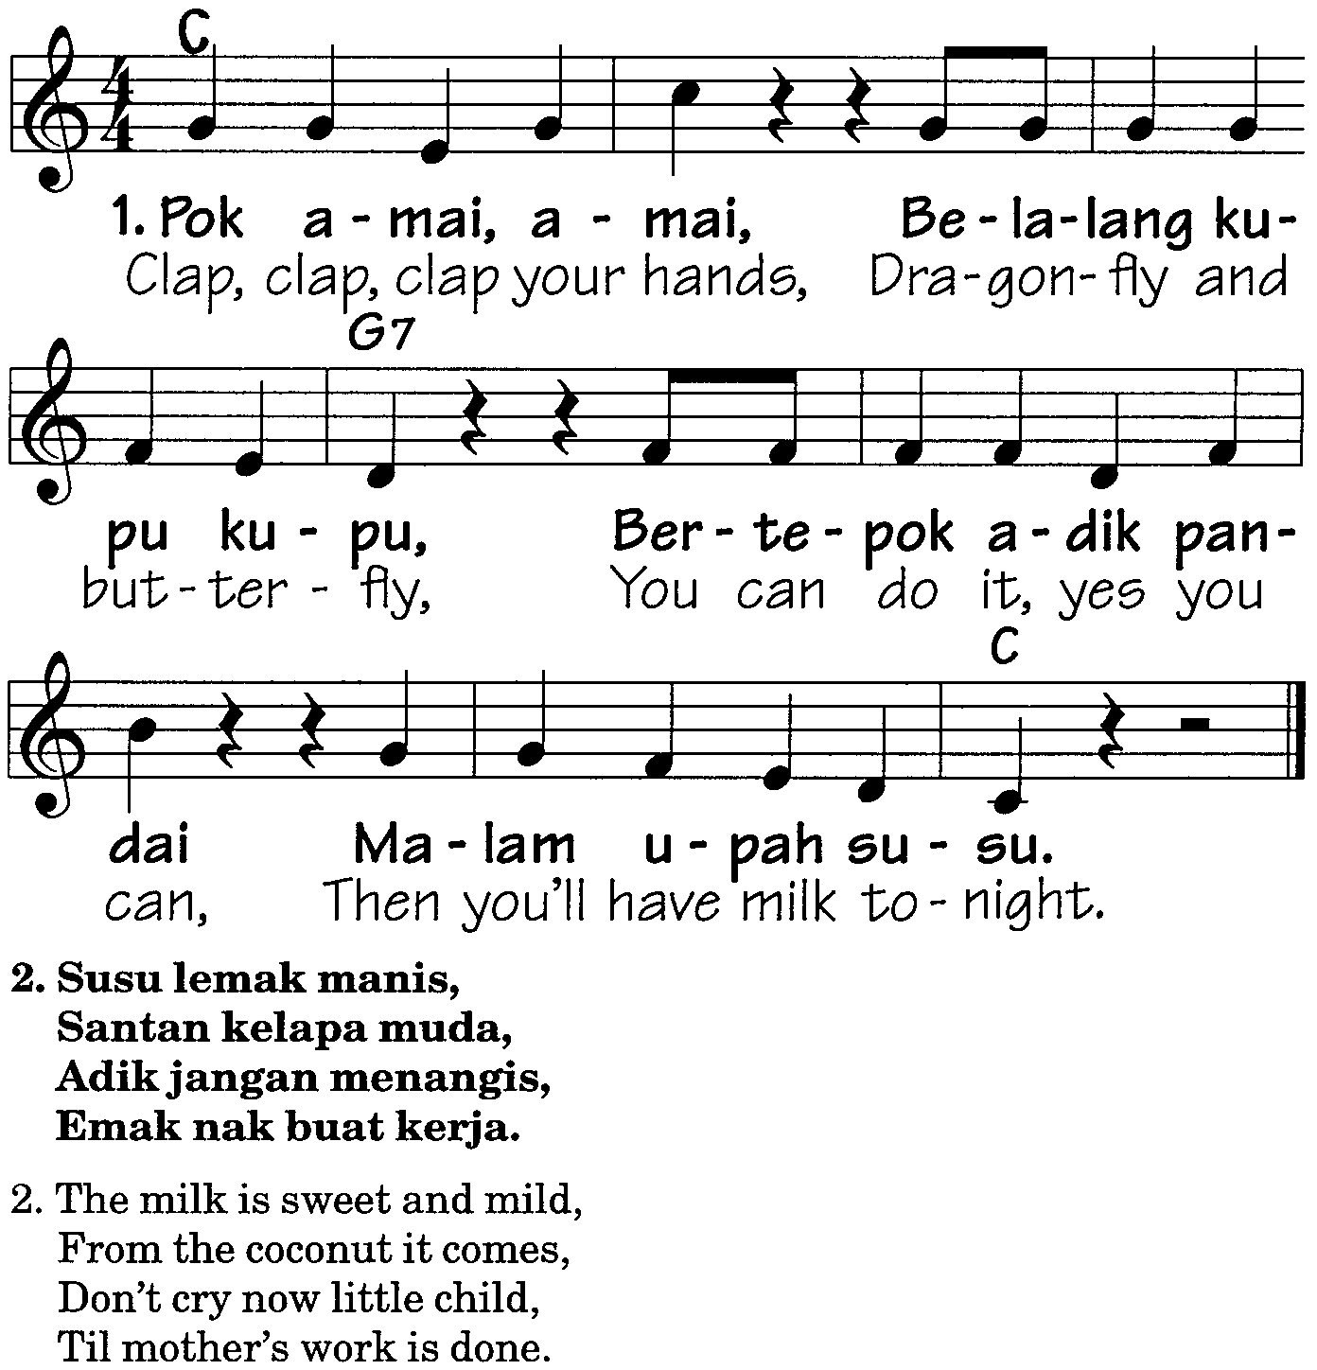

KAGOME KAGOME
Japan

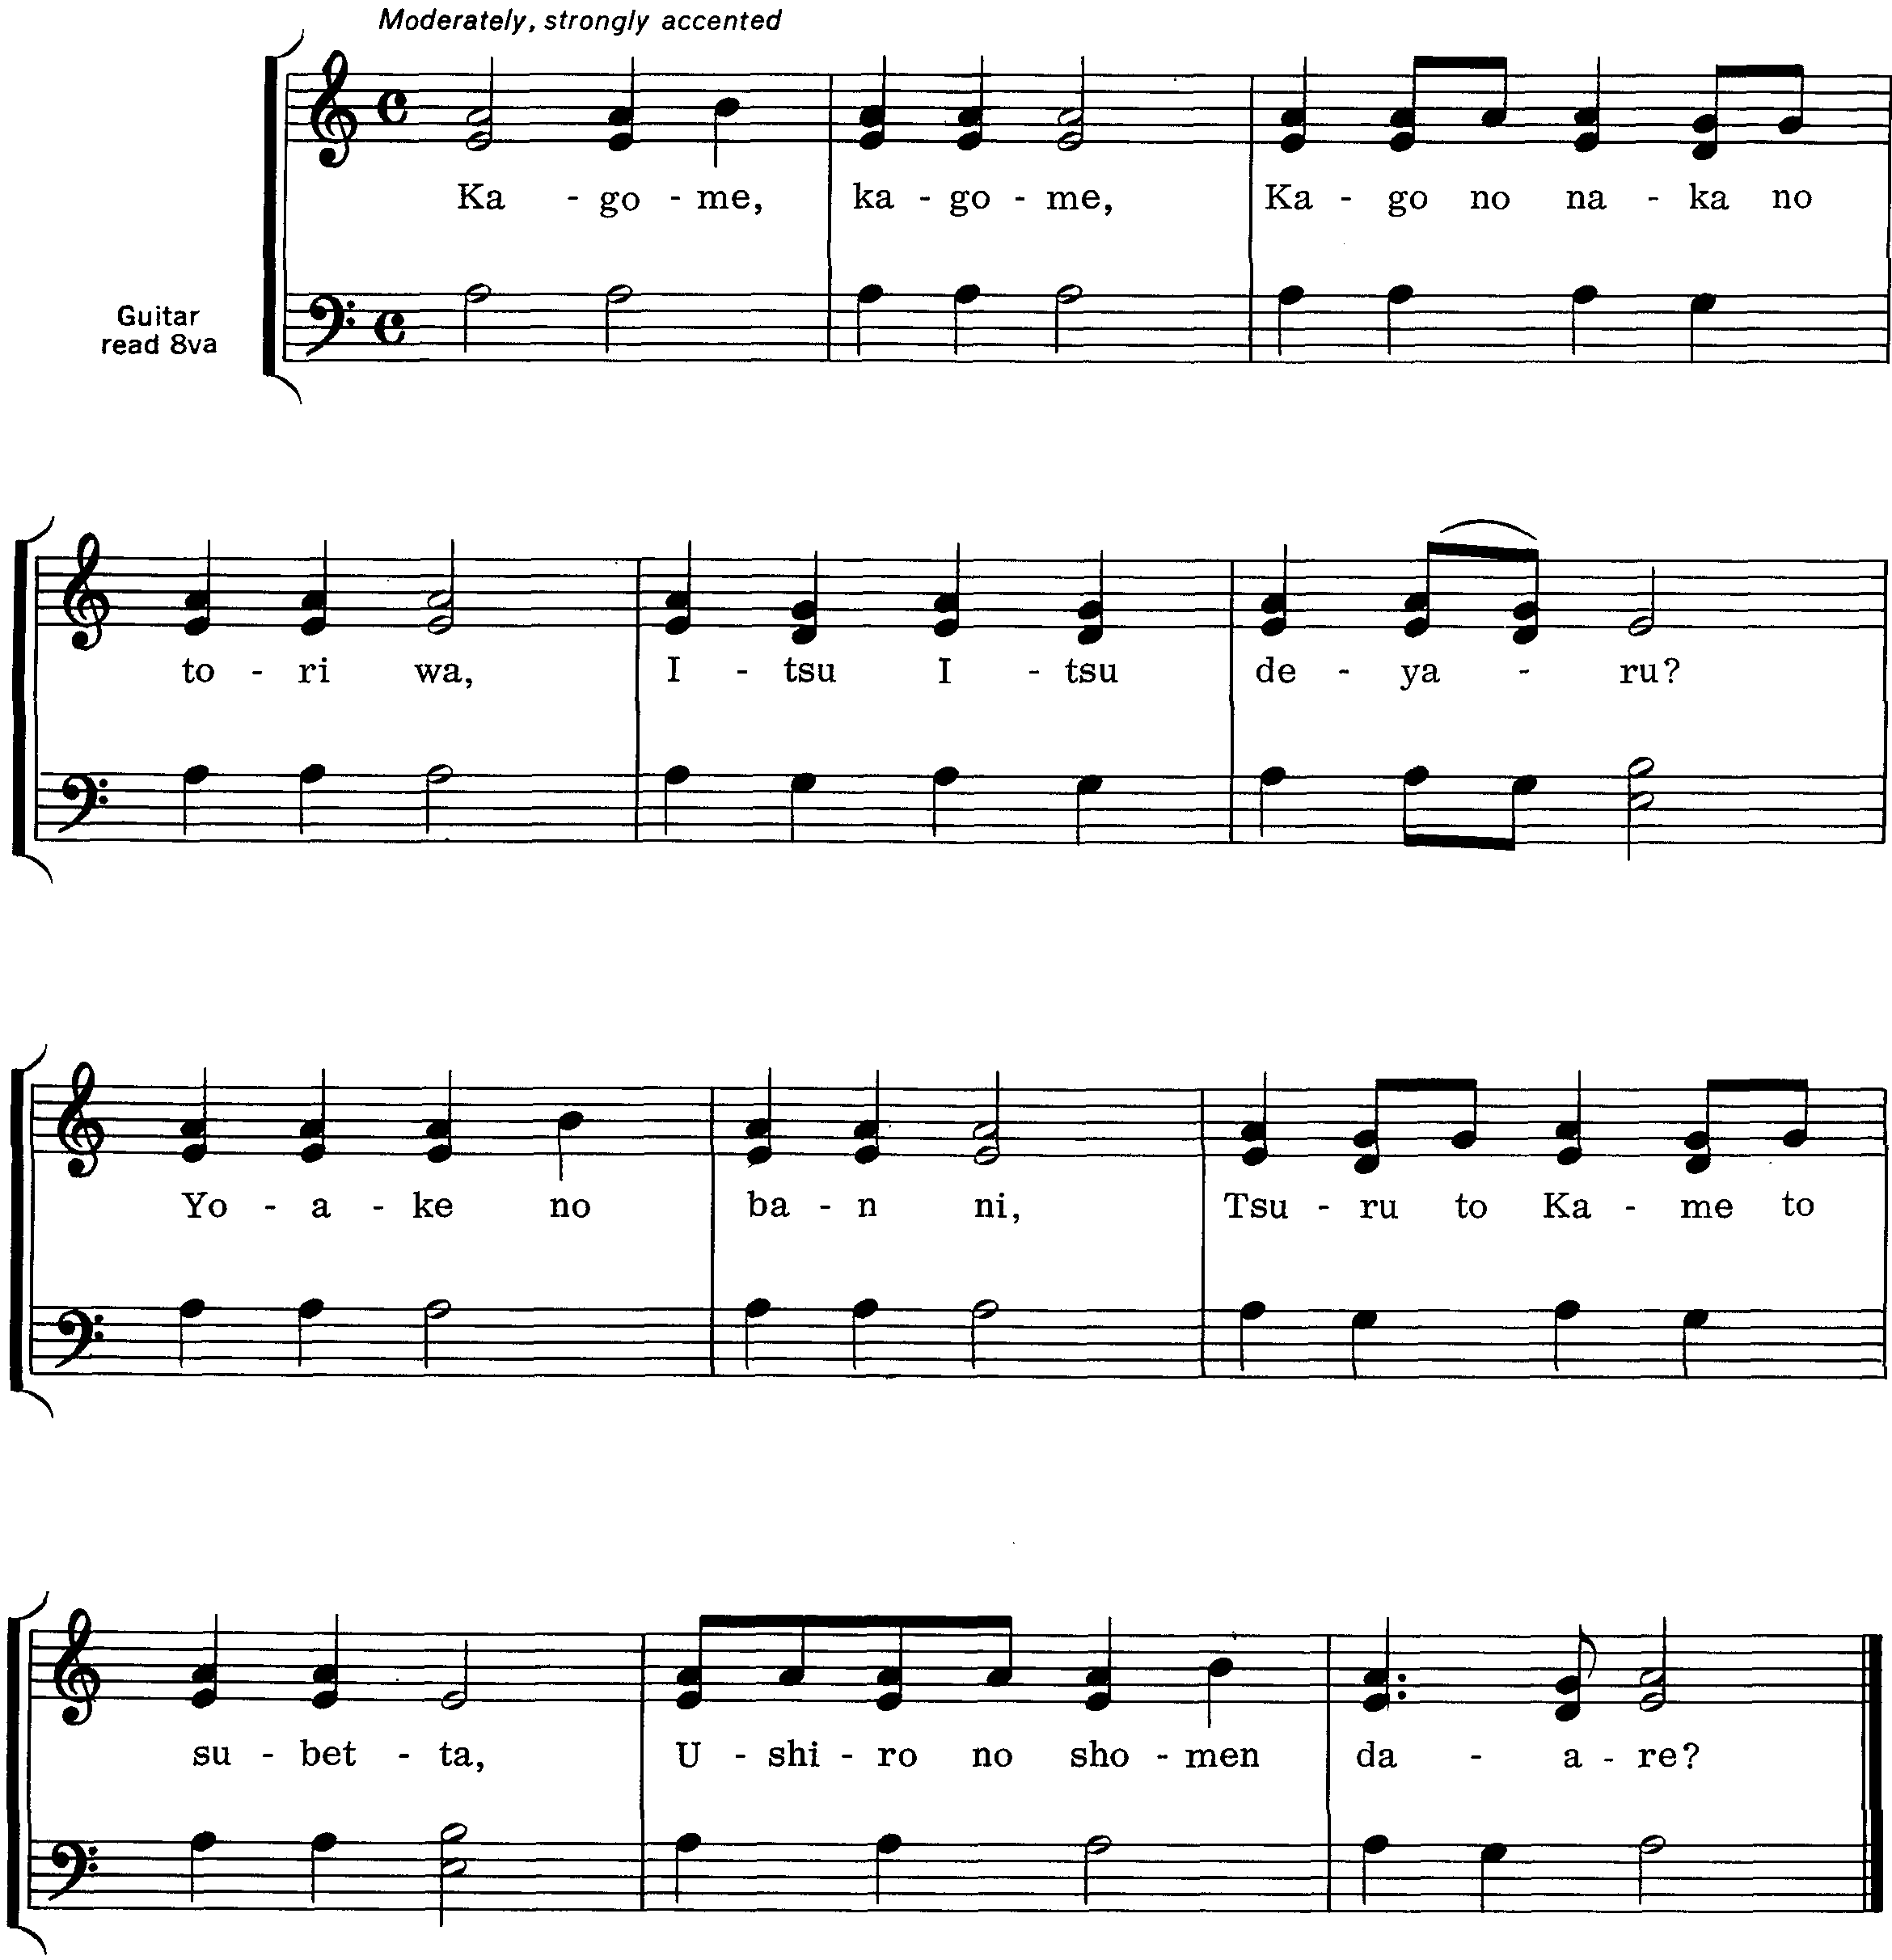

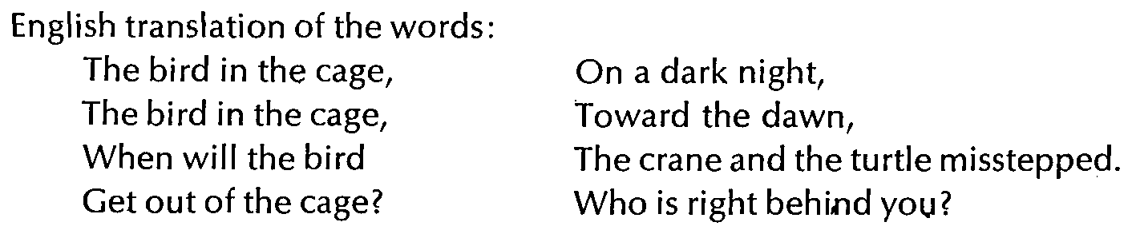

Kagome comes from a word for wicker basket.
The players stand in a circle holding hands. One player is “It” and stands in the center, blindfolded or with hands covering eyes. Other players walk or skip around in the circle while they sing the song. When the song ends they must stop. “It” then tries to guess the name of the child standing directly in back of him.
If he guesses right, the player whom he has named becomes “It.” If he guesses wrong, he must be “It” again.

ULAR NAGA
Indonesia

Players stand in single file, each holding the waist of the player in front of him. Walk in tempo with the song as you sing, and as soon as it is finished, the “head’ of the dragon (first player in line) chases the “tail.” It is important not to break the line, so everyone runs while hanging on. The “tail” does his best not to be caught, but he may not let go of the player in front of him. If he is caught, he must drop out of the line and the game starts all over again with the next-to-last player in line as the new “tail”

