Legends and Lore
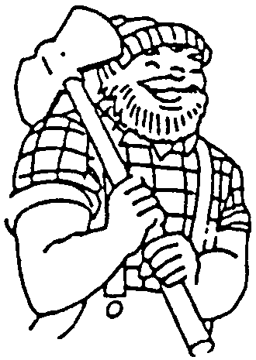

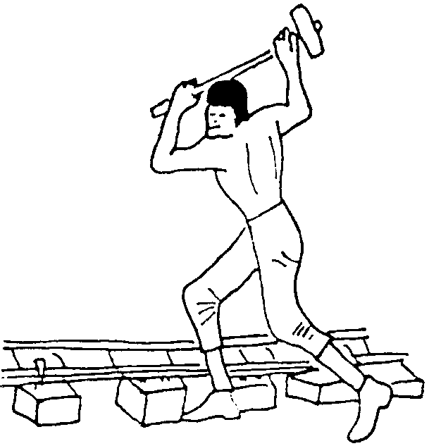

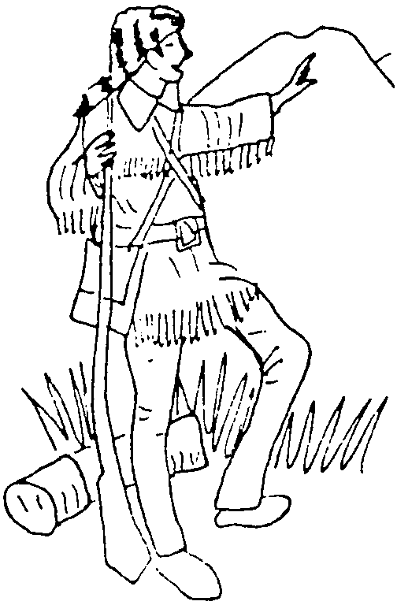
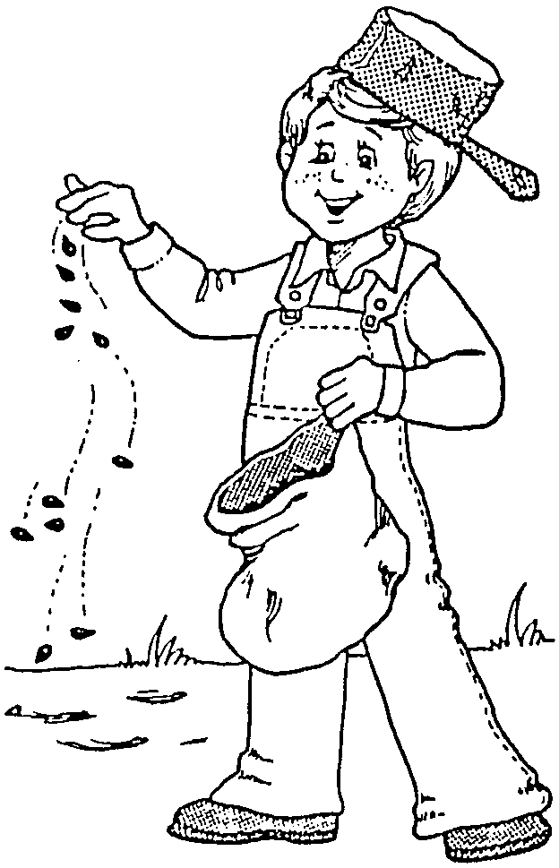

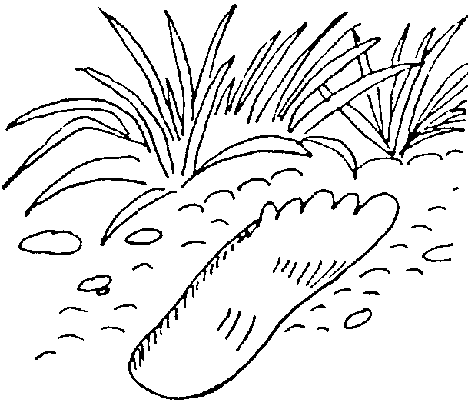
MAY 1999
YEAR-ROUND PROGRAM

From a page in Jimmy’s diary:
“Our Cubmaster and the others decided the Cub Scouts didn’t want any Cub Scouting this summer, so we aren’t having any. I think this is too bad ‘cause we’ve got more time than ever. I guess the Cubmaster and Den Leaders are kind of tired, only I wish They hadn’t decided We didn’t want any Cub Scouting this summer...
“The other day Jacky got some marshmallows and we decided to rost them and we got a lot of branches from Billy’s last years Christmas tree that was still in his yard and made a swell fire out behind his garage. But when we lit it, it just went up like an explosion! We got scared and so did the ladie next door I gess, ‘cause she called the firemen and the engine came clinging up the alley and they got out some stingwishers and put it out and it didn’t do anything but burn off one door. After it was out the firemen talked to all our folks and we got whopped again. Gee, I been whopped so much this summer I’m getting num.
“That’s what I mean when I say we don’t have any trouble thinking up things to do. It’s after we do ‘em that we have the trouble. I hope that next summer the Cubmaster and the other grown-ups won decide we dont want any Cub Scouting.
“I think maybe they are working harder this summer than when we have Cubbing.”

NATIONAL SUMMERTIME PACK AWARD

For many packs the May pack meeting is the last meeting of the Scouting year, with a break during summer. Plan pack activities for the next three months, have fun and earn the National Summertime Pack Award too. A boy registers for a year and deserves a full year of Cub Scout fun and activities. Having a summer program keeps a pack healthy, parents interested, and Cub Scouts eager to re-register for another year. You will find it easier to resume the weekly program in September if you kept in touch with the boys (and the boys with each other) during the summer, even though you won’t be seeing them more than once a month. Also the pack summertime program is one of the optional requirements for the Cub Scout Pack National Quality Unit Award. For more on the National Summertime Pack Award, please read pages 10-2 and 17-22 to 24 in the Cub Scout Leader Book.

NATIONAL DEN AWARD

This award recognizes dens that conduct a quality year-round program. The award is earned by dens as a team, not by individual members of the den. Please refer to pages 9-17 to 18 in the Cub Scout Leader Book.

Remember: Triumph is just a little "umph" added to "try."

LEADER RECOGNITION AND “THANK YOU” TO PARENTS

For most of the packs May is the last regular pack meeting of the year. It is a good time to recognize those leaders and parents who went an extra mile for the pack throughout the year. Special recognition will be especially appropriate for those leaders who are leaving the pack. Recognition can be done in many different ways. It can be serious or humorous, formal or less formal, expensive or inexpensive, store-bought or hand-made. It’s up to you. The important thing is to let them know that you really appreciate them. Chapter 10 of Cub Scout Leader How-to Book includes some “Thank You” ideas.
Don’t forget the “Thank Yous” from the boys to their parents. Cub Scouting is a family program. Graduating boys can write thank you notes or make thank you gifts for their parents for their support during their Cub Scouting years. This may be presented at the den or at graduation.

DEN AND PACK ACTIVITIES

TALL TALE CONTEST AT THE PACK MEETING
Each den prepares a tall tale and acts it out at the pack meeting. Tall tales do not have to be long or elaborate. Make sure all the boys are involved at some phase of the production.

STORY TELLING NIGHT
Have a story telling night at the pack or den meeting. Sit around a “campfire” and tell stories. You don’t have to have a real fire to have a “campfire” program. You can make an electrical campfire with logs, light bulb and red tissue paper (see Staging Den and Pack Ceremonies, pp. 10 and 16 or Cub Scout Leader How-to Book, pp. 12-6 & 12-17 for examples), or twigs and red Christmas lights or flashlight and red paper. Boys are quite happy just sitting around even a Coleman lantern. If it’s done at the pack meeting, have each den prepare and tell some legend or story. Ask a parent who is a good story teller to tell a story. (Library and the Scout Shop have campfire story books.) Cook a treat in a Dutch oven while the story telling is going on.

LOCAL LEGENDS
Call your local historical society and ask if they know of any legends of the valley. Librarians can help you locate the historical society (or even some legends).

BOOKS
With the boys in your den, choose a story or two from those listed in Achievement 4 from The Big Bear Cub Scout Book. Go to the library and check out a book that has longer versions of the stories and read it at the den. Many tall tale books come with outrageous illustrations that appeal to the boys.

FIELD TRIPS (For details, please refer to the Field Trip section)
San Jose Historical Museum, Kelly Park, San Jose
Winchester Mystery House, San Jose

FOLKLORE WORD FINDER

How many times can you find OX? Circle OX in red.

C A T F I S H Z O X B A R E F O O T
O X L I T T L E D I P P E R Q Z R W
J O H N N Y A P P L E S E E D V A E
O X O A T O X A Q W C O W B O Y I D
H B X X R S L U E F O O T S U E L D
N T U E E Y Z L A S S O Y Q W B R I
H A E S E O X B O X B F R O X A O N
E L B X T T P U A Z I L C I T B A G
N E R E A L C N O G L E U L V E D D
R V O X M S E Y O X L A D E W E Z R
Y W I D O W M A K E R H A M M E R E
R A T T L E S N A K E L O G G E R S
F U N N Y E X A G G E R A T E O X S

AX BABE
BAG BAREFOOT
BLUE BUSTLE
CATFISH COYOTE
EXAGGERATE
FLEA FUNNY
HAMMER
JOHN HENRY
JOHNNY APPLESEED
LASSO
LITTLE DIPPER
LOGGER
PAUL BUNYAN
PECOS BILL
RAILROAD
RATTLESNAKE
RIVER
SLUE-FOOT SUE
TALE TEXAS
TREE
WEDDING DRESS
WIDOW MAKER

BIG FOOT

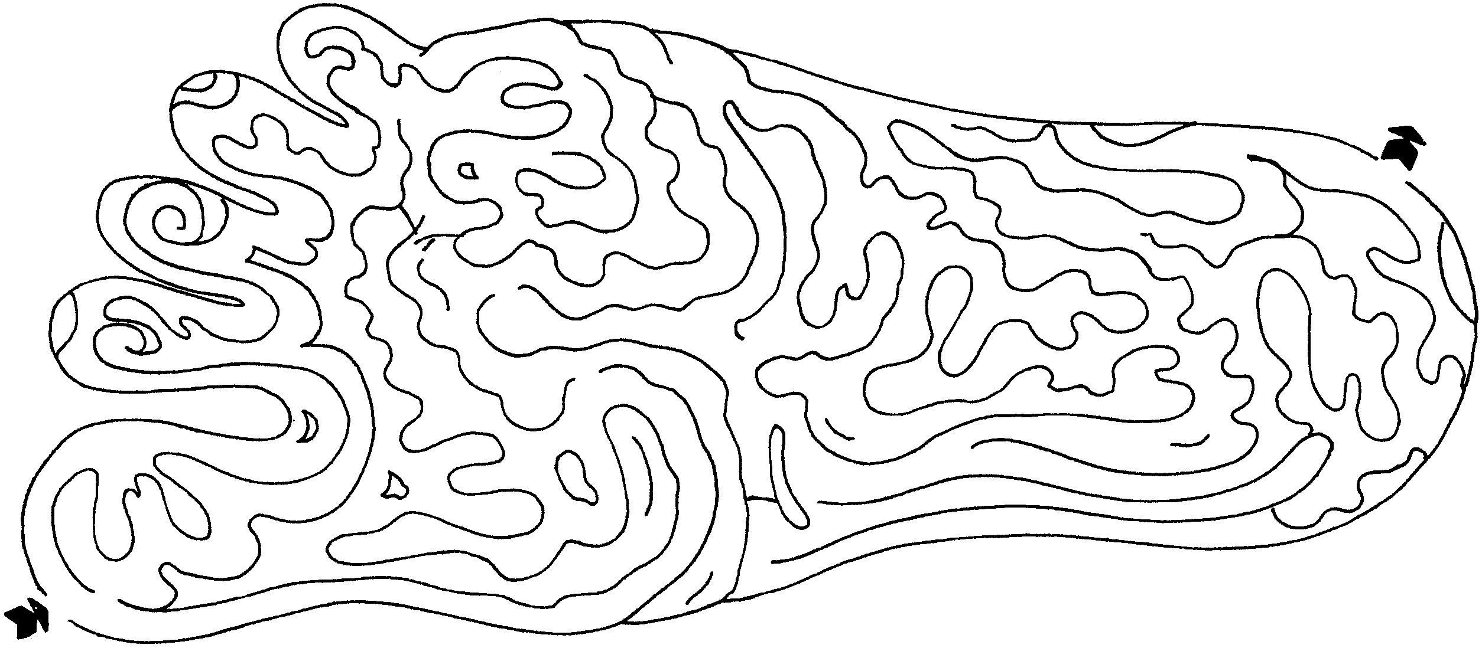
WHO AM I?
If you don’t know the answer, look it up in The Big Bear Cub Scout Book. To make this more challenging for older boys, give one clue at a time for each character.

I am a steel-driving man. My record has never been equaled. In 35 minutes I drove two 7-foot shafts into solid rock while a steam drill only put one 9-foot shaft in. Who am I?

I am a hen-pecked husband who went into the woods to hunt. There were a group of little men playing nine pins. I stopped to play with them. When I was done, I lay down for a long nap, 20 years to be exact. Who am I?

I am a man-like creature from the Pacific northwest. People only see fleeing glimpses of me. I walk barefoot. I doubt they make shoes big enough for me. Who am I?

I am a backwoods hero and a member of Congress. I died at the Alamo with its other defenders. Who am I?

I am at home in the woods. However, after I am there, the woods seem to disappear. I like flap jacks on a huge scale. When I am not around, my friend Babe is real blue. Who am I?

They say I am “unsinkable.” I am a tough frontier lady from Colorado who saved some of the survivors of the Titanic. I was raised in a silver mining town called Leadville. Who am I?

I am a hunter and trail maker who led settlers over the Allegheny mountains into Kentucky. Some say I am half man, half horse, and half alligator. Who am I?

My real name is Jonathan Chapman. I am a Christian missionary. I was a friend of the Indians and the settlers. I spent my life traveling around the wilderness planting orchards. I bet you like the fruit of the tree I planted. Who am I?

I was raised by a pack of coyotes, fought a ten-foot rattler, and then used it for a whip. I caught and rode a mountain lion like a horse. I staked out new Mexico and dug the Grand Canyon. Who am I?

CHEERS
PAUL BUNYAN CHEER: When you point to one half of the group, they yell, CHIP! When you point to the other half, they yell, CHOP! Then alternate CHIP! CHOP! CHIP! CHOP! faster and faster, ending with a loud “TIMBER!”

PAUL BUNYAN CHEER: “Don’t be blue, Babe!”
PECOS BILL: Pretend to twirl a 10 ft rattlesnake lasso and say “Rattle, rattle, rattle!”

RIP VAN WINKLE CHEER: Pretend to snore then wake up. Stretch and say, “WOW, that was a great dream.”
FOLKLORE CROSSWORD PUZZLE

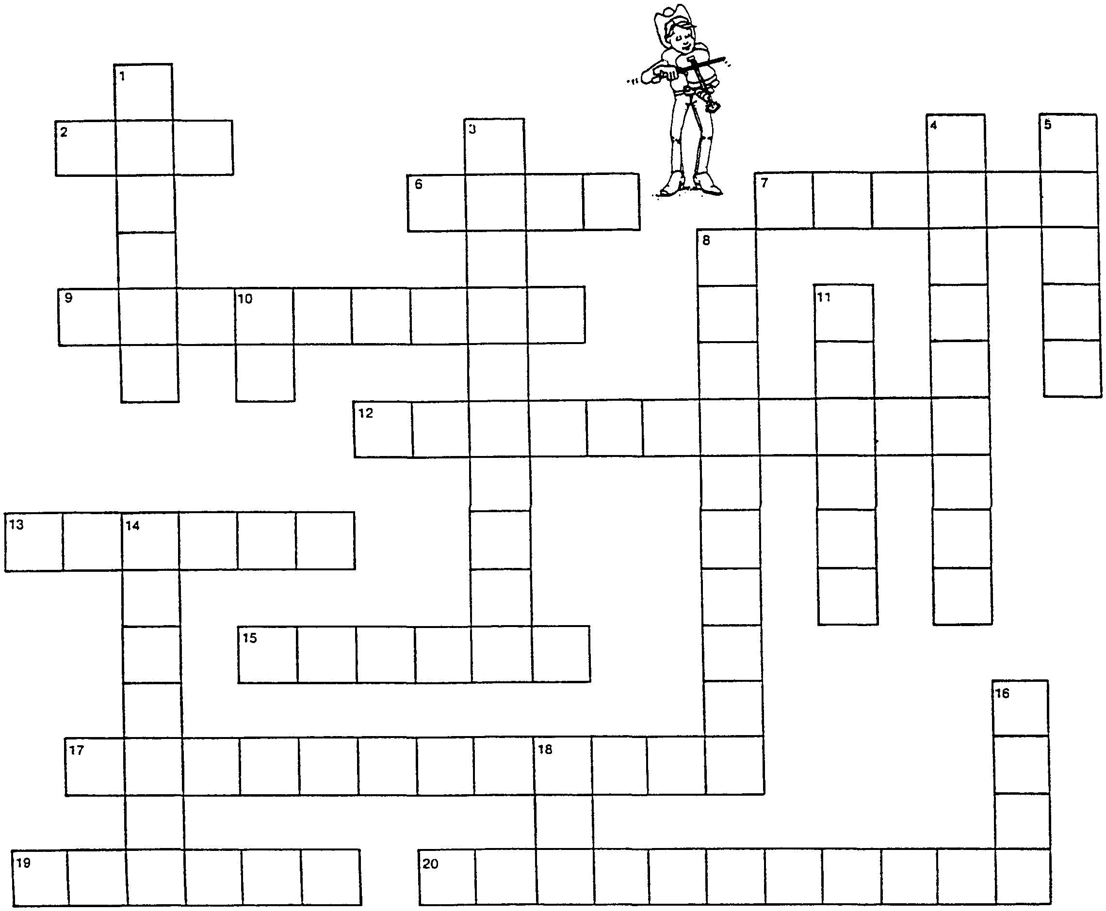

Across:
2. Johnny Appleseed carried his seeds in a _____.
6. Paul Bunyan named his ox _____.
7. Pecos Bill was raised by a _____.
9. The best cowboy in the state of Texas was _____.
12. Pecos Bill loved _____.
13. Pecos Bill was a _____.
15. _____ Appleseed planted trees all across the country.
17. Pecos Bill lassoed the _____ to get water during a drought.
19. Paul Bunyan was a _____.
20. Pecos Bill used a _____ for a whip.
Down:
1. John Henry used a _____ to pound steel spikes.
3. _____ was a giant-sized logger.
4. _____ was a “steel-driving” man.
5. Johnny planted apple _____.
8. Pecos Bill’s horse was named _____.
10. Babe was an _____.
11. Slue-Foot Sue bounced on her _____.
14. Sue wanted a _____ dress.
16. What color was Babe?
18. Johnny Appleseed wore a _____ on his head.

If you don’t know the answer, look at the word finder above! (There is also a story about Slue-Foot Sue in the Audience Participation section of this month.)

FOLKLORE OPENING

Arrangement: 8 Cub Scouts each holding up a sign with an appropriate picture on it. On the back of each sign is one letter, all together spelling FOLKLORE

C.S. #1: Rip Van Winkle took a nap that lasted 20 years;
Cub Scouts learn to respect their peers.

C.S. #2: Johnny Appleseed just loved to plant apple seeds;
Cub Scouts learn to do many good deeds.

C.S. #3: Davy Crockett was said to have killed a ‘bar;
Cub Scouts help out, they’ll go far.

C.S. #4: Barbara Frietchie put back our American flag;
Cub Scouts would put it back, we can brag.

C.S. #5: Daniel Boone led settlers over the mountains into Kentucky;
Cub Scouts learn to help you and me, aren't we lucky?

C.S. #6: John Henry drove steel into solid rock;
Cub Scouts are courteous, ‘round the clock.

C.S. #7: Jim Bowie became famous for his hunting knife;
Cub Scouting improves everyone’s life.

C.S. #8: Pecos Bill lassoed the Little Dipper to cause a downpour;
Now we’ve learned all about Cub Scouting and;
(All turn signs over to spell FOLKLORE)
ALL: American folklore

JOHNNY APPLESEED OPENING

Cubmaster is dressed as Johnny Appleseed. (Use a pot for a hat. Take a dishtowel and tie the ends together to make a bag of appleseeds. Attach a piece of rope and loop it over the shoulder.)

Cubmaster walks in singing or reciting “Johnny Appleseeds” (or ask the audience to join him in singing)

The Lord is good to me
And so I thank the Lord
For giving me the things I need,
The sun and the rain and the appleseed,
The Lord is good to me.
(See Cub Scout Songbook for the music.)

TALL TALE HEROS

Materials: An American flag set up on stage; costumes for Paul Bunyan, Pecos Bill, John Henry, Davy Crockett, and Johnny Appleseed; spotlight to light each boy as he speaks.

Cub #1: I am Paul Bunyan. I have faith - anything is possible.
Cub #2: I am Pecos Bill. I have courage - courage to battle rattlesnakes and tame tornadoes.
Cub #3: I am John Henry. I have strength - the strength to overcome obstacles & never give up.
Cub $4: I am Davy Crockett. I am an explorer who is always learning new things and blazing new trails for others.
Cub #5: I am Johnny Appleseed. I am a planner - always willing to share and make the world a better place.

Narrator: As Cub Scouts, I hope we can learn the traits of these tall tale heroes and share our knowledge with those around us. Please stand, salute, and join me in the Pledge of Allegiance.

RIP VAN WINKLE OPENING

In a little village on the Hudson River lived a simple, good-natured fellow by the name of Rip Van Winkle. Being unlucky enough to have to live with a wife who had a short temper and an all-around mean disposition, he took himself off to the highest parts of the Catskill Mountains in search of happiness. Being fatigued, he sat down to rest on a green knoll - and there he slept for 20 years.

Upon awakening, he noticed nothing different at first. Then he noticed his long white beard and became aware that something was mighty strange. He was no longer able to go back to where and what he was, but he sure came upon something more wonderful and fulfilling than his wildest dreams.

He woke up into a new world of fun and adventure where everyday was a new pleasure and the game of nine-pins echoed throughout the hollows.’’

Wake up with us to Cub Scouting and enjoy!

RUN-ONS
I heard you had an accident today.
All I had was to get bit by a rattlesnake.
Isn’t that an accident?
Heck, No. He did it on purpose.

Boy 1: Yesterday I saw a man at school with very long arms. Every time he went up the stairs, he stepped on them.
Boy 2: Wow! He stepped on his arms?
Boy 1: No, on the stairs.
JOHNNY APPLESEED AND THE STAR CLOSING

The ceremony may be read by several boys or adults. Cubmaster says the last paragraph.

Johnny Appleseed was a pioneer, one of the very best. He didn’t look much like one. He was small and not very strong. He wore a tin pot for a hat and a coffee sack for a coat. Under his arm he carried a Bible and over his shoulder, a bag of appleseeds.

He had no knife. He had no gun. But he walked through sunshine and walked through rain--over the mountains, over the plains, and through forest trails knee-deep in mire looking for places to plant appleseeds.

While he was working, he thanked the Lord for giving him “the sun, the rain, and the appleseed.” As legend goes, God was so pleased with Johnny Appleseeds’ selfless service that he put in the middle of every apple a star.
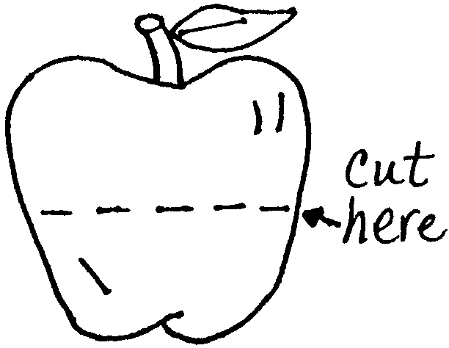

Cubmaster:
At the close of our pack meeting, I would like to give each person an apple and ask that when you get home you slice the apple in half (demonstrate this) just as I did. You will see the star given to Johnny and to you for being part of our pack.

FOLKLORE CLOSING THOUGHT

Folklore is the stories, customs, songs and sayings from our past. Some are true, some are fiction, and some lie somewhere in between. They tell the spirit of America, of our happiness, fears, dreams and hopes. They are the part of the world that we feel with our hearts and imagination. Let us keep our spark of imagination glowing.

END OF THE YEAR CLOSING

God gave us memories so that we might have roses in December or a cool breeze in August.
This is the last regular pack meeting of the year. Some of our Cub Scouts are now leaving us to go on to Boy Scouting. Some of the families may be moving away. May the happy times we’ve had during the past Scouting year remain with us wherever we go.

APPLAUSE

APPLE APPLAUSE: Get out your apple, pretend to shine it on your shirt, look it over, open your mouth, breathe on it, pretend to shine it again, then take a big bite out of it. Say, “Yum, yum.”

BIG FOOT CHEER: Hold one foot up off the floor. (like the Big Hand Cheer).

JOHNNY APPLESEED ADVANCEMENT

Cubmaster:
Many years ago a man named John Chapman fell in love with a particular fruit. He had visions of people all over the country enjoying this fruit. He decided to make that happen by planting the seed wherever he traveled. The man’s nickname was Johnny Appleseed.

Johnny planted thousands of appleseeds in his lifetime. First he would dig a small hole and then drop the seed in and cover it with dirt. He probably watered it before he went on his way.

(Call the Bobcats forward)
The seed would grow into a tiny tree. It would have to survive the elements and animals in the wilderness. Our Bobcats are beginning to grow in Scouting. With the help and guidance of their families and leaders, they have learned the steps to the Bobcat Badge. Congratulations!

(Call the Wolves forward)
The sapling grows into a stronger tree. It has to withstand harsh winds and cold winters. It gets nourishment from the soil, sun and rain. Parents and leaders have encouraged our Wolves to continue in Scouting. Twelve more steps have been taken to earn the Wolf Badge. Congratulations!

(Call the Bears forward)
The tree is now large enough to produce blossoms. It is starting to mature. Our Bears worked on various tasks and have earned the more difficult Bear Badge. Congratulations!

(Call the Webelos forward)
Finally the apples appear on the tree. They are nearly ready to be picked. The Webelos are maturing in Scouting. They have earned their badges by working on many different activities and exploring the world of Boy Scouting. Congratulations!

The apple is usually washed and polished before it is eaten. Would all the leaders and parents please stand? By sending treats, driving on field trips, participating in pack activities, helping a boy complete a Scout task and supporting Cub Scouts, you are fantastic apple polishers. Thank You! May Scouting continue to grow and be a vital part of our children’s life.

JOHNNY APPLESEED ADVANCEMENT

Cubmaster is dressed as Johnny Appleseed. Awards are attached to cutouts of apples cut from red cardstock or posterboard. Cubmaster tells them that while he usually carries only appleseeds in his bag, this time he has some fruit as well.

Cubmaster says something like “Those little appleseeds have to work very hard to become big apples and these boys have worked very hard to earn these awards. For generations, apples from orchards Johnny planted helped feed people and give them joy. These boys too will help others and give them joy throughout their Scouting years and beyond.” Present the awards as he takes the apples from the bag.

DANIEL BOONE ADVANCEMENT

Arrangement: Assistant Cubmaster is dressed in Daniel Boone costume complete with wooden rubber-band gun. Cubmaster is in uniform.

Daniel: Howdy, folks! My name is Dan’l Boone. I understand this is a good place to get me a mess of Bobcats.

CM: You must be a stranger around here. This is a Cub Scout meeting and the only Bobcats around here are the Cubs who have earned the Bobcat badge. Would the following Cub Scouts and their parents please come forward?

(CM presents badges and pins. Parents pin the badges upside down on their sons’ uniform. They return to their seats.)

Daniel: Well, that was very interesting, but you must have that pack of Wolves I was told about.

CM: No, Mr. Boone, our Wolves are the Cub Scouts who have climbed the trail of Scouting to the next advancement rank.

(CM calls forward boys receiving Wolf badges and their parents and presents badges.)

Daniel: Very impressive! But I don’t see nary a single bear out there. (Shades eyes and looks into audience.)

CM: Our Bears are a year older and wiser than our Wolves. They have learned to take care of knives and tools, learned how to tie knots, and even learned about you, Mr. Boone.

(CM calls forward Bear recipients and their parents and presents badges.)

CM: Would you like to see our Webelos get their awards?

Daniel: What in tarnation is a Webelos?

(Prompt boys to yell “We’ll be loyal Scouts!”)

Daniel: Now, that I understand. I’m a loyal TRAIL Scout, too.

CM: Webelos Scouts have learned about our government, know the rules of outdoor fire safety and have slept under the stars.

(CM presents activity badges and Webelos badges.)

Daniel: Well now, Cub Scouting sounds like a mighty fine way to raise up a young‘un. Wish we had Cub Scouts when I was a lad. So long, now.

DEN INDUCTION AND GRADUATION

Personnel: Cubmaster, den leaders, Scoutmaster
Arrangement: One large lit candle at the center of the table, behind it are 5 smaller unlit candles. Graduation bridge.

Cubmaster:
We are here tonight to honor those boys who are moving forward in the Scout program. Before you shines a large candle which represents the Spirit of Scouting. This candle brings to mind the spirit of Baden-Powell and all other Scouters who have given their time to Scouting. It also represents the spirit of adventure and excitement you find in Scouting.

(Lights the first candle from the big one.)
First come the Tiger Cubs, the beginners. They and their adult partners have been busy in their Tiger Cub den. These Tigers now stand ready to continue in Cub Scouting by becoming part of a Wolf den. There are many new adventures and challenges that await them in the coming year. Will these Tiger Cubs and partners please come forward? (Reads off names.)

Tigers and partners, to welcome you to the Wolf den your den leader will present to you the yellow Wolf neckerchiefs. Yellow stands for warm sunlight, happiness and good cheer. May your journey in the Wolf den be filled with sunlight, happiness and good cheer. (Parents place neckerchiefs on Tigers.) Congratulations.

(Lights the second small candle.)
During the year in their Wolf den, these boys have learned about the flag of the United States, how to keep strong, and many other things. It is now time for them to move up. (Reads off names.)

We welcome you into the Bear den by presenting to you the blue Bear neckerchiefs. Blue stands for truth, loyalty and the sky above. May you stay true and loyal to our country and your family and friends. May you soar high in the sky above. (Bear den leader presents the neckerchiefs; parents replace the old ones with new ones.) Congratulations and welcome to the Bear den.

(Lights the third candle.)
The Bears have accomplished many things in the past year and we are proud of their work. Now they are ready to join the Webelos Scouts. (Call them forward.)

As part of the Webelos den you will learn what it takes to be Boy Scouts. The Webelos neckerchiefs are very distinctive, as the Webelos are special because you will soon be loyal Scouts. Wear the neckerchief with pride. (Webelos den leader presents the neckerchiefs.) Congratulations and welcome to the Webelos den.

(Lights the last candle.)
A boy stays in a Webelos den for two years working on many types of activity badges. These boys are now ready to join a Boy Scout troop (call boys and parents forward)

Webelos Scouts, your journey in Cub Scouting is now complete and we encourage you to continue on in Boy Scouting until you achieve the highest award in Scouting, the rank of Eagle

Scout. You have been a part of our pack family and we have enjoyed watching you grow. You will leave us with memories of many great times together. Tonight we have members of Scout Troop _____ to welcome you and your family into their Troop. As in Cub Scouting, your parents will continue to be an important part of your Scouting experience. We ask your parents to remove your neckerchief and stand with you as you prepare to cross the bridge into Boy Scouting.

Scoutmaster: Scouts from Troop _____, please welcome our new members as they cross the bridge into Boy Scouting. The new Scouts have traveled long and are prepared to continue their journey with us. (Graduating Scouts cross the bridge with parents following.)

Scouts, we welcome you and your parents into our Troop. We present to you the Troop neckerchiefs. As in Cub Scouting, the neckerchief will remind you of your commitment to Scouting and all that you are going to accomplish as a Boy Scout. Please repeat the Boy Scout oath. Welcome to the Troop.

ADULT RECOGNITION CEREMONY

Tonight we would like to recognize some adults who have given their time and effort so this pack and the Cub Scout program would be stronger. (Call adults forward and list some of their contributions.)

I’d like to read a poem which tells of service to Scouting:

He hasn’t much in worldly goods
Yet he’s richer than you know,
For he’s chosen to be a Scouter
And his spirits are all aglow.

He’s just a Scouter, nothing more;
But he molds the lives of boys,
He teaches them how to do their best
And he shares their many joys.

They work on badges, go on hikes,
Share campfires in the night,
They practice skills and follow laws,
And learn to do things right.

He watches them grow from boys to men;
And it makes it all worthwhile,
When they turn to him and say, “Gee, Thanks!!”
And their faces wear a golden smile.

LEGEND OF THE WARM FUZZIES - ADULT RECOGNITION

This can be read straight or have the audience participate, saying “Thank you” or smiling every time “Warm Fuzzie” is mentioned.

Once upon a time, there was a tiny village nestled between two mountains. Each person in the village was very happy because at birth he was given a bag of “Warm Fuzzies.” You could reach into your bag and pull out a “Warm Fuzzie” whenever you wanted, and everybody wanted them all the time. “Warm Fuzzies” were given to other people on the street, at home, everywhere. The more you give away, the more you got. “Warm Fuzzies” made you feel like they sound--warm, happy and contented. Everyone in the village was happy.

With time, people became afraid that if they kept giving away their “Warm Fuzzies” that there wouldn’t be any left for themselves. So people stopped giving them away and they hid them. They hid them away in jars, in cupboards, and in attics. After a while people forgot about the “Warm Fuzzies” and the village became cold and dreary. The village was no longer happy. There wasn’t a “Warm Fuzzie” to be found!

This went on for years and years until one day a little girl found a “Warm Fuzzie” and asked her grandmother what it was. The grandmother looked at it and pondered. Then she took it in her hand. Immediately, she could feel the warmth of the “Warm Fuzzie” and she told her granddaughter how there used to be an abundance of “Warm Fuzzies” in the village long ago, before it became so dreary. The little girl gave the “Warm Fuzzie” to her grandmother with a loving hug and went about her way. Remembering the old days, the grandmother gave the “Warm Fuzzie” to another villager. It was the first “Warm Fuzzie” given in some time. The village people soon remembered hiding and hoarding their “Warm Fuzzies” and one by one, they went home to find their “Warm Fuzzies” and soon everyone was giving out “Warm Fuzzies” again. To their surprise, the more “Warm Fuzzies” they gave away, the more they had.

(Ask leaders to be recognized to come forward.)
Please accept this “Warm Fuzzie” as a small token of our love and support for you. Carry it with you while Scouting to remind you of the small village and the need to freely give “Warm Fuzzies.” Someday, when you meet a fellow Scouter needing a “Warm Fuzzie,” give one from your heart; you’ll find it multiplies and you’ll both have even more to give the next time.

HOW TO MAKE A WARM FUZZIE
Use a large pompom (available at a craft store). Attach two ribbons on the back to form streamers. Glue 2 wiggle eyes on the front. Attach a pin-back (or safety pin) or 1/2" PVC pipe piece to the back.

PACK LEADER TOAST

Personnel: Cubmaster, committee chairman, unit commissioner or chartered organization representative could act as narrator
Equipment: Toast (painted styrofoam); Large knot; Rulers; Large number “4”; Lettuce (real or green crepe paper rose); Box of Glad Bags; Stick; Can of Pledge

Narrator:
(Call forward the people to be recognized.)
I would like to offer the leaders of our pack a TOAST. Here’s to you! Without your leadership abilities, time and energy, our pack would KNOT exist.

As RULERS of our group, your responsibilities are many, such as recruiting Cub Scout leaders, planning den and pack meetings, planning activities, and encouraging participation FOUR the success of the pack.

LETTUCE assure you that your hard work does not go unnoticed. We appreciate all your efforts. To let you know that we are GLAD to STICK by you, we PLEDGE you our support. Whenever you need our help, we will give you a HAND (Audience stands and applauds).

FUN WAYS TO SAY THANK YOU

Apple (real or plastic): “You’re the apple of our eye and such a polished leader!”
For the person with great appeal.
Clock (draw 13 hours on face, write ‘Official BSA’): For the person who finds an extra hour to get the job done.
Ladder (toy): For Advancement Chairman.
Lantern: “Thank you for lighting our way.”
Scout-O-Rama patch on a plaque: For the pack SOR Chairman.
Packet of thyme: “Thank you for all the time you put in for the pack.”
Packet of thyme with label “Spare thyme”: “Thank you for giving up all your spare time.”
Toy rocking chair: For a retiring Scouter.

Cubmaster’s Belt: Have all the boys and leaders to participate in making a belt. Purchase a belt “blank” from a leather store, and have each boy, grouped by dens, add his initials with leather stamps. Have leader do the same. Add a few little decorations and Cubmaster’s name, stain, and add a buckle.

More leader appreciation ceremonies in Staging Den and Pack Ceremonies:
“A Den Leader Farewell and an Induction: (p. 135)
“Den Leader Appreciation” (pp. 135-136)
“Den Chief Appreciation” (pp. 136-137)
“Den Chief Service Award Ceremony” (p. 138)
“Appreciation Bouquet” (pp. 139-140)
“Beatitudes for Leaders” (p. 142)
Cub Scout Leader How-to Book, Chapter 10 “Prizes and Special Awards”
SLUE-FOOT SUE

Slue-Foot Sue: “Yippy, yi-ya!”
Pecos Bill: “Howdy, pardner”

SLUE-FOOT SUE, one of Texas’ great heroines, was married to PECOS BILL. She first met PECOS BILL when she was riding past his ranch on the back of the world’s largest catfish (riding motion). It was love at first sight! PECOS BILL proposed marriage on the spot. SLUE-FOOT SUE said she would marry him on two conditions. She wanted a brand-new, store-bought, wedding dress with a bustle and she wanted to ride PECOS BILL’S horse Widow Maker to the wedding.

PECOS BILL rode non-stop to Dallas that very afternoon and picked up the prettiest wedding dress you ever saw.

Now even though SLUE-FOOT SUE was a mighty good rider, no one but PECOS BILL had ever ridden Widow Maker before. As soon as her bustle touched that powerful animal’s back, SLUE-FOOT SUE was blasted clean out of the saddle and into space. SLUE-FOOT SUE must have bounced off the ground twenty times before PECOS BILL was able to lasso her and pull her safely to earth.

During this unfortunate trip, however, SLUE-FOOT SUE learned a whole lot about the heavens above which helped her to save Texas from the great drought. The drought had lasted so long that children in Texas had no idea what rain was. It was so dry that your spit would disappear before it would ever hit the ground. All the cattle walked around with their tongues hanging out making puny, little coughing noises.

SLUE-FOOT SUE knew that she was the one who had to end this serious situation. She directed PECOS BILL to gather up all the rope he could find. Then SLUE-FOOT SUE and PECOS BILL climbed up the highest mountain on their ranch, where they set to work tying all the rope together. When they were done, they had the longest lasso anyone had ever made.

SLUE-FOOT SUE pointed to the Little Dipper and told PECOS BILL to lasso the handle of the constellation. PECOS BILL began to spin the loop of his lasso larger and larger, faster and faster, until finally he let loose, sending the lasso streaking into the sky. PECOS BILL and SLUE-FOOT SUE waited for hours, but at last the loop of the lasso found the handle of the Little Dipper. PECOS BILL and SLUE-FOOT SUE pulled and tugged on the end of the lasso all through the night until the dipper began to tip toward the earth.

Finally, as the first rays of the morning sun began to appear, water that was stored up in the Little Dipper began to spill towards earth as rain. The great Texas drought was finally at an end thanks to SLUE-FOOT SUE, her bustle and her out-of-this-world ride.

THE FIRST STORY

Small Hunter: “Story, please”
Grandfather Stone: “Long, long ago”

Longer than long ago, there were no stories. The winters were long and cold. SMALL HUNTER was a boy from this village and one cold day he went hunting. His luck was good and he managed to kill several birds. As he trudged his way back through the snow he became tired and sat down to rest next to a large stone. As SMALL HUNTER rested, he heard a large rumbling voice speak. “Do you want to hear a story?” SMALL HUNTER felt the stone vibrate behind him as the voice spoke. Now this was back in the old days when the people could talk to the animals and other things in nature. SMALL HUNTER turned to the stone and seeing that no one else was there, addressed it. “Is it you who speaks to me GRANDFATHER STONE?” “It is indeed,” said GRANDFATHER STONE. “Then tell your story,” said the SMALL HUNTER. “First you must give me something in trade,” demanded GRANDFATHER STONE. The boy gave GRANDFATHER STONE one of his birds.
GRANDFATHER STONE started to speak. He told a beautiful tale of how the Earth was formed and how life came to be. During the telling of the tale SMALL HUNTER began to feel warmer and the cold was not so bitter. When the story was done SMALL HUNTER stood up and thanked GRANDFATHER STONE for the story. “I will go to my village and tell my people this story and will return tomorrow for another,” said SMALL HUNTER.
That night villagers gathered around the campfire and SMALL HUNTER told them the story the GRANDFATHER STONE had told him. Again the cold and the snow seemed to go away as the story was told. The people were relaxed and slept well that night and dreamed good dreams.
The next day SMALL HUNTER went hunting and returned to GRANDFATHER STONE and offered another bird. “I shall now tell a story, said GRANDFATHER STONE and SMALL HUNTER listened. This continued for a long time and each day SMALL HUNTER would bring an offering of small game. GRANDFATHER STONE told him the stories of the old days and about monsters and animals, about good people and bad people. The stories were wonderful and taught important lessons to help guide the village people through life. The stories spread to people beyond the village and all over the land. SMALL HUNTER told each story as he had heard it from GRANDFATHER STONE and the winter was never again as long or as cold as it was before the stories.
Then on a day when spring was approaching, SMALL HUNTER brought another gift to hear another story. “GRANDFATHER STONE, tell me another story,” said SMALL HUNTER. But this time GRANDFATHER STONE had no more stories. This time he said, “Those are all the stories I have to tell you. They are for you and your people to keep and pass down to your children and your children’s children. Other stories will be added and passed on. Stories will give birth to other stories.”
This is how stories came into the world. To this day they are told around the fires of the villages. This is why whenever the teller of the tale is done, the people always give thanks just as SMALL HUNTER thanked GRANDFATHER STONE.

HOW THE BEAVER GOT HIS FINE FUR

This can be played by the boys with costumes or signs identifying who they are. This can be made into a puppet play as well. (Beaver has very fine, thick, soft fur.)
Narrator: In the days when the earth was new and there were no men, but only animals, the sun was far away in the sky. It was so far away that there was no summer. Things did not grow as they should and the rivers were always cold. He-Who-Made-the-Animals saw how it was, that there was not enough sun to heat the earth, so he fashioned a snare.

The sun walked into the snare and the snare held him fast. Summer came to the earth. HOT summer came to the earth. There was no night, only day with the sun shining hot upon the earth. The animals called a council. The animals spoke to the sun.
Wildcat: Sun, you give too much heat to the earth.
Sun: Set me free from this snare and I will go away. I will stand above the earth and warm it so that the trees and grasses and the flowers will grow and there will be many fish in the streams.
Wildcat: Who is going to set the sun free? Whoever sets the sun free must get so close to the sun that he will be burned to death.
Lynx: I shall not do it. Whoever sets the sun free must chew the leather thong that holds the sun in the snare. The sun will burn him to death before he can do it.
Deer: I shall not do it.
Opossum: I shall not do it.
Raccoon: I shall not do it.
Beaver: I shall do it!!
Deer: How can you set the sun free? Your teeth are small; they are not even sharp.
Raccoon: You can chew only a blade of grass with your teeth. How can you chew the leather thong that holds the sun?
Narrator: None of the animals liked the beaver. He was small and his fur was so thin it hardly was fur at all. He could not do any of the things the other animals could. They never asked him to play. He could not run. He could not carry the ball.
Beaver: I shall set the sun free. (Other animals laugh.)
Opossum: Let him try. He will burn up but we won’t miss him.
Lynx: Set the sun free if you can.
Narrator: So beaver set off toward the place in the sky where the sun was caught in the snare. Beaver was slow. It took him many days to get there. He began to chew on the leather thong. His skin blistered in the heat. His eyes felt like dry hot stones in his head. But beaver did not stop.

Suddenly, he chewed through the leather. The sun rose into the sky. Beaver had freed the sun from the snare. Beaver stood in the council circle. There was no fur on his body. His teeth were only blackened stumps.
He-Who-Made the Animals (voice from off stage): Beaver, the animals will not forget what you have done for them. I will see that they do not forget. I will give you new teeth, broad and flat and so strong that you can cut down strong trees. I will give you fine fur. No other animal shall have fur so fine. But there will be no fur on your tail, so the other animals will never forget what you did for them.
THE TALLEST TALE

Arrangement: As the Narrator talks, each character comes in as his name is mentioned and pantomimes an action. Each Cub should be dressed to resemble his particular character. For instance, Pecos Bill as a cowboy, Windwagon Smith as a sailor, etc.

Narrator: (Enter Pecos Bill twirling a rope.)
Pecos Bill, they say was quite a baby.
He was raised by coyotes--well, maybe.
As a grown-up he did one day seize
A cyclone and turned it into a breeze. (Exit.)

Narrator: (Enter Johnny Appleseed, sprinkling apple seeds.)
John Appleseed was his name,
And planting apple trees was his game.
After many many years went by
The angel took Johnny to the sky. (Exit.)

Narrator: (Enter Paul Bunyan with ex in his hand.)
If you wander in a forest, just listen to the breeze.
You may hear a voice far away, singing through the trees.
If you’ve guessed who I’m talking about, you’re sly as a fox.
Who else but Paul Bunyan and his big, blue ox. (Exit.)

Narrator: (Enter John Henry pounding sledge hammer)
John Henry was a big man
Who challenged the railroad as nobody can.
With his great big hammer, he came in first
But ended up dying when his great heart burst. (Exit.)

Narrator: (Enter Windwagon Smith as a proud sailor.)
(This character can just strut as if proud of his efforts.)
Windwagon Smith was quite a sailor
Who built a ship--it wasn’t a whaler.
Indeed he came from the seven seas
But he sailed his ship on the lone prairies. (Exit.)

BEWILDERED BOONE

After coming back from Kentucky, Daniel Boone was talking with a settler.
“Daniel, did you ever get lost?” asked the settler.
“Lost?” said Boone, “no, I can’t say I was ever lost, but I was bewildered once, for three days.”

JOHNNY APPLESEED SEED-PLANTING RELAY

You will need 6 small-mouthed jars or cups per team, and dried beans or pasta shells.
Using a heel-toe action each person in turn follows a line drawn on the floor by placing the heel of one foot against the toe of another. About every three feet he must stop and place a seed (beans or pasta pieces) in a jar set about 1 1/2 feet on each side of the line. When the “Johnny” reaches the end, he runs back and taps the next boy on the team.
Variation: Johnny Appleseed traveled the country barefooted; as a variation have the team members remove their shoes/socks and run the course barefooted. Explain why.

DAVY CROCKETT’S BEAR HUNTING

Give each player a loosely rolled newspaper. Blindfold and place them around the room. On the command “Look out for the bear!” have the players try to swat everyone else. Each player is eliminated as he is hit. The player remaining is the winner.
(Davy Crockett is said to have killed bears “bear” handed.)

DANIEL BOONE’S DIRECTIONS

Have all the players except “Daniel Boone” form pairs and stand in a circle. When Daniel Boone says, “Face to face,” the partners face each other. When he says “Back to back, “ or “ Side to side,” his directions must be followed. If he says “Daniel Boone,” everyone, including himself, tries for a new partner. The one left out becomes Daniel Boone, and the game continues.
(Daniel Boone led settlers over the mountains to new settlements.)

LOG ROLLING CONTEST

Make logs from 4-inch cardboard cylinders. Paint, if desired. This can be a relay, with each boy rolling a log with a dowel or stick to a given point and back to the next person in line.

PURPLE LURPLE

A Purple Lurple is a two-headed, four-armed, four-legged, four-eyed monster who likes to chase and catch people. To play this game, you need a large group of people and a big room. Two people are in the middle holding hands. They have to stay connected at all times. Everyone else is in a line facing the monster at one end of the room. When the monster yells “Purple Lurple Ready!!!” everyone must run to the other side of the room without being tagged by the monster. If you are tagged, you wait until the monster gets you a partner and then you become a Purple Lurple Monster and chase people to your hearts content.
WHO AM I?

Prepare in advance slips of paper with names of folklore characters written on them, one for each Cub Scout. Attach them to the backs of the players with safety pins. Each player can then see what name everyone else has, but not his own. Have the players mingle. The object of the game is for each player to find out what name he carries on his back. He can ask any questions he likes of other players. Only “yes” or “no” answers may be given. When each player thinks he knows who he is, he goes to the judge (e.g., den chief, Cubmaster) and makes a guess. He is allowed only three guesses. This is a good game for the gathering time before the pack meeting too.
One special point: Before playing this game, all mirrors should be covered up or removed.

APPLE BALANCE

At starting signal, players balance an apple on the top of their heads and then walk to the finishing line (make it a short distance first). If the apple falls off, put it back and continue. Two can play the game at a time, or you can work the game in teams.

BIG FOOT

Players are divided into two equal teams, half of each team being at either end of the playing area. The first person on each team is given two large feet, cut out of posterboard. On the signal the players set the feet on the floor and walk across to the other part of his team. That person then walks back on the feet, and so on. The catch is that the posterboard feet must be lifted off the floor for each step.
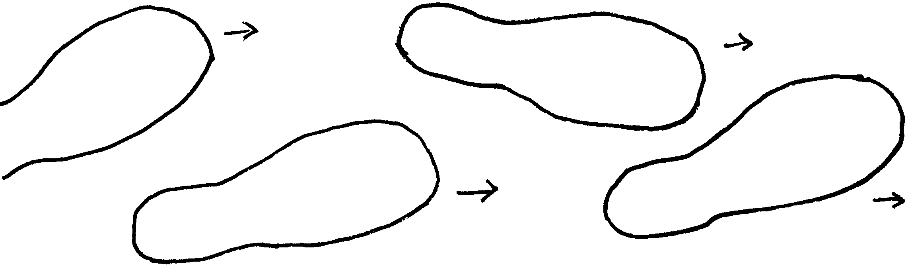

THE MAD MONSTERS
You will need pencils and paper. Give a pencil and strips of paper about six inches long to each Cub Scout. Tell everyone to draw the head of a person, an animal or a bird, leaving a couple of small lines for the next player to join on to before folding the paper so that the drawing of the head is hidden. The strips are then passed round clockwise and the next Cub Scout draws a body. One more fold, and the slips are passed on again for the next Cub Scout to draw legs. When the slips are unfolded, there will be some pretty strange monsters. Make up some tall tales about these monsters.
WHERE HAS MY TIGER CUB GONE
(Tune: Where Has My Little Dog Gone)

Where oh where has my Tiger Cub gone?
He’s gone a Wolf Cub to be.
Let’s give him a hand and we’ll help him along,
And soon a Bear Cub he’ll be.

Where, oh where has my Wolf Cub gone?
He’s gone a Bear Cub to be.
Let’s give him a hand and we’ll help him along,
And soon a Webelos he’ll be.

Where, oh where has my Bear Cub gone?
He’s gone a Webelos to be.
Let’s give him a hand and we’ll help him along,
And soon a Boy Scout he’ll be.

Where, oh where has my Webelos gone?
He’s gone a Boy Scout to be.
Let’s give him a hand and we’ll help him along,
And he’s the best he can be.

PAUL AND BABE
(Tune: Polly Wolly Doodle)

Paul Bunyan was a burly guy
Singin’: Watch that mighty man!
The trees would shake when he walked by
Singin’: Watch that mighty man!

CHORUS:
Paul and Babe, Paul and Babe
What a team with only an ax
They swept through the forest
Just choppin’ down trees
And take a look at those tracks!

Now babe his ox was, oh, so blue
Singin’: Babe that mighty ox.
He was 42 ax handles long, it’s true,
Singing’: Babe that mighty ox!
CHORUS

Yes, Paul, he loved those cakes of wheat
Singin’: Eat those cakes right down!
Those boys would skate with bacon on their feet
Singin’: Eat those cakes right down!
CHORUS
CUBMASTER’S HYMN
(Tune: On Top of Old Smokey)

On top of Old Smokey,
All covered with snow,
I learned a great lesson
All people should know.

I met a Cubmaster,
A helper of youth,
He was roaming God’s mountains,
In search of the truth.

He told me he found it
In the red sunset’s glow,
In the voice of the thunder,
In the touch of the snow.

His truth was quite simple,
As plain as could be.
I’ll never forget what
That leader told me.

Do your duty to God,
To the red, white, and blue.
To all others be helpful,
To thine own self be true.

GRADUATION SONG
(Tune: Reuben, I’ve Been Thinking)

Oh, (Name of the graduate), we’ve been thinking
What a grand Scout you have been;
May the Boy Scouts treat you kindly
As we have in our den.

Your achievements are outstanding
And we’ll miss you very much,
But we cannot always keep you,
So we wish you, best of luck.

See Cub Scout Songbook for:
“Johnny Appleseed”
“‘Round the Campfire”
“Taps”
“Cub Scout Vespers”
“Scout Vespers Song”

TRUE STORIES
(Tune: Clementine)

I was raised up in the mountains
Where the snakes all have two legs.
Where the hoot-owls speak in English
And the roosters lay flat eggs.

I shaved off my beard and mustache
On the morning I was born.
That night I beat up a Cyclops
And tore off his ugly horn.

I have had some great adventures,
I have sailed the seven seas.
I have tamed man-eating monsters
From alligators down to fleas.

I have swam the great Pacific,
And I’ve walked around the moon.
I’ve waded through an icy blizzard
On the thirty-first of June.

Well I used to be a pilot
And up in my fast airplane,
I flew across the ocean
And then started home again.

When I got ‘bout half way over,
Well the doggone motor balked;
So I left the old thing sit there
And I got out and I walked.

Now I am a truthful fellow,
And they call me True Blue Bill,
Cause I never told a falsehood,
You can bet I never will.

HOW TALL IS A TALE?
(Tune: Row, Row, Row Your Boat)

To be sung as a round:
Tall, tall, tall tale
How tall is a tale?
No sir! That’s wrong!
A tail’s not tall--it’s long.
PECOS BILL
(Tune: Ghost Riders in the Sky)

Pecos Bill was a cowboy out in Texas,
And a western superman to say the least,
He was the roughest, toughest critter -
Never known to be a quitter,
And he didn’t have no fear of man or beast.

CHORUS:
So, yipee-yi-ay, Yippe-yi-oh,
He’s the toughest critter west of the Alamo.

Once a band of rustlers stole a herd of cattle,
But they didn’t know the herd they stole was Bill’s,
And when he caught them ornery critters-
Then he knocked out all their fillings,
That’s the way they got the gold in them thar hills.
CHORUS

Once while ridin’ out across the burning desert,
It was ninety miles across the burning sand,
He knew he’d never reach the border -
If he didn’t get some water,
So he got a stick and dug the Rio Grande.
CHORUS

Once there was a drought that spread all over Texas,
So to sunny Californey he did go,
And though this really may sound corny -
He brought rain from Californey,
That’s the way we got the Gulf of Mexico.
CHORUS

While reclining on a cloud high over Texas,
With his gun he made the stars evaporate,
And when he saw those stars declinin’-
He left one brightly shinin’,
As the emblem of the Lone Star Texas State.

SEED MOSAICS
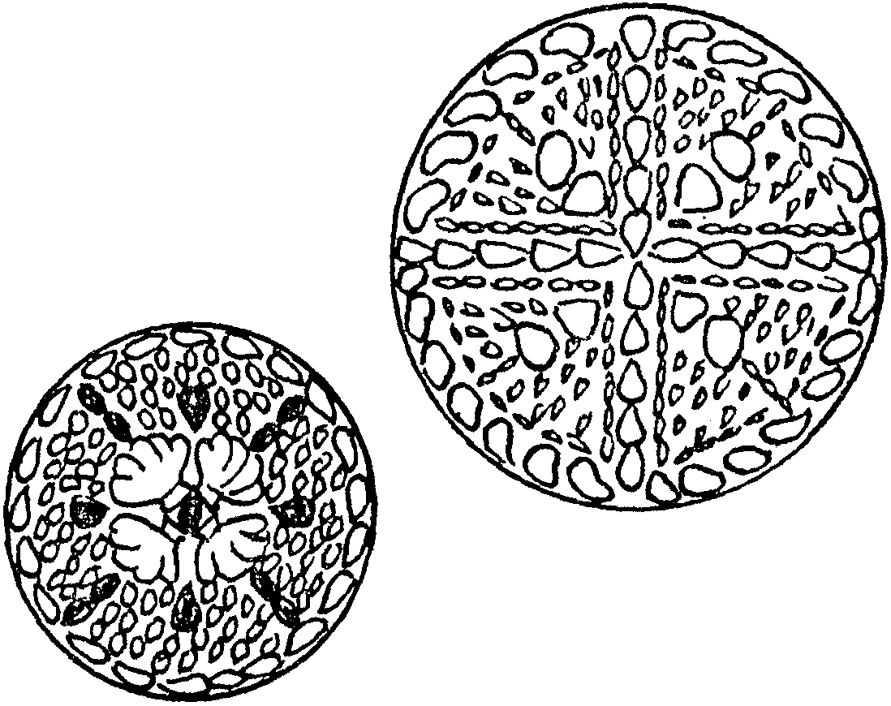
Make a pretty picture, necklace or pin with different seeds for Mother’s Day. Or make a paper weight or coaster.

You will need: Assorted tiny seeds (corn, bean, sunflower, fennel, dill, watermelon, squash, lentils, rice, pearl barley, kidney beans, etc.); Piece of stiff cardboard or meat tray; White glue. (Keep types of seeds separated in different containers.)
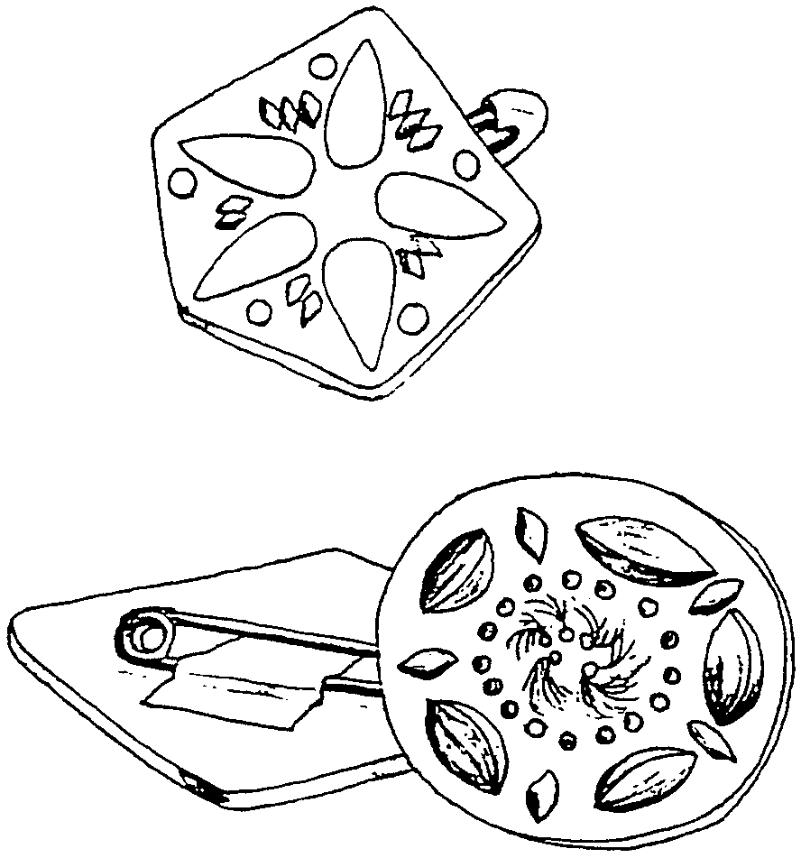
1. Cut the cardboard or meat tray into a desired shape (circle, square, heart, bell, etc. Keep it simple). If you are making a necklace, make a hole now. You may want to draw a design on the cardboard--or have a free-hand art piece.
2. Spread glue on a small area of the cardboard.
3. Set seeds into the glue,
4. When dry, you can spray with glossy finish if you want.
5. Add a pin back or safety pin for a pin. Use pretty string for a necklace.

Variation:
Use plastic lids. Press old playdough into a lid and use as a background for the seed collage. No paste or glue is necessary. This could be a coaster or paper weight.

SEED NECKLACE

You will need: Large seeds (sunflower seeds, melon seeds, pumpkin seeds, pine seeds with “wings”); Needle; Thread; Pretty cord.

1. Thread a needle. Knot the end of the thread and then push the needle through seeds.
2. If you want, thread dry leaves between clusters of seeds.
3. Tie a knot at the end to secure all the seeds and leaves.
4. Take a length of cord about 2 1/2 feet long. Position the string of seeds in the middle. Tie the cord to the string of seeds using thread, about every inch or so.
COAT HANGER SEED MARKER
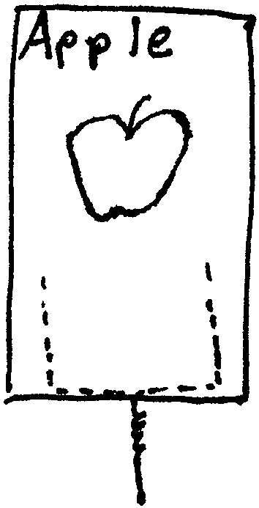

Plant some seeds and mark the spot with these seed markers.

You will need: Coat hanger; Construction paper; Clear Con-tact paper; Wire cutter.

1. Measure 16 cm from the hook and cut with wire cutter. (You may need adult help.)
2. Measure 6 cm and bend as shown.
3. Straighten the hook.
4. Cut two sheets of paper larger than the coat-hanger base. Be creative in the shape.
5. Draw picture and/or write name of the seed you planted.
6. Glue two sheets with the coat-hanger between them.

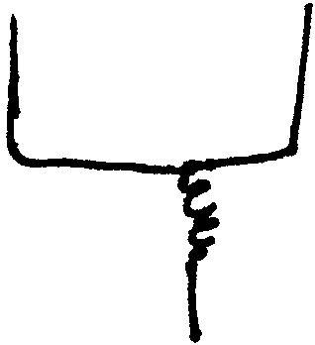
7. Cover both sides with clear Con-tact paper.
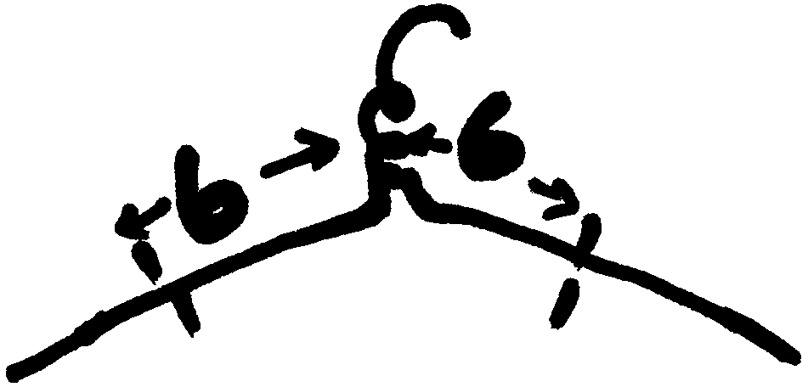
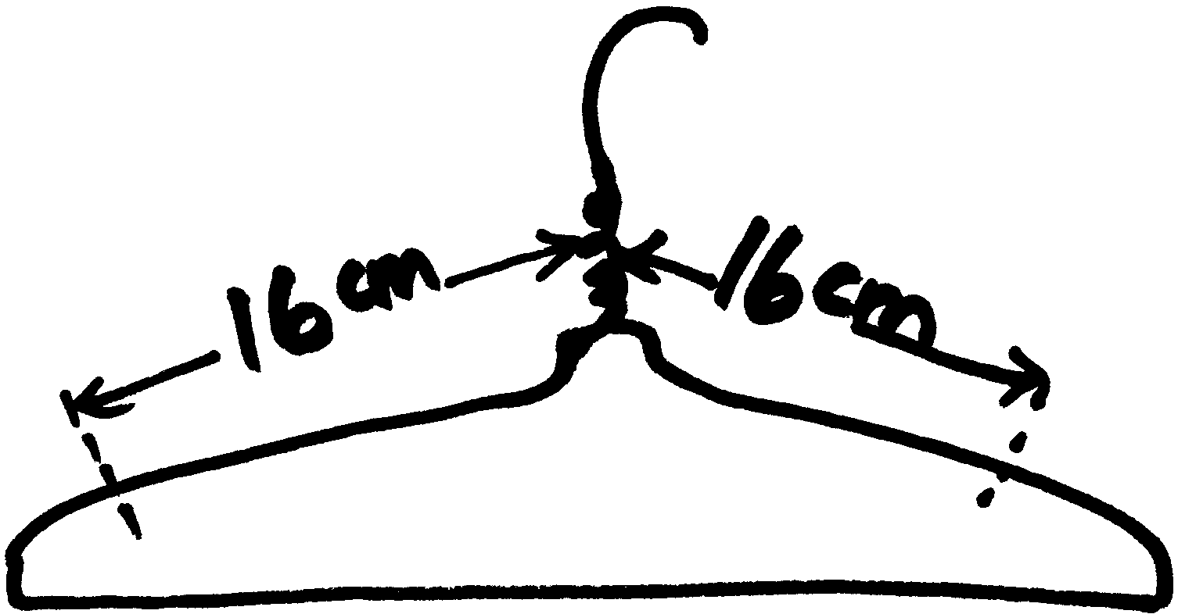

DAVY CROCKETT’S POUCH
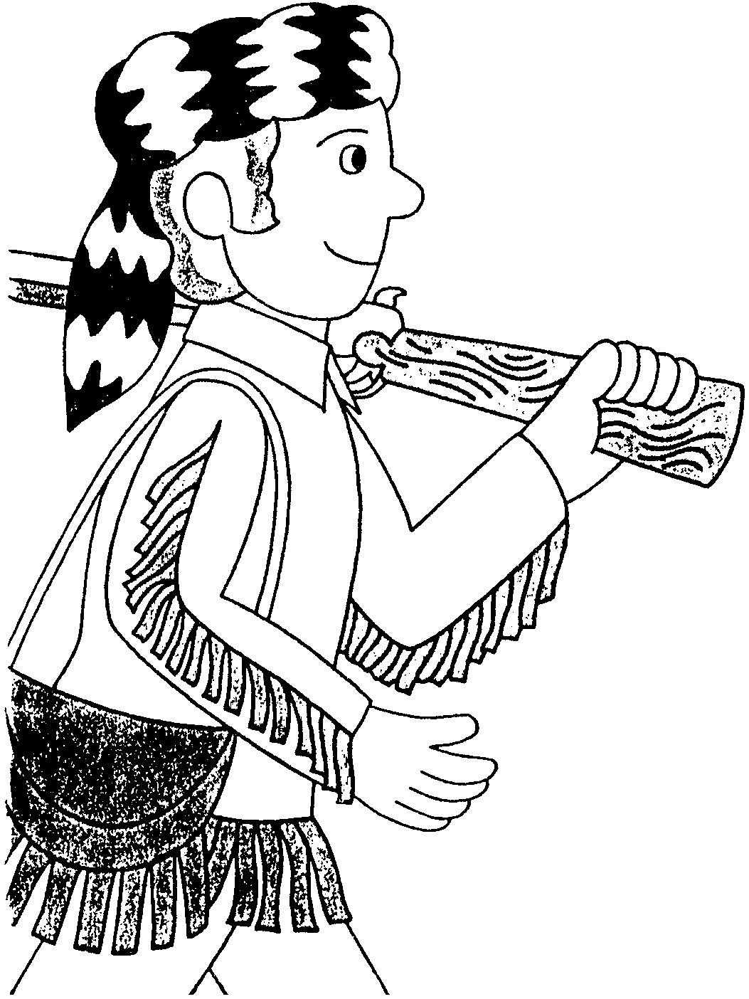
Davy Crockett crossed the Cumberland Gap wearing a coonskin cap and carrying his deerskin pouch slung over his shoulder.

You will need: Brown naugahyde, felt or vinyl pieces; Paper plate.

1. Place a paper plate on the naugahyde and trace a circle.
2. Cut the paper plate in half on a slightly curved line. Trace this pattern.
3. Cut the circle and half-circle out of the naugahyde.
4. Using scrap pieces, cut “fringe” pieces--don’t make them too small.
5. Glue these “fringes” on the inside edge of the half-circle.
6. When this is dry, glue two pieces together at the edges.
7. Cut a long piece out of naugahyde for a handle or use a piece of rope. Attach to the pouch.
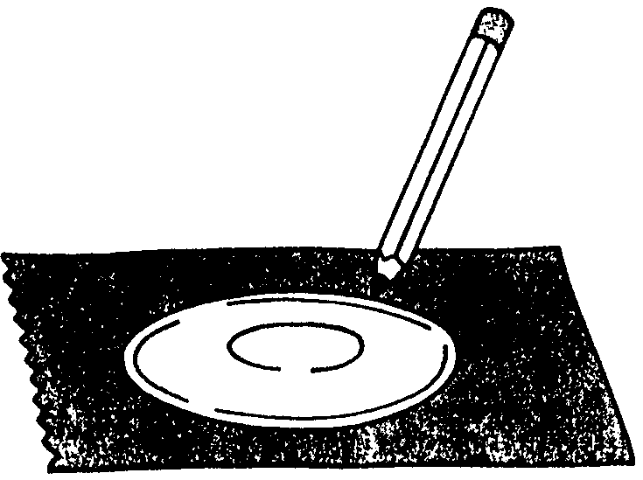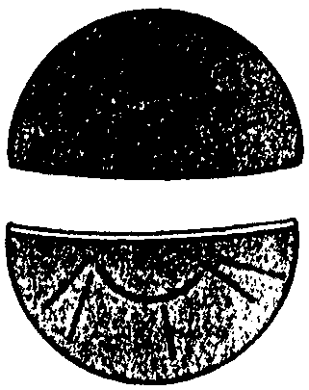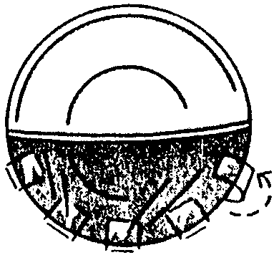

AMERICAN FOLKLORE FIGURES

You will need: Cardboard rolls; Acrylic paint; Markers; Colored construction paper; Scissors; Glue.

1. Draw faces with markers.
2. For the clothes, trace patterns onto construction paper and cut out. Glue clothes in place.
3. If desired paint details on clothes with acrylic paint or markers.

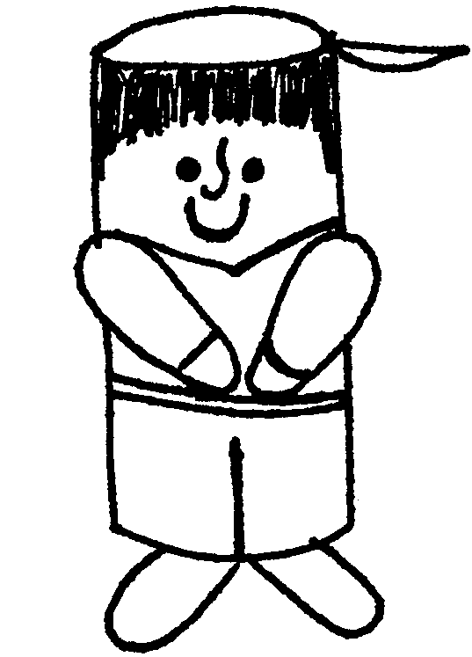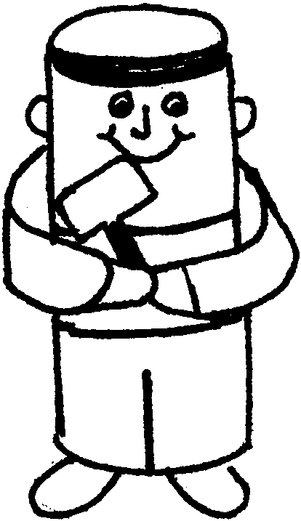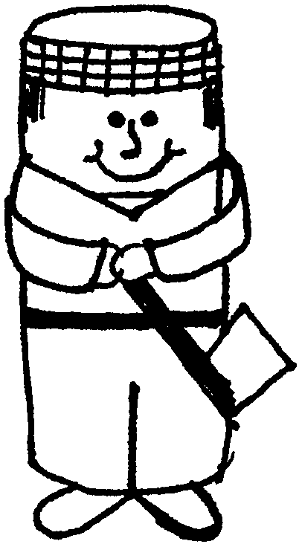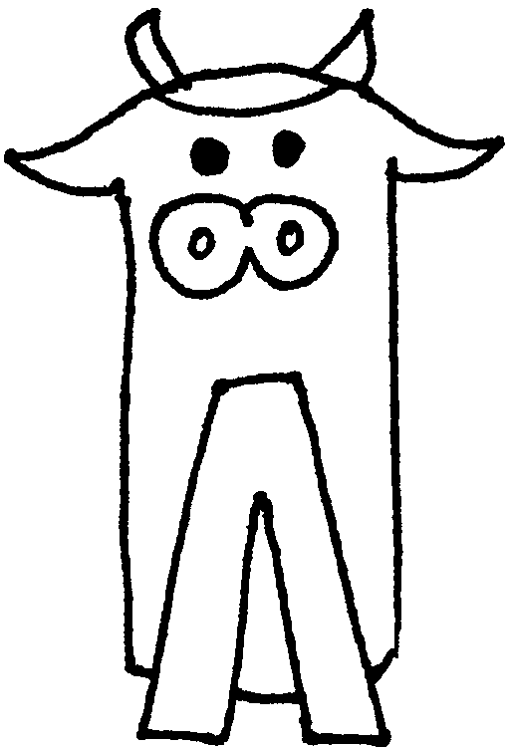
Johnny John Paul Babe
Appleseed Henry Bunyan
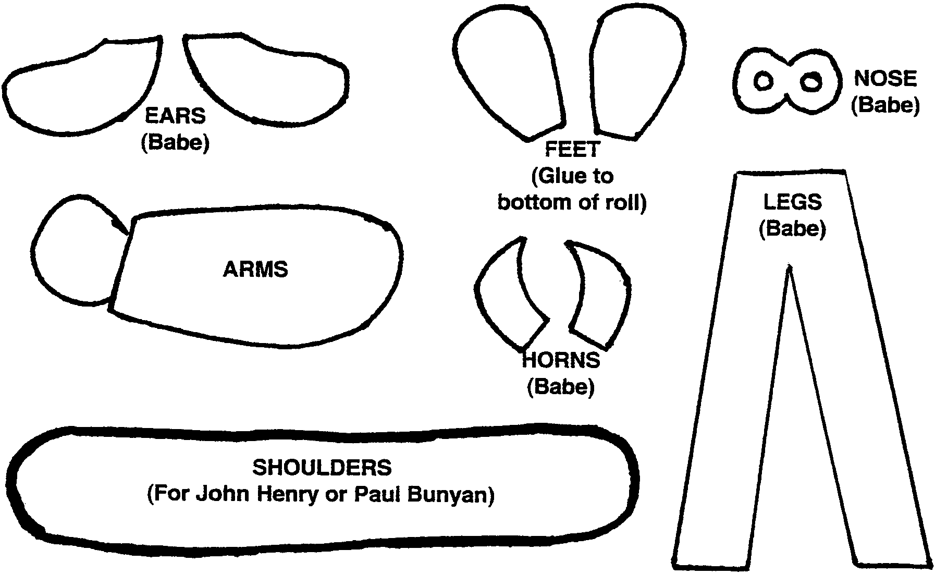

THANK YOU PIN

Glue a Cub Scout decal or other symbol of Cub Scouting on a square of balsa wood. The wood piece should be larger than the decal. Write a message on border with fine marker or wood burning pen. Glue a pin-back on the back. Give to parents who have been helpful.

Each Scout can make these for their parents and give them as a thank you at the last meeting of the Scouting year or any other time.
HELPING HAND SOAP DISH

You will need: Fist size piece of oven-baking clay (Fimo, Sculpie, Friendly Clay, etc.); Wax paper.
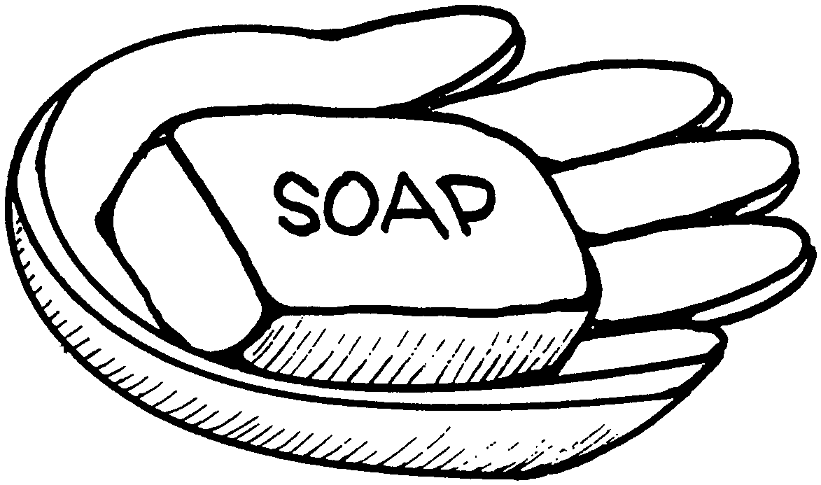

1. Cover your working surface with wax paper.
2. Manipulate clay until it is pliable. Flatten it until it is approximately 1/4" thick.
3. Place your hand on the clay, fingers together, and trace around it with a pencil.
4. Cut out the hand shape with a knife and peel the clay carefully from the wax paper.
5. Place on a cookie sheet. Turn up the edges of the hand so it can hold soap.
6. Bake as directed on the package.

APPLE AND WORM NECKERCHIEF SLIDE

You will need: Large round wooden beads (large ones usually come unpainted, a few to a bag); Red paint; Knife or small hand drill; 2 small wiggle eyes; Green pipe cleaner; Green felt scrap; Glue.
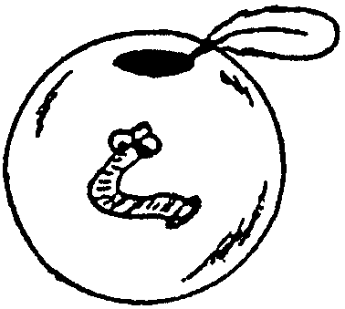

1. If hole in the bead is not large enough for neckerchief to fit through, enlarge hole.
2. Paint the bead red.
3. Make a small hole on one side to hold a green pipe cleaner worm. (Be careful, making a hole on a round surface is not easy.)
4. Glue tiny eyes on worm. Glue worm on the bead. (If the pipe cleaner is too small to glue the eyes, combine two pieces to make a fat worm.)
5. Add a green felt leaf near the top of the apple.

COONSKIN CAP NECKERCHIEF SLIDE


Use 3/4” strip of tan fake fur, glue around suitable tie slide material (cardboard circle, PVC pipe). Use glue gun or tacky glue. Cut a tail out of fur. With a black permanent marker, make stripes on hat and tail. Glue tail to hat.

BIG FOOT NECKERCHIEF SLIDE
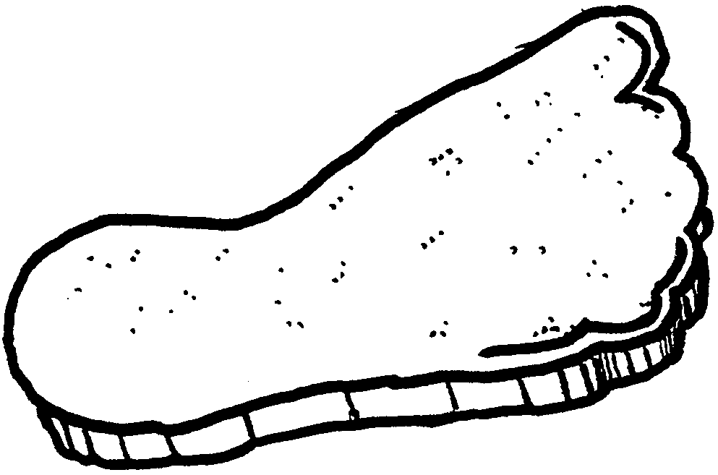
Cut out footprint shape from meat tray. Glue to a piece of 1/2" PVC pipe.

APPLE CRISP

2 medium tart cooking apples, pared and sliced (about 2 cups)
2 Tbsp water
3 Tbsp all-purpose flour
2 Tbsp sugar
2 Tbsp margarine, softened
1/4 tsp ground cinnamon

1. Preheat the oven to 350.
2. Divide the apple slices between two 10-ounce custard cups. Sprinkle water over apple slices.
3. Mix flour, sugar, margarine and cinnamon with a fork until crumbly. Sprinkle over apples.
4. Bake uncovered until the topping is light golden brown and apples are tender, 25 to 30 minutes.

Makes 2 servings.

BUTTERSCOTCH APPLE CRISP: Stir 1 tablespoon of butterscotch-flavored chips into the crumbly mixture.

APPLE RING SNACKS

2 apples
3-oz pkg. cream cheese
1 1/2 tsp honey
2 Tbsp chopped walnuts
2 Tbsp raisins

1. Wash apples and remove cores, but don’t peel.
2. Mix cream cheese in bowl until smooth. Add honey and mix well.
3. Stir in raisins and walnuts.
4. Fill apple cavities with cream cheese mixture. Cut into rings.
5. Enjoy! (You can also fill with peanut butter or try other fillings.)

FRUIT GULP

1 ripe banana
1/2 cup chopped fresh fruit or drained canned fruit, chopped
1 cup fruit flavored yogurt
1/2 cup fruit juice

1. Cut the banana into chunks. If other fruit pieces are large, cut into chunks.
2. Measure the fruit, yogurt, and juice and place in the blender. Blend for about 5 seconds. If there are still chunks, blend for another 5 seconds.
3. Pour into 2 glasses.

Makes 2 large drinks.

BANANA S’MORES

The banana skin becomes the bowl you serve it in!

6 bananas
6 Tbsp semisweet chocolate chips
1 cup miniature marshmallows

1. Preheat the oven to 400.
2. Slit each banana skin on the inside curve with a sharp knife, taking care not to cut the banana. Use your hands to loosen the skin slightly, but keep the ends together.
3. For each banana, tuck 1 tablespoon of chips and some of the marshmallows along the sides between the fruit and the skin. Push the skin together--it won’t close completely-- and wrap the banana tightly in aluminum foil.
4. Bake on a cookie sheet for 10 minutes.
5. Take the cookie sheet out, let the bananas cool for a few minutes. Open the foil carefully (watch out for a hot burst of steam).
6. Eat the bananas out of the skin with a spoon.

FUNNY FACES

See who can make the funniest or most realistic face!

Toppings: Pickle slices, shredded cheese, alfalfa sprouts, scallions (trimmed and cut lengthwise), mushroom slices, red and green pepper strips, carrots cut into rounds, radish slices, olive slices, tomato wedges, etc., (choose items that your Scouts will probably eat)
2 cans tuna fish packed in water
Mayonnaise (to taste, about 2 Tbsp)
1/2 lemon, seeds removed
6 bread slices

1. Put each topping in a small bowl.
2. Make the tuna salad. Place the drained tuna in a mixing bowl and flake it with a fork into small pieces. Add mayonnaise to taste, then squeeze in the juice from the lemon. Mix.
3. Place a rounded scoop of tuna on each slice of bread and serve one to each person. Use a spoon to flatten the tuna into a circle.
4. Let each boy create a face using cheese, scallions, or sprouts for hair or beards; pickle slices or mushroom slices for ears; radish, carrot, or olive slices for eyes; and red peppers or tomatoes for a mouth.

Makes 6 faces.

