Miscellaneous

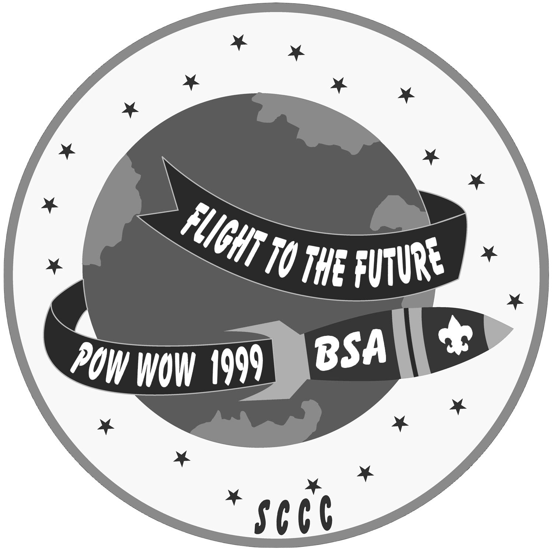
JUNGLE BOOK AWARD
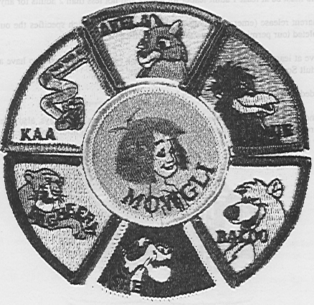
How about earning the Jungle Book Award? This award has been developed by Old Baldy Council to assist Cub Leaders in promoting outdoor programs and summertime activities. The award consists of a 2” center patch with six surrounding segments. The Jungle Book Award may be earned by den chiefs and adult leaders who participate in the outings as well. The award is available at the South Bay Scout Shop at 970 West Julian St., San Jose. (Please note that only one award may be earned for each outing.)

Requirements:
THE MOWGLI AWARD: (2” Center Patch)
This award MUST be earned prior to earning any of the individual segments.
1. Study the stories of The Jungle Book by Rudyard Kipling and by Disney. Answer the following questions:
a. Who was Mowgli?
b. Who was Akela?
c. Who spoke for Mowgli to join the wolf pack?
d. Who taught Mowgli the “Law of the Jungle?”
e. What did Kaa do to help Mowgli?
f. What was the “Red Flower?” Why did Mowgli use it?

AKELA SEGMENT: (May be earned as a WOLF, BEAR, or WEBELOS.)
1. Participate in a den or pack outing to a local zoo or nature center and observe one of the animals represented by a character from the Jungle Book stories. Draw a picture of the animal OR describe the following:
(a) Animal’s features; (b) Native habitat; and (c) Foods the animal eats
2. Complete two requirements toward an arrow point elective or Webelos activity badge on animal or family topics.

KAA SEGMENT: (May be earned as a WOLF, BEAR, or WEBELOS)
1. Participate in a den , pack, or council outdoor or summertime activity OR earn one the following Cub Adventure Awards*:
(a) Cub Ranger; (b) Firebird Trail**; (c) Vasquez Rock-Geologic Hike**; (d) Big Sycamore Canyon**
2. Complete two requirements toward an arrow point elective or Webelos activity badge related to outdoor topics.

BALOO SEGMENT: (May only be earned while a BEAR or WEBELOS.)
1. Participate in a den, pack or council outdoor or summertime activity OR earn one of the following awards*:
(a) Cub Scout World Conservation Award (for requirements, see Webelos book, p. 397, or the April Theme Related section of this book.); (b) Whale Watcher** OR Whale Award**; (c) Grunion Run**
2. Complete two requirements towards an arrow point elective or activity badge on a nature or conservation topic.

KING LOUIE SEGMENT: (May only be earned while a BEAR or WEBELOS.)
1. Participate in a den, pack or council outdoor or summertime activity OR earn one of the following awards:
(a) Home Town Historic Sites; (b) Historic Cycling Tour**; (c) El Camino Real**; (d) Owl Town Heritage**; (e) Los Fierros**
2. Complete any two requirements towards an arrow point elective or activity badge on games or sports topics OR earn a Cub Sports Award.

BAGHEERA SEGMENT: (May only be earned as a WEBELOS.)
1. Participate in a Webelos den or council outdoor or summertime activity OR earn one of the following awards:
(a) Webelos 5-mile Hiker; (b) Mormon Battalion Trail**; (c) Webelos cycling 25-km; (d) Penguin Club**
2. Earn the Readyman activity badge, AND
3. Complete ONE of the following activity badges:
(a) Athlete; (b) Fitness; (c) Sportsman; (d) Aquanaut

SHERE KAHN SEGMENT: (May only be earned as a WEBELOS.)
1. Participate in a den, pack, council outdoor or summertime activity OR earn one of the following awards:
(a) Webelos Scout Hiker; (b) Webelos Under the Stars; (c) Webelos Overnight; (d) Scout-Webelos Weekend; (e) Webelos Trail Maintenance
2. Complete any two of the following activity badges:
(a) Forester; (b) Outdoorsman; (c) Naturalist; (d) Geologist
3. Earn or have earned the Readyman activity badge.

* These are awards offered by other councils. For the requirements for these, refer to the Cub Adventure Award booklet available at the Scout Shop. Those marked with ** must be earned at specific locations outside our area.

