California Gold Rush

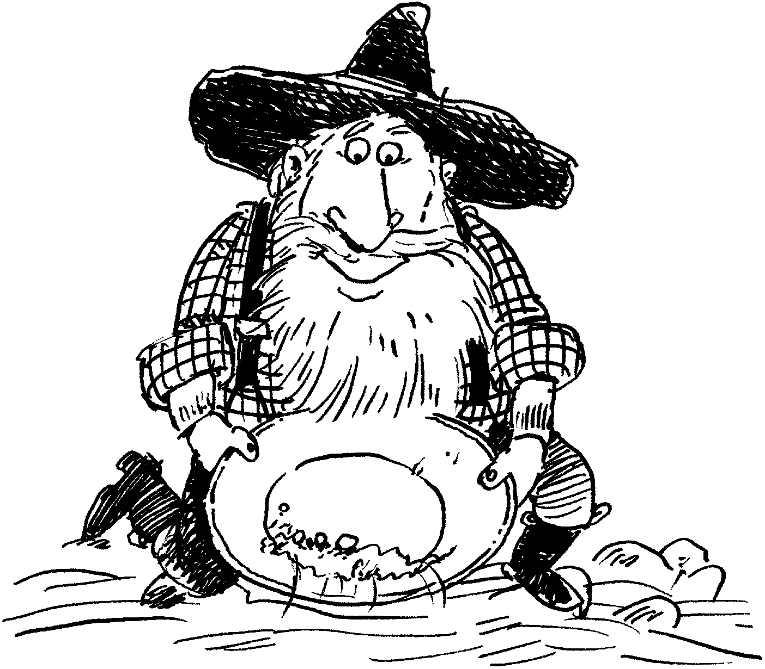

OCTOBER 1999

DEN PACK ACTIVITIES
PACK GOLD RUSH DAY
Have each den adopt a mining town name. Many towns and mining camps in California’s Gold Country had colorful names. There were places called Sorefinger, Flea Valley, Poverty Flat (which was near Rich Gulch), Skunk Gulch, and Rattlesnake Diggings. Boys in each den can come up with an outrageous name for their den! They can make up a story behind the name. Have a competition between mining camps. Give gold nuggets (gold-painted rocks) as prizes. Carry prize in a nugget pouch (see Crafts section). For possible games, please see the Games section. Sing some Gold Rush songs (see Songs section). As a treat serve Cheese Puff “gold nuggets” or try some of the recipes in the Cubs in the Kitchen section.

For more suggestions see “Gold Rush” in the Cub Scout Leader How-to Book, pp. 9-21 to 9-23.

FIELD TRIPS--Please see the Theme Related section in July.

GOLD RUSH AND HALLOWEEN
How about combining these two as a part of a den meeting? Spin a tale about a haunted mine or a ghost town.

CALIFORNIA GOLD RUSH
James Marshall worked for John Augustus Sutter on building a sawmill on the South Fork of the American River near the area which is now the town of Coloma. On January 24, 1848, he was inspecting a millrace or canal for the sawmill. There he spotted a glittering yellow pebble, no bigger than his thumbnail. Gold, thought Marshall, or maybe iron pyrite, which looks like gold but is more brittle. He struck the metal with a hammer. It flattened but did not break--a good sign. But Marshall was a busy man. He stuck the pebble in his hat and went back to work. Later, he rode to Sutter’s Fort to see his boss. Sutter and Marshall carefully examined the rock. They bit it to see if it was soft like gold. It was. The dabbed it with acid to see if its shine would dim. It didn’t. Then they weighed it against silver and other things they knew were lighter than gold. The rock passed every test. It was gold all right! (Amazingly, this small piece of gold that changed the history of California and lives of so many people survived and is now kept at the Smithsonian!)

Peak Gold Rush years were from 1849 to 1852. The forty-niners came to California by sea, by land, and by land and sea, from other parts of American and the world.

The sea route was the favorite of gold seekers. The 15,000 mile voyage, around Cape Horn, took from four to eight months or longer. (See “The Banks of the Sacramento” in the Songs section.)

People from the Midwest favored the land route to California. From Missouri the trip was 1,800 miles by wagon train. Travelers carried weapons to defend themselves from rattlesnakes, grizzly bears and Indians but more men were killed by accidents with guns than by any run-ins they had along the trail. The big killer on the trail was cholera.
CALIFORNIA GOLD RUSH (continued)

The third group took a boat to Panama, trekked across Panama, and took another boat to California. The sea trips held few dangers because they were brief, but the sixty-mile journey through the jungle was hot and filled with mosquitoes that carried malaria.

A conservative estimate of the population in California in 1850 was 125,000. About 8 out of every 10 of these Californians arrived during the Gold Rush!

Only a few forty-niners made a fortune, but the merchants who sold goods to miners at high prices did well. San Francisco, the port where many people entered California, mushroomed into a sizable city. Early in the Gold Rush Sam Brannan bought all of the available gold pans in San Francisco for 20 cents each and later sold them for between $8 and $16 in gold. His store at Sutter’s Fort made a whopping $35,000 in the first four months of the Gold Rush! (Brannan died a poor man.)

Marshall’s gold was not the first in California. The first piece of gold in California was found in March, 1842. A ranch hand named Francisco Lopez y Arballo was eating his lunch under a large oak tree (now called “The Oak of the Golden Dream”) in Placerita Canyon near Newhall. He used his knife to dig up a wild onion to eat and found gold nuggets attached to the onion’s roots! The California Gold Rush did not start until six years later when a larger gold discovery was made.

It is believed that only 10 % of California’s gold has been dug out. 90% remains to be found.

How much gold has been discovered? Not very much, when you consider how many people have tried to find this precious metal. Since the beginning of history, the entire world’s production would probably fill an American football field (300 feet x 600 feet) to a depth of only 2.6 feet.

Pure gold is one of the softest metals and the easiest metal to work into different shapes. A single ounce of gold can be drawn into a wire more than 40 miles long. Purity of gold is measured by karat. Pure gold is 24 karat. 12 karat gold is 50% pure gold.

Which is heavier, a pound of bread or a pound of gold? A pound of bread is heavier than a pound of gold! Bread is measured by avoirdupois weight, which is 7,000 grains per pound. Gold is measured by troy weight, which is 5,760 grains per pound. (A grain is a unit of measure smaller than an “ounce.” A grain in the avoirdupois system is the same as a grain in the troy system.)

Find gold on the Internet. For information on the California Gold Rush, connect to: www.calgoldrush.com

FIND GOLD NUGGETS OF SCOUTING AT THE ROUNDTABLE

STATE OF CALIFORNIA
ADMISSIONS DAY September 9, 1850. California was the 31st state in the United States.
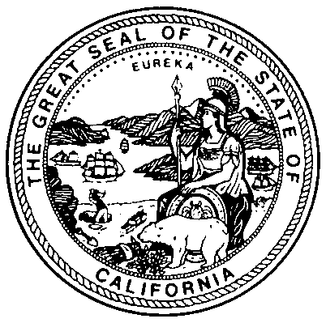STATE SEAL ”The Great Seal of the State of California” contains the State Motto “Eureka,” which is a Greek word meaning, “I have found it.” It also contains the Roman Goddess Minerva, a grizzly bear, a gold miner, wheat and grapes, a bay with ships, and 31 stars.
STATE NICKNAME The Golden State
STATE COLORS Blue and gold
STATE SONG ”I Love You, California”
STATE TREE California Redwood
STATE FLOWER Golden Poppy
STATE BIRD California Valley Quail
STATE ANIMAL Grizzly Bear (There are no more grizzly bears in California but they still live in other parts of the United States and Canada)
STATE MARINE MAMMAL California Gray Whales
STATE FISH California Golden Trout
STATE REPTILE Desert Tortoise
STATE INSECT Dogface Butterfly
STATE FOSSIL Saber-toothed Cat (Lived more than 10,000 years ago.)
STATE MINERAL Gold
STATE GEM Benitoite
STATE ROCK Serpentine (a shiny blue-green rock)
STATE PREHISTORIC ARTIFACT The chipped Stone bear (our newest state emblem the bear was chipped from a stone by a Native American 7,000 to 8,000 years ago)

WHO AM I?

I am a native of California. To find out who I am, finish the patterns below and unscramble the letters on the right.

A B C A B C A B C __
U I I I U I I I U __
G G B B G G B B G __
M M M M N M M M M __
S C O U T S C O U __

L M N O P Q R S T __
A I O U E A I O U __
B B B A A B B B A __
S O S S O S S O S __
X W V U T S R Q P __
Q R S Q R S Q R S __
F C A L I F C A L __

Answer: __ __ __ __ __ __ __ __ __ __ __ __
GOLD RUSH CHEERS:

"Yor are a gold Nugget!"

"Gold Gold it's worth gold!"

"There's gold in them thar Hills!"

AS GOOD AS GOLD CROSSWORD PUZZLE
Across
1. Another name for the mineral pyrite is _____ _____.
4. The “sickness” caught by people on a rush for gold is called GOLD _____.
5. An athlete at the Olympics can win a GOLD _____.
7. The entrance to the bay near the city named in the puzzle is called the GOLDEN _____.
9. An older name for the city named in the puzzle is _____ BUENA.
10. In a famous tale from Greek mythology, everything KING _____ touched turned to gold.
12. California’s official state flower is the GOLDEN _____.
13. The full name of the man who hired the man in #15 Across is JOHN _____ SUTTER.
14. The place where the man in #13 Across lived when gold was discovered is called SUTTER’S _____.
15. The man who is credited with finding the gold near Sutter’s mill was _____ MARSHALL.
16. In Greek mythology, the hero Jason led the Argonauts on a quest for the GOLDEN _____.
17. According to an old legend, at the end of a rainbow is a _____ OF GOLD.
18. The location at the tip of South America that many Gold Rush ships passed on their way to California is called CAPE _____.
19. The real name of author Mark Twain was SAMUEL _____.
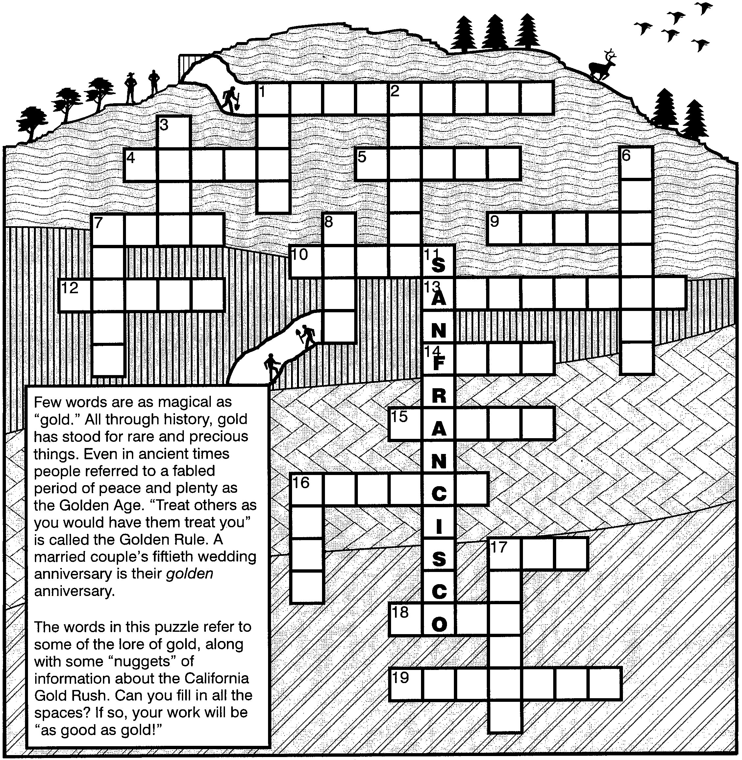Down
1. The man named in #15 Across discovered gold near the SOUTH _____ of the American River.
2. The mountain range where much of the Gold Rush took place is called the _____ NEVADA.
3. Gold seekers who took the overland route to California headed _____.
6. A famous bandit of Gold rush days was named _____ MURRIETA.
7. In an old fable, golden eggs were laid by a _____.
8. The name of Sir Francis Drake’s ship was the GOLDEN _____.
11. The northern California village that became a famous city almost overnight during the Gold rush is known as ___ _______.
16. The gold trout is California’s state _____.
17. The Central American country that many gold seekers crossed to get from the Caribbean sea to the Pacific Ocean is called _____.

Puzzle solution found on page 10
CALIFORNIA OPENING

C is for the community of Cub Scouting
A is for Akela who leads us on the Cub Scouting trail
L is for loyalty to country and family
I is for ideals, the people we admire and imitate
F is for fun at our den meetings and pack meetings
O is for obedience to the Law of the Pack
R is for real service and respect for others
N is for neighborhoods of friends and nature
I is for inviting our pals to join our pack
A is for all of us making our state a better place to be

GOLD RUSH IN CUB SCOUTING OPENING

G is for gathering of friends and families
O is for outstanding objectives of the program
L is for learning that lasts your lifetime.
D is for dreams that will come true with diligent work.

R is for responsibility to do what is right
U is for the understanding of others we develop
S is for soaring of spirit and strength of character
H is for happiness and sense of humor

That’s GOLD RUSH in Cub Scouting.
Let’s find our gold!

GOLD RUSH OPENING

Welcome to the pack meeting. This month we learned about the California Gold Rush.

Coloma is where it all started in 1848. Then they found gold in Columbia, Murphy, Grass Valley, Bear Valley, Angel Camp, Chinese Camp, Coulterville, Downieville, Placerville and many other places along the Mother Lode. Gold Rush towns sprang up quickly and died quickly when there was no more gold.

But there’s one place where gold will always be found, where golden opportunity and the Mother Lode of Fun never dries up.

That’s our pack _____! So let’s have fun at tonight’s meeting!

GOLD IN CUB SCOUTING
Gold is one of the Cub Scout colors, color of warm sunlight, good cheer and happiness
Gold is Golden opportunity the program provides for the boys and families
Gold is Golden Rule we practice--Treat others as you would have them treat you
Gold is Golden Age of childhood we spend in Cub Scouting
Gold is Gold mine of Fun and Fellowship in Cub Scouting
Gold is the Heart of Gold we see in our leaders

GOOD NIGHT
C.S. #1: Thank you for coming to our Gold Rush party
C.S. #2: Aren’t you glad that you weren’t tardy?
C.S. #3: We’ve played some games and had great fun.
C.S. #4: Gold was found by everyone.
C.S. #5: We’ve advanced in rank and received our awards
C.S. #6: From Bobcat to Webelos--our golden reward.
C.S. #7: Now as you go on your way tonight,
C.S. #8: Remember, Pack _____ is out of sight!
ALL: Good night, everyone, see you next month!

HARD WORK CLOSING
Gold mining was a very hard work. Miners just didn’t go to the hill and dig up gold. Very often they spent days or weeks with little result. They worked from dawn to dusk, six or even seven days a week. For hours at a time they waded in cold, snow-fed streams, or attacked the hard ground with digging tools. In heat and cold they prospected in steep, rocky canyons and along the rugged ridges of the Sierra foothills. Sunday was the day of rest for many miners. Then they washed clothes in the river, baked bread, bought their supplies and relaxed.

To find something good, you have to work hard and keep trying. Don’t give up.

GOLD IN YOURSELF
Gold prospectors dug for gold in the hills. They may or may not have found gold in “them thar hills” no matter how hard they worked. But there’s another kind of gold that you will always find with hard work. That’s gold in yourself--kindness, love, understanding and consideration. Just like the gold in the hills, this gold shines inside you. Search for gold nuggets in yourself.

GOLD RUSH: Divide the group into two. First group says, "Gold! gold!," , and the second group says "Eureka!" Leader’s left hand controls volume and right hand controls which section.

GOLD NUGGETS IN CUB SCOUTING

Tonight we played Gold Rush games and had fun panning for gold. There are gold nuggets in Cub Scouting too.
Parents and leaders, let’s not forget that our Cub Scouts are our gold nuggets.
Cub Scouts, each thing you learn and each award you earn are your gold nuggets. Each accomplishment you make and each Good Turn you do will add to your wealth. We hope you will find riches greater than what any of the miners ever found!

FUN WAYS TO SAY THANK YOU

Candle: For the person who really lights up (mount small candle on base)
Gold Candy Coins: “You’re worth your weight in gold”
For the treasurer or fund raiser
Golden Egg (spray an Easter egg): For someone who comes through
For someone who doesn’t crack under pressure
“Thanks for being a good egg and doing an eggceptional job”
Golden knot (use rope and spray gold): For someone who kept everyone together on a field trip
Golden Pen: For the committee secretary who takes all the notes at meetings.
Weight in gold (Draw a balance scale, glue a picture of the person on one side and glitter on the other side): “You are worth your weight in gold”
Broom: For the person who sweeps all the mistakes away
Skeleton: “Thanks for working yourself to the bone for us

BOBCAT PROSPECTORS

Arrangements: Bobcat badge recipients and families are standing in front with Cubmaster.

We have here tonight Bobcat badge prospectors. Like gold prospectors of old, they have worked very hard digging and panning for the Bobcat badge.

They first went to the Cub Scout Hills and dug out a nugget called Promise. It was such a big promise but they did not have any problem carrying it out.

While in the hills they learned to salute in a Cub Scout way.

Then they followed the Cub Scout sign to the Webelos Stream and learned the meaning of the word Webelos. In the stream they panned for the Law of the Pack. It was not easy for they had to memorize and also understand the meaning of the Law. While they were doing this, they learned what it meant to do their best, which is the Cub Scout Motto.

I am proud to introduce our new Bobcats and their families. Please notice, unlike the gold prospectors, these Bobcats look clean and neat in their uniform!

“WORTH OF A BADGE” ADVANCEMENT
Equipment: Assayer’s scale (see below) and “nuggets” of gold-painted pebbles.

(Call forward the award recipients and their parents.)
Here’s a scale and some gold nuggets. And here are the badges to be awarded tonight. Let’s see what these badges you Cub Scouts have earned are worth in gold. (Put all badges to be awarded in one pan of the scale, then balance it with “nuggets” in the other. Try ahead of time to see how many “nuggets” you’d need to balance the scale.)

It didn’t take much gold to balance the badges, did it? Does that mean the badges aren’t worth much? Yes and no.

Yes, because it’s true that these badges are just small pieces of embroidered cloth. They don’t cost much in money.

But that does not mean they don’t have great value. These badges represent the work you have all done to advance on the Cub Scouting trail and the help your parents have given you. That work and the love and concern your parents have shown, are beyond price.
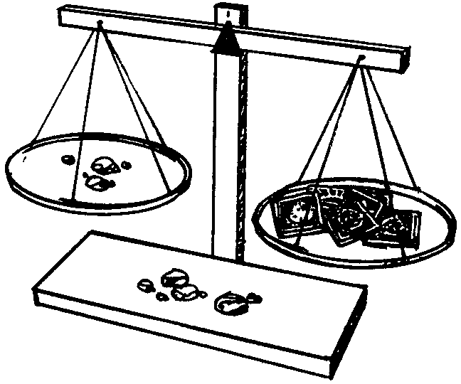So it is a pleasure to present your award tonight. (Present badges to parents to pin on son’s uniform shirt.)

Wear your badges with pride. Remember they are symbols of something priceless, beyond the price of gold. Congratulations.

ASSAYER’S SCALES
Ask parents if they have a scale at home. How about a toy scale? If not, make your own. Make from scrap wood. Pans are coffee can tops suspended with string. Use cardboard triangle for pivot.

GOLD RUSH AND CALIFORNIA ADVANCEMENT IDEAS
Cubmaster is dressed as a prospector and goes looking for the gold in “Them thar hills.” Awards are hidden in the room. Say something like, “These awards were not just found but earned with hard work.”

Attach awards to gold pans (pie tins), one for each boy. Cubmaster digs for gold in a pretend stream. Say something like, “The gold we are looking for is worth more than money. This gold had to be earned. Get ready to strike it rich!”

Attach awards to California emblems that are symbols of magnificence or strength, like Redwood, Grizzly Bear and Gray Whale.

How many Cub Scouts are there in your pack? Happen to make 31? Including leaders? You can be the 31 stars on the state seal!

For Bobcat ceremonies see Staging Den and Pack ceremonies, pp. 64-71.
CHAMPION JUMPING FROG OF CALAVERAS COUNTY
Owner: “I’m so proud”
Frog: “Ribbit, ribbit”
Stranger: “I’m just visiting”

Sometime around 1849 or 1850, a resident of Calaveras County had himself a pet FROG. Now, this wasn’t just any ordinary FROG. The OWNER had spent countless hours training it to jump farther than any other FROG. The FROG even did somersaults and jumped high in the air to catch flies!

Being mighty proud of his FROG, the OWNER sometimes carried it with him in a small box. One day a STRANGER became curious about what was in the box. The OWNER promptly displayed his FROG and bragged that it was a champion jumper. Why, the OWNER would even bet anyone that his FROG would outjump any other FROG in Calaveras County!

The STRANGER said if only he had a FROG of his own, he might be willing to bet. The OWNER said he would gladly fetch him a suitable jumper. The OWNER left this pet FROG with the STRANGER and went to a nearby swamp to find a worthy opponent.

While the OWNER was gone, the STRANGER began having second thoughts about the bet. The STRANGER didn’t want to back out, but he didn’t want to lose his money, either! Then he had an idea. Making sure no one was looking, the STRANGER picked up the FROG, opened its mouth, and poured in some bird shot (tiny balls of lead used as ammunition). Now the FROG was weighed down!

Soon the OWNER was back with a second FROG, and the contest was ready to begin. Each man gave his jumper a pep talk and a pat on the head for good luck. With a gentle nudge to get the FROGS hopping, the OWNER and the STRANGER settled back and hoped for the best.

Well, you can imagine what happened. The STRANGER’S FROG happily jumped away, while the OWNER’S FROG squatted meekly on the ground, looking fat and foolish

Stunned by his defeat, the disheartened OWNER paid the STRANGER. After watching the STRANGER saunter off, the OWNER turned to his FROG, which still hadn’t moved an inch. For the first time he realized how full his pet looked. Stooping to pick it up, the OWNER gasped at how much the FROG weighed! With a frown, he turned his FROG upside down to see what was going on. Just then the weighed-down beast gave a noisy belch. Out of its mouth came a bellyful of bird shot!

Oh, but the man was furious! Putting his pet down, he raced off to find the STRANGER. But the STRANGER was nowhere to be found.

(This story was the basis of the Famous “The Celebrated Jumping Frog of Calaveras County” by Mark Twain. Twain was staying in Angels Camp in the 1860s. From Tales and Treasures of the California Gold Rush by Randall A. Reinstedt.)

Have a den frog jumping contest. See the Craft section.
THE GOLD MINER

Miner: “There’s gold in them thar hills!” or “Where’s the gold?”
Gold: “Eureka!”

There once was a GOLD MINER. He was a tired MINER who had been prospecting for GOLD for months without much luck. So one day the MINER sat on the rock all depressed.

He was not always a tired MINER. He used to be full of energy and hope. The MINER heard about the GOLD in California and wanted to strike it rich himself. The MINER spent half of his money to buy a ticket on a ship to come to California to find GOLD. It didn’t matter that the MINER didn’t have much money left. He was going to find GOLD and be rich. It didn’t matter that he was going to be alone in California, with no family or friends. He was going to find GOLD and be rich and go home to his friends and family. So the MINER got on the ship. He was not much of a sailor and was seasick most of the time. And the food was terrible. And the bugs on the ship! The six-month voyage around the Cape Horn was long and boring and rather smelly. Just think, no bath for how long???!!! But it didn’t matter. He was going to find GOLD soon and be rich and go home. Throughout the voyage the MINER was dreaming about GOLD.

Finally the ship arrived in San Francisco. What a place--full of activities and people! The MINER spent most of his remaining money buying tools for GOLD digging and he headed for the hills.

There the MINER dug for GOLD and he panned for GOLD. He looked and looked---and looked some more for GOLD. The MINER worked for months looking for GOLD. His money was almost gone. And he was so homesick. So he sat on this rock complaining about his lack of luck in finding GOLD. A passerby heard his mumbling and suggested that he look under the rock he was sitting on. With a shrug, the MINER took the stranger’s advice and dug where he was sitting. And guess what, sure enough he found GOLD!

The moral of the story is instead of sitting around and complaining about a problem, just get off your rock and do something about it.
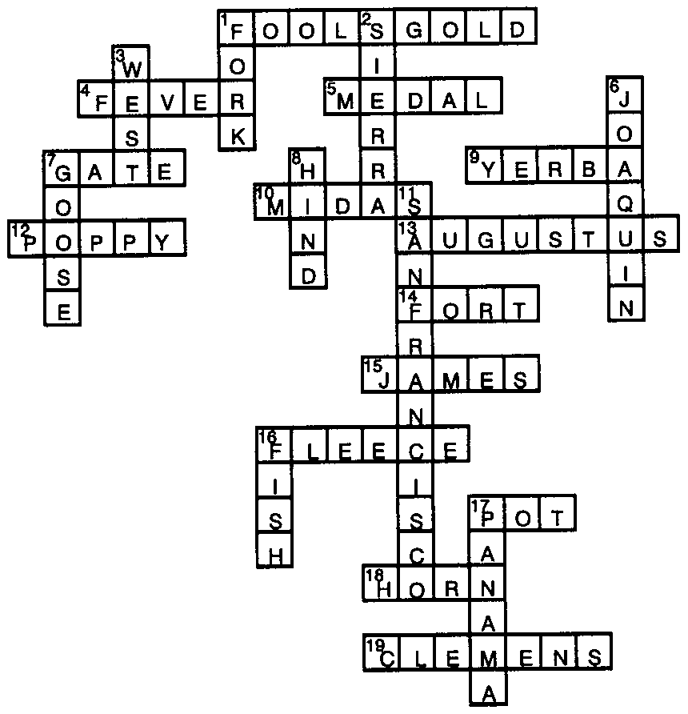 Solution to crossword puzzle on page 4

GOLD IS WHERE YOU FIND IT

Cast: Prospector and 4 sons.
Props: Pan, gold rocks, buckets, hat, shovel.
Setting: Prospector is panning for gold.

Son #1: Pa, what are you doing?
Prospector: Panning for gold.
(Son #1 walks off flipping a golden rock.)
Son #2: Pa, what are you doing?
Prospector: Panning for gold.
(Son #2 walks off carrying a hatful of gold rocks.)
Son #3: Pa, what are you doing?
Prospector: Panning for gold.
(Son #3 walks off carrying a bucket full of gold rocks.)
Son #4: Pa, what are you doing?
Prospector: Panning for gold.
Son #4: What is gold?
Prospector: It’s a precious ore that will make us rich.
Son #4: What does it look like?
Prospector: It’s a shiny yellow stone.
Son #4: Oh! Like those that my brothers are using to build their dam downstream?
(Prospector screams and swoons. Son #4 walks off with shovel.)

RUN-ONS

What is the difference between a forty-niner and a meat eater?
One stakes a claim. The other claims a steak.

Gold Miner #1: I’m giving up this work.
Gold Miner #2: Why? You can do it!
Gold Miner #1: Not anymore. It’s all in vein.
Gold Miner #2: Guess you’re disappointed it didn’t pan out.
Gold Miner #1: I just don’t want to strain myself any longer.
Gold Miner #2: What about all the gold that remains?
Gold Miner #1: Oh, never mined.

Cub 1: What tool do you bring to a gold rush?
Cub 2: Take your pick.

Cub 1: What was the forty-niners’ mascot?
Cub 2: A mynah bird.

Cub 1: What did the gold miner say when he staked out his property?
Cub 2: Be mine.

Cub 1: Why did monsters come to California?
Cub 2: It was the ghoul rush.

ARE WE THERE YET?

Cast: Dad, Grandpa, 4 boys
Setting: In the wagon (line up chairs) on the way to California.

Boy #1: Dad, are we there yet?
Dad: You just asked me that a while ago. No we are not there yet.
Boy #2: How much longer, Grandpa?
GP: Oh, about 1,243 miles more.
Boy #3: Last time we asked it was 1,244 miles...so that means...
Boy #4: We’ve come one whole mile!
Dad: Boys, a big rock ahead. Ready for a bump.
(Boys hang on and all go “bump.”)
Boy #1: I wonder if we are almost there yet.
Boy #2: I don’t think so. Dad said we have to be on this wagon for weeks.
Boy #3: But we HAVE been here for weeks.
GP: Boys, there’s a big dip ahead of us. Be ready.
(Boys hang on and all go “dip.”)
Boy #1: Well, I still want to know if we are there yet.
Boy #4: Then ask.
Boy #1: I asked him last time.
Boy #3: You ask.
Boy #4: OK. Dad, are we there yet?
Dad: NO, NOT YET.
All Boys: Well, how much longer?
GP: Not for a long long time. We’ll have to go beyond that hill and a big river beyond that and a mountain range beyond that and...
Boy #2: I’ll be so old by the time we get to California.
Boy #3: All my life spent on this wagon.
Boy #4: Getting dusty.
Boy #1: And nothing for us to do.
Dad: You could count trees.
Boy #2: We went up to 286,542.
Boy #4: I wish we brought more toys.
Boy #3: Yeah. When we get to California, I’m going to get a Nintendo.
Boy #1: Silly, Nintendo isn't invented yet.
Boy #3: Well, at the rate we're going, by the time we get there, it will be....

Knock, knock.
Who’s there?
Nugget.
Nugget who?
Nugget off. You’re bothering me.
RACE TO SUTTER’S MILL

This course can be run as a timed race by individuals, race between two teams (one round at a time), or a relay race.

START
Have one Scout as a miner with a wagon, or another Scout as a trusted pack horse instead of the wagon. For a wagon, use a red wagon.

GENERAL STORE
Load supplies (cup, rolled blanket, gold pan--strainer or pie pan with holes) on the wagon or horse.

DESERT
Drink a cup of water (and feed horse) from “spring.”

MOUNTAIN CAMP (Have a few logs ready)
1. Unload supplies. 2. Lay logs for fire. 3. Roll out bedroll. 4. Lay down. 5. Get up. 6. Roll up bedroll. 7. Scatter fire 8. Load supplies.

SUTTER’S MILL
1. Unload supplies. 2. Pan for gold (gold painted pebbles buried in the sand. Use “gold pan.”). Have miner find 2 or 3 nuggets (decide ahead of time).

ASSAYER’S OFFICE
This is the end of the race.
Weigh the gold and give scout a certificate for “authentic fake gold.”

49ERS OBSTACLE COURSE

The following tests are set up as stations and manned by adults or den chiefs who give each boy a large gold nugget (painted rock or piece of wrapped candy) if he performs the required test. (Adjust for younger boys.)

1. Climb Rope--Touch 8-foot mark.
2. Quicksand Bottom--Run over six tires, stepping in each.
3. Cross the Gulch--Swing across ladder, using hands.
4. Over the Cliff--Scale 5-foot plywood wall.
5. One Push-up.
6. One Chin-up.
7. Jump the Creek--Do a 6-foot running broad jump.
8. Dodge the Rattler--Dodge and jump 2 feet.
9. Tunnel Escape--Crawl under sticks or through cardboard boxes for 10 feet.

GOLD PANNING

Use lead weights for gold. If they are two big, crush them and paint them with gold. Mix them with sand and some rocks and put them in water (wading pool or in a large bucket). Give each boy a pie tin. Instruct them to scoop up the material from the bottom with water (no more than 2/3 full), and tilt and swish the pan vigorously so that the water and dirt make a very loose mixture of slush. Now dip the pan in and out the water and keep washing the lighter material out. This will move the gold to the bottom (heavy). THINK GOLD. When you are near the bottom, remove the pan from the water leaving a small amount of water in the pan. Swirl the material around. Do you see any gold?

GOLD PANNING CONTEST (without water)

At the pack meeting, each den puts a team of two boys on the floor. One on each team has a cup of “gold ore” (sugar). The other has a sieve and an empty can. On signal, the boys with the sugar start feeding it into the sieve held by the second boy. The can beneath catches the sugar as it “pans” through. First team to finish panning (without spilling) wins. You can also use salt that has been colored with yellow food coloring.

WHEELBARROW RACE

If you can obtain two wheelbarrows, have an obstacle race between two teams. The obstacle course includes, but is not limited to, pushing the wheelbarrows over the hill (bunch of blankets), over the railroad tracks (two dowels), and through winding trail (trail outlines marked by chalk or ropes).

If you cannot obtain wheelbarrows, how about a human wheelbarrow where one boy walks on his hands while the other boy holds his legs, one on each side?

STAGECOACH

Boys are seated in a circle, except the story teller. Each one is given the name of some part of a stagecoach--wheel, hub, axle, spoke, seat, door, harness, brake, step, horses, driver, passengers, baggage, etc. Den Chief begins telling a story about a stagecoach, bringing in different things related to the stagecoach. As each thing is mentioned, the boy (or boys) representing it gets up and runs around his chair. At some point in the story, the storyteller shouts, “Stagecoach!” Everyone must leave his seat and get a different one. The storyteller tries to get a seat in the scramble, thus leaving one of the players to begin a new story. (Or den chief continues story telling, after removing the seat he took in the scramble. The boy without a chair is out of the game.)

JUMPING THE CLAIM

You will need several inflated balloons tied to small weights. Place one balloon in the center of a 15-foot circle. One player is the “prospector,” who stands guard over his “claim” (the balloon). The other players are outside the circle. In turn, they enter it and try to burst the balloon and get back outside the circle without being tagged. A tag does not count, however, until the balloon has burst. When the claim has been “jumped,” the boy who did it becomes the new prospector with a new claim.

DONKEY RACE

Two boys straddle a broomstick, back to back. On signal, one runs forward and the other runs backward for about 50 feet. They then race back to the starting line, this time the forward runner becoming the backward runner. Several teams may compete.

GOLD!

You will need 4 hoops and 24 beanbags (sockballs). Place one hoop in each corner of a large play area like a gym or cafeteria. Put 6 beanbags in each hoop. Divide boys into 4 teams. Each team has a hoop. The boys will go to another team’s hoop and take one beanbag, bring it back to their hoop. Continue to “steal” the beanbags until time is up. No more than one bean bag on one trip. No guarding hoops.

FORTY WAYS TO GET THERE

Teams line up relay fashion. In this relay each competitor must travel in a different way. The first might run, the next hop, the next skip, the next run backward, the next jump sideways, and so on. None may travel in a way that has already been used by a teammate.

PAN TOSS

You will need 5-6 ping-pong balls, two shallow boxes (one larger size and one medium size) and an empty tuna can. Label each pan with a value--the large box=5, the medium box=10, the tuna can=25. Bounce the balls so they will hop into the pans. Score according to value indicated. (If ping-pong balls prove to be too difficult, substitute with metal washers.)

NUGGETS IN THE BAG

Den Chief puts a counted number (known only to him) of different sized rocks in a cloth draw-string bag. Each boy is given the bag for 15 seconds (he cannot open the bag), then passes it to the next boy. When all the boys have examined the bag, it is returned to the den chief. The boys write the number of rocks they guess are in the bag on a slip of paper, and the boy who is closest then takes his turn as the one who puts in a certain number of nuggets, and the game continues.

Singing and music was a major entertainment for the gold seekers on their way to California and at the mines. Popular tunes like “O, Susannah!” and “Camptown Races” were sung in many different verses. This page contains some authentic “period” songs. (except "Gold Rush")

OH CALIFORNIA
(Tune: O, Susannah!)

And all of us--have we not left
Our best of life for this?
But cheer we up! We will return
Laden with gold and bliss!
Then saddle our mules! away we go
With hopes by fancy led,
To where the Sacramento flows
Over its glittering bed!

CHORUS:
Oh California!
Thou land of glittering dreams,
Where the yellow dust and diamonds, boys,
Are found in all thy streams!

SACRAMENTO
(Tune: Camptown Races)

A bully ship and a bully crew,
Dooda, dooda,
A bully mate and a captain, too,
Dooda, dooda day

CHORUS:
Then blow ye winds hi-oh
For Californi-yo
There’s plenty of gold, so I’ve been told
On the banks of the Sacramento.

Oh around Cape Horn in the month of May,
Dooda, dooda,
Oh around Cape Horn is a very long way,
Dooda, dooda day.
CHORUS

Oh around Cape Horn in the month of snow,
Dooda, dooda,
We came to the land where the riches flow
Dooda, dooda day.
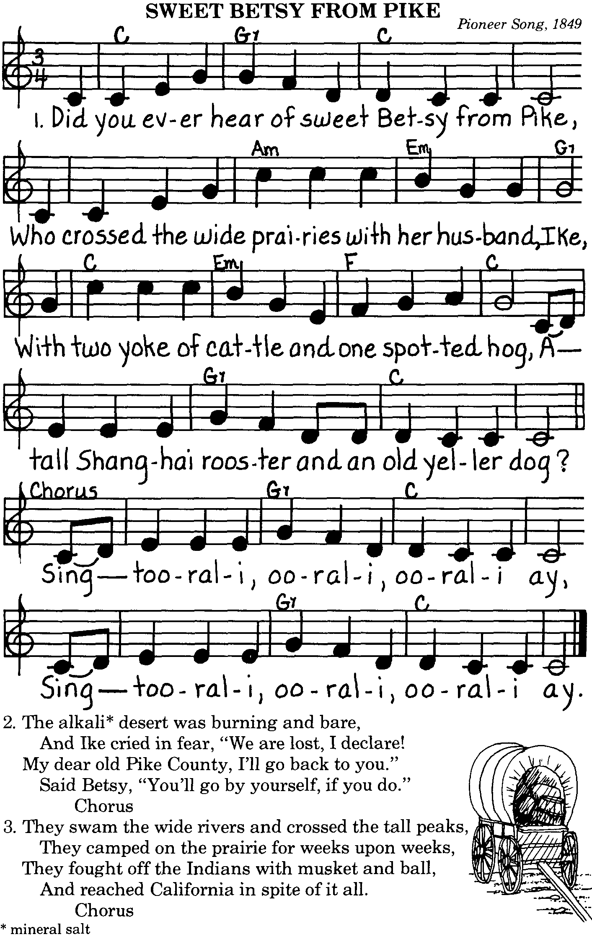

GOLD RUSH
(Tune: Yankee Doodle)

California had a gold rush
Back in forty nine
And everyone thought they could get
A share of a gold mine.

They just had to stake a claim
Didn’t matter where
Just dig and dig and work so hard
And then you’d get your share.

For some, I guess, it worked just fine
They worked and they succeeded
But others had a different time
And luck is what was needed.

Didn’t get to stake a claim
Didn’t get some nuggets
And after working, oh, so hard
They finally said “FORGET IT.”

GOIN’ TO CALIFORNIA
(Tune: 99 bottles)

I’m goin’ to California
To find myself some gold
I’ll find it in the mountains
Or so I have been told.

But if it’s in the mountains,
There’s sure to be a breeze
Will it be worth the effort
If all I do is freeze.

AN EXPERIENCE
(Tune: Row Row Row Your Boat)

In eighteen hundred forty nine
I thought I’d like a thrill
My friends all said, “Just follow me.
There’s gold in them thar hills.”

We’ll just dig a hole
With shovel and a pick
To see if what they say is true
Or if it’s just a trick.

GOLD PROSPECTORS
(Tune: Old Gray Mare)

Here we stand like
Gold prospectors,
Gold prospectors,
Gold prospectors.
Here we stand like
Gold prospectors
Freezing in the streams
Freezing in the streams
Here we stand like
Gold prospectors
Panning for the gold

(continue with your own verses)

GOLD SEEKERS’ CROSSING
(Tune: My Bonnie Lies Over the Ocean)

The gold seekers crossed the mountains
The gold seekers crossed the sea
The gold seekers crossed the praries
In search of gold in Californey.

Digging, digging
Digging for gold in them thar hills
Panny, panny
Panny for gold in stream chills.

CLEMENTINE, THE MULE
(Tune: Clementine)

In a cavern, in a canyon,
Excavating for a mine.
Was a den of trusty Cub Scouts
And their mule named Clementine.

She was stubborn, and mule headed,
Couldn’t get her in the mine.
Now she’s lost and gone forever,
We’re not sorry Clementine.

Tried to lead her, tried to feed her,
All she’d do was stand and whine.
When we pulled her by the tail is
When we lost our Clementine.

First she sea-sawed, then she hee-hawed,
Then she broke loose from the line.
To the mountains we had lost her,
We’re not sorry Clementine.

See Cub Scout Songbook for “Clementine” and “Mules”

JUMPING FROG (of Calaveras)

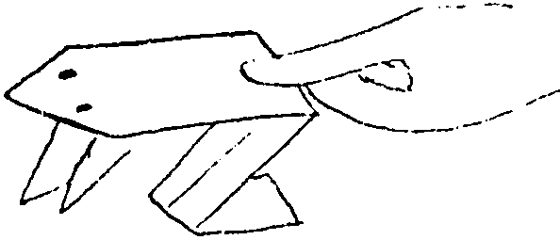The story is in the Audience Participation section. Read it with the den and have a den frog jumping contest.

You will need one 3 x 5 index card (preferably green) for each frog.

1. Fold down right top corner. Unfold.
2. Fold down left top corner. Unfold.
3. Fold backward as shown by broken line, where two previous lines meet in “X”. Unfold.
4. Turn over. Push down at the “X.” Bring sides A and B to meet in middle.
5. Turn back again. Push down top triangle and crease well.
6. Fold outer points of the top triangle up as shown.
7. Fold sides of card to the center.
8. Fold in half by bringing the bottom edge up to the top.
9. Fold down top layer in the direction of arrow. Make the top layer smaller than half.

Give the frog a pep talk then stroke back of frog to make him jump.
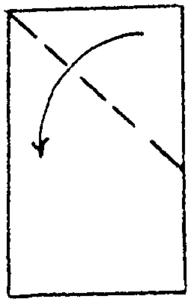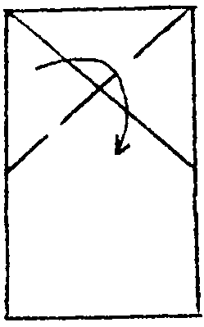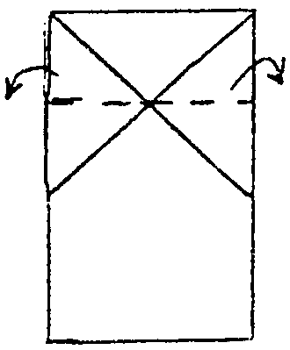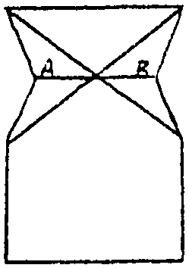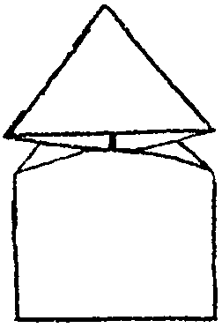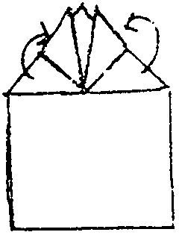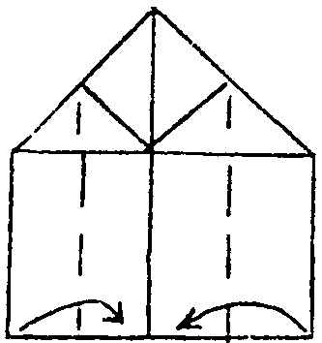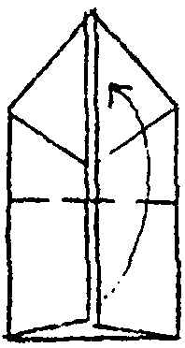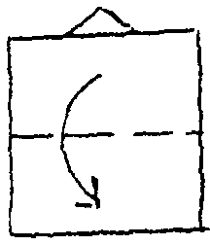

Did you know?
A Southern Cricket frog is less than 1 inch long but can jump 3 feet.
A North American leopard frog jumps more than 5 feet.

The Jumping Frog Jubilee is held in conjunction with the Calaveras County Fair during the third week of May.
DIPPED CANDLES

You will need: Paraffin wax; Candle wicks; Crayon; Newspaper; Cooking pot; Two tall tin cans (one should fit comfortably in the pot).

1. Cover the work surface with newspaper. Fill one of the cans with cold water and place it on the work surface.
2. Fill the other can about half full of water and place it in a pot. Fill the pot about half full with water and put it over a medium heat.
3. As the water in the pot and can begins to boil, add chunks of paraffin to the can until the can is nearly full. Wax is lighter than water, and as it melts it will form a layer on top of the water. This method of melting the wax is very economical for candle dipping and saves you the expense of filling the entire can with wax. Optionally, add crayon bits to color the wax.
4. When the wax is melted, take the can out to the work surface, next to the can with cold water.
5. Cut a piece of wick longer than the can height. (For younger children, tie the wick to a pencil and tell them to hold the pencil when they dip the wick in the wax.)
6. Dip the dangling wick into the can until the wick touches bottom. Pull the wick out of the can. As the wick passes through the layer of melted wax, the wax will be deposited on it.
7. Dip the wick in cold water.
8. Dip the wick alternately in wax and cold water.
9. After a few dippings the wick may need to be straightened. You can do this by hand.
10. When the candle has the thickness you want, roll on the work surface to remove uneven places. (If the candle becomes too fat and heavy, the wax may fall off the wick.)
11. Hang the candle to cool.

Note: If the wax becomes too cool and thick for dipping, reheat it.

This activity is good for only 1 or 2 boys, unless you have several cans of wax going. Have the remaining boys make a candle stand for a candle or a tin lantern (for smaller candle).

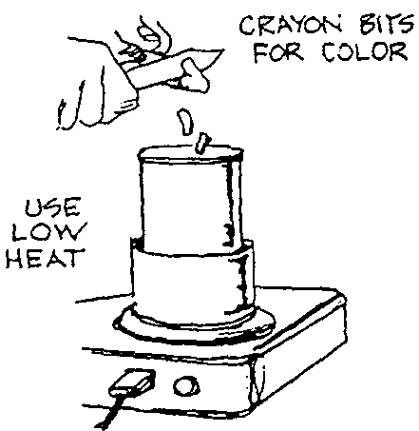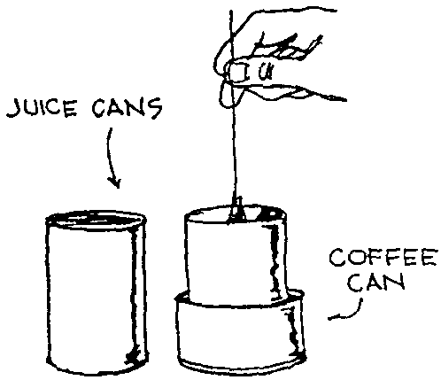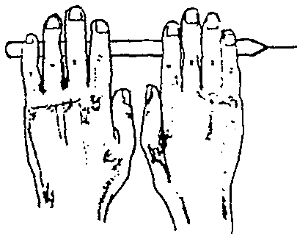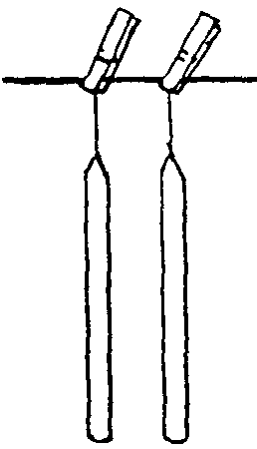

RUN-ONS

Boy 1: Which candles burn longer, blue candles or gold candles?
Boy 2: I don’t know. Which?
Boy 1: Neither. They both burn shorter!

CANDLEHOLDERS
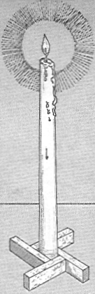
WOOD
You will need: Four 1/2" plywood pieces, 1" x 3"; Glue; Stain or paint.

Stain the wood before gluing, or paint the candleholder after the glue dries.
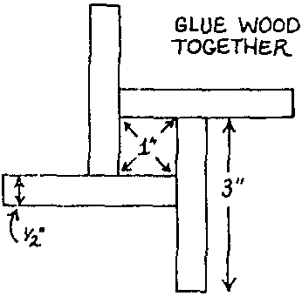
1. Sand the wood pieces.
2. Glue together as shown, leaving a 1" square opening in the center for the candle.

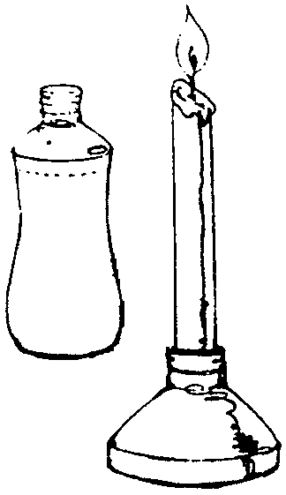If the opening for the candle is too big, wrap some rubber bands around the base of the candle to make a snug fit. If the opening is too small, shave some wax from the base of the candle.

BOTTLETOP
Cut the top from a half-gallon bleach bottle or similar bottle.
Spray paint. Decorate as desired.

TIN LANTERN
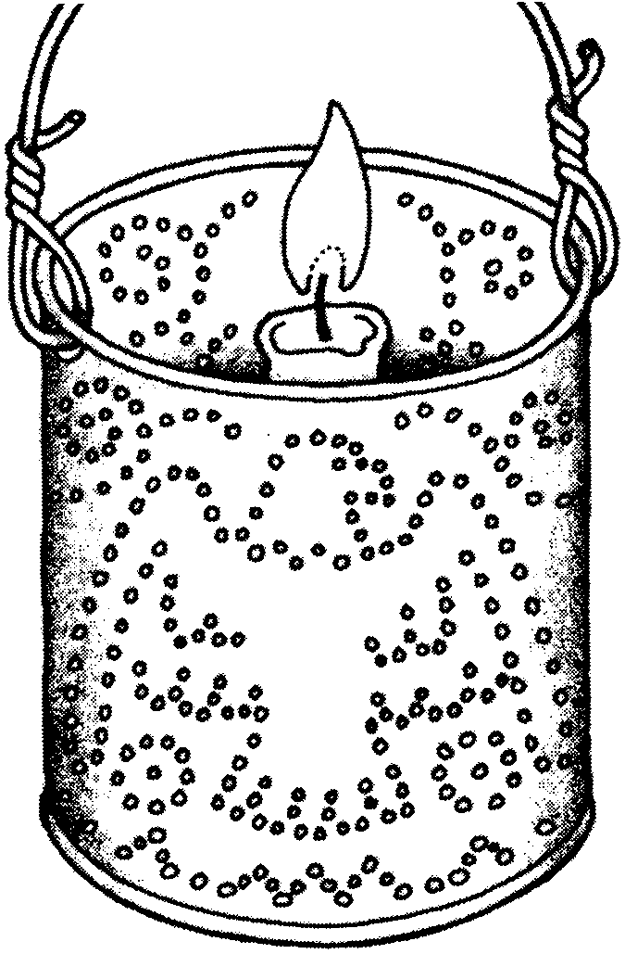
You will need: A tin can with lid removed and without a label (coffee can size is best but any size will do); Wire; Candle* (at least one inch shorter than the can--old candle stubs, tea candle); White paper; Marker or crayon; Newspaper; Nails; Hammer.
* Votive candle is not a good one for this because when it melts, the wax runs and seeps out of the lower holes of the lantern. I find that the tea candle is the easiest and cheapest.

1. Cut a piece of white paper so that it wraps around the can. Make your dot design on it with crayon or marker. Don’t make the dots too close to each other. Keep the design simple.
2. Stuff the can with newspaper. Pack it tight. (You may want to dampen the paper as you stuff the can so it packs tight.) Hold it in with sticky tape across the top.
3. Tape the design on the can.
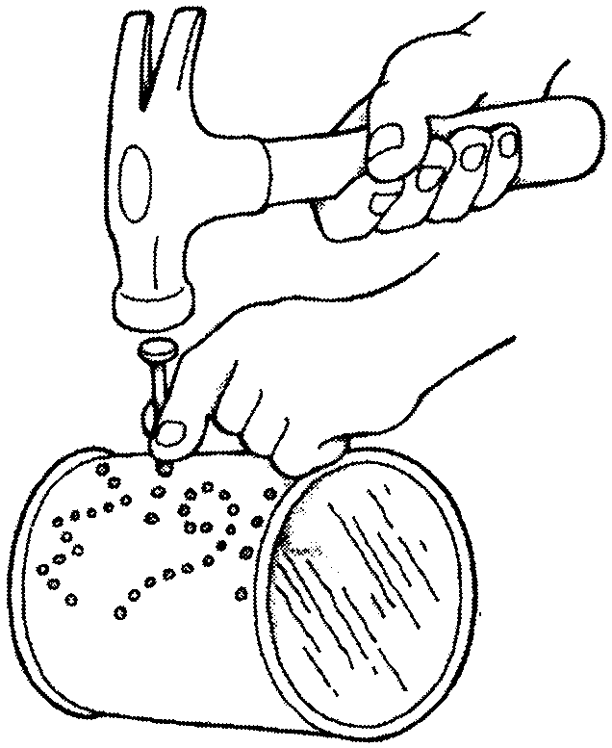4. Using a hammer and nail, hammer holes in the can following the pattern. You can vary the size of the holes by using different-sized nails. Remove the design.
5. Make holes for the handle at opposite sides of the can rim.
6. CAREFULLY remove the newspaper. There will be many sharp edges inside the can.
7. Cut wire and make a handle.
8. Optionally, you may want to paint the can with heat-resistant paint.
9. Drop the candle carefully to the bottom. If the candle is skinny, drip wax from the candle onto the bottom of the lantern and mount the candle in it.

WEATHER ROCK

How did the miner know the day’s weather? He looked at the weather rock! Well not really but this weather rock is very accurate.

You will need: 9 pieces of rug yarn 36" each (or jute, Maxicord, string, etc.; if the cord is thicker than rug yarn, you’ll need only 6 pieces); One piece of rug yarn 12"; One small rock (skinny and long shapes work better); One 3 x 5 index card; One key chain ring; Clear Con-Tact paper.
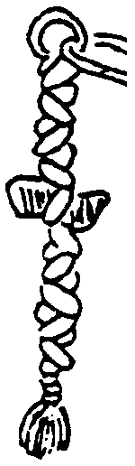
1. Knot the ring in the middle of yarn and divide yarn into 3 sections of 6 strands each (or 4 strands if using 6 pieces of cord).
2. Braid about 5 inches, place rock in yarn and continue braiding until 3" of yarn remains. (It will be easier for the boys if you put a small dab of glue (non-water-soluble) on the rock so it will stay securely in the braid.)
3. Tie 12" piece of yarn at bottom to prevent raveling.
4. Copy the weather “forecast” on the card and cover it with clear Con-Tact paper.
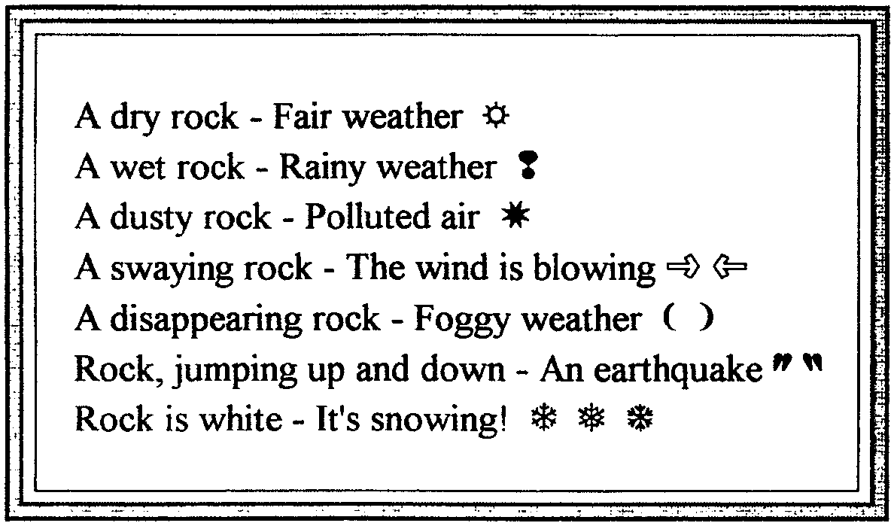5. Attach card to the ring. Keep it outside.

A dry rock - It’s fair
A wet rock - It’s raining
A swaying rock - It’s windy
A disappearing rock - It’s foggy
A white rock - It’s snowing!

Some people suspend their weather rock from three sticks that are lashed into a tripod.
Then you can add one more to the list above:
Rock, jumping up and down - It’s an earthquake!

SPARKLE PAINTS

You will need: Empty squeezable bottles; Flour; Salt; Water; Tempera paint; Paper.

1. Mix equal parts of flour, water and salt.
2. Pour some of the mixture in each squeeze bottle.
3. Add tempera paint to each bottle and shake well.
4. Squeeze the paint onto paper, creating a design, word or picture.
5. Let dry. When the paint is dry, the salt makes the picture sparkle.

You can substitute zip-top freezer bags for squeeze bottle. Cut a small hole at one of the bottom corners.
If you like, you can brush the paints on instead of squeezing them.

GOLD FLAKE SHAKERS
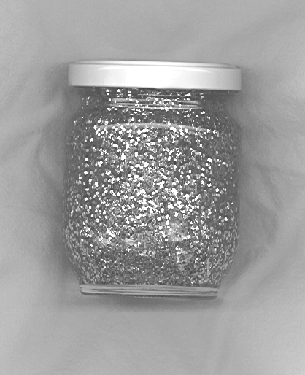
You will need: Clean baby food jar or similar small jar; Gold glitter; Clear oil like baby oil or clear syrup like Karo Syrup; Small pebbles like fish tank gravel; Acrylic gold paint; Glue.

1. Paint the gravel gold. Allow to dry.
2. Put a tablespoon of gold glitter and the gravel in the jar.
3. Fill the jar with oil or syrup (use a spoon to mix the glitter for the first time only if using syrup.)
4. Put glue on the inside threads of the jar lid, and close the jar tightly.
5. If desired, decorate the top of the lid with gold nuggets.
Note: For syrup it will take some shaking of the jar for the glitter to float. But glitter will stay floating longer.

GOLD POUCH

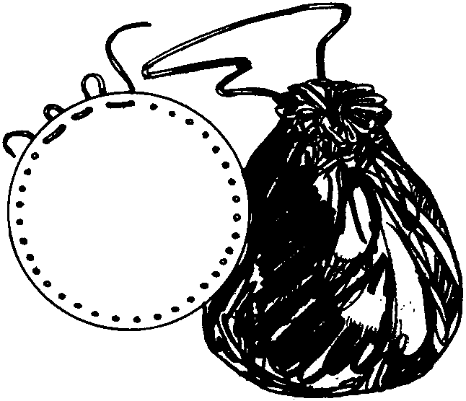Carry your gold nuggets (or candy or small toys) in a pouch. Or you can keep Band-Aids, and a few other first aid items. Vary the size according to your use. Take it on your outing and store some “nuggets” you find on the way like pebbles, acorns, etc. Attach the bag to a hiking stick or to a belt loop.
This is an easy, no-sew pouch that even younger boys can make.

Cut a 9 to 10-inch circle from scrap leather, vinyl or naugahyde. Leather must be thin and soft. Tight-weave fabric such as double knit works well too. A piece of felt will work too.

Using leather punch or paper punch, make holes around the edge about one inch (or less) apart. Lace with leather thongs, cord, or string (anything strong and thick). Draw string tight to close.

STATE OF CALIFORNIA NECKERCHIEF SLIDE
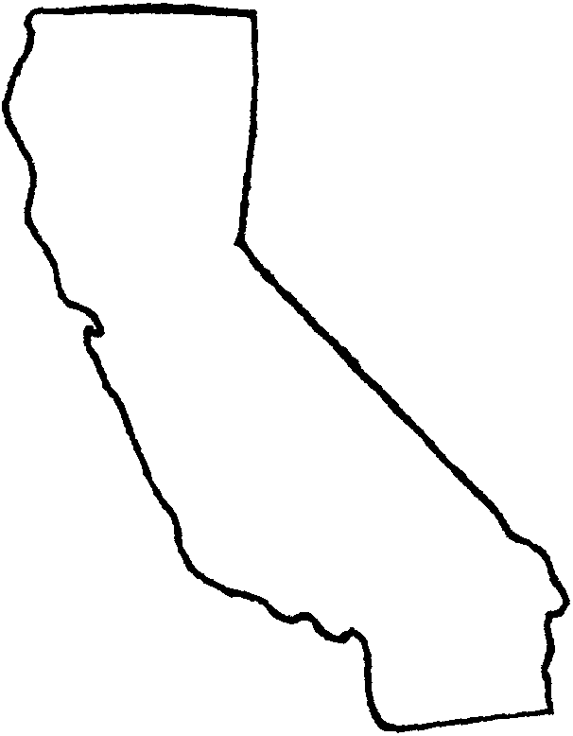
Trace the outline of the state on plywood or masonite. Cut out with a coping saw and paint.
OR trace on cardboard or Fun Foam in a color of your choice.

Glue a section of PVC pipe (1/2") on the back.

LUCKY MINER

This is a rolled-up treasure hunt game.

You will need: Cardboard tube (paper towel, toilet paper); 18 to 24 inches of adding machine tape.

Decorate the tube by wrapping with colored paper and drawing on it. Or use colorful gift wrap paper.

Draw a “map” to your mine(s) on the adding machine tape. See examples below. You can make more than one starting point, have some “roads” end at a sheer cliff or water fall (dead end), have some “roads” merge and then split again. Have one of the “roads” reach a gold mine at the end or have different mines (gold, silver, diamond) at the end. Use your imagination. Leave about an inch at the end of the tape.

When you are done drawing the map, tape or glue the end to the cardboard tube. Roll up your map.

To Play: Unroll only a little and have your friend choose his way to the gold.
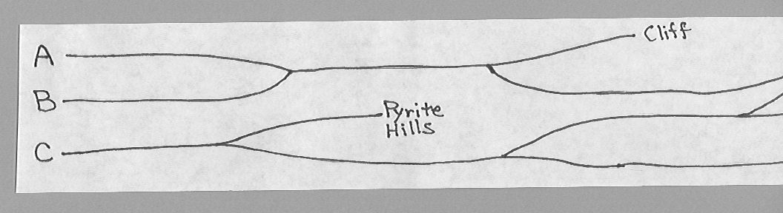

HOMEMADE POPCORN POPPER
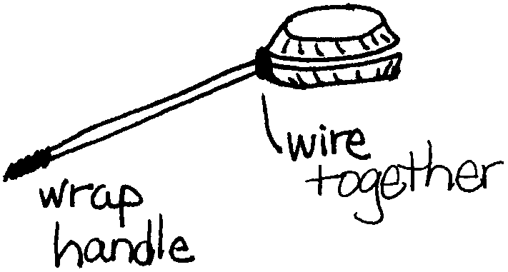
Use this popper over open fire.

You will need: Two foil pie plates (same size); Wire clothes hanger; Fine wire; Scrap fabric.

1. Remove the hook from the clothes hanger and straighten the remaining wire. Bend the wire in half. Bend the ends of the wire out about 1" from each end.
2. For the popper place two pie plates together rim to rim. The bent end of the handle will be attached to the popper with fine wire. Punch holes for wire through both rims, twist ends of wire to hold handle securely. To hold popper closed while in use, secure rims opposite handle with metal spring clip. Tape the other end of the handle and wrap it with scrap cloth.

To make popcorn. Place one tablespoon of oil and 1/4 cup of popcorn in the popper. Keep the popper moving while it is over the heat to keep the popcorn from burning.

GOLD PAN NECKERCHIEF SLIDE
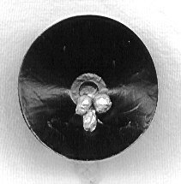
You will need: One 1 1/2” to 2” suction hook; Black and gold acrylic paint; Small pebbles; Pipe cleaner; (optional) Gold glitter.
The suction part is your gold pan.

1. Take the hook off of the front.
2. Paint the inside of the suction cup black and pebbles gold. (You may have to paint the suction cup with two layers of black.)
3. Take a pipe cleaner and make a round circle for slide and hook to the knob. Glue to the knob to secure it.
4. Glue a few gold pebbles in the middle and/or some gold glitter (not too much!).
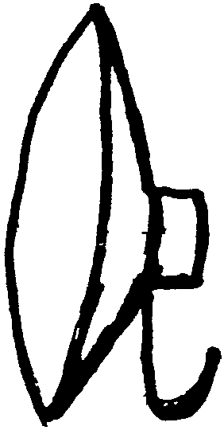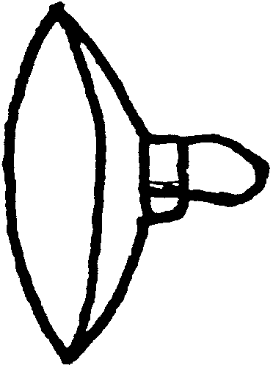
Note: In place of the suction cup, you may want to use a tin plate for a doll house (30-50cents).

“GOLD NUGGET” NECKERCHIEF SLIDE

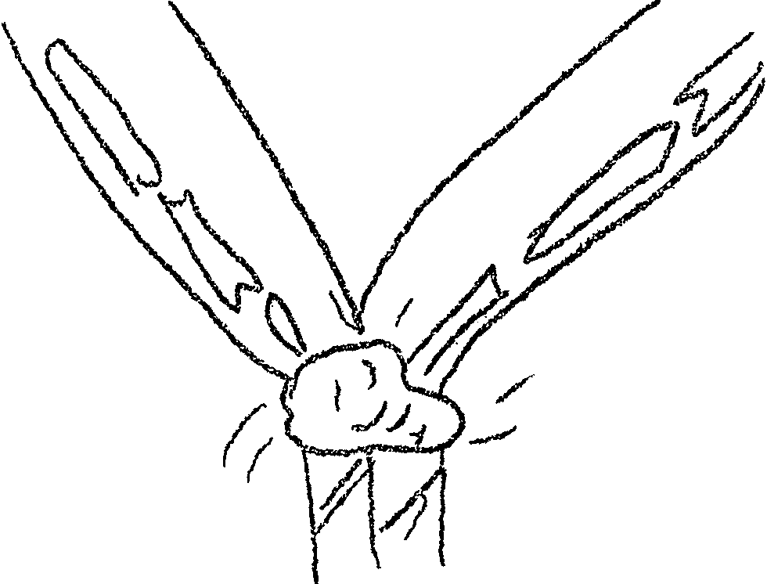For the “nugget” use a small rock.
Or make your own “nugget”: Mix a small amount of plaster of paris. Drop a “blob” down on a smooth surface. Using a popsicle stick, dent it, smooth it poke it or whatever to make it interesting. Make sure the “blob” is large enough to accommodate the ring for the neckerchief.

1. Spray rock with gold paint.
2. (Optional) Add gold glitter while wet.
3. Let it dry. If you used gold glitter, respray with clear shellac to keep glitter on the rock.
4. Glue a section of PVC pipe on the back.

GOLD NUGGET COOKIES

1/2 cup salad oil
2 medium, ripe bananas, mashed
1 cup sugar
1 cup flour
1 tsp. baking soda
1 cup salted peanuts, chopped

1. Blend the oil, bananas and sugar.
2. In a separate bowl, mix together the flour, baking soda and peanuts.
3. Combine the two mixtures, stirring until thoroughly mixed.
4. Place the dough by rounded tablespoonfuls onto a greased cookie sheet.
5. Bake at 350 for 12-15 minutes or until the edges are browned.

BAKED DOUGHNUT NUGGETS

This is a quite easy and the doughnuts are non-greasy.

BATTER:
1 1/2 cups all-purpose flour
2 tsp baking powder
1 tsp ground nutmeg
1/2 tsp salt
1/2 cup (1 stick) butter or margarine, at room temperature
1/3 cup sugar
1 large egg
2/3 cup milk
OPTIONAL TOPPING:
2 Tbsp confectioner’s sugar
1/4 tsp ground cinnamon

1. Preheat oven to 350.
2. Mix dry ingredients: Put the flour, baking powder, nutmeg and salt in a mixing bowl and stir them together.
3. Put the butter and sugar in another mixing bowl. Using an electric mixer, beat on medium-high speed until light and fluffy.
4. Add the egg and beat until completely blended.
5. Add half the flour mixture and mix on low speed until smooth. Pour in half the milk and mix again.
6. Add the remaining flour mixture and mix until blended. Then add the remaining milk and mix until smooth.
7. Using a spoon, fill each cup of a muffin tin 2/3 full with batter.
8. Bake 20 minutes.
9. (Optional) Mix confectioner’s sugar and cinnamon for topping.
10. Let the nuggets cool 5 minutes in the muffin tin. Then turn the tin and let the nuggets fall out.
11. Serve the nuggets plain or lightly sprinkle with the topping.

GOLD NUGGETS POPCORN

1/3 cup melted butter 1 pkg yellow Jell-O 8 cups popped popcorn

Put popcorn in a clean paper sack. Pour butter over popcorn, close sack and shake well. Sprinkle Jell-O over popcorn, close sack, shake well again.

POLLY’S APPLE CAKE

This was the miners’ delight.

2 cups diced apples
1 egg, beaten
1 cup sugar
1/2 cup salad oil
1 tsp cinnamon
1/2 tsp nutmeg
1 tsp baking soda
1 cup flour
1 cup nuts

1. Mix all ingredients and stir well.
2. Grease and flour an 8 x 8 x 2-inch pan.
3. Pour the mixture and bake at 350 for 35 minutes.

(from Nuggets from Coloma Kitchens.)

POVERTY PUDDING

This recipe is more than 100 years old.

1/2 cup uncooked rice
1 qt milk (whole)
1/2 tsp salt
1/4 tsp cinnamon
1/2 cup brown sugar

1. Mix rice and 3 cups milk.
2. Add salt and cinnamon to the sugar. Mix into the milk.
3. Pour into a well-buttered baking dish. Bake at 300. Stir with fork often. Add remaining cup of milk as needed.
4. Good served with maple syrup.

(from Nuggets from Coloma Kitchens.)

WALNUT WAFERS

2 eggs
1 cup brown sugar
Pinch of salt
3 heaping Tbsp flour
1/2 cup chopped walnuts

1. Beat the eggs with brown sugar and salt.
2. Add the flour and walnuts. Mix well.
3. Drop on buttered cookie sheet and bake about 5 minutes in a 425° oven.

(from Nuggets from Coloma Kitchens.)

