Hey, Look Us Over

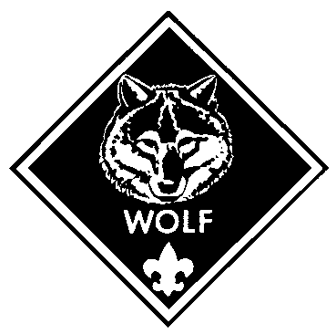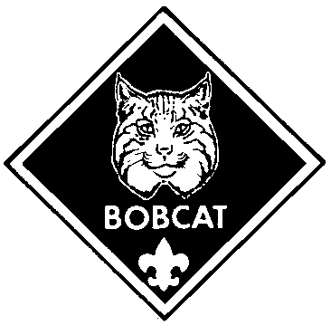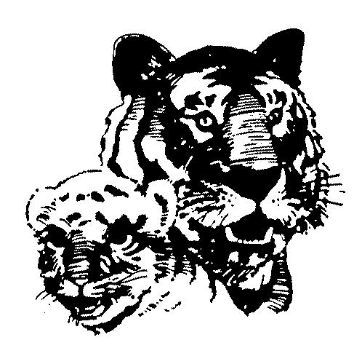

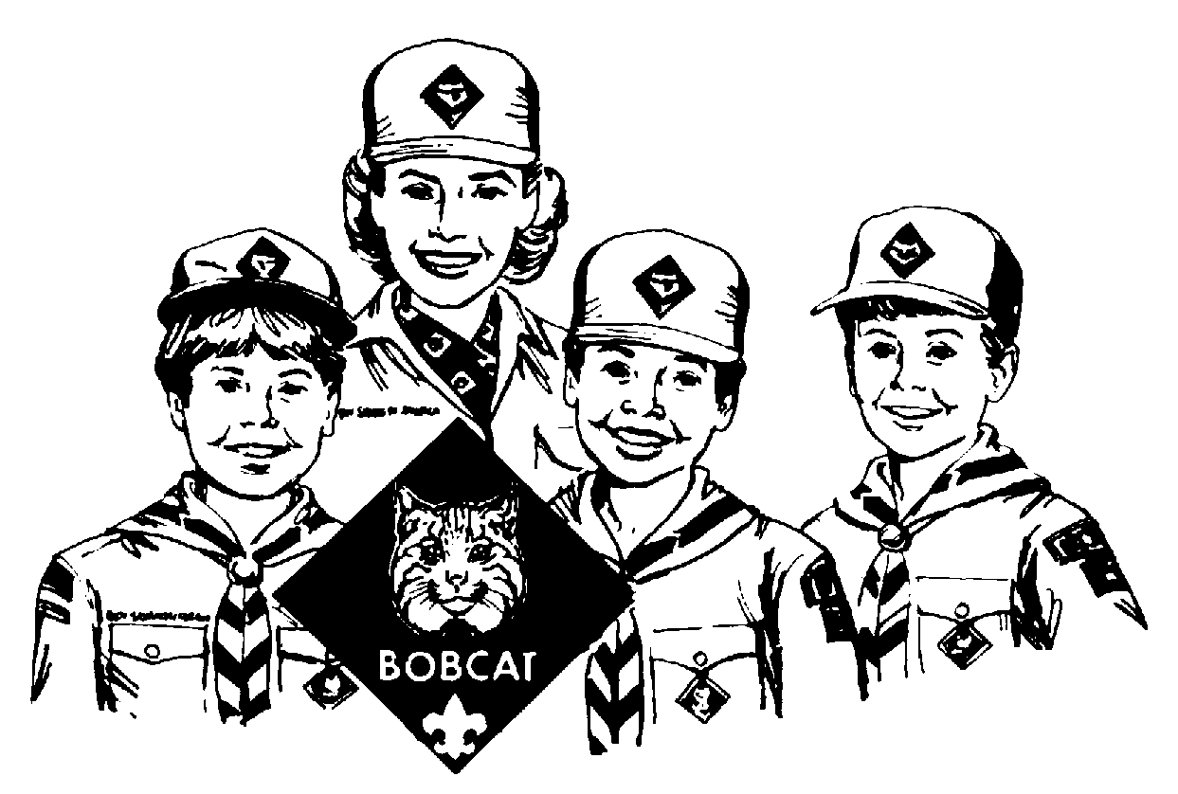

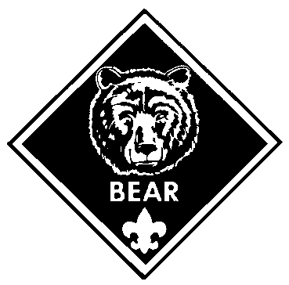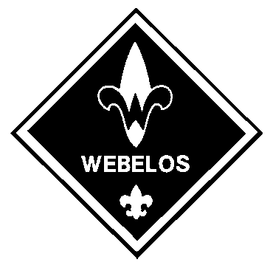
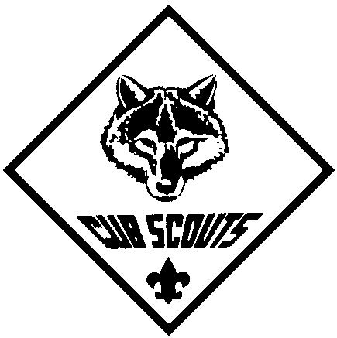

SEPTEMBER 1999
HEY, LOOK US OVER--TIME FOR SCOUTING
This is a perfect theme for the beginning of the Scouting year. Celebrate Cub Scouting and welcome new boys and their families to the pack.
Decorate your hall with Scout memorabilia. Have a display of award ribbons and pack achievements. Make a collage of photos of the pack activities from the past years. A display of Pinewood derby cars is a favorite among boys.
For many new families the uniform is a new and confusing issue--patches, colors, Cub Scout, Boy Scout, what to buy, where to buy, etc.--Provide information on the uniform. Display uniforms on coat hangers and on real boys.
Have an achievement parade. Have boys come up and show off the patches on their uniforms--one rank at a time. (Display Tiger T-shirts with lots of Tiger paws on clothes hangers--the owners themselves should be in their brand new blue uniforms, of course.) Have den chiefs show off their full uniforms including their merit badge sashes. Can an Eagle Scout make a brief visit to your pack in his full glory? This is always impressive.
During the meeting, make new boys and families feel welcome. Include in the pack meeting program some opportunities for the continuing families and new families to meet. Involve parents from the beginning.
Introduce leaders, new and continuing. Make it fun and easy for new leaders to start by providing support, immediate Fast Start training, and the materials needed for their new positions. Inform them of the upcoming Basic Training in October (check with your district executive for the dates.) Boys deserve trained leaders. And leaders need all the help they can get.

SCOUTING FACTS
As of September 30, 1998, the total youth membership in Cub Scouts, from Tiger Cubs through Webelos Scouts, in the United States was almost 1,800,000!

If one million Cub Scouts climbed onto one another’s shoulders, they would be taller than the tallest building, higher than the highest mountain, and farther up than airplanes can fly.
(This is for a Cub Scout who is of the average height of 4'8".)

If a billion Cubs made a human tower, they would stand past the moon.

If a trillion Cubs stood on top of each other, they would reach way, way, way, beyond the moon, beyond Mars and Jupiter too and almost as far as Saturn’s rings.

26 of the first 29 astronauts were Scouts.

Scouting’s alumni record is impressive. A recent nation-wide survey of high schools revealed:
85% of student council presidents were Scouts
89% of senior class presidents were Scouts
80 % of junior class presidents were Scouts
75% of school publication editors were Scouts
71% of football captains were Scouts
HEY, LOOK US OVER WORD SEARCH

G H E Y L O O K U S O V E R W
F A N T A S T I C O O A L I N
S A O O F C P E J O R K R W A
Q X W K S M B E S G R E A T K
P N O E H L D J C O O I Z J A
V A N D S S J S J I M A R V E
T F D K C O O L A D A W G W P
Z F E D A J M A R V E L O U S
J S R L H A E E J V V I O I U
G J F A B U L O U S A J D J P
Z D U R S W M D I O M A U Q E
K K L G I N C R E D I B L E R
V H G W K H U R P W A U W B W
T W Q G T E R R I F I C O T B
HEY LOOK US OVER
AWESOME
COOL
FABULOUS
FANTASTIC
GOOD
GREAT
INCREDIBLE
MARVELOUS
SPECIAL
SUPER
TERRIFIC
WONDERFUL

--created by Alan Wehrman (age 12)

HOW GOOD AR YOU?

Finish the words using the hints on the right.

1. A R __ “Cub Scouts ___ boys in first to fifth grades.”
2. A R __ Barking sound of a dog.
3. A R __ Noah’s boat
4. A R __ You use this to throw a ball.
5. A R __ Painting, sculpture...One of the Webelos activity badge is about this.
6. __ A R Milky Way is a kind of candy ___.
7. __ A R Each Cub Scout makes one for the Pinewood Derby.
8. __ A R Work hard and you will go ___.
9. __ A R Container for cookies
10. __ A R Scratch; ruin; injure
11. __ A R Golfer’s score
12. __ A R This is a sticky, black stuff they use to cover roads.
13. __ A R Armed conflict
14. __ A R Two fingers for the Cub Scout sign looks like a wolf’s _____s.
15. __ A R You use this to move a boat.
16. A __ R Let’s keep this clean.

GREETINGS
Arrangement: This ceremony is introduced by the Cubmaster or the Den Chief. He explains that the audience is to respond by doing as the boys say. The Cub Scouts hold cards which spell GREETINGS. After the last line is read, the Cubmaster enters and starts the program. Presentation of the Colors could follow.

G Glad to see you’re here tonight.
R Reach out your hand to a friend left and right.
E Everyone smile and shake your head.
E Everyone smile and nod at another friend.
T Together now, stand on your feet.
I I’d like for you all to take your seat.
N Now that we’re all friends, we’ll start the show.
G Goodwill is a feeling we all like to know.
S So now we say greetings to everyone.
We’ve tried to spread goodwill, and that we have done.
So Cubmaster, our program’s begun.
Will the audience please rise and join us in repeating the Pledge of Allegiance?

WHAT IS A CUB SCOUT - OPENING
Equipment: At his turn each Cub Scout holds up a card with his part written on the front (PROMISE, LAW OF THE PACK, MOTTO, SIGN, etc.) and his lines on the back.

C.S. #1: I have a promise. It has three parts and Cub Scouts all over the nation are brothers and friends in this promise.

C.S. #2 I have a law. It is the Law of the Pack. This law should be used daily in each Cub Scout’s life, in all he does at home, school and play.

C.S. #3: I have a motto, “Do Your Best.” This means that I am willing to try as hard as I can in everything I do.

C.S. #4: I have a sign. This I give whenever I repeat my promise or the Law of the Pack. The two fingers stand for two parts of the Promise and look like a wolf’s ears ready to listen to Akela.

C.S. #5: I have a salute. My salute means that I respect my country and flag. I give my salute like this. (Give salute.)

C.S. #6: I have a handshake. I give it with my right hand. I have two fingers up and two fingers down. This means that I will help others and obey the Law of the Pack. (Give handshake.)

C.S. #7: I have a uniform and am proud to wear it. It must be neat at all times. When in uniform I try even harder than usual to obey the Law of the Pack.

Now will the audience stand and recite the Cub Scout Promise and the Law of the Pack?

U.S. AND PACK FLAGS OPENING

Arrangements: The audience stands. Narrator reads the following as the color guards bring in the U.S. flag and the pack flag.

Would the audience turn and face the pack flag extending right hand towards it.
Here stands the flag which represents our pack with pride,
A group of growing Cub Scouts with parents at their sides.

Now would the audience turn and face the American Flag, stand at attention.
And here stands the flag we call Old Glory,
Standing for all we hold dear, it tells our country’s story.

Let us all now join together in the Pledge of Allegiance to the flag of our country.

SCOUTING IS... OPENING

Scouting is a sea of blue and gold uniforms.
Scouting is a shirt full of awards.
Scouting is a new tie slide that you made yourself.
Scouting is sleeping under the stars.
Scouting is putting the worm on the fish hook by yourself.
Scouting is a hike in the mountains or around the block.
Scouting is learning a new game.
Scouting is pledging allegiance and feeling your heart swell with love for your country.
Scouting is all these and more.

Please join us in repeating the Pledge of Allegiance.

DO YOUR BEST - OPENING
Den Leader: Today, in our country, there are over 6 million boys and adults in Scouting, from Cub Scouts to Boy Scouts and Explorers, working towards the same goal and that is working to “do their best,” “to help other people” and to “respect God and County.”

C.S. # 1: We are the America of tomorrow.
C.S. # 2: I may be President.
C.S. # 3: I may be Chief Justice of the Supreme Court.
C.S. # 4: I may serve in the Senate.
C.S. # 5: I may serve in the House of Representative.
C.S. # 6: I may become governor of a state.
C.S. # 7: We do not know what we will grow up to be.
C.S. # 8: But we will all be good citizens of this great nation.
C.S. # 9: We will always do our best, help other people, and respect God and Country.
C.S. # 10: Tonight we will simply DO OUR BEST to have a great pack meeting.
C.S. # 11: Let’s start out our meeting just right as we salute our flag and unite in the Pledge of Allegiance.
SPOTLIGHT THE BOY

Arrangement: The U.S. Flag and a pack flag are carried to the front by the color guards. They face the audience. The lights are turned down and a Cub Scout stands in between the flags. A spotlight is turned on the setting. A good reader reads the verse below.

He’s just seven years old.
He’s a mixture of
Noise, energy, imagination, curiosity and hunger.
He’s the “cute little boy down the street,”
“That spoiled imp next door,” or
“My Son,”...depending on who you are.
He’s something to be kept fed, clothed, healthy, happy and out of trouble.
But...
He’s more...
He’s tomorrow.
He’s the future we’ve been fighting for.
He’s part of the world’s most important generation.
Our generation must win the peace.
His generation must keep the peace.
His generation must decide whether it was all worth doing.
He is one of the most important people in history,
And
Everyone who influences his life is also a mighty important person.

YOU ASK ME - OPENING OR LEADER INDUCTION

You ask me what it’s all about,
Why turn a boy into a Scout?
To take some boy, so young and frail,
And start him up the Cub Scout Trail.
From Bobcat, to Wolf, and on to Bear,
With all those awards and arrow points share.
Through to Webelos and then on to Scouts,
Giving Guidance through his problems, fears and doubts.
And on through school and into life he’ll trod,
With respect and love for his fellow man and God.
To watch him grow so tall and free,
Till one day, a leader, he too will be.
And then, he too, just like you and me,
Will take another boy so small and wee.
And will teach that boy,
With pride and joy,
To grow in love and kindness and to be a Scout.
Yes, Yes! That’s what tonight is all about!

“A CUB SCOUT’S PLEDGE TO HIMSELF” - OPENING OR CLOSING

C.S. # 1: May I grow in character and ability as I grow in size.
C.S. # 2: May I be honest with myself and others in what I do and say.
C.S. # 3: May I learn and practice my religion.
C.S. # 4: May I always honor my parents, my elders, and my leaders.
C.S. # 5: May I develop high moral principles and the courage to live by them.
C.S. # 6: May I strive for health in body, mind, and spirit.
C.S. # 7: May I always respect the rights of others.
C.S. # 8: May I set a good example so that others may enjoy and profit from my company.
C.S. # 9: May I give honest effort to my work.
C.S. # 10: May I regard my education as preparation for the future.
Please rise and repeat the Cub Scout Promise.

HAPPY FACES - CLOSING

Arrangement: 7 Cub Scouts with self-made happy face signs.

C.S. #1: I think there were 1,000 smiles here tonight, but did you know...
C.S. #2: A smile costs nothing,...but creates much.
C.S. #3: It happens in a flash, but the memory sometimes lasts forever.
C.S. #4: It cannot be bought, begged, borrowed or stolen.
C.S. #5: But it is of no earthly good to anyone unless it is given away.
C.S. #6: So, if, in your hurry and rush, you meet someone who is too weary to give you a smile, leave one of yours.
C.S. #7: No one needs a smile quite as much as a person who has none left to give. What better way to spread good will!

K I S M I F

Keep it simple, make it fun
Kids in Scouts, Men in Future

It takes more than 40 muscles to frown but only 17 to put a smile on your face.

ONE HUNDRED SCOUTS

Arrangement: The following should be read by a few adults.

Of any one hundred boys who become Scouts, it must be confessed that thirty will drop out in their first year. Perhaps this may be regarded as a failure, but in later life all of these will remember that they had been Scouts and will speak well of the program.

Of the one hundred, only rarely will one ever appear before a juvenile court judge. Twelve of the one hundred will be from families that belong to no church. Through Scouting, these twelve and many of their families will be brought into contact with a church and will continue to be active all their lives. Six of the one hundred will become pastors.

Each of the one hundred will learn something from Scouting. Almost all will develop hobbies that will add interest throughout the rest of their lives. Approximately one-half will serve in the military, and in varying degrees, profit from their Scout training. At least one will use it to save another person’s life and many will credit it with saving their own.

Four of the one hundred will reach Eagle rank, and at least one will later say that he valued his Eagle above his college degree. Many will find their future vocation through merit badge work and Scouting contacts. Seventeen of the one hundred boys will later become Scout leaders and will give leadership to thousands of additional boys.

Only one in four boys in America will become a Scout, but it is interesting to know that of the leaders in this nation in business, religion and politics, three out of four were Scouts.

This story will never end. Like the “Golden Pebble” of service dropped into the human sea, it will continue to radiate in ever-widening circles, influencing the characters of men down through unending times.

MY CUB SCOUTING LIGHT - CLOSING
Equipment: 3 candles
Personnel: Narrator (an older Cub Scout) and two assistant Cub Scouts.

This is my Scouting Light...it is all I know and it is all I can do. If I pass this knowledge on to another (lights 1st assistant’s candle with his) what you will have is a greater light and two of us who know and can do more.

And if he were to pass his knowledge and his Scouting light to another (1st assistant lights the 2nd assistant’s candle with his), there is even more light and knowledge.

You will notice too I have given my Scouting light to others but my own light burns just as brightly. Let us all share our Scouting Light.

I MADE A PROMISE

C.S. #1: I made a promise...I said that whatever I did I would do the best I could.
C.S. #2: I made a promise...to serve my God and my country the best I could.
C.S. #3: I made a promise...to help other people the best I could.
C.S. #4: I made a promise...to obey the Law of the Pack the best I could.
C.S. #5: I have done my best, and I will do my best because I made a promise...I am a Cub Scout
C.S. #6: Will everyone now join us in repeating the Cub Scout Promise?

DO SOMETHING
(by Baden-Powell)

You should not be content with sitting down to defend yourselves against evil habits, but should be also active in doing good. By “doing good” I mean making yourselves useful and doing small kindness to other people--whether they are friends or strangers.

It is not a difficult matter, and the best way to set about it is to make up your mind to do at least one “good turn” to somebody every day, and you will soon get into the habit of doing good turns always.

It does not matter how small the “good turn” may be--even if it is only to help an old woman across the street, or to say a good word for somebody who is being badly spoken of. The great thing is to do something.

SERVICE WITH A SMILE

The word SCOUTS begins and ends with the letter S. This S stands for Service to others. Also S stands for Smile. Service to others with a smile--that’s the way of the Scouts. Let’s remember.

FUN WAYS TO SAY THANK YOU

Bouncy ball: “You put a lot of bounce into our pack program.”
Eraser: “Cub Scouting rubs off on you.”
Wiggle eyes glued to ribbon: “Our eyes are on you”
“We love looking at the result of your work!”
For the leader who sets the example.
Box of Total: For being totally awesome.
Box of Cheer: For being the official cheerleader.
For always being cheerful.

LEARNING - ADVANCEMENT

Arrangement: The 4 boys representing 4 ranks face the pack and read their scripts. After each boy reads his script the boys receiving the award for that rank are called forward with their parents.

Bobcat: I have learned 7 new things to earn my Bobcat badge. I can live the Cub Scout Promise and the Law of the Pack. I know what Webelos means. I know the Cub Scout sign and handshake. (Salutes.) I promise to do my best.

Wolf: I have learned 12 new things to earn my Wolf badge. I grew physically and spiritually. I developed habits and attitudes of good citizenship. As I grew in mind and body, I also grew within my own family. I learned to get along with others and developed a sense of personal achievement. It is fun being helpful and doing your best.

Bear: I too learned 12 things to earn my Bear badge. They required more skill and more effort on my part, but they were fun and interesting. Many of the things I learned were preparation for me to be a Boy Scout. The electives started giving me ideas about hobbies and things I might do with my life.

Webelos: I have earned the Webelos badge. I have earned Fitness and two other activity badges. I planned and led a flag ceremony in my den. I know and understand the requirements to be a Boy Scouts. I will continue to work hard and soon I will earn my Arrow of Light and become a Boy Scout.

APPLAUSES

DYBS YELL: DYBS means “Do Your Best, Scouts” and is pronounced like 'dibs'. Leader raises his fist in the air and brings it down hard each time ‘DYBS” is yelled. Number of DYBS given is according to accomplishment.

PACK CHEER: “Clap your hands, stamp your feet, Pack _____ can’t be beat!”

BRAVO: The cheer leader says, “That deserves a Bravo! We’ll do this in a circle.” He then proceeds to have one end of the circle start with the ‘BRR’ sound and proceeds to point around the circle while they do the ‘AVOOOO’ sound. The sound level should rise as more of the circle comes in.

THE GOOD TURN: Stand up and turns around while clapping.

HEART AND SOUL APPLAUSE: (For people who put their heart and soul into something.) Pat the palm of your hand on your heart and then on the sole of one shoe.
NICKNAME ADVANCEMENT
Award Chairman: Friends and family sometimes call each other with nicknames. So it is in Cub Scouts... In our pack the nicknames are a bit unique...

Cubmaster: I see you have the list of Cub Scouts receiving awards. How many do we have?
Award Chairman: Five--a Bobcat, a Wolf, a Bear, and two arrowpoints.

CM: Well, let’s start with the Bobcat. Who is getting his Bobcat badge tonight?
AC: Yes, that’s right, WHO is getting his Bobcat badge.

CM: What?
SC: No, WHO.

CM: Let’s start over again. What is the boy’s name that is getting his Bobcat badge?
AC: WHAT is a Bear.

CM: What do you mean “What is a Bear?” A Bear is a Cub Scout rank. Now who is getting his Bobcat badge?
AC: That’s right.

CM: Wait a minute. Let’s try it this way. After the pack meeting the boys that have earned awards will be happy and proud, their mothers will sew on their badges---Right?
AC: Yes, that sounds right.

CM: Now, whose mother will sew on his Bobcat badge?
AC: Not until he does a good deed.

CM: Who will do a good deed?
AC: I should certainly hope so!

CM: You certainly hope what?
AC: No, I certainly hope WHO will do a good deed.

CM: Let’s forget the Bobcat badges for the moment.
AC: Sounds good to me. I think you’re getting confused.

CM: Let’s try the Wolf. Who is getting his Wolf.
AC: No, WHO is getting his Bobcat.

CM: I said to forget about Bobcat.
AC: You brought it up.

CM: Someone is getting his Wolf badge tonight and his name is...?
AC: I DON’T KNOW.

CM: Jokes aside, let’s call ______ for the Bobcat award. etc.
A LEADER INDUCTION CEREMONY

There is a special group of parents here that the boys and parents of Cub Scout Pack ____ wish to honor at this time. These people are the Den Leaders, Webelos Den Leaders, and Pack Committee Members. Will they come forward and form a line facing the rest of the pack?

These volunteer leaders not only guide their own boys through Cub Scouting, but believe strongly enough in the program that they are willing to devote some extra time and effort to making the dens and the pack GO. For this the Cub Scouts and parents of Pack ____ salute you. (Round of applause)

I have asked one father, mother and their son (Mr. and Mrs. _____ and _____) to represent the entire pack by presenting these badges of office to our den leaders and committee members.

And in awarding these badges we are also presenting you with RESPONSIBILITY--for great will be your responsibility as our leaders; HARD WORK--for that’s what makes the pack go; ENTHUSIASM--for it is contagious and accomplishes much, and GRATIFICATION--for that will be the reward of your efforts.

As parents we pledge you our wholehearted support!

THE SPARK - LEADER’S PRAYER

Please God, grant me--
The spark to imagine,
The daring to innovate,
The discipline to plan,
The skill to do,
The will to achieve,
The commitment to be responsible,
The leadership to motivate.

LEADER’S PROMISE

I _______ promise to do my best as an adult leader to guide these boys in doing their duty to God and our country. Not only will I instruct them to help others but I will show them in all that I do. And I promise to teach them to know and to understand the Law of the Pack.

CUB SCOUT LEADERS’ SANITY KIT

Make a kit with items like those listed below and present it to the new leaders.

Sheriff’s star: Use to deputize parents--don’t try to do everything yourself.
Sponge: To help you soak up all the Cub scouting information you need.
Smarties: To remind yourself that you are smart enough to do the job right.
Smiley Face: To remind yourself to smile and keep your spirit up!
Heart: To remind yourself that volunteer leaders are the heart of Scouting; You are also all heart!
Kazoo: To help you keep a song in your Cub Scouting heart.
2 Pennies: When people say, “Oh, no! You’re a den leader??? Have you lost your good sense?” you can say, “Why, no, here they are!” (marbles work well too.)
Knotted rope: When you reach the end of your rope, tie a knot in it and hang on!
Lifesaver: When things are tough, the boys make you crazy, the parents don’t help, nothing works the way you planned, and you’re at the end of your rope and even the knot is slipping through your hands, just reach out and grab that life saver, make that phone call, get some help, and just hold on a little longer ‘cuz those boys are really counting on you.

CUB SCOUT PARENT’S PLEDGE

I promise to do my best to help my son reach the highest goals in Scouting according to his ability.
I pledge my time and effort in making the best of the young years of my son.
I will give of my heart, my time and my ears to help him grow in mind and body.
I will guide him to God.
I will help my son build good character and self respect, that he will like others as well as himself.
I will assist those who are leading my son, in any way I can.
I will do my best as a Cub Scout parent that my son may grow into the Scout and man, he and I will be proud of.

See Staging Den and Pack Ceremonies for:
“This is Cub Scouting” (p. 64)
“Beginning of the Year” (pp. 51-52)
“Explaining the Promise” (p. 52)
“Parents’ Participation Promise” (p. 64)
“Parents’ Promise” (p. 66)
“Induction of New Families” (pp. 69-70)
Leader Inductions and Recognitions (Chapter 12)
See Cub Scout Leader How-to Book for:
“A Cub Scout Parent’s Prayer” (p. 9-58)
I WANNA BE A CUB SCOUT

Cub Scout: “Do your best”
Tiger: “GRREEAATT”
Bobcat: “It’s the beginning”
Wolf: “I’m learning and growing”
Bear: “I’m well on my way”
Webelos: “Boys Scouts is next”
Parents: “Can I help?”
Leaders: “Keep it simple make it fun”
Pack: “Pack ____!”

Once upon a time, not a long time ago actually, there was a boy. This boy had a dream of becoming a CUB SCOUT. He asked his PARENTS if he could join a PACK. A PACK was the CUB SCOUT organization at his school (church). His PARENTS were thrilled. Their son wanted to be a CUB SCOUT.

The PARENTS and their son went to the first PACK meeting. On entering the school cafeteria (church hall) they saw many other PARENTS and sons.

Waiting in the cafeteria were LEADERS with their sons, who are now TIGERS, BOBCATS, WOLVES, BEARS, and WEBELOS. The PARENTS and their son were so impressed. All the LEADERS, TIGERS, BOBCATS, WOLVES, BEARS, and WEBELOS were in uniform and they all looked important and so happy. There they stood greeting everyone and ready to answer questions about CUB SCOUTING and the PACK.

The LEADERS told the story of Akela and Mowgli. The LEADERS spoke about the TIGER ideas, the BOBCAT trail, the WOLF trail, the BEAR trail, and the WEBELOS achievements. The PARENTS listened intently as it was explained that their involvement would help their son be a good CUB SCOUT.

Everyone there was reminded that it takes LEADERS, who were once “just” PARENTS and CUB SCOUTS who were once “just” sons to make a PACK successful. This is how CUB SCOUTING continues to thrive.

The Best thing to spend on a Boy is your time

A CUB SCOUTING YEAR

Pass out a few small treats to the audience. Make some packages bigger or appear more special in fancy wrapping. Tell the audience that each time they hear the word that indicates some direction, they move the package to the person closest to then in that direction. Directions are RIGHT, LEFT, IN FRONT and BEHIND.

The Cub Scout year is filled with such fun. RIGHT at the end of summer the pack has a grand round-up to invite new boys into the pack. After the Webelos have LEFT to join the troop there is room for all the new Tiger Cubs and Bobcats. The pack leaders didn’t want anybody to feel LEFT out.

In the fall in the Scouting for Food drive, all the Cubs LEFT bags on the doorsteps for the neighbors to fill. Then there were Christmas service projects, caroling and holiday crafts. After those events there were not many days LEFT in December.

The Boy Scouts from the troop invited the Webelos to their winter outing. Looking to the RIGHT and the LEFT, they found the troop’s sled RIGHT in the FRONT.

At the derbies in January the excited Cubs stood IN FRONT to see the racing. Did you see the one that LEFT the others BEHIND in his dust?

At the Blue and Gold Banquet the Cubmaster was careful to give the boys their RIGHT awards IN FRONT of the pack.

The fun continued with Scout Expo and displays and activities jam packed RIGHT in a row. What Cub Scout in his RIGHT mind could forget the fantastic time at summer camp?

Den meetings, field trips, pack meetings, outings galore! You had better WRITE it all down because you would certainly feel sad, if you were LEFT BEHIND!

RUN-ONS

Spell “we” using two letters other than W or E.
U and I.

What a Cub Scout should keep after he gives it away?
A promise.

What can a person wear that is never out of style?
A smile.

Knock, knock.
Who’s there?
Gladys.
Gladys who?
Gladys time for Scouts.
THE DUMBBELL

Cast: 4 Cub Scouts in uniform or Cub T-shirts, Johnny in street clothes, Den Chief
Scene: Local park (cardboard cutouts of trees, rocks, etc.) As scene opens, Johnny is sitting on a rock, chin in hand, looking very dejected. He says to himself...

Johnny: I’m bored...there’s nothing to do around here. I’m almost glad school’s starting.

(4 boys enter, Mike carrying small home made barbells.)

Steve: OK, Jim, you and Billy can practice your broad-jump. Mike and I are going to lift weights.

(They proceed to practice as Johnny watches.)

Jim: I can hardly wait for the Physical Fitness Contest.
Billy: Yeah, we’re bound to make a good showing the way we’ve been practicing.
Mike: I think my muscles are getting real big. (Lifts weight)
Steve: (Laughing) Nothing’s going to happen THAT fast, Mike. It takes lots of time and practice.
Johnny: (In a puzzled voice) What are you guys doing?
Mike: Getting ready for the big Physical Fitness Contest. Don’t you know about it?
Johnny: No. What is it?
Jim: I thought everyone knew about it. Aren’t you a Cub Scout?
Johnny: Naaw...I just moved here this month...there sure isn’t much to do around here.
Billy: Sure there is. You just haven’t been here long enough.
Steve: Are you coming to the roundup this week? Then you could be a Cub Scout too.
Mike: Yeah, and be in the contest too. You’ll have lots to do then. You want to start practicing now. (Hands him the weights.)
Billy: Hey, do you want to work out with a real Big dumbbell? That’s what we’re waiting for.
Johnny: Well, yeah, I guess.
Jim: Here comes our den chief.

(Den Chief enters, carrying a big dumbbell.)

Johnny: (Taking a couple of steps toward Den Chief) Are you the Dumbbell we are going to work out with?

(Rest of boys start to laugh.)

Jim: He’s not a dumbbell! He’s our Den Chief!
Mike: (Pointing at big barbell) That’s the Dumbbell.

(They all walk off together)

DO A GOOD TURN DAILY

(A Webelos Scout stands center stage. He does a pivot turn and falls down. He gets up and tries again and again and again. A second Webelos Scout enters, watches the first Scout. A third Webelos Scout enters, watches and then asks the second boy.)

W.S. #3: What is ________ doing?
W.S. #2: I don’t know.

W.S. #4: (Enters) What is ________ doing?
W.S. #2, 3: We don’t know.

W.S. #5: (Enters) What is ________ doing?
W.S. #2, 3, 4: We don’t know.

W.S. #5: Why don’t you ask him?
W.S. #2,3,4: Hey, ________, what are you doing?

W.S. #1: I’m trying to get ready to be a good Boy Scout. I didn’t know it would be so hard.
W.S. #2, 3, 4: A good Boy Scout?

W.S. #5: What do you mean?
W.S. #1: Well, the Webelos leader told me that if I want to be a good Boy Scout, I have to learn to do a good turn every day!

RUN-ONS

Cub 1: So we’re supposed to do a run-on, right?
Cub 2: Yup.
Cub 1: Ya got one in mind?
Cub 2: Nope.
Cub 1: Then guess we’ll just do a run off.
Cub 2: Yup. (Both run off stage.)

Announcer: We interrupt this program for a spot announcement.
Dog: (Offstage) Arf, arf, arf.
Announcer: Thank you Spot.

HUMAN KNOTS

Five to ten players stand in a circle. Each places his hands in the center and takes hold of the hands of two people other than those standing next to him. The group must work together to untie the human knot without releasing hands.

CLAP IT BACK

This activity depends upon good listening skills and memory. Each boy must be able to repeat the rhythm he has heard. Clap a rhythm and then let one boy clap it back. Next let the boy clap one back to you or another boy. Always try to change the number and speed of your claps to make it more interesting.
In a larger group, the game leader claps a rhythm. All are on their feet and try to repeat the rhythm. Those who did not repeat it correctly will seat themselves. Keep repeating, varying the rhythm and speed until only a few, or only one, remain standing. Applaud those still standing.

NECKERCHIEF RELAY

Dens line up in relay formation. The first Cub Scout in line for each den holds a neckerchief and a neckerchief slide in his hands. At the other end of the room sits the father of one of the boys in the den.
At the signal, the first Cub Scout runs to the father, places the neckerchief around the father’s neck, puts the slide on, salutes, takes the slide off, removes the neckerchief and returns to his den. He then passes the slide and neckerchief to the next boy in line who repeats the procedure until each boy in the den has had a turn. The den finishing first wins.

BAREFOOT MARBLE RELAY

All players take off their shoes and socks. The boys line up. First boy runs to a line fifteen feet away. He then grasps and carries one marble with toes of each foot, returns to tag the next boy in line. First team to collect all the marbles wins.

ELASTIC RELAY

You will need 2 lengths of elastic about 1 1/2 yard long, tied together to make 2 rings. Divide the den into two teams standing in line. The first boy in each team is given a circle of elastic. At the signal, he must stretch the elastic over his head and over the head of the boy next to him, and pass the circle down to the floor, stepping out of it. The second boy then takes the elastic and repeats the process with the boy next to him, and so on down the line. The last player goes to the head of the line and repeats the process with the starter. The team that finishes first wins.
LINE ‘EM UP!

Give your den chief a card reading: “As quickly as possible, form up the den as follows:
1. All those over eight years of age stand on one leg.
2. Have the youngest Cub Scout close one eye.
3. Have boys line up in order of height, shortest on your left.
4. All eight year olds sit on the floor.
5. Tallest stand on a chair.
6. Third from left salute when you are ready.”
Tailor the orders according to your den. Time the teamwork and check accuracy. (Be positive. Praise more than pointing out what’s wrong.) Give yourselves a great cheer.

GETTING TO KNOW YOU

This is a good game to play at your first den meeting. Have the boys form a circle. Pass a roll of toilet paper around to each boy and instruct him to tear off as much as he would like. After everyone has some paper, tell the boys they must talk about themselves for as long as it takes to roll the toilet paper onto a small pencil. They can talk about their likes and dislikes, summer vacation, family, school, hobbies, etc., but they must continue talking until the paper is rolled into a tube.

CUB SCOUT UNIFORM GAME

The object is to teach correct uniforming. Have one boy leave the room and rearrange his uniform so that several things are wrong. Depending on their years in Cub Scouting, you may want to give the demonstrating boy suggestions or let him dishevel his own uniform (he needs to know what is right before he can make it appear wrong!). Divide remaining boys into two teams and give each team a pencil and paper. Call the disheveled boy back and in one minute have the team write down all the things they see wrong. Some ideas: Cap on backwards, Neckerchief not rolled, One shirt button unbuttoned, Wearing Denner cord on wrong shoulder, Cub Scout wearing den chief cord, One shirt sleeve rolled up, Service star pinned to neckerchief, Pocket turned inside out.

KNOWING

The object is to teach Bobcat requirements. This is a game for a new den or it can be used as a review. Ahead of time make slips of paper with Bobcat requirements written on them. One requirement per slip. Fold the slips and put them in a hat. Have each boy in the den write his name on a piece of paper. Fold and put these into another hat. The den chief draws a name, and that Cub Scout picks a requirement slip from the other hat. The Cub reads out loud and does what is on the slip.

HEY LOOK ME OVER
(Tune: Hey, Look Me Over)

Hey, look me over,
Lend me an ear
I’m in my uniform
Cub Scout up to here!
Nothing sad for me, folks.
Happy all the time
Cause I’ve got a Mom and Dad with me
To make this old pack shine.
And so I bust out my buttons
Proud as I can be.
Fellows on the corner
How they envy me!
So come on all you guys and join in the fun
Don’t be an old sad sack
Because ours is the greatest Pack!!!

CUB SCOUT NEAT THINGS
(Tune: My Bonnie Lies Over the Ocean)

In Cub Scouts we make all these neat things
Like race cars and sail boats and planes.
We always have fun when we race them,
Cause learning’s more fun as a game.

CHORUS:
Racing, sailing and flying sometimes with
mom and dad
Come and join us
We’ll show you good times we had.

There’s Pinewood, a derby we race in,
And Raingutter, sailing with the wind.
The Space Derby’s rockets are flying
And happy we are when we win.
CHORUS

C-U-B S-C-O-U-T
(Tune: Mickey Mouse Song)

What’s the name of the group
That’s made for you and me?

C-U-B (Do Your Best) S-C-O-U-T
Hey there, Hi there, Ho there
You’re as welcome as can be!

C-U-B (Do Your Best) S-C-O-U-T
Cub Scout! (Do Your Best!)
Cub Scout! (Do Your Best!)
We’re the ones who have more
FUN, FUN, FUN
Come along and sing a song
And join in Fun and Glee
C-U-B (Do Your Best) S-C-O-U-T!

CALL A SCOUT
(Tune: If You’re Happy...)

When you’re down and feeling blue
Call a Scout
They’ll know just what to do
Call a Scout
If you’re ever in a hurry
Don’t take the time to worry
All you have to do is shout
Call a Scout!

If you need a helping hand
Call a Scout
They’ll take your garbage out
Call a Scout
If the traffic that you meet
Has you scared to cross the street
They’ll be there to help you out
Call a Scout!

Now the Scouts are always helpful
Don’t you see
They will lend a helping hand
To you and me
For they’re wise in what they do
They are kind and cheerful too
And they always help you out
Call a Scout!
A SMILE
(Tune: Auld Lang Syne)

A smile is quite a funny thing,
It wrinkles up your face,
And when it’s gone you’ll never find
Its secret hiding place.
But far more wonderful it is
To see what smiles can do.
You smile at one, he smiles at you,
And so one smile makes two.

He smiles at someone since you smiled
And then that one smiles back.
And that one smiles, until in truth,
It gets hard to keep track.
And since a smile can do great good
In showing that you care,
Let’s smile and smile and not forget
That smiles go everywhere.

WE’RE GLAD
(Tune: Auld Lang Syne)

We’re glad this week has come around,
For boys like you and me
Are closer drawn, and ties made clear,
That not forgot shall be.
So, here’s my hand, my friend, my pal,
My heart you’ve filled with cheer
Let’s make each day a time like this
Throughout the livelong year.

See Cub Scout Songbook for:
“Cub Scout Advancement song”
“I’ve Got That Cub Scout Spirit’
“The (Wolf) (Bear) (Webelos) Went Over the Mountain”
More greeting songs and songs about Cub Scouts

IT’S A CUB WORLD
(Tune: It’s a Small World)

CHORUS:
It’s a Cub World, after all
It’s a Cub World, after all
It’s a Cub World, after all
It’s a Cubbing World.

There are Cubs in England and Italy.
There are Cubs in France and Germany.
When the Cub flag’s unfurled
All around the world
It’s for Cubs like you and me.
CHORUS

There are Bears and Wolves and Webelos
We wear different patches on our clothes
But I’ll tell you, it’s true
We all wear gold and blue
In our Cub world, after all.
CHORUS

Akela guides us all, you see
To learn and do and grow and be.
And we all meet the test
‘Cause we all DO OUR BEST
In our Cub World, after all.
CHORUS

TIGER TO WEBELOS
(Tune: I’m a Little Teapot)

I’m a little Tiger Cub honestly,
And I got my parents, they’re helping me.

I’m a bigger Wolf Cub, with loyalty
Cause my den leader is teaching me.

Now I’m a Bear Cub, don’t you know
And the next year I’ll be Webelos.

I’m a Webelos Scout, have no doubt
And I can’t wait to be a Boy Scout.
POPSICLE STICK PLAQUES
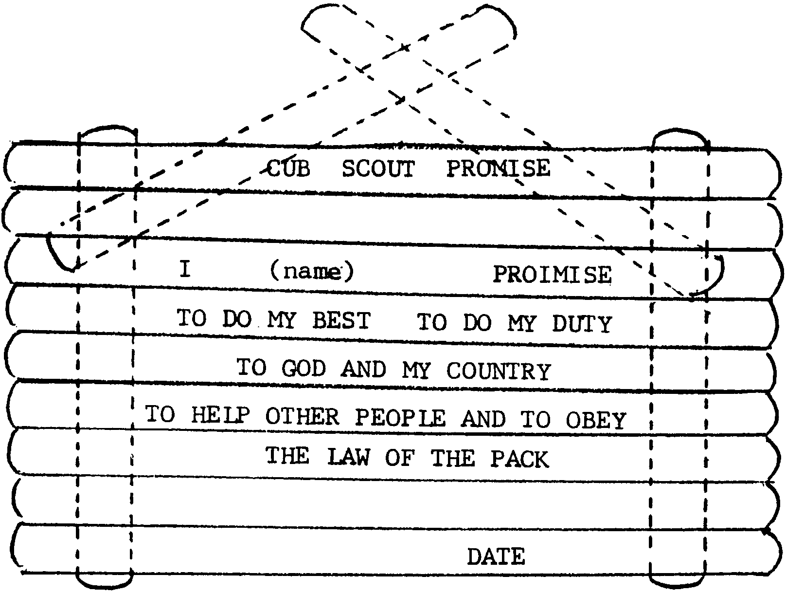
Write Cub Scout Promise, Law of the Pack, or Motto on a popsicle stick plaque and hang it on the wall or stand it on your desk. You may want to glue alphabet macaroni instead of writing with markers. Write or draw some other messages too.

WALL PLAQUE
You will need 13 sticks.
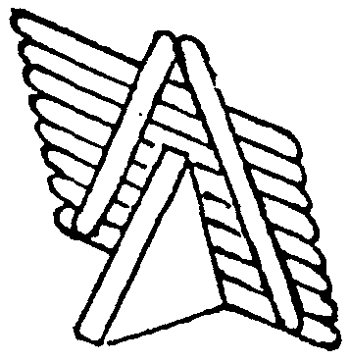
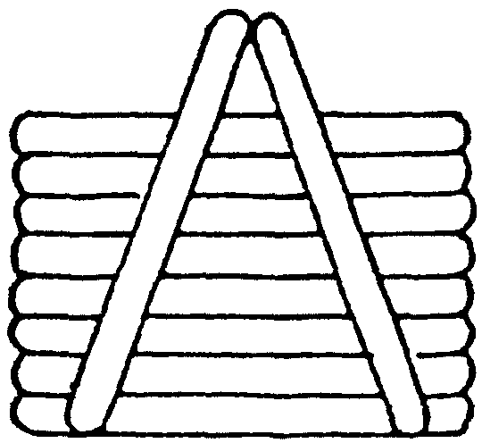

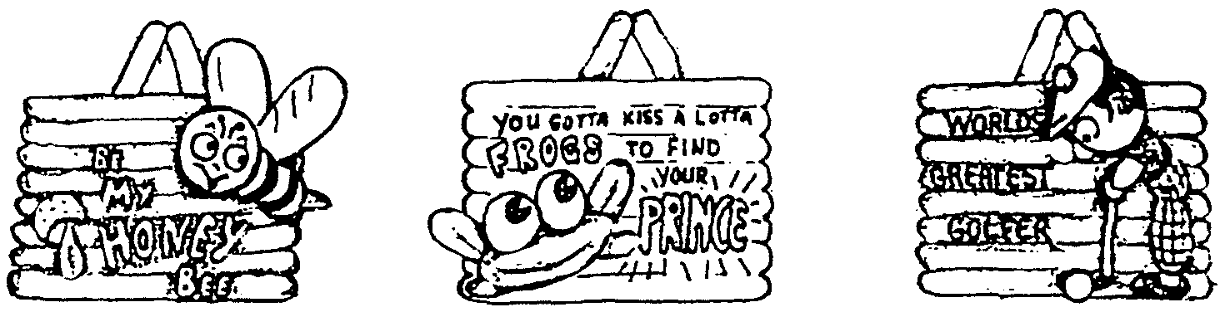

EASEL PLAQUE
You will need ten sticks and a scrap wood in the shape of a triangle or a triangle building block.

UNIFORM ORGANIZER
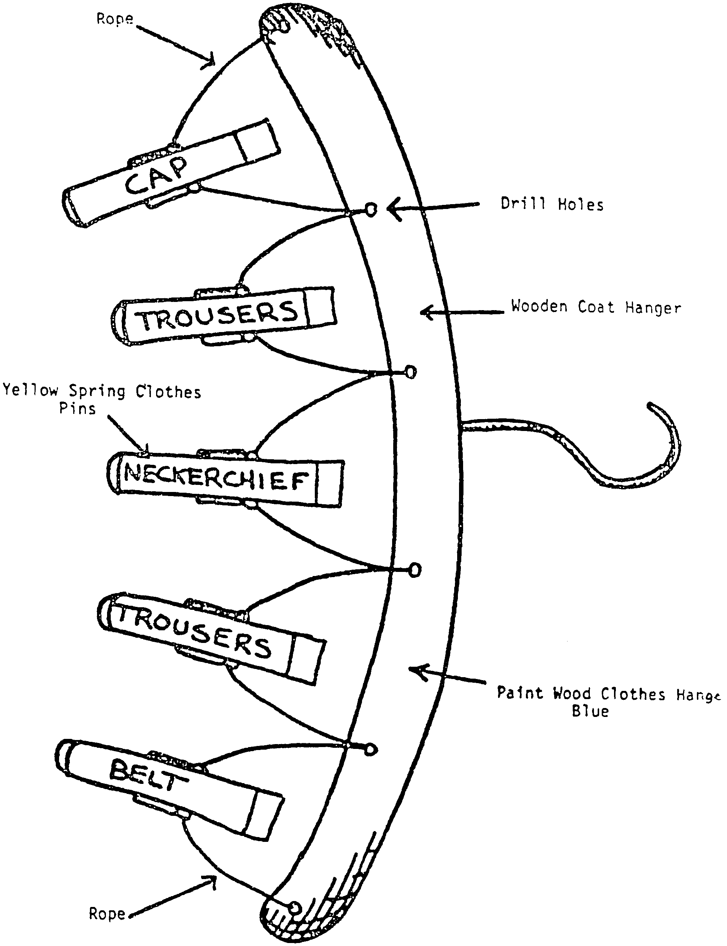
You will need: A wooden coat hanger; 5 spring type clothes pins; 60" of string or cord; Blue and yellow wood paint.

1. Paint the hanger blue and clothespins yellow. It would be easier to paint if you take the clothespins apart.
2. Assemble as in the illustration.

HEY, LOOK ME OVER--THE ACROBATIC WONDER!

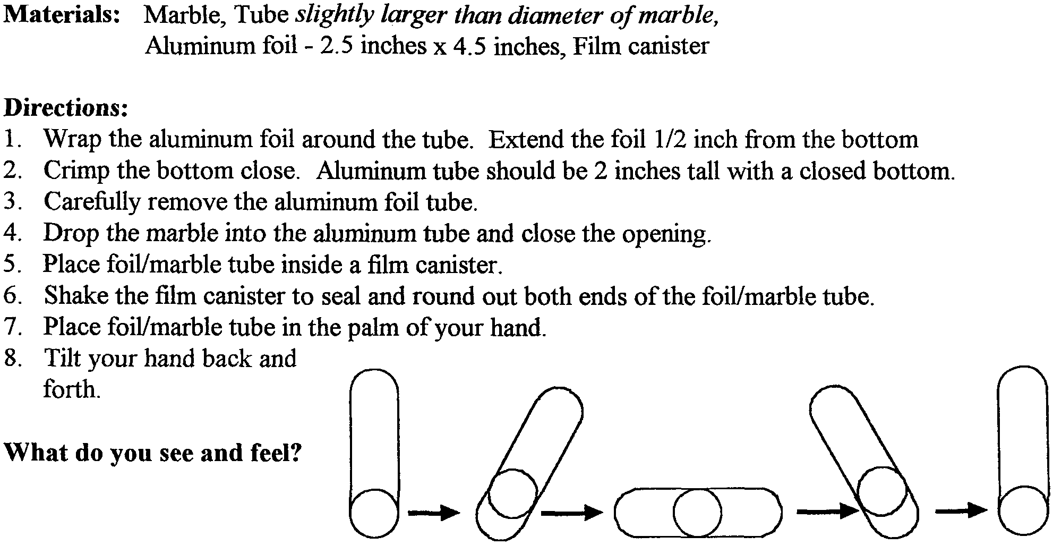

SUPER BALL FOR SUPER SCOUT
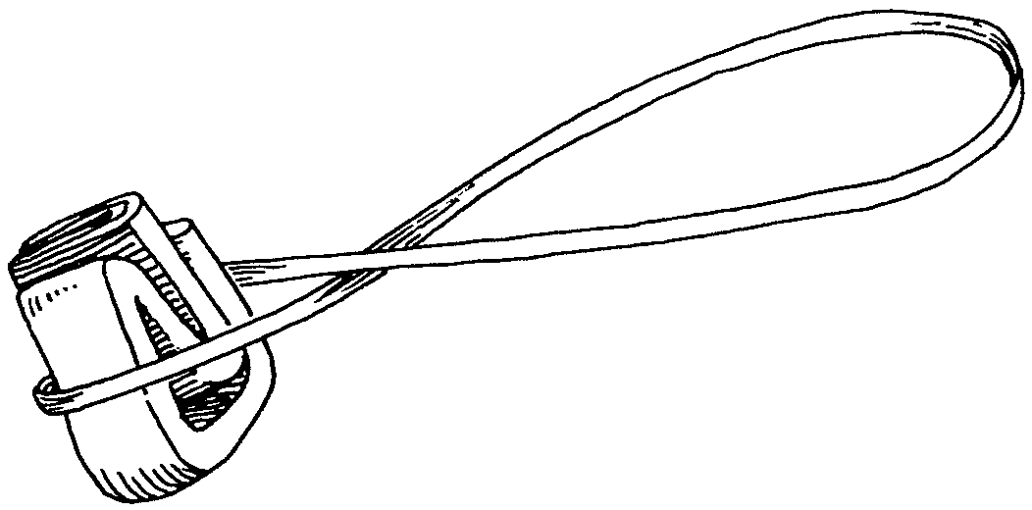
You will need lots of rubber bands!

1. For the core of the ball, use a small piece of paper or cardboard, folded up tiny. You could use a jack too.
2. Wrap a rubber band around the paper. Then twist the rubber band, wrap it back across, twist it again, and repeat until you use up the rubber band. (Or loop and twist a rubber band around a jack.)

3. Twist on a second rubber band, then a third and a fourth...you get the idea.

TO PLAY:

Because it’s uneven, the ball will bounce funny, going off into unexpected directions.
Try setting up targets outside to see if you can hit them.
Bounce the ball on the ground or against the side of a building and catch it.
Try bouncing and clapping your hands before you catch it. Or bounce the ball, spin around, and catch it.
Play a new version of jacks by picking up acorns, leaves, stones, twigs or bottle caps between bounces.

STAR FRAME FOR STAR CUB SCOUT

Hang all the stars in your den from a coat hanger and display the star mobile at the pack meeting. Later attach a magnet on the back for the Scout’s family refrigerator.

You will need: Dark blue and yellow craft foam pieces (e.g. Fun Foam or felt pieces) ; Gold glitter glue (or glue and glitter); Photo; Overhead transparency sheet (optional); Ribbon; Round or strip magnet.

1. Using the star pattern in July Craft Section, cut the star of your desired size. Trace it on yellow or blue foam. Refold the pattern and cut it slightly smaller. Trace it on the other fun foam. Refold the pattern and cut it smaller again. This star will be the opening for the frame. Trace the opening on the smaller star.
2. Cut out pieces.
3. Using glitter glue, decorate the smaller star (with the opening). Wait until it’s dry before going on to the next step. (It is best to decorate now than after the picture is set.)
4. Optional: If you want to protect the picture, cut and glue a piece of transparency sheet on the inside of the opening.
5. Trim picture to fit inside the star frame; center picture in opening and tape to secure.
6. Center and glue the back piece.
7. For the den display, attach a piece of ribbon on the back. (adopted from Crafts'n Things)

GOD’S EYE
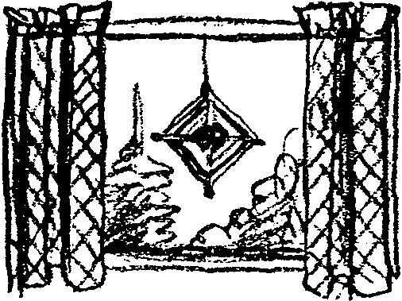

You will need: 2 sticks (twigs, dowels, popsicle sticks, etc.); Yarn or string; Glue.

1. Put two sticks together to make a cross.
2. Optional for younger children. Glue the sticks together.
3. When the glue is dry, tie the end of the string where the sticks meet. The knot should form an X on the front. The side where the knot is ties becomes the back.
4. Form the diamond by wrapping the yarn once around each arm of the cross.
5. Continue working around each arm. Vary the colors as you go so you work up a nice pattern. Shells with holes or beads can be added at intervals.
6. When you decide the diamond is big enough, tie off the end of the yarn.
7. Optional. Tie tassels or glue feathers to the ends of the sticks.
8. Hang the God’s eye in a window with a piece of string.
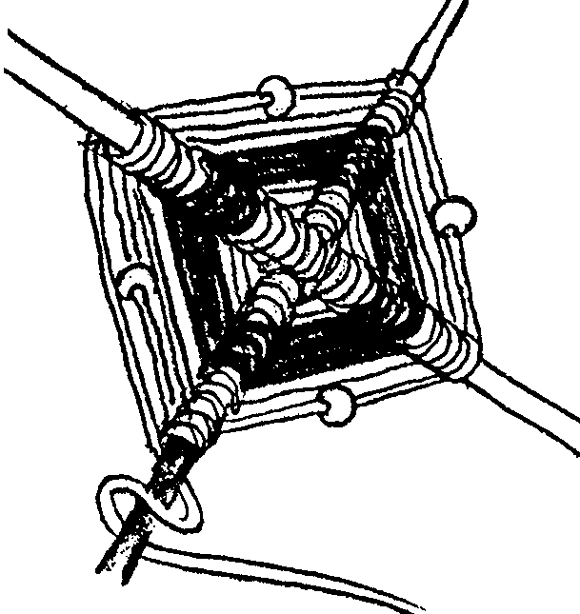
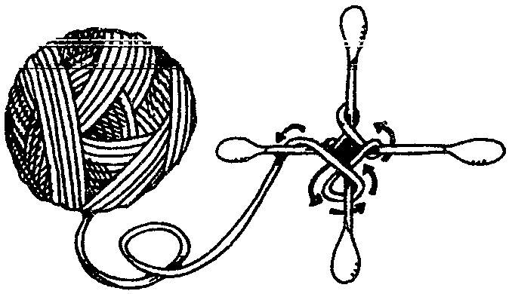
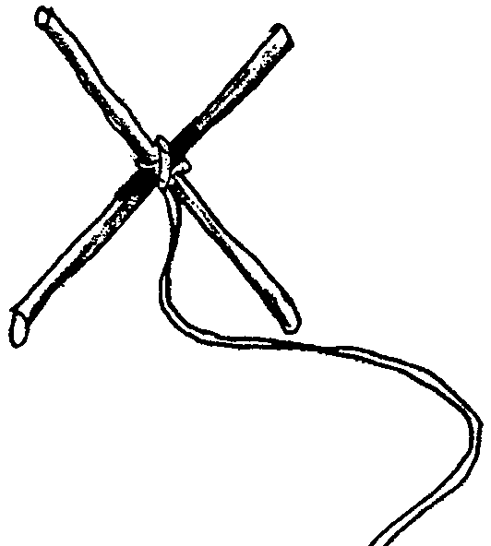

CHOCOLATE MEDALS FOR WINNERS
You will need: Large bars of chocolate (or chocolate made for candy molds); Paper cupcake cups; Shiny paper (gold or silver); Colored ribbons; Tape.
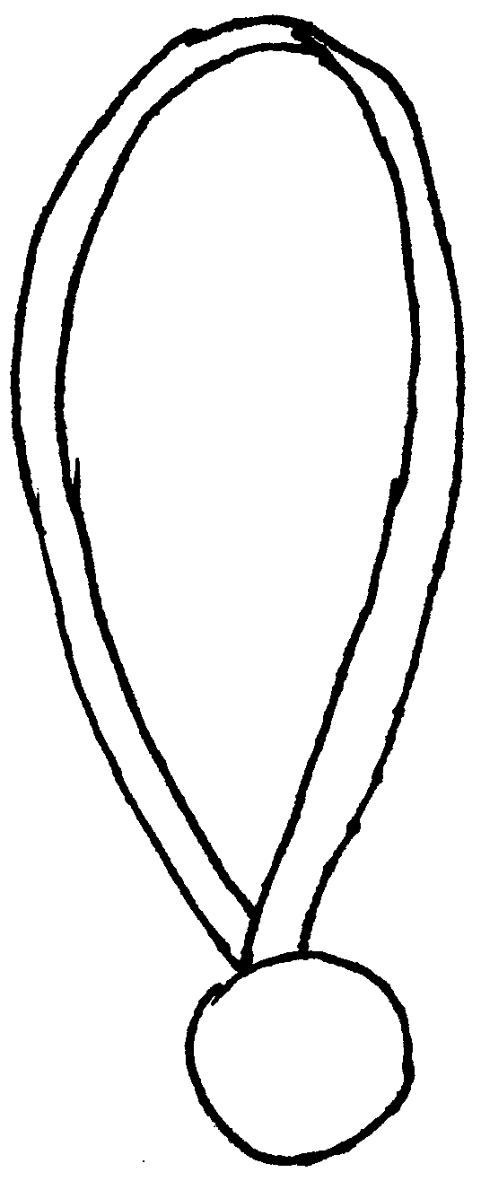

1. Break chocolate bar. Melt chocolate in a double boiler or in the microwave. (If using microwave, go slowly--chocolate can burn easily. Stir often.)
2. Set cupcake cups on a plate. Pour about 1/4" of melted chocolate into each cup. Put the plate in the refrigerator.
3. When the chocolate disks are set hard (doesn’t take long), gently push them out of the paper cups.
4. Wrap each chocolate medal in shiny paper, taping it down at the back of the medal with tape.
5. Attach a piece of ribbon (28" or so) to each medal.

RAINBOW FLOAT
Red fruit punch drink or fruit juice
Lemon sherbet
Lemon-lime carbonated beverage or sparkling water

1. Fill a tall glass halfway with punch or fruit juice.
2. Scoop into the glass 2 medium scoops sherbet (about 2/3 cup).
3. Fill the glass with carbonated beverage or sparkling water.
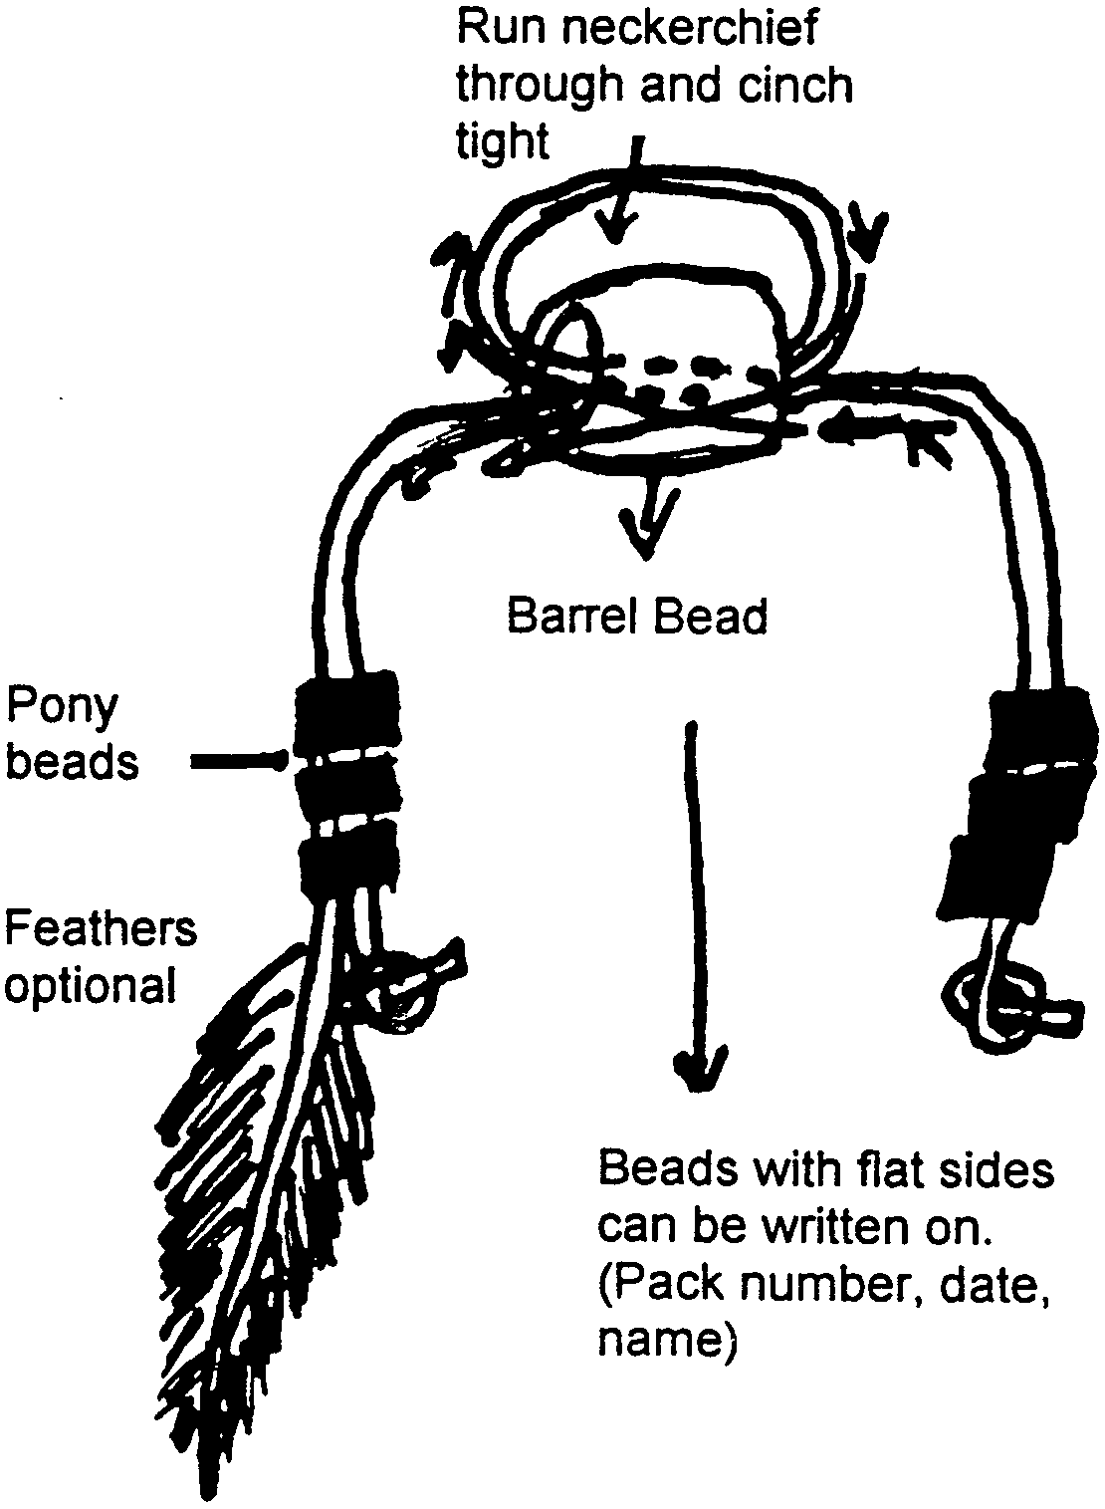
4. Serve right away.

THE BARREL TIE SLIDE.

You will need: Wooden barrel bead, 1/2" inside diameter (or big enough for two pieces of leather lace to go through); 12-16" leather lace; Pony beads; Feathers (optional).

Follow the illustration. Carefully write pack number on the side of the bead with fine-tip permanent marker. Use blue and yellow pony beads, or red, white and blue.

