Webelos Scouts

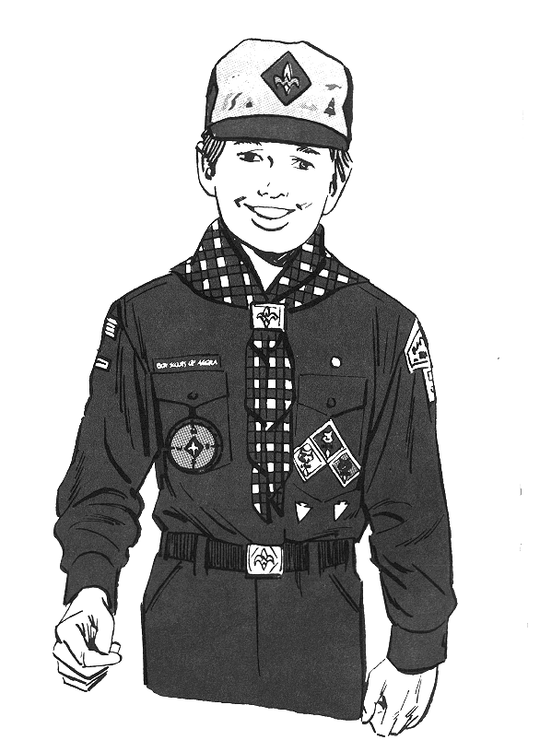

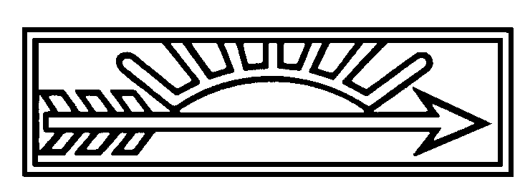

SUCCESSFUL TRANSITION TO BOY SCOUTING

Attend your district’s Cub Scout Leader Basic Training. If you have taken the Basic Training before (as a den leader, for example), attend at least the Webelos leader split session so that you can understand the Webelos requirements.
Attend the Council’s next Webelos Leader Outdoor Experience, so that you can understand the Webelos outdoor requirements and sharpen your own outdoor skills. In the second Webelos year, consider attending your district’s Scoutmastership Fundamentals training. This is a great way to get firsthand knowledge of how a troop works and of the patrol method. You can then take your knowledge back to your Webelos and get them excited.
Have a Boy Scout act as your den chief to assist you in your weekly Webelos den meetings.
Get help from other experienced Webelos leaders or your Webelos Den Leader Coach.
Attend your district’s monthly Roundtable and meet other Webelos leaders and Boy Scout leaders.
Attend your district’s WeST Fair.
At every opportunity, talk about Boy Scouting.
Take your Webelos Scouts camping. Teach them the basics about fire building, knots, camp tasks, cooking, site selection, and camp rules.
Introduce your Webelos to service projects.
Show pride in your uniform.
Gradually hand over den leadership to the boys. Let them learn what it is like to have the added responsibility.
In their second year expose the boys to as many Boy Scout troops as you have the time for.
Attend your district Camporee and meet Boy Scout troops. Visit them at their campsites.
Create games as a form of learning the Scout Oath, Law, signs, and Scout skills. There is nothing like a little intra-den competition to spark boys this age.
If you were a Boy Scout, talk about your adventures and apprehensions. Show the boys some of your old gear or pictures.
Let the boys talk about their ideas of what Boy Scouting is, their anticipation and their fears.
Have Boy Scouts visit your den, especially Eagle Scouts in full uniform.
Get a list of the key troop leaders in your area. Call the leaders, ask for a brief description of troop activities and present them to your den. Let them decide what troops to visit.
Using these ideas and those of your own should make the transition to Boy Scouts easier for your Webelos Scouts and you too. After all, what are you going to do when your Webelos move on? Join the boys in Boy Scouting and continue the adventure. It’s a lot of fun!

THE SCOUT BADGE

To teach Webelos Scouts the parts of the Scout badge, enlarge the design below and cut the separate parts from thin plywood or pressboard (or cardboard). Cut out with a scroll saw and paint or stain. Use the individual parts to teach the badge requirement for the Webelos badge.

The Scout badge was adapted from the north point of the old mariner’s compass. The design is often called a trefoil--a flower with three leaves. It is also known by its French name “fleur-de-lis”--lily or iris flower. It goes so far back in history that it is uncertain whether it actually stands for a flower or for an arrowhead. With slight changes, the trefoil badge is used by Scouts around the world.

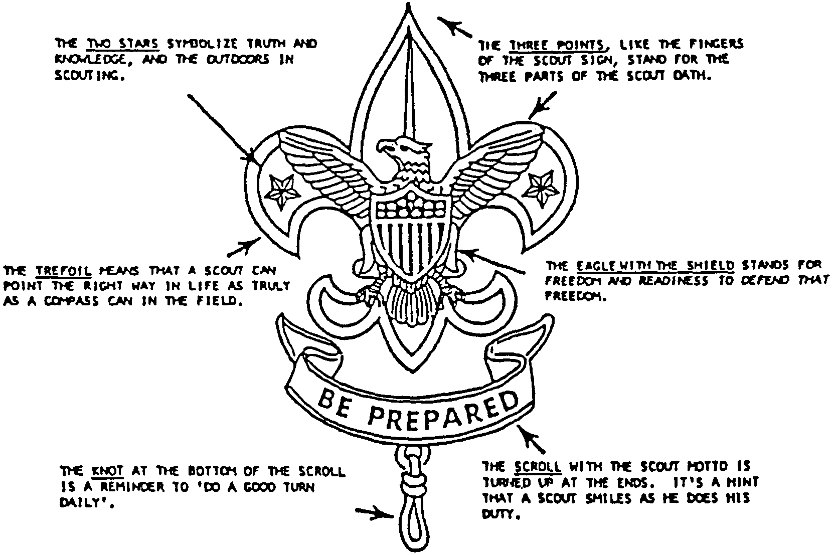

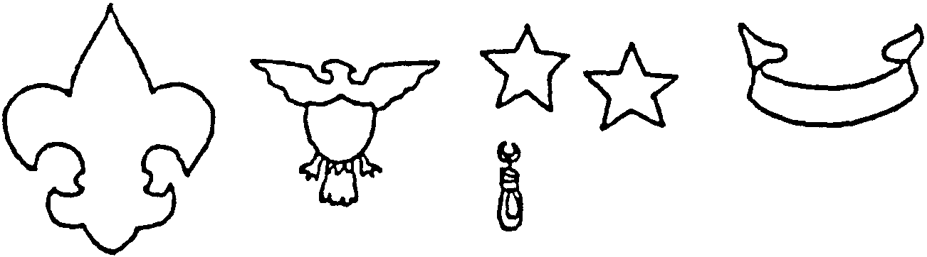
SCOUT BADGE AND UNIFORM QUIZ

Q: The three-point design of the Scout badge is like what?
A: It is like the sign of north on the mariner’s compass.

Q. To what do the three points of the Scout badge refer?
A: The three points refer to the three points of the Oath: (1) “to do my duty to God and my country and to obey the Scout Law,” (2) “to help other people at all times,” (3) “to keep myself, physically strong, mentally awake, and morally straight.”

Q: The eagle with a shield on the badge is the emblem of what?
A: The eagle is the national emblem of the United States of America.

Q: What does the eagle stand for?
A: The eagle stand's for freedom and for readiness to defend that freedom.

Q: What do the two stars stand for?
A: The stars stand for the ideals of truth and knowledge, foundation of strong Scout citizenship.

Q. Why is the scroll turned up at the ends?
A: It is like a Scout’s mouth, because a Scout smiles as he willingly does his duty.

Q: The knot at the bottom reminds of Scout of what?
A: To do at least one good turn for somebody everyday.

Q: What is written on the scroll?
A: The scroll has the Scout Motto, “Be Prepared.”

Q: What part of the badge does the Tenderfoot wear?
A: The upper three-pointed part, or trefoil.

Q: What part does the Second class Scout wear?
A: The scroll.

Q: What does the Scout uniform stand for?
A: The spirit of service. It shows that you are a good citizen and are ready and willing to help other people.

Q: Should a Scout wear his uniform on a hike?
A: Yes. A Scout should wear his uniform on all Scout activities, patrol or troop meetings, hikes, camps, etc.

Q: Name three occasions besides troop activities when a Scout should wear his uniform?
A: Formal Courts of Honor, during Scout Anniversary Celebration, and for special Scout or civic service projects.

GAMES

The three basic rules: DON’T PANIC, THINK, SAVE YOUR STRENGTH.
Tell what to do for cramps, currents, undertows, weeds; how to disrobe in the water, use clothing for floatation, and use survival floating techniques. The following are some good beginner games.
1. Catching a ball in shallow water.
2. Passing beach ball while standing in water.
3. Tunnel ball--passing a ball back and between the legs.
4. Cat and mouse--cat outside circle, mouse inside.
5. Spoon and ping-pong ball relay.
6. Kick board race for 10 to 25 yards.
7. Relay race in shallow water, running and gliding on stomach.

FLOATING EXERCISES
Some boys may not be able to swim yet. Floating exercises can help overcome fear or unfamiliarity with water.
TURTLE FLOAT
In waist-deep water, take a deep breath. Reach down and wrap arms around knees. Hold the knees. Your body will bob to the surface and float.
JELLYFISH FLOAT
In waist-deep water, take a deep breath, reach down and grab ankles. Hold ankles. Your body will bob to the surface and float.
PRONE FLOAT
After doing the turtle float, extend arms and legs. The next step is to add a swimming kick to move through the water!

BALL BETWEEN KNEES RACE
This game is played in any swimming area in which you can define a start and finish line. This game can be played as a race between swimmers or as a relay race between teams. You will need one floating ball for each team. It may be of any size that can be held between a boy’s knees. The object of the game is to swim to the finish line with the ball held between the knees. If a swimmer loses the ball, he must chase it and bring it back to the point where it was lost and continue the race. If you are playing relays, each swimmer after crossing the finish line must toss the ball to the next swimmer so that the race can continue.

AQUA HOOPS
1. Place a hula hoop on the water in the center of the pool. Let the boys throw balls into the hoop while in the pool themselves. The hoop can be held in place by anchoring with filled milk jugs.
2. Anchor hula hoops vertically underwater at different depths. Use a gravel and water filled milk jug as an anchor. Boys must swim underwater through hoop obstacle course. Leave enough room between hoops for “coming up for air.”
3. A hula hoop towing contest is worth a few smiles. Two boys tow a leader from one end of the pool to another, or one boy tows another.

SWIMMING SPELL DOWN
This is a game for swimmers. Leader calls out a stunt. Swimmers performing it remain in the game, others are eliminated as in a spelling match.
1. Swim with one arm out of water (side stroke).
2. Swim on the back with both arms out.
3. Steamboat (arms forward and feet do crawl kick).
4. Duck dive (surface dive).
5. Log roll (arms and feet extended, roll the body).
6. Front somersault.
7. Pendulum float.

SAFETY IN THE BUDDY SYSTEM

BUDDY PLAN: Pair every boy with a buddy in his own ability group. Make sure each buddy understands that he is to be on constant look-out for his buddy and vice-versa, and that they are to stay near each other at all times. Buddies join and raise hands together every time they hear the call, “Buddy Check!”

BUDDY TAGS: Cut two-inch circles from light wood or plastic. Drill a hole in the center for hanging. Write Webelos Scout’s name on circle with water-proof ink. Use stripes to indicate skill--red for non-swimmer; blue for beginner; green for swimmer.

MAKE A BUDDY BOARD TO KEEP BOYS RESPONSIBLE FOR EACH OTHER
You will need:
1. One 3/4" pine board, press-board or plywood. Size about 40" x 16".
2. Buddy tags, about 2" diameter.
3. 24 L-hook screws 1/2" long. Big enough for holes drilled in circle centers.
4. Sweat wrist bands. Colors: red, blue and green.
Have enough buddy tags and sweat wrist bands for the boys in your den.

All the circles will be in the “IN” position until the boys enter the water. When the boys enter the water, they will take the buddy tag hung in their skill level and place it in the “OUT” position below, and put on the sweat wrist band of their skill level color that is hanging on the “OUT” hook.. Have the boys keep the bands on until they are ready to leave the swimming area, dress and leave. Sweat bands are for the supervisors to identify the level of the boys easily.

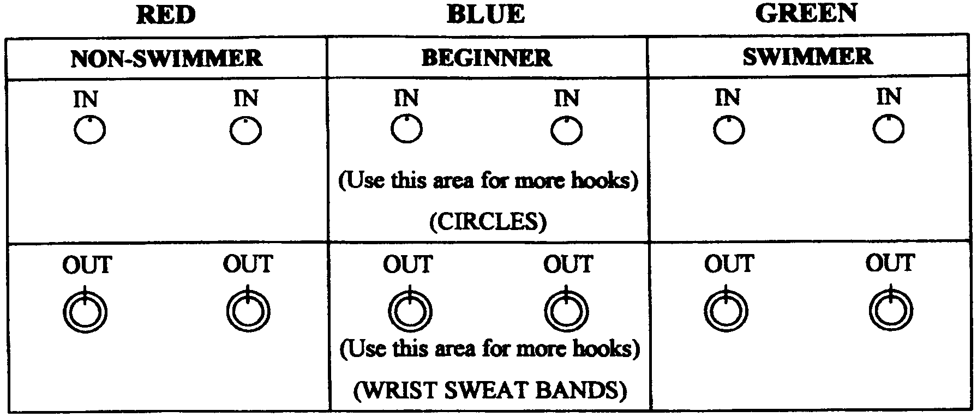
GAMES

FIVE DOTS
Give each Webelos Scout a piece of paper and have him place five dots on it wherever he pleases. He then gives the paper to another boy who tries to fit on it a drawing of a person with the head at one dot, the hands at two other dots, and the feet at the two remaining dots. The drawing may not be a simple stick figure.

EYES-SHUT DRAWING
Have the Scouts draw a picture of a clown, a car or some other object while blindfolded. Agree on the picture ahead of time and then blindfold the Scouts. Take up the pictures and see if the Scouts can identify their own drawing. You may have winners or no winners.

OUTLINE OR WIGGLES
Have each Scout draw a wavy or zigzag line on paper. Have the boys exchange papers and make their line into a picture. The one with the best or funniest picture is the winner.

TIN FOIL SCULPTURES

You will need: Plenty of aluminum foil; clear tape; wire; long straight pins; acrylic paint and brush or permanent markers; scraps of fabric, paper, yarn, etc.; glue.

1. Crumble aluminum foil to form shapes of objects or creatures, or shape the foil around a wire frame.
2. Fasten clumps together with pins, wire, or tape.
3. Use paint or markers to add color.
4. Glue on scraps of fabric, paper, yarn, etc. to add details.
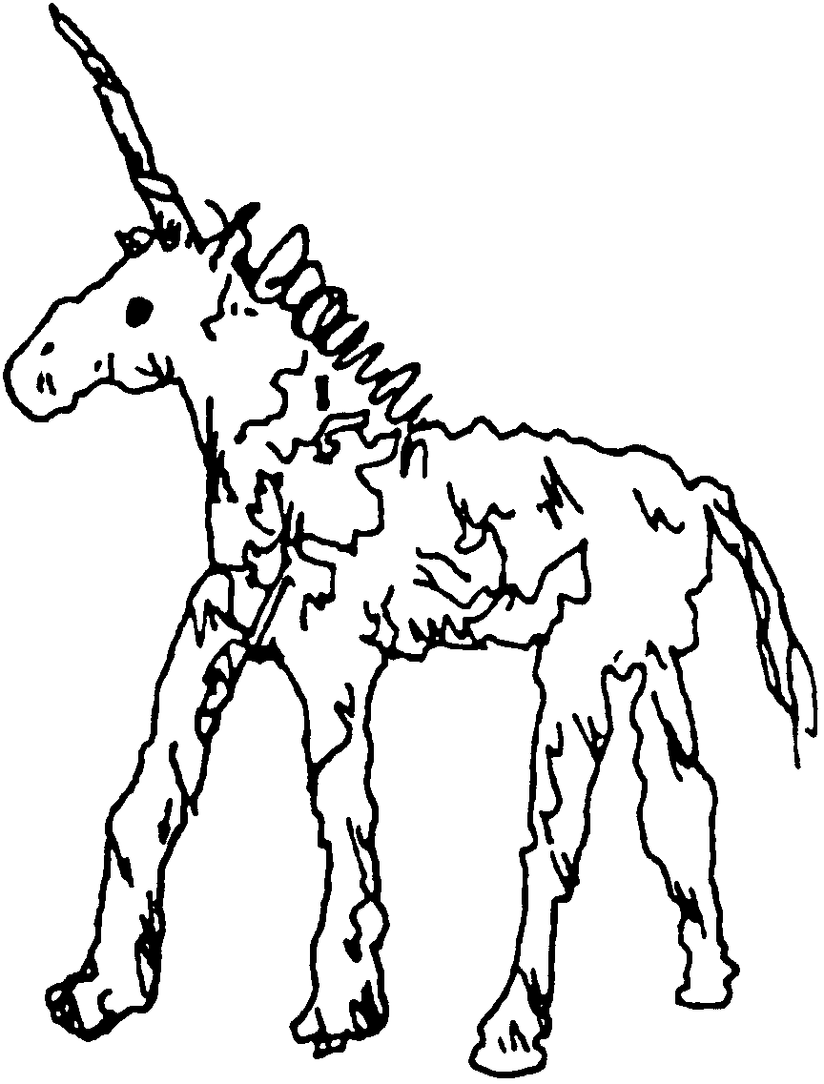
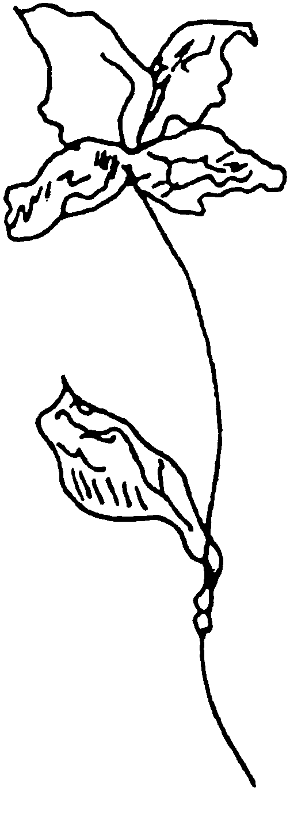

EASELS
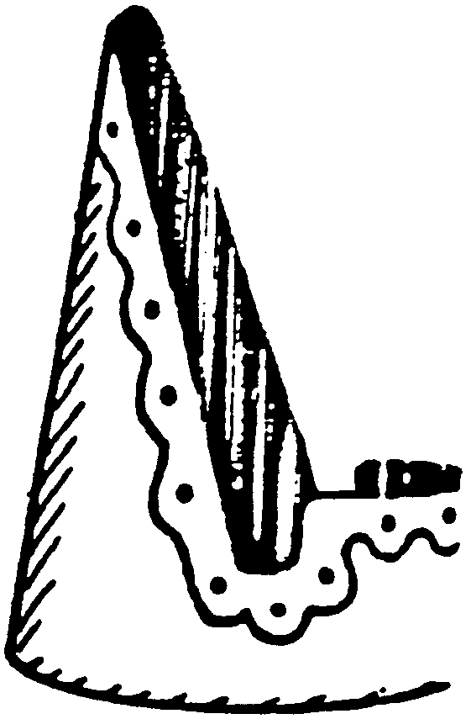
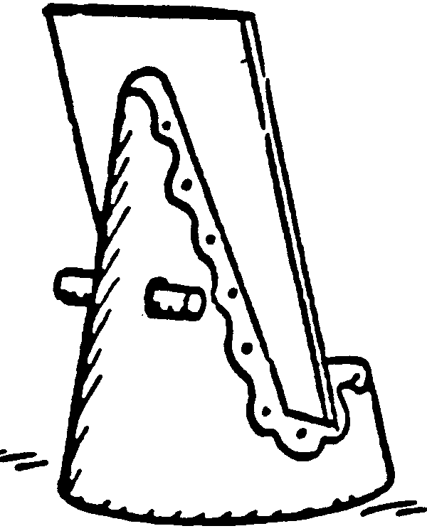
DETERGENT BOTTLE EASEL
You will need: Detergent bottle; plaster of paris; permanent markers.

1. Cut bottle as shown.
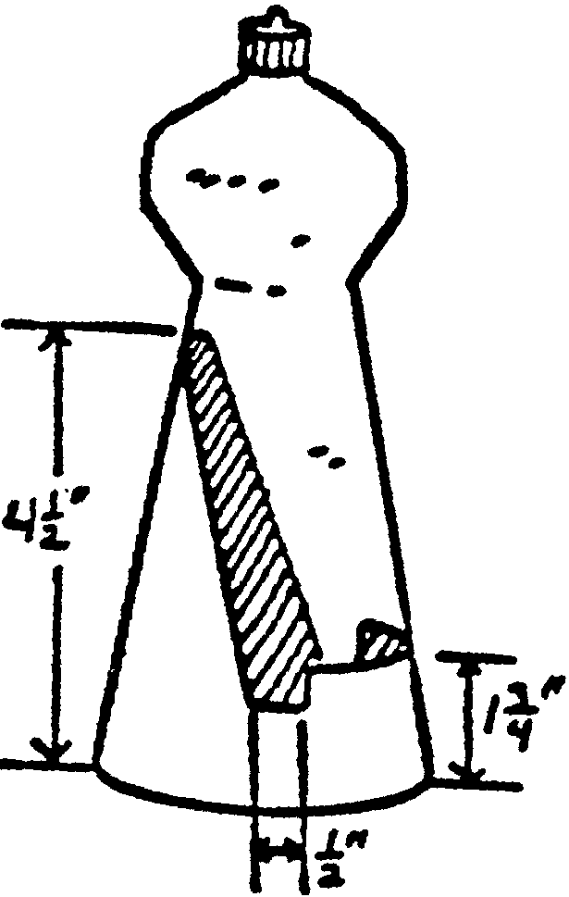
2. Fill base with plaster.
3. Decorate with markers.

Suggestions:
1. Cut it with a higher back from a larger bottle and it will hold an open book.
2. Cut it from a small bottle and it is just the right size for index cards.
3. Two easels placed in a row will support a small chalkboard or a poster.
4. Punch matching holes in the back of the easel and you have a hideaway for pencils etc.
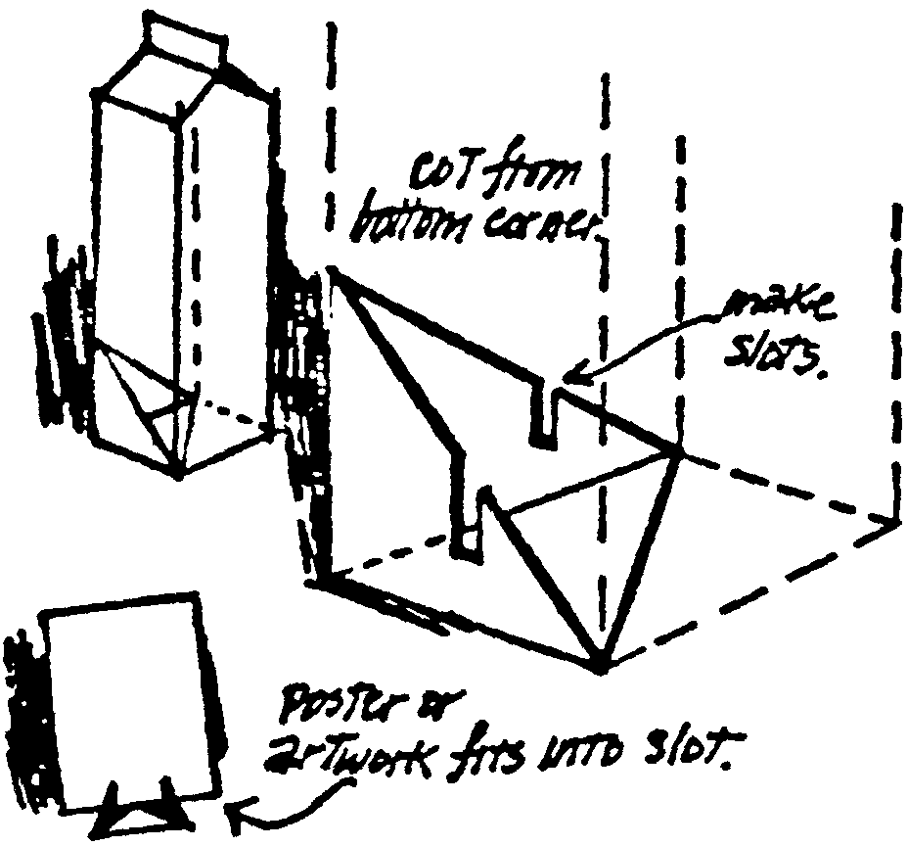

MILK CARTON EASEL

ARTIST NECKERCHIEF SLIDE

You will need: A thin piece of plywood, masonite or similar material; paint (beige or off white, and colors indicated on the illustration below); black marker; varnish; 1/2" PVC pipe; glue or glue gun.
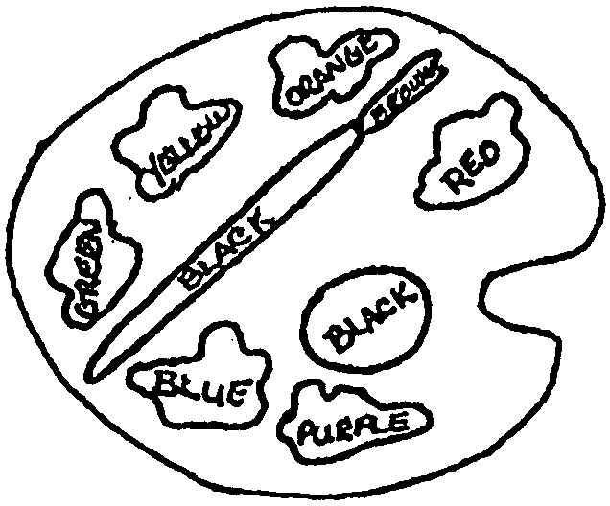
1. Cut shape out of a thin piece of plywood, masonite or any such material.
2. Paint the entire shape a light color, such as beige or off-white.
3. Paint as directed--note that the color placement makes a color wheel.
4. When the paint is dry, outline the colors with a black pen to accent the colors.
5. Apply a thin coat of varnish.
6. Glue a section of the PVC pipe onto the back.
AGILITY EXERCISES

Perform these exercises within the designated time limits. Rest two minutes between each set of exercises.

SET 1. (8 minutes)

1. Fish Flops: Lie flat on your stomach, arms and legs extended and off the ground. Rock back and forth. (2 minutes)
2. Grass Drill: Run in place. Drop to ground and bounce up again. (2 minutes)
3. Quick Foot-Knee Touch: Drop quickly to one knee and bounce up again. Alternate knees. (2 minutes)
4. Root Drill: You need a partner for this one. Square off on all fours, locking right shoulder to right shoulder. Try to rock your opponent back off his feet. (2 minutes)

REST TWO MINUTES

SET 2. (6 minutes)

1. Crab Mirror: Two players on all fours. One moves at random to the left, right, back or forward, and the other mirrors his moves. Switch leaders and repeat. (2 minutes)
2. Bear Hug Take-Down: Two players, one standing behind the other. Player in rear grasps other player around arms and chest and tries to pull him down. Reverse positions and repeat. (3 minutes)
3. Sit-Ups: Lie on back, feet together, hands clasped behind head. Raise up and touch elbows to knees. Do as many as possible. (1 minute)

REST TWO MINUTES.

SET 3: FLEXIBILITY EXERCISES

1. Fingers: Extend arms to the side, palms down. Quickly flex by alternating between fist and open hand position. (30 seconds)
2. Palms: Extend arms to the front, palms down, wrists locked. Turn palms inward and outward in quick, short movements. (30 seconds)
3. Wrists: Same position as palms above. Rotate wrists clockwise, then counterclockwise. (30 seconds)
4. Forearm Twist: Arms extended sideways and parallel to ground. Flex at elbow bringing tips of fingers to shoulders. Return to starting position. Perform both palms up and palms down. (1 minute)
5. Shoulder Stretches: 3-part exercise. (2 minutes)
(A) Rotate one arm over your head and down slowly. Repeat with other arm.
(B) Shrug your shoulders slowly in complete circle starting the movement by moving up and back.
(C) Lock your hands behind head and pull back slowly from shoulder.
LUNG CAPACITY

You will need: A large plastic bag (kitchen garbage bag); marker that will write on bag; a funnel; a pitcher or measuring cup marked in quarts.

1. Bunch together opening of the bag to make a mouthpiece. Make the opening large enough to blow into with your mouth open.

2. Squeeze the bag to get the air out.

3. Hold on to the bag away from your mouth and take two normal slow breaths. On the next breath, breathe in as much air as you can, then bring the plastic bag to your mouth.

4. Pinch your nose and breathe out hard into the bag in one breath. Keep your mouth open wide. Continue pushing the air out until you feel as though every last drop of air is squeezed from your lungs. It helps to bend forward as you breathe out. Close the bag tightly and hold while taking it away from your mouth.

5. Slide your hand down the neck of the bag until the bag is completely expanded. Mark the bag at the point where you’re holding it.

6. Push the neck of the funnel into the mouth of the bag, still keeping a firm grip on the bag so it doesn’t move. Don’t worry about the air escaping--you don’t need it.

7. Using the marked pitcher, pour water into the bag until it’s fully expanded with water as it was with air. The bag might get heavy, so rest it in the sink or on a table.

This will give you an approximate idea of your lung capacity. The average 4'6" boy has a lung capacity of 2 quarts. The average 5' boy has a lung capacity of about 3 quarts. The larger your lung capacity, the greater your advantage in endurance sports like long-distance running or swimming.

THREE-WAY TUG OF WAR

You will need: One 12-foot length of rope; three bandannas or neckerchiefs.

1. Tie the ends of the 12-foot rope together securely.
2. Evenly space three tuggers around the rope. Have the tuggers drop their bandannas or neckerchiefs just out of reach as they each hold the rope.
3. On signal, each tugger tugs and tries to reach his bandanna or neckerchief.

COULD YOU BECOME A CITIZEN?

These are questions taken from the Basic Guide to Naturalization, published by the Immigration and Naturalization Service of the United States Department of Justice. (Answers on next page.)

1. Who discovered America and what was he looking for?
2. What were the first 13 original states which formed the Union?
3. How many amendments to the constitution have been made so far?
4. What must be done before the Constitution can be amended?
5. What right is provided in the 15th Amendment?
6. When was the Constitution of the United States adopted?
7. What form of government do we have in the United States? What is the difference between a republican type of government and a monarchy?
8. How many Presidential electors does each state have?
9. What is the most important right that the Constitution gives us as Americans?
10. What are the first 10 amendments to the Constitution called?
11. Who established the first permanent colonies in North America?
12. What is meant by referendum?
13. What are the colors of the United States flag and what do they stand for?
14. Who was President during the Civil War and about when was this war fought?
15. What document was signed on July 4, 1776? Where was it signed and what did it declare?
16. What are the basic principles of the US Constitution?
17. Who is eligible for the office of President or Vice President?
18. When and where does Congress meet?
19. Why is the government divided into three branches?
20. How many members are there in the Supreme Court? What is the term of office for these judges?

U. S. PRESIDENTS

How many of our presidents do you know? See if you can sort out their names. If all else fails, use the encyclopedia.

Example: DRFO FORD

1. S D M A A
2. V H E R O O
3. L L N N I O C
4. N J H O O N S
5. V O O S R T E E L
6. S F F J O E R E N
7. R T A N G
8. R R A I O H N S
9. K L P O
10. L Y T R E
11. V E E C L L N D A
12. N V A N U B R E
13. K A J C N S O
14. E Y H S A
15. N I S W O L
16. N O D I S A M
17. M T U R N A
18. X N N I O
19. Y T L O A R
20. W H O S E E E I N R
21. E P I C R E
22. H R A T U R
23. F T A T
24. O N A W S H I G T N
25. O O C G E L I D
26. M O E R L L I F
27. D Y N N E E K
28. I G H D A N R
29. K C M L Y I N E
30. R N O O M E

Answers: 1-Adams; 2-Hoover; 3-Lincoln; 4-Johnson; 5- Roosevelt; 6-Jefferson; 7-Grant; 8-Harrison; 9-Polk; 10-Tyler; 11-Cleveland;
12-Van Buren; 13-Jackson; 14-Hayes; 15-Wilson; 16-Madison; 17-Truman; 18-Nixon; 19-Taylor; 20-Eisenhower; 21-Pierce; 22-Arthur;
23-Taft; 24-Washington; 25-Coolidge; 26-Fillmore; 27-Kennedy; 28-Harding; 29-McKinley; 30-Monroe

ANSWERS TO CITIZENSHIP QUESTIONS
1. Christopher Columbus discovered America in 1492. He was looking for a short route to the Orient.
2. Connecticut, Delaware, Georgia, Massachusetts, Maryland, New Hampshire, New Jersey, New York, North Carolina, Pennsylvania, Rhode Island, South Carolina and Virginia.
3. Twenty-six amendments have been made so far.
4. Both Houses of Congress must pass the amendment, and 36 states must ratify and approve it.
5. The 15th Amendment gave all American citizens the right to vote, regardless of race, creed, or color.
6. The Constitution of the United States was adopted March 4, 1789.
7. A republic. In a republican form of government the supreme power rests in all citizens entitled to vote and is exercised by representatives elected directly or indirectly by them and responsible to them, while in a monarchy the head of the nation is from a family that inherits the throne.
8. Each state has as many Presidential electors as it has United States Senators and Representatives.
9. It gives us Equality before the laws regardless of race, color, or religion. It gives us freedom so long as we do not interfere with the rights of others.
10. The Bill of Rights.
11. The English were first with permanent colonies.
12. Referendum means that people may ratify or annul acts of the legislature.
13. Red is for courage, white stands for truth, and blue is for justice.
14. Abraham Lincoln was President. 1861-1865.
15. The Declaration of Independence, signed at Philadelphia. Declared our independence from England.
16. Liberty, Equality, and Justice.
17. A native-born American citizen who is at least 35 years old.
18. Congress meets in Washington DC on January third of each year.
19. To provide a system of checks and balances to prevent any group from becoming too strong.
20. There are nine Justices in the Supreme Court. They serve for life with good behavior.

“HEAR, HEAR!” GAME

This is a game identifying sounds. The Webelos den leader or den chief produces sounds from behind a screen while the Webelos Scouts listen. As each sound is produced, tell the boys to write down what sounds they heard. Have the boys write their guesses as specific as possible. Examples of sounds are:

sandpaper rubbed on wood deck of cards being shuffled
manual egg beater in water golf ball bouncing on wood floor
cutting into an apple removing groceries from plastic bag
opening an envelope opening a can of soda
harmonica adding machine

Vary the objects, sounds, and duration of the sound. Boys may also be blindfolded instead.

COMMUNICATIONS CALISTHENICS

Not all communication is verbal. Prepare 3x5 cards with emotional phrases or statements written on them. Place the cards in a container so that the boys can draw them out. Each boy, in turn, draws a card and then must convey what it says without using any verbal language or sounds. The boys may use body language and facial expressions only.

Some expressions:
Come over here! Stop! That smells bad!
I’m tired! That smells good! Help!
OK! I need to use the bathroom I’m thirsty!
I’m choking! Watch out! Go away!
Be quiet! What time is it? Listen to me!

Some facial expressions to try:
exhausted confused ecstatic suspicious
angry frustrated sad confident
happy embarrassed disgusted frightened
depressed lonely surprised shocked

MIXED-UP MESSAGES GAME

Boys will line up in teams of five or six. You will need two adults to give the first boy in each line the same message. Messages should be written or whispered. On signal, the first boy runs to the finish line, eats two crackers, then runs back and whispers to the next boy what the message is. All boys do this until the last boy on the team eats his crackers and tells the message to the adults, who will decide if the message is the same as the starting message. The first boy in each line moves to the back and the game continues with a new message.
VARIATION: Everyone sits in a circle and the message is whispered from one end of the circle to the other end. No crackers are used here. If the boys are good at this, then try two messages going in opposite directions around the circle.

GOING TO THE BEACH

The leader starts off by saying, “I’m going to the beach. Everyone needs to come along. I’m bringing LOTION. What are you bringing?” Each boy answers in turn what they will bring to the “beach.” The trick is that their answer must begin with the first letter of their first name. Do not give away the secret. Let the boys figure it out as they continue to guess. Soon they will catch on, but they should not reveal the secret when they guess it. Example: Leader’s name is Leslie.

Leader: I’m going to the beach and I’m bringing Lotion.
Teddy: I’ll bring a chair.
leader: No, you can’t bring that.
Frank: I’ll bring a Frisbee.
Leader: Good, Frank can come along. I’m also bringing a ladder.
Johnny: I’ll take my dog, Rex.
Leader: No sorry, Rex can’t go.
Teddy: Can I bring a Towel?
Leader: You can bring a towel. I’m bringing a Ladle.

Keep going!

MRS. MACGILLICUTTY’S CAT

The leader starts, “Mrs. MacGillicutty’s cat likes summer, but not winter.” Boys can ask if her cat likes other items. The trick here is that each item the cat likes has double letters and what it dislikes is an item similar or related but does not have double letters.

Examples: Likes hammers, doesn’t like nails
Likes ladders, doesn’t like steps
Likes letters, doesn’t like mail
Likes Bill, doesn’t like Lucy
Likes rooftops, doesn’t like ceilings

PIG LATIN

Try Pig Latin with your den. Move the first consonant sound to the end of the word and add “ay” to it. For example, “pig latin” becomes “igpay atinlay” and “cub scout” becomes “ubcay outscay.” For words that start with vowels, add “ay” at the end; so “achievement” becomes “achievementay.”

TOOL IDENTIFICATION

Pictured below are some of the basic tools Webelos Scouts may use when working with wood, leather or tin. See how many they can name.

1. Saw
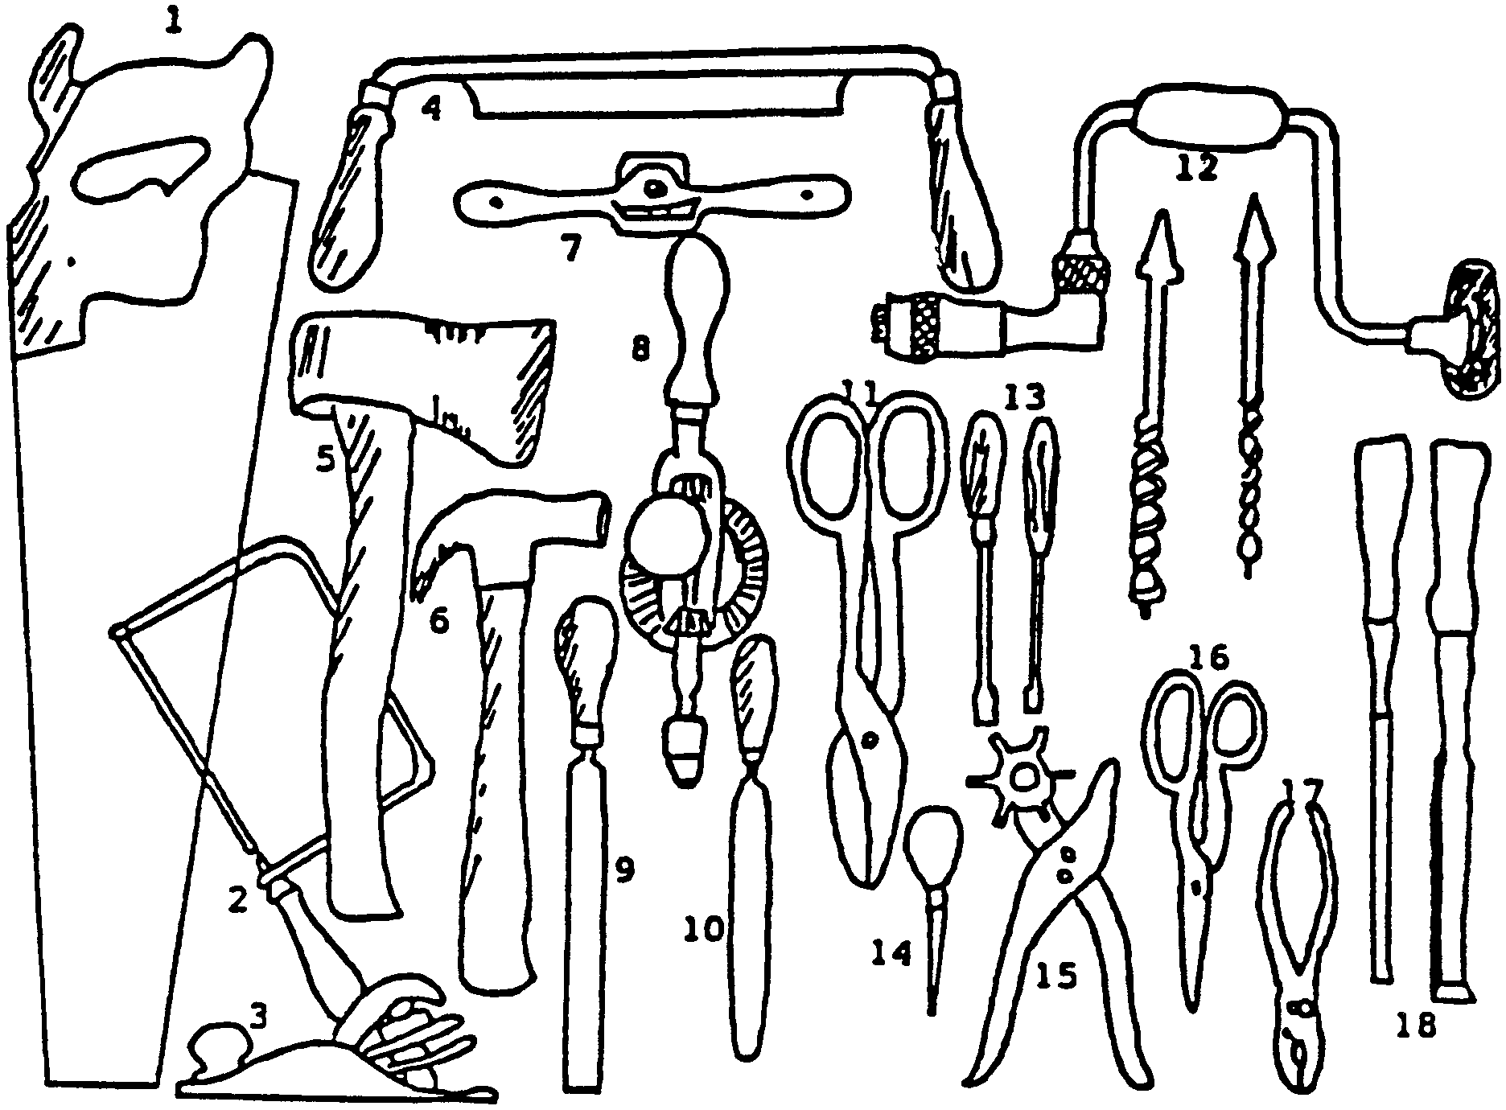
2. Coping Saw
3. Plane
4. Drawknife
5. Hand Ax
6. Claw Hammer
7. Spokeshave
8. Hand Drill
9. File
10. Half-round File
11. Tin Snips
12. Brace and Bits
13. Screwdrivers.
14. Awl
15. Leather Punch
16. Shears
17. Pliers (slip-point)
18. Chisels

TOOLS KIM’S GAME

Arrange on a table, 12 to 15 tools and cover them. Uncover for the boys to study them, without touching, for one minute and cover them again. Ask the boys to write down what they saw. Variation: Mix wood tools with leather tools. After re-covering the tools, ask them to name them in separate categories.

EASY BOOK ENDS

You will need: Thin plywood or shelf board, 1 piece 6" x 18", 2 pieces 6" x 6"; Four small hinges; Screws
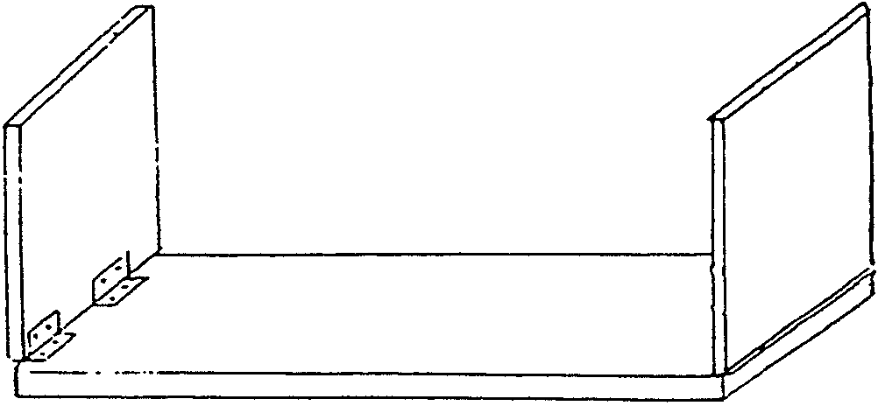

1. Cut wood and sand smooth.
2. Place one 6" x 6" piece at the end of the longer base piece. Make sure it is flush with the edge of the base.
3. Place hinges along inside edge, where two pieces fit together. Mark holes for screws.
4. Attach hinges to both pieces and repeat with other end piece.
5. Paint or decorate as desired. When ends are raised, books can be placed in between.

DOORKNOB PLAQUES
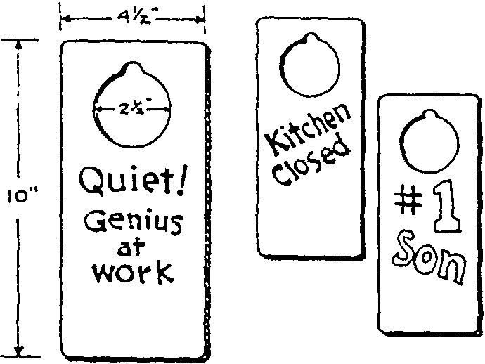
Just-for-fun signs boys can hang on door knobs around the house. Cut from 1/2" plywood. decorate as desired.

DISH BRACKET

Trace the pattern. Cut the back out of a 1/2" pine. The two feet are pieces of 1/4" plywood. Sand and paint or stain.

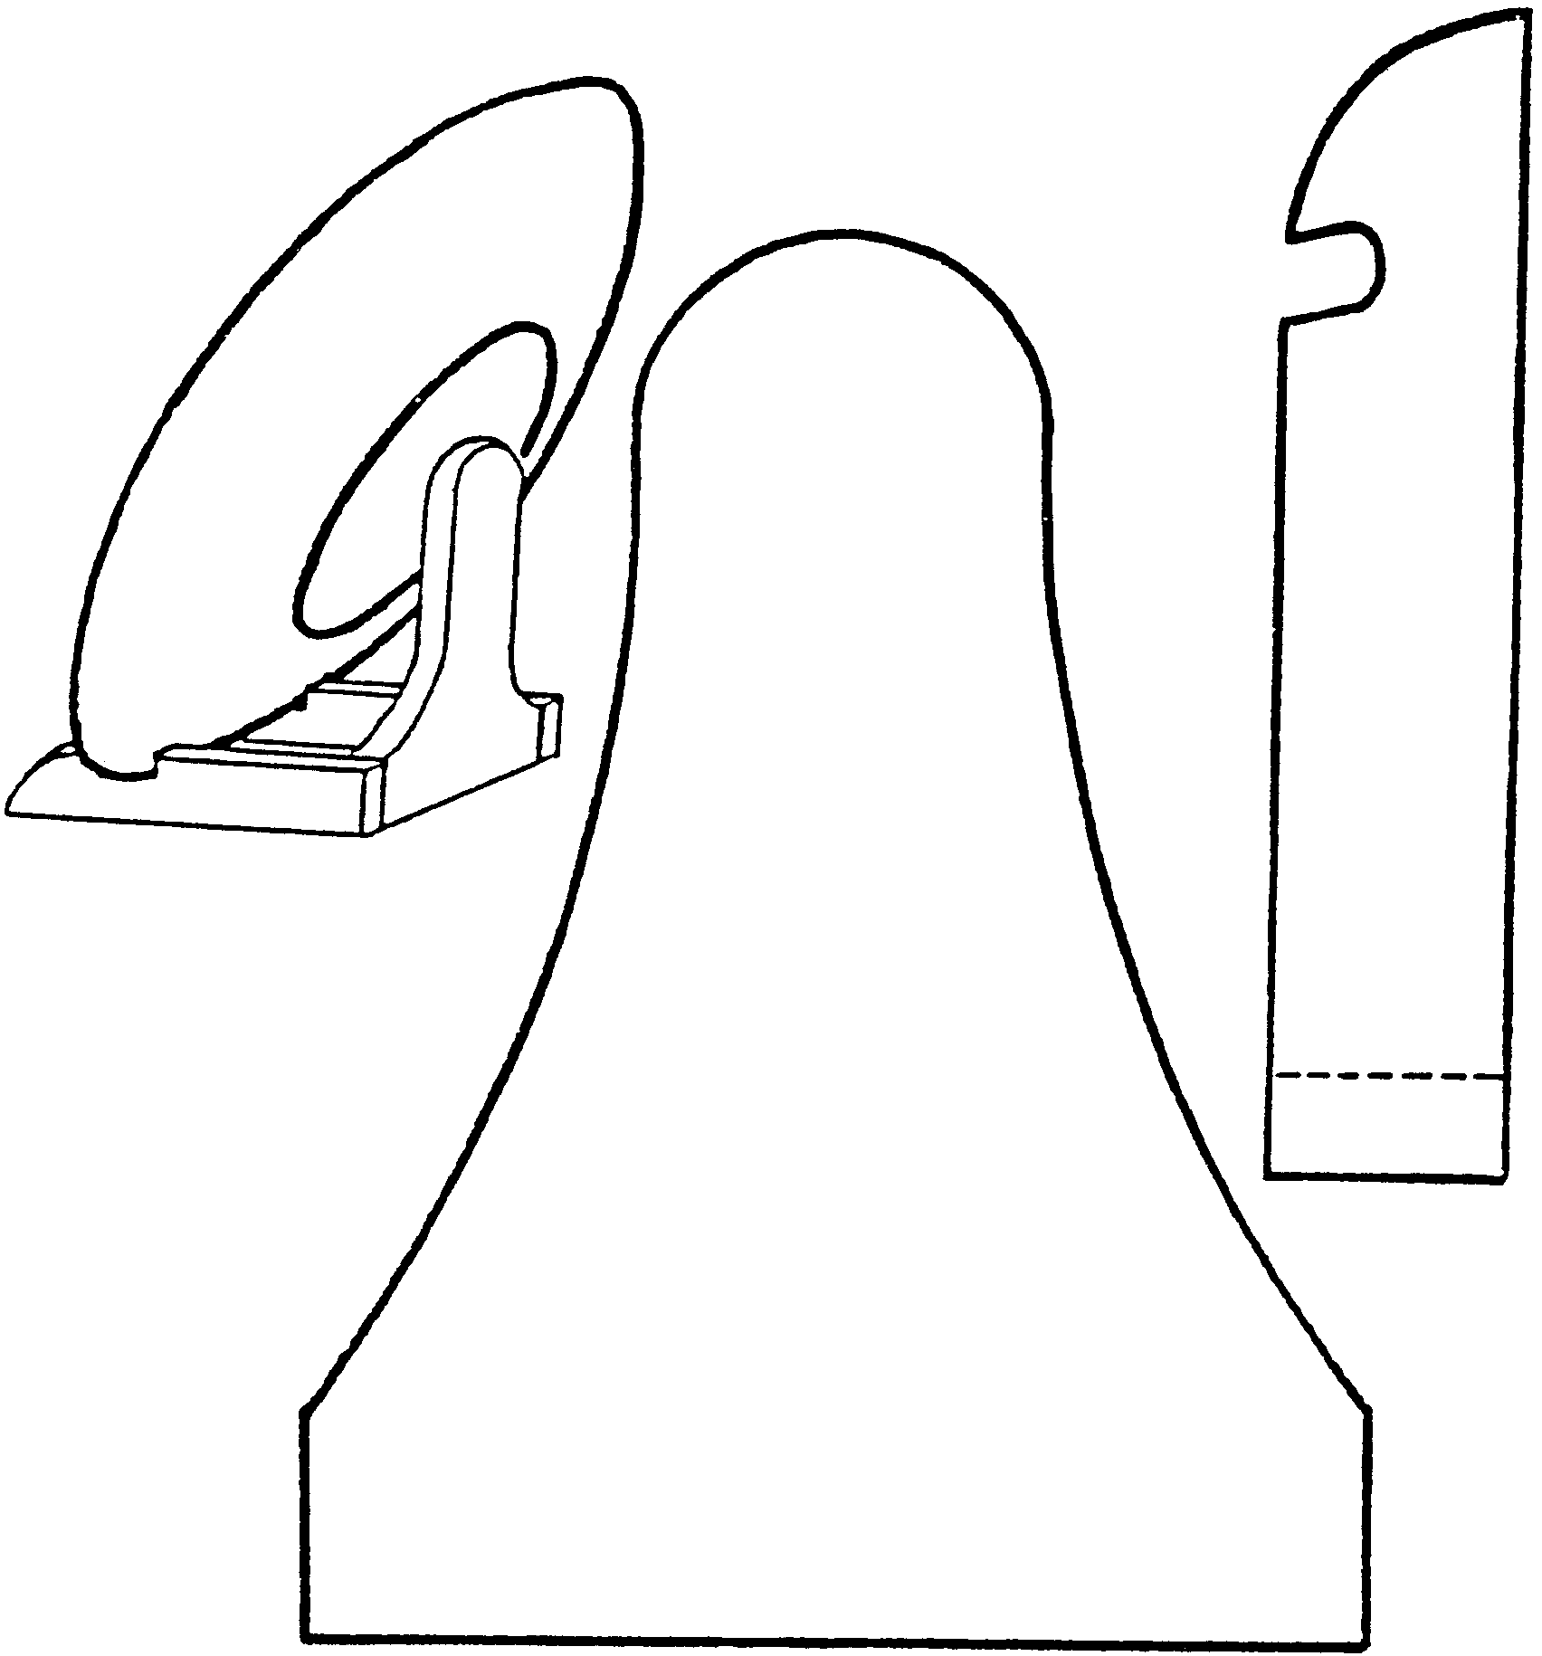
WHERE CAN YOU FIND ENGINEERS?

Almost every large business in Silicon Valley will have an engineer of one kind of another. And what do these engineers do? Here is a partial list of the fields that engineers specialize in:

Acoustical
Aerospace
Air Conditioning
Airport
Architectural
Automation & Control systems
Building Inspections
Civil
Construction
Drainage
Electrical
Electronic
Energy Management
Environmental
Foundation
Geotechnical-Soils
Industrial
Land Planning
Mechanical
Mining
Municipal
Petroleum
Safety
Software
Structural
Traffic

Discuss with the boys the types of things that these specialties might deal with. How are their engineering problems different from other engineers?

BLOCK AND TACKLE TUG-O-WAR

This simple apparatus shows how a block and tackle increases power. You need two lengths of broomstick and a length of clothesline. Fasten one end of the line to one of the sticks. Wrap line loosely around both sticks as shown. Have two of your biggest den members grasp the sticks and try to keep them apart while the smallest den member pulls on the line. He should be able to pull the sticks together no matter how the others try to keep them apart.
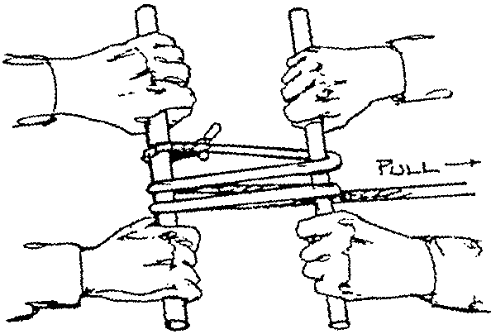

SUSPENSION BRIDGES

These bridges are actually suspended in mid-air by cables strung from high pillars on either end of the bridge. They are quite an engineering feat. The five longest suspension bridges in the United States are as follows:
Verrazano-Narrows, New York, NY 4260 feet
Golden Gate, San Francisco, CA 4200 feet
Mackinac, Straits of Mackinac 3800feet
George Washington, Hudson River, NYC 3500 feet
Tacoma Narrows, Tacoma, WA 2800feet

The Tacoma Narrows Bridge actually collapsed right after the first one was built. A big wind storm came through and the bridge started vibrating and fell apart. You may want to have the boys look into these bridges and exchange information that they have found.
BRIDGE BUILDING CHALLENGES
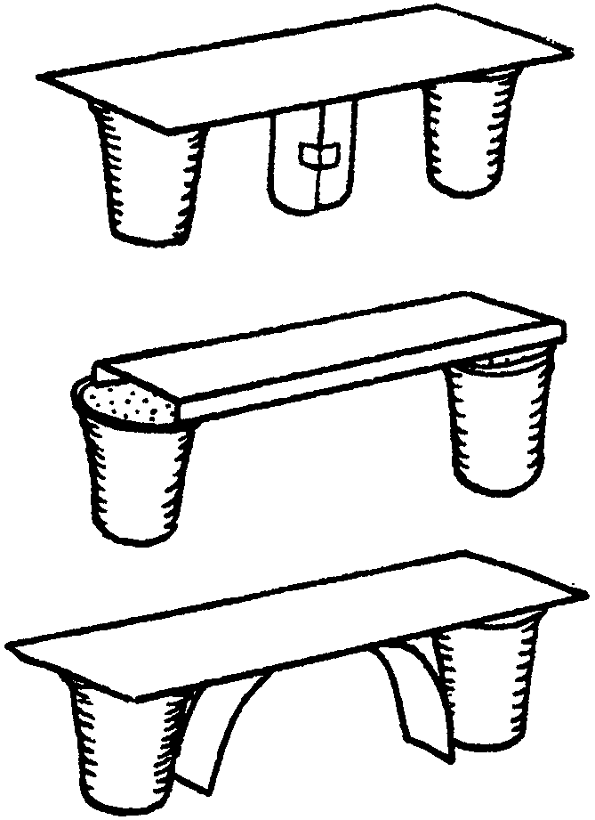
PAPER BRIDGE
Give the Webelos Scouts paper (e.g. 4x6 index cards), two paper cups and a Matchbox car. Tell them to build a bridge that will support the toy car. They are to use as few cards as possible. They may use small pieces of tape but not to tape different items together. This can be a group effort, team play or on an individual project.

When the bridges are constructed, test the strength by running the toy car across. Also try piling pennies in the center of each bridge. How many pennies does each support?

Strongest bridges:
1. Roll up one card and tape it. Use this as a support.
2. Fold two long edges of the card.
3. Fit a card curved under the bridge as a support.

STRAWS AND STRING
You will need: Lots of paper straws, String, Several bricks.

1. Challenge the boys to create a bridge with the straws and string that will support the brick between two other bricks.
2. After several bent straws and bent minds, explain the trick.
3. Run the string through a straw. Leave lots of slack and tie the ends together using a strong knot. Make another string/straw combination with an equal size string.
4. Place the straws between two bricks and suspend the third brick inside the string loops. A bridge is formed with straws and string that supports a brick between two others.

The weight of the brick is transferred longways through the straw. The string pulls on the ends of the straw and will support the brick. Up until this point, the boys have been putting the brick across the top of the straw, probably. This put the weight across the straw and it will not hold up the brick.

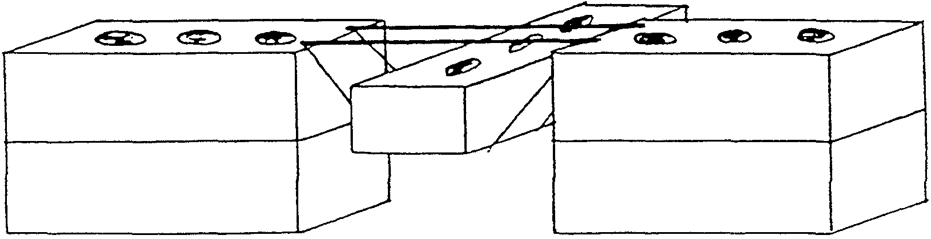

ACCIDENT PREVENTION IN THE HOME

BE YOUR OWN HOME INSPECTOR

First, locate unsafe conditions and eliminate all hazards promptly. The following questions will aid you in making an inspections of your home.

1. Have you a strong, safe step ladder for reaching heights?
2. Are halls and stairways safe and well lighted?
3. Are means taken to prevent rugs from slipping, particularly on polished floors?
4. Is a rubber mat provided for the bathtub to prevent slipping?
5. Are metal boxes provided for storing matches out of reach of children?
6. Have you a screen for use in front of open fires?
7. Are your furnace and stove pipes clean?
8. Are all gas pipes and fixtures tight, to prevent leaks?
9. Have you a cabinet, which can be locked, for storing poisons and medicines out of reach of children?
10. Are emergency numbers for police, fire, and poison control center handy by the telephone?

Second, discover and correct unsafe habits which you or other members of the family may have. The following questions will be helpful:

1. Are toys, brooms, soap, and other articles kept off stairs and walks?
2. Are ice, grease or other slippery substances removed from stairs and walks promptly?
3. Do you, if possible, go out of doors to use flammable cleaning fluids?
4. Have the children in your home been taught the danger of playing with knives, scissors, bottles and matches or near stoves and open fires?
5. Is the garage door kept open when the car is inside with the engine running?
6. Do you always check twice to be sure appliances are off before leaving the house?
7. Are there proper containers in the home for cigarettes? Better yet, if anyone smokes in the home, encourage them to quit, for their own and the family’s health.
8. Is the dryer lint filter cleaned after each load?
9. Do you know how to use tools safely and are they stored properly?
10. Are firearms stored out of reach and unloaded?
11. Are plastic bags and plastic materials kept out of reach of young children?

ENERGY WASTER HUNT

Before the den meeting, set up several examples of energy wasting in the areas where your den meets. Give each Webelos Scout paper and pencil, then send buddies out to find the waste. Allow five to ten minutes, depending on the size of the area. All the boys are winners, but a special prize should go to the team who finds the most energy waste. Hopefully they will only find the planned waste! Here are some simple examples:

1. Light on in an empty room
2. Television on in an empty room
3. Refrigerator door blocked open by items inside
4. Water dripping in sink
5. Thermostat set too high or too low
6. Outside doors open

CRIME PREVENTION

Webelos Scouts who are having family meetings during their work on the Family Member Activity Badge should consider discussing crime prevention. A crime prevention security checklist can be used by families:
1. Secure your home with quality locks on doors and windows.
2. Take care of your keys; don’t give others a chance to duplicate them.
3. Don’t let your home look unoccupied; stop mail, newspapers, etc. when out of town.
4. Leave a light on when you’re away, preferably on a automatic timer.
5. Don’t let strangers in or let them know when you’ll be away.
6. Have police and a trusted neighbor check on your home.
7. Insure your possessions and keep an up-to date inventory of them.
8. Record serial numbers or identifying marks on theft-prone items.
9. Keep valuables in a safe deposit box.
10. Consider installing and learning to use a burglar alarm system.

FAMILY FAX GAME
Nothing gives more enjoyment to a family than, “Remember when...” Children learn who they are from their parents and grandparents. To play Family Fax, have each member of your family write out questions that only your family would know--the more personal the better. Then have fun getting the answers from family members. This can be played at any time...in the car, sitting home on a rainy day, or best of all during large family gatherings. Encourage your den boys to play with their families.

Sample questions:
Who went to Arizona on vacation? What was our family’s first pet? Who broke an arm during the school play? Where did Grandma first go to school? What was the name of Dad’s high school? When did Mom first meet Dad? How were the children’s first names chosen?
SEVEN RULES OF HEALTH

Have the boys discuss the following 7 rules.

KEEP CLEAN 1. Body--take hot baths or shower often with soap.
2. Hands--wash before meals and after using toilet.
3. Teeth--brush well every night. Whenever possible brush teeth or rinse mouth after eating. See your dentist twice a year.

EAT PROPER FOOD 4. Drink plenty of the right kinds of liquids--water, milk, and fruit juices.
5. Eat different kinds of good food. Don’t stuff yourself. Avoid too many sweets. Eat regular meals. Avoid between meal snacks.

KEEP FIT 6. Exercise--lots of active play outdoors.
7. Rest--enough sleep at regualr hours

TREAT YOUR BODY RIGHT!

True or False? After boys take this test, discuss each item with them.

T F 1. Smoking or chewing tobacco makes you cool.
T F 2. Smoking can cause lung cancer and heart disease.
T F 3. Athletes who smoke always play as long and as hard as athletes who don’t smoke.
T F 4. Smoking will not affect your eyes at all.
T F 5. Smoking stains teeth and fingers.
T F 6. Chewing tobacco is OK becasue it doesn’t get into your body’s organs.
T F 7. Alcohol doesn’t slow down the brain and body.
T F 8. Alcohol can make a person see double.
T F 9. Alcohol can make people do bad things that they would never consider doing when sober.
T F 10. Drunk drivers kill thousands of people each year.
T F 11. All drugs, even prescription drugs, are dangerous.
T F 12. It’s OK to take someone else’s medicine if you’re sure you have the same illness.
T F 13. Sniffing glue is OK to do once in a while.
T F 14. Toxins from certain sniffing substances can affect the liver, kidneys and muscles.
T F 15. Marijuana is OK in small amounts, but cocaine, heroin and LSD are not.
T F 16. Eating a cheeseburger, french fries and a soda for every lunch would be a balanced diet.
T F 17. There are five food groups.
T F 18. You should have two or more servings from each food group everyday.
T F 19. Your body needs vitamins, minerals, carbohydrates, fat and protein to operate smoothly.
T F 20. Rushing meals or skipping meals can be harmful to your body.

NUTRITION

No program concerning fitness and health should leave out the subject of nutrition. While working on the Fitness Activity Badge, in addition to discussing the danger posed by smoking and abuse of alcohol and drugs, den leaders should plan to have some discussion on the importance of good nutrition.

Have the boys make a poster or collage showing foods that belong in each food group. Use magazines and advertisements from the Sunday papers for these.

Let each boy make up a menu for a meal and let the other den members check it for balance. This would be good to do for a campout menu. They need to be balanced also.

MILK GROUP: Builds teeth and bone.
Milk and milk products; Cheese; Cottage cheese; Ice cream

FRUIT-VEGETABLE GROUP: Builds energy and helps your body defend against disease.
All kinds of fresh fruits and vegetables

PROTEIN GROUP: Builds muscles, bones and blood.
Beans; Meat; Fish; Peanut butter; Eggs

BREAD-CEREAL GROUP: Quick energy builders, helps to make your body work better.
Rice; Cereal and grits; Bread; Flour products; Spaghetti

SLEEP
Most people need between seven and ten hours of sleep a night, but some people need as little as three hours or as much as twelve hours of sleep.
After two or three days of no sleep, a person can hallucinate just as if they had taken drugs.
People have stayed awake for as much as eleven days...but they thought their food was poison and people were trying to kill them.
People who sleep enough live longer.
Sleep is one of your body’s ways to renewing its energy. It is important for growing bodies to have a plenty of sleep. Most boys need 9 to 10 hours of sleep every night.

LEAF COLLECTIONS

One of the best ways to become familiar with the trees that grow in your area is to make a leaf collection. There are several ways to preserve the leaves once you have collected them. On each collection, write the name of the tree, where it was collected, and the date of collection.

1. LEAF MOUNTING: Place the leaf on a piece of thin cardboard and cover the cardboard with clear Con-tact paper on both sides.
2. DRY LEAF COLLECTION: Put each leaf between separate sheets of newspaper. Place something heavy on your leaves to “press” them. Store them in a scrap book after they are flat and dried.
3. CRAYON PRINT: With the vein side up, place a clean sheet of paper on top of the leaf. Rub a crayon over the leaf. The veins and edges of the leaf will give a good printing.
4. PARAFFIN COATED LEAVES: Melt paraffin carefully in a double boiler. When it is melted, turn off the heat. Dip one leaf at a time into the wax. Shake off the excess. Hold leaf until it cools. Makes an interesting mobile when seven or eight coated leaves are used.

USEFUL TREES

Here are some examples of useful trees.

Cedar--shingles, fences, and moth proofing
Redwood--water resistant wood furnishings
Pine--lumber, turpentine and paper
Pecan--nuts, furniture
Oak--furniture
Ash--furniture, tools
Douglas fir--lumber
Ponderosa pine--telephone poles

DO TREES EAT?
A simple demonstration can be done with celery. Use a piece of celery with leaves for each boy. Place three drops of red food coloring in a glass of water and place the celery in the water. Over a couple of days, the veins on the outside of the celery will start changing color showing how the liquid goes up the stalk. The same type of activity takes place inside a tree.

TREE PLANTING
Collect acorns or other tree seeds and plant in small styrofoam cups filled with dirt. Water, and after the seeds sprout and are fair sized, plant in a suitable place, like the church where your pack meets, the schools where the boys attend, or the grocery store back lot on the corner. (First obtain permission from the property owner.)

“ADOPT” A TREE PROJECT

1. Select a tree that is near your home so there can be daily contact, finding out what is going on in, under, and around the tree. Select more than one kind of tree to compare the action in each type of tree.
2. With a notebook in hand, visit the “adopted” tree.
3. Describe the tree as it is right now, today.
4. Look at its physical characteristics (size, leaf, shape, bark, color, and other features).
5. Look to see whether it is alive. How can you tell?
6. Look to see whether it appears to be asleep or awake. How can you tell?
7. Listen to find out if it makes any noise.
8. Smell to find out whether it has an odor. Do different parts of the tree smell differently? The leaves? The bark? Does the smell change during the day or in different seasons?
9. Repeat the visits throughout the year and compare observations.
10. Look to see how the tree has changed. Look to see how the tree remains the same.
11. Think and talk about what the tree might look like the next time you visit.
12. Are there any animals calling the tree home?
13. Write a poem about the tree and sketch a picture of it.
14. Did the leaves turn colors before the fall?
15. Keep your notebook and come back to the tree in the years to come.

HIDDEN TREES - GAME

The sentences below contain hidden tree names. The names are spelled out correctly but may be inside another word or be split between two or more words.

1. The ranger’s map led us safely through the woods.
2. Will owls hoot in daylight if they see someone in the forest?
3. It’s fun to tramp in every direction before enjoying a picnic in the woods.
4. Forest rangers wear white helmets.
5. In a beautiful glade, we saw a honey bee checking clover blossoms for honey.
6. Many forest fires are caused by human carelessness, according to rangers.
7. Woodcutters have expensive tools, and keep them locked in sheds.
8. Don’t plant those seedlings so thick or you won’t give them room to grow.
9. We got soaked when we were caught in a spring cloudburst.
10. Our grandson’s face darkened when we told him it was time to go home.
11. Our lollipop larder is raided when children come to call.
12. We all chased him as he ran down the hill.

Answers: 1. maple; 2. willow; 3. pine; 4. elm; 5. beech; 6. fir; 7. hemlock; 8. hickory; 9. oak; 10. cedar; 11. poplar; 12. ash

MODEL OF GEOLOGIC FORMATION

You will need modeling clay in at least four colors, approximately 1/4 pound each. You will also need talcum powder, a knife and a wooden dowel.

When building the models, be sure to put the talcum powder between the layers so that they can be easily separated. The dowel can be used to show underground lakes or rivers. These models also make a great display for a pack meeting.

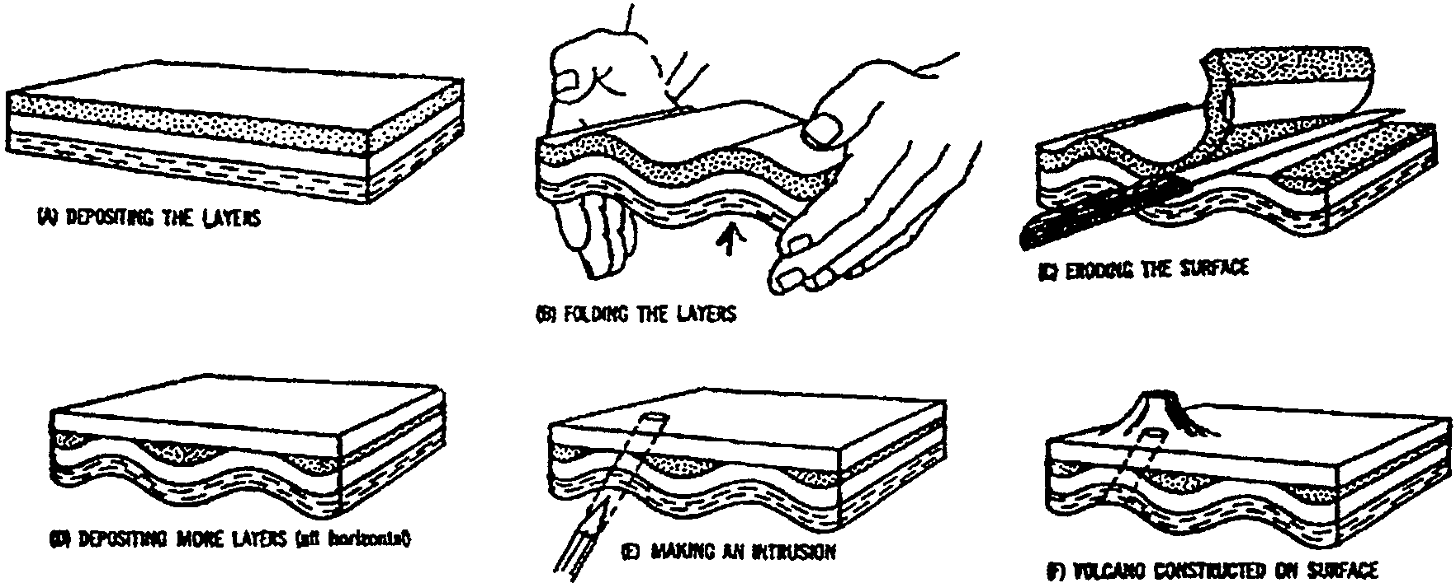

PLASTER AND ICE PROJECT

You will need: Plaster of paris, water, a small balloon, two empty pint milk cartons (bottom halves only).

1. Fill the balloon with water until it is about the size of a ping-pong ball and tie a knot in the end.
2. Mix water with plaster until the mixture is as thick as yogurt. Pour half of the plaster in one milk carton and the other half in the other.
3. Push the balloon down into the plaster in one carton until it is about 1/4" under the surface. Hold the balloon there until the plaster sets enough so that the balloon doesn’t rise to the surface.
4. Let the plaster harden for about 1 hour.
5. Put both milk cartons in the freezer overnight.
6. Remove the containers the next day to see what happened.

WHAT TO THINK ABOUT
What happened to the plaster that contained the balloon?
What happened to the plaster that had no balloon?
Why is there a difference?
Which carton acted as the control? Why?
How does this experiment show what happens when water seeps into a crack in a rock and freezes?

WHAT SHOULD HAVE HAPPENED
The plaster containing the balloon should have cracked as the water in the balloon froze and expanded. Explain that when water seeps into cracks in rocks and freezes, it can eventually break rocks apart.
A SOUR TRICK

You will need: Lemon juice, vinegar, medicine dropper, and two pieces each of limestone, calcite, chalk, and quartz

1. Put a few drops of lemon juice on four of the rock samples.
2. Put a few drops of vinegar on each of the four other rock samples.
3. LOOK and LISTEN carefully each time you add vinegar or lemon juice.

WHAT TO THINK ABOUT
What happens when you put lemon juice on each rock?
What happens when you put vinegar on each rock?
Did the lemon juice and vinegar act the same way on each rock?
Why did some of the rocks react differently?
What does this experiment have to do with weathering?

WHAT SHOULD HAVE HAPPENED
The lemon juice and vinegar both contain weak acids. The lemon juice contains citric acid and the vinegar contains acetic acid. These mild acids can dissolve rocks that contain calcium carbonate. The lemon juice and vinegar should have bubbled or fizzed on the limestone, calcite, and chalk, which all contain calcium carbonate. There should not have been a reaction on the quartz, which does not contain calcium carbonate. Explain that water often contains weak acids that dissolve rocks containing calcium carbonate and other minerals. You may want to discuss ACID rain, too.

STEEL WOOL AND WATER
You will need: 3 shallow dishes, 3 pieces of steel wool, salt, water.

1. Place each piece of steel wool in a shallow dish.
2. Pour equal amount of water over two of the steel wool pieces and leave the third piece dry.
3. Sprinkle one of these wet pieces with plenty of salt.
4. Observe and compare the 3 pieces every day for a week.

WHAT TO THINK ABOUT
What happened to each piece of steel wool?
Which piece changed the most?
Why do you think the steel wool changed?
Which piece of steel wool acted as the control?
What does this experiment have to do with weathering?

WHAT SHOULD HAVE HAPPENED
When iron gets wet, the water acts as an agent to speed up oxidation. Oxidation occurs when oxygen combines with another substance. In this case, oxygen in the water combined with the iron in the steel wool to form oxide, or rust. Rust is a weaker material than the original metal and erodes quickly. When salt is added to the water, it speeds up the oxidation of iron. So the steel wool in salt water will be the one that changed the most.

HANDYMAN SCAVENGER HUNT

In a boy’s home or meeting place, hunt for the following items or create your own list. Boys should be accompanied by a leader or parent. They should not gather the items but instead have the boys write down the location of each.

Here is a sample:

Pruning shears Edge trimmer Lawn mower
Gasoline can Oil can File
Pliers Hammer Nails
Screwdriver Air pump Tire tube
Old newspapers Old rags Window cleaning solution
Aluminum cans Tire pressure gauge Crescent wrench
Tire changing tool Auto jack and stand Paint

After the locations for these items are recorded, go over the list and see if any of the items are not stored in the proper location. For example, are the old rags stored on top of, or next to, the gas can in a closed cabinet? Are the pruning shears laying on the floor where young children may be able to “play” with them? Also check the tools for cleanliness and sharpness. These factors influence their serviceability.

THE HOW’S OF POWER MOWERS

12 safety rules for users of power lawn mowers. (NOTE: Webelos Scouts should be encouraged to use hand-pushed, non-power mowers.)

1. Always disconnect the spark plug wire before working on the underside of the motor or when refueling.
2. Remove sticks, stones, wire, or other debris from the mowing area before starting to mow.
3. Never refuel indoors or when the motor is running or hot.
4. Mow only when grass is dry. Never use a power mower barefoot. Wear heavy shoes. Thousands of toes are amputated or mangled every year when feet slip under the blades.
5. Keep children out of your mowing area. Never let anyone get in line with the grass-throwing side of the mower while it’s running.
6. Never leave motor running when mower is unattended.
7. Practice so you can disengage the clutch or stop motor quickly in case of an emergency.
8. Never allow youngsters or inexperienced people to operate the mower.
9. On hills and banks cut grass sideways, not up and down.
10. Stand firmly behind the machine. Don’t pull it backwards towards you or run with it.
11. Don’t use an electric power mower in the rain. Be sure its frame is grounded through the cord.
12. Have your mower inspected and serviced by an experienced serviceman yearly.
DEN CAR WASH
Start a tradition of a Webelos Den Car Wash Morning. Pick a location central to boys and families in the den or pack. Work the Scouts in teams, in swimsuits if necessary, so two, three, or four boys take care of a single car. You’ll be surprised how quickly they catch on, how they catch each other’s mistakes and they’ll get the job done well. They may need some help with the roofs on cars, but they may surprise you in that area, too.
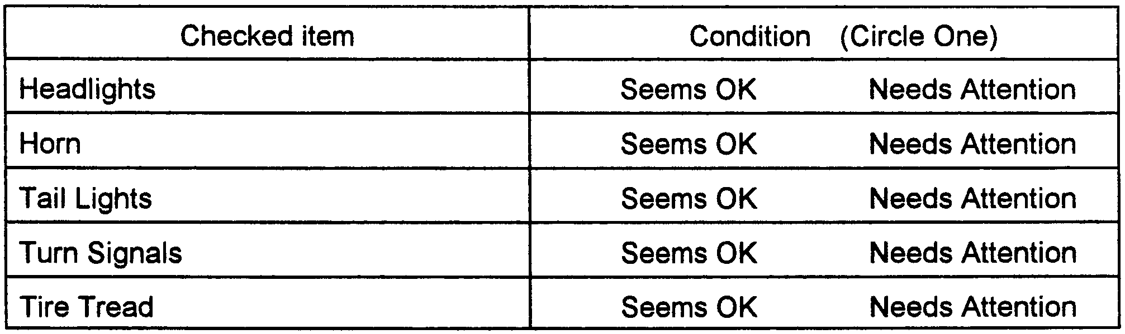
After washing, a second team vacuums the car out and straightens up the interior of the car. After the car wash, they can also use a checklist like the one below.

BE A TIRE DETECTIVE
You can be a tire detective and analyze tread on your family car--or any car. The tire tread offers many clues about a car’s condition and the way it is being driven. Most tires have built-in tread wear indicators, which appears as hard rubber bars across the tread when it has worn down to 1/16 of an inch above the tire’s surface. When they appear in two or three places, the tire is considered too worn for safe driving.

Look at the pattern of wear on each tire. Is it over-inflated? If the tread is worn in the middle and not on the sides, there is too much air in the tire. Is it under-inflated? If the tread is worn on the sides and not down the middle, it does not have enough air. Check the sidewall of the tire or the car owner’s manual for the correct inflation pressure. It will be listed in pounds per square inch (PSI). Then check the pressure with a tire gauge and have more air added at a service station. Because air in tires heats up and expands with a lot of driving, check the tire pressure in the morning before the car is used.

CAR WINDOW WASHER
You will need: Plastic milk jug; plastic net potato sack; sponge; rubber bands; heavy thread; large-eye needle; scissors.
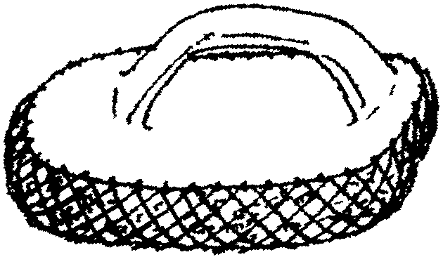

1. Wash and dry the milk jug. Cut off the handle, leaving a 3"x6" oval at the base.
2. Cut the sponge into a 3"x6" oval. Fold netting to fit over sponge, turning cut edges under. Place jug handle on top of covered sponge. Hold together with rubber bands.
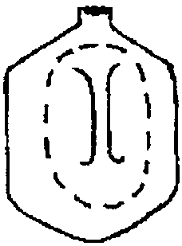
3. Thread the needle with thread and knot the end.
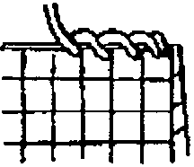
4. Whipstitch the netting to the handle around all the edges. DO NOT SEW THROUGH THE SPONGE.

BIRDS OF A FEATHER

1. Birds have been found in every corner of the world except ________.
the Sahara Desert the Antarctic interior
tropical jungles the Himalayas
2. Biologists believe that birds developed from ________.
reptiles fishes amphibians insects
3. Birds have something no other animal has: ________.
wings fins webbed feet feathers
4. An Archaeopteryx is a ________.
small dinosaur primitive architecture
prehistoric bird form of dodo
5. Penguins cannot fly. Neither can rheas, emus, kiwis or ________.
whooping cranes ostriches
wild turkeys ground-based cuckoos
6. Two birds imported from Europe during the last century are the English house sparrow and the ________.
falcon curlew starling warbler
7. Information on flight paths and distribution of birds is scientifically gathered by ________.
macro-photography bird-banding
radar photoelectric counters
8. The largest penguin species in the world is called the ________.
king emperor president polar
9. Some birds can do it all--fly, walk, swim and dive. One of these is the ________.
common loon river hawk roadrunner waterthrush
10. There are now close to ________ living species of birds.
1,500 9,000 5,000 15,000
11. An adult ostrich may weigh ________.
45 pounds 160 pounds 210 pounds 345 pounds
12. The smallest bird in the world is the ________.
wood peewee bee hummingbird shrimp owl titmouse
13. Birds of prey, such as hawks and owls, divide the natural world into two parts, ________.
land and water rainforest and desert
day and night urban and rural
14. The Great Auk, the Carolina parakeet, the passenger pigeon and the ivory -billed woodpecker share a common problem: ________.
they cannot fly they are extinct
sensitivity to cold vanishing habitat

Answers: (1) the Antarctic interior (2) reptiles (3) feathers (4) prehistoric bird (5) ostriches (6) starling (7) bird banding (8) emperor
(9) common loon (10) 9,000 (11) 345 pounds (12) bee hummingbird (13) day and night (14) they are extinct.

ANIMAL FAMILIES

In the left hand column below, there is a list of animals. Fill the center column of blanks with the name for the young of the species, and the right hand column with the term used for an assemblage of these animals.

Animal Young Assemblage

Whale _______________ _______________

Bear _______________ _______________

Sheep _______________ _______________

Deer _______________ _______________

Lion _______________ _______________

Wolf _______________ _______________

Cod _______________ _______________

Elephant _______________ _______________

Goose _______________ _______________

Goat _______________ _______________

Answer: Whale--calf--herd; Bear--cub--sloth; Sheep--lamb--flock; Deer--fawn--herd; Lion--cub--pride; Wolf--cub--pack; Cod--codling--school; Elephant--calf--herd; Goose--gosling--gaggle or flock; Goat--kid--flock

DO YOU BELIEVE?

1. Birds do not have teeth. True
2. The ostrich is capable of flying, but rarely does. False
3. Bats fly by radar. True
4. The piranha is a huge, deadly fish. False; piranha is small.
5. Some animals never drink water. True
6. The dinosaur is the largest animal ever to grace the face of the earth.
False; whales are largest.
7. Flying squirrels cannot fly. True

TEACHING KNOTS

Try to teach basic knots over an extended period. Do not try to teach them more than two knots in any given session. Most boys will start to get confused after the second knot.
Repetition is the key to teaching knots. Once you have introduced them, keep including the skills in various games and other activities. Using rope of two different colors helps some boys see more clearly how knots are correctly tied and lessens confusion. Boys will need your individual attention in learning and demonstrating these knots; so try to get some help in watching them tie them. Your den chief would be good at this. You might ask him to bring a fellow Boy Scout along who has earned the Pioneering merit badge to help out when you are teaching the boys knots.

GAMES

WHAT IT IS AND WHAT IT’S KNOT
Divide the group into two teams. On separate slips of paper, write the names of the knots you have learned. Place names in two jars--one for each team. On signal, the first member of each team draws a slip of paper. That player must act out what the knot is used for, and his teammates must try to guess the name of the knot. When the correct name is guessed, someone else from the team pulls out another knot name. The games ends when a team successfully guesses all the knots. If a player has difficulty acting out the use of a knot, he may replace it and draw another.

HOT KNOT (From “Games Galore,” BSC publication)
All players sit in a circle, with the exception of one who has a rope. On signal he drops the rope at the foot of one of the players, at the same time calling out the name of a knot. He then commences to hop round the circle, while the knot is being tied. If tied correctly, the tier becomes the hopper.

KNOT STEP CONTEST
Have the Webelos Scouts line up side-by-side at one end of the room. Call out the name of a knot. Each boy ties the knot. Judges quickly check the knots. Each Webelos Scout who ties his knot correctly can take one step forward. Leader calls out another knot and the same procedure is followed. The first Scout to reach the opposite wall is the winner.

KNOT EASY
Divide the group into two teams. Give first player of each team a 12" length of clothesline rope. At a signal you give them the name of a knot. The captain ties the knot in the rope and passes it to the next in line. The second player unties the knot and passes it to the third player who ties the knot again and so on down the line. The first team to finish wins. The first player moves to the end of the line. The next round begins with a new knot.

COMPASS GAME
Players stand spread out around the room and orient themselves to north. Everyone except the caller and the referee is then blindfolded. The caller calls out a direction, for example ‘east.’ All players point in the direction of east. The referee goes around and taps the shoulder of anyone not pointing in the right direction. These players are out. The game continues until one player is left.

TENT UP AND TENT DOWN
You will need one tent for each team. This is a good game for a boy and his parent or three to four boys for each team. Object of the game is to see which team can set up their tent in the fastest time and THE TENT HAS TO STAY UP!

ROPE SWING

You will need: 3/4" or thicker cotton rope; rubber tire (optional)
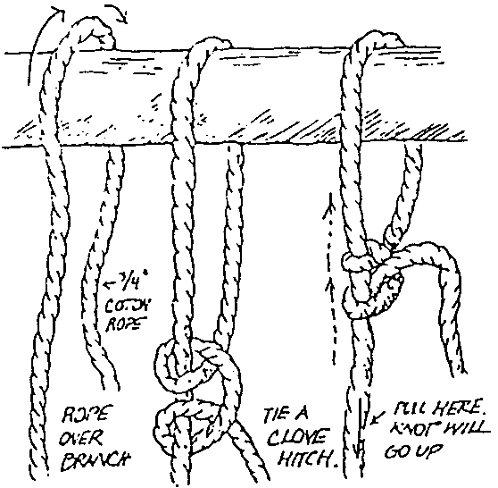
The rope is simply slung over a high but strong branch and fastened with a clove hitch. Overhand knots are tied at intervals down its length, giving a grip for feet and hands and making for quick climbing or swinging. Optional: Tie a rubber tire at the end for a swing.
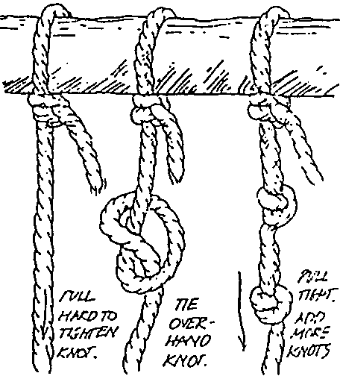

EGG CARTON FIRE STARTERS
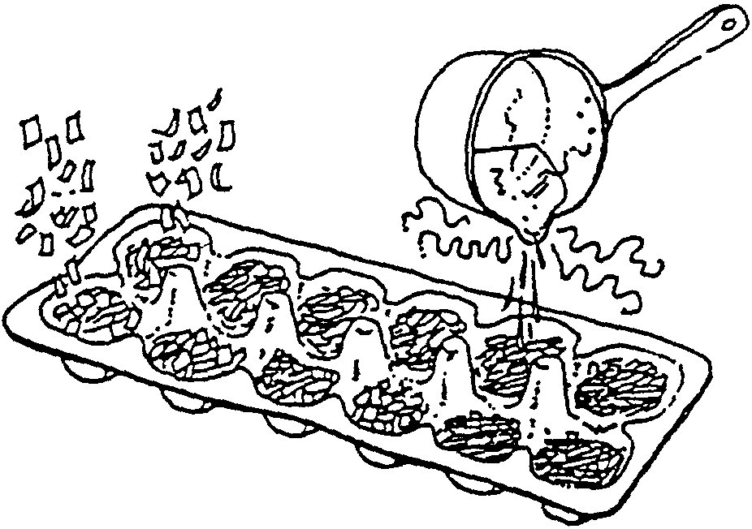
Fill cups of a cardboard egg carton with sawdust, dryer lint or shredded paper. Melt paraffin and pour into the cups. When it cools you can break into sections. One carton will make 12 starters. Take these starters to campouts and use them to start a campfire or charcoal briquettes.
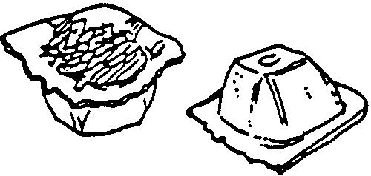
You can make these in your den but only with close adult supervision and assistance. Paraffin should always be heated in a double boiler of some sort and never over a direct or open flame.

CLOVE HITCH NECKERCHIEF SLIDE

You will need: 12" cord (1/8" diameter); 2 small beads; glue.
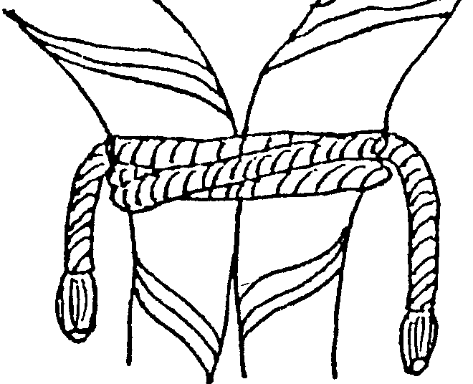

This is a very simple slide.
1. Whip or fuse the ends of the cord.
2. Glue beads to the ends of the cord.
3. If desired, decorate the cord with permanent markers. (stripes and the like)
- To wear this slide, the Webelos Scout needs to learn to tie a clove hitch. He ties the slide around his neckerchief.

Through their work on the Readyman Activity Badge, your Webelos Scouts will be better prepared to handle emergency situations. They will also be better prepared to check for safety concerns which could help prevent those same emergency situations.

Contact a Scout troop to assist with the activity badge. They can lead first aid discussions and show techniques. Make sure you talk to the Scoutmaster about getting qualified Scouts to teach the topic.

SPECIAL SPEAKERS

A paramedic/EMT Police Officer Fireman
911 Dispatcher Doctor or Nurse Lifeguard/Water Safety instructor
CPR/First Aid Trainer Civil Defense worker Poison Control Center worker
Scout troop Red Cross employee Utility/Gas company employee
Handyman Electrician Bicycle shop employee

DEN OUTING

1. Visit a local emergency center in your area; fire station, police station, 911 dispatch center.
2. Visit a police, fire, or medical BSA Explorer Post in your area.
3. Visit a pharmacy and speak with the pharmacist.
4. Visit a bicycle shop.

GAMES

BANDAGE DEMONSTRATION
Equipment: As needed.
One member of the den is the patient, the rest are first aiders. On signal, first boy runs to patient and ties head bandage and runs back. Second ties across the chest; third, thigh; fourth, ankle; fifth, arm sling; sixth and seventh transport patient to starting line. NO TIME ELEMENT. Base scoring on excellence.

WHAT’S WRONG WITH ME?
Write down several different accidents or afflictions. (Examples: A broken leg, a nose bleed, choking, shock) Place these in a hat and have the boys draw them out one at a time. The boy that drew will have to act out that particular problem. The first boy to identify the problem must show how to treat it. He then gets to pick and act out an accident.

SAFE BICYCLE RIDING TRUE OR FALSE QUIZ

1. A bicycle should be ridden on the right hand side of a street.
2. Bicycle riders should obey all traffic signs and signals.
3. Stop signs are round in shape.
4. Pedestrians have the right-of-way on sidewalks and crosswalks.
5. Bicycles should be “walked” across busy intersections.
6. The signal for a right turn is stretching the right arm straight out.
7. Riding a bicycle at night without a front light or rear reflector is unsafe.
8. It’s safe for a bicycle rider to carry a passenger.
9. You don’t have to stop at an intersection if there is no traffic.
10. Hitching a ride on another vehicle is safe if the driver is careful.
11. Bicycle riders should give a hand signal before making a turn or stopping on the street.
12. It’s safe to ride a bicycle that is in poor condition if you are a good rider.
13. If you’re riding bicycles with friends, you should go single file.
14. Your chain should be loose enough to slip off easily.
15. It’s okay to ride a bicycle in either direction on a one-way street.
16. If you live in the country, it’s okay to ride on either side of the road.
17. Even a good rider should “walk” his bicycle through heavy traffic.
18. The faster you ride, the safer it is.
19. Bicycle riders should stay at least 3 feet away from parked cards.
20. If you don’t ride on busy streets, you don’t need a horn or bell.

Answers: 1. True; 2. True; 3. False, they have 8 sides. Railroad crossing signs are round. 4. True; 5. True; 6. False, it’s extending the left arm, with forearm raised and the palm of the hand facing forward; 7. True; 8. False; 9. False; 10. False; 11. True; 12. False; 13. True; 14. False;
15. False; 16. False; 17. True; 18. False; 19. True; 20. False.

SUNSCREEN EXPERIMENT

You will need: Plastic wrap, scissors, photosensitive paper (e.g. Sunprint, available at toy or hobby stores); tape; sunscreens with different SPF numbers.
1. Cover the photosensitive paper with plastic wrap slightly larger in size and if necessary tape the wrap in place. Don’t expose the photosensitive paper to bright light yet.
2. Paint on top of the wrap with different sunscreens. Label the SPF number of each sunscreen.
3. Place the photosensitive paper in bright sunlight. Leave in the sun for the specified duration of time.
WHAT HAPPENED
The areas where there was no sunscreen became lighter colored, while the area covered with sunscreen did not change color as much. The greater the SPF, the less color change. The ultraviolet rays from the sun caused the chemicals in the paper to react. Sunscreen contains chemicals that do not allow the ultraviolet rays to get through. The higher the SPF number, the more protection you will get from the ultraviolet rays.

Don’t forget your sunscreen when you play in the bright sunlight. Be prepared.

SEVEN WAYS TO IMPROVE YOUR GRADE

1. Learn to listen--Concentrate on the speaker. You may miss important facts if you’re not paying attention.
2. Develop good study habits--Have a study place away from distractions. Have supplies handy. Do your homework at the same time everyday so it becomes a habit.
3. Use the right reading technique--Slow careful reading is necessary when you must understand and remember.
4. Improve your vocabulary--Look up a word you don’t know. Write it down. Note spelling, pronunciation and meaning.
5. Sharpen your writing skills--Organize your thoughts. Make sure your handwriting is neat. Double check spelling and punctuation.
6. Learn how to take tests--Study for a test ahead of time. DO NOT CRAM. Read all the directions and make sure you understand them. If there is an answer you don’t know, skip it and come back to it later. Double check your work for careless errors before you hand it in.
7. Develop a positive attitude--This is most important. You are what you think you are. Think you are going to pass and you probably will.

When you really want something at school and you are willing to work for it, your teacher is the best person to help you.

GOLLY, OLOGIES!!

Do you know what field of study on which each of the following “ology” focuses?

1. Anthropology a. plant b. man c. cars d. ants
2. Biology a. life b. stars c. clouds d. bicycles
3. Archaeology a. ancient civilizations b. stars c. plants d. sky
4. Chronology a. crowns b. birds c. man d. order of
events
5. Cosmology a. universe b. plants c. man d. the future
6. Dermatology a. man b. birds c. skin d. eyes
7. Ecology a. stars b. organisms & c. eyes d. money
their environment
8. Egyptology a. land b. boats c. Egypt d. hands
9. Entomology a. plants b. man c. flowers d. insects
10. Psychology a. body b. mind c. farming d. baseball

WORD CHAINS

Start with a word or picture. Add another word to form a compound word with a new meaning. To the second part of the compound word, add a third word. How long can you go? Here are a couple of examples:

PIN + CUSHION, CUSHION + COVER, COVER + STORY, STORY + BOOK
or
TRAIN TRACK DOWN HILL SIDE STEP LADDER

WORD PUZZLES

Answers: I understand; Upon; Four-wheel drive; Just between you and me; Downtown; Red overcoat; Tricycle; Back fire; (Eggs) over easy; Head over heels; Railroad crossing; Six feet under ground; Calm before the storm; Downstairs; Paradise; Buckle up for (four) safety; Crossroads.

BERNOULLI’S PRINCIPLE

TENT FLATTENING TRICK
Fold a 5"x8" piece of paper into a pup tent shape and place it on a table. Now blow through the tent. Does it blow away? No? Why not? The moving air stream through the ten brings down the air pressure. The greater pressure above the tent pushes it down and prevents any horizontal movement.

SWING PING-PONG BALL

Tape thread to two ping-pong balls and suspend them from the ceiling about 6" apart. Using a soda straw, blow between the suspended balls, and watch them move closer together. No matter how hard you blow, they never fly apart. The balls move together because of the lower pressure generated on the carved surface.

BOTTLE AND FLAME EXPERIMENT
You will need: A candle; a candlestick; 2 bottles (one with rounded sides and one with square sides--metal or cardboard containers may be used instead of bottles).

Light the candle and place the round bottle in front of it. Blow hard against the bottle and the candle will go out. Place the square bottle in front of the re-lit candle and blow hard. The candle will remain lit.

WHAT HAPPENS
With the round bottle, the air current flows around the bottle and puts out the flame. With the square bottle, the air currents are dispersed.
Using different shaped bottles, and two ping-pong balls on strings, place on opposite side of the bottle so that they are close, but not touching. Blowing against the bottle at right angles to the balls, one ball will come closer to the bottle and the other one will move away. The shape of the bottle will determine the way the balls move due to the ease with which the air currents move around the bottle. This is the principle that supports airplanes.

AIR PRESSURE

THE UPSIDE-DOWN GLASS THAT WON’T SPILL
1. Fill a drinking glass to the very top with water. The water should spill over the top a bit.
2. Carefully place a cardboard square so it completely covers the top of the glass. Holding the cardboard on top, turn the glass over until it is straight upside down. Stop holding the cardboard on. It will stay on by itself..

THE UNDRINKABLE DRINKS
1. Using a can opener, make a small hole in a can of juice. Try to drink the juice. What happens when you punch another hole in the can?
2. Open a bottle of juice. Add enough water to fill the bottle to the very top. Put in a straw. Use clay to completely block the opening of the bottle around the straw. Try to drink the juice.
WHAT IS HAPPENING
There is no air in the glass of water to punch down on the cardboard. The air pressure pushing up on the cardboard is greater than the weight of the water. And the juice won’t come out of the hole unless air can get in to push down on it; you need a second hole to let air in. Juice won't go up the straw because no air is getting in to push down on the juice.

MORE FUN WITH SCIENCE

CONNECTING PLUNGERS
Another way to show the tremendous pressure exerted by the ocean of air above us is to take two plumbing plungers, wet the rims, and create a partial vacuum by pressing them together slightly, and then trying to pull them apart.

CRUSHING SODA BOTTLE
Another way to show the effects of atmospheric pressure is to pour hot water into a two liter plastic soda bottle, empty the hot water, cap the botle and then cool it with ice water. Use hot water about 150 degrees F. Use extreme caution when working with water this hot.

INERTIA

RULER AND MARBLES
Lay a ruler with a center groove on a table. Place 5 marbles in the groove touching each other. Place another marble about 1 inch form the group and flick it so that it strikes the group. The marble will stop when it hits the end of the group and a marble on the opposite end will move forward. Repeat with two marbles and two will leave the group from the other end. The moving marble has energy of motion (inertia) and when it strikes the marbles at rest, which have a tendency to stay at rest, the energy is transferred from marble to marble. The last resting marble starts rolling when it receives the transferred energy of motion.

BALANCE

A BAT TEEPEE
You need 3 baseball bats of similar size. Point the handles of the bats together so that they form a “Y.” Slide the handle of the lower bat over the handle of the bat to the left. Slide the handle of the bat to the right under the handle of the bat to the left and over the handle of the lower bat. The bats should form a low solid stool.

WHAT IS HAPPENING
Due to the interlocking arrangements, each bat supports another, making a simple experiment not only in balance, but also in structural engineering. This can also be done with 3 table knives, the blades being the handle, or 3 piece of wood that are the same general shape.

PANTOMIME

Pantomime is the expression of a thought, emotion, or action without words. In advanced forms, words may be supplied by a narrator, chorus, or other means, but the actor never speaks.

Encourage the group to think about how many thoughts, feelings or actions can be shown without words. Try the following.

Show how you would walk if:
You had to go into a room where a baby was sleeping
You had done something you were ashamed of
You were on skis
You had a nail in your shoe
It was very hot
It was very cold
You were scared
You were happy

Show how you would lift:
A little kid
Something hot
Something heavy
Something very fragile
something big and bulky

How would you look if:
Someone gave you a ferocious lion
Someone game you a beautiful ring
You lost that ring
You found that ring
You slipped on ice
Your report card was all A’s
Someone pinched you
You smell something bad
You saw someone kick a dog

How would you act if:
You heard a sudden thunder crack
You heard a far away bell
You heard dance music
Smelled your dinner burning
Smelled a skunk
Smelled smoke
Tasted hot soup
Tasted bitter medicine
Saw an automobile crash
Saw a house on fire
Saw an old friend

GAMES

FASHION SHOW
This can be quite hilarious if performed for parents to watch. Divide the group into teams of about 4 each. Give each team a bundle of newspapers and a package of pins (safety pins) and tape. They select one person from their team to be the model. The others dress him in a newspaper costume, tearing the paper where necessary and pinning the piece in place. Do not provide scissors. The most sensational costume wins a prize.

NEWSPAPER MAGIC
Announce that you can perform a strange feat. You take an ordinary sheet of newspaper, lay it on the floor and have two people stand on it, facing each other. Say they will be unable to see or touch each other. Make your claim come true by laying the paper in the doorway, with the door closed. One person stands on each side of the door.

NAME THAT TUNE
Record the first line of about 15 different songs on a tape player. The Webelos Scout who can correctly name the most songs wins.

FRUIT PASS
Webelos Scouts pass a fruit (lemon, orange, lime) from one to another as music is being played. When you stop the music, the player holding the fruit has to do some miming or sing a song. At the end those who were lucky enough not to end up with a fruit during the game, have to perform.

WHISTLING CONTEST
Divide the Webelos Scouts into two teams. Have one team start whistling and see which one can whistle the longest. The other team can try to make the boys laugh, forcing them to drop out of the contest.

MUSICAL NUMBERS
Webelos Scouts form a ring, join hands and march around the room until the leader calls out a number. The players must form smaller rings containing the same number as the one the leader called. The leader (knowing the number of players) should call a number that will force some to be left out of the game. The remaining players re-form one circle again and continue until only two groups remain.

MUSICAL CHAIRS WITH BOOKS
The players hum or sing with the music as long as it’s played. They must stop their singing as soon as the music stops and kneel down. To make this more interesting, have them balance books on their heads The last one down and anyone dropping his book is out of the game.

WAYS TO CHOOSE “IT”
1. All boys form a tight circle with the leader in the middle. The circle moves counterclockwise and the leader spins clockwise, eyes closed. On signal all stop and the one facing the leader is “it.”
2. Boys line up by height. Pick tallest or shortest.
3. Denner picks a letter between A-Z. Boys line up alphabetically and the boy with the chosen letter occurring first anywhere in this first name is chosen.
4. Draw the short straw from the leader.

Make sure you vary the choosing method and keep track of who is chosen so that no one feels picked on.

GAMES
BROOM HOCKEY
You will need a small ball, and a broom for each player. Play on any size field. Goals are marked with cones or rocks about six feet across and centered on the end lines of the playing field. Use regular hockey rules. Use a small balloon for an indoor version.

SOCCER DODGE BALL
You will need a soccer ball and a large open grass field. Set boundaries or form large circle and decide on “it.” This game is played like a dodge ball, except that the player who is “it” kicks the ball to try to tag other players. Those tagged can then pass the ball to each other in an effort to tag the remaining Scouts. Use this as a variation of freeze-tag as well, where each player tagged is frozen in place until touched by an “untagged” teammate.

BALLOON VOLLEYBALL
You will need a large inflated balloon and a long piece of string.. Boys should be divided into two teams and seated on the ground in volleyball positions. The net is the string fastened between two trees, poles or attached to the walls for indoor use. The balloon is put into play by a serve and normal volleyball rules apply, except that the players cannot move from their seated positions on the floor or ground.

TOE FENCING
This game may have been invented in the 1950’s when two rivals attempted to scuff each other’s freshly powdered white bucks. It has recently enjoyed a renaissance among white shoed tourists waiting for the cable car in San Francisco.

To play, we face each other, holding hands. Then we try to tap the toes of each other’s toes with our own. When one of us scores three hits, it’s time to switch to a new partner.

The frenzy generated by Toe Fencing places a premium on honest, self-refereeing--the name of the game is NOT Toe Stomping. Players should be equally armed--barefoot to barefoot, sneakers to sneakers, moccasins to moccasins--and we do not advise players in steel-toed boots or six-inch spike heels unless everyone is equipped with shin guards.

SPORTS TERMINOLOGY

1. In American football a ball bounces “out of bounds;” in the English game of rugby it is ________.
“beyond bounds” “into touch”
“outside lines” “off field”

2. A “rub of the green” in golf occurs when a moving ball ________.
goes off the green lands on the wrong green
bounces out of the cup is stopped by an outside agency

3. The last rider in each lap is eliminated in a “miss and out” bicycle race, which is also called
“devil take the hindmost” “last ‘n’ lost
“sudden death laps” “cutthroat circuits”

4. In a squash court, an out-of-bounds strip of resonating material at the base of the front wall is called the ________.
“telltale” “deadline” “thunker board” “footer”

5. “Travers,” “renvers,” and the “piaffer” are competitive moves in ________.
synchronized swimming rhythmic gymnastics
figure skating equestrian

6. A pitch in baseball means a thrown ball; in field hockey it refers to ________.
a short shot on goal the goalie tossing the ball
the field of play the area around the goal

7. A ________ strives for a perfect “clean and jerk.”
racehorse jockey trapeze artist
judo competitor weight lifter

8. A game of ________ starts with “throwing the cork.”
rugby lawn bowling darts dominoes

9. A basketball player guards an opponent, but a soccer player calls it ________.
shadowing marking hounding tracking

10. “Unsportsmanlike conduct” in American football is called “________ conduct” in soccer.
ungentlemanly uncivilized uncouth unseemly

Answers: 1. into touch; 2. is stopped by an outside agency; 3. “devil take the hindmost”; 4. telltale; 5. equestrian; 6. the field of play;
7. weight lifter; 8. darts; 9. marking; 10. Ungentlemanly

CAR PASSENGER CODE

This code provides hints on how car passengers can help make each trip a safe and pleasant one.

1. Help yourself by:
Always wearing your seat belt.
Sitting down, so that you won’t be hurt if there is a sudden stop.
Keeping your hands away from door handles, gear sticks, ignition key and the driver.
2. Help the driver by:
Sitting down, so that you don’t distract her.
Looking out for road signs.
Keeping the noise down.
3. Help other passengers by:
Not teasing younger passengers.
Not putting anything dangerous in the car.
Saving all litter until you get home; use litter bags.
4. Help others on the road by:
Staying in the car.
Not sticking your hands, feet, or heads out the windows.
Not throwing things out the window.
Getting out of the car on the side away from the traffic.

SAFE DRIVING TIPS FOR FAMILIES AND DENS

1. Allow enough time to avoid feeling rushed. On long trips allow for frequent stops.
2. Have your car checked before you leave--tires, brakes, lights, turn signals, windshield wipers--to ensure proper functioning.
3. Use seat belts. They help save lives.
4. Be alert to hazards--adjust your driving speed accordingly.
5. Be courteous.
6. Follow the rules of the road--signals, speed limits, road marking,--for a safe, enjoyable trip.

SHOE BAGS FOR GAMES

Webelos Scouts can help prepare a game show bag (same idea as a hanging shoe bag for the closet) kit to keep smaller children entertained in the back seat of the car. The bag is made from a piece of cloth, long enough to hang over the front seat and provide six or more pockets containing surprises such as paper and crayons, magnetic checkerboard, small games, deck of cards, blunt scissors, etc.

GAMES

MAP STUDY
Each boy is given the same state or regional map. They are then given the names of two cities which are located fairly far apart on the map. Using crayons, the boys try to trace as many different routes as possible that connect the two cities without duplicating a road in any of the routes. This could be played by teams.
You can use the same map to teach the boys map symbols, how to calculate mileage and other map skills.

CB RESCUE
You are far from home, and you’re out of supplies. But luckily, you have a pocket CB (Citizen band) radio. Hoping for rescue, you broadcast your location using map coordinates to tell other CBers where you are. “I’m at I-5,” you might say. Two people can play this game . One player is the stranded traveler. That player uses the map to give the coordinates of a place. The other player finds the place by using the coordinates, and calls out its name. The first player times the rescue. Then they trade places. The one with the fastest time wins.

INTERSTATE VACATION
You need a US map. Your family has decided to take a cross-country vacation. Find your home state on the map. Then decide where you want to go. Try to pick the shortest route between your home and the place you want to visit. This game has only one rule: You must drive on the Interstate Highway System at least part of the way. The Interstate System shows in bright red on the map.. You may have to use a ruler to help you plan your route. If your hometown isn’t shown on the map, begin your trip at the closest town that is shown.
NAME THAT STATE
Two or more people can play this game. Take turns holding the map. The player with the map calls out the name of a capital- say “Sacramento!” The other players must call out the state-”California!” The first person to miss is out. Continue playing until one player remains. Once you become good at matching the capitals with their states, try the game in reverse. Call out the name of the state. The correct answer would be the capital.

LICENSE LANGUAGE--TRAVEL GAME
On the road choose a car and look at its license plate. If it has three letters, you have 60 seconds to make a sentence, using words which start with the three letters in the order they were on the plate. The sentence may be longer than three words but the first three words must start with letters matching the license.

SEEN ALONG THE ROADSIDE--TRAVEL GAME
Before starting on your trip, make a list of objects which may be seen from the highway. Then as you travel, see how long it takes you to find each of these objects. Examples might be: a wild rose, a haystack, a tractor at work in the field, a historical sign, etc.

WEBELOS ACTIVITY BADGE CRISSCROSS

Place the activity badge names into the diagram so that they interlock as in a crossword puzzle. When you are done, all the names will have been used only once. One name has been filled in to start you off. But don’t forget MEMBER of the Family Member activity badge which is a separate words in this puzzle.

