Land of the Pharaohs

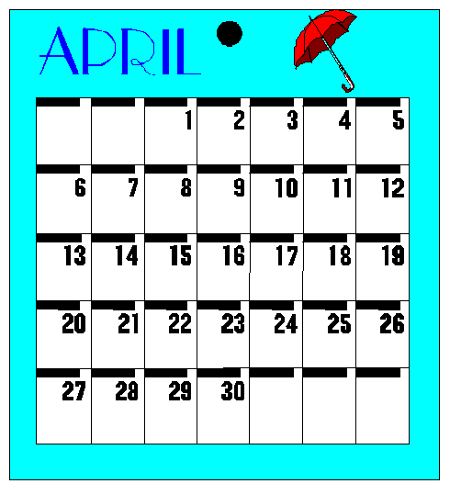

April 2003

Mummy Maze  Find your way through this mummy cat.  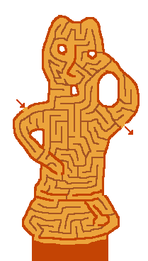 | Mummy Animals  The ancient Egyptians mummified animals as well as people. Unscramble the letters to reveal the animals they mummified.  BAROC__________________________  COFLAN_________________________  NOABBO________________________  MESOU _________________________  ETBELE _________________________  DREILOCCO______________________  CTA_____________________________  ISBI______________________________  SFIH_____________________________  TURVULE________________________  Answers: cobra, falcon, baboon, mouse, beetle, crocodile, cat, ibis, fish, vulture

Scattergories

Fill in the table below with words that begins with the letter in the first column for that row. For example, a Girl’s name that starts with C, might be Carol. To compete with a partner, see how many words you can fill in that are not in your partner’s list.

 | Girl's Name | Boy's Name | Sports Team | Food | Car Brand | Country
C
A
M
E
L
S

Ancient Egypt Word Search

Y R L E W E J S P H I N X L E

M N C P C H B E N L U R D L G
M I O S N A K E D E D M I O Y
U F U T R C T H V M E D M T P
M D S A N N L H U A O G A U T
P S C P R A O E E C Y A R S S
C S O H W M C I O B X U Y A I

M G U A F A U R P P E O P G B
O I S R L N C O A R A S P L I
D F Q A Y B I G T M O T L Q E
U N P O A P D L J R F C R L E
R T E H L C A Y E C A E S A R
D Y M E L O T P C I Q H K L A
K U X E U S E H R O S Q K Z B
N X B U C Q S O P U P G P H T

ASP | CROCODILE | KHARTOUM | PTOLEMY
BARGE | DATES | LOTUS | PYRAMID
CAESAR | EGYPT | MARC ANTONY | QUEEN
CAIRO | FIGS | MUMMY | SCARAB
CAMEL | HEIROGLYPH | NILE | SCORPION
CAT | HUMMUS | PALACE | SNAKE
CLEOPATRA | IBIS | PAPYRUS | SPHINX
COUSCOUS | JEWELRY | PHARAOH | THEBES

Opening

Hieroglyph Welcome

Copy each of the following symbols unto large sheets of paper or card stock:

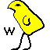 |  | 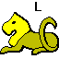 | 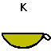 | 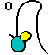 | 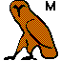

Have seven Cub Scouts, each holding up one of the above signs, read the script that is written on each of their signs.

W – is for the warm welcome we would like to give to you.
E – is for the Egyptian theme this month.
L – is for the loads of fun we will have tonight.
C – is for the Cub Scouts who have worked hard on their badges.
O – is for the ovation for a job well done.
M – is for the Moms (and Dads) who give us lots of support.
E – is for everyone to join in the fun.

The Cub Scout Promise Pyramid

Preparations: Cut out 4 large triangles from a sheet of poster board. Write the words: “Duty to God” on one, “Duty to Country” on the second, “Helping Others” on the third, and “Do Your Best” on the fourth. Have 4 boys stand in front of the audience, each holding one of the triangles.

LEADER: The ancient Egyptians believed in the power of the pyramids. They believed that the pyramid could bring healing and spiritual powers. The pyramids were an important part of their lives. There are 4 points in the Cub Scout promise that every Cub Scout promises to live by, and they are:
- Duty to God
- Duty to Country
- Helping Others
- Do My Best
(As each point is read, have each boy form one side of the pyramid)
When you put these points together, they form the Cub Scout Promise pyramid. Cub Scouts, please join me in the Cub Scout Promise…

Audience Participation

A Flying Alligator
A flying alligator (make waving wing movements with arms out to side)
Is quite a curious sight (move hands in questioning motion by sides of face)
But I swear I saw one (one hand on hip, the other making wagging motion in front of you)
Just the other night (one hand on hip, the other palm up in front of you)
I was driving with my sweetie (pretend to be holding a steering wheel)
And right before our eyes (touch corner of eyes)
We saw that alligator (hands in front, palms together, make opening and shutting hand movements like an alligator jaw opening and shutting)
Buzzing like a fly (hands to sides, wave fingers like the wings of a fly)
We drove into a parked car (pretend to be holding a steering wheel in your hands)
The police were not amused (hands on hips, grumpy look on face)
And they did not believe us (shake head from side to side, hands still on hips)
They thought we were confused (make swirling motion to the side of the head with one hand, the other hand still on hip)

CHEERS

Mummy Applause: Stand up straight with hands at your sides. Slap the sides of your body with stiff arms.

Zombie Applause: Stand up straight with both arms straight out in front of your body. Slowly move each arm up and down.

JOKES/RUN -ONS

- Why are mummies good at keeping secrets?
- They keep everything under wraps.
- Why did the mummy leave his tomb after 3000 years?
- He thought he was old enough to leave home!
- What do mummies do at 11 o' clock each morning?
- Take a coffin brake!
- How does a mummy begin a letter?
- Tomb it may concern...
- How do mummies pass through locked doors?
- They use a skeleton key!
- What did the ancient Egyptian Priest say when he finished bandaging the Mummy?
- That about wraps it up!
- What did the sign in the Egyptian funeral home say?
- Satisfaction guaranteed or double your mummy back!
- How do mummies hide?
- They wear masking tape!
- How can you tell if a mummy has a cold?
- He starts coffin!
- How many sides does a pyramid have?
- Two: an inside and an outside!

Scout 1: Would you like some Egyptian Pie?
Scout 2: What's Egyptian pie?
Scout 1: You know, the kind mummy used to make.

Limerick:

An archaeologist in Luxor
Was looking for gold and more
He opened King Tut's tomb
With gold, room after room!
And got more than he looked for!

Poem:

Pomi the Camel
by Ellen Cammaratto

Pomi the camel lived in a zoo
And never did what camels could do.
He dreamed of deserts in foreign lands
And green oases amid burning sands.

His ancestors wore diamonds, gold and jewels
And carried the guards of the great sheikh Abdul.
Some others were known for their speed and strength
And won camel races wherever they went.

A huge caravan was where he should be
Carrying his owner through Iran or Turkey
Not locked behind bars or in pens made by man
But free to roam over dunes made of sand.

Not laughed at for spitting or for the hump he wore
But really well loved for the burdens he bore.
Appreciated for being a helper of man
Who live in these changing and waterless lands.

Sally the Camel

Sally the camel has five humps.  Sally the camel has five humps.  Sally the camel has five humps.  So go, Sally, go. | Sally the camel has two humps.  Sally the camel has two humps.  Sally the camel has two humps.  So go, Sally, go.
Sally the camel has four humps.  Sally the camel has four humps.  Sally the camel has four humps.  So go, Sally, go. | Sally the camel has one hump.  Sally the camel has one hump.  Sally the camel has one hump.  So go, Sally, go.
Sally the camel has three humps.  Sally the camel has three humps.  Sally the camel has three humps.  So go, Sally, go. | Sally the camel has no humps.  Sally the camel has no humps.  Sally the camel has no humps.  Now Sally is a horse.
Guardian’s Egypt
(http://guardians.net/egypt)
This is one of the most comprehensive sites on Egypt. From art tours to kids sections to chats and discussions this site is loaded with useful information.
History of Ancient Egypt
(http://www.library.nwu.edu/class/history/B94)
Check out this site to find resources used in the classroom as well as a chronology of Egyptian history.
Egypt Search
(http://www.egyptsearch.com)
From religion to science, this site makes it possible for you to find anything that you need related to Egypt—past and present.
Egypt and Ancient Near East—Web Resources for Young People and Teachers
(http://www-oi.uchicago.edu/oi/dept/ra/abzu/youth_resources.html)
This list of museums has resources and cyber tours of Egypt as well as some interesting ideas for teachers.
Pyramids: The Inside Story
(http://www.pbs.org/wgbh/nova/pyramid)
Take a tour through some of the most famous tombs in the world—the Egyptian pyramids. Go down the descending passage, up the ascending passage, and straight into the king’s and queen’s chambers.
Egypt Antiquities
(http://touregypt.net/antiq.htm)
This “Official Site of the Egypt Ministry of Tourism” offers sections, among others, entitled “Rulers of Ancient Egypt” and “Who’s Who of Egypt,” with mini-biographies as well as a glossary that covers important architectural and iconography terminology.

Teacher's Guide- The Egypt Game
(http://www.sdcoe.k12.ca.us/score/egyp/egyptg.html)
This is a supplemental unit of study on Egypt. This unit was designed to integrate sixth grade core literature with social studies, art, and technology including current online information resources.

Sand Paper Art

This is a very simple, but very effective way to make a drawing that looks like it came right off the walls of an Egyptian tomb.

Materials:
- Piece of coarse sandpaper (we used a 4inch x 6inch (ish) piece, but you could use whatever size you like)
- Crayons

Instructions:
- Draw an Egyptian scene on the sandpaper with crayons (A pyramid landscape works well)
- If you draw Egyptian people, remember that they are always drawn as if the body is facing towards you and the head is turned to the side.
- Press hard on the crayons.

Sugar Cube Pyramid
(From Family Fun)

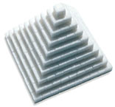
Kids can try their hand at Egyptian-style construction by turning a pile of sugar cubes into a model pyramid.

Supplies:
- 1 egg white
- Pinch of cream of tartar
- 1½ cups confectioners' sugar
- Sugar cubes

Directions:
- Mix up a batch of "mortar." Just beat together one egg white and a pinch of cream of tartar until soft peaks form. Add 1½ cups of confectioners' sugar, ¼ cup at a time, beating until well combined. (Since the egg in the sweet mortar is raw, be sure your kids don't eat it.)
- Assemble the base of the pyramid. Using the mortar and a pastry brush, glue together ten rows of ten sugar cubes each.
- Glue together the rows to form a square.
- For the second layer, glue together nine rows of nine cubes each and then center and glue the layer on top of the base square.
- Use this method to add seven more layers, each time decreasing the length of the rows by one cube.
- Top the pyramid with a single cube.

Egyptian Straw Bracelet

Materials:
- Straws, yarn, gold paint, needles, and scissors.
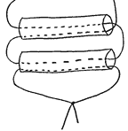

Instructions:
- Cut the straws up into 1 1/2” pieces or whatever size you would like.
- Cut a long piece of yarn. Place a needle on each end of the yarn.
- Insert one end of the yarn through one of the straw pieces and pull the yarn through so that the straw is at the halfway point of the yarn.
- Insert one end of the yarn through another straw piece and push the straw down so that it touches the other piece. Insert the other end of the yarn through the opposite end of the straw piece that you just put on and pull the yarn tight.
- Keep going like this until you have enough pieces of straws on your bracelet to fit around your arm.
- When you are finished tie the ends of the yarn together.
- Cut a short piece of yarn and thread it through the first piece of straw you put on. Tie the ends together.
- Spray paint the bracelet gold.

Origami Pyramid
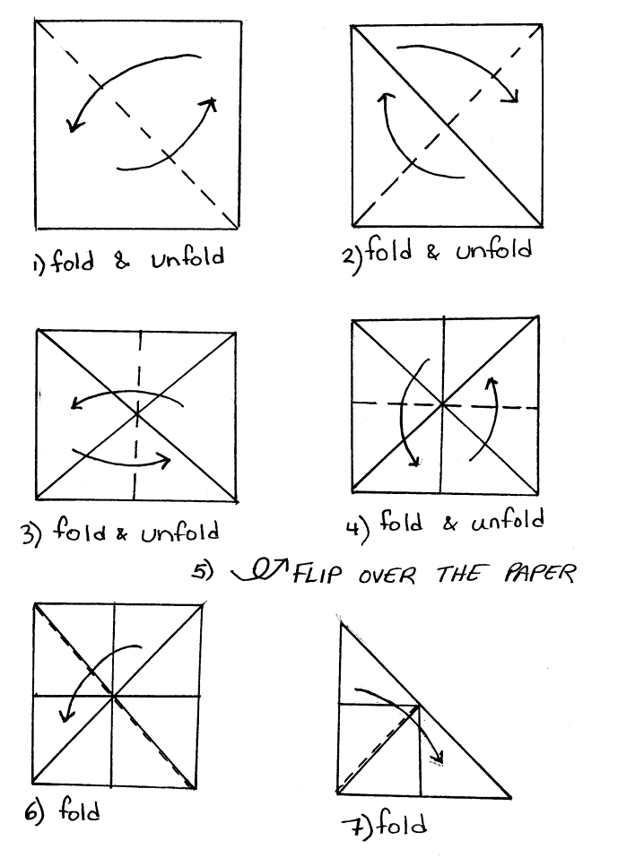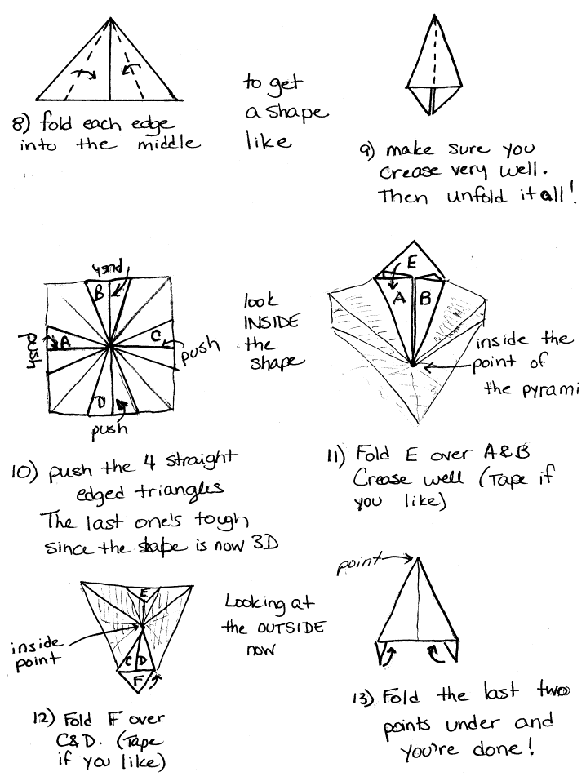

No Mess Sand Art

Do this project outside in the sand box so you won’t have a big mess to clean up in the house.

Materials: Heavy paper (card stock), white glue, watercolor paint, and sand.

Draw a design on the heavy paper with the glue. Place the picture in the sand box and sprinkle sand all over the design. Dump off the excess sand. Let dry for a while and then paint with water colors.

In the Tomb, Out of the Tomb

Draw a long line using string or masking tape. Have the children line up in a straight line facing the leader on the right side of the line. The right side of the line is called "In the tomb" and the left side of the line is named "out of the tomb". The leader yells "out of the tomb or in the tomb". Upon hearing the command the children jump from one side to the other. If the children jump in the wrong direction or don't jump to the other side when it's a valid command they are out of the game. The last player in wins the game. The leader will try and get the players to miss jump by pointing to one side as they yell to jump to the opposite side or by repeating the same side and/or changing the pace.

Mummy Wrap Relay

Materials: Old sheets (1 for each team)

Divide into as many teams as needed; have each team divide into 2 groups, which are at opposite ends from each other. The first person in each individual team must wrap themselves into the sheet by laying down and rolling up into the sheet, (must have arms inside of sheet) stand up (can get help from team members to stand up, if needed) and then run to their other team group and unroll themselves, then that team member at the other end must do the same. The first team to have everyone do the same wins.

Jump The Nile

Place two long thin sticks, or dowels, two feet apart. Tell the children that the Nile River runs through Egypt. It is a wide river, but full of crocodiles. Have those that want to jump the Nile line up behind one of the sticks. They will all get a chance to jump across the river. After everyone has had a turn, move the sticks a little further apart. Anyone who lands in the “water” leaves the game to do something else. Continue until only one person is left. If there is a large age range, divide the group into smaller groups closer in age.

Pyramid Bowling

Stack up 10 empty soda cans in the shape of a pyramid, with 4 on the bottom, 3 on the next row, then 2 and finally 1 on top. Boys take turns knocking down all the cans with tennis balls. Each boy gets 3 shot s per turn.

Pyramid Building Contest

Divide the group into an equal number of teams. Give each team an equal number of wooden craft sticks, and a tube of white glue or a roll of tape. See which team can build the largest or tallest pyramid in a given amount of time (15-20 minutes). The pyramid can have 3 or 4 sides, the base of each side must be the same length, and the pyramid must be able to stand on its own. This contest can also be done with toothpicks or straws.

Commercial Games

Bring history to life with some hands-on fun. Here are some commercial games based on Ancient Egypt. Some of these games originated in Ancient Egypt, some are modern games packed with fun and information about Ancient Egypt. Most of the games are available at toy stores or game shops that sell board games.

- Senat Game
Senat is a fun game of chance and strategy from the time of ancient Egypt. The goal is to move your pieces around and off the board. Use the traditional sticks to determine your move or use a die.
- Mancala
Mancala is said to be the oldest game. It originated in Africa, but was very popular in Ancient Egypt. It is played with gemstones on a board that has little "cups" cut out. The goal is to collect the most gems in your mancala (the big cup at the end of the game board).
- Ra Game
Set in ancient Egypt, Ra spans 1500 years of Egyptian history. The players seek to expand their power and fame by: influencing the Pharaohs, building monuments, farming on the Nile, paying homage to the Gods, and advancing the technology and culture of the people. From Rio Grande Games. (for 3 to 5 players, ages 12 and up)
- Luxor
Archaeologists have discovered a giant wall covered in hieroglyphics. Help reconstruct the wall and find which mummies are waiting to be discovered. (for ages 8 and up)
- Ceega
Ceega is another strategy game from Egypt. It used a wood board and glass beads. This challenging game is for ages 8 and up.
- Wadjet
Wadjet is an exciting and educational board game. "Experience the thrill and the danger of a true archaeological expedition. Uncover authentic Egyptian treasure, buried for thousands of years beneath the desert sand, learn the meaning of symbols, myths, and magic of the ancient Egyptians as you embark upon the expedition of a lifetime!" From Timbuk II Games. (ages 10 and up)

Yummy Mummy Cookies
(From www.s-t.com; The Standard-Times)

Ingredients:
- 2/3 cup butter or margarine, softened
- 1 cup sugar
- 2 teaspoons vanilla extract
- 2 eggs
- 21/2 cups all-purpose flour
- 1/2 cup cocoa
- 1/4 teaspoon baking soda
- 1/2 teaspoon salt
- 1 to 2 packages (10 ounces each) white chocolate chips
- 1 to 2 tablespoons shortening (do not use butter, margarine or oil)
- Miniature semisweet chocolate chips, for garnish

Directions:
- Beat butter, sugar and vanilla in a large bowl until creamy. Add eggs; beat well.
- Stir together flour, cocoa, baking soda and salt; gradually add to butter mixture, beating until blended. Refrigerate dough 15 to 20 minutes or until firm enough to handle.
- Heat oven to 350 degrees F.
- To form mummy bodies, using 1 tablespoon dough, roll into 31/2-inch-long carrot shape; place on an ungreased cookie sheet. To form the mummy's head, roll 1 teaspoon dough into a ball the size and shape of a grape, press onto the wide end of the body. Repeat procedure with remaining dough.
- Bake 8 to 9 minutes or until set. Cool slightly; remove from cookie sheet to wire rack. Cool completely.
- Place 12/3 cups (10-ounce package) white chips and 1 tablespoon shortening in microwave-safe pie plate or shallow bowl. Cook on high (100 percent power) for 1 minute; stir until chips are melted.
- Coat tops of cookies by placing one cookie at a time on table knife or narrow metal spatula; spoon white chip mixture evenly over cookie to coat. (If mixture begins to thicken, return to microwave oven for a few seconds.)
- Place coated cookies on waxed paper. Melt additional chips with shortening, if needed, for additional coating. As coating begins to set on cookies, using a toothpick, score lines and facial features into coating to resemble mummy. Place 2 small semisweet chocolate chips one each cookie for eyes. Store covered in cool, dry place.
- Makes about 30 cookies.

Egyptian Pyramids

Ingredients:
- 1 pound bag of coconut
- 1½ cups of sugar
- 6 egg whites

Directions:
- Beat the egg whites until stiff.
- Mix the coconut and sugar and mix into the eggs.
- Grease a cookie sheet and shape the meringue into pyramids.
- Bake at 400 degrees for 10 minute or until a light brown.

Egyptian Taboulleh Salad
(Adapted from Lynne Fredericks' Cooking Time is Family Time)

This is an ancient Middle Eastern dish made with bulgar that kids shy away from at first because there are so many ’green things.’ It is especially delicious in summer when tomatoes are vine-ripe and sweet and mint is fresh and pungent. Kids love to mix it up with their hands and the parsley is rich in calcium and vitamins A and C. Bulgar can be easily found in health food stores or Middle Eastern markets as well as in some supermarkets.
Ingredients:
- 2 cups #2 grade bulgar
- 2 fresh ripe tomatoes
- 1 bunch scallions
- 1 bunch fresh mint
- 1 bunch fresh parsley
- 3 lemons
- 1/2 cup olive oil
- Kosher salt and freshly ground pepper

Directions:
- Place the bulgar in a bowl and cover it with hot water. Let it set for about 20 minutes.
- While the bulgar is soaking, have the older kids chop tomatoes and scallions. Meanwhile have the little ones help you wash and pat the herbs dry. Then have them pluck the mint and parsley leaves from their stems. Discard the stems.
- Place the chopped veggies in a salad bowl. Drain the bulgar of excess water, squeezing one handful of bulgar at a time over the sink, and placing each handful of squeezed bulgar into the salad bowl with tomatoes and scallions. While little ones are helping with this task, older kids can be chopping the herbs.
- When all the bulgar is in the salad bowl, have children squeeze the juice from the lemons into the salad. Now measure and add the olive oil. Next, let the kids mix everything up with their hands -- as usual, kids love this! Adjust seasoning to taste with salt and pepper while children mix. This salad will sit in the refrigerator and improve in flavor for 3-4 days. It’s great for a party and can be made in advance.

Monkey Bread
(Recipe by Mary Kay Radnich)

This is a fun, sweet recipe that the entire family will enjoy, and kids can help make it, too. It’s not Egyptian, but it is good!

Ingredients:
- 2 (1 pound) loaves frozen white bread
(If you don’t have frozen bread dough in your area, you can substitute homemade bread dough, enough for a 2-pound loaf, which would use 4 cups of flour.)
- 1¼ C. sugar, divided
- ¼ C. packed brown sugar
- ¼ C. milk
- 1-2 Tablespoons butter or margarine
- 1 3/4 Teaspoons ground cinnamon, divided
- Cooking spray, such as PAM or butter or margarine to grease the pan

Directions:
- Thaw the bread dough in the refrigerator for 12 hours. (Skip this step if you are using fresh dough)
- Combine 1-cup sugar, brown sugar, milk, margarine/butter and 1¼ teaspoon of the cinnamon in a small saucepan. Bring to a boil; cook 1 minute. Remove sugar syrup from heat; let cool 10 minutes.
- Combine ¼ cup sugar and ½ teaspoon in a shallow dish and mix well. Cut each loaf of thawed dough into approximately 24 equal portions. Roll each portion in the cinnamon sugar and then layer the dough balls in a 12-cup Bundt pan or tube pan, that has been coated with the cooking spray (or greased).
- Pour the sugar syrup over all of the dough; cover and let rise for 35 minutes or until doubled in bulk.
- Preheat over to 350F.
- Uncover, and bake at 350 or until lightly browned. Immediately loosen edges of bread with a knife. Place a plate upside down on top of the pan; invert pan onto plate. Remove pan and drizzle with any remaining sugar syrup.

Egyptian Sweet Couscous

Ingredients:
- 1 c. couscous
- 2 c. fruit juice
- 2 T. rose water

Directions:
- Steam the couscous as directed on package. When done, rub in 3 T. butter.
- Steam it again. When done rub in 4 T. melted butter, ¼ c. ground almonds, ¼ c. ground pistachio nuts.
- Mound it onto a platter and sprinkle with powdered sugar and cinnamon combined.
- Surround the couscous with candy coated almonds and/or pomegranate seeds.

Caterpillar Bananas

Ingredients:
- A bunch of bananas
- 1 jar of peanut butter
- 1 package of raisins
- Uncooked spaghetti

Directions:
- Peel a banana. Cut it into round even slices.
- Spread peanut butter on one side of each slice of the banana.
- Stick banana slices together.
- Add raisins with a dab of peanut butter to one of the ends for eyes.
- Use uncooked spaghetti for the antenna.
- Eat your caterpillar!

Egyptian Night Crawlers

Ingredients:
- 12 large apples
- 8 oz jar of boysenberry jam
- 4 T. butter
- 12 gummy worms

Directions:
- Preheat your oven to 350 degrees.
- Core the apples from the stem end to one half inch from the bottom. Don’t push it through.
- Stuff each of the apples with 1 t. jam and butter.
- Place apples in a pan and bake 35-45 minutes, uncovered. The apples should be juicy and tender but not completely mushy.
- Remove from oven and let cool 15 minutes.
- Set each apple in a bowl and spoon syrup from the baking pan.
- Insert a gummy worm with half of its body protruding from the top.

Sailboat Down the Nile

Ingredients:
- Several stalks of celery
- 1 jar of peanut butter
- Some fruit roll snacks
- Toothpicks

Directions:
- Cut a 3-4" section of a celery stick.
- Fill center of celery stick with the peanut butter. Spread it out smooth.
- Cut a triangle from a fruit roll snack. Attach a toothpick to the fruit roll to make it look like a sail. Poke the end of the toothpick with fruit sail into the celery.
- You can also fill the celery with cream cheese, softened, yogurt.

