Lights, Camera,
Cub Scout Action!

Pow Wow 2003
Santa Clara County Council
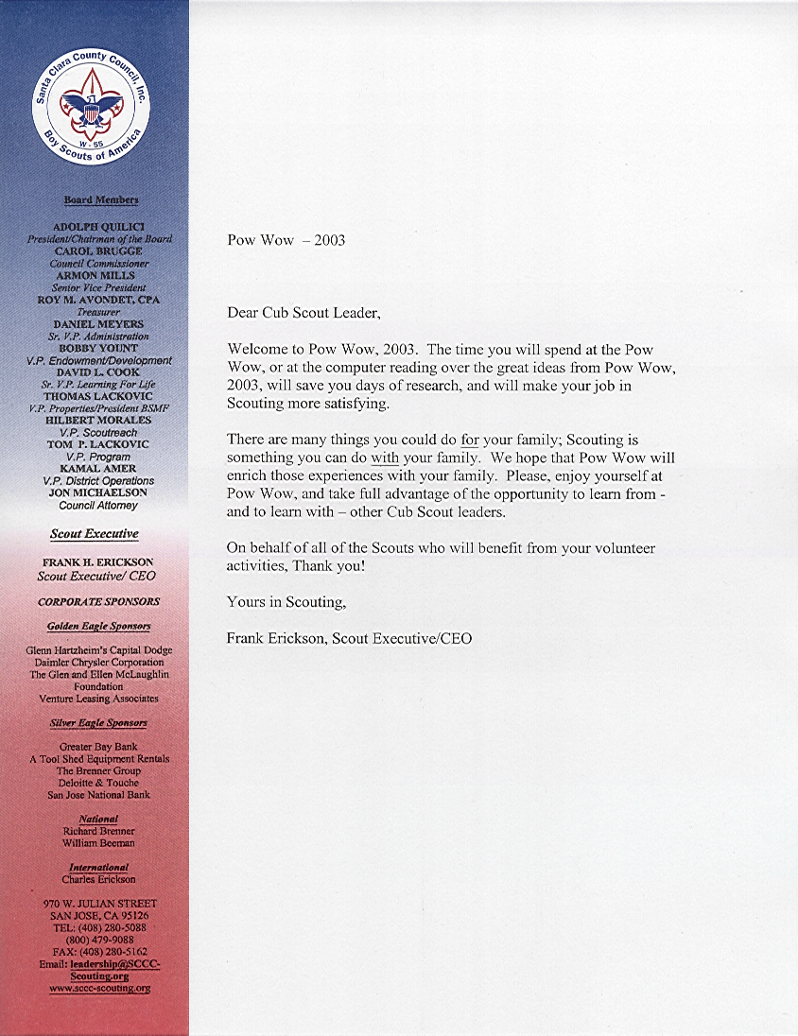

January, 2003

Dear Scouters,

Although this isn’t the broad, expanded version of the Pow Wow Book I envisioned when I agreed to be the editor a second year, I expect it will prove to be a useful resource (even if you might come across a few items that’ll make you wonder, “What was she thinking?!!!”). While I sincerely believe we humans never stop learning (what would be the point of Pow Wow if we did?), this doesn’t seem to have been the year when I learned to overcome procrastination….

The good news is as follows:

- I was able to draw on some new sources of information;
- Wesley Wong made even more contributions;
- Sakiko & Phil Wehrman’s (extended?) family graciously updated the Field Trips; and,
- Some of the instructors made contributions which add weight and value!

My heartfelt appreciation to all of them.

Again, I encourage the participants to take advantage of all the Scouting resources available to help make doing a great job both fun and rewarding. Thank you for your devotion to making this invaluable program available to the boys of our council. If, during the year, I can provide any assistance to you, please contact me.

Sincerely,

Leslie Gibbons
H: (408) 395-0596
C: (408) 656-2756
emmenles@attbi.com

SANTA CLARA COUNTY COUNCIL POW WOW 2003
LIGHTS, CAMERA, CUB SCOUT ACTION!

Staff and Faculty

POW WOW CHAIR Sakiko Wehrman
VICE CHAIR Dick Noack
PROFESSIONAL ADVISOR “J” Anderson
POW WOW CORE STAFF
Faculty Coordinator Linda Idemoto
Facilities Chris Kroninger
Promotion Steve Chiang
Lynn Wang
Midway Frank Diaz
Registration: Computer Phil Wehrman
Check-in Judy Haccou
Service Support Cindy Lusk

SUPPORT STAFF
Child Care Girl Scout Troop
Lunch, Snack Mike Imazumi and Venturing Crew 214
Boy Scout Team Richard Blume, Scoutmaster
Boy Scouts from Troops 218, 325, 342, 394, 501, 578
Patch Design Wesley Wong
Pow Wow Posters Lynn Delucchi
“Pow Wow Man” Kevin Pung

POW WOW BOOK
Editor Leslie Gibbons
CD Production Wesley Wong, Phil Wehrman

POW WOW FACULTY
Academics & Sports Mike Berryhill
Boy Behavior Donna White, Joyce Kroninger
Cooking—In the Kitchen Cindy Smith, Richard Smith
Cooking—Outdoors Scott Morse
Crafts—Leathercraft Lisa Corley
Crafts—Theme Crafts Adriana Rangel, Lynn Delucchi
Crafts—Working with Wood Bill Flood, Norman Phillips
Cub Dens on the Go Kassie Goldsworth, Neal Goldsworth
Cub Scouting with Disabilities Andrew Duprey, Patti Keegan
Dealing with ADD/ADHD Patti Keegan, Andrew Duprey
Den Gathering Activities Dan DePalmo
Den Leadership Team Pete Shyvers
Derbies Vince Ventura, Ron Cannon
Duty to God Anne Resch, George Imokawa,
Willis Clayton, Jose Saleme
First Aid for Leaders Laura Rodriguez
Fundraisers & Finance Chuck Guthery
Games to Play Indoors Marcia Morrow
Games to Play Outside Marcia Morrow
Games for Den Chiefs Tom Brodack, Mike Riachy
How to Say “Thank You” Teri Schell
Knives Brian Belet
LDS Church Sponsored Cub Program Mark Collins, Mike Davis
Magic Wesley Wong, Leslie Gibbons
Nature for Webelos Sarah Rouse
Nature for Wolf and Bear Sarah Rouse
Neckerchief Slides Walt Stephenson, Jim Pierce
Our Flag Jeremy White, Shane Truskolaski
Outdoor Resources Neal Goldsworth, Kassie Goldsworth
Pack Ceremonies Charlie Schenck, Bill Hartman
Pack Ceremony Props Charlie Schenck, Bill Hartman
Pizzazz Tina Urata, Bruce Kawanami
Planning around the Monthly Themes Charlie Schrey, Debbie Ward
Recruiting Cub Scouts Phil McCarty
Rocket Fun Wesley Wong, Vince Ventura
Science Brian Guastaferro
Selecting Quality CS Leaders Pete Shyvers
Singing Songs with Cub Scouts Bruce Kawanami, Tina Urata
Tied up in Knots Garry Holst
Using Den Chiefs Ron Salwasser
Using Your Resources “J” Anderson
Webelos I Activity Badges Mary Bujalski
Webelos II Activity Badges Mary Bujalski
WEST George Booth

Internet Sites for Kids

www.funbrain.com
Play games for free, including Math Baseball, Stay Afloat, Grammar Gorillas, Fun Match and more. Special sections for kids, parents and teachers.

www.discovery.com
Official website for the Discovery Channel, this site is packed with educational materials, games and more. Jump to the Animal Planet page, the Learning Channel, and the Travel Channel. Lots of information about dinosaurs.

www.littlecritter.com
The official website of Mercer Mayer’s “Little Critter.” Little Critter information, jokes, coloring books, puzzles and more.

www.clickmag.com
The website for Click magazine “opening windows for young minds.” Interesting, concise information on various topics; fun, easy crafts. Tends more toward science and nature.

www.kidsdomain.com
Kids Domain, a wholly owned subsidiary of Kaboose Inc., is an acclaimed educational and entertainment site for kids, parents, and educators. Kids Domain is packed with kid-friendly content including interactive games, crafts and holiday activities, downloads, graphics, and contests that entice users to greater experiences. They even have crafts specifically for Tiger Cubs and Cub Scouts.

Ask Dr. Universe: http://www.wsu.edu/DrUniverse
This site from Washington State University has answers to many science-related questions, such as why does the earth turn, or how do mirrors work? You can even post your own question.

The Science of Baseball: http://www.exploratorium.edu/baseball
Learn about the science behind baseball, and why a curveball curves.

Bill Nye Website: http://www.billnye.com
The popular science guy’s website.

TABLE OF CONTENTS

Page #

Part I Monthly Themes

March 2003 How Does It Do That? 1
April 2003 Land of the Pharoahs 16
May 2003 Lights, Camera, Action! 33
June 2003 Fun in the Sun 50
July 2003 A Hiking We Will Go 62
August 2003 Circle the Wagons 79
September 2003 Soaring to New Heights 97
October 2003 Once Upon a Time 111
November 2003 Pilgrims of Plymouth Rock 124
December 2003 A Cub Scout Gives Goodwill 136
January 2004 Home Alone 148
February 2004 Fiesta! 159

Part II Field Trips 172

Part III Class Notes Songbook 199
Working with Wood 205
Duty to God 215
Pizazz 216
Outdoor Cooking 224
Derbies 228
Activities Calendar
Using Themes in your Pack
WEST

