Once Upon A Time

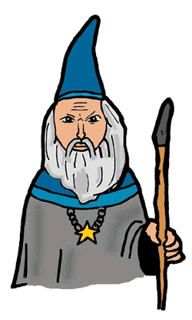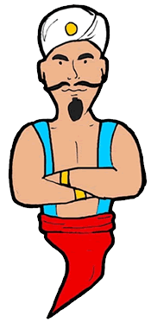

October 2003

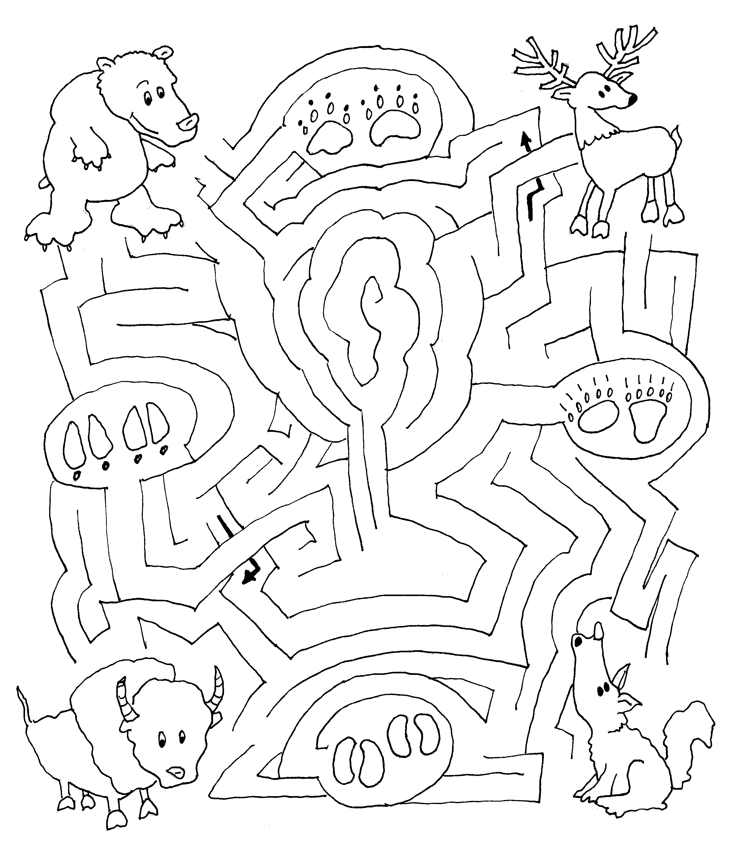

Opening
Match the buffalo, coyote, bear and elk with the correct set of tracks.

American Folklore

Cub #1: American folklore is more than just heroes and make-believe.

Cub #2: It is how the early settlers made clothing.

Cub #3: How they trapped for food.

Cub #4: How they work.

Cub #5: How they played.

Cub #6: Folklore is about America.

Cub #7: Let us do an American thing. Please stand and join me in the Pledge of Allegiance.

Across America

Cub #1: I traveled across America and many legends I did meet.

Cub #2: I rode the Pony Express from Missouri to California.

Cub #3: I saw Daniel Boone in Kentucky.

Cub #4: Met Davy Crockett at the Alamo.

Cub #5: Rode with Pecos Bill in New Mexico.

Cub #6: Looked for the Lost Dutchman in Nevada.

Cub #7: Walked with Bigfoot in the Northwest.

Cub #8: And rode Babe the Blue Ox across the Dakotas.

Cubmaster: But tonight, I’m going to meet the legends of tomorrow. Those legends
are the Cub Scouts in Pack _____.

Closing

American Folklore Heroes

CUB #1: All of our American Folklore heroes were hard working people – not a shirker in the bunch.

CUB #2: Campfire stories about them tell us so.

CUB #3: All were Americans trying to improve this young country of ours.

CUB #4: As we leave here tonight, let us keep those hard working Americans in our mind.

CUB #5: Do the same as they did, do more than your share.

CUB #6: Help your parents whenever they ask and even when they don't.

CUB #7: Maybe some day, there will be a legend that tells about your great deeds.

Good Deeds of Old

Tonight we have enjoyed recalling the days of old when brave men went forth doing good deeds. They carried their banners high, proud to show who they were. Tonight we would like one member from each den to come forward (either with the den flag or use the number on the sleeve. Line the boys in a row in front showing the den number.) Now, as we look at the symbol which stands for our group let us all stand and sing "God Bless America."
(All sing.)
Let us now go forth and be proud of our Cub Scout uniform and make every effort to live up to our Cub Scout Law and Promise.

Advancement

Sung to the tune of “When Johnny Comes Marching Home”

When the Cub Scouts all achieve a rank,
Hoorah! Hoorah!
When the Cub Scouts all achieve a rank,
Hoorah! Hoorah!
The moms will cheer (moms cheer) and the dads will shout (dads shout)
The leaders all will turn about (leaders turn around in a circle)
And we’ll clap our hands (all clap)
When the Cub Scouts achieve a rank!

Tall Tales for Small Males (an advancement skit)

Setting: A den meeting at Mrs. Smith’s home. All are seated.

Mrs. Smith: Today, Cub Scouts, we’re going to have ourselves some fun. This month’s theme is Once Upon a Time, so answer roll call with a far-fetched dream. Johnny…

Johnny: My name is Johnny, and long ago,
My great grandpa planted many a row.
And if hadn’t you’d surely cry,
Cause you wouldn’t have any apple pie.
He was Johnny Appleseed!
And with me I have a bag of special seeds
For the new Bobcats.

Mrs. Smith: Very good, Johnny! Now, David…

Paul: Just call me Paul—that’s my uncle’s name;
A big blue ox was part of his fame;
When Babe got thirsty from the heat,
Uncle Paul dug the Great Lakes—wasn’t that neat?
He was Paul Bunyan, and he saw lots of great Wolves on his travels.

Mrs. Smith: Oh, Paul—what a story! All right, David, it’s your turn…

David: My name is Davy, and back many a year
The forest bears would shake with fear
If by chance they saw a coonskin hat--
‘Cause that was my Uncle, Davy Crock-at!
At times Uncle Davy gave gifts to the special Bears.

Mrs. Smith: That’s pretty tall, David. Now, let’s hear from Casey…

Casey: When I was little, and Christmas came,
My folks gave me a set of trains.
I guess folks thought I was kind of racy,
So now they call me “Little Casey.”
Webelos badges would ride on my train.

Mrs. Smith: Well boys, I’d no idea that this den had such famous uncles and granddads. And, I’ve never heard such tall, tall tales from so many different small, small males!
The King With The Terrible Temper

Characters:
KING – “Grrr-r-r”
FAT DAUGHTER - Loud grunt
THIN DAUGHTER - Shrill moan
BEAUTIFUL DAUGHTER – “Wow”
PRINCE – “Ah, hah!”

Once upon a time there was a KING with a terrible temper who had three DAUGHTERS. One, who was exceedingly FAT, one exceedingly THIN and one exceedingly BEAUTIFUL. To this king with the terrible temper came a charming young PRINCE who courted one of DAUGHTERS. Not the one that was FAT or the one who was THIN but the one who was BEAUTIFUL. But then the KING with the terrible temper got mad. But regardless, the charming young PRINCE married not the FAT DAUGHTER or the THIN DAUGHTER but the very BEAUTIFUL DAUGHTER. And so the KING with the terrible temper forgave his BEAUTIFUL DAUGHTER and the charming young PRINCE and they lived happily ever after.

The Little Orange House

(As you tell the story, cut a piece of orange paper as described. Depending on the size of your group, you could hand out orange paper and scissors and have everyone participate.)

Once upon a time a very small witch was walking in the woods. The cold wind was blowing the dry leaves all around her. The little witch was frantically searching for a house for the winter. She could not find one. Suddenly, a piece of orange paper, blown by the wind, landed at her feet. She picked it up.
The little witch looked closely at the paper, and then she said, “I shall make myself a little house from this piece of orange paper.” She folded the paper in half. The she took her scissors (she always carried a pair of folding ones in her pocket) and cut off the two corners to make a roof.
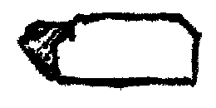
“This will do just fine,” she said, as she looked at her new house. “But I will need a door.” With her scissors, she cut a special door. It looked like this.

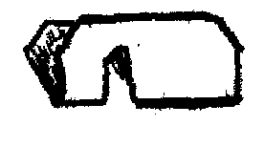
The little witch walked through the door into the little orange house. It was very dark inside. She quickly hurried back out. “I will need to make windows to let in the light,” she said. She cut a front and back window that looked like this.
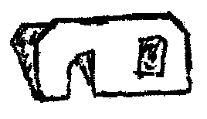
Oh, it was a very fine looking house. Her very own little house with a roof, a door, and windows, was all finished. But just as the little witch started to go inside for the winter, she saw a tiny ghost floating down the windswept path. As the tiny ghost came to a stop near the little house, the witch saw that she was crying.
“Why are you crying?” asked the little witch.
The tiny ghost stopped crying and answered, “It is cold and windy. It is getting dark and I have no place to spend the winter.”
“You may spend the winter with me in my new house,” said the kind little witch.
“Oh, thank you,” the happy, tiny ghost said, as she peeked in through the window. “This is a very nice house.”
“First,” said the little witch, “I will need to make you a little door of your own.” She took her scissors again and began to cut. She cut a very tiny door. It looked like this.
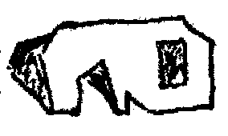
The two happy friends went inside. The tiny ghost went in the very little door, and the little witch went through her own special door. All winter long they lived happily together inside the little orange house.
If you want to see inside their little orange house, get a piece of orange paper and do just what the little witch did.

(Then unfold the paper—surprise!)

Run-ons

Cub #1: What do birds say on Halloween?
Cub #2: “Twick or tweet!”

Cub #1: What do little ghosts chew?
Cub #2: Boo-ble gum.

Cub #1: Why did Dracula go to the orthodontist?
Cub #2: To improve his bite.

Cub #1: What do you do with a blue monster?
Cub #2: Cheer him up.

The Unknown Legend

Scene: A group of boys standing around.

Cub #1: I hear the unknown legend is coming.

Cub #2: Have you seen him?

Cub #3: No.

Cub #4: Couldn’t be as strong as Paul Bunyan.

Cub #5: Nor as courageous as Casey Jones.

Cub #6: Couldn’t be as good a shot as Pecos Bill.

Cub #7: Oh yeah? He’s more than all those folk heroes put together!

All: Here he comes!

Out walks a Cub Scout, flexing muscles and grinning. (Curtains close/boys exit.)

The Ballad of Davy Crockett

Born on a mountain top in Tennessee,
Greenest state in the land of the free
Raised in the woods, so's he know ev'ry tree
Kilt him a b'ar when he was only three
Davy, Davy Crockett, King of the Wild Frontier

Fought single-handed through the Injun war
Till the Creeks was whipped and the peace was in store
While he was handling this risky chore
Made himself a legend forevermore
Davy, Davy Crockett, King of the Wild Frontier

Went off to Congress and served a spell
Fixing up the government and laws as well
Took over Washington, so I hear tell
And patched up the crack in the Liberty Bell
Davy, Davy Crockett, King of the Wild Frontier

He give his word and he give his hand
His Injun friends could keep their land
The rest of his like he took the stand
That justice was due every redskinned man
Davy, Davy Crockett, King of the Wild Frontier

When he came home, his politickin' done
The western march had just begun
So he packed up his gear and his trusty gun
And lit out grinnin' to follow the sun
Davy, Davy Crockett, King of the Wild Frontier

He heard of Houston and Austin and so
To the Texas plain he just had to go
Their freedom was a fightin' another foe
And they needed him at the Alamo
Davy, Davy Crockett, King of the Wild Frontier.

5 Little Pumpkins

5 little pumpkins sitting on a gate;
The first one said "Oh my it's getting late".
The second one said "There's a chill in the air."
The third one said "Well, I don't care".
The fourth one said "Let's run and run and run".
The fifth one said "I'm ready for some fun".
OOOOOOOOO OOOOOOOOOO went the wind
And OUT went the light and the five little pumpkins
rolled out of sight.
Deck the Patch
(Tune: Deck the Halls)

Deck the patch with orange and black
Fa La La La La La La La La
Take along your goody sack
Fa La La La La La La La La
Don we now our gay apparel
Fa La La La La La La La La
Toll the Ancient Pumpkin Carol
Fa La La La La La La La La.

Hooky Spooky
(Tune: Hokey Pokey)
Put your right arm in,
Put your right arm out,
Put your right arm in and shake it all about
Do the Hooky Spooky and everybody shout,
'That's what it's all about! BOO!' "

Great Pumpkin is coming to Town
(Tune: Santa Claus Is Coming to Town)
You better not shriek,
You better not groan,
You better not howl,
You better not moan –
Great Pumpkin is comin' to town!

He's going to find out, from folks that he meets,
Who deserves tricks and who deserves treats –
Great Pumpkin is comin' to town!

He'll search in every pumpkin patch,
Haunted houses far and near,
To see if you've been spreading gloom
or bringing lots of cheer.

So you better not shriek, you better not groan,
You better not howl, you better not moan –
Great Pumpkin is comin' to town!"

Knight's Shield

Take a large cardboard box and cut a shield shape out of the side. Cut a strip (about 8 inches by 2 inches) of heavy fabric or leather and glue or fasten it to the back. You can also use cardboard but it won't last as long. This is the handle. Either spray paint the front of the shield silver or cover it with tin foil (you can glue down the tin foil). Paint designs on the front or cut out the knight's symbol and tape it to the front of the shield.

Scepter

Take a cardboard tube from a roll of paper towels. Glue a Styrofoam ball on top (hobby shops or fabric stores with carry this). Cover the scepter with gold fabric or spray paint. If you spray paint it, you might want to dust it with sparkles while the paint is still wet. You can then twirl bright color ribbon around the scepter gluing the top and bottom strands. Some fake "jewels" that glitter adds a nice touch.

Castle Bowling
Cut and discard the top sections from 6 half-gallon milk cartons. Cover the cartons with glue and paper. Using scissors, cut turrets along the top to look like a castle. Add stone designs and doors with a marker.

To Play - Set up the castles like pins in bowling. Using a rubber ball, have your guests take turns trying to bowl over the castles.
Silver Treasure
Make silver pieces out of cardboard circles covered with foil. Tell the kids that a dragon broke into the castle and stole the silver treasure. Hide the silver all through the room and have the kids hunt for it. Another idea for coins is to use the metal juice lids
Capture the Dragon
Select various types of cardboard boxes to make a dragon shape. Cover the boxes with glue and construction paper. Decorate with pieces of cut paper. Add a paper tail and features to the head. Cut three long, thin strips of poster board. Staple the ends of each strip together to make three hoops.

To Play - Toss the hoops over the dragon's head. The player who gets the most hoops over the head wins.

Dwarfs, Wizards & Giants

Similar to “Rock, Scissors & Paper,” except this game is played with your whole body, instead of just your hands.

Wizards zap Giants
Dwarfs attack Wizards
Giants smash dwarfs

Divide the players into two groups. Each team huddles together to decide which character they will be at the line. The entire team must agree on the same character: Wizard, Giant or Dwarf.

The teams form lines (teammates shoulder to shoulder), facing each other across a centerline. At the count of 3, both teams make the gesture representing their selected character.

Dwarfs: Raise hands to shoulder height and bend fingers forward.
Wizards: Extend one arm forward and wiggle fingers on extended hand as if casting a spell.
Giants: Raise both arms straight up overhead and bend fingers forward.

The dominating team reaches across the line and tries to touch the opposing team as they attempt to escape by quickly moving backwards. For example, if one team shows Wizards and the other shows Giants, the Wizards quickly try to reach over and touch the Giants. None of the players may step across the line. If a subordinate player is touched, he must leave his team and join the other side. If someone goofs, and thinks his team’s character is supposed to beat the other team’s character and he reaches across and touches a member of the other team, he must join that team. If a player makes the wrong sign (e.g., makes the gesture of a Wizard when the team had decided to be Dwarfs), he must also join the other team.

To make the game more intense, players can line up facing each other behind lines drawn approximately 3 to 4 feet apart. Upon showing their characters, the dominant-character team chases the subordinate-character team, trying to touch them. A “safe” line can be set at any distance you choose, depending on your field of play. If a retreating player is touched prior to reaching the safe line, he must join the opposition.

The object of the game is to get everyone on the same side of the line.
A real vs. folk hero, American scientist, George Washington Carver devised over 100 ways of preparing the peanut as food, including peanut cheese, peanut fudge, peanut butter, peanut soup, and even peanut ice cream.

Peanut Candy

2 cups sugar
1 cup roasted, skinless peanuts
Butter

Melt the sugar slowly in a frying pan, stirring constantly.

Butter a shallow dish and cover the bottom with the peanuts. Pour the melted sugar over them.

Set aside. When cool, break into pieces and serve.

Peanut Salad with Bananas

Slice bananas and spread them out on lettuce leaves. Sprinkle liberally with chopped peanuts and serve with mayonnaise, plain salad dressing or yogurt.

Dinosaur Punch

1 can frozen lemonade concentrate, thawed
1 can frozen limeade concentrate, thawed
1 cup water
1 liter Sprite
Green food coloring

Mix together concentrates, water and Sprite. Add food coloring to achieve desired look.
Refrigerate. Serve over ice.

