DUTY TO GOD

Resources

Baden-Powell, the founder of Scouting, believed that Reverence and Duty to God should be an important part of the Scouting Movement and of every Scout and Scouter.

“Our objective in the scouting movement is to give such help as we can in
bringing about God’s kingdom on earth by inoculating among the youth the
spirit and the daily practice in their lives of unselfish goodwill and cooperation.”

- Baden-Powell

RESOURCE | CONTACT INFO | MATERIAL
Your Council District Executive |  | “Duty to God” quick reference chart of Religious Emblems Programs.  The chart lists:  - Religious groups  - Contact info for emblems programs  - Age-specific program name  - Program material BSA supply # (if applicable)
BSA website | www.scouting.org/awards/religious/index.html | Describes purpose of Religious Emblems Programs with index to:  - Frequently asked questions  - How to get started  - Chart of programs
PRAY (Programs of  Religious Activities with Youth) | www.praypub.org  (800) 933-7729 | - BSA’s “Promoting Duty to God” video (interfaith resource promoting the religious emblems of all faiths)  - Religious Emblems Presentation scripts (to be used with the above video by unit leaders)



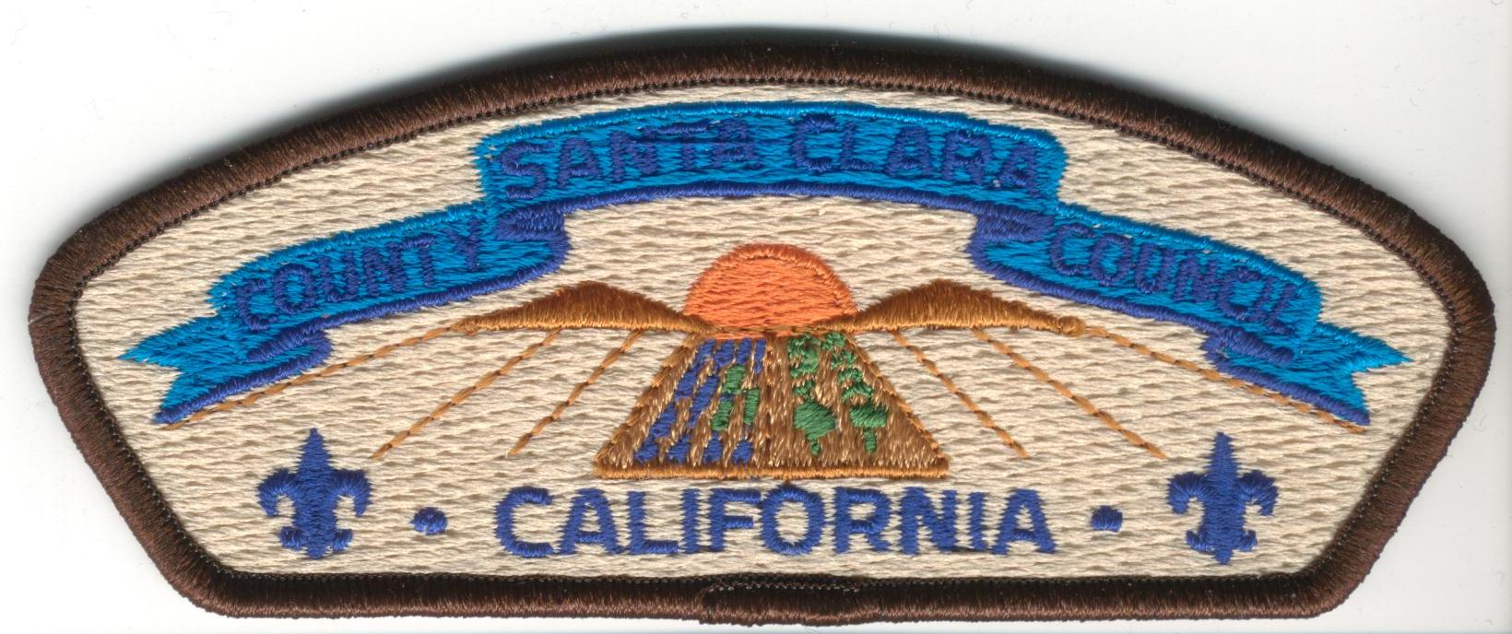

THE RELIGIOUS EMBLEMS PROGRAMS
LOCAL CONTACTS

BAHA’I  Don Burt | (408) 997-2621; donburt@sbcglobal.net
BUDDHIST  Rev. Gerald Sakamoto, San Jose Betsuin Buddhist Church  George Imokawa | (408) 293-9292  (408) 984-1035
CATHOLIC  www.ccscf.homestead.com  Ann Resch  Jose Saleme  Joan Schenck  Donna Marcopulos  (Stanford District, Pac. Skyline Council) | (408) 227-8587; a.resch@att.net  (408) 255-9966; josesaleme@comcast.net  (408) 266-1182; Jschenck@aol.com  (650) 960-4025; donna@marcopulos.com
HINDU  North American Hindu Association,  Pleasanton, CA. | (925) 846-3811
ISLAMIC  Sabir Khan | salikhan@yahoo.com
JEWISH  Merrin Davidson | (408) 848-5748  the_momstable@rocketmail.com
LDS  Local Ward Bishop  Max Parker | (408) 264-4024
PROTESTANT DENOMINATIONS  Debbie Wright | (408) 842-9613; deblwright@earthlink.net
(Rev 8-2003)

