Pow Wow

Cub Scout Leader Training
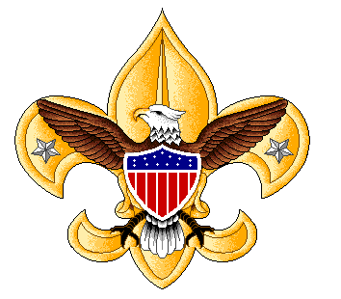

“Knives”

January 24, 2004

Brian Belet, Instructor
Scoutmaster, Troop 330
Pioneer District Training Committee, SCCC
Eagle Scout (1969)

408/379-2772
sm@troop330.org

Pow Wow
Cub Scout Leader Training

January 24, 2004

“Knives”

Course Objectives:

To provide Cub Scout leaders with the necessary information and skills so that they feel confident to teach Bear Cubs how to:
- To properly and safely handle a knife
- To earn their Whittling Chip

Whittling Chip Safety Requirements — Cub Scout Agreement
Cub Scouts, BSA

- I will treat my pocketknife with the respect due a useful tool.
- I will always close my pocketknife and put it away when not in use.
- I will not use my pocketknife when it might injure someone near me.
- I promise never to throw my pocketknife for any reason.
- I will use my pocketknife in a safe manner at all times.

Packet Contents:
  - Course Objective (this page)
  - Whittling Chip Safety Requirements (this page)
  - Demonstration wooden knife — plans and directions
  - Whittling projects suitable for Bear Scouts
  - Sample letter from Bear Den Leaders to Parents of Bear Scouts

DEMONSTRATION WOODEN KNIFE
CUB SCOUTS, BSA

Materials and Tools needed:
- 2 paint stir sticks
- 3 – ¹/₈-inch diameter x ¹/₂-inch rivets washer or pop rivets (same size)
- Coping saw
- Hand drill
- ¹/₈-inch drill bit
- 120 grit sandpaper
- 2 clamps
- Scissors
- Hammer —or— pop rivet tool
- Cellophane tape

Construction steps:
  - With scissors cut out patterns for knife parts (see pattern sheet).
  - Tape patterns onto paint sticks.
  - Clamp prepared sticks to a counter top and cut out the four pattern pieces.
  - Sand any rough edges before assembly (Step #5).
  - Starting with part number 1, stack four parts in the same sequence (#1-4) and direction as indicated on the pattern sheet.
  - With parts lined up evenly, clamp to bench top and drill three ¹/₈-inch holes exactly on the black dots.
  - Insert rivets into three holes and turn assembly over.
  - Place washers over protruding rivets and then set with hammer or pop rivet tool.
NOTE 1: Open blade before securing blade rivet.
NOTE 2: Secure blade rivet gently to allow blade to open and close.
  - Sand completed knife handle to shape both ends.
  - Enjoy!

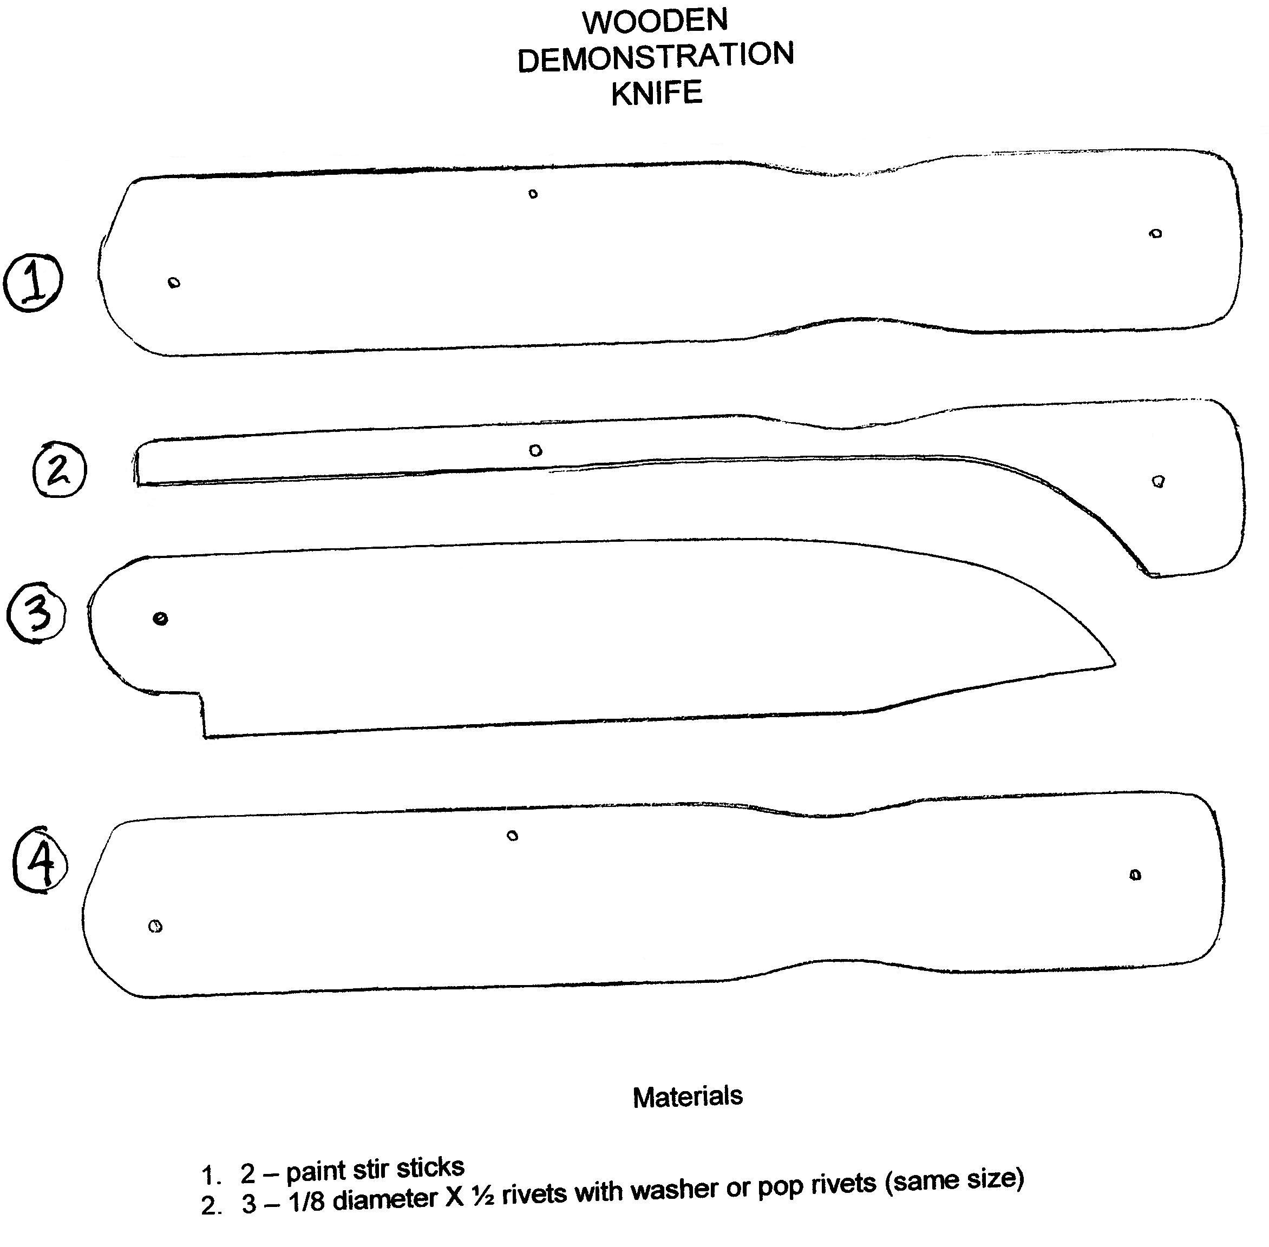

WHITTLING PROJECTS FOR BEAR-LEVEL CUB SCOUTS

- Fuzz stick (fire starter)
- Ring and pin (game)
- Propeller stick (game)

(see attached pages)

KNIFECRAFT – FUZZ STICK

A good sharp knife and skill in handling it will make a camper’s life easier – and more fun. Making shavings and fuzz sticks for starting fires is a test of both skill and knife care. Shavings may be made from any stick picked up at the cook-out site to make the simplest, most effective tinder. When shavings are left on the stick the product is called a fuzz stick.

Small fuzz sticks are made from a short stick, with five to ten shavings made on one side; the small fuzz sticks are piled one on top of another to make the base of a fire. A craftsman’s fuzz stick will be larger, with shavings on the stick all around and a pointed end to stand the fuzz stick in the ground. With kindling piled around the fuzz stick, fire building is simple. Fuzz sticks are especially good to make when wood is damp or wet, as the inside of the stick is always drier than the outside.

You will need: Piece of soft wood (pine kindling, etc.) about 10 inches lone, one-inch diameter and without knots.

- Hold top of stick with one hand and brace it against a bench, stump, or whittling board.
- Cut long, slim shavings down the length of the stick (avoid short, thick ones). Cut into wood at bottom, to keep from cutting shavings off, and draw knife out at bottom of stroke.
- Turn stick as work progresses, making shavings evenly on all sides.
- Point end of top of stick so it will stand in the ground.

Swedish craftsmen use this technique in making intricate trees, crosses, and animals for Christmas decorations. Southern mountain craftsmen make roosters of twigs, making the tails like a fuzz stick. Camp craftsmen can explore these same activities for favors or ornaments.

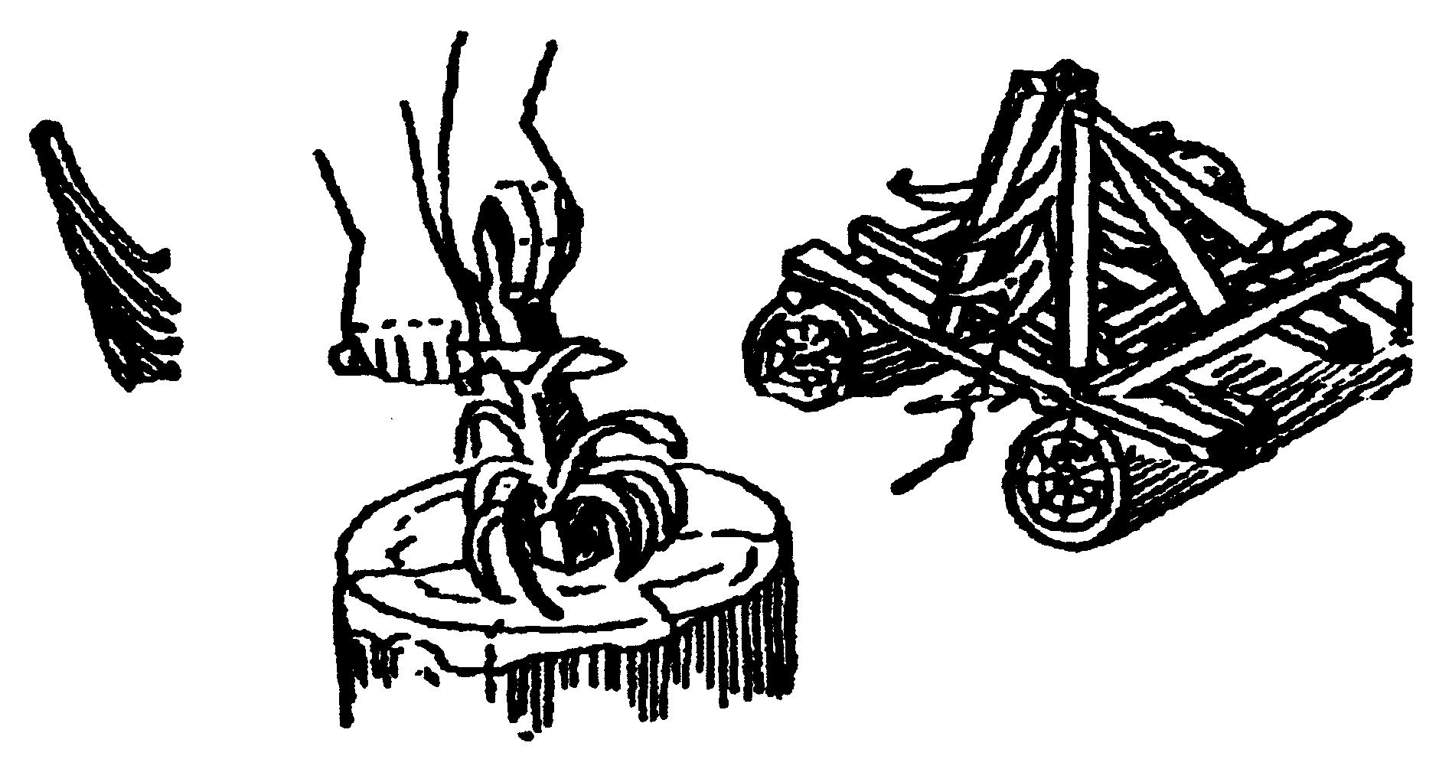

RING AND PIN

You need: rings (2 – 4 inches across), stick (10 – 12 inches long), heavy string (3 feet long), pocket knife

Suggestions for the rings: wooden curtain rings; rings cut from a heavy paper tube or plastic drinking cup; rings sliced ¾ inch thick from a dried gourd or squash; rings sawed from a dried marrow (“pin”) bone.

- Carve one end of the stick down to a dull point.
- Tie one end of the string to the fat end of the stick – a small whittled groove will keep the string from slipping off.
- Thread all but one of the rings onto the string, and then tie the remaining ring to the free end of the string. If all the rings are not the same size, the tied-on ring should be the biggest.

Make up your own rules for keeping score, and the first one to score a total of twenty points is the winner.

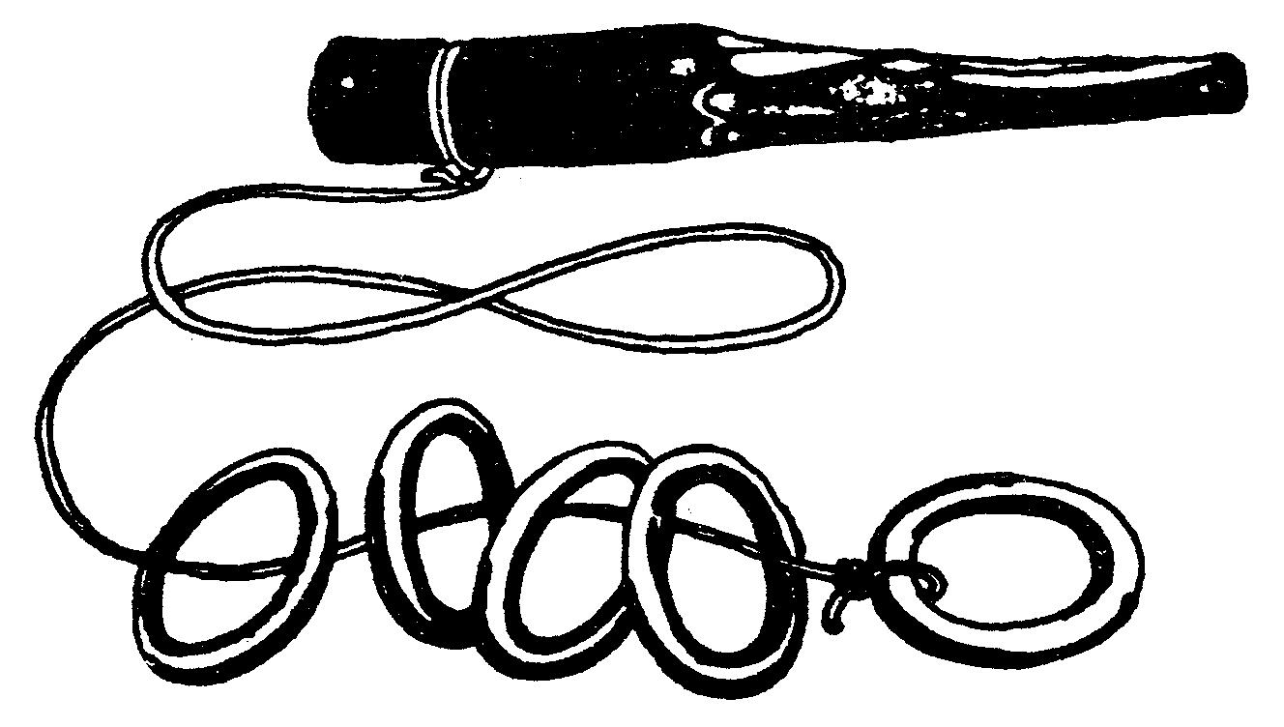

propeller stick

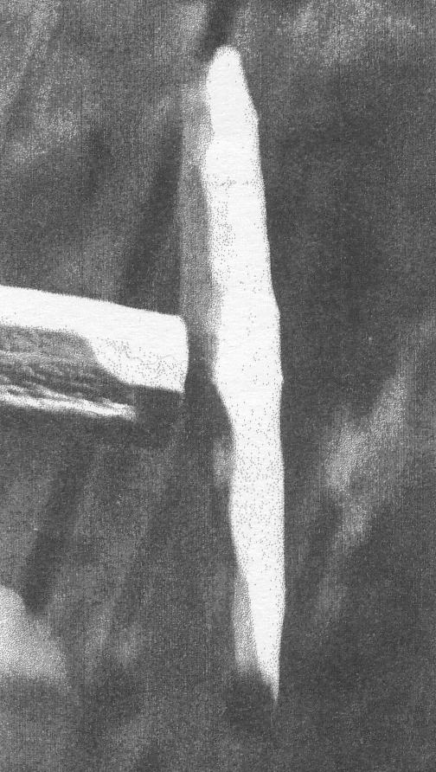
American Indians know the magic of how to make the propeller spin, stop and then spin in the other direction. If you know the magic, you can pretend to make the PROPELLER STICK work as a lie detector. Get the propeller spinning and ask a question. If the answer is yes, the propeller will continue to spin in the same direction. If the answer is no, the propeller will stio and then start spinning the other way. Actually, there is no magic to it at all – if you know the trick.

MATERIALS TOOLS
Small sticks Penknife
Headed nail Hammer

CONSTRUCTION
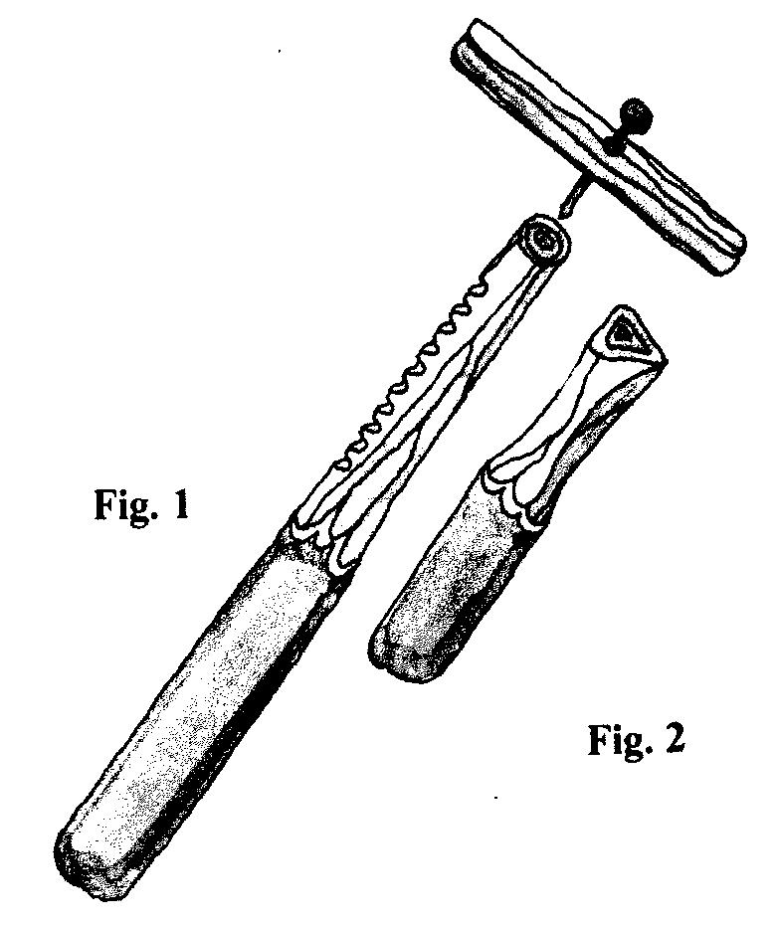
Cut a stick, or a piece of dead tree branch, about 8 to 12 inches lone, and whittle half the length of it down to bare wood. (Always be careful when using a knife. Never point the sharp edge or tip of the blade towards yourself or anyone close by, and carve with the knife blade cutting un the direction away from you.) On the whittled end of the stick, cut about six or eight notches in a row (Fig. 1). Make the propeller from a smaller stick about 3 inches long, and whittle it down to bare wood- it does not need to be the shape of a propeller at all. Measure to the center of the propeller, and make a hole through it slightly bigger than the thickness of the headed nail. You can make the hole with a drill, or by hammering a fatter nail through, wiggling it around, and then pulling it out. Mount the propeller onto the notched end of the bugger stick with the headed nail (Fig. 1), but don’t drive the nail in all the way. Leave it out just a little so that the propeller spins very easily. If necessary, balance the propeller by carving chips off the heavier end.

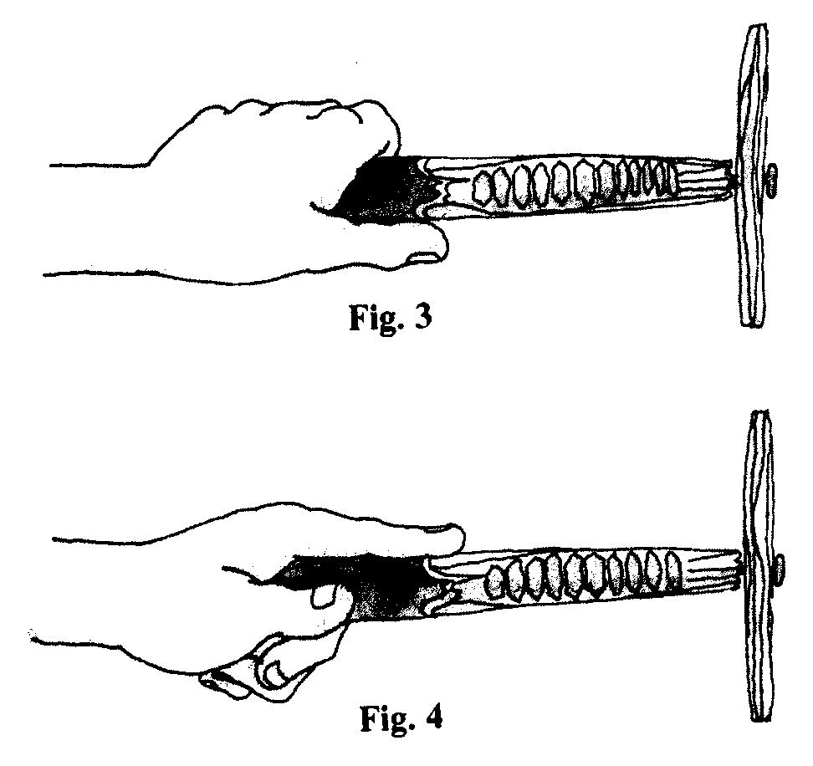
The rubbing stick is made from another wood piece as round as the notched stick, but only half as long (Fig. 2). Whittle down one end of the rubbing stick to a slightly pointed edge that will used for rubbing the notches. Now you’re ready to try the “trick.” Hold the propeller stick in one hand, and point it slightly down. Hold the rubbing stick in the other hand, and rub the pointed edge back and forth over the notches. Try rubbing fast then slow, easy then hard, until you find just the right rhythm and pressure to make the propeller spin. If you have trouble, try holding the propeller stick a little closer to the notches or a little further away from the notches. To make the propeller change direction, put your pointing finger out along the side of the notched stick (Fig. 3). Which way does the propeller spin? Now take your pointing finger back, and put your thumb out along the other side of the stick (Fig. 4). Does the propeller change direction? It should. The hand is quicker than the lie.
Sample letter from Den Leaders to Pare nts of Bear Cub Scouts

<Date>
Dear <Parent>,

In our past two den meetings we have discussed safety rules for handling a pocketknife. We understand that this is a matter of concern for some of you and we feel that you must decide if you want your son to be allowed to carry and use a pocketknife.

Each one of the boys will have earned his Cub Scout Whittling Chip card. This card entitles that each boy has learned the safety rules and is capable of carrying a pocketknife. Under these conditions pocketknives can be carried and used at outdoor Scout functions or with your direct approval; never at school. Each boy must have the card with them when carrying or using a pocketknife. If a boy is found using the knife in an unsafe manner, a corner will be removed from his card. If all four corners are removed then he will not be allowed to carry or use a pocketknife.

With your son, please read over the attached safety rules from Achievement 19 in the Bear Book. [NOTE: Attach safety rules to letter.] Please work with your son if you choose to complete Achievement 19 by teaching him how to sharpen the pocketknife, as we do not provide these items for the Scouts.

Attached is the enlarged pattern for carving the Bear figure. [NOTE: Attach pattern from Bear book.] While soap (e.g., Ivory) is recommended in the Bear book, balsa wood in many ways works better. The resistance of the wood is actually safer than the softer soap. Please bring the carved Bear to the June Pack Meeting for display.

Please contact us if you have any questions or concerns.

<Bear den leaders names and signatures>



