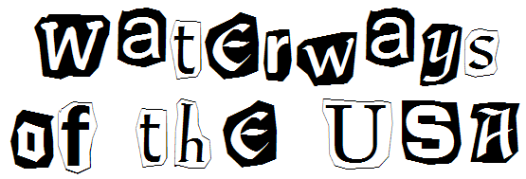

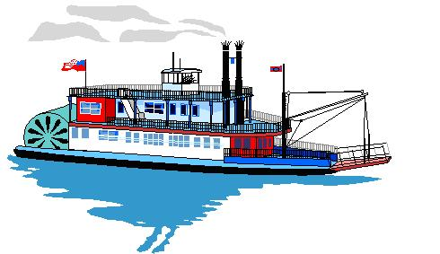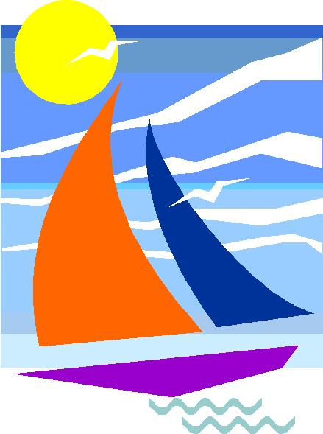

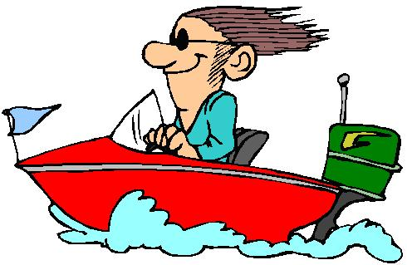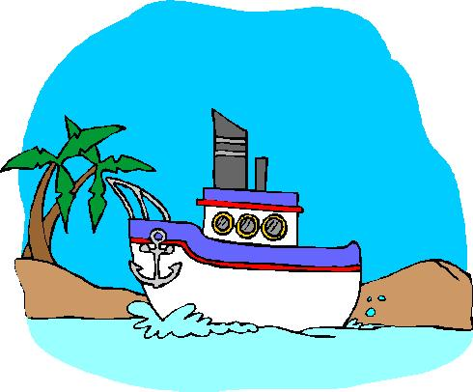

April 2005
APRIL 2005 - Waterways of the USA
Rivers have been a vital part of our environment for many years. Cub Scouts can use a map to trace where their local river begins, then draw other waterways that connect to it as the water flows to the ocean. Dens can invite environmental agencies to talk about the local rivers and their resources. Scouts can also learn how early explorers used rivers, and how important rivers are in transporting people and products. Discover how rivers are used as a water irrigation source and how we harness the power of some rivers for electricity. Investigate the history, folklore or legends, songs, and types of boats that are associated with rivers. Dens can help with the cleanliness of their local river while working on their World Conservation Award or the Conservation Good Turn Award.

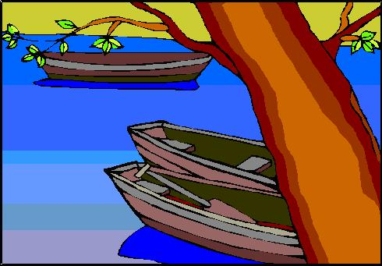

Books:
- Warner, Penny, Splish, Splash: Water Fun for Kids, Chicago, IL.: Chicago Review Press, 1996

Websites:
- California Department of Boating & Waterways: www.dbw.ca.gov
Learn about the regulations and programs available from the Department of Boating and Waterways. They also have a program that partners with local fire stations and the CSUS Aquatic Center to make life jackets available to the public on a loan basis.
- Conservation Good Turn Award: www.geocities.com/~pack215/cgt.html
Background information, forms and project ideas for the Conservation Good Turn Award that your Scouts can earn.

- Arbor Day: www.arborday.net/kids
Did you know that the largest living thing on our planet is a tree? Arbor Day is all about appreciating trees. Learn about the life of a tree, and how you can make a difference in the world by planting a tree. You can even receive some free trees by joining the Arbor Day Foundation. National Arbor Day is the last Friday in April.

Whirlpool, Aircraft Carrier Maze
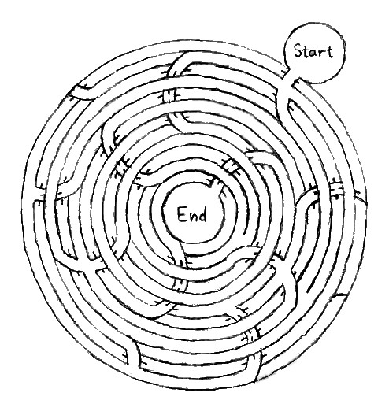

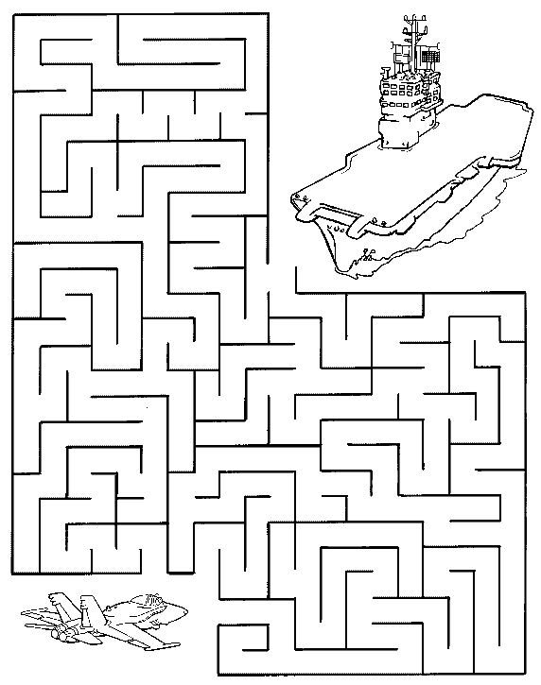
Find the right path to land the jet plane onto the aircraft carrier.

Watercraft Word Search
From: www.puzzlechoice.com

Can you find the types of watercraft hidden in the puzzle below?
They may be horizontal, vertical or diagonal, forwards or backwards.

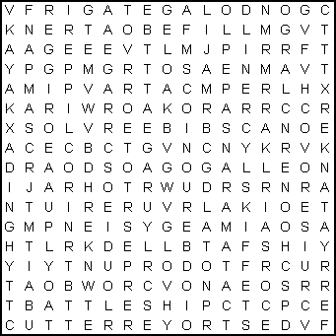

BARGE BATTLESHIP BOAT  CANOE  CARRIER CATAMARAN  CLIPPER CORSAIR CORVETTE CRUISER CUTTER | DESTROYER DINGHY  DORY  FERRY  FRIGATE GALLEON  GONDOLA  JUNK  KAYAK LIFEBOAT | LINER  LUGGER  MOTORBOAT PACKET PRIVATEER PUNT  RAFT  RIGGER  ROWBOAT SAMPAN | SCHOONER SCOW  SHIP  SKIFF  SLOOP  SMACK  TANKER TRAWLER TUGBOAT YACHT

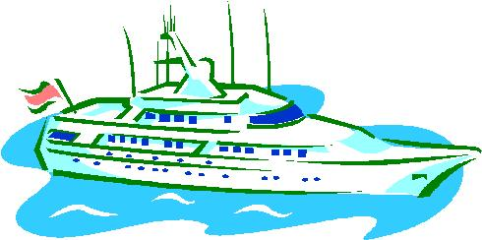

Quotations

Quotations contain the wisdom of the ages, and are a great source of inspiration for Cubmaster’s minutes, material for an advancement ceremony or an insightful addition to a Pack Meeting program cover.

“No Scout can consider himself a full-blown Scout until he is able to swim and to save life in the water.”  – Lord Robert Baden-Powell  “Every man ought to be able to swim… it gives him the power of helping others in.” – Lord Robert Baden-Powell  Though living near a river, do not waste water; though living near mountains, do not waste firewood.  – Chinese Proverb, cited in 1875 collection | “In rivers and bad governments, the lightest things swim at the top.”  – Benjamin Franklin  “All rivers do what they can for the sea.”  – Thomas Fuller: Gnomolagis, 1732  Sit by a river.  Find peace and meaning  In the rhythm  Of the lifeblood of the Earth  – Author Unknown

Ceremonies
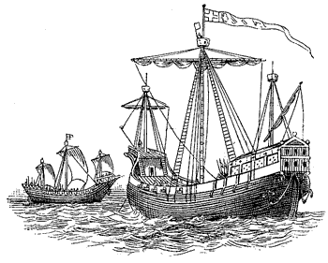

Sailing Ships Opening

Props: Pictures, silhouettes and models of sailing ships, together with the Cub’s craft projects, decorate the front of the meeting hall. The Pack and American flags are already posted.

Cub 1: The ocean-going ships of the 18th century were a very important part of our early fight with England in the Revolutionary War.
Cub 2: Without the sailing ships of France bringing supplies, and later, our own fighting ships, we might still be part of England.
Cub 3: Old Ironsides, the U.S.S. Constitution, achieved fame and glory in the War of 1812.
Cub 4: The Merrimack and the Monitor waged fierce battle in an important test of floating iron in the Civil War.
Cub 5: American Clipper ships were the fastest afloat in the 19th century.
Cub 6: Convoys of American ships supplied our allies throughout both World Wars.
Cub 7: Tonight we celebrate the sea and the adventures you can find there. Please join us in paying tribute to those early sailors and the flag that flew high above their ships. (Cubs lead the audience in the Pledge of Allegiance)

Boating Advancement
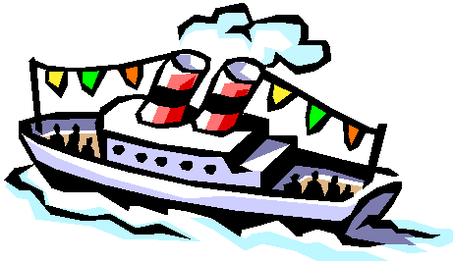
Make up international code letter flags to use for this ceremony, as shown below, for each rank, Tiger, Bobcat, Wolf, Bear, and Webelos. They can be made from colored construction paper – this is a good project for a Den meeting. If you have a large pack, Den Leaders, Den Chiefs, or Pack Committee members can hold up the flags for each rank. If you have a small Pack, you may want to tape the flags vertically to a broomstick or dowel for each rank so that one person can hold all the flags for one rank.

Cubmaster:
Tonight we want to recognize those Cubs who have bravely sailed into the deep waters. These boys have worked hard to advance in rank. They have set their sights and sails toward far shores. Let us call them to our harbor now. (As Cubmaster calls out letters, those holding the letter flags come forward and stand in the proper sequence, until the next rank is called.)

TANGO – INDIA – GOLF – ECHO – ROMEO! Will the following new Tigers please come forward (call out boys names).

BRAVO – OSCAR – BRAVO – CHARLIE – ALPHA – TANGO! Will the following new Bobcats please come forward (call out boys names).

WHISKEY – OSCAR – LIMA – FOXTROT! Will the following new Wolves please come forward (call out boys names).

BRAVO – ECHO – ALPHA – ROMEO! Will the following new Bears please come forward (call out boys names).

WHISKEY – ECHO – BRAVO – ECHO – LIMA – OSCAR – SIERRA! Will the following new Webelos please come forward (call out boys names).

To all of you boys, and your parents, Congratulations. Your voyage of discovery has just begun. We wish you fair winds to take you wherever you sail.

 |  |  |  |  |  | 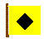
A  ALPHA | B  BRAVO | C  CHARLIE | E  ECHO | F  FOXTROT | G  GOLF | I  INDIA
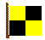 |  |  |  |  | 
L  LIMA | O  OSCAR | R  ROMEO | S  SIERRA | T  TANGO | W  WHISKY

Chambered Nautilus Closing
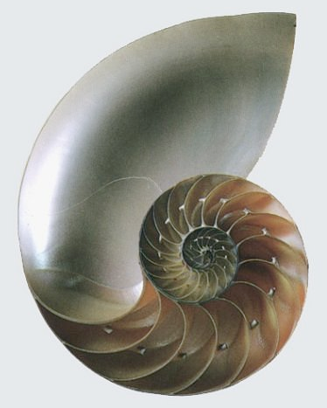
Cubmaster hold up a large nautilus shell and says the following.

Boys, look at this shell and see how it grows bigger and bigger. That is because as the animal that lived here grew larger he had to make a bigger place to live. We are much like this shell. First we grow and learn. Then as we can do things better, we feel good about ourselves. That makes us want to do our best to do things even better. A great poet Oliver Wendell Holmes in The Chambered Nautilus said it this way:

Build thee more stately mansions, O my soul,
As the swift seasons roll!
Leave thy low-vaulted past!
Let each new temple, nobler than the last,
May we always do our best to be the best we can be.

Sailing Ship Closing

Hold up a picture of a beautiful sailing ship.

Cubmaster:
A ship is safe in the harbor, but that is not what ships are meant for. What is a ship meant to do? Where can it go? How does it get there? (Accept all answers for a minute or two). (Then ask) Can a ship go to any of these places or do any of these things in a harbor? Sometimes we have to take risks to achieve. That doesn’t mean we take foolish chances, but we won’t have any fun if we never do anything because someone would make fun of us or we might get hurt. Let’s be like ships and go to new places and try new things.

Run-Ons

- What do you get if you cross the Atlantic with the Titanic?
  - Half-way.
- What’s the difference between a hunter and a fisherman?
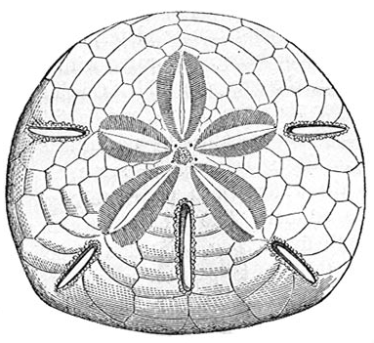
  - A hunter lies in wait, while a fisherman waits and lies!
- What sea creature do you look for if you want cash?
  - A sand dollar.
- What school has no teachers?
  - A school of fish.
- Don’t be afraid to try something new. An amateur built the ark. Professionals built the Titanic.
- Two goldfish are in a tank. One says to the other, “How do you drive this thing?”
- Boy, enters with a large board, and throws it down. Says, “Man over board!” while jumping over the board.

Applauses/Cheers

Motorboat: Move hand in and out in a swishing manner while fluttering tongue on roof of mouth.
Buccaneer: “Yo, ho, ho, and a bottle of coke.”
Deep Sea Diver: “Blub, blub, blub”
Pirate: “Avast, ye landlubber, Walk the plank! Glub, glub, glub.”
Viking: Motion as if using the oars on a Viking Ship, row together back and forth several times.
Fisherman: “The fish I missed was this long, no this long, well maybe this long!”
Sailboat Regatta: Hold right hand palm up in front of face and blow across it with a series of puffs.

Lobster: While speaking in a low voice say, “Pinchy, pinchy, pincy.” At the same time move all the fingers and thumbs together in pinching motions.

Lighthouse: Stand straight and tall with hands at shoulder height, fingers open and shut while saying, “Blink, Blink, Blink.” Then say very loudly like a foghorn, “BAAAAAAH.”

Steamboat: Use both hands to make large rotary motions as if they were paddle wheels on an old side-wheeler. At the same time, say “Chug-a-chug-chug,” then reach up with right hand and pull down, saying “Toot, toot!”

Big Wave: Best done in a big group. Have the odd numbered rows lean to the right first and the even numbered rows lean to the left first and say swoosh as the move back and forth.
Audience Participation
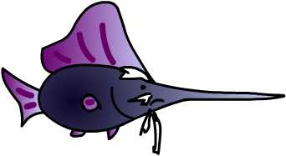

The Adventure Under the Sea

TREASURE: “Gold, Gold”
SWORDFISH: “Stab, Stab”
CHARLIE THE TUNA: “I’m the Best”
SCHOOL OF FISH: “Reading, Writing, Arithmetic”

Let’s pay a visit to a little dreamer boy who probably lives in every home where a boy resides. For boys and their dreams are inseparable.

One day, dreamer boy was lying on the beach looking far out across the water day-dreaming about what life must be like under the sea. He knew there must be buried TREASURE, many SCHOOL OF FISH swimming around with some SWORDFISH, and he couldn’t help but wonder if CHARLIE THE TUNA was really there like the television says.
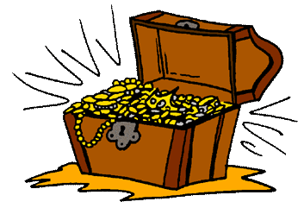
So dreamer boy decided it was time for him to take a trip down under the sea and find out some of these things for himself, for he knew that a boy’s dreams can take him anywhere he wanted to go. Slowly dreamer boy let himself down into the sea, looking all the while for buried TREASURE. After a few minutes he saw a SCHOOL OF FISH swim by just as he had expected and next a SWORDFISH or two came by, but who he was really looking for was CHARLIE THE TUNA. Well you can imagine dreamer boy’s delight when he reached the bottom of the sea and there sat CHARLIE THE TUNA chanting his favorite little tune. He knew then that his trip had been worthwhile, but how worthwhile he was yet to find out. For dreamer boy was totally unprepared for what took place next.

A SCHOOL OF FISH swam by and were immediately attacked by some SWORDFISH while CHARLIE THE TUNA and his pals kept chanting their silly little chant which made the SWORDFISH turn on them and the SCHOOL OF FISH began accusing CHARLIE THE TUNA and his pals of just being the chickens of the sea.

In fact, things were so confusing that dreamer boy didn’t even realize he was seated on a TREASURE chest. He just hurried out of there as fast as he could swim. When he came back to the beach, he threw himself down and thought for awhile about how his greatest TREASURE should be getting along with others, with none of the confusion like he just witnessed with CHARLIE THE TUNA and his bragging, the SWORDFISH and their continuous stabbing at others and the SCHOOL OF FISH with their silly accusations.

So as dreamer boy got up and left the beach, he told himself that he was going to TREASURE his friends and do his best to get along with everyone and not be like bragging CHARLIE THE TUNA or the stabbing SWORDFISH or the SCHOOL OF FISH who really didn’t seem to have learned anything at all! He knew that he, indeed, had learned a lot that day.
Songs

A Sailor Went to Sea  Chorus:  A sailor went to sea sea sea  To see what he could sea sea sea,  But all that he could see see see  Was the bottom of the deep blue  sea sea sea.  Oh, Helen had a steamboat,  The steamboat had a bell,  When Helen went to heaven  The steamboat went to -----  (Chorus)  Hello, operator,  Just give me number 9,  If the line is busy  I’ll kick your big -----  (Chorus)  Behind the old piano,  There was a piece of glass,  Helen slipped upon it  And hurt her little -----  (Chorus)  Ask me for a muffin,  I’ll give you some old bread  And if you do not like it,  Just go and soak your head.  (Chorus) | I Went Into the Water  (Tune: My Bonnie Lies Over the Ocean)  Oh, I went into the water,  And I got my feet all wet,  I went into the water,  And got my feet all wet,  I went into the water,  And got my feet all wet,  But I didn’t get my (clap, clap) wet – yet.  Oh, I went into the water,  And I got my ankles wet.  I went into the water,  And I got my ankles wet.  I went into the water,  And I got my ankles wet.  But I didn’t get my (clap, clap) wet – yet.  Oh, I went into the water,  And I got my legs all wet.  (and so on, up to your head)  Last stanza:  Oh, I went into the water,  But I didn’t get it wet.  I went into the water,  But I didn’t get it wet.  I went into the water,  But I didn’t get it wet.  I didn’t get my camera wet.
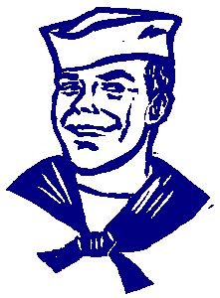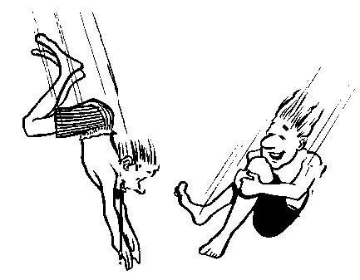

Ship Titanic

O they built the ship Titanic, to sail the ocean blue,
And they thought they had a ship, that the water wouldn’t go through,
But it was on her maiden trip when an iceberg hit the ship,
It was sad when the great ship went down.

Chorus:
Oh, it was sad, so sad.
Oh, it was sad, so sad.
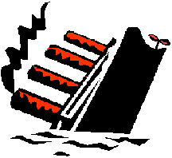
It was sad when that great ship went down (to the bottom of the sea) –
Husbands and wives, little children lost their lives!
It was sad when that great ship went down.

They were nearing into shore, about a thousand miles or more,
When the rich refused to associate with the poor..
So they threw them down below, where they'd be the first to go.
It was sad when the great ship went down.
(Chorus)

The moral of this story is clearly plain to see –
Always wear a life preserver when you go out to sea.
For husbands and wives, little children lost their lives! –
It was sad when that great ship went down.

Swimming
(Tune: Sailing, Sailing, Over the Ocean Blue)

(Each time you repeat the verse (8 times in all), leave out one of the lines but still do the actions. The last verse will be all actions and no singing. You can also try going faster and faster each time you repeat the verse.)

Swimming, swimming Swimming action
In the swimming pool, Trace outline of pool
When days are hot, Swipe hand across forehead
And days are cold, Shiver
In the swimming pool. Ttrace outline of pool
Breaststroke – Do the breaststroke
Sidestroke – Do the sidestroke
Fancy diving, too. Dive action
Don’t you wish you never
Had anything else to do.
But …

Walnut Ship
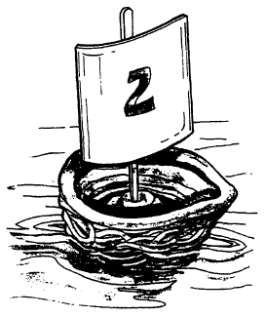

Supplies: Walnuts (unshelled), nutcracker, clay or Playdoh, scissors, paper, tape, toothpicks.

Directions:
- Crack the walnuts in half and remove the insides (eat them, if you like).
- Fill the hollow shells with clay or Playdoh.
- Use the scissors to cut out small flags from paper, approximately 1 inch square, and decorate them anyway you like. Use permanent markers, so the colors don’t run when wet.
- Tape the paper to the toothpick top, or insert the toothpick into the paper to make a sail.
- Stick the other end of the toothpick into the clay.
- Sail the ship down a creek or stream. Have a boat race with your buddy.

Chalk Melt

Water works wonders on a substance like chalk. Get your chalk wet and see what happens.

Supplies: Colored chalk, pan of water, slick white paper.

Directions:
- Soak colored chalk in a pan of water for 5 to 10 minutes. Remove the chalk after the chalk has soaked.
- Get slick white paper (other paper is OK but slick paper works best) and dip the paper into the pan of water, or run it under the faucet. Set it on the table with newspapers underneath, and let the boys draw on the wet paper with the wet chalk. Keep the pan of water nearby for dipping chalk. This can be a messy activity, so have the boys wear old clothes.

Variations:
  - Add sugar to the water to give it an interesting texture. Mix well so the sugar is completely dissolved, then let the kids dip their chalk into the sugar water.
  - Let the boys draw on a wet sidewalk with wet chalk. They can make giant monsters, whole cities, or write their names. When they are finished, hose off the surface to clean it up.

Land Boat

Have you ever seen a sailboat speed across the waves? In this activity you will build a sailboat that travels on land and test it with a variety of different sails to find out which type works the best.

Supplies: 2 straws, Paperclip, 5-6 wooden skewers, wire or twigs, Tape, Push pin or small nail, Ruler, 4 lids (from film canister, yogurt contains, milk jugs, etc.), a Styrofoam tray (milk carton, or small box will also work), Variety of materials for sails (paper, foil, plastic sheet)

Directions:
- Cut 2 wooden skewers for the axles, 2 inches longer than the width of the Styrofoam tray.
- Make the casings for the axels by cutting two straws so that they are just shorter than the width of your boat.
- Attach the straws with tape to the bottom of the hull – one closer to the front and the other closer to the back.
- Poke a starter hole into the center of each of the lids by pushing a small pin into the lid.
- Insert the axles into the straws on the bottom of the boat and push the lid wheels onto the ends of the axles. Flip the boat over and try rolling it. Adjust the wheels if they rub.
- Cut out a piece of material for the sail, and tape or thread a skewer through it. Unfold a paperclip to a right angle, and tape one side of the paperclip to the inside of the boat.
- Tape the skewer mast to the other side of the paperclip.
- Blow on the mast to make your land boat sail. How far can you sail the boat on just one blow?
- Experiment with different materials, sizes and shapes of the sail. Chart the results of each experiment. Which sail traveled the farthest?

Homemade Underwater Viewer

Supplies: Plastic gallon milk jug, Sharp cutting tool, Heavy-duty plastic warp, Rubber bands or duct tape, Permanent markers

Directions:
- Thoroughly wash out a plastic gallon milk jug.
- Have den leader cut off the bottom inch of the jug and recycle it.
- Have the boys decorate their viewer with permanent markers.
- Spread a piece of clear plastic wrap over the cut end of the jug. Attach it with thick rubber bands or duct tape to form a tight seal.
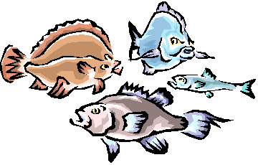
- Your underwater viewer is complete. To use the viewer, place viewer in the water while squinting your eye over the mouth of the jug. The plastic wrap provides a slight magnification to the objects below the water.

Zuke Boats

Cut one zucchini in half lengthwise and hollow out each half with a spoon, making “dugout canoes.” Then, tape small paper sails onto sticks or straws and poke them into the boats. Send the boats across a bathtub, pool or pond.

Submarine
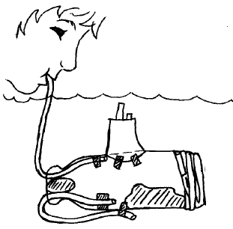
Supplies: (2) Plastic bottles, Scissors, Tape, 12” piece of plastic tubing, 24” piece of plastic tubing, Clay

Remove cap from bottle. Cut around bottle 2” from bottom. Push both pieces of tubing into the bottle through the neck and secure as shown. Bend the short piece around and tape it to the outside of the bottle. To make it float properly, add a large wad of clay inside bottle as shown. Be careful not to plug tubes. Use a second piece of clay to make the top airtight. Replace bottom of bottle and tape tightly. Use a second bottle to make a conning tower, tape in place. Place sub in water. Blow into long tube to make it rise and suck air out to make it sink.

Ships Wheel

For the wheel, use a plastic lid from a can of potato chips. Cut out the center of the lid, leaving about one inch around the edge. Paint the wheel with acrylic paint. Use 8 Popsicle sticks for spokes. With a sharp knife, shape one end of the sticks for a ribbed effect. For the hub of the wheel, use a plastic cap. Around the bottom of the hub, cut 8 slots about 1/8” apart to fit the plain ends of the sticks. After inserting the sticks, add a little glue to help keep them in place. With the rim of the wheel down, glue the spokes to the wheel. If there is a ridge around the edge of the wheel, cut notches so spokes fit flush.

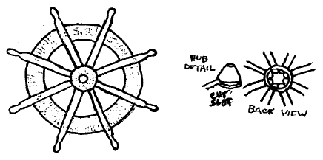
Tips for Swimming Events & Games
- Follow the BSA Safe Swim Defense Guidelines.
- Before the races start, divide the group into swimmers and non-swimmers. All non-swimmers must wear life jackets.
- Ask a non-swimmer to be the official starter.
- Ask the judges to pick the top three competitors in each event. Everyone should encourage and cheer on all participants.

A Variety of Swim Races:
- Shallow-water Challenge: Bob or handstand a required number of times from start to finish.
- Sing and Swim: Swim, with your head out of the water, while singing the national anthem. If you stop singing, you have to start over.
- Watermelon Dash: Run one length in waist-deep water, carrying a watermelon.
- Find the Floaters: Throw a pail full of corks or Ping-Pong balls into the swimming area. At the count of three, all swimmers from both teams retrieve the corks and place them in two piles on the shore or dock. The team that collects the most corks wins.

A Variety of Water Relays:
- Ping-Pong Ball Race: Divide each team in half and have one half stand on one side of the pool and the other half on the other side of the pool. On one side of the pool place Ping-Pong balls in front of each team. When you say “Go!’ the first players on each team begin blowing their ball to the other side where the other half of their teams are waiting. When the ball reaches the other side, have another player take over, and blow the ball back to the starting line. Repeat laps until all players have had a turn. The first team to complete the race wins.
- Tennis Ball Race: Place tennis balls in the water in front of the teams. The first player must push the balls across the pool with their chins.
- Balloon Race: The players use their noses to push balloons across the pool.
- Hoop Race: Toss several hula-hoops onto the water. Have the players dive in, swim to the hoops, slip them over their bodies, and continue collecting more hoops.
- Raft Race: A player from each team paddles a plastic raft across the pool and back, lying on their stomach. The second group races across and back lying on their backs. The third group sits on the raft and uses only their feet to kick the raft across the pool and back. The fourth group pushes the third group across and back. The fifth group races with their eyes closed. Try this game with two players on a raft, then add another, and another, until the raft sinks. Continue to make up different ways of getting across the pool until a team wins, or everyone is worn out.

Underwater Swimming

Give a pair of flippers and a glass of water to each team. The first player stands at the start-line, puts on the flippers, takes the glass of water and lifts it above the head. So he/she is "under the water". At the signal the players begin to move forwards. On having covered the fixed distance the first "submariner" passes the flippers and the glass to the next player. If the water spilled from the glass after the first run, add some more water.
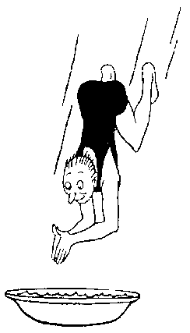

Keep It Dry

It’s easy to get wet when there’s a pool or lake nearby. But is it possible to keep something dry? Give each player a small object that changes when it gets wet to hold in one hand, such as a stone, cotton ball, or marshmallow. Players should swim from one end of the pool to the other, holding the object and trying to keep it dry. The swimmer with the driest object wins.

Variations:
- Players swim with objects in both hands or on top of their heads, on a spoon in their mouths, or set on the backs of their hands.
- Wearing different articles of clothing, the players swim across the pool trying to keep the clothing dry. Begin with the hats, which should be fairly easy. Add gloves and have the swimmers try to keep them dry while swimming a lap. For subsequent laps, swimmers wear shirts, socks, and then pants.
- Have a relay race where players exchange a large bath towel. Divide players into teams and have the first players on each team swim from one side of the pool to the other, holding the towel up to keep it dry. Repeat the laps with all team players and see which team has the driest towel at the end of the race.

Water Drop

Divide the group into teams of not more than 10 people each. The group lies in a circle facing the center with their legs in the air. The leader places a plastic dishpan of water on top of the players’ feet. The object is for everyone to remove their shoes without spilling the water. To do this, one person at a time brings their legs down and removes their shoes. The others, meanwhile, are still holding up the pan of water. If the water is dropped, a new dishpan is placed on their feet and the game continues. The first team to get their shoes off is the winner.

Crossing the River

With stones or stakes, mark out a river 10 feet wide. Divide the den into two teams and have both teams on one side of the river. Have the Den Leader or Den Chief stand on the other side of the river, and toss a ball across the river. Whoever catches it before it touches the ground shares it’s magic properties and is able to walk across the river. From the other side he throws the ball over to one of his own team while the others try to intercept the ball and gain passage across the river. Anyone stepping into the river in the excitement of the game loses a life. When he has lost three lives, he is considered drowned and is out of the game. The team that gets its members safely across first is the winning team.

Raft Race

Teams line up in relay formation. The first Cub Scout in each line is the ‘skipper’ and he stands with his feet on separate pads of newspaper. The second Cub Scout is the passenger, and he stands on the same pad with the skipper. On a signal from the leader, the skipper bends over and takes hold of the pads, one in each hand. By shifting their weight and sliding the papers forward, the two boys maneuver themselves to the goal line without stepping off the pads. On reaching it the passenger picks up the pads of paper, runs back to his team, and brings the next boy across the river. The first team to cross the river wins.

Sink The Ships

Supplies: 6 empty milk cartons (smallest size), Masking tape, Small wading pool or washtub, Old tennis ball (or any small, soft ball), Magic marker.

Wash out the cartons, and let them dry out. Tape the ends shut. Number each carton with the magic marker. Some cartons should be worth 5 points; some should be worth 10 points. Fill a pool or washtub with water. Float the cartons in the water. Mark a throwing line about 10 steps back from the pool.

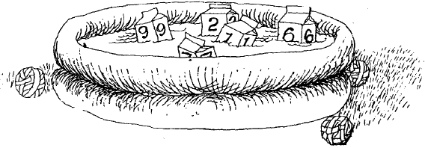

Stand behind the line. Take turns throwing the ball at the floating milk cartons. See if you can make a ship duck under the water. Every time you hit a carton, you get the number of points written on it. The player with the highest number of points wins.

Grasshopper Ice Cream Tartlets

Supplies: Large bowl, Serving spoon, Table knife, Aluminum foil, Cookie sheet

Ingredients:
- 1 pint low-fat mint chocolate chip ice cream
- 1 package of 6 individual graham cracker pie crusts (4-inch diameter)
- Chocolate sauce

Directions:
  - Scoop the ice cream into the large bowl. Thaw the ice cream in the refrigerator for about 2 hours until it is soft but not liquid.
  - Spoon an even amount of ice cream into each graham cracker crust. Use the table knife to smooth the top of the ice cream.
  - Cover each graham cracker crust loosely with aluminum foil. Place on a cookie sheet.
  - Place the cookie sheet of tartlets in the freezer and freeze for at least 4 hours or until you are ready to serve.
  - Drizzle with chocolate sauce before serving.

Sailboat Sandwiches

These cool sandwiches, filled with tuna salad and topped with Cheddar cheese sails, give kids a real feel for the seashore. Set these treats in a plateful of blue corn tortilla chips to complete the nautical theme.

Ingredients:
- 4 dinner rolls  - 1 cup tuna salad  - 4 slices Cheddar cheese | - 8 toothpicks

Directions:
  - Slice the tops off the dinner rolls and hollow them out.
  - Fill the rolls with the tuna salad or any other filling your Scouts like.
  - Slice the Cheddar cheese into rectangles about ¼ inch thick and cut the rectangle on the diagonal to make triangles.
  - Insert a toothpick into each triangle to make little sails and add them to the top of your “boats.” Makes 4 sandwiches.

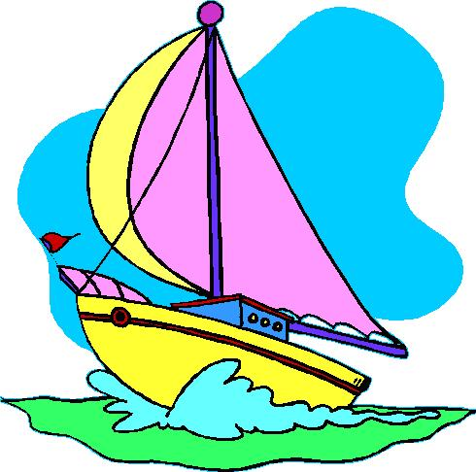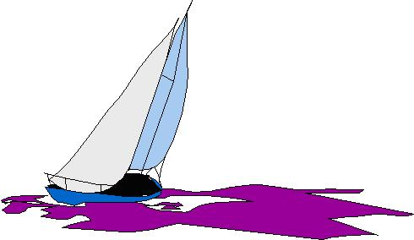

Pizza Burgers

Ingredients:
- 1 pound ground beef  - 1 cup shredded mozzarella cheese  - 1 tablespoon minced onion  - ½ teaspoon dried oregano leaves | - 1 teaspoon dried basil leaves  - Salt and pepper, to taste  - Prepared pizza sauce heated  - 4 English muffins, split and toasted

Preheat grill or pan. Mix together the ground beef, cheese, onion, oregano, basil, salt and pepper and form into four patties. Cook 8 minutes, turning once, or until done as desired. Place one patty on each English muffin bottom. Top with pizza sauce. Serve with tops of muffins. Serves 4.

Domino’s Cinna Stix

Ingredients:
***Sticks***  - 1 package refrigerated pizza dough (or your favorite recipe)  - ¼ cup melted margarine  - ½ cup sugar  - 2 teaspoons cinnamon | ***Icing***  - 1 pound powdered sugar  - 1 tablespoon milk  - 1 tablespoon melted butter  - ¼ teaspoon vanilla extract

Preheat oven to 350 degrees. Roll out pizza dough into a large rectangle. Brush melted margarine over dough. In a small bowl combine sugar, and cinnamon; mix well. Sprinkle the cinnamon and sugar mixture liberally over the pizza dough. Slice the dough into either long sticks, or cut dough in half, and then slice into smaller sticks. (The smaller sticks are easier to handle.) Place on a lightly greased cookie sheet and bake for approximately 15 minutes or until done.

While the pizza sticks are cooking, mix together the powdered sugar, milk, melted butter, and vanilla. Mix until smooth. You may need to add an extra teaspoon of milk. Serve icing with sticks.

Stuffed Frankfurters

Ingredients:
- 4 frankfurters  - 1 slice cheese cut in 4 strips  - 8 tablespoons sauerkraut | - 4 strips bacon  - 4 frankfurter rolls  - Mustard

Slit frankfurters lengthwise to make a pocket. Brush with mustard. Place a strip of cheese and 2 tablespoons of sauerkraut in each slit. Wrap a strip of bacon spiral fashion around each hot dog; fasten with toothpicks. Grill over hot coals or place under broiler until bacon is crisp. Serve on frankfurter rolls. Serves 4.

