A Scouting Mystery

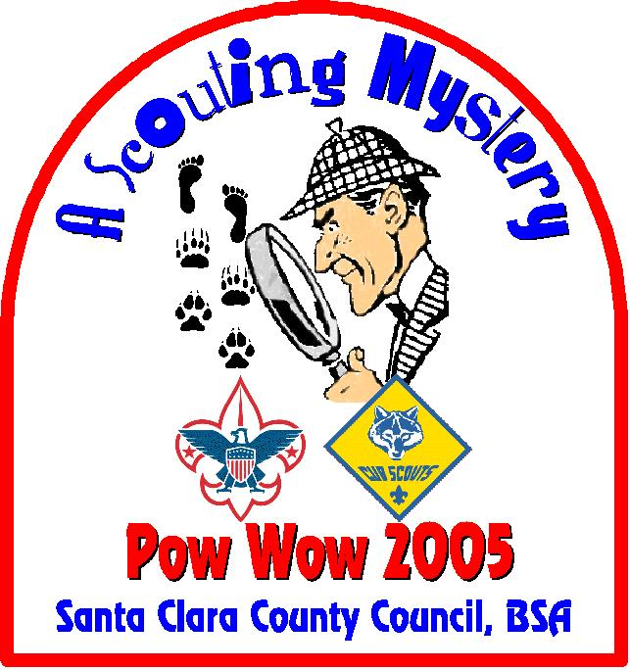

Pow Wow 2005

Santa Clara County Council

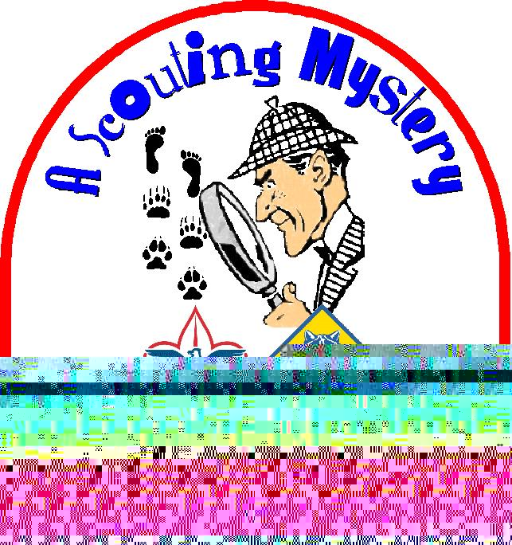

Santa Clara County Council Boy Scouts of America

January 22, 2005

Dear Cub Scout Leaders and Parents,

Thank you for attending A Scouting Mystery, Pow Wow 2005! All of us who have been involved for the past year in preparing for this year’s Pow Wow are delighted that you are here.
Pow Wow 2005
Committee Members

Dick Noack,
Chair, Pow Wow 2005

Anne Johnson,
Registration Coordinator

Linda Idemoto,
Faculty Coordinator

Wesley Wong,
Book Coordinator

Charlie Schrey and
Pete Shyvers,
Publicity Coordinators

Ron Schoenmehl,
Professional Advisor

Sakiko Wehrman,
Council Training Chair

Special Thanks to Our 2005 Pow Wow
Patron Packs

Packs 43, 374, 411, 453

It is no mystery to me why you decided to attend Pow Wow. You know that Scouting is the best program available to help us grow our boys. No other program has the fun and values of Scouting. No other program helps develop their characters the way Scouting does. No other program helps them grow as citizens the way Scouting does. And no other program emphasizes personal fitness the way Scouting does.

Our goal in preparing this year’s Pow Wow was to help you get the resources and tools and ideas you need to deliver the kind of Cub Scouting program that makes a tangible difference in the lives of boys. We hope you will make the most of Pow Wow—meet with experienced Scouters from throughout the Council who have been in your shoes; learn from your peers who have exciting ideas about getting families and boys involved and interested in Cub Scouting; ask many questions and get many new ideas.

Above all, have fun, both here at Pow Wow and in your positions as Cub Scout Leaders and parents. Boys are very perceptive—they know that when you’re having fun, so will they.

Realistically speaking, few of us have the opportunity to bring about any significant change in our world. But the Scouting program offers each of us the opportunity to make a significant difference in the lives of boys. Hopefully when these same boys become the leaders of tomorrow they will remember and live by the values they lived and learned in the Scouting program, thereby bringing about positive change in our communities, nation, and world.

And to think it all begins with a little boy in a blue uniform.

Yours in Scouting,


Dick Noack,
Chair, Pow Wow 2005
TABLE OF CONTENTS

Page #

Part I Pow Wow Schedule 6

Introduction & Resources 11

Part II Monthly Themes

March 2005 Invention Convention 25
April 2005 Waterways of the USA 43
May 2005 Cub Pet Pals 61
June 2005 Destination Parks 87
July 2005 Play Ball! 105
August 2005 Campfire Tales and Traditions 125
September 2005 Cub Scout Round-up 145
October 2005 To The Rescue 163
November 2005 My Family Tree 181
December 2005 Faith, Hope and Charity 203
January 2006 Music Magic 225
February 2006 Cubs in the Future 245

Part III Field Trips 265

Part IV Class Notes Using Den Chiefs 305
Knives 309
Packmaster 319
Planning an Action Pack Program 327
’05-’06 Theme Quotations 345
Cub Scouts and the Silver Screen 349
Ideas for Webelos Activities 365
Pack Fundraisers and Finance 373
Scrap Booking 381
Rocket Fun 387
Sample Pack Yearly Plan 403
Selecting Cub Scout Leadership 425
Our Flag 429
Invitation Methods for Cub Scouts
(Cub Scout Recruiting) 433

A Scouting Mystery: Pow Wow 2005

Schedule
January 22, 2005

7:15 a.m. to 8:00 a.m. Registration

8:00 a.m. to 8:20 a.m. Opening

8:30 a.m. to 9:30 a.m. Session 1

1.1 Boy Behavior
1.2 Scrap Booking
1.3 Den and Pack Ceremonies
1.4 Rocket Fun (Outdoor Session)
1.5 Jazzing Up Meetings with Songs and Pizzazz
1.6 Nature for Wolf and Bear (Outdoor Session)
1.7 Outdoor Cooking with Cub Scouts (Outdoor Session)
1.8 Planning an Action Packed Program
1.9 Selecting Quality Leaders
1.10 Terrific Tigers
  - Webelos Activity Badges 1
  - Keeping the Doors Open: Fundraisers and Finance

9:40 a.m. to 10:40 a.m. Session 2

2.1 60 Den Leader Tips in 60 Minutes
2.2 Boy Behavior
2.3 Cool Science for Cub Scouts
2.4 It’s Magic
2.5 Jazzing Up Meetings with Songs and Pizzazz
2.6 Nature for Webelos (Outdoor Session)
2.7 Outdoor Cooking with Cub Scouts (Outdoor Session)
2.8 Games to Play Outside (Outdoor Session)
2.9 Supercharging Your Pack Committee
2.10 The Scouting Adventure Continues: How to make sure your Cub Scouts become Boy Scouts
  - Using Den Chiefs
  - Knife Safety

10:50 a.m. to 11:50 a.m. Session 3

3.1 Calling All Cubs: Assuring Your Pack’s Survival by Recruiting Cub Scouts
3.2 It’s Magic
3.3 Den and Pack Ceremonies
3.4 Games to Play Outside (Outdoor Session)
3.5 Nature for Wolf and Bear (Outdoor Session)
3.6 Outdoor Cooking with Cub Scouts (Outdoor Session)
3.7 Planning an Action Packed Program
3.8 Cubmaster Roundtable
3.9 Packmaster – Keeping Track of Your Pack
3.10 The Scouting Adventure: How to make sure your Cub Scouts become Boy Scouts
  - Webelos Activity Badges 2
  - Our Flag (Outdoor Session)

11:50 a.m. to 1:30 p.m. Lunch and Baker Street Interactive Sessions (see Next Page)

1:30 p.m. to 2:30 p.m. Session 4

4.1 60 Den Leader Tips in 60 Minutes
4.2 Boy Behavior
4.3 PackMaster – Keeping Track of Your Pack
4.4 Cool Science for Cub Scouts
4.5 Nature for Webelos (Outdoor Session)
4.6 Outdoor Cooking with Cub Scouts (Outdoor Session)
4.7 Rocket Fun (Outdoor Session)
4.8 Safe Scouting for Dens and Packs on the Go
4.9 Terrific Tigers
4.10 Using Den Chiefs
  - Webelos Activity Badges 1
  - Cub Scouts and the Silver Screen

2:40 p.m. to 3:40 p.m. Session 5

5.1 Boy Behavior
5.2 Calling All Cubs: Assuring Your Pack’s Survival by Recruiting Cub Scouts
5.3 Den and Pack Ceremonies
5.4 It’s Magic
5.5 Jazzing Up Meetings with Songs and Pizzazz
5.6 Planning an Action Packed Program
5.7 The Scouting Adventure: How to make sure your Cub Scouts become Boy Scouts
  - Webelos Activity Badges 2
  - Games to Play Outside (Outdoor Session)
  - Our Flag (Outdoor Session)
  - 60 Den Leader Tips in 60 Minutes
  - Knife Safety

3:45 p.m. to 4:00 p.m. Closing

A Scouting Mystery Schedule
Pow Wow 2005 January 22, 2005

Class | Sessions
 | 1 | 2 | 3 |  | 4 | 5
60 Den Leader Tips in 60 Minutes |  | ❖ |  | Lunch and Baker Street Interactive Sessions | ❖ | ❖
Boy Behavior | ❖ | ❖ |  |  | ❖ | ❖
Calling All Cubs! Assuring Your Pack’s Survival By Recruiting Cub Scouts |  |  | ❖ |  |  | ❖
Cool Science for Cub Scouts |  | ❖ |  |  | ❖
Cubmaster Roundtable |  |  | ❖
Cub Scouts and the Silver Screen |  |  |  |  | ❖
Dan and Pack Ceremonies | ❖ |  | ❖ |  |  | ❖
Games to Play Outside (Outdoor) |  | ❖ | ❖ |  |  | ❖
It’s Magic |  | ❖ | ❖ |  |  | ❖
Jazzing Up Meetings with Songs and Pizzazz | ❖ | ❖ |  |  |  | ❖
Keeping the Doors Open: Fundraisers & Finance | ❖
Knife Safety |  | ❖ |  |  |  | ❖
Nature for Wolf and Bear (Outdoor) | ❖ |  | ❖
Nature for Webelos (Outdoor) |  | ❖ |  |  | ❖
Our Flag (Outdoor Session) |  |  | ❖ |  |  | ❖
Outdoor Cooking with Cubs Scouts (Outdoor) | ❖ | ❖ | ❖ |  | ❖
Packmaster – Keeping Track of Your Pack |  |  | ❖ |  | ❖
Planning An Action Packed Program | ❖ |  | ❖ |  |  | ❖
Rocket Fun (Outdoor) | ❖ |  |  |  | ❖
Safe Scouting for Dens and Packs on the Go |  |  |  |  | ❖
Scrap Booking | ❖
Selecting Quality Leaders | ❖
Supercharging Your Pack Committee |  | ❖
Terrific Tigers | ❖ |  |  |  | ❖
The Scouting Adventure Continues: How to make sure your Cub Scouts become Boy Scouts |  | ❖ | ❖ |  |  | ❖
Using Den Chiefs |  | ❖ |  |  | ❖
Webelos I Activity Badges | ❖ |  |  |  | ❖
Webelos II Activity Badges |  |  | ❖ |  |  | ❖

Baker Street Interactive Sessions (Expanded Midway):

- Academics & Sports Program
- Adult Recognition
- Cub Scout Camping
- Cub Scouting for Boys with Special Needs
- Den Gathering Activities
- Derbies
- Duty to God
- Games to Play Indoors
- LDS Church Sponsored Cub Programs
- Leathercraft
- Neckerchief Slides
- Outdoor Resources
- Pack Ceremony Props
- RAFT
- Scouting Resources
- Scout-O-Rama
- Scrap Booking
- Theme Crafts
- Tied Up in Knots
- Training for Cub Scout Leaders
- Working With Wood
- Wood Badge

The Scouting Mystery

Puzzle

The Mystery of Scouting is . . .

◻◻◻◻◻◻◻◻◻◻◻◻◻
1 2 3 4 5 6 7 8 9 10 11 12 13
◻◻◻◻◻◻◻◻◻◻◻◻◻
14 15 16 17 18 19 20 21 22 23 24 25 26
◻◻◻◻◻◻◻◻◻◻◻◻◻
27 28 29 30 31 32 33 34 35 36 37 38 39
◻◻◻◻◻◻◻◻◻◻◻◻
40 41 42 43 44 45 46 47 48 49 50 51
◻◻◻◻◻◻◻◻◻◻?
52 53 54 55 56 57 58 59 60 61

(The letters to the puzzle can be found in the Clues that are scattered
throughout the Pow Wow Book)
2005-2006 Cub Scout Themes

MONTH | THEME | Description
March 2005 | Invention Convention | Every Cub Scout can be a genius or an inventor. Learn about inventors and geniuses of the past, present, and future.
April 2005 | Waterways of the USA | Cubs can learn about the history, legends of their local rivers, and types of boats used on the different waterways.
May 2005 | Cub Pet Pals | Learn to care for a pet, visit a veterinarian, or a local pet shop and see different kinds of exotic pets.
June 2005 | Destination Parks | Explore the trails at a local, state or national park, or work on a service project to improve the park.
July 2005 | Play Ball! | This is the time of year for sports, outdoor picnics, and exploring. Dens should play sports and learn about sportsmanship.
August 2005 | Campfire Tales and Traditions | A campfire is a great way to close the summer and begin the fall; tell a few tall tales, and sing campfire songs.
September 2005 | Cub Scout  Round-up | Explore the wild and wooly West as you round-up new membership.
October 2005 | To The Rescue | Cub Scouts will learn how to avoid accidents and be prepared for emergencies this month. Visit the local center for 9-1-1 calls.
November 2005 | My Family Tree | Learn where your ancestors came from and trace your family's heritage. Find out what they did and what their customs were.
December 2005 | Faith, Hope & Charity | This time of year is packed with family faiths, hopes for the future, duty to God, and charity to all.
January 2006 | Music Magic | Cub Scouts will get their vocal cords humming and their instruments strumming in a musical extravaganza!
February 2006 | Cubs in the Future | How will Cub Scouts celebrate the blue and gold banquet in the year 2106?

RESOURCES

Books:

- Nelson, Esther L., The World’s Best Funny Songs, New York: Sterling Publishing, 1988
- Drake, Jane & Love, Ann, The Kids Winter Handbook, Toronto, ON: Kids Can Press, Ltd., 2001
- White, Linda, Cooking on a Stick, Salt Lake City: Gibbs Smith Publisher, 1996
- Anderson, Adrienne, Fun & Games for Family Gatherings, San Francisco: Reunion Research, 1996
- Thomas, John and Thomas, Danita, The Ultimate Book of Kid Concoctions 2, Strongville, OH: Kid Concoctions Company, 2000
- Bany-Winters, Lisa, Funny Bones Comedy Games and Activities for Kids, Chicago: Chicago Review Press, 2002
- Hetzer, Linda, Rainy Days and Saturdays, New York: Workman Publishing, 1995
- Buck-Murray, Marian, The Mash and Smash Cookbook Fun and Yummy Recipes Every Kid Can Make!, New York: John Wiley & Sons, 1998
- Allue, Josep, 100 Games for Fall, Hauppauge, N.Y.: Barron’s, 2001
- Allue, Josep, 100 Games for Spring, Hauppauge, N.Y.: Barron’s, 2001
- Lithgow, John, A Lithgow Palooza, New York: Fireside Books, 2004
- Wise, Debra, Great Big Book of Children’s Games, Pleasantville, N.Y.: Reader’s Digest, 1999
- Loeffelbein, Robert, The Recreation Handbook 342 Games and Other Activities for Teams and Individuals, Jefferson, N.C.: McFarland & Company, 1992
- D’Amico, Joan, The Math Chef Over 60 Math Activities and Recipes for Kids, New York: John Wiley & Sons, 1997
- Sweet, Julia, 365 Activities for Fitness, Food and Fun for the Whole Family, New York: Contemporary Books, 2001
- Clark, Silvana, 301 Bright Ideas for Busy Kids, Naperville, IL: Sourcebooks, Inc, 2003
- Trumbauer, Lisa, Homework Help for Kids on the Net, Brookfield, Conn: The Millbrook Press, 2000
- Trumbauer, Lisa, Cool Sites Free Stuff for Kids on the Net, Brookfield, Conn: The Millbrook Press, 1999


Cool Websites for Kids & Scout Leaders

- Smithsonian Institution: www.si.edu
Visit the many museums of the Smithsonian Institution, such as the museum of science, space, and natural history.

- Library of Congress: www.loc.gov
Visit the online galleries, and search the catalogs of the world’s largest library.

- Discovery Channel School: www.school.discovery.com
This site is sponsored by the Discovery Channel, and the content changes all the time – it is a good source for great ideas and interesting information.

- History Channel: www.historychannel.com
This is an excellent reference site, and is as good as having an encyclopedia. Search for articles on just about any historical topic. Enter your birth date and find out what historical event happened on that date.

- Academy of Achievement: www.achievement.org/mainmenu.html
This site includes biographies of many people in recent history who have made an impact on the world. The “halls” include Art, Business, Courage, Sports, the American Dream, Science, and much more.

- The CIA World Factbook: Flags of the World: www.cia.gov/cia/publications/factbook/docs/flagsoftheworld.html
Every flag in the world can be found in this site. Click on a country and learn about the geography, people, government, and economy of that country.

- FOTW (Flags of the World): www.crwflags.com/fotw/flags
Learn about the history and symbolism behind any flag of the world. The site contains over 45,000 images of flags.

- U.S. Gazetteer: www.census.gov/cgi-bin/gazetteer
Find the exact location of any place in the U.S. Enter the name of the city and state and you will get information on the population, latitude, longitude, zip code, and a map of the location.

- Envirolink: www.envirolink.org
This site has lots of information on ongoing environmental projects as well as ways people can get involved.

- Craftbits - Free Crafting Projects and Plans: www.craftbits.com
Visit this very well done site for 100's of free craft projects and plans ... plus loads and loads of other cool crafting articles, bulletin boards, advice and much more!

- Crayola: www.crayola.com
You can find lots of great arts and craft ideas; search by activity, theme or art media. You can also create electronic cards, or print out a card, and color it yourself with Crayola crayons.

- Craft Freebies: www.craftfreebies.com
The place for everything free for crafts. 100's of free craft patterns and projects. Applique, Christmas, clay, crochet and knitting, doll patterns, cross stitch, floral, needlepoint, quilts, rubber stamping, sewing, stained glass, tole painting, and more!

- Crafts for Kids: www.enchantedlearning.com/crafts
Lots of craft ideas.
- Family.com: www.familyfun.go.com
Lots of fun feature articles on family activities, travel, recipes, education, and more.
- Eddy the Eco-Dog: www.eddytheeco-dog.com
This site has free games, free riddles, free comics, and activities that give advise for how to take care of the planet.

- Jelly Belly Candy Shop: www.jellybelly.com
You can get a free sample of jellybeans by taking a survey. You can also take a virtual factory tour, visit the bean art gallery, and join the Jelly Belly Taste Bud Club.

- Kid’s Domain: www.kidsdomain.com/kids.html
Lots of games and pictures to color, software downloads, clip art and a list of similar sites.
- The Virtual Kite Zoo: www.kites.org/zoo
Did you know you can make a tetrahedral kite from drinking straws? The site contains many easy-to-make kite plans.
- Idea Box: Recipes: www.theideabox.com/ideas.nsf/recipe
This site has over 30 easy recipes for kids. There are recipes for holidays and regular days, breakfasts, lunches, and dinners.
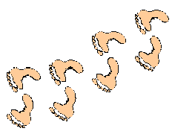
SCIENCE WEBSITES:

- Extreme Science: www.extremescience.com
Learn some cool science stuff about time, weather, space, Earth Science, scientists, and technology in this site.

- Science Odyssey: www.pbs.org/wgbh/aso
Scroll through the 20th century and see what changes happen in home technology. Also learn about advances in medicine, human behavior, astronomy and life sciences.
- Science Experiments for Kids: www.fatlion.com/science
Lots of cool science experiments on air pressure, paper airplanes, slime, and sounds. Plus links to other science-related sites.
- Do Science! www.doscience.com
This page offers “things to do while waiting for the food to come” in a restaurant. You’ll learn how to make a lava lamp, and lots of things for science fair magic.
- Ask Dr. Universe: www.wsu.edu/DrUniverse
Do frogs sleep? Why are flowers colored the way they are? Why does electricity shock? These are some of the questions answered by a cat named Dr. Universe. She hunts down the answers to questions from people all over the world.
- Thinking Fountain: www.sci.mus.mn.us/sln/tf/nav/thinkingfountain.html
This is good site for science project ideas. Click on Theme Clusters to find projects by topic. The projects also tell how to tie your topic to science, math and language arts.


FREE STUFF

Running Den meetings on a budget can be a challenge. Crafts materials and snacks for the boys can be expensive. Listed below and in the monthly sections are some ideas for getting some free stuff. Please note that we are not endorsing any of the products listed, nor has any compensation been provided their listing. They are listed mainly for their access to some free and cool stuff.

Tips for ordering Free Stuff:

- Read Carefully: Read the descriptions of the offers carefully to find out exactly what you’re getting, so you won’t be disappointed when it arrives.
- Follow Directions: You must following the directions exactly as stated, or else you might not get your request.
- Ask for only one of anything you send for.
- Family members, or members in the den must send separate requests. You can do this as a den activity; supply enough notepaper, envelopes, pens, and stamps.
- When sending post cards for your request, use a postcard that is at least 3½ by 5½ inches. You can use blank post cards that are available from the post office, or ones with pictures on them.
- If the directions say to enclose a long self-addressed stamped envelope:
  - Neatly print your name and address in the center of a 10” long envelope as if you were mailing it to yourself. Print your return address in the upper left corner too. Put a first-class stamp on it.
  - Fold up (but don’t seal) the long self-addressed envelope and put it inside another 10” long envelope along with your letter to the supplier. Put a first-class stamp on the second envelope too.
  - Neatly print the supplier’s address on the outside envelope, along with your return address.
- Expect to wait four to eight weeks for your stuff to arrive. Sometimes you may need to wait longer.
- Abbreviations: SASE=Self-addressed Stamped Envelope, LSASE=Large Self-addressed Stamped Envelope (usually 8”x10”)

- Popular “Free Stuff” website: www.myfree.com

You can order these items FREE from the U.S. Geological Survey:
- Poster: Oceans - Ask for: 96-0455
- Pamphlet: Severity of Earthquake - Ask for: 93-0505
- Pamphlet: Volcanoes of the United States - Ask for: 93-0610
Write to:
USGS Information Services
Box 25286
Denver, CO 80225
Telephone 1-888-ASK-USGS (1-888-275-8747)
http://www.usgs.gov
You can order these items FREE from the National Weather Service:
- Wallet Card: Survival in a Hurricane - Ask for: #70027
- Map: Atlantic Hurricane Tracking Map - Ask for: #96071
- Booklet: Owlie Skywarn - Watch Out Storms Ahead! - Ask for: NOAA/PA 200451
Write to:
Customer Service Core
National Weather Service Headquarters
1325 East West Highway
Silver Spring, MD, 20910
You can order these items FREE from the Environmental Protection Agency:
- Coloring Book: Happy Earth Day
- Coloring Book: Save our Species Coloring Book
- Poster: 50 Ways to Make Your World a Better Place
- Comic Book: Adventures of the Garbage Gremlin

Write to:
Publications
Office of Public Affairs
U.S. EPA Region 5
77 W. Jackson Blvd.
Chicago, IL 60604
More Free Stuff:
- HotTexas.com - Free Hot Sauce Sample: www.hotexas.com/freesamples.htm
Fill out their form to receive a free sample of the best habanera H.O.T Sauce on earth.
- Free Chocolate Lovers Cookbook: www.candy-lovers.com/chocolate.html
Sign up for their candy lovers newsletter full of candy recipes, ideas and free stuff and they will send you a free recipe book.
- Sizzling Chicken on the Grill
Write to: Delmarva Poultry, 16686 County Seat Highway, Georgetown, DE. 19947
Receive a booklet of sizzling chicken recipes that are hot off the grill. Include SASE.
- Wall Poster of Sign Language
Write to: Sign Language Fun, P.O. Box 367, Stanhope, N.J. 07874
Free wall poster of sign language, and helpful guide.
- Life’s Little Book of Wellness
Write to: Wheat Foods Council TAB, 2305 Grand Blvd 700, Kansas City, MO. 64108
Free copy of Life’s Little Book of Wellness, with healthy suggestions.
- Pet Magnet
Write to: St. Huberts Animal Welfare Center, P.O. Box 159, Madison, N.J. 07940
Free magnet containing life saving pet poison control hotline phone number. Include SASE.
- Pet ID Tag
Write to: PALS, P.O. Box 1271, San Luis Obispo, CA. 93406
To receive a Pet ID tag, print your pet’s name, address and your phone number. Include large SASE. Include postage and handling charge of: $1.
- Memory Stickers
Write to: Memory Stickers, 13435 S. Cedar, Cedar, MI. 49621.
Receive some archival-quality acid-free stickers for your memory book. They come in party, sports and hobby themes. Include SASE. Limit is 1 per household.


GENERAL CRAFT TIPS

Discounts for Craft Supplies – Some Arts and Crafts stores, such as Michaels and Aaron Brothers offer discounts to Scout groups. Ask the store manager if the store offers such a discount; you may need to provide your Scout leader card, and submit letter with Pack letterhead.

Scrap Plastic and Leatherette – can be obtained from auto upholstery companies’ scrap material. Use for Indian costumes, bookmarks, stool covers, etc.

Scrap Wood – can be obtained from a lumber supply or hardware store that sells wood, such as Home Depo. Ask the store manager for scrap wood for your Cub Scout woodcraft projects.

Cracked Marbles – Heat marbles in 375° oven. Remove and pour into bowl of ice water and watch them crack. These have numerous uses in craft projects.

Puppet Stuffing – Lint from automatic dryers makes good, clean stuffing for puppets. Or stuff them with plastic dry-cleaning bags or worn-out nylon stockings.

Glue – Buying white glue in quart size is more economical. Pour into small containers for use by boys.

To Clean Eggshells – Put empty eggshells in jar and cover with bleach. Leave for 48 hours. This dissolves all the membrane.

Cutting Styrofoam - Some types of Styrofoam can be cut with a knife; the kind with a serrated edge, which can be used as a saw, works best. Heavier types of Styrofoam can be cut best with a coping saw or jigsaw.

Punching Holes in Plastic - To make a hole in plastic, use a hot ice pick or nai1. If you use the nail, be sure to hold it with pliers or something similar so you don't burn your fingers. Coping saws or jigsaws will cut the thick portion of plastic bott1es easier than scissors or knives.

Painting Plastic Bottles - Mix tempera paint with a little powdered detergent. This makes it adhere to the bottles better. Acrylic paint works well, too.

Using Rubber Molds - Dip rubber molds in liquid detergent before removing the plaster casts from inside. The molds will slip off easily without breaking the plaster.

Indian Necklaces - Save cantaloupe seeds and pumpkin seeds. String them together with colored beads in between to make Indian necklaces.

Using Felt-Tip Markers on Plastic – Felt-tip markers will work better on plastic bottles if you first sandpaper the plastic lightly. Then spray with hairspray to protect the decoration. Permanent markers, such as Sharpie pens also work well on plastic.

Bonding Plastic - To bond clear plastic to cardboard, first sandpaper lightly. Then press plastic on with a moderately warm iron, using constant circular motions.

Dyeing Rice, Beans, Macaroni – First, rinse in cold water. Then soak in diluted food coloring until proper shade. Dry on paper towel or newspaper.

Working with Tin - When working on tin projects, rub the edges with steel wool and you will be less likely to cut yourself on sharp edges.

Paint Brush Substitutions - When painting large objects such as scenery for a skit, use a sponge dipped in tempera. Some small objects can be painted with a Q-tip instead of a brush.

RAFT – Resource Area for Teachers (www.raft.net) is a great place for up picking ideas and cheap materials for craft projects. RAFT collects surplus materials donated by local businesses, ranging from cardboard tubes to computers. They also provide workshops on science and craft projects for classroom use. Discount memberships to RAFT are available through the Santa Clara County Council.




Cub Scouting Diamond Jubilee

In 2005 Cub Scouting marks its 75th Anniversary. The official celebration started in September 2004, and continues through December 2005. Here are some things you can do to celebrate this jubilee year:
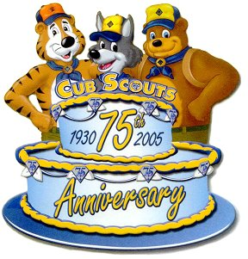

- Ensure that all members of your Pack, including Tiger Cubs, Cub Scouts, Webelos Scouts, families, and leaders know about this event.
- Plan a celebration commemorating the 75th Anniversary of Cub Scouting by making the anniversary the theme for your Blue and Gold banquet.
- Conduct a service project for your chartered organization or the community. Post a sign or write an article about your project.
- Find out about typical games of the 1930s and play one or more at pack or den meetings during the year.
- Look for former leaders in your pack and invite them to a special event, such as your Blue and Gold banquet.
- Have your pack historian (appoint one if you don’t have one) start or update your den or pack scrapbook.
- Make a time capsule. Have each boy contribute an item that represents him. Set a date for when the capsule will be opened.
- Conduct a “Joke-a-Thon 75” at the pack campout. Assign each den a certain number of jokes (totaling 75 for the pack) to tell at your campfire. Boy’s Life magazine is a great resource for jokes.

More 75th Anniversary Activities

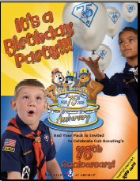

Cub Scout Anniversary Products

Many products marking Cub Scouting’s 75th Anniversary are available for purchase at the Scout shop, including balloons, stickers, pens, mugs and specialty items.

See the Birthday Party Flyer

In honor of the 75th Anniversary of the Cub Scouting Program, which began in 1930, BSA has developed a set of 75th Anniversary Awards which can be earned by individual Cub Scouts (including Tiger, Wolf, Bear, and Webelos Scouts), Cub Scout Leaders, Families of Cub Scouts, and Cub Scout Packs. Award requirements vary for each level. Each award emblem border features a different color.
Award Requirements Form
Youth Award  Patch with red border.  For Tiger Cubs, Cub Scouts, and Webelos Scouts. | 
Leader Award  Patch with blue border.  For any registered leader who works with Cub Scouts. | 
Family Award  Patch with yellow border.  For all Tiger Cubs, Cub Scouts, Webelos Scouts, and family members. | 
Pack Award  Patch with silver border,  plus a ribbon streamer for the pack flag.  For each youth and adult member of qualifying packs. | 



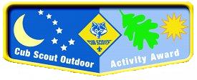

The Cub Scout Outdoor Activity Award is a new award for Tiger Cubs, Wolf and Bear Cub Scouts, and Webelos Scouts. Boys may earn the award in each of the program years as long as the requirements are completed each year. The first time the award is earned, the boy will receive the pocket flap award (shown above), which is to be worn on the right pocket flap of the uniform shirt. Each successive time the award is earned, a wolf track pin (also shown above) may be added to the flap. Leaders should encourage boys to build on skills and experiences from previous years when working on the award for a successive year.

Requirements

All Ranks
Attend Cub Scout day camp or Cub Scout/ Webelos Scout resident camp.

Rank-Specific
- Tiger Cubs. Complete one requirement in Achievement 5, “Let’s Go Outdoors” (Tiger Cub Handbook) and complete three of the outdoor activities listed below.
- Wolf Cub Scouts. Assemble the “Six Essentials for Going Outdoors” (Wolf Handbook, Elective 23b) and discuss their purpose, and complete four of the outdoor activities listed below.
- Bear Cub Scouts. Earn the Cub Scout Leave No Trace Award (Bear Handbook, Elective 25h) and compete five of the outdoor activities listed below.
- Webelos Scouts. Earn the Outdoorsman Activity Badge (Webelos Handbook); and complete six of the outdoor activities listed below.

Outdoor Activities
With your den, pack, or family:
- Participate in a nature hike in your local area. This can be on an organized, marked trail, or just a hike to observe nature in your area.
- Participate in an outdoor activity such as a picnic or park fun day.
- Explain the buddy system and tell what to do if lost. Explain the importance of cooperation.
- Attend a pack overnighter. Be responsible by being prepared for the event.
- Complete an outdoor service project in your community.
- Complete a nature/conservation project in your area. This project should involve improving, beautifying, or supporting natural habitats. Discuss how this project helped you to respect nature.
- Earn the Summertime Pack Award.
- Participate in a nature observation activity. Describe or illustrate and display your observations at a den or pack meeting.
- Participate in an outdoor aquatic activity. This can be an organized swim meet or just a den or pack swim.
- Participate in an outdoor campfire program. Perform in a skit, sing a song, or take part in a ceremony.
- Participate in an outdoor sporting event.
- Participate in an outdoor Scout’s Own or other worship service.
- Explore a local city, county, state, or national park. Discuss with your den how a good citizen obeys the park rules.
Cub Scouts Outdoor Activity Award Flyer



