ENGINEER(1) -- TECHNOLOGY GROUP
Den Activities
- Arrange for boys to visit an engineer or surveyor in a municipal county office. Plan for the boys to look through the surveyor's manual and read a rod.
- Visit a construction site and see the plans that are being followed.
- Visit the county water works or a TV or radio station.
- Have someone explain how to read topographic maps.
- Make a block and tackle. Be sure to explain its purpose.
- Make catapults and demonstrate them at pack meeting, shooting at a safe target (away from people) candies for distance.
- Discuss different types of engineers. If one can visit your den, let him describe briefly what his duties are.
- Have an engineer or surveyor visit your den meeting.
- Demonstrate the basic principles of leverage by using a teeter-totter or a plank with a fulcrum made of bricks or blocks.
- Invite a civil, electrical, mechanical or chemical engineer to the meeting to discuss his/her occupation.
- Obtain a blue print of a building and ask an engineer to discuss the plans. Then tour the building.
- Measure the dimensions of your meeting place and include the locations of doors and windows. Show how to sketch a simple floor plan with these measurements.
- Have a resource person demonstrate the use of drafting tools.
- Invent a machine to do a task. You might even have fun concocting a "Rube Goldberg" invention.
- Have an engineer visit your den and tell about his profession. He might be able to bring a set of blueprints, and explain the symbols used, and show how he uses blueprints.
- Ask your local Boy Scout troop to give a demonstration of some of the skills needed for the Pioneering Merit
- Badge. One particular item of interest would be to see a rope monkey bridge being lashed together.

Model Monkey Bridge
Based on a foot bridge found in the high mountains of India, the monkey bridge uses one thick rope to walk on and two others as hand ropes.
The same design and knots used in the full-sized version are used in this model. The monkey bridge is often built in Scout camp as part of the Pioneering merit badge.
You'll need some hemp cord, some pieces of strong string, four 1/4" dowels 10" long, and two 1/4" dowels 4" long. A piece of scrap lumber at least 30" long and 4" wide makes a good base.
Make the shear lashings first, about 4" from the top of the shear legs. Tie loosely so the legs can open. Add the crosspieces, fastened with square lashings about 2" from the bottom. All lashings begin and end with a clove hitch.
Stretch the cord between the supports and tack the ends in place. Add the hand ropes and fasten them to the same anchor. Paint or stain the wood to give the bridge a rustic look.

Speakers in the following Fields of Engineering
You may be lucky enough to have some Moms and Dads of your Scouts who are Engineers. Invite them to speak about what they do. Perhaps, they could even take the den to see where they work and what they do. Or maybe there is a big local plant near you that has Engineers who would be willing to volunteer some time to show your den around. I live near a large Dupont facility and have met some of their staff and toured their Waste Treatment facility.
Here are some ideas about what engineers do -
Aeronautical Engineering - deals with the whole field of design, manufacturing, maintenance, testing, and the use of aircraft.
Industrial or Management Engineering - pertains to the efficient use of machinery, labor, and raw materials in industrial production.
Chemical Engineering - concern with the design, construction, and management of factories in which essential processes consist of chemical reactions.
Civil Engineering - is one of the broadest of the engineering fields dealing with the creation improvement and protection of the communal environment. Buildings, roads, bridges, airports and other constructions are just a few of the areas civil engineers impact.
Electrical Engineering - involves the use of electrical power, electrical machinery and communication, information, and control systems.
Geological and Mining Engineering - includes activities related to the discovery and processing of minerals.
Mechanical Engineering - speaks to the design and operation of all types of machinery.
Safety Engineering - is concerned with the prevention of accidents.

Make A Steam Engine
Circle Ten Council
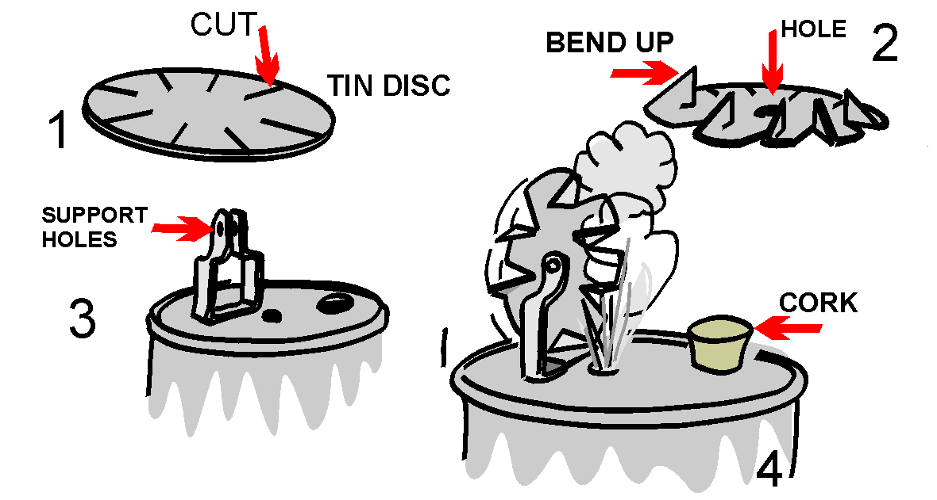
A Webelos Scout may get a graphic demonstration of the power of steam by building the simple steam turbine shown in this illustration. Materials needed are a tin can, a lid from a second tin can, a pair of tin snips, a sheet metal screw, a cork, a power drill, an extra piece of tin to make the support for the turbine wheel, a finishing nail, and a source of heat.
Assemble to look like the illustration.

Blueprint Symbols
Can be used in floor plans drawn for requirement 8 of the Webelos Engineer activity badge. Make a game of learning them by putting each one on a 3" x 5" card and using them as flash cards.
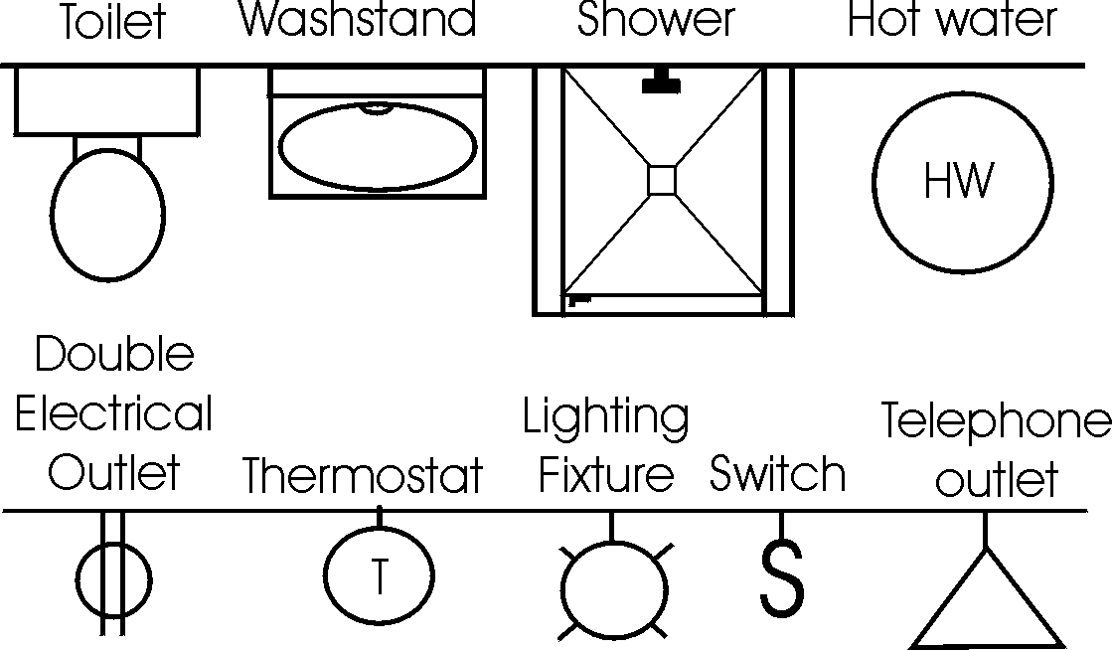
Paper Bridge Competition
Karen, Webelos Leader (and an engineer),
Pack 23, Suffern, NY
Materials:
2 rolls masking tape
2 stacks of newspaper (a good size Sunday paper will do)
4 chairs with backs
2 identical sets of books or blocks (for weight)
Divide the Den into two groups. Let an adult help each group if available. Give each group a roll of masking tape and a stack of newspapers. Set up the chairs in pairs about 4 feet apart. Each group must make a bridge using the materials provided that spans from one chair to the other.
After a set amount of time (15 to 20 min), see how much weight each bridge can support without failing. The bridges may be a truss, suspension, or cable stayed bridge, but must span from one chair to the other without touching the ground in between.

Gumdrop Truss Bridge
This is a fun project that illustrates the strength and rigidity of a truss bridge. You will need a box of round toothpicks and a couple of bags of inexpensive gumdrops (or spice drops). Scouts can work as pairs or individuals on this project. Each scout should start by assembling a single triangular panel using 3 gumdrops and 3 toothpicks. (It is important to notice the strength of the triangular shape.) From there they can extend the side panel of the truss by adding more toothpicks and gumdrops.
Once the single truss is about 4 panels long, the scouts can begin the second side truss. The two sides are then connected together by adding toothpicks between matching gumdrop node points. This short bridge span, which is about 8 inches long, will be very stiff and strong. Spanning the bridge between two stacks of books, or the like can test the strength. A cup full of pennies can be used to load the truss. After testing the strength, the scouts can extend the bridge length by adding more pieces. A second level of truss may be added for really long spans (2 ft or more). The scouts will enjoy testing out various different bridge configurations.

The Right "Man" (or Woman) for the Job!
Use a word from this list to fill in the correct answer.
Aeronautics Electrical
Chemical Physical
Computer Industrial
City Mechanical
Agricultural Civil
- An engineer who designs plants to make water safe to drink - __________.
- An engineer who designs machines in a factory - _________________.
- An engineer who tests new processes and checks old ones in a chemical plant - ________________.
- An engineer who plans new circuits and directs workers in an electrical plant - ________________.
- An engineer who designs and tests new space techniques - ________________.
- An engineer who designs and tests new techniques for new equipment for industry - ___________________.
- An engineer who designs and tests equipment for farmers and ranchers - __________________.

Bridges & Machines
Use a word from this list to fill in the correct answer.
Catapult Arch Bridge
Pulleys Suspension Bridge
Beam Bridge Levers
Plank Bridge Block & Tackle
Truss Bridge Pier Bridge
- A flat surface over two supports -
- A flat surface over three or more supports -
- A flat surface over an arched support -
- A flat surface with turned up edges -
- A bridge with sides made up of a series of triangles -
- A bridge that appears to hang from strong strung cables
- A pulley(s) and a rope or cable -
- A slingshot or other device used to project something -

Basketball Catapult
Instructions
- Base, backboard and hoop are made from a 1"x4" board.
- Drill holes in base and backboard 3/8" diameter and 1/2" deep.
- Cut a slot at a 15 degree angle in a cube block large enough for the handle of a plastic spoon.
- Cut hole for the hoop first; then finish cutting the hoop piece. (We used a slice of 2" diameter PVC pipe and screwed it into backboard.)
- Glue the hoop to the backboard; then glue dowel rod into backboard and base.
- Glue cube block to base and insert spoon into slot.
- Cut string and attach one end to dowel rod at base and the other end to any 1" sized ball (ping pong balls work well).

Rubber Bands & Engineering
Rubber Band Strength
One of the requirements for engineer is to make a catapult. This requires the use of a rubber band or two, or a piece of tire inner tube. The rubber band is "elastic" and it stretches, but then returns to it's original shape. Before using materials in building, engineers must know the characteristics. Does it expand or contract? Is it weak or strong? Does it burn or not?
You can try an experiment to learn more of the characteristics of rubber bands and other elastic material. Get a collection of different sized rubber bands. Measure them for length, width and thickness (if you can). Make a chart that shows this information and mark each rubber band clearly so you know which is which. (Using colored rubber bands is best.)
With each rubber band, attach one end to a cup hook that is screwed into a board. Attach the other end to a known weight. How far down does each rubber band stretch? Does its thickness change? Does its width change? Which rubber band is the strongest? Which rubber band is the weakest? How can you tell?

Rubber  band | Original |  |  | Stretched
Rubber  band | Length | Width | Thickness | Length | Width | Thickness

This page intentionally left blank. Well, maybe not exactly intentionally, but not by accident either. See, it’s often a good idea to have a section or chapter start on an odd numbered page. And this last section had an odd number of pages. So, to get the next section to start on the usual odd numbered page, it’s common practice to insert a blank page, so that the previous section, which started on an odd numbered page, has an even number of pages. Oddly enough, some people think that it’s necessary to put something on the page, like, “This page intentionally left blank.” That idea probably began with the military industrial complex and their specifications and instructions. For our military folk it’s really important that nothing ever be blank, unused, pristine. Something found blank might mean that something important was left out, and they never, ever leave anything out. And they would never want you to think that something had been left out. Anyway, back to this epic document. The problem now is that even though this page was supposed to be intentionally left blank, it is now unintentionally left messy. But it truly did not contain anything useful, interesting or instructional. So at least part of the original intent was accomplished. And now, intentional or unintentional, blank or messy, it’s time to get back to the Book.

